Electronic Supplementary Material

Data Recoding.
To maximise the phylogenetic signal in the typological data, we recoded 49 of the 138 characters by splitting up aggregate categories and combining feature states with few members. First, most of the changes (affecting 26/49 recoded features) involved decomposing aggregate sets. For example, the feature HASWAN (‘Want’ complement subjects) consisted of state 1 (the complement subject is left implicit), state 2 (the complement subject is expressed overtly), and state 3 (both construction types exist). Here, the languages belonging to the aggregate state 3 were decomposed to belong to both of the non-aggregate categories 1 and 2.

Second, we recoded states that were implicitly uncertain in the WALS data to be explicitly uncertain (i.e. character state “?”) to allow the phylogenetic analyses to estimate the most appropriate state (4/49 recoded features). For example, in state 6 of feature DRYPRO (Expression of Pronominal Subjects) contained languages with “more than one of the above types with none dominant”. These were recoded as uncertain.

Third, in order to increase the chance of finding deep signal in the data, some of the more subtle divisions between traits were eliminated (22/49 recodings). For example, in BICEXP (Exponence of Selected Inflectional Formatives), the types of case distinction in inflectional formatives were merged, in favour of a simple distinction between case and no-case systems.

All changes are listed in table S3.

Supplementary Figures.

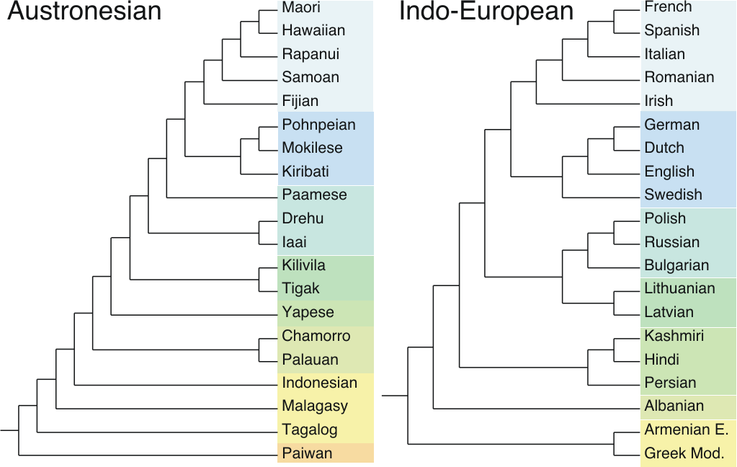

Electronic Supplementary Material Figure 4: Trees for the Austronesian and Indo-European language families derived from linguistic classification. Languages are color-coded according to accepted subgroups.
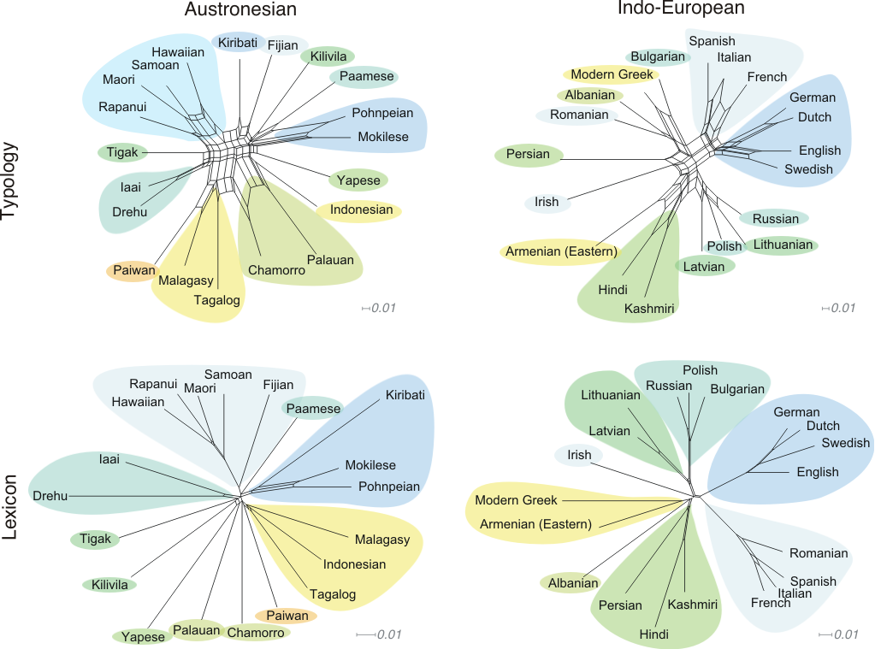Electronic Supplementary Material Figure 5: NeighborNets for each lexical and typological dataset. Colors represent accepted subgroups.
Supplementary Tables.

Table 1: Original WALS feature list showing the WALS code, feature class, and a description of each character.
ID | Name | Feature Class | Description
1 | MADCON | Phonology | Consonant Inventories
2 | MADVOW | Phonology | Vowel Quality Inventories
3 | MADCVR | Phonology | Consonant-Vowel Ratio
4 | MADVOI | Phonology | Voicing in Plosives and Fricatives
5 | MADGAP | Phonology | Voicing in Gaps and Plosive Systems
6 | MADUVU | Phonology | Uvular Consonants
7 | MADGLO | Phonology | Glottalized Consonants
8 | MADLAT | Phonology | Lateral Consonants
9 | ANDANG | Phonology | The Velar Nasal
10 | HAJNAS | Phonology | Vowel Nasalization
11 | MADFRV | Phonology | Front Rounded Vowels
12 | MADSYL | Phonology | Syllable Structure
13 | MADTON | Phonology | Tone
14 | GOEFIX | Phonology | Fixed Stress Locations
15 | GOEVAR | Phonology | Weight-Sensitive Stress
16 | GOEFAC | Phonology | Weight Factors in Weight-Sensitive Stress
17 | GOERHY | Phonology | Rhythm Types
18 | MADABS | Phonology | Absence of Common Consonants
19 | MADPRS | Phonology | Presence of Uncommon Consonants
20 | BICFUS | Morphology | Fusion of Selected Inflectional Formatives
21 | BICEXP | Morphology | Exponence of Selected Inflectional Forms
22 | BICSYN | Morphology | Inflectional Synthesis of the Verb
23 | BICHDC | Morphology | Locus Marking in the Clause
24 | BICHDN | Morphology | Locus of Marking in Possessive Noun Phrases
25 | BICHDM | Morphology | Locus of Marking: Whole-Language Typology
26 | DRYPRE | Morphology | Prefixing vs. Suffixing in Inflectional Morphology
27 | RUBRED | Morphology | Reduplication
28 | BAECSY | Morphology | Case Syncretism
29 | BAEPSY | Morphology | Syncretism in Verbal Person/Number Marking
30 | CORNUM | Nominal Categories | Number of Genders
31 | CORSEX | Nominal Categories | Sex-based and Non-sex-based Gender Systems
32 | CORASS | Nominal Categories | Systems of Gender Assignment
33 | DRYNPL | Nominal Categories | Coding of Nominal Plurality
34 | HASNPL | Nominal Categories | Occurrence of Nominal Plurality
35 | DANPLU | Nominal Categories | Plurality in Independent Personal Pronouns
36 | MORASP | Nominal Categories | The Associative Plural
37 | DRYDEF | Nominal Categories | Definite Articles
38 | DRYIND | Nominal Categories | Indefinite Articles
39 | CYSIND | Nominal Categories | Inclusive / Exclusive Distinction in Independent Pronouns
40 | CYSVRB | Nominal Categories | Inclusive / Exclusive Distinction in Verbal Inflection
41 | DIEDDD | Nominal Categories | Distance Contrasts in Demonstratives
42 | DIEPRO | Nominal Categories | Pronominal and Adnominal Demonstratives
43 | BHADEM | Nominal Categories | Third Person Pronouns and Demonstratives
44 | SIEGEN | Nominal Categories | Gender Distinctions in Independent Personal Pronouns
45 | HELPOL | Nominal Categories | Politeness Distinctions in Pronouns
46 | HASIND | Nominal Categories | Indefinite Pronouns
47 | KONDIF | Nominal Categories | Intensifiers and Reflexive Pronouns
48 | BAKADP | Nominal Categories | Person Marking on Adpositions
49 | IGGNUM | Nominal Categories | Number of Cases
50 | IGGCMA | Nominal Categories | Asymmetrical Case-Marking
51 | DRYCAS | Nominal Categories | Position of Case Affixes
52 | STOCIS | Nominal Categories | Comitatives and Instrumentals
53 | STOORD | Nominal Categories | Ordinal Numerals
54 | GILDIS | Nominal Categories | Distributive Numerals
55 | GILCLF | Nominal Categories | Numeral Classifiers
56 | GILCUQ | Nominal Categories | Conjunctions and Universal Quantifiers
57 | DRYPOS | Nominal Categories | Position of Pronominal Possessive Affixes
58 | NICOBL | Nominal Syntax | Obligatory Possessive Inflection
59 | NICPOC | Nominal Syntax | Possessive Classification
60 | GILDIF | Nominal Syntax | Genitives, Adjectives and Relative Clauses
61 | GILAWN | Nominal Syntax | Adjectives without Nouns
62 | KOPNOM | Nominal Syntax | Action Nominal Constructions
63 | STACOO | Nominal Syntax | Noun Phrase Conjunction
64 | HASCON | Nominal Syntax | Nominal and Verbal Conjunction
65 | DAHPFV | Verbal Categories | Perfective / Imperfective Aspect
66 | DAHPAS | Verbal Categories | The Past Tense
67 | DAHFUT | Verbal Categories | The Future Tense
68 | DAHPFC | Verbal Categories | The Perfect
69 | DRYTAA | Verbal Categories | Position of Tense-Aspect Affixes
70 | AUWIMP | Verbal Categories | The Morphological Imperative
71 | AUWPRH | Verbal Categories | The Prohibitive
72 | AUWHOR | Verbal Categories | Imperative-Hortative Systems
73 | DOBOPT | Verbal Categories | The Optative
74 | AUWSIT | Verbal Categories | Situational Possibility
75 | AUWEPI | Verbal Categories | Epistemic Possibility
76 | AUWSEM | Verbal Categories | Overlap between Situational and Epistemic Modal Marking
77 | HAAEVD | Verbal Categories | Semantic Distinctions of Evidentiality
78 | HAAEVC | Verbal Categories | Coding of Evidentiality
79 | VESTAM | Verbal Categories | Suppletion According to Tense and Aspect
80 | VESNUM | Verbal Categories | Verbal Number and Suppletion
81 | DRYSOV | Word Order | Order of Subject, Object and Verb
82 | DRYSBV | Word Order | Order of Subject and Verb
83 | DRYOBV | Word Order | Order of Object and Verb
84 | DRYXOV | Word Order | Order of Object, Oblique, and Verb
85 | DRYADP | Word Order | Order of Adposition and Noun Phrase
86 | DRYGEN | Word Order | Order of Genitive and Noun
87 | DRYADJ | Word Order | Order of Adjective and Noun
88 | DRYDEM | Word Order | Order of Demonstrative and Noun
89 | DRYNUM | Word Order | Order of Numeral and Noun
90 | DRYREL | Word Order | Order of Relative Clause and Noun
91 | DRYDEG | Word Order | Order of Degree Word and Adjective
92 | DRYPQP | Word Order | Position of Polar Question Particles
93 | DRYCOQ | Word Order | Position of Interrogative Phrases in Content Questions
94 | DRYOSC | Word Order | Order of Adverbial Subordinator and Clause
95 | DRYRPO | Word Order | Relationship between the Order of Object and Verb and the Order of Adposition and Noun Phrase
96 | DRYRRO | Word Order | Relationship between the Order of Object and Verb and the Order of Relative Clause and Noun
97 | DRYRAO | Word Order | Relationship between the Order of Object and Verb and the Order of Adjective and Noun
98 | COMALN | Simple Clauses | Alignment of Case Marking of Full Noun Phrases
99 | COMALP | Simple Clauses | Alignment of Case Marking of Pronouns
100 | SIEALI | Simple Clauses | Alignment of Verbal Person Marking
101 | DRYPRO | Simple Clauses | Expression of Pronominal Subjects
102 | SIEVPA | Simple Clauses | Order of Person Markers on the Verb
103 | SIEZER | Simple Clauses | Third Person Zero of Verbal Person Marking
104 | SIEAPV | Simple Clauses | Verbal Person Marking
105 | HASDIT | Simple Clauses | Ditransitive Constructions: The Verb 'Give'
106 | MASREC | Simple Clauses | Reciprocal Constructions
107 | SIEPAS | Simple Clauses | Passive Constructions
108 | POLANT | Simple Clauses | Antipassive Constructions
109 | POLAPP | Simple Clauses | Applicative Constructions
110 | SONPER | Simple Clauses | Periphrastic Causative Constructions
111 | SONNON | Simple Clauses | Nonperiphrastic Causative Constructions
112 | DRYNEG | Simple Clauses | Negative Morphemes
113 | MIESYM | Simple Clauses | Symmetric and Asymmetric Standard Negation
114 | MIEASY | Simple Clauses | Subtypes of Asymmetric Standard Negation
115 | HASNEG | Simple Clauses | Negative Indefinite Pronouns and Predicate Negation
116 | DRYPOQ | Simple Clauses | Polar Questions
117 | STAPOS | Simple Clauses | Predicative Possession
118 | STAADJ | Simple Clauses | Predicative Adjectives
119 | STALOC | Simple Clauses | Nominal and Locational Predication
120 | STAZER | Simple Clauses | Zero Copula for Predicate Nominals
121 | STACMP | Simple Clauses | Comparative Constructions
122 | KUTRSJ | Complex Sentences | Relativization on Subjects
123 | KUTROB | Complex Sentences | Relativization on Obliques
124 | HASWAN | Complex Sentences | _Want_ Complement Subjects
125 | CRIPUR | Complex Sentences | Purpose Clauses
126 | CRIWHE | Complex Sentences | When Clauses
127 | CRIREA | Complex Sentences | Reason Clauses
128 | CRIUTT | Complex Sentences | Utterance Complement Clauses
129 | BROHAN | Semantic Lexicon | Hand and Arm
130 | BROFIN | Semantic Lexicon | Finger and Hand
131 | COMNUM | Semantic Lexicon | Numeral Bases
132 | KAYNDC | Semantic Lexicon | Number of Non-Derived Basic Colour Categories
133 | KAYBCC | Semantic Lexicon | Number of Basic Colour Categories
134 | KAYGRE | Semantic Lexicon | Green and Blue
135 | KAYRED | Semantic Lexicon | Red and Yellow
136 | NICMTP | Semantic Lexicon | M-T Pronouns
137 | NICNMP | Semantic Lexicon | N-M Pronouns
138 | DAHTEA | Semantic Lexicon | Tea
139 | ZESNEG | Sign Languages | Irregular Negatives in Sign Languages
140 | ZESQUE | Sign Languages | Question Particles Sign Languages
142 | GILTUT | Other | Para-Linguistic Usages of Clicks

Table 2: Languages in the worldwide dataset, showing the language family, WALS code, and the ISO-639-3 Language code.
Language | Family | WALS | ISO
Arabic (Colloquial Egyptian) | Afro-Asiatic | aeg | arz
Berber (Middle Atlas) | Afro-Asiatic | bma | tzm
Hausa | Afro-Asiatic | hau | hau
Hebrew (Modern) | Afro-Asiatic | heb | heb
Iraqw | Afro-Asiatic | irq | irk
Oromo (Harar) | Afro-Asiatic | orh | hae
Ainu | Ainu | ain | ain
Evenki | Altaic | eve | evn
Khalkha | Altaic | kha | khk
Turkish | Altaic | tur | tur
Mapudungun | Araucanian | map | aru
Apurina | Arawakan | apu | apu
Gooniyandi | Australian | goo | gni
Kayardild | Australian | kay | gyd
Mangarrayi | Australian | myi | mpc
Martuthunira | Australian | mrt | vma
Maung | Australian | mau | mph
Ngiyambaa | Australian | ngi | wyb
Tiwi | Australian | tiw | tiw
Vietnamese | Austro-Asiatic | vie | vie
Chamorro | Austronesian | cha | cha
Fijian | Austronesian | fij | fij
Indonesian | Austronesian | ind | ind
Malagasy | Austronesian | mal | mlg
Maori | Austronesian | mao | mbf
Rapanui | Austronesian | rap | rap
Tagalog | Austronesian | tag | tgl
Tukang Besi | Austronesian | tuk | khc
Awa Pit | Barbacoan | awp | kwi
Basque | Basque | bsq | bsq
Imonda | Border | imo | imn
Burushaski | Burushaski | bur | bsk
Hixkaryana | Cariban | hix | hix
Wari | Chapacura-Wanhan | war | pav
Rama | Chibchan | ram | rma
Epena Pedee | Choco | epe | sja
Chukchi | Chukotko-Kamchatkan | chk | ckt
Kannada | Dravidian | knd | kan
Greenlandic (West) | Eskimo-Aleut | grw | kal
Maricopa | Hokan | mar | mrc
English | Indo-European | eng | eng
French | Indo-European | fre | fra
German | Indo-European | ger | deu
Greek (Modern) | Indo-European | grk | ell
Hindi | Indo-European | hin | hnd
Latvian | Indo-European | lat | lat
Persian | Indo-European | prs | pes
Russian | Indo-European | rus | rus
Spanish | Indo-European | spa | spa
Japanese | Japanese | jpn | jpn
Krongo | Kadugli | kro | kgo
Georgian | Kartvelian | geo | kat
Nama (Khoekhoe) | Khoisan | kho | naq
Korean | Korean | kor | kkn
Kutenai | Kutenai | kut | kun
Canela-Kraho | Macro-Ge | ckr | ram
Wichi | Matacoan | wch | mzh
Jakaltek | Mayan | jak | jac
Piraha | Mura | prh | myp
Koasati | Muskogean | koa | cku
Slave | Na-Dene | sla | scs
Hunzib | Nakh-Daghestanian | hzb | huz
Ingush | Nakh-Daghestanian | ing | inh
Lezgian | Nakh-Daghestanian | lez | lez
Koromfe | Niger-Congo | kfe | kfz
Luvale | Niger-Congo | luv | lue
Sango | Niger-Congo | san | saj
Supyire | Niger-Congo | sup | spp
Swahili | Niger-Congo | swa | swa
Yoruba | Niger-Congo | yor | yor
Zulu | Niger-Congo | zul | zul
Bagirmi | Nilo-Saharan | bag | bmi
Kanuri | Nilo-Saharan | knr | kph
Lango | Nilo-Saharan | lan | laj
Nivkh | Nivkh | niv | niv
Abkhaz | Northwest Caucasian | abk | abk
Mixtec (Chalcatongo) | Oto-Manguean | mxc | mig
Shipibo-Konibo | Panoan | shk | shp
Yagua | Peba-Yaguan | yag | yad
Quechua (Imbabura) | Quechuan | qim | yum
Alamblak | Sepik | ala | amp
Burmese | Sino-Tibetan | brm | bms
Mandarin | Sino-Tibetan | mnd | chn
Meithei | Sino-Tibetan | mei | mnr
Lakota | Siouan | lkt | lkt
Lavukaleve | Solomons East Papuan | lav | lvk
Thai | Tai-Kadai | tha | tha
Amele | Trans-New Guinea | ame | ami
Kewa | Trans-New Guinea | kew | kjs
Kobon | Trans-New Guinea | kob | kpw
Guarani | Tupian | gua | gug
Finnish | Uralic | fin | fin
Hungarian | Uralic | hun | hun
Yaqui | Uto-Aztecan | yaq | yaq
Warao | Warao | wra | wba
Maybrat | West Papuan | may | ayz
Sanuma | Yanomam | snm | sam
Ket | Yeniseian | ket | ket
Yukaghir (Kolyma) | Yukaghir | yko | yux

Table 3: Recoding used for WALS characters, showing original states, and the recoding process used.
HASWAN | 'Want' Complement Subjects
 | 1: The complement subject is left implicit
 | 2: The complement subject is expressed overtly
 | 3: Both construction types exist
 | 4: 'Want' is expressed as a desiderative verbal affix
 | 5: 'Want' is expressed as an uninflected desiderative particle
 | Recoding – Split Aggregates: set 3 was split into sets 1 & 2
 | Recoding – Merge Categories: sets 4 & 5 were merged
BAECSY | Case Syncretism
 | 1: Inflectional case marking is absent or minimal
 | 2: Inflectional case marking is syncretic for core cases only
 | 3: Inflectional case marking is syncretic for core and non-core cases
 | 4: Inflectional case marking is never syncretic
 | Recoding – Merge Categories: 2 & 3 were combined, set 4 relabeled to set 3
BICEXP | Exponence of Selected Inflectional Formatives
 | 1: Monoexponential case
 | 2: Case + number
 | 3: Case + referentiality
 | 4: Case + TAM (tense-aspect-mood)
 | 5: No case
 | Recoding – Merge Categories: Changed to case/no-case distinction (1, 2, 3 & 4 combined into set 1)
BICFUS | Fusion of Selected Inflectional Formatives
 | 1: Exclusively concatenative
 | 2: Exclusively isolating
 | 3: Exclusively tonal
 | 4: Tonal/isolating
 | 5: Tonal/concatenative
 | 6: Ablaut/concatenative
 | 7: Isolating/concatenative
 | Recoding – Split Aggregates: set 4 split into sets 2 & 3, set 5 split into sets 1 & 3, set 6 split into sets 4 & 3 ( I.e. "Ablaut" replaces the old set 4), set 7 split into sets 1 & 2
BICHDC | Locus of Marking in the Clause
 | 1: P is head-marked
 | 2: P is dependent-marked
 | 3: P is double-marked
 | 4: P has no marking
 | 5: Other types
 | Recoding – Split Aggregates: set 3 was split into sets 1 & 2
BICHDN | Locus of Marking in Possessive Noun Phrases
 | 1: Possessor is head-marked
 | 2: Possessor is dependent-marked
 | 3: Possessor is double-marked
 | 4: Possessor has no marking
 | 5: Other types
 | Recoding – Split Aggregates: set 3 was split into sets 1 & 2
DRYPRE | Prefixing vs. Suffixing in Inflectional Morphology
 | 1: Little or no inflectional morphology
 | 2: Predominantly suffixing
 | 3: Moderate preference for suffixing
 | 4: Approximately equal amounts of suffixing and prefixing
 | 5: Moderate preference for prefixing
 | 6: Predominantly prefixing
 | Recoding – Merge Categories: state 2 became a "suffixing" category, and incorporated all sets 2 & 3, state 3 became a "prefixing" state and incorporated all of sets 5 & 6
 | Recoding – Split Aggregates: state 4 was split between the new sets 2 and 3
IGGCMA | Asymmetrical Case-Marking
 | 1: No morphological case-marking
 | 2: Symmetrical case-marking
 | 3: Additive-quantitatively asymmetrical case-marking
 | 4: Subtractive-quantitatively asymmetrical case-marking
 | 5: Qualitatively asymmetrical case-marking
 | 6: Syncretism in relevant NP-types
 | Recoding – Merge Categories: changed to a case-marking / no-case-marking distinction (sets 3, 4, 5, & 6 merged into set 2)
DRYDEF | Definite Articles
 | 1: Definite word distinct from demonstrative
 | 2: Demonstrative word used as marker of definiteness
 | 3: Definite affix on noun
 | 4: No definite article but indefinite article
 | 5: Neither definite nor indefinite article
 | Recoding – Merge Categories: Sets 1 & 2 merged into 1 (distinct/non-affixed marker), Set 3 relabeled to 2 (definite affix on noun), Sets 4 & 5 combined into set 3 (no definite article)
CYSIND | Inclusive/Exclusive Distinction in Independent Pronouns
 | 1: No grammaticalised marking at all
 | 2: 'We' and 'I' identical
 | 3: No inclusive/exclusive opposition
 | 4: Only inclusive differentiated
 | 5: Inclusive and exclusive differentiated
 | Recoding – Merge Categories: Sets 4 & 5 combined
BAKADP | Person Marking on Adpositions
 | 1: No adpositions
 | 2: Adpositions without person marking
 | 3: Person marking for pronouns only
 | 4: Person marking for pronouns and nouns
 | Recoding – Merge Categories: Sets 3 & 4 merged into set 3
DRYPOS | Position of Pronominal Possessive Affixes
 | 1: Possessive prefixes
 | 2: Possessive suffixes
 | 3: Both possessive prefixes and possessive suffixes, with neither primary
 | 4: No possessive affixes
 | Recoding – Split Aggregates: Set 3 split into 1 & 2, set 4 relabeled to set 3
NICPOC | Possessive Classification
 | 1: No possessive classification
 | 2: Two classes
 | 3: Three to five classes
 | 4: More than five classes
 | Recoding – Merge Categories: changed to "no possessive classifier" vs. "possessive classifier" (sets 2,3 & 4 merged into set 2)
MADABS | Absence of Common Consonants
 | 1: All present
 | 2: No bilabials
 | 3: No fricatives
 | 4: No nasals
 | 5: No bilabials or nasals
 | 6: No fricatives or nasals
Recoding – Merge Categories: Changed to reflect a "absence" vs "presence" distinction:
set 1 = "presence of bilabials" (contains original states 1,3,4,6)
set 2 = "presence of fricatives" (contains original states 1,2,4,5)
set 3 = "presence of nasals" (contains original states 1,2,3)
MADFRV | Front Rounded Vowels
 | 1: None
 | 2: High and mid
 | 3: High only
 | 4: Mid only
 | Recoding – Merge Categories: Changed to No Front Rounded Vowels (set 1) and Front Rounded Vowels (sets 2,3,4)
MADGLO | Glottalized Consonants
 | 1: No glottalized consonants
 | 2: Ejectives only
 | 3: Implosives only
 | 4: Glottalized resonants only
 | 5: Ejectives and implosives
 | 6: Ejectives and glottalized resonants
 | 7: Implosives and glottalized resonants
 | 8: Ejectives, implosives and glottalized resonants
 | Recoding – Split Aggregates: set 5 split into 2,3, set 6 split into 2,4, set 7 split into 3,4, set 8 split into 2,3,4
MADLAT | Lateral Consonants
 | 1: No laterals
 | 2: /l/, no obstruent laterals
 | 3: Laterals, but no /l/ or obstruent lateral
 | 4: /l/ and lateral obstruents
 | 5: No /l/, but lateral obstruents
Recoding – Merge Categories: set 5 merged to set 4 (lateral obstruents)
Recoding – Split Aggregates: set 4 split into sets 2 (/l/) and 4 (lateral obstruents)
MADPRS | Presence of Uncommon Consonants
 | 1: None
 | 2: Clicks
 | 3: Labial-velars
 | 4: Pharyngeals
 | 5: "Th" sounds
 | 6: Clicks and "th"
 | 7: Pharyngeals and "th"
 | Recoding – Split Aggregates: set 6 split into sets 2 & 5, set 7 split into sets 4 & 5
ANDANG | The Velar Nasal
 | 1: Velar nasal, also initially
 | 2: Velar nasal, but not initially
 | 3: No velar nasal
 | Recoding – Merge Categories: Changed to presence/absence of Velar Nasal: sets 1 & 2 merged (presence of VN), set 3 relabeled set 2 (no VN)
MADUVU | Uvular Consonants
 | 1: No uvulars
 | 2: Uvular stops only
 | 3: Uvular continuants only
 | 4: Uvular stops and continuants
 | Recoding – Merge Categories: Changed to reflect absence/presence of uvular consonants: sets 3 & 4 merged into set 2
MADGAP | Voicing and Gaps in Plosive Systems
 | 1: Other
 | 2: /p t k b d g/
 | 3: Missing /p/
 | 4: Missing /g/
 | 5: Both missing
 | Recoding – Split Aggregates: set 5 was split into 3, 4
MADVOI | Voicing in Plosives and Fricatives
 | 1: No voicing contrast
 | 2: Voicing contrast in plosives alone
 | 3: Voicing contrast in fricatives alone
 | 4: Voicing contrast in both plosives and fricatives
 | Recoding – Split Aggregates: set 4 was split into 2 & 3
COMALN | Alignment of Case Marking of Full Noun Phrases
 | 1: Neutral
 | 2: Nominative - accusative (standard)
 | 3: Nominative - accusative (marked nominative)
 | 4: Ergative - absolutive
 | 5: Tripartite
 | 6: Active - inactive
 | Recoding – Merge Categories: sets 2 & 3 merged into set 2
COMALP | Alignment of Case Marking of Pronouns
 | 1: Neutral
 | 2: Nominative - accusative (standard)
 | 3: Nominative - accusative (marked nominative)
 | 4: Ergative - absolutive
 | 5: Tripartite
 | 6: Active - inactive
 | 7: None
 | Recoding – Merge Categories: sets 2 & 3 merged
POLAPP | Applicative Constructions
 | 1: Benefactive object only; both bases
 | 2: Benefactive object only; transitive base only
 | 3: Benefactive and other; both bases
 | 4: Benefactive and other; transitive base only
 | 5: Non-benefactive object only; both bases
 | 6: Non-benefactive object only; transitive base only
 | 7: Non-benefactive object only; intransitive base only
 | 8: No applicative construction
 | Recoding – Merge Categories: sets 1, 2, 3, 4, 5, 6, 7 merged into 1
HASDIT | Ditransitive Constructions: The Verb 'Give'
 | 1: Indirect-object construction
 | 2: Double-object construction
 | 3: Secondary-object construction
 | 4: Mixed
 | Recoding – Explicit Uncertain: set 4 was recoded to "?" (i.e. uncertain)
DRYPRO | Expression of Pronominal Subjects
 | 1: Pronominal subjects are expressed by pronouns in subject position that are normally if not obligatorily present
 | 2: Pronominal subjects are expressed by affixes on verbs
 | 3: Pronominal subjects are expressed by clitics with variable host
 | 4: Pronominal subjects are expressed by subject pronouns that occur in a different syntactic position from full noun phrase subjects
 | 5: Pronominal subjects are expressed only by pronouns in subject position, but these pronouns are often left out
 | 6: More than one of the above types with none dominant
 | Recoding – Explicit Uncertain: set 6 changed to "?" ( i.e. uncertain )
SONNON | Nonperiphrastic Causative Constructions
 | 1: No morphological type or compound type
 | 2: Morphological type but no compound type
 | 3: Compound type but no morphological type
 | 4: Both morphological type and compound type
 | Recoding – Split Aggregates: set 4 split into sets 2 & 3
SONPER | Periphrastic Causative Constructions
 | 1: Sequential type but no purposive type
 | 2: Purposive type but no sequential type
 | 3: Both sequential type and purposive type
 | Recoding – Split Aggregates: set 3 split into set 1 & 2
DRYPOQ | Polar Questions
 | 1: Question particle
 | 2: Interrogative verb morphology
 | 3: Question particle and interrogative verb morphology
 | 4: Interrogative word order
 | 5: Absence of declarative morphemes
 | 6: Interrogative intonation only
 | 7: No interrogative-declarative distinction
 | Recoding – Split Aggregates: set 3 split into set 1 and 2
STAADJ | Predicative Adjectives
 | 1: Predicative adjectives have verbal encoding
 | 2: Predicative adjectives have nonverbal encoding
 | 3: Predicative adjectives have mixed encoding
 | Recoding – Split Aggregates: set 3 split into 1 & 2
MASREC | Reciprocal Constructions
 | 1: There are no non-iconic reciprocal constructions.
 | 2: All reciprocal constructions are formally distinct from reflexive constructions.
 | 3: There are both reflexive and non-reflexive reciprocal constructions.
 | 4: The reciprocal and reflexive constructions are formally identical.
 | Recoding – Split Aggregates: set 3 was split into sets 2 & 4
MIEASY | Subtypes of Asymmetric Standard Negation
 | 1: In finiteness: Subtype A/Fin
 | 2: In reality status: Subtype A/NonReal
 | 3: In other grammatical categories: Subtype A/Cat
 | 4: In finiteness and reality status: Subtypes A/Fin and A/NonReal
 | 5: In finiteness and other grammatical categories: Subtypes A/Fin and A/Cat
 | 6: In reality status and other grammatical categories: Subtypes A/NonReal and A/Cat
 | 7: Non-assignable (no asymmetry found)
 | Recoding – Split Aggregates: set 4 split into 1&2, set 5 split into 1&3, set 6 split into 2&3.
MIESYM | Symmetric and Asymmetric Standard Negation
 | 1: Symmetric standard negation only: Type Sym
 | 2: Asymmetric standard negation only: Type Asy
 | 3: Symmetric and asymmetric standard negation: Type SymAsy
 | Recoding – Split Aggregates: set 3 was split into sets 1 & 2
AUWEPI | Epistemic Possibility
 | 1: The language can express epistemic possibility with verbal constructions
 | 2: The language cannot express epistemic possibility with verbal constructions, but with affixes on verbs
 | 3: The language cannot express epistemic possibility with verbal constructions or with affixes on verbs, but with other kinds of markers
 | Recoding – Explicit Uncertain: set 3 was recoded as "?" ( i.e. uncertain )
AUWHOR | Imperative-Hortative Systems
 | 1: The language has a maximal system, but not a minimal one
 | 2: The language has a minimal system, but not a maximal one
 | 3: The language has both a maximal and a minimal system
 | 4: The language has neither a maximal nor a minimal system
 | Recoding – Merge Categories: Changed to IH vs. No-IH systems: sets 1, 2, & 3 were merged into set 1, set 4 was relabeled set 2
AUWSEM | Overlap between Situational and Epistemic Modal Marking
 | 1: The language has markers that can code both situational and epistemic modality, both for possibility and necessity
 | 2: The language has markers that can code both situational and epistemic modality, but only for possibility or for necessity
 | 3: The language has no markers that can code both situational and epistemic modality
 | Recoding – Merge Categories: Sets 1 & 2 were combined (has markers) into set 1, set 3 was relabeled set 2 (does not have markers)
HAAEVD | Semantic Distinctions of Evidentiality
 | 1: No grammatical evidentials
 | 2: Only indirect evidentials
 | 3: Both direct and indirect evidentials
 | Recoding – Split Aggregates: set 3 was split into sets 1 & 2
VESTAM | Suppletion According to Tense and Aspect
 | 1: Suppletion according to tense
 | 2: Suppletion according to aspect
 | 3: Suppletion in both tense and aspect
 | 4: No suppletion in tense or aspect
 | Recoding – Split Aggregates: set 3 split into 1 & 2, set 4 relabeled to set 3
AUWIMP | The Morphological Imperative
 | 1: The language has morphologically dedicated second singular as well as second plural imperatives
 | 2: The language has morphologically dedicated second singular imperatives but no morphologically dedicated second plural imperatives
 | 3: The language has morphologically dedicated second plural imperatives but no morphologically dedicated second singular imperatives
 | 4: The language has morphologically dedicated second person imperatives that do not distinguish between singular and plural
 | 5: The language has no morphologically dedicated second person imperatives at all
 | Recoding – Merge Categories: sets 1, 2, 3, & 4 merged into set 1
DAHPAS | The Past Tense
 | 1: Past/non-past distinction marked; no remoteness distinction
 | 2: Past/non-past distinction marked; 2-3 degrees of remoteness distinguished
 | 3: Past/non-past distinction marked; at least 4 degrees of remoteness distinguished
 | 4: No grammatical marking of past/non-past distinction
 | Recoding – Merge Categories: sets 2 & 3 combined into set 2 ( "past tense with remoteness distinction" )
AUWPRH | The Prohibitive
 | 1: The prohibitive uses the verbal construction of the second singular imperative and a sentential negative strategy found in (indicative) declaratives
 | 2: The prohbitive uses the verbal construction of the second singular imperative and a sentential negative strategy not found in (indicative) declaratives
 | 3: The prohibitive uses a verbal construction other than the second singular imperative and a sentential negative strategy found in (indicative) declaratives
 | 4: The prohibitive uses a verbal construction other than the second singular imperative and a sentential negative strategy not found in (indicative) declaratives
 | Recoding – Split Aggregates: set 1 split into 1&2, set 2 split into 1&3, set 3 split into 4&2, set 4 split into 3,4
DRYOSC | Order of Adverbial Subordinator and Clause
 | 1: Adverbial subordinators which are separate words and which appear at the beginning of the subordinate clause
 | 2: Adverbial subordinators which are separate words and which appear at the end of the subordinate clause
 | 3: Clause-internal adverbial subordinators
 | 4: Suffixal adverbial subordinators
 | 5: More than one type of adverbial subordinators with none dominant
 | Recoding – Explicit Uncertain: set 5 changed to "?" ( uncertain )
DRYDEG | Order of Degree Word and Adjective
 | 1: Degree word precedes adjective (DegAdj)
 | 2: Degree word follows adjective (AdjDeg)
 | 3: Both orders occur with neither order dominant
 | Recoding – Split Aggregates: set 3 split into sets 1 & 2
DRYOBV | Order of Object and Verb
 | 1: Object precedes verb (OV)
 | 2: Object follows verb (VO)
 | 3: Both orders with neither order dominant
 | Recoding – Split Aggregates: Set 3 split into 1 & 2
DRYCOQ | Position of Interrogative Phrases in Content Questions
 | 1: Interrogative phrases obligatorily initial
 | 2: Interrogative phrases not obligatorily initial
 | 3: Mixed, some interrogative phrases obligatorily initial, some not
 | Recoding – Split Aggregates: set 3 split into 1 & 2
GOEVAR | Weight-Sensitive Stress
 | 1: Left-edge: Stress is on the first or second syllable
 | 2: Left-oriented: The third syllable is involved
 | 3: Right-edge: Stress on ultimate or penultimate syllable
 | 4: Right-oriented: The antepenultimate is involved
 | 5: Unbounded: Stress can be anywhere in the word
 | 6: Combined: Both Right-edge and unbounded
 | 7: Not predictable
 | 8: Fixed stress (no weight-sensitivity)
 | Recoding – Split Aggregates: set 6 split into 3&5
DRYIND | Indefinite Articles
 | 1: Indefinite word distinct from numeral for 'one'
 | 2: Numeral for 'one' is used as indefinite article
 | 3: Indefinite affix on noun
 | 4: No indefinite article but definite article
 | 5: Neither indefinite nor definite
 | Recoding – Merge Categories: sets 4 & 5 merged into 4 ( "no indefinite article")
SIEVPA | Verbal Person Marking
 | 1: A and P do not or do not both occur on the verb
 | 2: A precedes P
 | 3: P precedes A
 | 4: Both orders of A and P occur
 | 5: A and P are fused
 | Recoding – Split Aggregates: set 4 split to 2,3

Table 4: Languages in WALS matching the languages in the Austronesian Basic Vocabulary Database.
WALS Code | Language | ABVD (ID)
cha | Chamorro | Chamorro (18)
dre | Drehu | Dehu (196)
fij | Fijian | Fijian (Bau) (11)
haw | Hawaiian | Hawaiian (52)
iaa | Iaai | Iaai (471)
ind | Indonesian | Bahasa Indonesia (233)
klv | Kilivila | Kilivila (159)
krb | Kiribati | Kiribati (346)
mal | Malagasy | Merina (Malagasy) (92)
mao | Maori | Maori (85)
mok | Mokilese | Mokilese (342)
pms | Paamese | Paamese (South) (108)
pai | Paiwan | Paiwan (177)
pal | Palauan | Palauan (109)
poh | Pohnpeian | Ponapean (179)
rap | Rapanui | Easter Island (264)
sam | Samoan | Samoan (118)
tag | Tagalog | Tagalog (277)
tgk | Tigak | Tigak (135)
yap | Yapese | Yapese (77)

Table 5: Languages in WALS matching the languages in the Dyen et al. language sample.
WALS Code | Language | Dyen Name
alb | Albanian | Albanian_G
arm | Armenian (Eastern) | Armenian_Mod
bul | Bulgarian | Bulgarian
dut | Dutch | Dutch_List
eng | English | English_ST
fre | French | French
ger | German | German_ST
grk | Greek (Modern) | Greek_Mod
hin | Hindi | Hindi
iri | Irish | Irish_B
ita | Italian | Italian
kas | Kashmiri | Kashmiri
lat | Latvian | Latvian
lit | Lithuanian | Lithuanian_ST
prs | Persian | Persian_List
pol | Polish | Polish
rom | Romanian | Romanian_List
rus | Russian | Russian
spa | Spanish | Spanish
swe | Swedish | Swedish_List

WALS labels this category “Lexicon” but it is higher-level information about semantic groupings, such as whether a language differentiates between words for “hand” and “arm”, as such we shall refer to this category as “semantic lexicon” here to distinguish between this category and the word-list based lexical data we compare with.

