Response of grassland birds to management in national battlefield parks

Megan Massa, Frostburg State University, 101 Braddock Road, Frostburg, MD 21532, USA

Emily B. Cohen, University of Maryland Center for Environmental Science, 301 Braddock Road, Frostburg, MD 21532, USA

Thomas L. Serfass, Frostburg State University, 101 Braddock Road, Frostburg, MD 21532, USA

Amy E. M. Johnson, Smithsonian Conservation Biology Institute, 1500 Remount Road, Front Royal, VA 22630, USA

W. Gregory Shriver, University of Delaware, 210 South College Avenue, Newark, DE 19716, USA

Elizabeth R. Matthews, National Park Service, 1100 Ohio Drive SW, Washington, DC 20242, USA

Updated September 11, 2022

**ABSTRACT** Grassland birds are in steep decline, with population declines reported in 74% of North American grassland species in the past 50 years. Habitat loss and agricultural intensification are major drivers of this decline. The National Park Service (NPS) maintains several civil war battlefields as historical parks that may provide habitat refuge for grassland birds within an increasingly urbanized matrix. To assess the conservation importance of these National Battlefield Parks, we analyzed point count data collected as part of the NPS Inventory and Monitoring Program to model occupancy of four grassland-breeding species. We modeled the impact of habitat and management covariates on the occupancy of these species. Occupancy varied by park. We found that habitat, landscape, and management covariates were all included in top occupancy models. Agricultural lease had a positive impact on occupancy of Eastern Meadowlark, Grasshopper Sparrow, and Red-winged Blackbird. Prescribed fire within the past 2 years had a positive impact on occupancy of Grasshopper Sparrow. Occupancy was consistently higher in hayfields than in row crops.

# Introduction

Grassland ecosystems are threatened and declining globally. Although temperate grasslands account for nearly 8% of global landcover, only 3.4% of that land area is protected in any way (IUCN n.d.). With the loss of as much as 99% of tallgrass and shortgrass prairie area in North America (Samson and Knopf 1994), it is therefore not surprising that grassland birds are in steep decline, with population declines reported in 74% of North American grassland species in the past 50 years (Rosenberg et al. 2019). These precipitous losses are attributed to habitat loss due to conversion of grasslands to urbanized or forested areas and changing agricultural practices that have favored intensive row crops over pasturelands (Bollinger et al. 1990, Masse et al. 2008, Hill et al. 2014). In addition to changing crop species, agricultural intensification can take the form of tighter harvest schedules, which leave grassland-breeding birds without habitat during crucial reproductive periods or in ecological traps where they cannot fledge young (Bollinger et al. 1990, Masse et al. 2008). Compounding the issue is the use of non-native cool-season grasses in pasture and hayfields, which are less favorable for native bird species (Walk and Warner 2000).

Eastern grasslands exist in a different historical context than the shortgrass and tallgrass prairies of Midwestern North America. Historical accounts and the existence of eastern subpopulations show that grassland bird species have always existed in isolated habitats in the east, maintained prior to European colonization by Native American land management alongside natural disturbance patterns (Askins 1999). The initial deforestation of eastern North America by Europeans may have then created and expanded habitats, leading to increased populations or expanded the ranges of grassland species that were harmed by the conversion of Midwest prairies to agriculture (Brennan and Kuvlesky 2005, McCracken 2005). Declines of grassland birds in the past half-century have been particularly rapid in eastern North America (Sauer et al. 2017). Their current status and trends are less well understood at local to regional scales and there is an urgent need to identify the drivers of their declines and relationships to specific management activities.

Conservation and management of eastern grasslands for declining bird species is complicated by the fact that the majority of this habit is privately owned. Privately-owned lands are both a challenge and an opportunity for conservation, but in the case of agricultural practices, financial incentives to plant and harvest certain crops are difficult to overcome. Efforts to maintain suitable habitat for grassland birds have mostly seen success on private lands growing hay and pasturelands rather than agricultural land (West et al. 2016, Johnson 2017). Public lands, conversely, are subject to different motivations for management. For example, management recommendations from Mass Audubon meant to conserve grassland birds have been more widely adopted on lands held in public trust than in privately-owned grasslands (Atwood et al. 2017). Several studies have quantified the value of protected areas such as parks for wildlife conservation (Palomo et al. 2014, Dettling et al. 2021) particularly because these areas differ in quality from the surrounding privately-owned landscape. A fragmented landscape of privately-owned grasslands also vary in their ability to support grassland species with differing patch size needs (Weidman and Litvaitis 2011). Public lands therefore present an under-appreciated opportunity for grassland bird conservation.

Public lands managed by the National Park Service (NPS) host a diverse array of bird species, including several species that are in decline and of conservation concern. In the NPS National Capital Region, which encompasses Maryland, the District of Columbia, and portions of Virginia and West Virginia, there are several civil war battlefield parks that may provide habitat refuge for grassland birds within an increasingly urbanized matrix. These parks are maintained as open grasslands to replicate their historical appearance for use as cultural landmarks and in historical interpretation (National Park Service 2014). However, the effectiveness of these parks as habitat for grassland species in an urbanizing landscape is not known. Long-term population monitoring for grassland birds began in 2014 as part of the NPS Inventory and Monitoring Program. The NPS Inventory and Monitoring Program collects ecological data to assess the condition and changes in NPS natural resources over time to support resource management decision-making. Bird populations are often seen as indicators of the health of natural resources in the parks (National Park Service 2005), with changes in bird populations reflecting both ecological change and potential ramifications for public experience in parks. Further, park managers require sound scientific data and analyses as well as their interpretation and communication to identify the best management practices of their resources. To provide the scientific basis for this management, the NPS Inventory and Monitoring Program has collected bird occurrence and abundance data in the National Capital Region since 2005 (National Park Service 2005). While previous analyses have focused on interior forest birds in National Parks (Ladin and Shriver 2013), little insight exists into grassland birds in parks of this region.

## Focal species

We analyzed four focal species, Eastern Meadowlark (*Sturnella magna*), Field Sparrow (*Spizella pusilla*), Grasshopper Sparrow (*Ammodramus savannarum*), and Red-winged Blackbird (*Agelaius phoeniceus*). All four have breeding habitats associated with grassland or agriculture (North American Bird Conservation Initiative 2016).These species have all shown significant declines in the Eastern Breeding Bird Survey region in the past 50 years (Sauer et al. 2017). Eastern Meadowlark, Field Sparrow, and Grasshopper Sparrow have been labeled “common birds in steep decline” by Partners in Flight (Partners in Flight 2021). Other high-priority grassland species such as Bobolink (*Dolichonyx oryzivorus*) were considered for analysis but were ultimately dropped due to a low number of detections.

*The level of detail that Emily wants here is high. I don’t want to write a species account, and it will need to be reduced for publication, but much of this will be moved to my literature review chapter and summarized:*

### Eastern Meadowlark. Habitat needs. Landscape needs. Management.

### Field Sparrow. Habitat needs. Landscape needs. Landscape needs. Management.

### Grasshopper Sparrow. *Habitat needs.* They use row crops but less than grasslands, and breeding may not occut there (Best 1997, Stallman 1996). Abundance in ND was increased by grass, litter, veg heigh; decreased by native grasses! (Schneider 1998). In MO, density negatively impacted by woody cover (Winter 1998). Area sensitivity (Wiens Heckert 1995, Vickery 1994, others.) But I am not looking at area effects in this paper. *Landscape needs.* Forest, mean perimeter-area ratio, grassland, low-intensity development (Irvin et al. 2013). *Management.* Response to fire is mixed. Nest productivity highest one year postburn (Johnson Temple 1986). Frequent fire (<4 yr average bur interval) had higher abundance in ND (Madden 1999). Density increased 2-3 years after burn in SD and WI (Forde 1984, volkert 1992). No impact of burning in MO (Winter 1998). OK had no difference in breeding metrics (nests, fledged) between fire/grazing managed plots and unmanaged plots. Haying/mowing may be better than burning (Bollinger 1988). Fields in NY that were mowed early had lower GRSP densities due to nest destruction(Collinger 1995).

### Red-winged Blackbird. Habitat needs. Landscape needs. Management.

## Objectives

*Objective 1.* Inform grassland bird management in National Battlefield Parks by determining which habitat and management factors that influence focal species occupancy. We predicted that management activities, particularly burning and harvest date, will influence occupancy for grassland species. These habitat covariates have been relevant in other studies of grassland-breeding species (Chapman et al. 2004, Powell 2006, West et al. 2016, Johnson 2017).

*Objective 2:* Investigate potential temporal trends in occupancy. Although grassland birds have not been monitored for as long as forest birds, early indicators of temporal patterns in occupancy can further inform management priorities.

# Study area

The parks included in this study were located within the NPS National Capital Region, which surrounds Washington, D.C. These four parks, Antietam National Battlefield (hereafter Antietam), Harpers Ferry National Historical Park (Harpers Ferry), Manassas National Battlefield Park (Manassas), and Monocacy National Battlefield (Monocacy), consist primarily of open areas maintained to replicate their historical appearance for use as cultural landmarks and in historical interpretation (National Park Service 2014). Most parks have proximity to a nearby urbanized area (Figure 1), most notably Frederick, MD (Monocacy) and the greater Washington, D.C. area (Manassas).

*History.*

*Size. Climate and general habitat Urban matrix and extent to which they are embedded in it.*

*Management programs: Ag lease, burning*

There are sites in agricultural lease in all four parks. Lease terms are set by the parks, but the leased fields are managed by private entities and typically farmed for hay or row crops, primarily corn. Prescribed fire is used to manage all parks except Harpers Ferry, though the extent of burned area is limited and only occasionally overlapped the sites in this study.

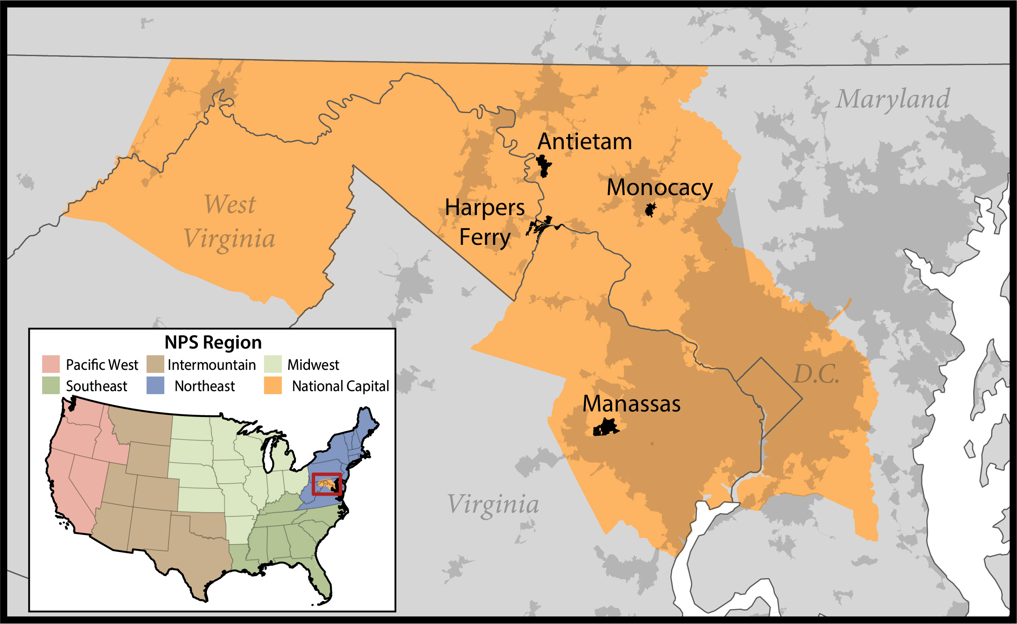

Figure 1: Map of battlefield parks in the National Park Service (NPS) National Capital Region where grassland bird populations were monitored from 2014-2021. Urbanized areas are shown in darker gray. Other NPS regions are shown in the inset map.

# Methods

## Bird surveys

The NPS National Capital Region Inventory and Monitoring program conducted point count surveys from 2014-2019 and in 2021 at Manassas, beginning in 2015 at Antietam and Monocacy, and beginning at Harpers Ferry in 2016. A total of 242 sites were surveyed across all four parks, distributed in a spatially-balanced Generalized Random Tessellation-Stratified scheme (Stevens and Olsen 2004) in accordance with the National Capital Region avian monitoring protocol. Sites were separated by at least 250 meters. Surveys were conducted two times per season during the breeding season between the first week of May and the last week of July. Each point count consisted of a single-observer survey divided into four 2.5-minute intervals for a total length of 10 minutes. The maximum distance at which birds were recorded was 100m.

Covariates with the potential to impact detection were recorded during each survey including date, disturbance, wind, temperature, humidity, time, and observer (Table 1). Disturbance was a subjective measurement by the observer that accounted for traffic noise consisting of four categories: 1) no disturbance, 2) disturbance with slight effect on count, 3) moderate effect on count, and 4) extreme effect on count. Wind was recorded in five categories using the Beaufort scale: 0 (0 mph, smoke rises vertically), 1 (1-3 mph, smoke drifts), 2 (4-7 mph, wind felt on face), 3 (8-12 mph, leaves in constant motion), 4 (13-18 mph, small branches sway), and 5 (19-24 mph, small trees in leaf sway). Temperature and humidity were recorded using a hygrometer. The time of each survey in minutes after local sunrise was calculated using the R package “suncalc” (Thiermel and Elmarhraoui 2019).

Site-specific habitat covariates were collected in 2021 (Table 2). The maximum angle to the horizon was collected using a clinometer. This measurement describes the visual enclosure of each site which has been shown to impact occupancy of other grassland species (Keyel et al. 2012, Marshall et al. 2020). The percent area of woody shrub cover was estimated in four quadrants and then averaged. Each site was classified as either hayfield (n = 76, cool-season grasses for hay production), row crop (n = 87; any non-hay crop), or meadow (n = 73; non-agricultural) by observers during the 2021 field season. All habitat information was assumed to be static during the study period for lack of complete agricultural or vegetation monitoring history at each site.

Table 1: Range, mean and standard error for potential detection covariates included in candidate models for grassland bird occupancy in National Capital Region battlefield parks from 2014-2021. Sample size is reported for continuous covariates.

| **Detection covariates** | **Range** | **Mean (SE)** |
| --- | --- | --- |
| Day of year (Jan 1 = Day 1) | 127 – 208 |  |
| Disturbance | None: 1214 |  |
| Slight: 1036 |  |
| Moderate: 450 |  |
| Extreme: 137 |  |
| Wind (Beaufort scale) | 0: 811 |  |
| 1: 944 |  |
| 2: 785 |  |
| 3: 250 |  |
| 4: 45 |  |
| 5: 3 |  |
| Temperature (C) | 4.6 – 43.5 | 21.6 (0.106) |
| Percent humidity | 7.3 – 99 | 70.7 (0.261) |
| Minutes since sunrise | -39 – 303 | 120 (1.56) |
| Observer | 24 unique |  |

Table 2: Range, mean and standard error for potential occupancy covariates included in candidate models for grassland bird occupancy in National Capital Region battlefield parks from 2014-2021. Sample size is reported for continuous covariates.

| **Occupancy covariates** | **Range** | **Antietam** | **Harpers Ferry** | **Manassas** | **Monocacy** |
| --- | --- | --- | --- | --- | --- |
| **Habitat** |  |  |  |  |  |
| Field type | Hayfield: 532 | 33 sites | 19 sites | 22 sites | 2 sites |
| Meadow: 511 | 25 sites | 8 sites | 21 sites | 19 sites |
| Row crop: 609 | 40 sites | 0 sites | 0 sites | 47 sites |
| % woody shrub cover within 100m | 0 – 80 | 4.35 (0.68) | 5.43 (1.45) | 9.47 (2.46) | 6.03 (1.06) |
| Maximum angle to horizon (degrees) | 4.33 – 71.7 | 37.5 (2.31) | 36.2 (4.44) | 23 (2.66) | 35.2 (2.87) |
| **Landscape** |  |  |  |  |  |
| % grassland (500m) | 1.38 – 96.8 | 51.3 (1.09) | 49.5 (2.35) | 51.9 (2.98) | 25 (1.48) |
| % developed (500m) | 0 – 55.6 | 3.67 (0.28) | 11.2 (1.73) | 6.51 (1.63) | 12 (1.24) |
| % forest (500m) | 0 – 71.6 | 12.9 (1.23) | 15.2 (2.56) | 24.3 (2.28) | 16.3 (1.29) |
| % wetland (500m) | 0 – 49.4 | 0.005 (0.003) | 0.69 (0.31) | 12.3 (1.97) | 4.12 (0.44) |
| % grassland (1km) | 7.39 – 68.1 | 50.3 (0.51) | 38 (1.38) | 37.7 (1.98) | 22.6 (0.79) |
| % developed (1km) | 0.34 – 59.5 | 4.33 (0.28) | 13.7 (1.29) | 10.5 (1.89) | 17.4 (1.54) |
| % forest (1km) | 1.17 – 53.4 | 14.5 (0.87) | 23.7 (2.02) | 30.9 (1.17) | 18.6 (0.88) |
| % wetland (1km) | 0 – 30.5 | 0.06 (0.02) | 0.97 (0.22) | 14.5 (1.2) | 3.96 (0.19) |
| % grassland (5km) | 14.9 – 37.3 | 35.7 (0.08) | 21.3 (0.09) | 20.7 (0.44) | 21.3 (0.19) |
| % developed (5km) | 2.79 – 36.2 | 3.69 (0.03) | 8.62 (0.20) | 27.2 (0.98) | 26.8 (0.54) |
| % forest (5km) | 18.8 – 46.0 | 34.5 (0.31) | 38.8 (0.53) | 28.9 (0.65) | 21.7 (0.19) |
| % wetland (5km) | 0.2 – 10.6 | 0.37 (0.005) | 1.06 (0.01) | 9.54 (0.12) | 1.51 (0.009) |
| **Management** |  |  |  |  |  |
| Year | 1 – 7 |  |  |  |  |
| Years since last burn | 0-2: 58 | 11 sites | 0 sites | 4 sites | 2 sites |
| 3+: 43 |  |  |  |  |
| Agricultural lease | Present: 1519 | 88 sites | 28 sites | 35 sites | 66 sites |
| Absent: 1296 |  |  |  |  |
| Harvest restriction | Present: 343 | 2 sites | 26 sites | 27 sites |  |
| Absent: 1296 |  |  |  |  |
| Day of first harvest (Jan 1 = Day 1) | 182 – 227 (1 July – 15 Aug) |  |  |  |  |
| Park |  | 100 sites | 29 sites | 44 sites | 69 sites |

We calculated landscape-level covariates using the National Land Cover Database (NLCD) (Dewitz and U.S. Geological Survey 2021), combining cover types into four broad categories: developed (developed low intensity, developed medium intensity, developed high intensity), forest (deciduous forest, evergreen forest, and forest), grassland (grassland/herbaceous, pasture/hay, shrub/scrub), and wetland (woody wetlands, emergent herbaceous wetlands) cover within 500m, 1km, and 5km buffers of each survey site (Figure 2). These distance bands were chosen to cover a gradient of spatial scales over which landscape covariates can have different impacts on grassland birds (Guttery et al. 2017). Burn history within the parks was obtained from the NPS Wildland Fire feature server. A site was counted as burned in a given year if any part of the annual fire perimeter polygon overlapped the 100m survey radius. We obtained information from park managers on the agricultural lease status of all sites, along with information about the timing and year of implementation of harvest restrictions. There were no harvest restrictions set at Monocacy during the survey period, but were instituted or maintained at other parks.

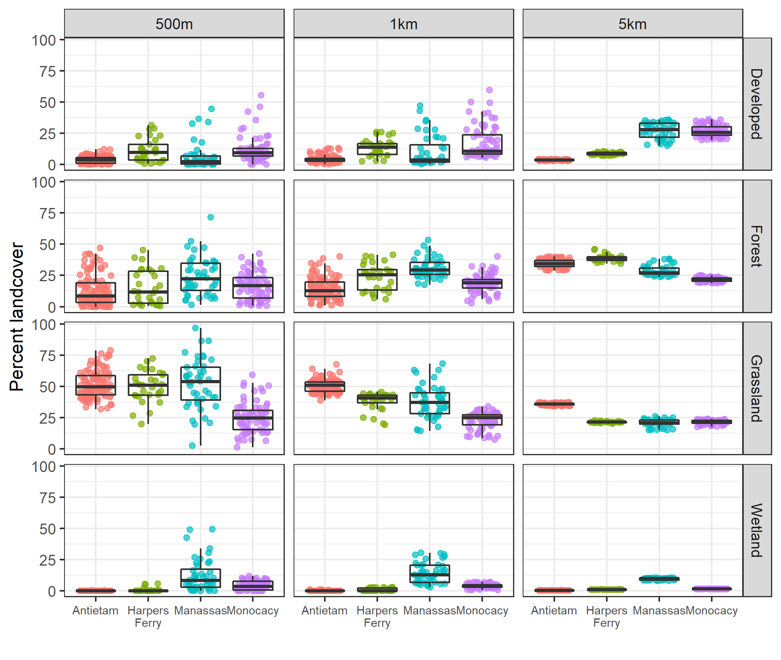

Figure 2: Mean percent cover of four landcover types surrounding surveyed sites in National Capital Region battlefield parks at three spatial scales.

## Analysis

Analysis was performed using program R version 4.1.2 (R Core Team 2021). We scaled all continuous covariates by centering on the mean and dividing by their standard deviations. We modeled the impact of habitat, landscape, and management on grassland species using the “occu” function from the R package “unmarked” (Fiske and Chandler 2011). We used a single-season occupancy model (MacKenzie et al. 2002) with a stacked approach, treating each site-year combination as a site and including year as a site covariate. This approach is commonly used when data is sparse because it increases the effective sample size at the cost of some pseudoreplication that leads to underestimates of model error (McClure and Hill 2012, Fogg et al. 2014). Using a stacked model, the total number of sites became n = 1694 site-year combinations, rather than a maximum of 242 sites per year.

We used a hierarchical approach for model selection for each species. First, we compared detection and occupancy models using Akaike’s Information Criterion for small samples (AICC), where models were ranked on ΔAICC with the lowest value being the best model (Hurvich and Tsai 1989). Null models were also included in each model comparison, including a detection-only model and a completely constant model. In cases of multiple models with ΔAICC < 2, we only used the top-ranked model. The top-ranked detection model for each species was used in all of its subsequent occupancy models. To investigate the effect of different types of site covariates, we started by running separate models for habitat, landscape, and management covariates. We did not include covariates with a Spearman’s rank correlation of r > 0.6 in the same model, ensuring no strong correlation between covariates (Figure 3). The top-performing models for habitat, landscape, and management were then combined to assess their combined ability to predict occupancy and to determine the relative impacts of these covariate categories. We modeled several additional management covariates separately because they could only be applied to a subset of sites. These management models included the number of years since the last burn, harvest restriction (a subset of sites under agricultural lease), and the date of harvest restriction. These models were compared only to null models as opposed to the fully specified models for each species. We assessed potential trends in occupancy by including year as a potential covariate as either a numerical or categorical variable to capture interannual variation. We assessed model fit using a parametric bootstrap approach (Kéry and Royle 2016). We report mean (± SE) throughout for all model predictions unless otherwise stated. *When I run my goodness-of-fit tests, which are still a work in progress, I will instead report mean and perhaps boostrapped confidence interval.*

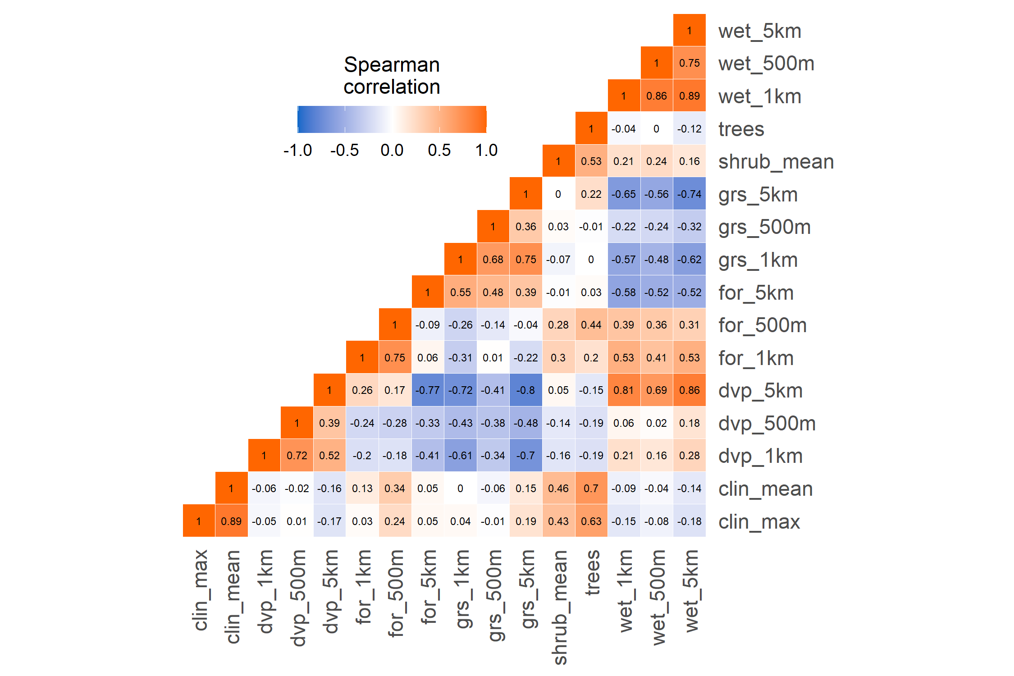

Figure 3: Correlation matrix of candidate variables for grassland bird occupancy modeling in National Capital Region battlefield parks in 2014-2021. When two variables were highly correlated (r > 0.6), they were not used in the same model.

# Results

A total of 3988 surveys across 7 years detected 128 total bird species, including 11 species designated Common Birds in Steep Decline by Partners in Flight (PIF) and 7 species on the PIF Yellow Watch List “D” facing steep declines and major threats (Table 3). Several of these vulnerable species in the parks are associated with grassland and agricultural habitat (e.g. Horned Lark, Northern Bobwhite, Prairie Warbler, Bobolink) but were not included in analysis due to a low number of detections across parks and years. All four focal species were detected in each park while their occupancy varied by park, with Monocacy typically being the lowest (Figure 4).

Table 3: Detection by park of grassland- and agricultural-breeding species (20 out of 128 total species) detected in National Capital Region battlefield parks surveyed from 2014-2021.

| **Common name** | **Scientific name** | **Antietam** | **Harpers Ferry** | **Manassas** | **Monocacy** |
| --- | --- | --- | --- | --- | --- |
| Northern Bobwhite1 | *Colinus virginianus* |  |  | X |  |
| Mourning Dove | *Zenaida macroura* | X | X | X | X |
| Killdeer | *Charadrius vociferus* | X | X | X | X |
| Northern Harrier | *Circus hudsonius* |  |  |  | X |
| American Kestrel | *Falco sparverius* | X | X | X | X |
| Eastern Kingbird | *Tyrannus tyrannus* | X | X | X | X |
| American Crow | *Corvus brachyrhynchos* | X | X | X | X |
| Common Raven | *Corvus corax* | X | X | X | X |
| Horned Lark1 | *Eremophila alpestris* | X | X |  | X |
| Barn Swallow | *Hirundo rustica* | X | X | X | X |
| Grasshopper Sparrow1 | *Ammodramus savannarum* | X | X | X | X |
| Field Sparrow1 | *Spizella pusilla* | X | X | X | X |
| Vesper Sparrow | *Pooecetes gramineus* | X | X | X | X |
| Savannah Sparrow | *Passerculus sandwichensis* | X |  | X | X |
| Bobolink2 | *Dolichonyx oryzivorus* | X |  | X | X |
| Eastern Meadowlark1 | *Sturnella magna* | X | X | X | X |
| Red-winged Blackbird | *Agelaius phoeniceus* | X | X | X | X |
| Brown-headed Cowbird | *Molothrus ater* | X | X | X | X |
| Common Grackle1 | *Quiscalus quiscula* | X | X | X | X |
| Dickcissel | *Spiza americana* |  |  | X |  |
| 1Partners in Flight (PIF) Common Birds in Steep Decline | | | | | |
| 2PIF Yellow Watch List “D” (Steep declines and major threats) | | | | | |

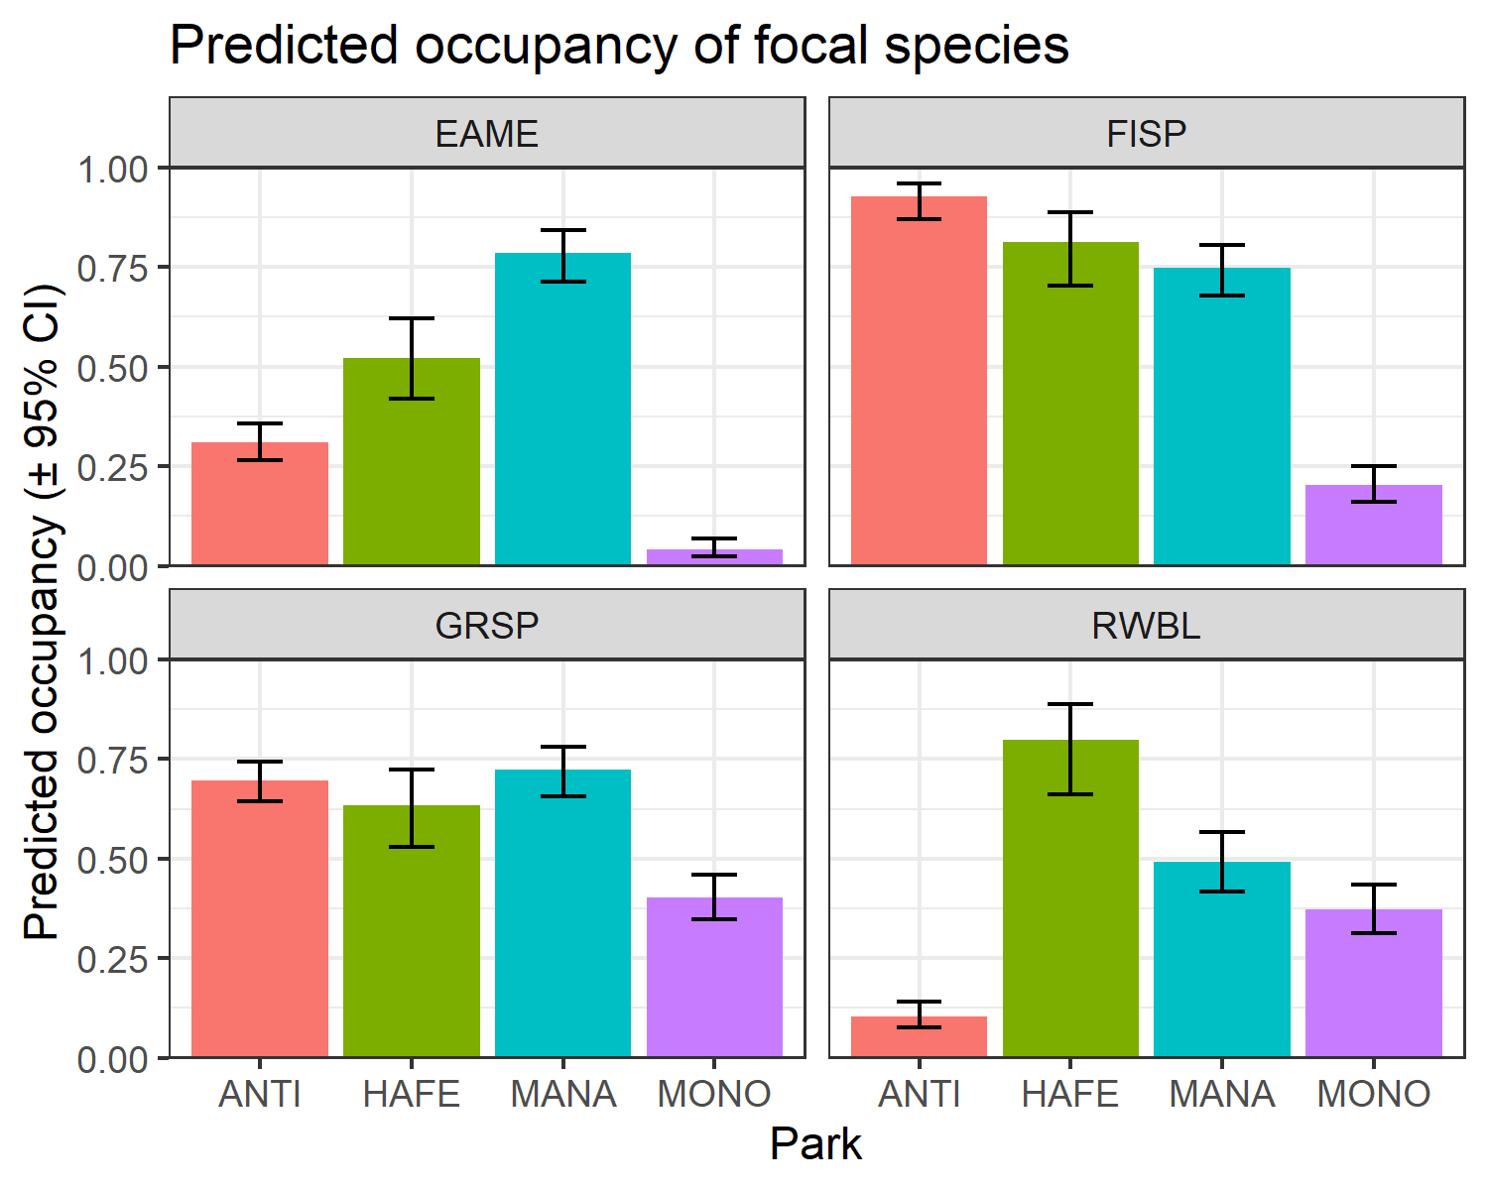

Figure 4: Predicted occupancy by park for focal species.

Habitat, landscape, and management all affected occupancy, while their overall influence and the covariates varied among species. The top supported models for Eastern Meadowlark, Grasshopper Sparrow, and Field Sparrow included habitat, landscape, and management covariates, while the top model for Red-winged Blackbird did not include any landscape-level covariates (Figure 5). The covariates that impacted detection probability (p) varied among species. Detection probability varied as a function of wind speed for Grasshopper Sparrow, disturbance due to traffic noise for Eastern Meadowlark and Field Sparrow, and time since sunrise for Red-winged Blackbird (Table ??. Mean probability of detection was similar for all species at approximately p = 0.7.

| **Species** | **Detection model** | **Delta AICc** | | **K** | |
| --- | --- | --- | --- | --- | --- |
| Eastern Meadowlark | disturbance | 0.00 | | 5 | |
| Field Sparrow | disturbance | 0.00 | | 5 | |
| wind + disturbance | 0.98 | | 10 | |
| Grasshopper Sparrow | wind | 0.00 | | 7 | |
| disturbance | 0.61 | | 5 | |
| wind + day of year | 1.44 | | 8 | |
| day of year | 1.59 | | 3 | |
| wind + temperature | 1.72 | | 8 | |
| wind + time | 1.73 | | 8 | |
| temperature | 1.97 | | 3 | |
| time | 2.00 | | 3 | |
| Red-winged Blackbird | time | 0.00 | | 3 | |
| day of year + time | 1.00 | | 4 | |
| temperature + time | 2.01 | | 4 | |
| Summary of top models affecting probability of detection for for four grassland bird species surveyed in National Capital Region battlefield parks from 2014-2021. We report the relative difference in Akaike's Information Criterion compared to the top-ranked model for the species (Delta AICc), and the number of parameters in the model (K) for all models within 2 AICc. | | | | | |
| **Species** | **Occupancy model** | | **Delta AICc** | | **K** | |
| Eastern Meadowlark | Field type + angle + developed (5km) + grassland (500m) + year (factor) | | 0.00 | | 14 | |
| Field type + angle + developed (5km) + grassland (500m) + park + lease + year | | 0.43 | | 15 | |
| Field type + angle + developed (5km) + grassland (500m) + park + lease + year (factor) | | 1.61 | | 20 | |
| Field Sparrow | Field type + angle + developed (1km) + forest (1km) + grassland (1km) + year (factor) | | 0.00 | | 17 | |
| Grasshopper Sparrow | Field type + angle + shrubs + developed (500m) + forest (500m) + grassland (500m) + park + lease + year | | 0.00 | | 19 | |
| Red-winged Blackbird | Field type + angle + shrubs + park + lease + year (factor) | | 0.00 | | 17 | |
| Summary of top occupancy models for four grassland bird species surveyed in National Capital Region battlefield parks from 2014-2021. We report the relative difference in Akaike's Information Criterion compared to the top-ranked model for the species (Delta AICc), and the number of parameters in the model (K) for all models within 2 AICc. | | | | | | |

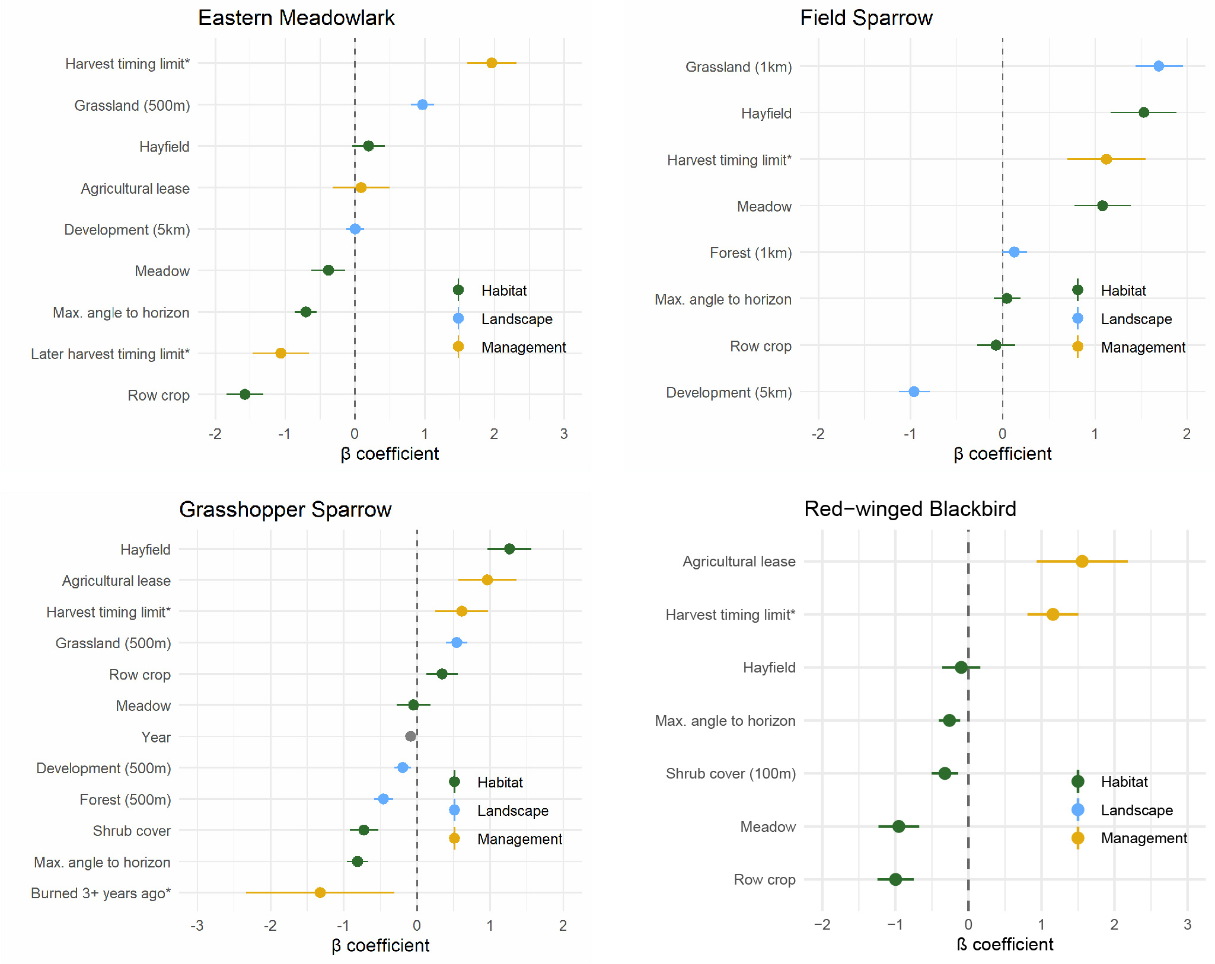

Figure 5: Estimated influence of habitat, landscape, and management covariates on the occupancy of the four focal species. Starred covariates were run on subsets and not included in the full model due to data availability. These will be edited.

### Habitat

Habitat covariates were included in top models for all species. Field type was included in the top model for all species, with hayfields having higher predicted occupancy than row crop (Figure 6). For Eastern Meadowlark, predicted occupancy in hayfields was 0.55 (± 0.03) while row crop was only 0.17 (± 0.02) and meadow was 0.41 (± 0.03). For Field Sparrow, predicted occupancy in hayfields was 0.82 (± 0.03) while row crop was 0.48 (± 0.03) and meadow was 0.75 (± 0.03). For Grasshopper Sparrow, predicted occupancy in hayfields was 0.55 (± 0.03) while row crop was only 0.17 (± 0.02) and meadow was 0.41 (± 0.03). Maximum angle to horizon had a negative impact on occupancy of Eastern Meadowlark, Grasshopper Sparrow, and Red-winged Blackbird, and no impact on Field Sparrow (Figure @ref:(fig:beta)). Woody shrub cover had a negative impact on the occupancy of Grasshopper Sparrow and Red-winged Blackbird.

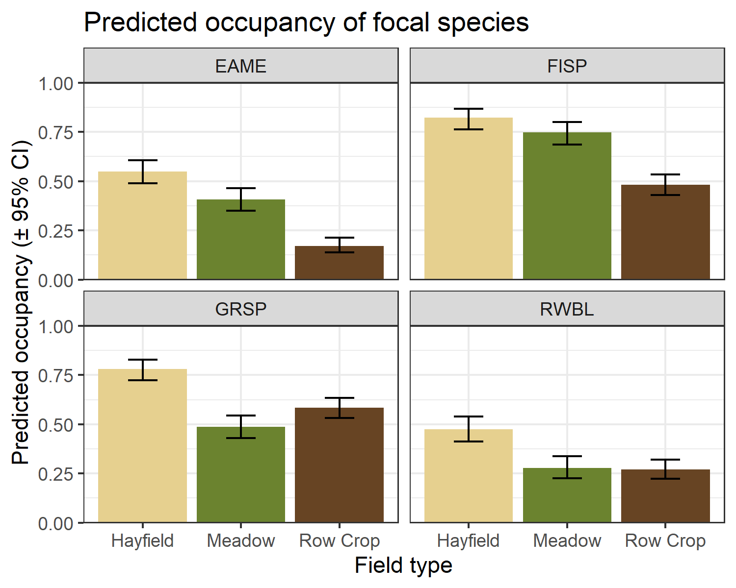

Figure 6: Predicted occupancy by field type for each focal species.

### Landscape

Eastern Meadowlark, Field Sparrow, and Grasshopper Sparrow responded to landscape variables at different spatial scales. Forest, grassland, and development were included in top-performing models but wetland was not. Eastern Meadowlark responded to landscape variables at mixed spatial scales. Increased grassland within 500m has a positive impact on occupancy, while development at a 5km scale had a slight negative impact (Figure 5). For Field Sparrow, increased forest cover within 1km responded had a slight positive impact, grassland within 1km had a strong positive impact, and development within 1km had a negative impact on occupancy. Grasshopper Sparrow occupancy was positively impacted by grassland within 500m and negatively impacted by development and forest within 500m. Landscape was not included in the top-performing models for Red-winged Blackbird.

### Management

The only management covariate run on the full dataset was agricultural lease, with 217 total sites leased and 25 not leased. Presence of an agricultural lease had a positive impact on occupancy of Grasshopper Sparrow and Red-winged Blackbird, no strong impact on Eastern Meadowlark, and a non-significantly positive impact on Field Sparrow (Figure 7). Lease was included in the top model for all species except Field Sparrow. A subset of 55 of the 217 leased sites were subject to harvest timing restrictions. In all species, a harvest timing restriction was associated with increased occupancy (Figure 5). The date of first allowed harvest among those restricted sites was only a significant predictor of occupancy for Eastern Meadowlark; however, there was little variation in the dates since the timing restrictions were set at the park level, and Eastern Meadowlark showed strong variation among parks (Figure 4).

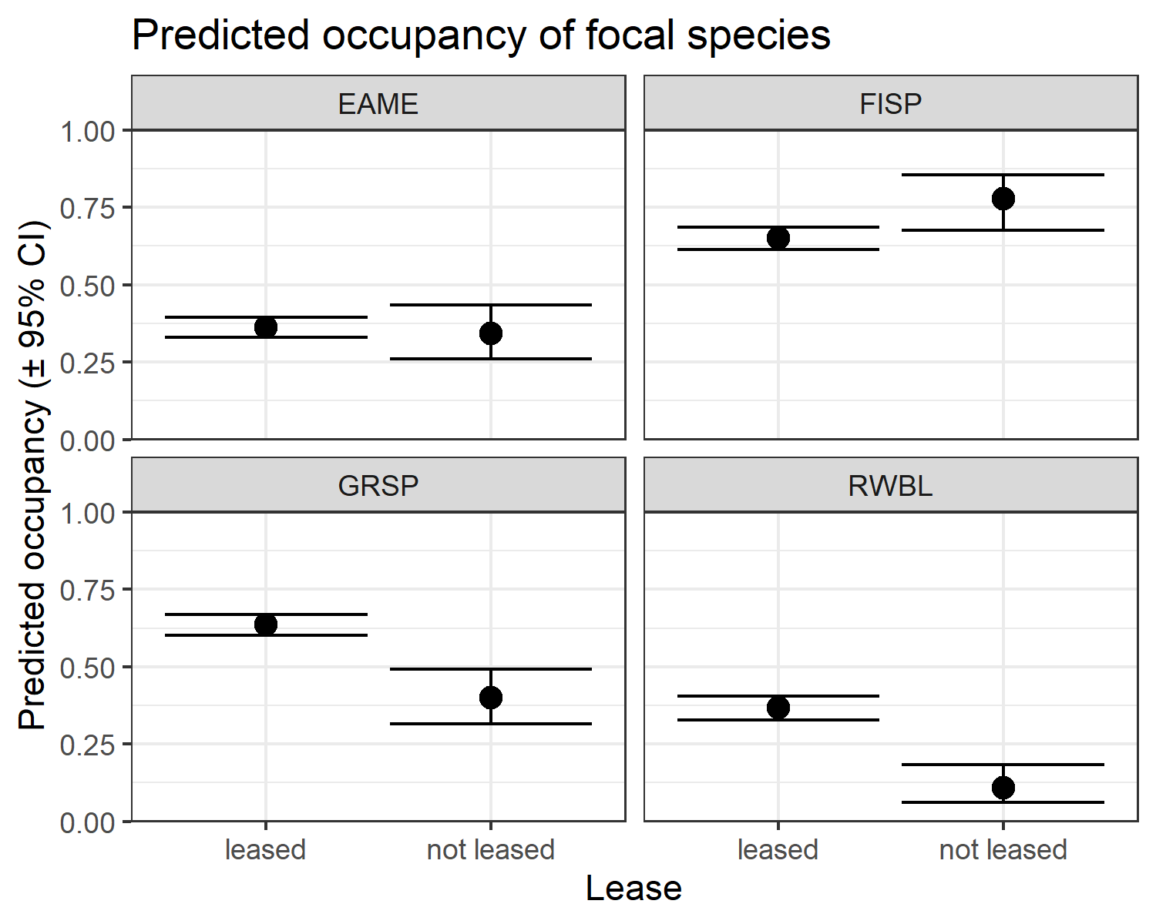

Figure 7: Predicted occupancy by agricultural lease for each species.

A total of 17 sites were ever burned, making for a total of 101 site-years. During the 8-year time span of the study, 58 site-years were surveyed within 0-2 years of last burn and 43 were surveyed when it had been 3 or more years since the last burn. Only Grasshopper Sparrow had a significant response to burn interval, with sites burned in the past 2 years having higher occupancy than those burned 3 or more years ago (Figure 8). Eastern Meadowlark occupancy was non-significantly lower when it had been 3 or more years since the last burn. Burning had no impact on Field Sparrow or Red-winged Blackbird.

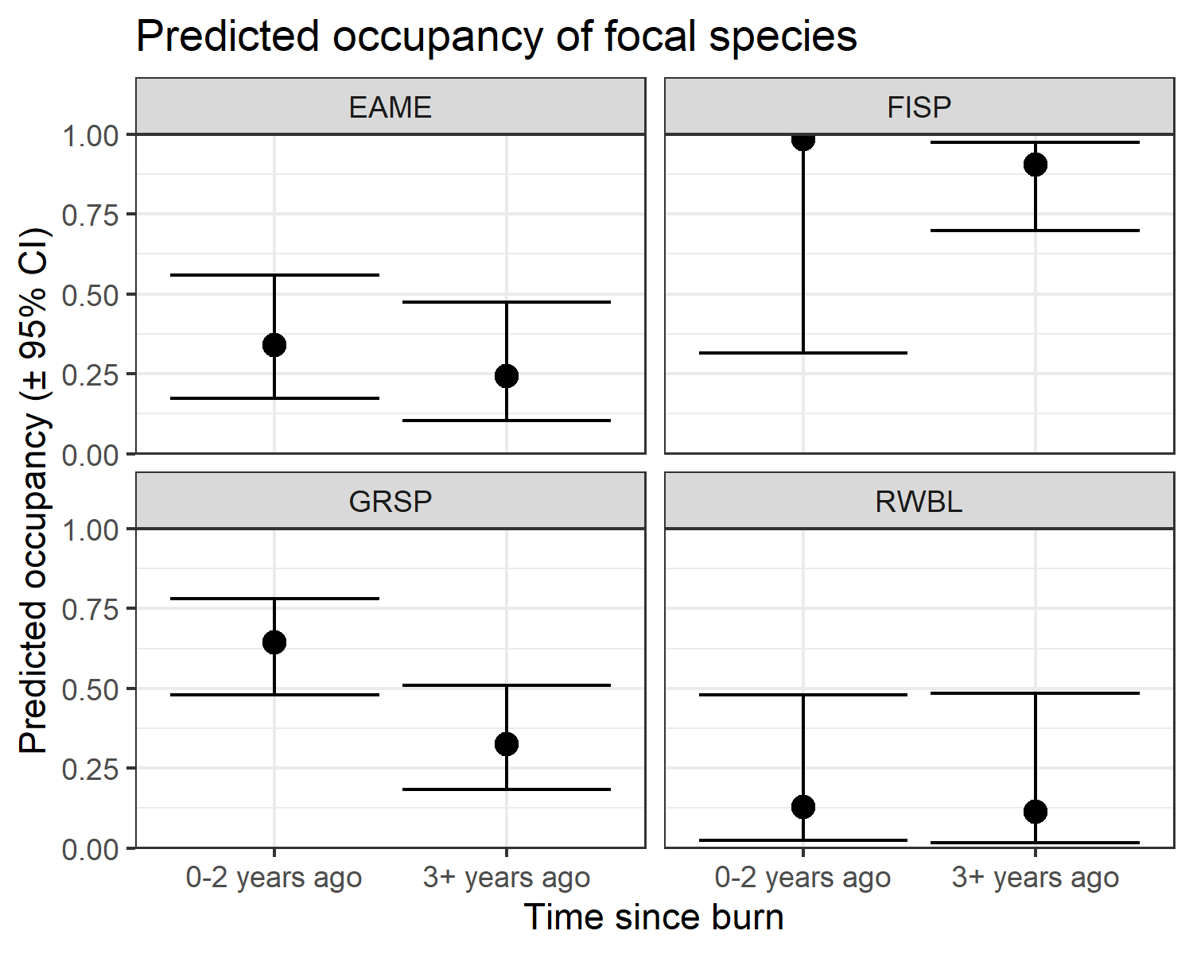

Figure 8: Predicted impact of time since burn on focal species.

### Trends

I investigated temporal trends by including year as a numerical covariate and interannual variation by including year as a factor. The only species that showed a significant annual trend was Grasshopper Sparrow, with year having a coefficient of -0.085 (± 0.032) when included (Figure 5). Field Sparrow and Red-winged Blackbird did not have annual trend in their best models rather interannual variation (Figure 9). Only Eastern Meadowlark had neither an annual or interannual variation in its best model.

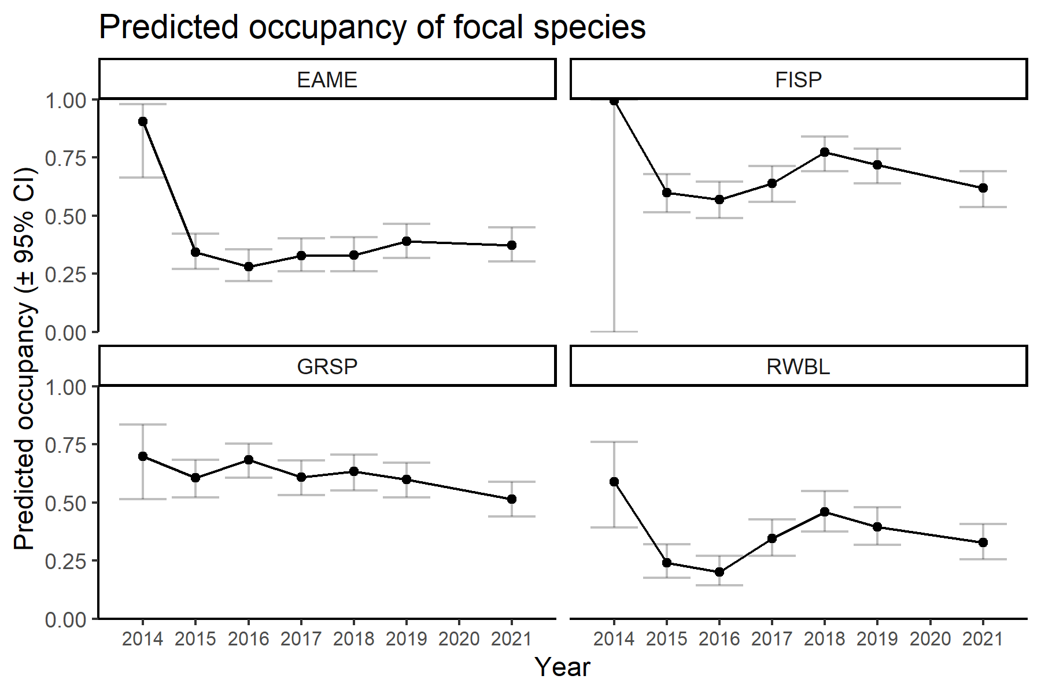

Figure 9: Interannual variation in occupancy by species.

# Discussion

# Management implications

# Acknowledgements

# Ethics statement

# References

Askins, R. A. 1999. History of grassland birds in eastern North America. Studies in Avian Biology 19:60–71.

Atwood, J., J. Collins, L. Kidd, M. Servison, and J. Walsh. 2017. Best management practices for nesting grassland birds. Mass Audubon, Lincoln, MA.

Bollinger, E. K., P. B. Bollinger, and T. A. Gavin. 1990. Effects of hay-cropping on eastern populations of the bobolink. Wildlife Society Bulletin 18:142–150.

Brennan, L. A., and W. P. Kuvlesky. 2005. [North American grassland birds: An unfolding conservation crisis?](https://doi.org/10.2193/0022-541X) Journal of Wildlife Management 69:1–13.

Chapman, R. N., D. M. Engle, R. E. Masters, and D. M. Leslie. 2004. [Tree invasion constrains the influence of herbaceous structure in grassland bird habitats](https://doi.org/10.1080/11956860.2004.11682809). Ecoscience 11:55–63.

Dettling, M. D., K. E. Dybala, D. L. Humple, and T. Gardali. 2021. [Protected areas safeguard landbird populations in central coastal California: Evidence from long-term population trends](https://doi.org/10.1093/ORNITHAPP/DUAB035). Ornithological Applications 123:1–12.

Dewitz, J., and U.S. Geological Survey. 2021. [National Land Cover Database (NLCD) 2019 Products (ver. 2.0, June 2021)](https://doi.org/10.5066/P9KZCM54). U.S. Geological Survey data release.

Fiske, I., and R. Chandler. 2011. Unmarked: An R package for fitting hierarchical models of wildlife occurrence and abundance. Journal of Statistical Software 43:1–23.

Fogg, A. M., L. J. Roberts, R. D. Burnett, A. M. Fogg, L. J. Roberts, and R. D. Burnett. 2014. [Occurrence patterns of black-backed woodpeckers in green forest of the Sierra Nevada Mountains, California, USA.](https://doi.org/10.5751/ACE-00671-090203) Avian Conservation and Ecology 9.

Guttery, M. R., C. A. Ribic, D. W. Sample, A. Paulios, C. Trosen, J. Dadisman, D. Schneider, and J. A. Horton. 2017. [Scale-specific habitat relationships influence patch occupancy: Defining neighborhoods to optimize the effectiveness of landscape-scale grassland bird conservation](https://doi.org/10.1007/S10980-016-0462-Y/FIGURES/5). Landscape Ecology 32:515–529.

Hill, J. M., J. F. Egan, G. E. Stauffer, and D. R. Diefenbach. 2014. [Habitat availability is a more plausible explanation than insecticide acute toxicity for U.S. Grassland bird species declines](https://doi.org/10.1371/journal.pone.0098064). R. M. Brigham, editor. PLoS ONE 9:e98064.

Hurvich, C. M., and C.-L. Tsai. 1989. [Regression and time series model selection in small samples](https://doi.org/10.1093/biomet/76.2.297). Biometrika 76:297–307.

Irvin, E., K. R. Duren, J. J. Buler, W. Jones, A. T. Gonzon, and C. K. Williams. 2013. [A multi-scale occupancy model for the grasshopper sparrow in the Mid-Atlantic](https://doi.org/10.1002/JWMG.609). The Journal of Wildlife Management 77:1564–1571.

IUCN. n.d. Temperate grasslands. https://www.iucn.org/commissions/world-commission-protected-areas/our-work/temperate-grasslands.

Johnson, A. E. M. 2017. Conservation and land management practices and their impact on sustaining breeding and non-breeding grassland bird populations in the southeast. PhD thesis, George Mason University.

Kéry, M., and A. Royle. 2016. Applied hierarchical modeling in ecology. Elsevier.

Keyel, A. C., C. M. Bauer, C. R. Lattin, L. M. Romero, and J. M. Reed. 2012. [Testing the role of patch openness as a causal mechanism for apparent area sensitivity in a grassland specialist](https://doi.org/10.1007/S00442-011-2213-8/FIGURES/4). Oecologia 169:407–418.

Ladin, Z. S., and G. W. Shriver. 2013. Forest bird monitoring in the National Capital Region Network: Summary report 2007-2011. Natural Resource Technical Report NPS/NCRN/NRTR-2013/698. National Park Service, Fort Collins, CO.

MacKenzie, D. I., J. D. Nichols, G. B. Lachman, S. Droege, A. J. Royle, and C. Langtimm. 2002. Estimating site occupancy rates when detection probabilities are less than one. Ecology 83:2248–2255.

Marshall, H., E. J. Blomberg, V. Watson, M. Conway, J. B. Cohen, M. D. Correll, C. S. Elphick, T. P. Hodgman, A. R. Kocek, A. I. Kovach, W. G. Shriver, W. A. Wiest, and B. J. Olsen. 2020. [Habitat openness and edge avoidance predict saltmarsh sparrow abundance better than habitat area](https://doi.org/10.1093/CONDOR/DUAA019). The Condor 122:1–13.

Masse, R. J., A. M. Strong, and N. G. Perlut. 2008. The potential of uncut patches to increase the nesting success of grassland songbirds in intensively managed hayfields: A preliminary study from the Champlain Valley of Vermont. Northeastern Naturalist 15:445–452.

McClure, C. J. W., and G. E. Hill. 2012. [Dynamic versus static occupancy: How stable are habitat associations through a breeding season?](https://doi.org/10.1890/ES12-00034.1) Ecosphere 3:1–13.

McCracken, J. D. 2005. [Where the bobolinks roam: The plight of North America’s grassland birds](https://doi.org/10.1080/14888386.2005.9712771). Biodiversity 6:20–29.

National Park Service. 2005. Long-term monitoring plan for natural resources in the National Capital Region Network.

National Park Service. 2014. Manassas National Battlefield Park foundation document. U.S. Department of the Interior.

North American Bird Conservation Initiative. 2016. The state of North America’s birds 2016. Environment and Climate Change Canada, Ottawa, Ontario.

Palomo, I., C. Montes, B. Martín-López, J. A. González, M. García-Llorente, P. Alcorlo, and M. R. G. Mora. 2014. [Incorporating the social-ecological approach in protected areas in the Anthropocene](https://doi.org/10.1093/BIOSCI/BIT033). BioScience 64:181–191.

Partners in Flight. 2021. Avian Conservation Assessment Database, version 2021.

Powell, A. F. L. A. 2006. [Effects of prescribed burns and bison (Bos bison) grazing on breeding bird abundances in tallgrass prairie](https://doi.org/10.1642/0004-8038(2006)123%5b0183:EOPBAB%5d2.0.CO;2). The Auk 123:183–197.

R Core Team. 2021. R: A language and environment for statistical computing. R Foundation for Statistical Computing, Vienna, Austria.

Rosenberg, K. V., A. M. Dokter, P. J. Blancher, J. R. Sauer, A. C. Smith, P. A. Smith, J. C. Stanton, A. Panjabi, L. Helft, M. Parr, and P. P. Marra. 2019. [Decline of the North American avifauna](https://doi.org/10.1126/science.aaw1313). Science 366:120–124.

Samson, F., and F. Knopf. 1994. [Prairie conservation in North America](https://doi.org/10.2307/1312365). BioScience 44:418–421.

Sauer, J. R., D. K. Niven, J. E. Hines, D. J. Ziolkowski, K. L. Pardieck, J. E. Fallon, and W. A. Link. 2017. The North American breeding bird survey, results and analysis 1966 - 2015. USGS Patuxent Wildlife Research Center, Laurel, MD.

Stevens, D. L., and A. R. Olsen. 2004. [Spatially balanced sampling of natural resources](https://doi.org/10.1198/016214504000000250). Journal of the American Statistical Association 99:262–278.

Thiermel, B., and A. Elmarhraoui. 2019. Suncalc: Compute sun position, sunlight phases, moon position and lunar phase.

Walk, J. W., and R. E. Warner. 2000. [Grassland management for the conservation of songbirds in the Midwestern USA](https://doi.org/10.1016/S0006-3207(99)00182-2). Biological Conservation 94:165–172.

Weidman, T., and J. A. Litvaitis. 2011. [Are small habitat patches useful for grassland bird conservation?](https://doi.org/10.1656/045.018.0207) Northeastern Naturalist 18:207–216.

West, A. S., P. D. Keyser, C. M. Lituma, D. A. Buehler, R. D. Applegate, and J. Morgan. 2016. [Grasslands bird occupancy of native warm-season grass](https://doi.org/10.1002/jwmg.21103). The Journal of Wildlife Management 80:1081–1090.