# ER Diagram

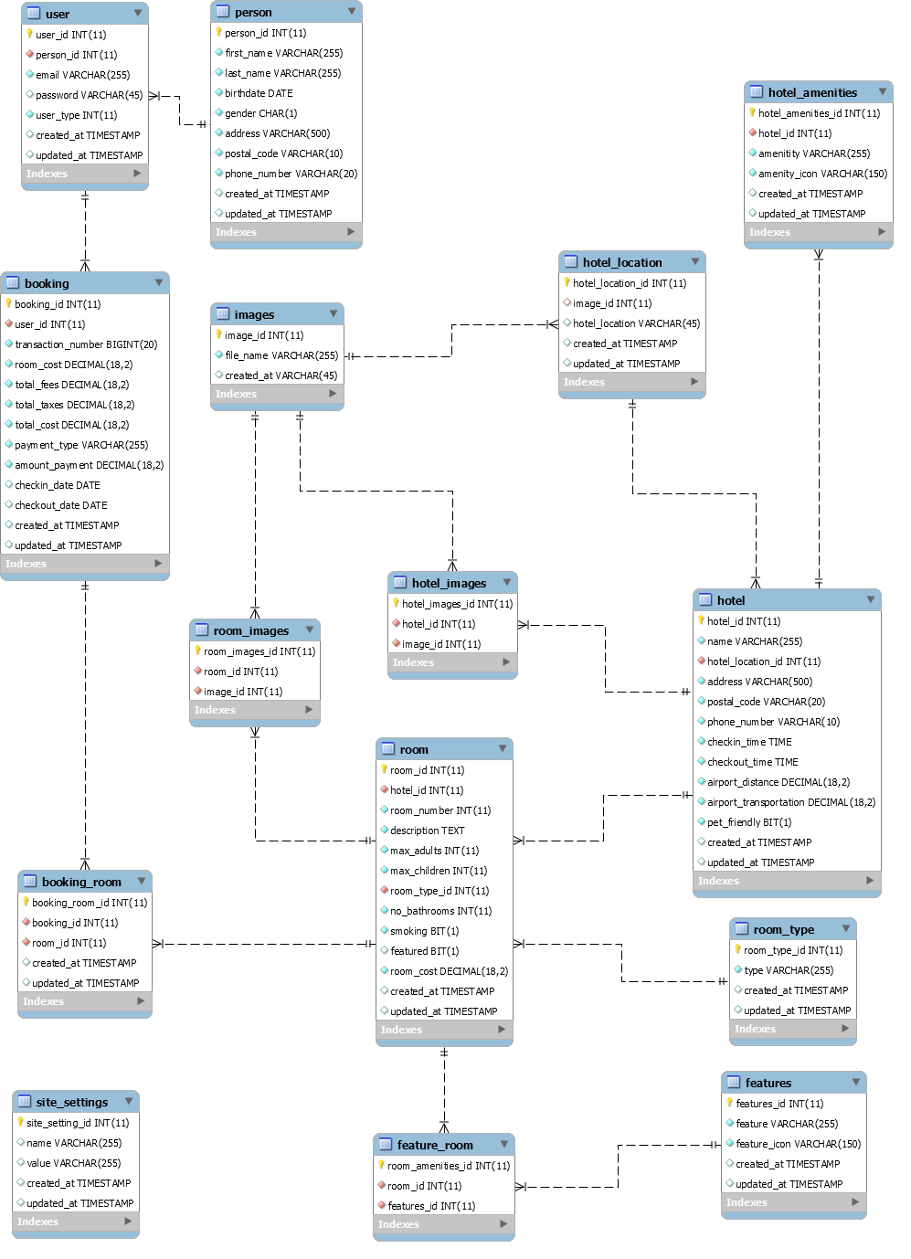

# Conceptual Model

User

Booking

Room

Person

Images

Hotel location

Hotel

Hotel amenities

Room type

Feature Room

Features

Site Settings

s

**1**

**1**

**1**

**m**

**m**

**m**

**1**

**1**

**m**

**m**

**1**

**m**

**1**

**m**

**1**

**m**

**m**

**1**

**m**

**1**

**m**

**m**

**1**