|  |
| --- |
|  |
| Team KōD­­­  Proposal for Website: Poseidon |
| |  |  |  | | --- | --- | --- | | Team KōD | 11/25/19 | E-Commerce Project | |

­

Table of Contents

Vendor Background 2

Client Background 2

Audience Assessment 2

A) Primary 2

B) Secondary 2

Goals and Objectives 2

Workplan 3

Project Assumptions And Scope 4

Team members 5

Recommended solution 5

Security approaches 6

Timesheet 7

Budget 10

Sitemap 11

Block Comps 12

Conceptual Model 15

ER Diagram 16

CONCLUSION 17

## **Vendor Background**

KōD is one of the reputed web development companies from the heart of Canada; Winnipeg, Manitoba. What started in 2010 as a single office company has now evolved into several offices across the prairies. KōD provides prestige web designs and web services. KōD has worked with notable clients such as Manitoba Lotteries, Booster Juice, and Trivago. Our objective is to create websites that stand out from others at an affordable cost. We at KōD believe that quality is what sets as apart.

## **Client Background**

We understand that Poseidon wants to create a web presence and allow their users to have an easy and enjoyable experience while visiting their website. Poseidon is an upscale resort with locations in the Caribbean and Gulf of Mexico who pride themselves in providing their clients with unique experiences. We have studied your requirements and recognized that Poseidon is looking for a web solution to bring more clients to their resorts with an easy to use website. We are in the digital age and having this site will be crucial to the success of Poseidon and growing its company. Poseidon is dedicated to recognizing, rewarding and communicating with you. Your satisfaction is their top priority.

## **Audience Assessment**

### **Primary**

The targeted audience for their website is middle to upper class families who want to get away from their busy lives. Poseidon is and all-inclusive resort that is upscale but still competitive in price with all its services. Poseidon offers a well-rounded number of amenities, services and experiences – fun for the whole family. Poseidon offers an exotic experience for couples making it a great choice for newlyweds who want to have a getaway from their busy lives. Being an all-inclusive resort, they take away all the stress and make it a place to come and enjoy quality time with family and loved ones.

### **Secondary**

The secondary audience is corporates. Poseidon has conference rooms and training rooms available to hold up to 100 people in each room. They provide corporate packages that include suites, private conference room, catering, and supplies included with room. The primary corporates that come to Poseidon are big companies in construction, automotive, and insurance.

## **Goals and Objectives**

The following are the goals and objectives of the project:

* Modern clean design
* Responsive design
* Easy to use booking
* SEO Friendly
* Professional Look
* Easy and Intuitive Navigation
* Ability to Register the Guest
* Social Media handles
* Dynamically Populated List for Destinations
* Contact Us form
* Login Page for guests
* SEO friendly
* Dynamically Updated Site Content like contact email and social media links
* Search and Filter Options to check for different rooms available
* Commenting section for users that are logged in
* New logo for Poseidon
* Dynamically updated available rooms
* Booking for users and guests
* Secure Payment Portal
* Easy Tracking of all Bookings and Available Rooms

## **Workplan**

**Phase 1**

Strategy, project meeting. Meeting with a client discuss details about a future project, get from the client RFP. Create an outline of the future project also include technology outline.

**Phase 2**

Project planning and resources. We will identify what do we need for the project. We can estimate the time and budget after we get all that we need for the project.

**Phase 3**

Design

Meeting with client discus potential graphic design for the website, create an organized PSDs, review and update content, as a result, we will know how the website must be present.

**Phase 4**

Development (coding)

Start to upgrade web site by using HTML, CSS, upgrade home page and all navigation elements on the website. Also, in this phase we will code back end programing as well. We will implement validation in JS and PHP. We will also create and normalize MySQL data bases for our website and test this. As a result, we get secure access and more attractive web pages and easy rational navigation.

**Phase 5**

Content transfer

We start to put content on a website such as home page, linking, social media connection, contact.

**Phase 6**

Quality review Testing

In this phase, we will check how web site goanna work, we will test navigation, links, social media links. In this phase, we will be testing web site to check if it's any bugs there, if yes, we will fix this problem before the website start working.

**Phase 7**

Final testing

In this phase, we will finally check web site with the client before we put our site on launch. If everything will be working well and no errors, we can go to our last phase.

**Phase 8**

Launch/maintains

In this phase after all testing, we can publish website live on a host server, after this final phase we can not change anything.

## **Project Assumptions And Scope**

The pricing and planning for the project are based on these assumptions:

* Images and written content will be provided by Poseidon
* The website will only be in the English language
* The client is responsible for entering all content into the content management system
* Project Domain and hosting service will be provided by Poseidon
* Additional Features and Support will result in increased cost

## **Team members**

KōD takes pride over its people. Our in-house team consists of unique combination of experience, creativity and knowledge. But the thing that sets us apart is our attitude to always provide the ‘best-ever’ experience for our valued clients. We have a dynamic team of capable and experienced web designers, developer, content writers, UI/UX developers and managers who uphold the highest standards in the industry. We have an excellent market reputation in Winnipeg IT stream and a lot of positive feedback from our clients. Our team has always been appreciated for the quality work that’s – on-budget and on-time.

For this project, the assigned team members include 5 skilled professionals, passionate about their work: Krita Maharjan (PM, 15 years experience), will be organize and responsible for all kick off meetings, budget and due dates, Evgheni Sipco (Web Designer, 2 years experience), will be responsible for design and mock up for this web site. Katie Peters (Front end Developer, 5 years experience), will be responsible for coding by using coding languages such as HTML, CSS, JS. Narain Madabhusi (Back End Developer, 10 years experience), will be responsible for programming by using programming languages such as PHP. Juan (My SQL, data base, server), will be responsible for the data base of our web site and set up server.

## **REcommended solution**

We are proposing a dynamic website, with an admin section, built using PHP and MySQL including validated HTML5 and CSS3 to meet your needs and provide the website with the unique functionalities it needs. We will be using the latest technologies available in web development that are used by millions of brands around the globe for their modern cutting-edge websites. POSEIDON chain of hotels need help to create a hotel reservation system for its customers.

* Through this new system customers can check the availability of the room based on their need and book a room in advance.
* We’ll design your web templates using a *responsive design* which means the webpages will scale and adapt according to the viewed device of the users. The pages will switch to a mobile design under 768 pixels wide. It will operate smoothly across a wide variety of devices including mobiles, tablets and desktops with the big screen without breaking its flow.
* The proposed web application will have two modules: general and administrative. The general module will be accessible to the public and registered visitors, while the administrative panel will be accessible to only authenticated users of the system.
* Social media links will be provided for the customers to visit and increase your web presence.
* The website will also be tested thoroughly for both functionality and usability to ensure that it runs smoothly and to improve overall performance.
* Customers can avail discounts by signing up to their Poseidon loyalty program.
* Members need to login to be able to avail discounts.

## **Security approaches**

KōD values the security aspect of your business and puts it among one of the top priorities during the development. At KōD, we understand the intensity and possible harm a poorly built website could cause. An e-commerce site is especially vulnerable to security threats as many sensitive information like transaction information, guest details etc. would be passed on a regular basis. This is why we use the best security approaches to protect you and your business against the security threats and limit your data to you. We use but not limit to the following approaches to ensure the most secure access to your website:

* SSL Certificate will be installed in the server to ensure secure exchange of sensitive information over the website and to payment portals
* Registration of member will be made more reliable by using email verification, where the user will require to verify the provided email address through a link sent to them with a unique registration code.
* All the passwords will be hashed using an encryption key before storing in the database using one-way hashing algorithm, to prevent against dictionary attacks.
* The content and inputs in the system will follow a FIEO principle (Filter Input and Escape Output). All form inputs will be filtered before processing into the system to protect against XSS (Cross Site Scripting) attacks. Automatically generated CSRF tokens will be used to avoid any CSRF (Cross Site Request Forgery) attacks. Most of this is done by Laravel, the framework we’ll be using.
* All major changes to the database will be tracked with the person responsible and datetime for each of them.
* Only the admin will have access to the admin panel.

## **Timesheet**

|  |  |  |
| --- | --- | --- |
| Completion Date | Item/ Action | Responsible |
| PLANNING AND EXPLORATION | | |
| November 21, 2019 | Kick off meeting | Team |
| November 21, 2019 | Gathering Requirements | Krita |
| November 25, 2019 | Server Set Up | Juan |
| PSD DESIGN STARTS | | |
| November 25, 2019 | Graphic Design starts and task assigned to everyone | Krita, Team |
| November 26, 2019 | Graphic design ready for approval | Evgheni |
| CODING STARTS | | |
| November 26, 2019 | HTML template work starts | Katie |
| November 27, 2019 | Work on templates complete | Katie |
| November 28, 2019 | Proposal ready with all elements attached | Team |
| December 4, 2019 | Front end complete, with ability with ability to browse product catalog, pages, etc | Krita |
| PROGRAMMING STARTS | | |
| December 9, 2019 | Back end programming starts | Narain |
| December 10, 2019 | Work on Back end Admin panel finished | Narain |
| December 11, 2019 | Final product finished | Narain |
| December 13, 2019 | Team presents to client. | Team |
| December 13, 2019 | All final deliverables handed prior to meeting with client. | Team |

## **Budget**

The table below shows a breakdown of total estimated hours worked on each phase and the cost estimated for each phase. KōD charges a reasonable amount of $100 on average for every hour worked. Detailed invoice will be mailed to Poseidon on mutually agreed dates.

|  |  |  |
| --- | --- | --- |
| **Task Description** | **Hours** | **Price** |
| Planning / Exploration | 45 | $4500 |
| Design / Content | 60 | $6000 |
| Coding / Programming | 85 | $8500 |
| Launch (Hosting) | 5 | $500 |
| **TOTAL (Without TAX)** | **195** | **$19500** |
| **TAXES** |  |  |
| GST (5%) |  | $975 |
| PST (7%) |  | $1365 |
| **TOTAL (Inclusive of TAX)** |  | $21,840 |

**Note:** The price mentioned above is not inclusive of maintenance services. In case of any change requests, additional costs would be invoiced to you depending upon the requested change. A deposit of 50% will be required before the project start date.

## **Sitemap**

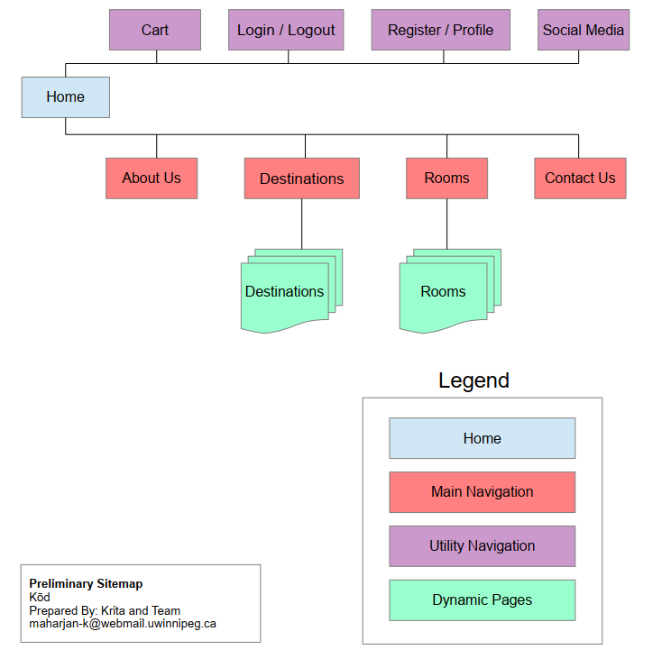

## **Block Comps**

**Home Page Block Comp – Page 1**

Utility Menu

Featured Hotel Room 1

Room Details

Room Details

Room Details

**Room Listing Page Block Comp – Page 2**

Footer

Contact Button

Banner Image

Statistics Section

Destination 2

Destination 3

Destination 1

Featured Hotel Room 3

Featured Hotel Room 2

‘Why Choose Us’ Block

Search Form

Main Slider

Logo

Main Navigation Menu

Utility Menu

Main Navigation Menu

Logo

Search

Filter Form

Pagination

Room Details

Hotel Room 6…

Room Details

Hotel Room 6

Hotel Room 3

Room Details

Hotel Room 4

Room Details

Room Details

Hotel Room 2

Room Details

Hotel Room 1

Bookmark

Tagline

Footer

**Contact Page Block Comp – Page 3**

Utility Menu

Main Navigation Menu

Logo

Contact Form

Hero Image

Footer

## **Conceptual Model**

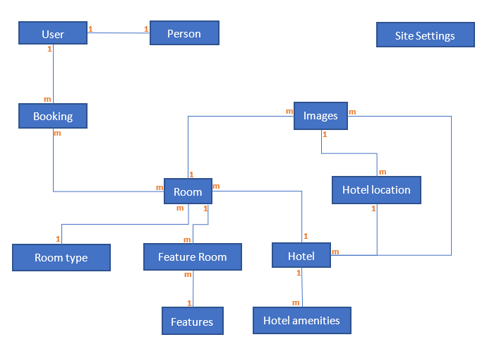

## **ER Diagram**

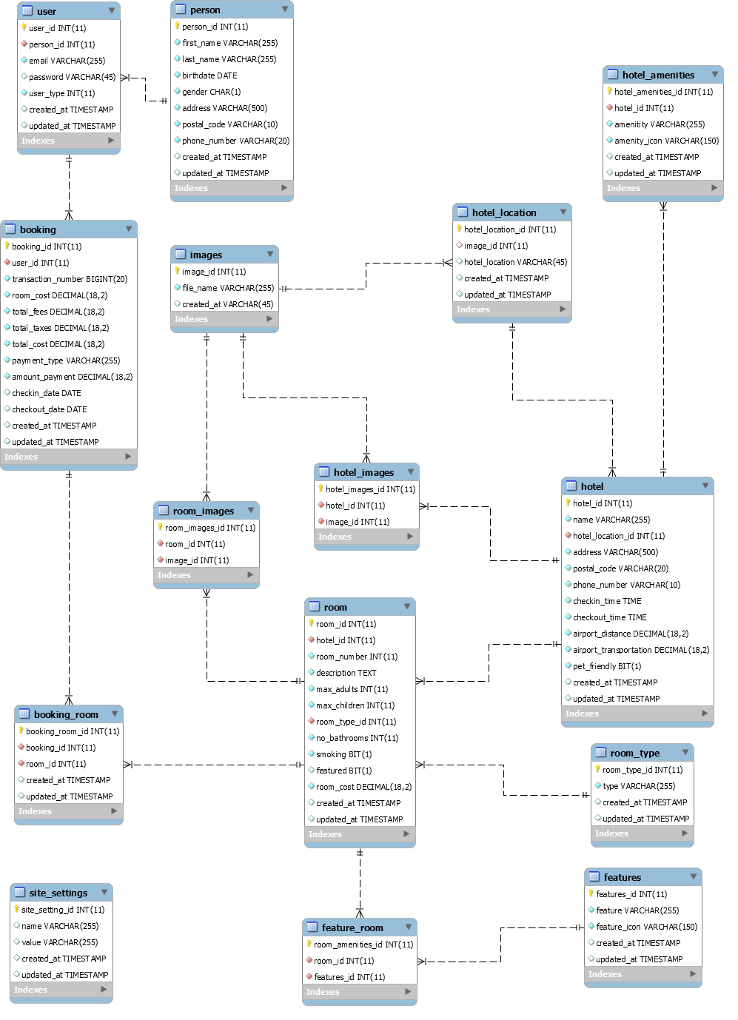

## **CONCLUSION**

Steve George thank you very much for the opportunity to work with you and contribute our efforts in this gorgeous project. We really appreciate your confidence it was a wonderful time and a great experience working for this project.

**Sincerely**,

KōD Consulting Solution