# Introduction

With the amount of computing power and the huge amount of data available for the researchers and companies to draw out insights and providing us with information about how, what, when and where has totally lifted the use of AI and Machine Learning to new heights.

Machine Learning on a very coarse level has been divided into 3 major areas, .namely Supervised Learning [1], .Unsupervised Learning [2], and .Reinforcement Learning [3].

* Supervised .Learning [1], it mainly deals with labeled data. Labeled data means that when the data is being trained, we already have told the learning algorithm about given inputs and expected outputs. A few examples of supervised machine learning are of linear regression, naïve .bayes, logistic regression, .K-Nearest Neighbor, .Support-Vector Machine, decision tree, neural networks etc. So the main requirement for this type of machine learning is labeled data.
* Unsupervised Learning [2], mainly uses .machine learning .algorithms to understand and cluster .unlabeled .datasets. These algorithms try to .discover hidden .patterns or groupings of data .without the need for .human interference. These abilities to. discover similarities and .differences in .information makes it the ideal .solution for different approaches like exploratory .data .analysis, bio-informatics, clustering, analysis of sequences, segmentation of customers, image recognition and many more. Few of the unsupervised learning approach are K-Means Clustering, Association Rules, Hierarchical Clustering, Neural Networks.
* Reinforcement Learning [3] finds its root in Psychology. As in day to day life we come across many situations which forces us to take a some actions. After taking such actions we get either positive reward or negative reward. This is the same idea and thought process behind reinforcement learning. You train a agent such that based on certain state it’s present in, it takes few actions and gets rewards. Now based on what we want to do with those rewards is the main idea that is being explored nowadays. Reinforcement learning has started to gain recognition mainly in the field of robotics, supply chain management, self- driving cars, computer vision, finance and trading and much more.

So starting with reinforcement learning, the first ever idea that started was mainly embedded in psychological journals. Taking notes and inspiration from how humans react to different methods of learning. For example, if a child is running a race and he/she wins the race, the child is rewarded with a chocolate or a medal or any sort of appreciation. This is known as “Positive Reinforcement”. If a child is playing in a playground and he accidently touches thorny bush, he immediately starts crying because the thorn is causing a pain. This is an example of “Negative Reinforcement”.

The historical backdrop of reinforcement learning generally deals with two main ideologies. One ideology is concerns itself when one learns by the method of trial and error which initiated with the understanding of animal psychology of how they learnt and responded. This idea runs along with some of the earlier works in the field of artificial intelligence which proceeded to the

resurrection of the field known as reinforcement learning in the 1980s. The next ideology it matters itself is with the problem of optimal control and whose solution is by generally found by using the approach of dynamic programming and value function. For the most part, this idea has not considered learning. Although both the ideas have been quite independent, though there are omissions revolving around a third and less transparent idea concerned with temporal-difference methods. All the three ideologies culminated together in the late 1980s to produce what we know as today’s modern field of reinforcement learning.

The term known "optimal control" arose in existence as of late 1950s which was used to describe a design problem dealing with a controller which minimizes the parameter of a dynamic system and its behavior a period of time. One among many of such ways to this problem was thought of in the mid-1950s by Richard Bellman and other researchers which was just the extension of a theory proposed by Hamilton and Jacobi in the 19th century [4]. The particular approach used the concept of the state of the dynamic system and that of a value function, or in other words an "optimal return function," [4] which was used to define an equation, now famously known as the “Bellman equation”. These types of approaches that aim at solving the control problem optimality by solving the “Bellman equation” is widely to known as “dynamic programming”. Bellman also popularized the stochastic as well as the discrete version of the control problem optimality famously known as Markovian decision processes (MDPs), and Ron Howard was the one who concluded the policy iteration method for MDPs [14]. All of the idea discussed above are the most essential elements which underlie in today’s comprehension of the present day .reinforcement .learning.

Dynamic .programming still to date is .widely considered .the only .feasible way to solve general stochastic. optimal control .problems. Such optimal problems suffer from what Bellman used to identify as "the curse of dimensionality," which means that as the number of state variable in the given problem increased the computational requirement needed to actually compute the values of the variable increase exponentially. But even after these setbacks it is still way more efficient, accepted and more widely applicable than any other general method. Dynamic programming has a very extensive arc of development starting since the late 1950s, which also includes and extension to the new and interesting field of partially observable DPs.

Now again focusing back on the other major idea which currently leads us into the current and new area of reinforcement learning revolves around the idea to learn from trial and error. This specific idea find its root in psychology, where "reinforcement" theories of learning are abundant and common. Perhaps the first one to express the essence of trial-and-error learning succinctly was Edward Thorndike, who in a nutshell said that any action rewarded with good i.e. positive or bad

i.e. negative outcomes have a tendency to be re-elected and changed accordingly. Thorndike proposed this phenomenon to be known as the "Law of Effect" because it described how the tendency of selecting different actions were actually effected by that of reinforcing events.

Now understanding the third idea, dealing with the history of reinforcement learning, concerned with the idea of learning known as .temporal-difference. These methods of learning are very unique in sense of idea that they are .motivated by .the differences in between short-term consecutive .predictions of .similar ..quantity, like considering the .prediction to win a game of tic-tac-toe . This approach is less distinctly used than the earlier approaches, but it has played a very. important role in this field mostly because methods involving temporal-difference seemingly are quite novel and unique in the current field of reinforcement .learning.

The origin dealing with that of temporal-difference learning can again be in part be attributed to psychology of animal behavior and learning notably in the concept known as “*secondary reinforcers”*. A secondary and primary reinforces work together when considering a stimulithat can be rewards or non-rewards and due to this leads to a interchange in the reinforcing properties. The optimal control and temporal-difference ideas fully coincided together in 1989 when Chris Watkins's proposed and developed a novel concept knows as “Q-learning” [7].

# Literature Survey

## Components of Reinforcement Learning [4]

After the brief introduction of reinforcement learning, there are a few key concepts that form an integral part of reinforcement learning ecosystem. For that here are the main or key components of a reinforcement learning algorithm:

* + 1. **Agent [4]:** The main component of a reinforcement learning algorithm is agent. This is the entity that take actions in a particular environment. For example: An industrial robot picking up non-biodegradable items in a recycling plant.
    2. **Environment [4]:** The surrounding in which the above mentioned agent will work or perform its activities. For example for an agent in computer vision the part of image enclosed by the bounding box can be the environment.
    3. **State [4]:** This is the defined as the present status of the interacting agent in a particular environment. For example is the robot arm in motion or it is stationary or is it going up or is it going down.
    4. **Action [4]:** Action is the steps the agent takes. More often than not in practical applications collection of actions called as action space is discrete in nature. For example the robotic arm moving left, right, up, down, close, open etc.
    5. **Reward [4]:** This is defined as the objective that is implicitly or explicitly defined for the agent to take actions and maximize.

After discussing and going through a couple of main building blocks, there has to be components that bring these building blocks together because they alone can’t act or execute independently. So connection all the above components here are the binding concepts of Reinforcement Learning. They are:

1. **Policy [4]:** A *policy* for an agent is a definition that learns its behavior and is kind of. way at a given instance of time. In other words, a policy can be defined as a mapping technique which maps the agent’s behavior from perceived states of the environment to actions it must take when it is present in one of those states. This can be correlated to psychological terms know as associations or stimulus- response rule. In some of the scenarios the .policy involved can be a very simple function or it can be a lookup table, while in other instances it can involve very in-depth computation, for example a process to search. The policy is at the main building block of an agent in reinforcement learning setting which means that all by itself, it is ample enough on it’s own to determine the behavior of agents. In layman’s term, policies can be .stochastic.
2. **Reward Function [4]:** A *reward function* is the one which gives the definition of a goal in a problem of reinforcement learning. In other words, it maps each state-action pair, in other words knows as perceived state, of the environment in which the agent is present to a unique countable number called a *reward*, which indicates intrinsically how desirable a given state is. The sole purpose and objective of a reinforcement learning agent is to maximize the total reward it will receive in the long run of the experiment instead of short term gain. The reward function also defines what good or bad events are for the agent in terms of the reward it gains. In a system of biology, it would only be appropriate to relate and analyze biological rewards with either pleasure or pain. These are the instantaneous and crucial features of the problem the agent faces in an experimental setting. The reward function should mandatorily be unchanged by the agent. It can instead be use as be a basis to alter the agent’s policy. For example, if an action selected by the policy is followed by low reward, then the policy may be changed to select some other action in that situation in the future. In general, reward functions can be stochastic.
3. **Value function [4]:** A *value function* is the one that tells the agent specifically about the goodness of what it is following for it’s own in the distant future. In other words we can say that the *value* of a particular state is the total amount of reward an agent expectedly accumulates over the future run of it’s experiment, starting from that specific state. Rewards are the parameters which helps the agent figure out the states immediate underlying desirability, whereas values specify the *long-term* appeal of states after taking into consideration of all those states that are likely to appear in future and the related rewards that might be available for those states. Let’s say for example a state may always yield a low immediate reward but still yield a high value because the future states that follows the current state tends to earn quite high rewards or vice versa. Let’s take for example human analogy. Rewards can be equated to pleasures if the reward is inflated and alternatively pain if the reward is minimal contrary to the values correlating to a more .clarified and futuristic .judgment of how satisfied or dissatisfied we are that the .environment is present in that noteworthy state.
4. **Model [4]:** *Model* can be thought of as one that tries to copy the way in with an environment acts out. Let’s say as an example, we know the state and the upcoming action, the model have the ability be able to predict the expected upcoming state and corresponding reward. Models are generally used for *planning*, which decides on the course of action the agent must take by taking into consideration all the future situations that are possible before they actually come to fruition. The amalgamation of

models and planning in reinforcement learning systems is quite relatively a new development. Early systems of reinforcement learning were straightforward learners of trial and error , which is actually the total *opposite* of planning. Nonetheless, slowly and gradually it became clearer that reinforcement learning methods are quite closely related to dynamic programming methods which in- turn does use models and are in turn closely related to planning methods involving state and space. Modern reinforcement learning covers the whole spectrum starting from low-level trial and error learning to high-level deliberative planning.

Rewards in a way are primary parameters, whereas the values, as predictions of rewards, can be understood as secondary parameters. Without the presence of rewards there would not be any values and the one and only purpose to estimate the numbers nevertheless .attain the most reward. Regardless on should be more concerned with values .when looking for .making and evaluating and reaching a conclusion. Value judgements are the one’s based on which actions are executed. The aim is to try to seek out actions that convey around the .highest .value .state but not the most award mainly because such actions procure for the agent the more award it can over the whole agent’s .future.

In planning and finalizing decisions the borrowed quantity is called value and it is one of the main parameters. Unfortunately, it is easier to determine the rewards rather than determining values. Rewards are directly given by the environment the agent is present in but values are the one’s that needs to be estimated and re-estimated from the sequences of observations an agent makes over its entire lifetime. As a matter of fact the most significant constituent of nearly all the algorithms that deal with reinforcement learning is a method on how to effectively estimate such values. The pivotal .role of estimation of values is arguably .the most essential thing that is known about .reinforcement learning over the past couple of decades. Although it’s not necessary to estimate value functions when solving a reinforcement learning problem. Like for example methods used for searching like genetic programming and much more, methods for optimization have already been well-used to solve problems dealing with reinforcement learning. These methods search precisely in the policy space without ever engaging into value functions. These are known as *evolutionary* methods for the very reason because the way they operate is similar to the way evolution biologically produces living organisms with skilled behavior even though they have not learnt it during their individual lifetimes. If the policy space is adequately small or can in some way be structured so that good policy implementations become common or effortless to find then evolutionary methods can be very effective. Also in addition to this, evolutionary methods have several advantages on problems in which the learning agent cannot accurately understand the state of its environment.

Nonetheless, what it means is that evolutionary methods don’t care about the agents interaction with the environment the agent is present in during its. interaction. Evolutionary .procedures generally tends to discount much of how useful structures of a problem dealing in reinforcement learning. Such methods ignore the fact that policy being searched for is actually a mapping of function from states to actions and do not consider the agent visits to these states .throughout during its lifetime or the selection of actions by the agent. In rare cases such .information can mislead (e.g., when misrepresentation of the state is having some possibility).

## Markov Decision Process [4]

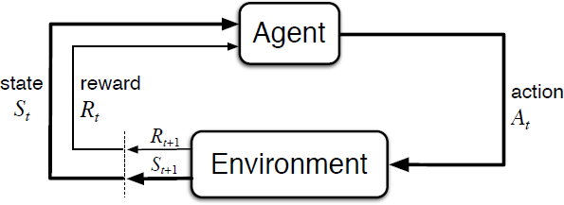

**Fig. Agent-Environment Interaction in a Markov Decision Process [4]**

Markov Decision Process (MDPs) [4] in simple words are nothing more but a direct framing up of a learning problem from interactions to achieve a specific goal. The main entity or learner and also the decision maker is known as an *agent*. The thing *agent* interacts with every single time which comprises everything outside the *agent*, is called an *environment*. They both interact again and again with the agent selecting actions and the environment responding to these *actions* and presenting new situations before the *agent*. The *environment* also gives rise to *rewards*, which are nothing but some special numerical values that the *agent* tries to *maximize* over time through its choice of *actions*.

If the states and action spaces are finite, then the problem so formed is known as a finite markov decision process (fMDP). Finite MDPs are very important for reinforcement learning [3] problems and most of literatures out in the scholarly world have assumed that the environment is a finite MDP in their works.

Any reinforcement learning problem can be modeled as a Markov Decision Process [14]. Markov Decision Processes are a classic formulation of sequential decision making, where actions tend to influence not just immediate rewards, but also subsequent situations or states, and through those, future rewards [4].

MDPs involves delayed reward and puts on a heavy emphasis on the need to adjust between immediate and delayed rewards. Conversely in problems contextualized as bandit problems, the for every action *a,* thevalue *q\*(a)* is estimated, whereas in MDPs we try to predict for particular action *a* which is present in each of the state *s,* it’s value ,*q\*(s, a)*, else we tend to predict the value function .*v\*(s)* of each state if optimal preference of actions is known to us. Such quantities that depend on state are very crucial in order to accurately assign values for future importance to independent election of actions.

The agent and environment interact with each other at each of the discrete time steps denoted by *t*

= 0, 1, 2, 3,… At each discrete time step *t*, the agent receives some sort of representational information of the environment’s current *state* given by *St ,* and on the basis of the state information it then selects an *action* given by 𝐴𝑡 ∈ 𝐴(𝑠)*.* Now after one time step reflecting the repercussion of an *action*, a reward is presented to the agent which is given by *Rt+1* ∈ *R* and thus lands itself in a new state denoted by *St+1.* Thus all this information above gives present to us collection of all the values which look like .*S0, .A0, .R1, .S1,. A1,. R2, S2, A2, R3,….* [4]

Now in a *finite* MDP, the multiple set of states, actions, and rewards (*S,A,R)* have a fixednumber of elements in them. In such cases, the reward *Rt* and state *St* both have specifically defined probability distributions which are discrete in nature and is reliant only on the previous state and corresponding *action*. Now considering a .specific value .of random variables, *s’ .*and .*r*, there is a probability of these values occurring at a given time *t* due. to the values .particularly given from that of the preceding states and corresponding actions which can be given by the equation mentioned below:

[4]

for all *s’, s S, r R,* and *a* *A(s).*

The function *p* here represents the system dynamics or the measurements of the specific MDP.

The dot on the equals sign in the equation conveys the information that it is a definition, particularly .in this case, the function . *p* rather than a fact that follows from given previous definitions. The function of dynamics given by [0, 1] is a simple deterministic function which consists of just four elements. The ‘|’ is borrowed from the notation which denotes conditional probability, but in this context it just points out to us that *p* indicates a distribution of probability for each choice of *s* and *a,* that is given by below [4],



In a Markov .decision .process, the probability values conveyed by *p* comprehensively characterizes that. environment and it’s dynamic nature which in other words can be understood as the probability of every achievable value for *St* and *Rt* depending only on the immediate earlier state and it’s corresponding action, given by *St−1* and *At−1* respectively and given both of the values and not at all on earlier action .or earlier states. .This can be seen as a limitation on the state, but not on the decision process itself. The state generally includes all the necessary information regarding the .characteristics of all the previous agent-environment interactions which makes always makes a difference in the future. So if the all of the above conditions are met and followed, then the state is understood as to follow a *Markov Property.* [4] Discount factors are associated with time horizons as given below [4].

C:\Users\anind\Downloads\1_NKX4zhTk9YKx4J5b0PKbBA.png

The MDP framework is quite conceptual but as well as very malleable and finds it’s application in many distinct problems in varied ways. Like the time steps are not needed to have fixed intervals of real time; they instead can have arbitrary consecutive decision making stages and performing an action. The actions can be of low-level controls like when voltages applied to the motors of a robotic arm, or high-level control decisions like whether or not to go and watch a movie or to go to a seminar or not. Similar to actions, states can take a lot of different forms. They can either be completely resolved by low-level sensations, like direct sensor readings, or they can be high-level and abstract in a sense as that of a symbolic description of objects present in a room.

The MDP framework can be thought of as a problem that deals with a directed method of learning with the goal to learn from various interactions. It comes up with the idea that details pertaining to that of the .memory or control and might be even sensor are there also whichever .aim one .is looking ahead to solve, all such complications of learning a objective, specific actions will always be reformulated as an ensemble three signals communicating in between its surrounding and the agent : 1st signal will represent the choice an agent makes (i.e. actions), 2nd signal will constitute the measure on which the alternatives are being made (i.e. states), and the 3rd more signal will define of what that agent will yield based on the choice and the measure on which choices are being made (i.e. rewards). .This substructure might not have .sufficient capability to mean .all .problems related to decision making useful, but it has shown the ability to be widely helpful and relevant. Just for a fun example below is a typical workday of a person.

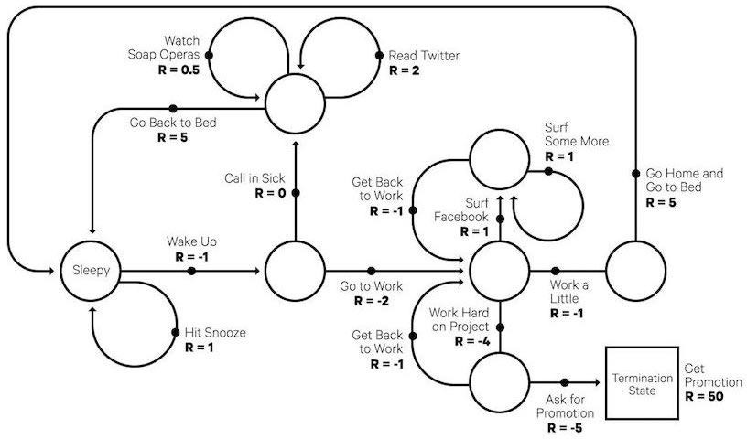

Fig. *A simple Markov Decision Process (MDP) that represents a typical workday* [16]

## Bellman Equations

Bellman .equations are the .equations that help us find value functions and optimal policies. Now from the knowledge one knows that in an environment the policy is bound to change with different experience and correspondingly different policies are bound to have different value functions. Thus the value function which gives the maximum value compared to all the other value functions is called the optimal value function. Below is the derivations of the Bellman Equation [4]

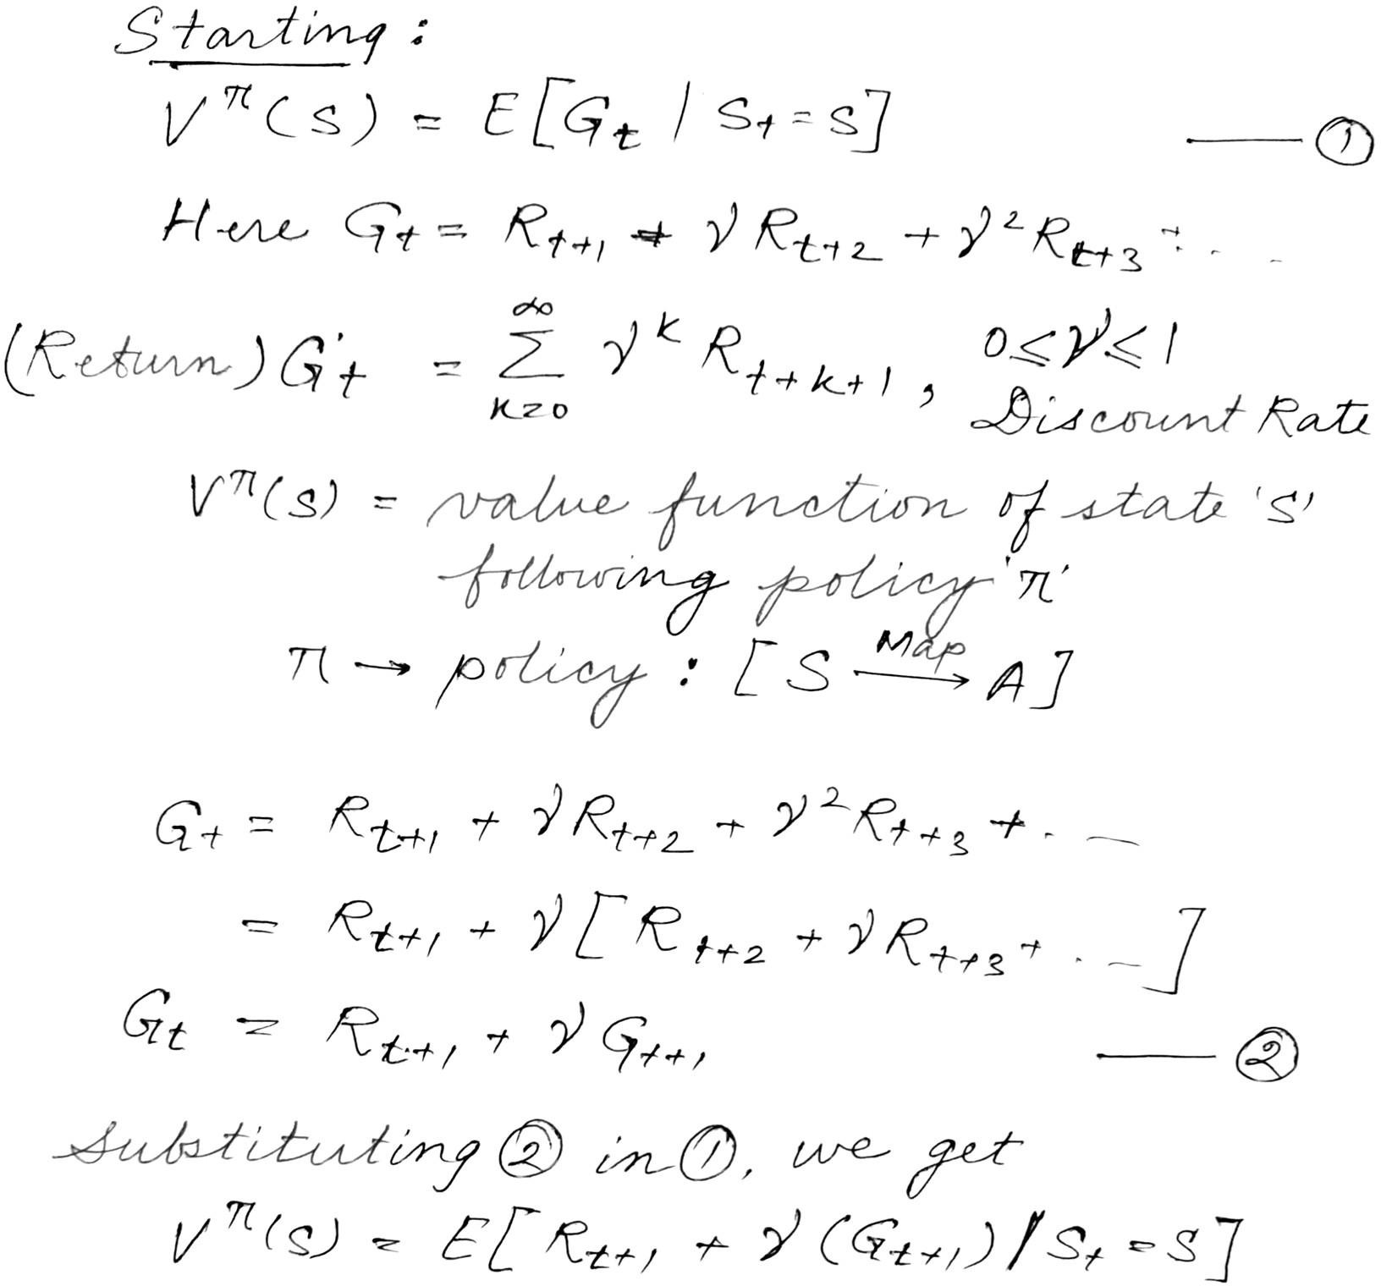

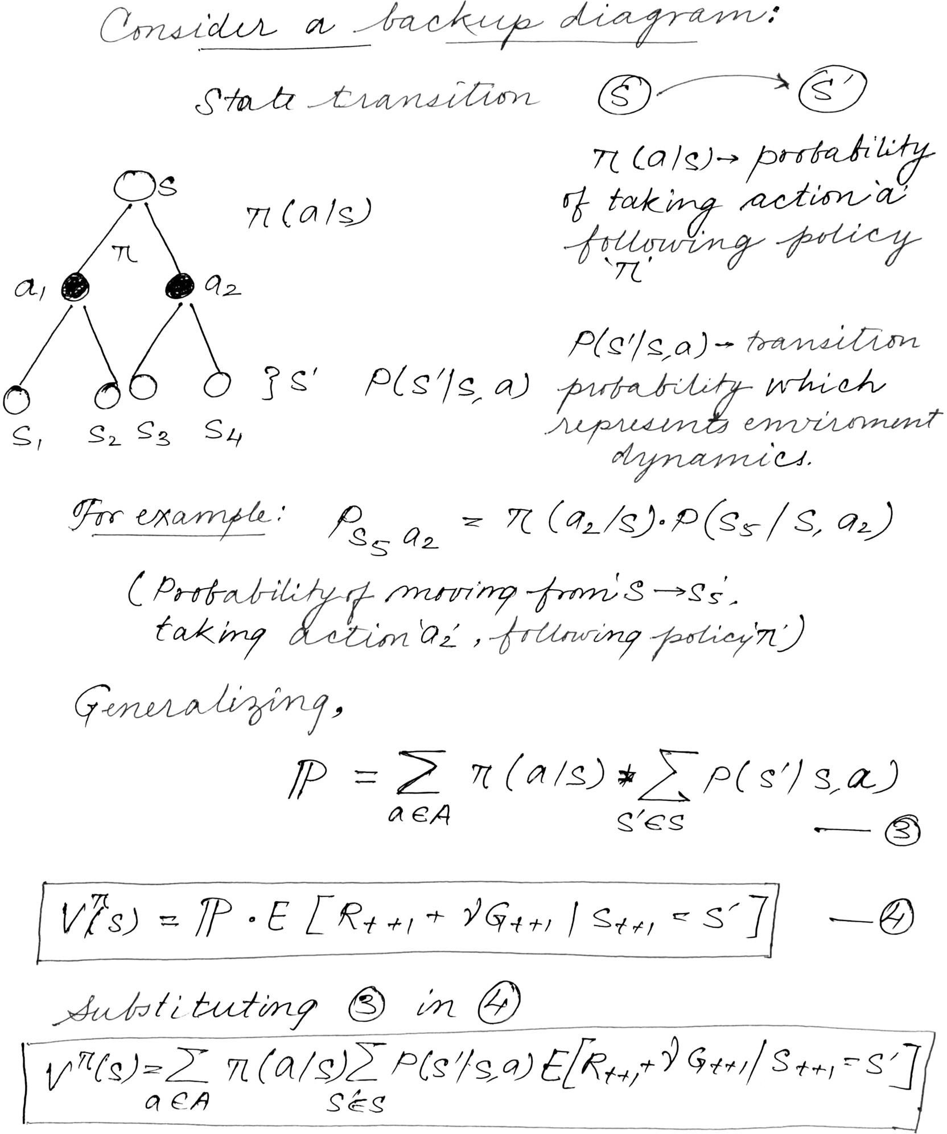

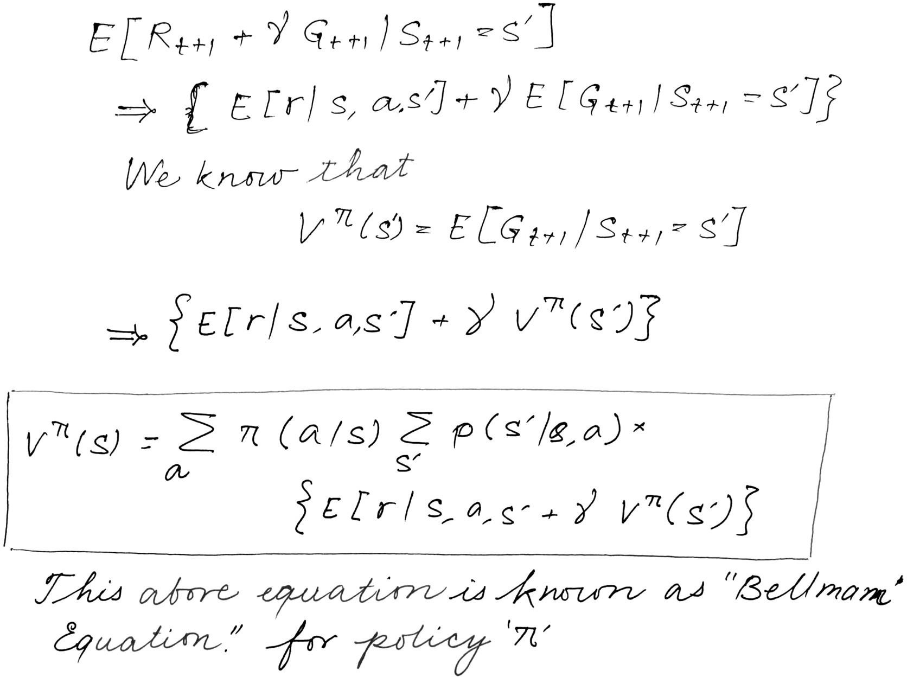

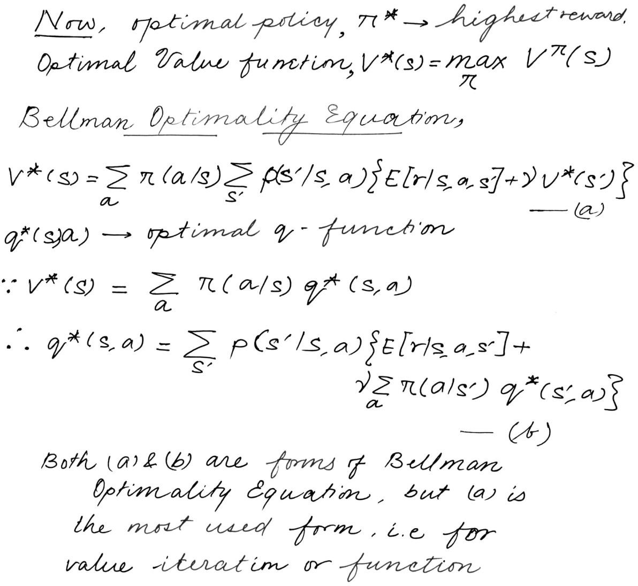

## Model Based and Model Free RL Algorithm [5]:

When going for different approaches to a RL problem, they can be broken broadly in 2 categories. Model-Free and Model-Based algorithms.

Model Free Algorithms are the ones that try to learn through various experience gained during its interactions with the environment, i.e. this algorithm tries to estimate the policy that is complete in itself without using or predicting the state (reward and transition functions) of the surrounding.

Model Based Algorithms on the other hand is an approach that uses a learnt-model i.e. transition probabilities and reward function to predict the future action (optimal policy).

* 1. **Q-Learning [6] :**

Q-learning in its all glory and form was brought as a result of a specific variant of temporal difference learning (TD) initially a part of PhD Thesis by Watkins [6] and adopted & proposed by Watkins and Dayan [7].

Q-learning is a model free learning .algorithm with used the values calculated by the agent. .Value .functions update the value based algorithms specified and following any particular .equation specifically Bellman .equation. Whereas the 2nd approach commonly estimates the .value .function while following policy and is called policy following with .a .greedy .policy .obtained .by executing the .penultimate enhancement that occurred of the policy.

The term ‘Q’ in Q-learning [7] is an abbreviation for quality. Quality in this setting represents how useful a given action is in regards of gaining some sort of future reward.

Speaking about reward, when considering rewards the following the reward tends to follow the same pattern as that of a MDP. A reward *Ra (sj, sk)* is obtained when executing an action *ai* in state *sj* and the environment or system transforms to state *sk* after the decision executer takes action *ai*. The decision maker tend to follows a policy, π such that π(⋅):S→A, that for each state *sj∈ S* takes an action *ai ∈ A*. So that it is the policy which tells the decision maker which specific actions

to take in each state. The policy π may be shuffled and randomized as well. Longer time experiences have .more variance as compared to smaller one’s as longer time includes .more unnecessary information, while .short .time .experiences are biased .only towards .short-term gains. The discounted reward phenomenon tends to make an infinite series finite. Thus aiming to maximize the long term reward instead of short term rewards. The discount factor essentially tells us the information on how .much the .reinforcement .learning agents actually cares .about its rewards in the distant future compared to those in the .immediate .future of its course of actions. Thus if γ=0, the agent will only focus on learning the actions that produce an immediate reward and if γ=1, the agent will calculate each of its .actions .based .on .the total sum of all. of its future .rewards.

## Bounding Box

Bounding box in it’s heart and soul is mostly just a rectangle that surround an object present in an image and tries to specify mainly it’s position in the image, it’s class and maybe confidence (probability of how likely that object is in that location). Bounding box are one of the most prominent techniques which draw the attention mainly when it comes to object detection and localization. They are generally used in the task of object detections where the main aim is to identify the position and type of maybe multiple objects in the image. A example’s ensues this line.

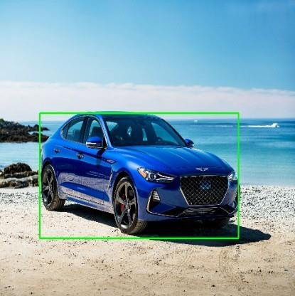

Fig. A Bounding-Box example

Now coming to the conventions used when specifying a bounding box are:

1. To specify the box with respect to the respective coordinates of it’s top left and bottom right points.

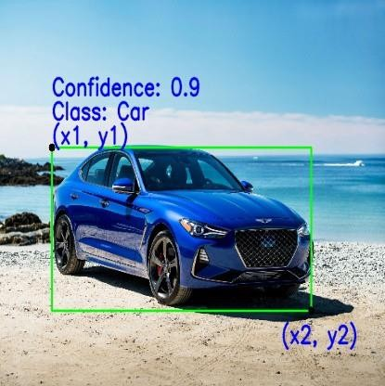

1. To specify the box with respect to it’s center, height and width.

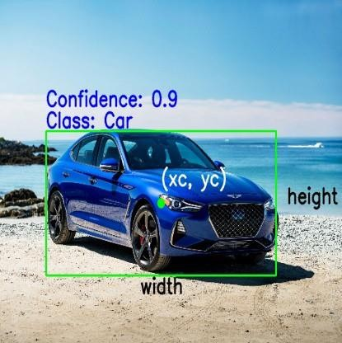

Now below are the list of parameters that are generally used to define the specifications of the bounding boxes:

1. Class: The first and foremost parameter is denoting the class to which a specific object in an image belongs to. For example car, person, truck, aeroplane etc.
2. (x1, y1): This corresponds to the x and y co-ordinates of the top left corner of the given rectangular box also can be written as xmin and ymin.
3. (x2, y2): This corresponds to the x and y co-ordinates of the bottom right corner of the rectangle also written as xmax and ymax.
4. (xc, yc): This corresponds to the x and y co-ordinates which denotes the center of the bounding box.
5. Width: This represents the width of bounding box.
6. Height: This represents the height of bounding box.
7. Confidence: This indicates the probability of the presence of the particular class of object present in that image. For example a confidence of 0.8 indicates that there is a 80% chance that the particular class of object actually exists in that box.

## Resnet50[11]

Deep residual networks have become popular and most being the infamous ResNet-50[11]. This deep neural network is a convolutional neural network (CNN) which is as deep as 50 layers. A residual neural network (ResNet [11]) is a special type of artificial neural network (ANN) which is known to stack residual blocks one over the other to form a deep neural network.

In the past few years, the fascinating field dealing computer vision has went into very extensive research and transformation with the advent of very fast changing landscapes and technologies. As a result of this due to such improvement, it is now possible for different models dealing with computer vision to easily outperform humans and in a very efficient way solving a multitude of problems specifically dealing with object detection, image recognition, object localization, face recognition, image classification and much more.

With this in mind, the launch of such deep convolutional neural networks deserve a round of applause. These neural networks has been used greatly and in-depth for analysis of images with exceptional precision.

Even though having the flexibility to just keep on stacking layers after layers to our CNN’s which might help us to solve even more complicated endeavors, they themselves come with their own sets of pretty big problems and issues. Most of the time it is observed that training a neural network becomes challenging and tough as we keep on increasing the number of layers. It is no guarantee that increasing the number of layers will be able to generate more feature and hence in a way increasing our accuracy, but instead the opposite happens. The training accuracy instead of improving actually deteriorates.

So to address the issue of deteriorating accuracy with the increase of layers the introduction and use of ResNet [11] became very important. The idea of ResNet [11] actually stemmed from the winning solution of ILSVRC 2012 known as “Imagenet classification with deep convolutional neural networks” authored by Alex Krizhevksy, Ilya Sutskever and Geroffrey E. Hinton [22]. This paper introduced the world to “AlexNet” named after the first author of [22]. This lead to a fierce battle among the researchers to build deeper CNN’s. But even after increasing the number of layers there was no significant increase in the training accuracy. Even after if the training accuracy increased due to increasing depth it saturated after some layers. At that moment ResNet dropped as bomb in the research community of computer vision.

Now what is ResNet? ResNet[11] is actually an acronym of Residual Network. It was an innovative deep neural network approach that was first made known by the team of researchers from Microsoft Research lead by Kaiming He in 2015 who proposed the research paper with the title “Deep Residual Learning for Image Recognition” [11].

The reason of this model to be extensively studied used and popularity can be known from the fact is that the culmination of this convolutional model won the winning accolade at the ILSVRC 2015 image classification competition with a minimal error of 3.57%. In addition to that it also took the top spot in various other competitions held in 2015 like ImageNet, COCO and ILSVRC.

ResNet [11] in itself has many variants consisting of a number of different layer embedded in it that run on the same concept initially proposed by the research group. Resnet50 is one of the most influential networks where the number ‘50’ denotes that the variant is working with 50 layer deep neural network.

When solving a problem related to areas like computer vision involving the use of deep convolutional neural networks, researchers engaged in stacking one layer after the other. But then came along the problem of vanishing/exploding gradients. This problem was then addressed by the used of normalized initialization of the layers. Thought the thought was that such additional layers might be able to help solve more and more complex problems with better efficiency as the different such layers can be trained for different tasks eventually leading and getting higher accuracy in results.

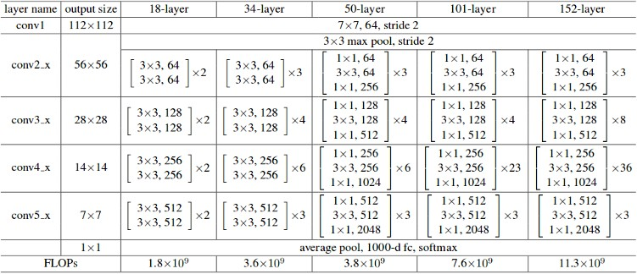

Fig. The different layer architectures of ResNet[11] variants

But the thought of multiple layers stacked one after the other can help enrich the features of the model, a network that is deep enough, ran into a problem. The problem of “degradation”. When such deep- networks start to converge, with the now the ever increasing depth of the network, accuracy gets saturated and then degrades rapidly.

Now from the common notion we might think that this degradation might be a result of overfitting, but it is not the case. On the contrary, this might be a result of problems caused due to varying initialization of the networks, different optimization functions and most importantly, the ever known problem of vanishing/exploding gradients.

ResNet[11] was formulated keeping the intent of addressing this exact problem of degradation. Deep residual nets improve the accuracy of its model by making use makes use of such .residual blocks [11].The use of “skip connections,” [11] makes up the essential building .of the residual blocks.

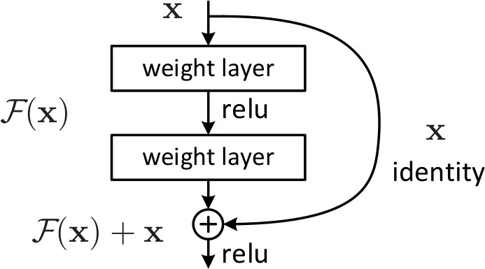

Fig. Skip Connection as mentioned in “Deep Residual Learning for Image Recognition” [11]

Now why skip connections? Skip connections as mentioned in the above diagram works in two ways. First of all they all mitigate the problem of vanishing gradient by creating an alternative route for the gradient to go via. Secondly they enable the neural network to learn an identity function. The aim of the identity function is to ensure that the upper layers of the neural network performs better that the lower layers.

Thus the presence of residual blocks helps to make it substantially convenient for the layers of network laying below to map and understand identity functions easily and efficiently. As a result, ResNet [11] enhances the efficiency of such deep neural networks which contains way more neural layers than vanilla CNN’s while having the ability to minimize the percentage of errors. In other words we can say that, the presence of skipping connections and adding the output from previous layers to the outputs of consecutive stacked layers skipping some of the layer in between making it easier to train much deeper networks than what was possible earlier.

The very first ResNet[11] architecture was the Resnet-34 which was initially mentioned in the research paper first introducing ResNet[11], which introduced shortcut connections so as to turn a simple neural network model into analogous residual network. In this case, the simple neural network drew inspiration from VGG [16] namely VGG-16 & VGG-19, with 3 X 3 filters making up the convolutional networks. But when drawing a comparison between VGGNets[16] and ResNet [11], the latter have lesser number of filters and comparatively less complex. The ResNet

[11] having 34 layer achieved a batter performance of 3.6 billion floating point operations compared to 1.8 billion floating point operations of a smaller ResNet [11] with 18 layers.

There were two very simple rules of designing such a neural network – first being the layers when having the identical size of output feature maps and that of filters in them, and the second being that size of feature map be halved corresponding to the number of filters being doubled in order to preserve the time complexity of each and every layer. It was made up of 34 weighted layers.

Then the simple neural network is infused with the skipping connection. Keeping the dimensions of input and output same for the network, the identity functions are used directly. With the expected increase in the dimensions, two options are needed to be taken into consideration. The first of such option was to pad extra zeros to increase the dimension keeping the shortcut intact and letting it perform identity mapping. The other option was to match dimensions using projection shortcut. Below is the image of the ResNet[11] architecture.

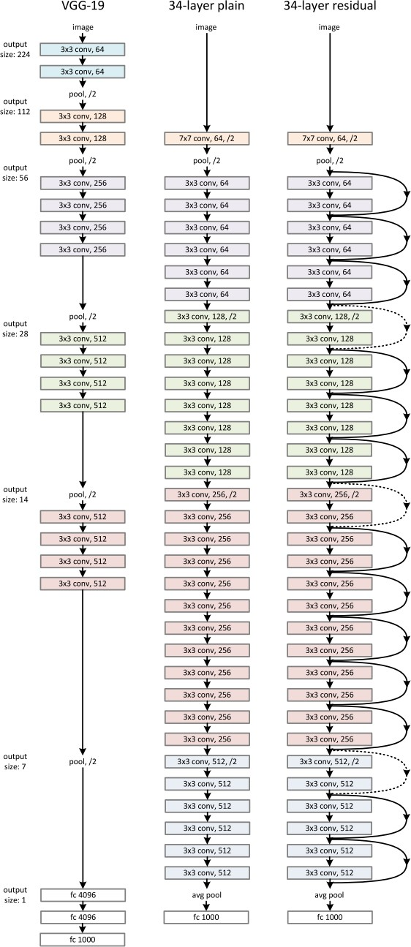

Fig. ResNet Architecture [11]

## Deep Q Network (DQN) [8]:

One of the breakthrough paper on implementation of deep learning for reinforcement learning can be credited to researchers from Deepmind for publishing their paper “Human-level control through deep reinforcement learning” [8] in 2015 which they trained agents on multiple Atari games which the only input being the screen on the game. This laid the foundation for the merging together of two fields Reinforcement Leaning and Deep Learning and birthed a new field of Deep Reinforcement Learning or DRL. Every time the agent makes a move in the environment, in this case the images of the game, it created a tuple of 4 variables called experience which consists current state, action it performed, the state it landed in and the reward it got for performing that operation *(s, a, st+1, r)* and then store these experiences by creating it’s own data set in a replay memory. *Replay Memory* sounds same as you might think. It stores all the past experiences of the RL agent and then replays it again and again and learns from it. Now here the Q values from the Q Learning comes into picture helping the agent to take future action.

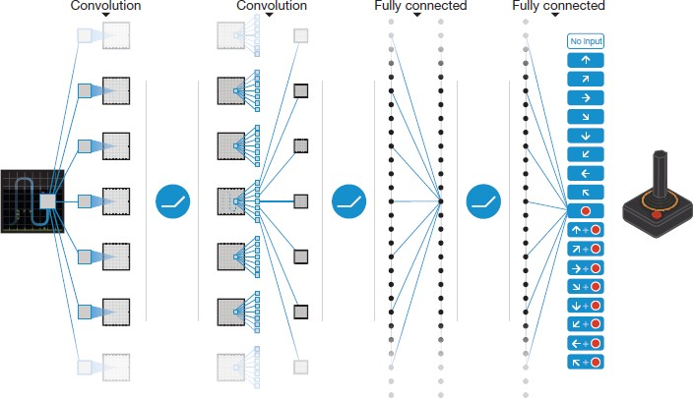

Fig. Network structure of Deep Q-Network (DQN), where Q-values Q(s, a) are generated for all actions for a given state [8]

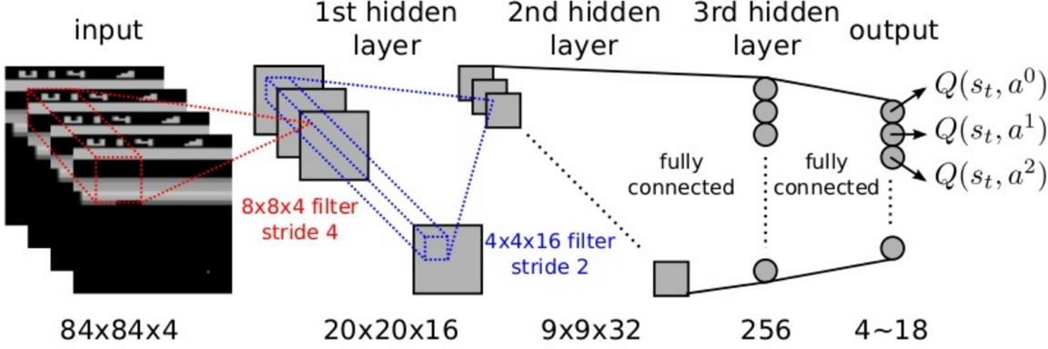

Fig. Exploded View of the above DQN [9]

## YOLO – “‘You Only Look Once”[19]

YOLO [19] (You .Only .Look Once) .real-time .object .detection .algorithm, in recent time has become one .of world’s very intriguing and creative approaches .emerging out of from the are of research working toward computer vision especially of those object detection algorithms which is extremely effective that also encloses many of the shortcoming of various state of the art methods. Object detection from a long time is a critical capability especially in the field of autonomous vehicle technology. It is an area of computer vision that’s exploding and working so much better than just a couple of years ago. YOLO [19] along with it’s continuous updates has tend to fascinate everyone especially in the computer vision community with it’s ease of implementation following better results every single time.

YOLO [19] appeared on the radar of computer vision when it was introduced in a paper in 2015 by Joseph Redmon known as “You Only Look Once: Unified, Real-Time Object Detection”[19] and in a small time grabbed considerable interest of scientists working especially in the field of computer vision. He gave a small introduction of this at University of Washington in .2017 by shining a spotlight on this novel and innovative approach of real time image processing.

Object detection is amongst that category of perennial question in computer vision in which we all work to understand the where and what, especially where .items are present in images and also to which class they fall into .in the .image or in other words what class do the object belong to. Classification problems are relatively simple than problems pertaining to detection of objects, which .also tends to perceive items and not necessarily .denote the presence and location of object is in that specific image. .In addition to this if there are more than one object present in the image then the classification fails.

In comes YOLO [19]. YOLO [19] completely changed to a approach that is a little different that the previous one’s. It is a very intelligent CNN which does real-time detection of objects. This method uses a full image, applies it to a standalone .neural network, bifurcates the whole image into multiple boxes and regions after that bounding boxes are predicted and for individual such region probabilities are calculated. The bounding boxes used are assigned their respective weights based on the probabilities calculated for such bounding boxes.

YOLO [19] is very popular because it has yielded very high accuracy compared to other SOTA methods while also having the ability to be executed in real-time. This algorithm considers the image for just once and in the way that it only requires forward propagation just once throughout the whole neural network to give predictions for that specific image. For multiple bounding box suggestions it uses non-max suppression method (which tries to make sure that it each object is just detected it only one time), it then gives us the output of the recognized objects together with the corresponding boxes bounding them.

A singular .CNN sequentially anticipate a number of bounding boxes in the implantation of YOLO [19] and corresponding probabilities of specific classes for these bounding .boxes. YOLO [19] lets it’s network train on complete images and optimizes the performance of its detections directly without any middle man. Given below are some of YOLO [19] has a .number of advantages:

* + The speed of YOLO [19] is its main selling point. Written in native CUDA and C, YOLO is blazing fast
  + The entire image is fed to the YOLO [19] network as input while training and testing so that it on its own can encode the classes context information about as well as appearance of it.
  + YOLO [19] .generalizes the depiction for the objects as to .when the network will get trained on non-preprocessed .images and then perform tests on other images, it surpass nearly every other method of detection.

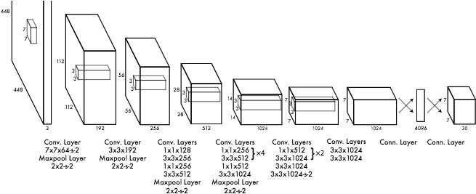Fig. YOLOv1 Architecture

Further research involving YOLO [19] has been conducted which resulted in the paper published in the month December of 2016 namely “YOLO9000: Better, Faster, Stronger,” [20] otherwise known as YOLOv2 by the same researchers ,which in itself supplied a .number of enhancements to the existing YOLO detection approach so as to include the recognition of .over 9,000 categories of objects by classification optimization and detection performed jointly.

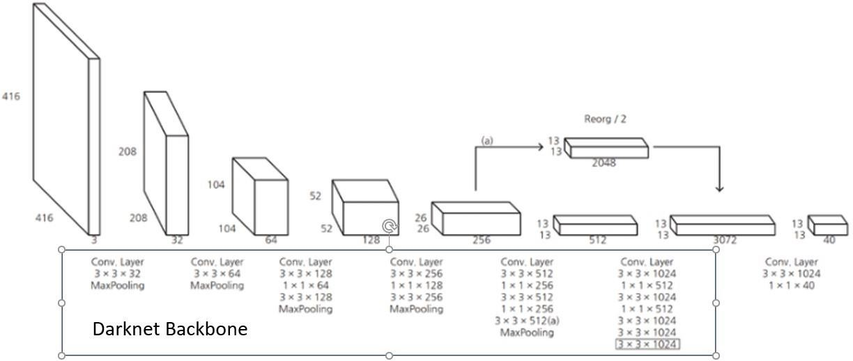

Fig. YOLOv2 Architecture

In recent time the very same researchers published yet an advancement paper in the month of April of 2018 on their improved advancement by developing the YOLO [19] detection algorithm even further, “YOLOv3: An Incremental Improvement” [21].

As with a nearly every area concerned with research especially in deep learning, huge amount of attempts goes into examination. In improvement of YOLOv3, the examinations effect of trial and error was in full swing for research team tried to a huge number of various ideas, most such ideas just failing straight out. Just a few of the ideas that stuck included a novel network to perform the process of feature extraction which contained of convolutional layers 53 to be exact, a novel metric for detection, having the ability to predict the score of object for each new bounding box using the well-known concept of logistic regression, and the loss metric to be used for class prediction as binary cross-entropy during training. In the end the novel approaches resulted in what we know today as YOLOv3 which runs outstandingly faster when compared than other methods of detection with generally the same accomplishment. In addition the current version of YOLO struggles lesser with small objects present in an image.

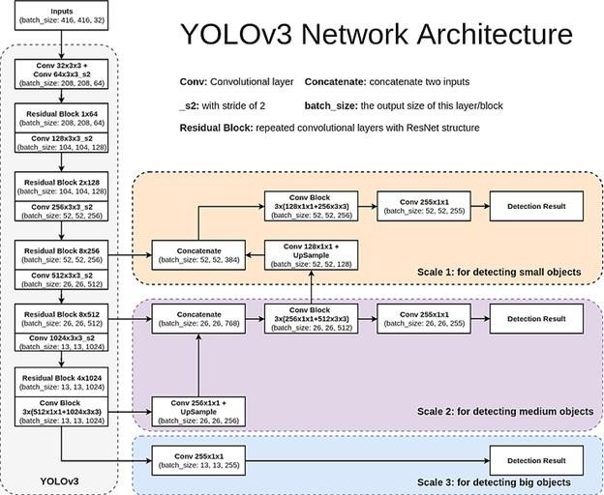

Fig. YOLOv3 Architecture

Now the current version of YOLO that is YOLOv4 and in development of YOLOv5. Redmon reportedly stopped working on YOLOv4 after the possibility of possible misuse of this technology specifically for data collection and military uses resulting into serious ethical violation.

# Problem Statement

The base paper that I am aiming to work on and improve is titled “BAR- A Reinforcement Learning Agent for Bounding-Box Automated Refinement” [10]. The paper starts with the brief introduction of how deep learning has basically taken over the world due to its wide ranging applications mainly in the field of computer vision. Object detection and recognition deep learning techniques allowing machines to visualize their environment with pretty high accuracy. Thus we are seeing a high number of industries using computer vision in their day to day operations be it inventory management, process control, quality control and much more. But there is a drawback, deep learning still being a mix of supervised and unsupervised learning needs amount of labeled data with a high degree of accuracy which takes considerable amount of effort, time and money. Image annotations also are highly prone to human error and it the might happen that the images being biased towards one side, the human annotator might label the image wrongly. Even thought the whole dataset is labeled, it might happen that the Region of Interest (RoI) of the target object might change because of industrial circumstances. The cost of re-labelling is just not feasible. To the best of knowledge existing literature tends to generate bounding boxes around the target object but no attempts have been made to correct these bounding boxes. In summary, existing work focuses on reducing the time spent by human annotators on manual labeling. While, in the literature, this goal is achieved by finding alternative ways to generate b-boxes proposals, our work focuses on learning to correct inaccurately generated b-boxes to later refine annotations regardless of their initialization [10].

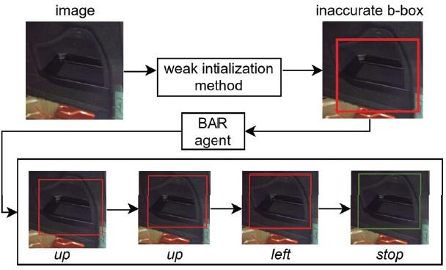Every image contains exactly one annotated target object whose b-box is represented by its upper-left corner (*xmin, ymin*) and its lower- right corner (*xmax, ymax*). This b-box is considered inaccurate if its IoU with the groundtruth is below a threshold, denoted by *β*. Given an image and an inaccurate b-box enclosing the target object, the goal of the agent is to correct the b-box as shown in figure here. The agent achieves this goal by executing a series of actions that modify the

position and aspect-ratio of the b-box. This series of actions corresponds to an

Fig. BAR agent workflow during the testing phase. Given an image and an inaccurate b-box enclosing the target object, BAR chooses the path *TE* with *T* = *{up,up,left}* [11]

episode that ends with the final correction of the agent [11]. At time step *t*, the agent updates its Q-value estimate in the following manner:

*Qt*+1(*s, a*) = (*α −* 1)*Qt*(*s, a*) + *α*(*r* + *γ* max*a’ Qt*(*s’, a’*)) [10]

The three main components of BAR-DRL are:

1. State: The state is composed of a feature vector *∈* R1238 extracted using ResNet50 [11] pre- trained on ImageNet [12] and a history vector. The b-box enclosed region is resized to 224*×*224, then fed to the feature extractor that outputs a vector of size 512. The history vector encodes the 10 actions of the episode, each of which is represented as a one hot encoder.
2. Actions: These are the eight translation actions shown in table below and the *stop* action.



1. Reward: The reward for a translation action *a* at step *t* is:

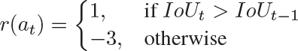

A higher negative value is necessary when the IoU decreases to prevent the agent from worsening the initial b-box, which defeats the purpose of a correcting agent. The reward for the *stop* action is:

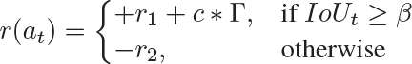

where : : Γ =, *r*1 = 6, *c* = 4, *r*2 = 3 [10].

**Problem Statement:** Most of the literature tends to create bounding boxes, be it for single objects or be it for multiple objects. The approach in this paper can be extended to multiple objects. But what happens if there are overlapping objects in the image and the methodology fails to correctly identify and create the bounding boxes in the image. This sort of application can be huge for the industrial applications and the scenarios where it’s bound to be a lot of overlapping objects. So to formally define my problem statement **“Bounding Box Refinement Agent for Overlapping Object Detection”**.

# Methodology

For simulation of the paper I am working on Pycharm with Tensorflow 2.7, Python 3.9, cuDNN

8.2.1 and cuda 11.5 on my laptop having 8GB RAM and Nvidia GTX1650 GDDR6 having 4 GB of VRAM. Since the authors used a private dataset, I have instead used PASCAL VOC 2007 [13].

For execution, multiple experiments involving images of “aeroplane” class was chosen from PASCALVOC 2007 [13]. Since the aim of my experiment is to reduce the manual effort of correcting the bounding boxes by the proposal produced by the reinforcement learning agent below will contain the table and list of all the experimental parameters that I created for my own testing. Wrong manual annotations where done on these 200 images and below contains the IoU of those images for different epochs starting from 50, 80 and thresholds varying from 0.50 to 0.80. The parameter for the metric used is Average IoU when testing on images.

The deep q neural network consists of two fully-connected layers of 500 neurons each with ReLu activation and random normal initialization, and an output layer of 9 neurons with linear activation. Mean square error loss with Adam optimizer and learning rate of 0*.*001 are used, and the discount factor *γ* for the Q-function is set to 0*.*90 [10].

**Results and Discussions**

Below are the various observations calculated by the experiments done by me on PASCAL [13] dataset. mAP is calculated at 50

1. Aeroplane Class:
2. Training Image : 25 Testing Image : 175

|  |  |  |  |  |  |  |  |  |
| --- | --- | --- | --- | --- | --- | --- | --- | --- |
|  | 50 IoU 50Epoch | 50 IoU  80Epoch | 70 IoU  50Epoch | 70 IoU 80Epoch | 80 IoU  50Epoch | 80 IoU 80Epoch | 85 IoU  50Epoch | 85 IoU 80Epoch |
| IoU Average | 0.4572 | 0.4685 | 0.4708 | **0.4821** | 0.4625 | 0.4780 | 0.4768 | 0.4448 |
| IoU Inc. | 188 | 155 | 128 | **168** | 139 | 155 | 145 | 120 |
| IoU Dec | 15 | 48 | 75 | **35** | 64 | 48 | 58 | 83 |
| AP bef | 15.29 | 16.32 | 26.33 | **29.20** | 27.75 | 25.96 | 29.47 | 24.28 |
| AP aft | 20.48 | 22.55 | 32.48 | **37.98** | 33.45 | 32.37 | 35.50 | 30.78 |

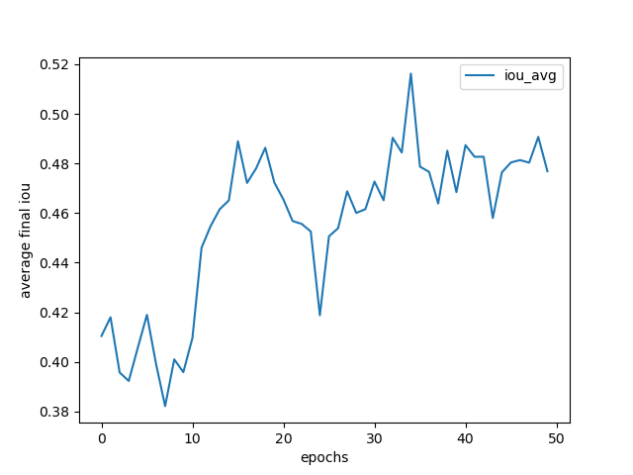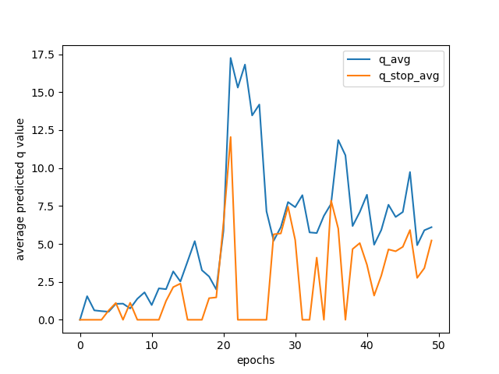

Fig. IoU: 50, Epoch: 50

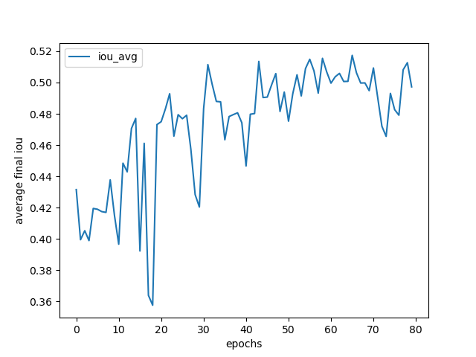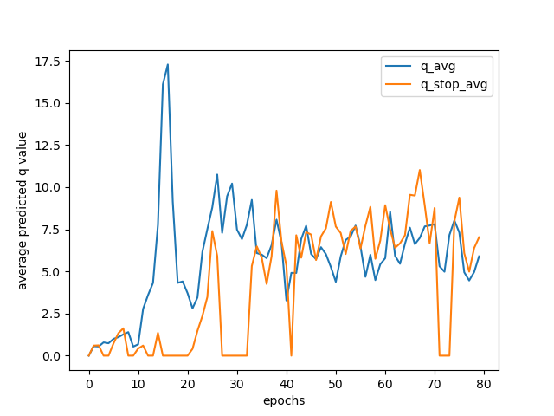

Fig. IoU: 50, Epoch: 80

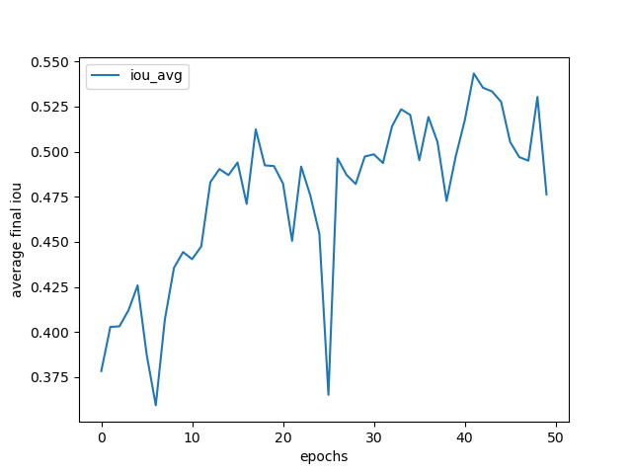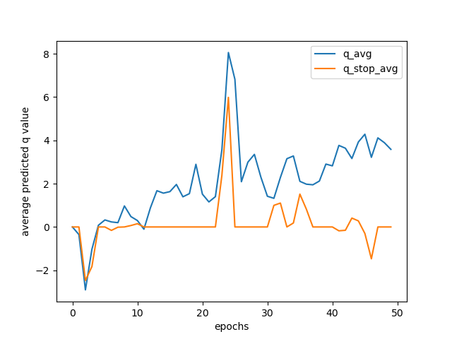

Fig. IoU: 70, Epoch: 50

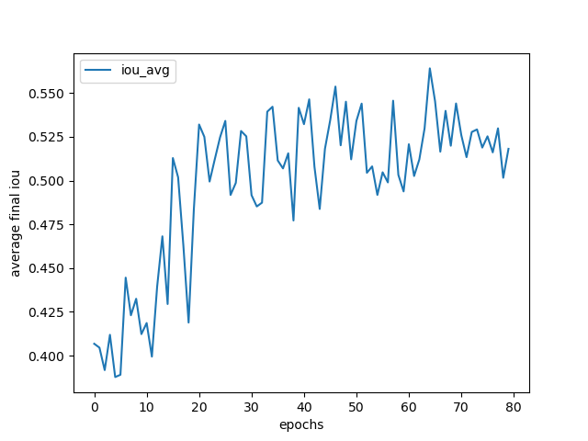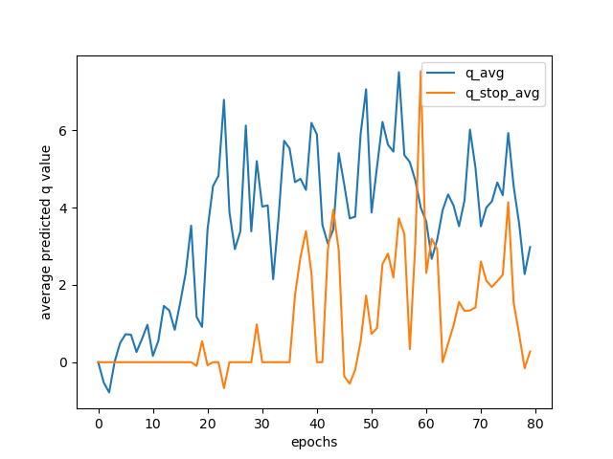

Fig. IoU: 70, Epoch: 80

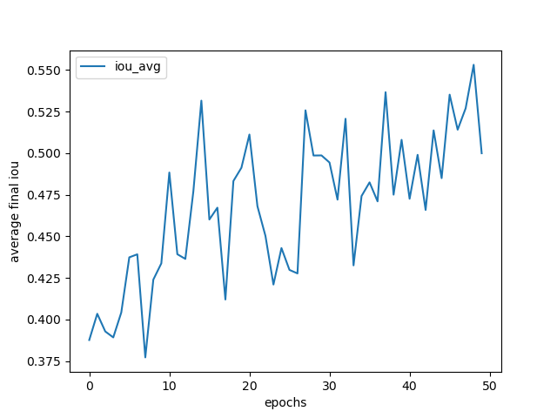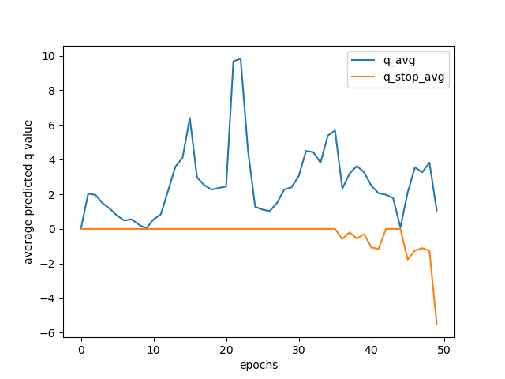

Fig. IoU: 80, Epoch: 50

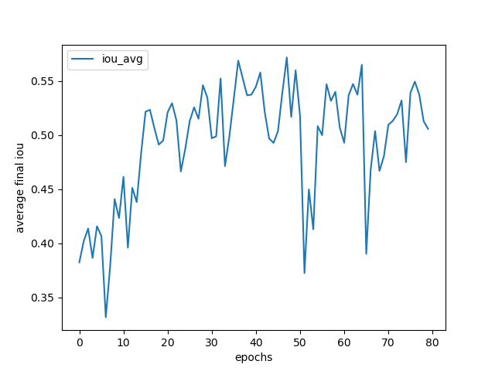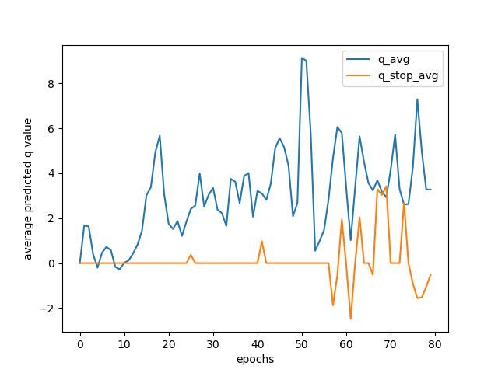

Fig: IoU: 80, Epoch: 80

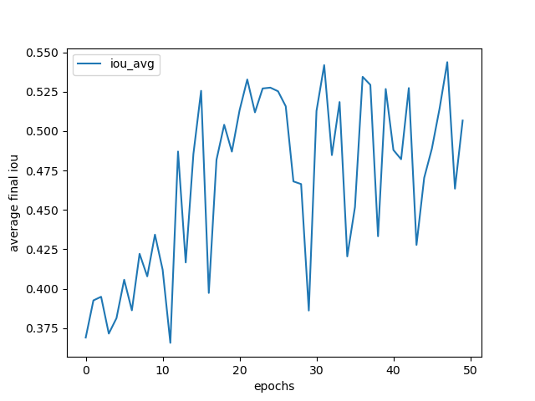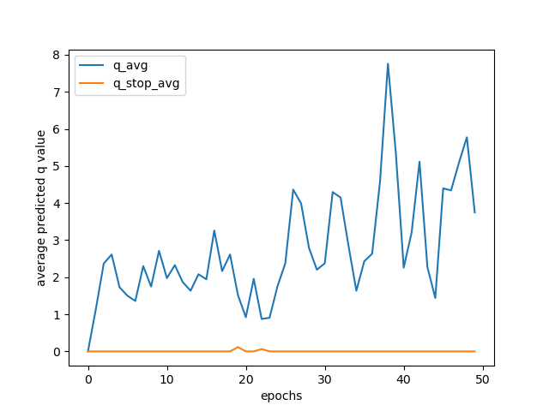

Fig. IoU: 85, Epoch: 50

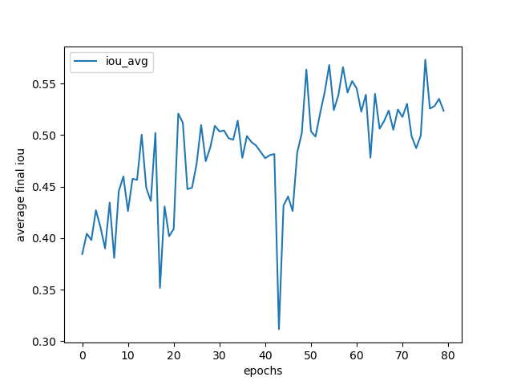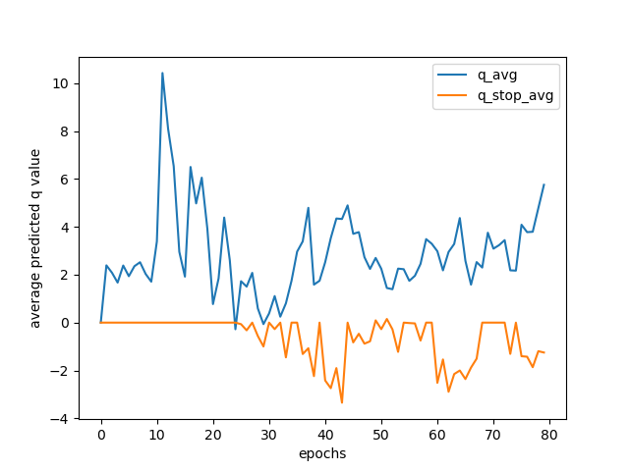

Fig. IoU: 85, Epoch: 80

1. Training Image : 50 Testing Image : 150

|  |  |  |  |  |  |  |  |  |
| --- | --- | --- | --- | --- | --- | --- | --- | --- |
|  | 50 IoU 50Epoch | 50 IoU  80Epoch | 70 IoU  50Epoch | 70 IoU 80Epoch | 80 IoU  50Epoch | 80 IoU 80Epoch | 85 IoU  50Epoch | 85 IoU 80Epoch |
| IoU Average | 0.4433 | 0.4627 | 0.3957 | 0.4641 | 0.4771 | **0.4869** | 0.4642 | 0.4518 |
| IoU Inc. | 110 | 118 | 105 | 132 | 140 | **132** | 133 | 134 |
| IoU Dec | 65 | 57 | 70 | 43 | 35 | **43** | 42 | 41 |
| AP bef | 13.52 | 16.45 | 12.83 | 22.58 | 25.82 | **36.53** | 23.47 | 25.66 |
| AP aft | 18.24 | 21.89 | 18.01 | 25.12 | 35.98 | **36.21** | 25.50 | 35.50 |

1. Training Image : 175 Testing Image : 25

|  |  |  |  |  |  |  |  |  |
| --- | --- | --- | --- | --- | --- | --- | --- | --- |
|  | 50 IoU 50Epoch | 50 IoU  80Epoch | 70 IoU  50Epoch | 70 IoU 80Epoch | 80 IoU  50Epoch | 80 IoU 80Epoch | 85 IoU  50Epoch | 85 IoU 80Epoch |
| IoU Averagebefore | 0.4947 | 0.4617 | 0.5194 | 0.5274 | 0.5213 | 0.5282 | 0.5043 | **0.5397** |
| IoU After update | 0.5328 | 0.4612 | 0.5209 | 0.5587 | 0.5866 | 0.5752 | 0.5424 | **0.5635** |
| IoU Inc. | 25 | 23 | 22 | 23 | 24 | 23 | 23 | **22** |
| IoU Dec | 1 | 3 | 4 | 3 | 2 | 3 | 3 | **4** |
| AP bef | 42.10 | 35.78 | 43.29 | 44.20 | 44.85 | 45.65 | 44.20 | **48.87** |
| AP aft | 51.3 | 37.93 | 50.11 | 51.15 | 51.87 | 52.52 | 49.62 | **53.69** |

# C:\Users\anind\Documents\Dissertation-Mtech\Phase_I\End-Sem_Aeroplane\175ImageTrain_25ImageTest\85thresh_80epoch\q_plot_79.png

# Fig. Q value plot of above experiment for IoU threshold set at 85 and epochs equal to 80 C:\Users\anind\Documents\Dissertation-Mtech\Phase_I\End-Sem_Aeroplane\175ImageTrain_25ImageTest\85thresh_80epoch\iou_plot_79.png

# Fig. Average Intersection of Union Plot for the above experiment

# Discussion: From the above 3 tables one can conclude that generally having the IoU threshold above 0.80 yielded better results with some better improvement of about 4-5% over all ranges. The AP(Average Precision) is calculated for a fixed threshold of 50 and the reason for calculating AP is because I am using just one class of object for detection. Since all the experiments were ran just once and updated just once and that too in the case when the number of images where more. So there is a lot of potential work that needs to be automated for the experiment that is to be performed. The average intersection of union was about 50 percent when number of images trained where more because of the ability of the agent to have a good amount of experience replay memory based on which it can take action when it lands on a specific state.

# Conclusion

# Reinforcement learning and it’s application brought together with the use of deep learning for the purpose of using it to create a new field of Deep reinforcement learning is very fascinating and exciting. Having just scratching the surface of this fascinating field is quite challenging and full of information on every way possible. Sometimes it becomes overwhelming to not find answers of peculiar issues. This specific report for the end sem evaluation consists of all the basics one needs to get started in the field of deep reinforcement learning. Though the experiments does not seem like much because it seems very similar and quite trivial to be honest, the main point of contension always boils down to processing power of the GPU available because we are dealing with raw pixels of a particular image. Further exploration is quite necessary and also my aim for the future work I am going to do in this particular topic.

# Future iWork

* The future work of mine which is the main focus of mine is actually suggesting bounding boxes of image based on state of the art approaches like YOLO and R-CNN.
* The main reason to explore the above two methods is their excellent approach to deal with overlapping object
* Since my main aim is to actually work on the approach to improve the bounding boxes for overlapping object the above state-of-art methods can help me explore various options regarding that.
* One possible approach that I am aiming to approach is modifying the present dqn with a custom dqn of mine based on most possibly one of the ResNet architechtures
* Every experiment done till now used a lot of manual labour on my individual part. For example calculation of mAP was the most cumbersome including manual updation of coordinates suggested by the DQN agent.
* DQN agent suggests just the class and corresponding coordinates of the probable coordinates to be updated. My future work also aims at automating this process so that whatever new annotation suggestions are given by the agent, it will overwrite the existing coordinates thus reducing manual labour.
* This report contains dataset of PASCAL. My other future work is exploring other standard datasets like COCO which is the bseline dataset used and also dataset images of warehouses because of the reason being that one of the area of potential application can be found in the field of logistics because it happens more often than not that we may find a huge number of images overlapped with each other at warehouses and store items.
* So from the above list is quite comprehensive and can be boiled down to 3 things, first being alternate detection algorithms for both images and dqn, changing the dataset, automating much of the manual labour especially regarding metric calculation