**Chapter 1**

**Introduction**

* 1. **Introduction**

Since the invention of the wheel, humans have always tried to reduce the load and burden of human effort. After the wheel was invented it opened up venues for transportation which included transporting humans, animals, food items, etc. throughout the world. This led to the discovery of gears leading to the invention of cars and automobiles. Just as the discovery of wheels started the industrial revolution, in the same way, the discovery of the “Difference Machine” by Charles Babbage [1] started the revolution in the field of using computers to automate and calculate large calculations in the field of science, mathematics, business and much more.

The concept of automation led to a curious start in the field of machine learning. “Making machines learn and do things on their own”, can be understood as a layman’s definition of machine learning. The sole focus of a machine learning system is to learn to automate the learning process [2]. Refining the algorithms and the observation that the machine learns to improve the future prediction over time.

Machine learning in itself is a concept modeled in parts, after the human brain. One of the earliest works done in this field was by Donald Hebb in 1949, in his book titled “The Organization of Behavior” [3]. After this one of the most influential works that kick-started the machine learning field was given by one of the most prominent personalities, Alan M. Turing. “Computing Machinery and Intelligence” is one of the key papers published by him in 1950, raised the question of “Can machines think?” [4].The paper argued that there isn’t any argument that can convince us that machines don’t have the ability to think like humans. The “Turing Test” designed by Alan Turing himself was the one that came up with the concept of identifying whether the answer given to a specific question is by a machine or a human being. Fig 1.1 illustrates the timeline of evolution of the field of machine learning and artificial intelligence.

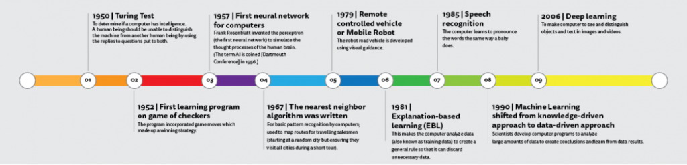

Fig 1.1 Evolution of the field of machine learning and artificial intelligence as we know it to date [5]

In the year 1952, Arthur Samuel from IBM developed a program to play checkers. In the year 1955, John McCarthy, a professor emeritus from Stanford coined the term “artificial intelligence” [6]. Keeping in conjecture to the history of the field of machine learning, in the year 1957, Frank Rosenblatt is credited with the work of the first-ever model of a computational unit modeled exactly like the brain and is best known by the name “Perceptron” [7]. The “Perceptron” can be thought of as the stepping stone for the creation of what we today know as an “Artificial Neural Network”. Moving forward in the year 1967, was the year when Cover and Hart proposed the algorithm famously known nowadays as “K-Nearest Neighbor” [8] which was then proposed to actually find the most efficient route for solving the infamous “Travelling Salesman Problem”. Moving forward in the same era, the creation of multiple layers in the area of neural networks paved a new road for research.

The creation of multiple layers led to the formation of what we today know as a “feedforward neural network”. This decade also is credited with a number of researchers coming up with the idea of one of the most important concepts in the field of deep neural networks known as “backpropagation”. Though the idea of backpropagation has been around for quite a long time, the use of backpropagation as a learning method for the neural networks can be credited to the infamous paper by Geoffrey Hinton named “Learning representation by back-propagating errors” [9]. The concept of backpropagation tells us that any artificial neural network adjusts its layers that are hidden based on reducing the value of a function which it tries to calculate by the difference between the expected and the calculated values which it terms the “error” caused due to mismatch in respective values.

Moving forward machine learning and artificial intelligence went on their separate ways with the latter generally focusing on using an approach based on logic and knowledge which is start different from what machine learning tries to do which is to draw out conclusions based on different algorithms. Machine learning started to leverage the ideas from statistics and probabilities along with concepts from artificial intelligence to solve practical problems and start leveraging for business usage.

* 1. **Literature Survey**
  2. **Problem statement of the Thesis**

The major aim of preparing this thesis is to accomplish the following goals:

1. To outline the basics in the field of machine learning and outline the different approaches in the field of machine learning.
2. To do an in-depth study of the field of deep reinforcement learning.
3. To outline the improvement that the experiment did to correct bounding boxes.
4. To provide future scope for the researcher to dive into the fascinating field of deep reinforcement learning
   1. **Organization of the Thesis**

The complete thesis is organized into multiple chapters as outlined in the following few lines:

Chapter 1: This chapter gives an overview, outlines the content, and contains the literature review that was done when working on the topic.

Chapter 2: This chapter gives a brief introduction to the field of machine learning covering various types and aspects of machine learning.

Chapter 3: This chapter will give a thorough outline of the most used neural network architecture in CNN in quite a lot of depth.

Chapter 4: This chapter will outline the field of reinforcement learning and how it was used in the area of computer vision.

Chapter 5: This chapter will go into the proposed methodology and the working principle of the work that has been done during the complete tenure.

Chapter 6: This chapter will outline the total outcomes that came as a part of different experiments that were performed.

Chapter 7: This chapter will provide a conclusion and the future scope.