Summative Assessment Solution (60 marks)
Two report-format tasks. Every R command below is in the two solution scripts in this folder, and every number quoted comes from actually running them:
Task | Script | Full console output | Plots
Task 1 (25 marks) | Summative_Task1_Solution.R | Summative_Task1_Output.txt | plots/task1_*.png
Task 2 (35 marks) | Summative_Task2_Solution.R | Summative_Task2_Output.txt | plots/task2_*.png

How to reproduce in RStudio: open the script, set the working directory to the Assessment_Solutions folder (Session → Set Working Directory → To Source File Location), and run it. The assignment asks for screenshots of the RStudio screen pasted into the Word report, so take a screenshot after each step.

Task 1 : Histogram function and linear regression (25 marks)
Dataset: Task1.csv, 32 cars with 11 numeric variables (the classic mtcars data). The outcome we model is mpg (miles per gallon).

Step 1 : Load and inspect the data
cars <- read.csv("../1. Formative and Summative Assessment/S-Assignment Task 1/Task1.csv")
dim(cars) # 32 rows, 12 columns
str(cars)
colSums(is.na(cars)) # all zero : no missing values
Explanation: str() shows every column is numeric except model (the car name). There are no missing values, so no cleaning is needed.

Part (a) : Histogram using a function with two parameters (10 marks)

Explanation
The task asks for a function that takes values and plots a histogram using two parameters. The function below takes the numeric vector and the number of bins. Two optional arguments add a label and a colour. It also prints the count on top of each bar and marks the mean with a dashed red line.

Program
draw_histogram <- function(values, n_bins,
label = "Value",
colour = "steelblue") {
hist(values,
breaks = n_bins, # parameter 2 : number of bars
col = colour,
border = "white",
main = paste("Histogram of", label),
xlab = label,
ylab = "Number of cars",
labels = TRUE) # count above each bar
abline(v = mean(values), col = "red", lwd = 2, lty = 2)
legend("topright", legend = paste("Mean =", round(mean(values), 2)),
col = "red", lty = 2, lwd = 2, bty = "n")
}
# Call it with different values and parameters
draw_histogram(cars$mpg, n_bins = 8, label = "Miles per gallon (mpg)", colour = "steelblue")
draw_histogram(cars$hp, n_bins = 10, label = "Horsepower (hp)", colour = "darkorange")
draw_histogram(cars$wt, n_bins = 6, label = "Weight (1000 lbs)", colour = "seagreen")

Output
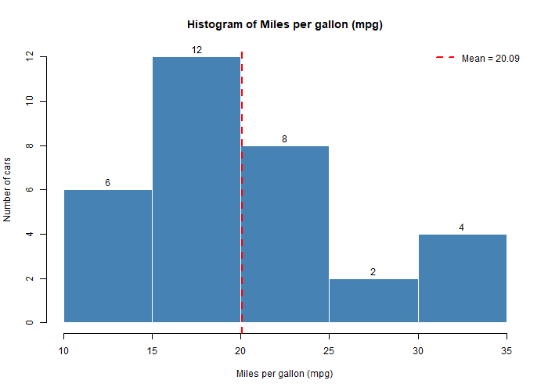
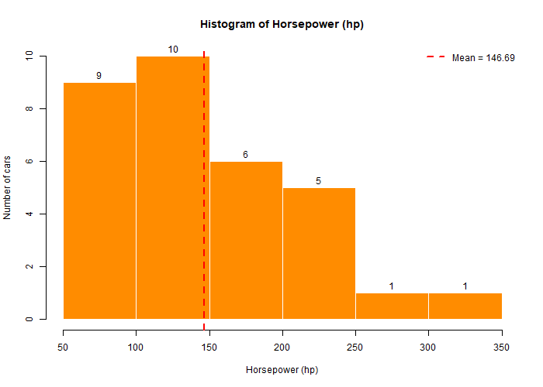
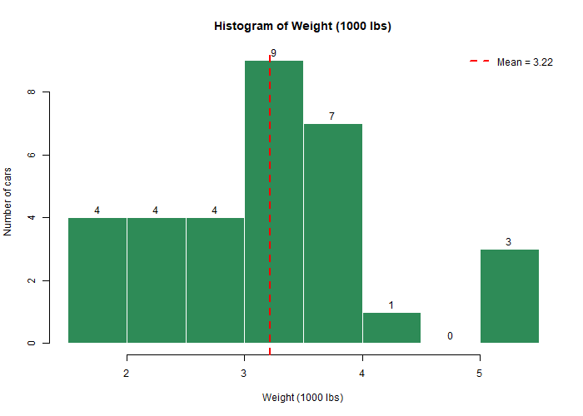
Summary of mpg : Min 10.40 1st Qu 15.43 Median 19.20 Mean 20.09 3rd Qu 22.80 Max 33.90
Summary of hp : Min 52.0 1st Qu 96.5 Median 123.0 Mean 146.7 3rd Qu 180.0 Max 335.0
Summary of wt : Min 1.513 1st Qu 2.581 Median 3.325 Mean 3.217 3rd Qu 3.610 Max 5.424

Interpretation
- mpg is slightly right-skewed: most cars do 15 to 23 mpg, with a few very economical cars above 30.
- hp is strongly right-skewed: a handful of cars above 250 hp pull the mean (147) above the median (123).
- wt is roughly symmetric around 3.2 (thousand lbs).
Marks note: the function has two required parameters (values, n_bins), the histograms are labelled and coloured, and it was called three times with different inputs.

Part (b) : Linear regression with variable selection (15 marks)

Step 2 : Initial data analysis, numerical
num_cars <- cars[, -1] # drop the text column
summary(num_cars)
sort(cor(num_cars)[, "mpg"], decreasing = TRUE)
Output (correlation with mpg):
mpg drat vs am gear qsec carb hp disp cyl wt
1.000 0.681 0.664 0.600 0.480 0.419 -0.551 -0.776 -0.848 -0.852 -0.868
Interpretation: wt, cyl, disp and hp all have strong negative correlation with mpg. Heavier, bigger, more powerful cars burn more fuel. But the full correlation matrix also shows wt, disp, cyl and hp are strongly related to each other (0.78 to 0.90). This is multicollinearity, and it means we should not put all of them in one model.

Step 3 : Initial data analysis, graphical
pairs(num_cars[, c("mpg", "wt", "hp", "disp", "qsec")], pch = 16, col = "steelblue")
boxplot(mpg ~ cyl, data = cars)
boxplot(mpg ~ am, data = cars)
boxplot(mpg ~ gear, data = cars)
plot(cars$wt, cars$mpg); abline(lm(mpg ~ wt, data = cars), col = "red")
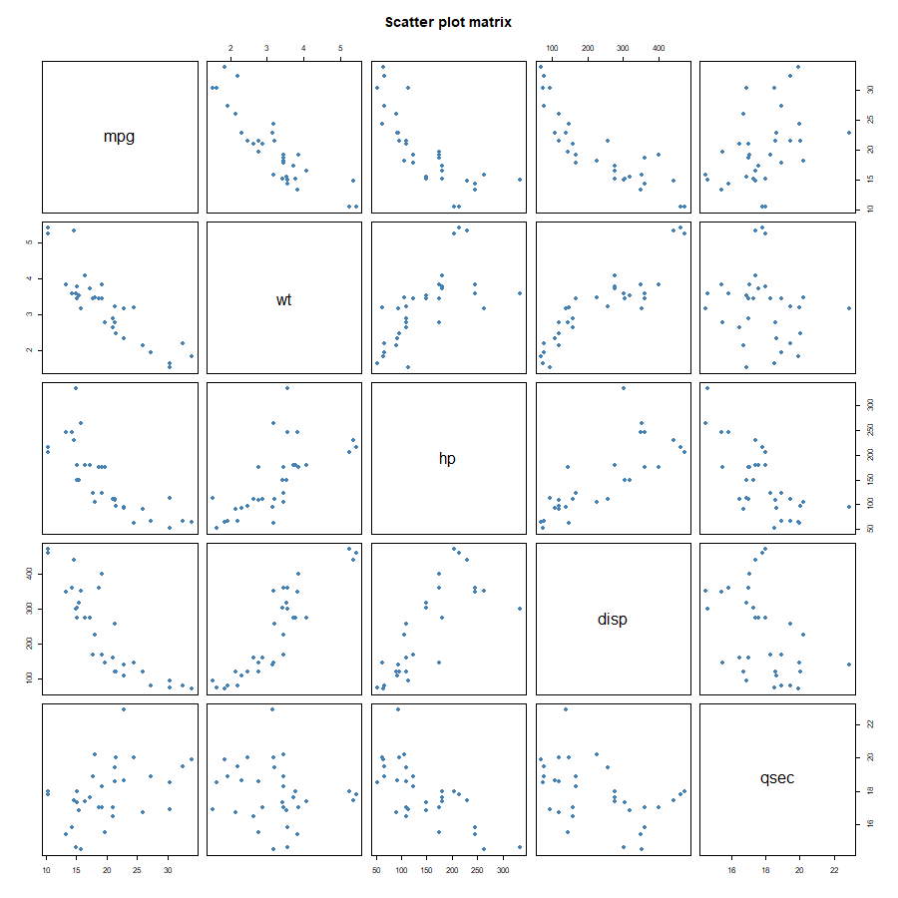
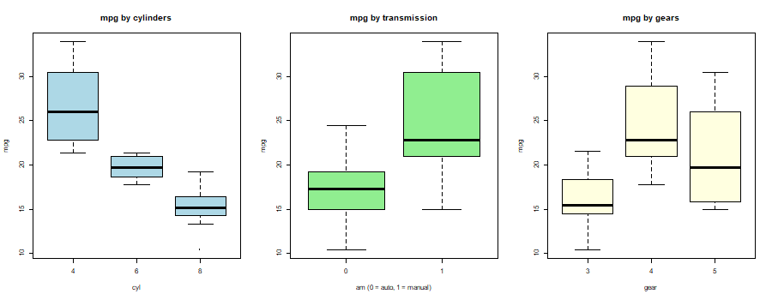
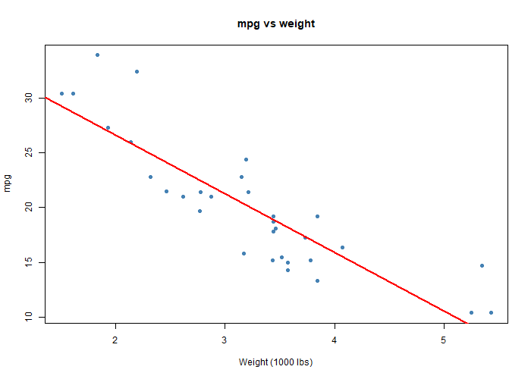
Interpretation: the scatter-plot matrix shows clear straight-line relationships between mpg and wt, hp and disp. The box plots show mpg drops as cylinders increase, and manual cars (am = 1) have higher mpg on average.

Step 4 : Simple model as a starting point
model_simple <- lm(mpg ~ wt, data = cars)
summary(model_simple)
Coefficients:
Estimate Std. Error t value Pr(>|t|)
(Intercept) 37.2851 1.8776 19.858 < 2e-16 ***
wt -5.3445 0.5591 -9.559 1.29e-10 ***
Multiple R-squared: 0.7528, Adjusted R-squared: 0.7446
Interpretation: every extra 1000 lbs lowers mpg by 5.34. Weight alone explains 75 % of the variation in mpg.

Step 5 : Full model with all predictors
model_full <- lm(mpg ~ ., data = num_cars)
summary(model_full)
Multiple R-squared: 0.869, Adjusted R-squared: 0.8066
(no single predictor has p < 0.05; wt is closest with p = 0.063)
Interpretation: R² is higher but no predictor is individually significant. That is the classic symptom of multicollinearity. The predictors overlap so much that the model cannot decide which one deserves the credit. Variable selection is needed.

Step 6 : Variable selection (backward stepwise by AIC)
model_step <- step(model_full, direction = "backward")
formula(model_step)
summary(model_step)
step() removes one variable at a time as long as AIC falls. The order of removal was cyl, vs, carb, gear, drat, disp, hp. AIC dropped from 70.9 to 61.3. The final model:
mpg ~ wt + qsec + am
Estimate Std. Error t value Pr(>|t|)
(Intercept) 9.6178 6.9596 1.382 0.177915
wt -3.9165 0.7112 -5.507 6.95e-06 ***
qsec 1.2259 0.2887 4.247 0.000216 ***
am 2.9358 1.4109 2.081 0.046716 *
Residual standard error: 2.459 on 28 degrees of freedom
Multiple R-squared: 0.8497, Adjusted R-squared: 0.8336
F-statistic: 52.75 on 3 and 28 DF, p-value: 1.21e-11

Step 7 : Compare candidate models
Model | Adjusted R² | AIC
mpg ~ wt | 0.745 | 166.0
mpg ~ wt + hp | 0.815 | 156.7
mpg ~ wt + am | 0.736 | 168.0
mpg ~ wt + qsec + am (stepwise) | 0.834 | 154.1
full model (10 predictors) | 0.807 | 163.7

The stepwise model has the highest adjusted R² and the lowest AIC. A formal F test comparing it with the full model gives p = 0.86, so the seven dropped variables added nothing.

Step 8 : Interpret the best model
coef(model_step); confint(model_step)
- wt = −3.92: each extra 1000 lbs costs about 3.9 mpg, holding qsec and am fixed.
- qsec = +1.23: each extra second of quarter-mile time adds about 1.2 mpg. Slower cars are less powerful and more economical.
- am = +2.94: a manual car gets about 2.9 mpg more than an automatic of the same weight and speed.
- All three 95 % confidence intervals exclude zero, so all three effects are significant.
- Adjusted R² = 0.834: the model explains about 83 % of the variation in mpg.

Step 9 : Check the model is valid
par(mfrow = c(2, 2)); plot(model_step)
shapiro.test(residuals(model_step)) # W = 0.941, p = 0.080
cor(cars[, c("wt", "qsec", "am")])
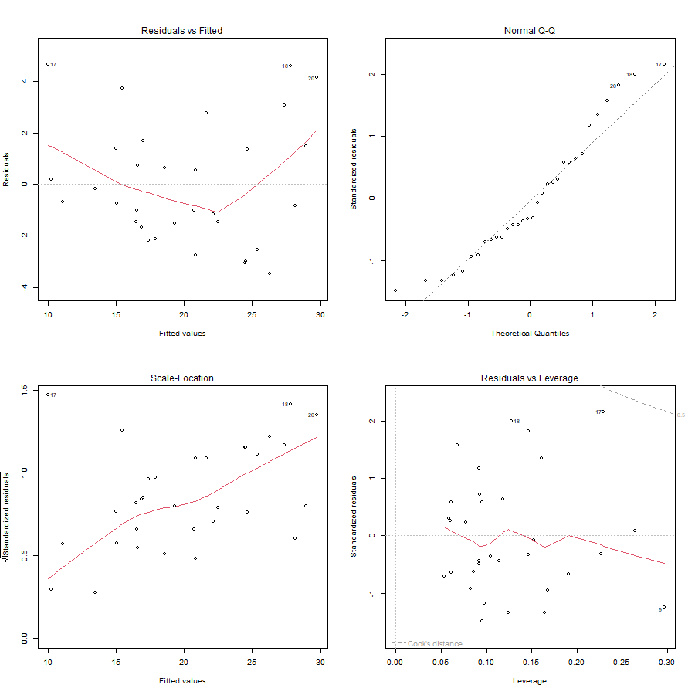
- Residuals vs Fitted: no curve or funnel, so linearity and constant variance hold.
- Q-Q plot: points close to the line. Shapiro-Wilk p = 0.08 > 0.05, so residuals are approximately normal.
- The three chosen predictors have modest correlations with each other (the largest is wt vs am at −0.69), so multicollinearity is no longer a problem.

Step 10 : Prediction
new_cars <- data.frame(wt = c(2.5, 3.5), qsec = c(18, 16), am = c(1, 0))
predict(model_step, newdata = new_cars)
# 24.83 15.52
A light manual car is predicted at 24.8 mpg; a heavier, faster automatic at 15.5 mpg.

Conclusion for Task 1
The best linear regression model for fuel economy is mpg = 9.62 − 3.92·wt + 1.23·qsec + 2.94·am. It was chosen by backward stepwise selection, has the lowest AIC of all candidates, explains 83 % of the variation, and passes the residual checks.

Task 2 : One-way and two-way ANOVA on crop yield (35 marks)
Dataset: crop_data.csv, 96 observations.
Variable | Type | Values
fertilizer | categorical | 1, 2, 3
density | categorical | 1 = low, 2 = high
block | categorical | 1 to 4
yield | continuous | bushels per acre

Step 1 : Data cleaning
crop <- read.csv("../1. Formative and Summative Assessment/S-Assignment Task 2/crop_data.csv")
colSums(is.na(crop)) # all zero
crop$fertilizer <- factor(crop$fertilizer, labels = c("F1", "F2", "F3"))
crop$density <- factor(crop$density, labels = c("Low", "High"))
crop$block <- factor(crop$block)
Missing values: none.
Factor conversion: the three categorical columns are stored as numbers. If left numeric, R would treat "fertilizer 3" as three times "fertilizer 1", which is meaningless. factor() tells R they are categories.
Outliers (1.5 × IQR rule):
Q1 <- quantile(crop$yield, 0.25); Q3 <- quantile(crop$yield, 0.75)
fence <- c(Q1 - 1.5 * (Q3 - Q1), Q3 + 1.5 * (Q3 - Q1)) # 175.07 to 178.79
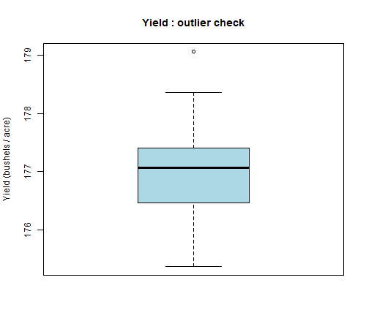
One value (179.06) lies just above the upper fence. It is a mild outlier and a plausible yield, not a data-entry error. Removing it would unbalance the design, so it is kept. Step 6 confirms it does not harm the assumptions.
Balance check:
Low High
F1 16 16
F2 16 16
F3 16 16
Every fertilizer × density cell has 16 observations. The design is balanced, which makes the ANOVA sums of squares unambiguous.

Step 2 : Exploratory data analysis
summary(crop$yield); sd(crop$yield)
aggregate(yield ~ fertilizer, data = crop, FUN = mean)
aggregate(yield ~ density, data = crop, FUN = mean)
aggregate(yield ~ fertilizer + density, data = crop, FUN = mean)
Group | Mean yield | SD | n
Fertilizer 1 | 176.76 | 0.69 | 32
Fertilizer 2 | 176.93 | 0.57 | 32
Fertilizer 3 | 177.36 | 0.60 | 32
Density Low | 176.78 | 0.61 | 48
Density High | 177.25 | 0.64 | 48

Cell means (fertilizer × density):
 | Low | High
F1 | 176.44 | 177.07
F2 | 176.78 | 177.09
F3 | 177.14 | 177.58

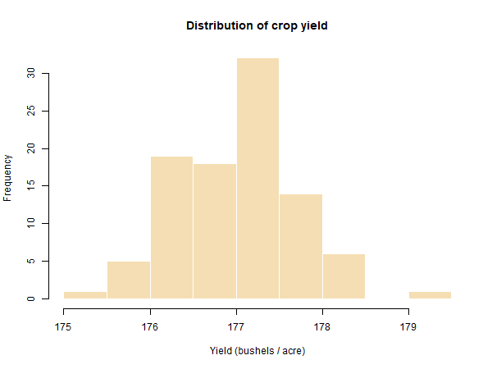
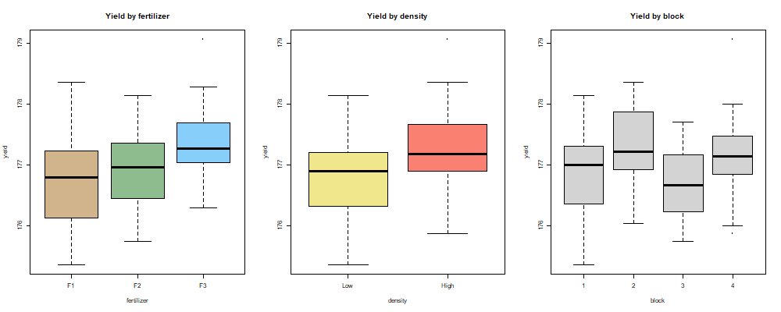
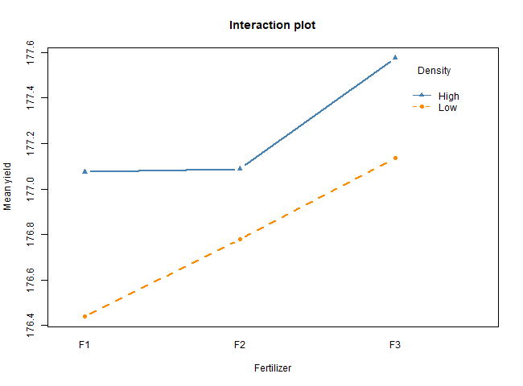
Interpretation: yield is roughly bell-shaped around 177. Fertilizer 3 has the highest mean, high density beats low density, and block shows no visible pattern. In the interaction plot the two density lines are almost parallel, which already suggests there is no interaction.

Step 3 : One-way ANOVA
Hypotheses
- H0: mean yield is the same for all three fertilizers (μ₁ = μ₂ = μ₃)
- H1: at least one fertilizer has a different mean yield
Assumptions (checked in Step 6): independent observations, normally distributed residuals, equal variances across groups.
one_way <- aov(yield ~ fertilizer, data = crop)
summary(one_way)
Df Sum Sq Mean Sq F value Pr(>F)
fertilizer 2 6.07 3.0340 7.863 7e-04 ***
Residuals 93 35.89 0.3859
Interpretation: F(2, 93) = 7.86, p = 0.0007 < 0.05. Reject H0. Fertilizer type has a statistically significant effect on crop yield.

Step 4 : Two-way ANOVA
Hypotheses
- H0(a): fertilizer has no effect on yield
- H0(b): planting density has no effect on yield
- H0(c): there is no interaction (the effect of fertilizer is the same at both densities)

4a. Additive model
two_way_add <- aov(yield ~ fertilizer + density, data = crop)
summary(two_way_add)
Df Sum Sq Mean Sq F value Pr(>F)
fertilizer 2 6.068 3.034 9.073 0.000253 ***
density 1 5.122 5.122 15.316 0.000174 ***
Residuals 92 30.765 0.334

4b. Interaction model
two_way_int <- aov(yield ~ fertilizer * density, data = crop)
summary(two_way_int)
Df Sum Sq Mean Sq F value Pr(>F)
fertilizer 2 6.068 3.034 9.001 0.000273 ***
density 1 5.122 5.122 15.195 0.000186 ***
fertilizer:density 2 0.428 0.214 0.635 0.532500
Residuals 90 30.337 0.337
Interpretation: both main effects are highly significant (p < 0.001). The interaction term has p = 0.53, so H0(c) is not rejected: the effect of fertilizer does not depend on density. The simpler additive model is preferred.

4c. Adding block as a control
two_way_block <- aov(yield ~ fertilizer + density + block, data = crop)
summary(two_way_block) # block p = 0.49 : not significant

4d. Which model is best?
Model | AIC
one-way: fertilizer | 185.97
two-way additive: fertilizer + density | 173.19
two-way interaction: fertilizer * density | 175.85
blocked: fertilizer + density + block | 175.66

Adding density to the one-way model cuts AIC by almost 13, a large improvement. Adding the interaction or block makes AIC worse. The additive two-way model is chosen.

Step 5 : Post-hoc test (which fertilizers differ?)
TukeyHSD(two_way_add)
$fertilizer
diff lwr upr p adj
F2-F1 0.176 -0.168 0.521 0.4453
F3-F1 0.599 0.255 0.944 0.0002 ***
F3-F2 0.423 0.079 0.767 0.0119 *
$density
diff lwr upr p adj
High-Low 0.462 0.228 0.696 0.0002 ***
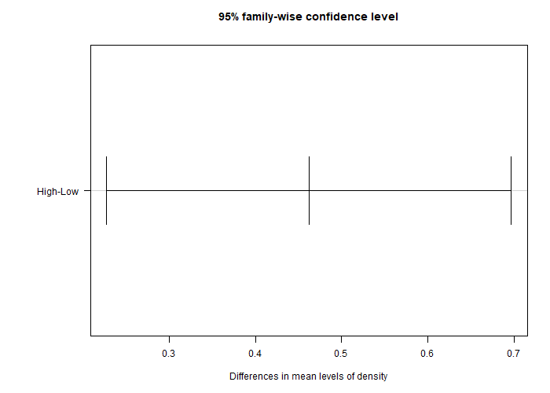
Interpretation: Fertilizer 3 gives significantly higher yield than both fertilizer 1 (+0.60, p = 0.0002) and fertilizer 2 (+0.42, p = 0.012). Fertilizers 1 and 2 are not significantly different (p = 0.45). High density gives +0.46 over low density (p = 0.0002).

Step 6 : Validity of the model (assumption checks)
shapiro.test(residuals(two_way_add))
bartlett.test(yield ~ fertilizer, data = crop)
bartlett.test(yield ~ density, data = crop)
bartlett.test(yield ~ interaction(fertilizer, density), data = crop)
par(mfrow = c(1, 2)); plot(two_way_add, which = 1:2)
Check | Test | Result | Verdict
Normality of residuals | Shapiro-Wilk | W = 0.985, p = 0.358 | Normal (p > 0.05)
Equal variance by fertilizer | Bartlett | p = 0.588 | Equal
Equal variance by density | Bartlett | p = 0.688 | Equal
Equal variance across all 6 cells | Bartlett | p = 0.963 | Equal
Independence | Design | one measurement per plot, randomised | Satisfied

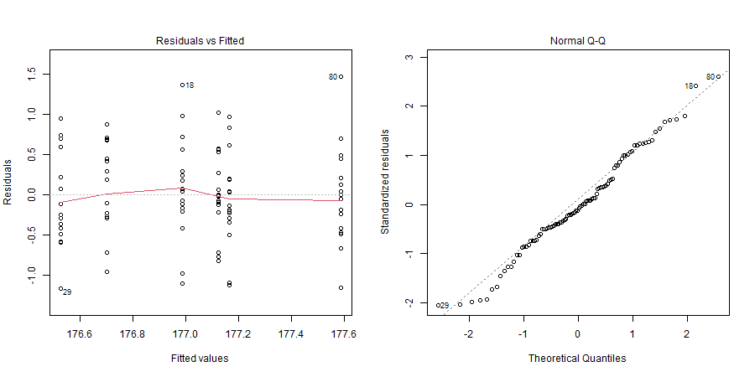
The Residuals vs Fitted plot shows a random cloud with no funnel, and the Q-Q plot points sit on the line. All assumptions hold, so the F tests and p-values are valid. The single mild outlier kept in Step 1 has not affected normality.

Step 7 : Summary of findings
- Fertilizer matters. One-way ANOVA: F(2, 93) = 7.86, p = 0.0007. Mean yields are 176.76 (F1), 176.93 (F2) and 177.36 (F3) bushels per acre.
- Density matters. Two-way ANOVA: F(1, 92) = 15.32, p = 0.0002. High density yields 177.25 versus 176.78 for low density.
- No interaction. p = 0.53. The best fertilizer is the best at both densities, so the two decisions can be made independently.
- Fertilizer 3 is the winner. Tukey HSD shows it beats F1 and F2; F1 and F2 are statistically tied.
- Block has no effect (p = 0.49), so field position did not bias the results.
- The model is valid. Residuals are normal and variances are equal, confirmed by Shapiro-Wilk, Bartlett and the diagnostic plots.
- Recommendation: plant at high density with fertilizer 3. That cell had the highest observed mean yield (177.58 bushels per acre).

Report checklist
Requirement | Where it is covered
Task 1(a) histogram via a function with two parameters, labelled and coloured | Part (a)
Task 1(b) numerical and graphical exploration | Steps 2 and 3
Task 1(b) variable selection and best model | Steps 5 to 7
Task 2 data cleaning (missing values, outliers) | Step 1
Task 2 exploratory analysis | Step 2
One-way and two-way hypotheses and assumptions | Steps 3, 4 and 6
Interpretation of results | After every output
Validity of the model and summary | Steps 6 and 7
Program and output pasted in the Word file | Copy from the two .R files and .txt outputs, plus RStudio screenshots

