Finance Case Study: Detecting Data Quality Issues in Financial Transactions
This case study is about a bank that found problems in its transaction data. There are duplicate records and extreme values in some columns. We will use data cleaning, data manipulation, and data visualization to find and understand these problems.

About the Dataset
The dataset contains 103 rows and 7 columns.
Column Name | Description
Transaction_ID | Unique ID for each transaction
Customer_Name | Name of the customer
Account_Type | Type of account (Savings, Current, or Fixed Deposit)
Branch | Branch where the transaction occurred
Balance | Current account balance of the customer (in ₹)
Transaction_Amount | Amount of money transacted (in ₹)
Credit_Score | Credit score of the customer (300–900)

Question 1: Are there duplicate rows in the data?
Duplicates mean the same transaction is recorded more than once. We can check this using data manipulation or visualization.
Total duplicate rows found: 2

Question 2: Are there any outliers in Transaction Amount?
Outliers are values that are much higher or lower than others. We can see them using a box plot.
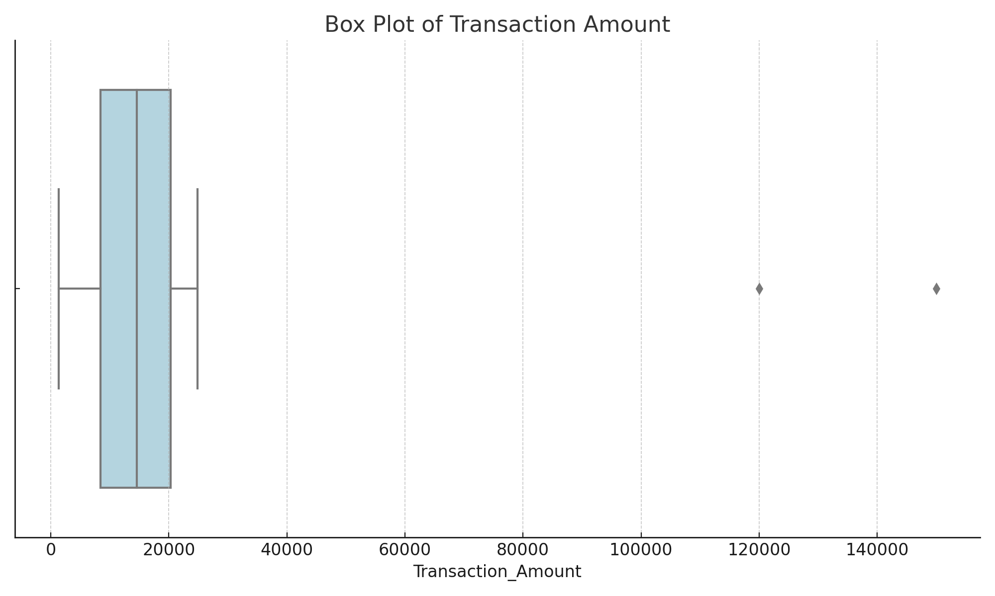
The box plot shows two points far away from others — these are outliers (120000 and 150000). They may be errors or special cases.

Question 3: What is the range of balances across customers?
We will use a histogram to see how many customers fall in different balance ranges.
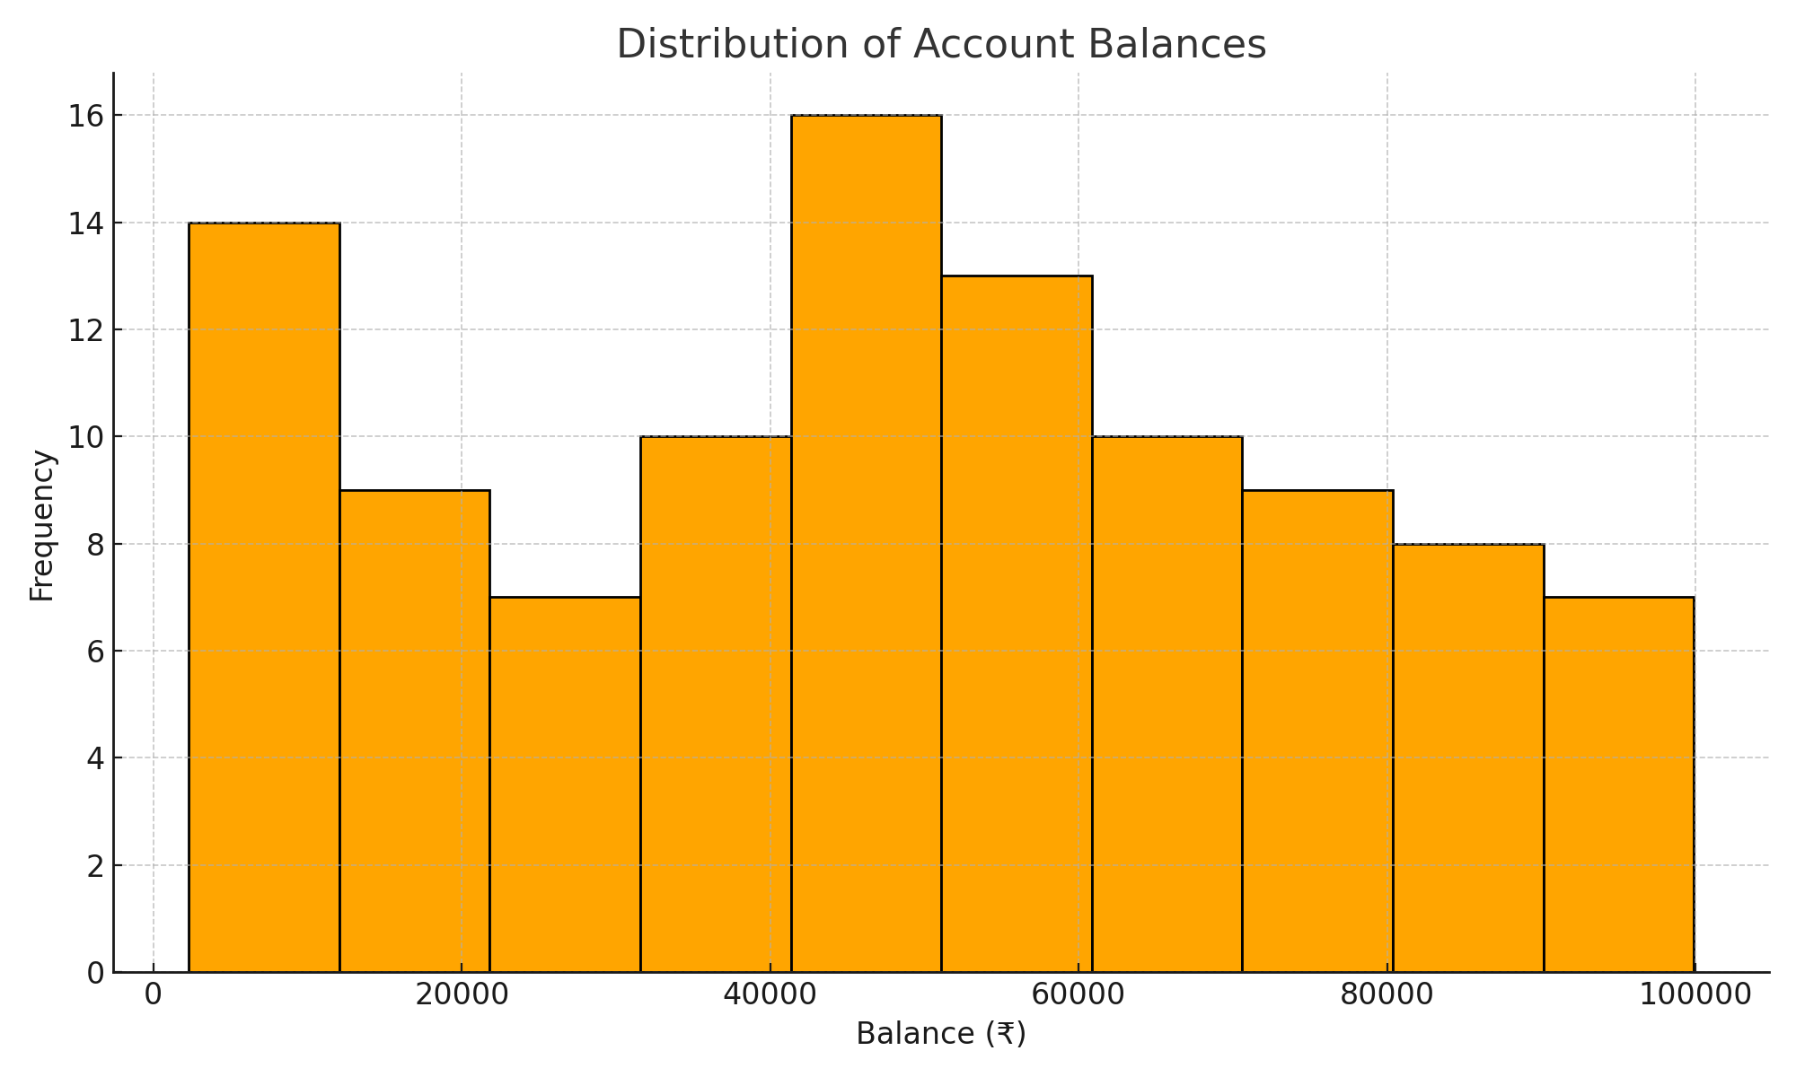
Most customers have balances between ₹20,000 and ₹60,000. Very few have balances near ₹1,00,000.

Question 4: Which branch has the highest total transaction amount?
We can group data by branch and sum the total transaction amount to see which branch has higher transactions.
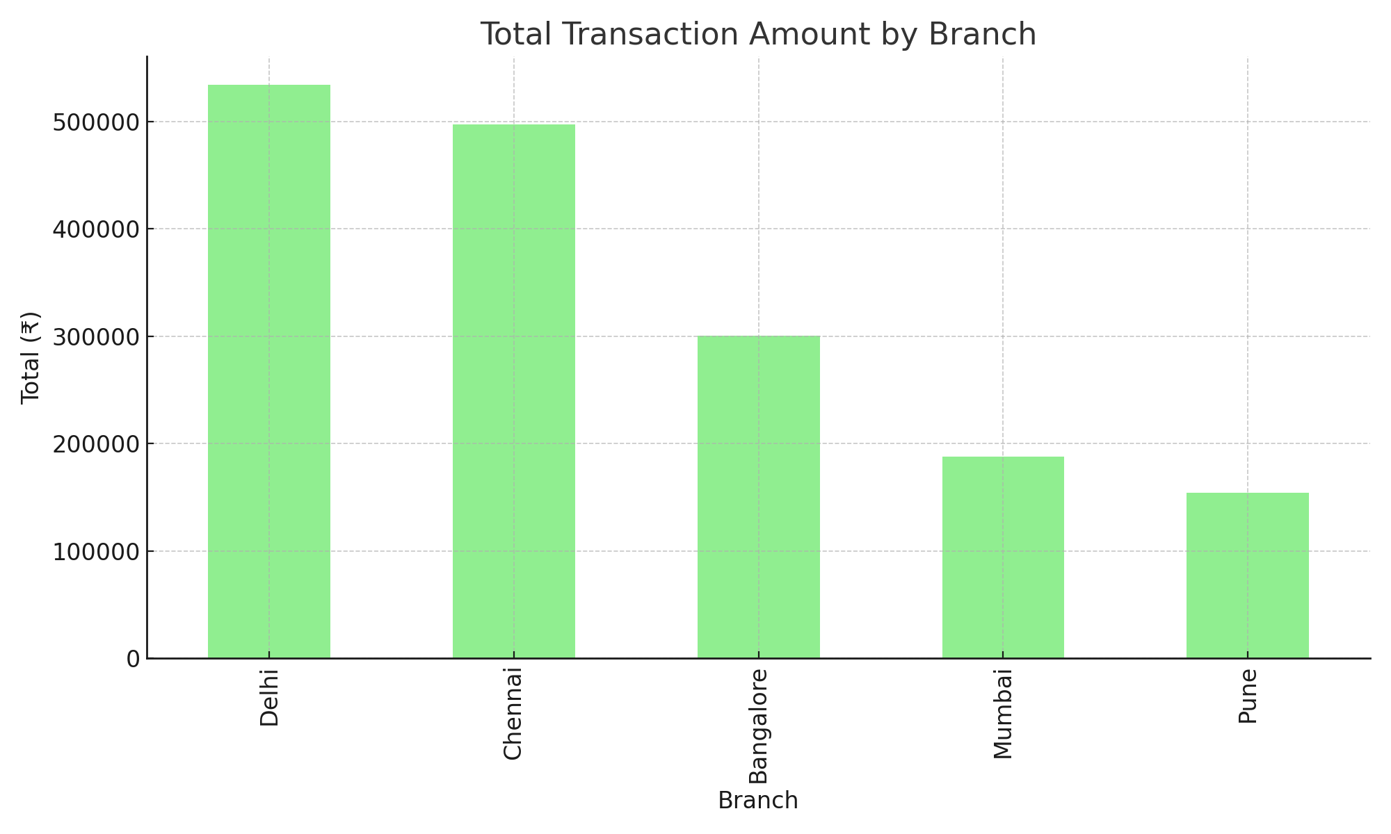
The branch with the highest total transaction amount is Delhi.

Question 5: Is there a relationship between Credit Score and Transaction Amount?
We can use a scatter plot to see if higher credit score leads to higher transactions.
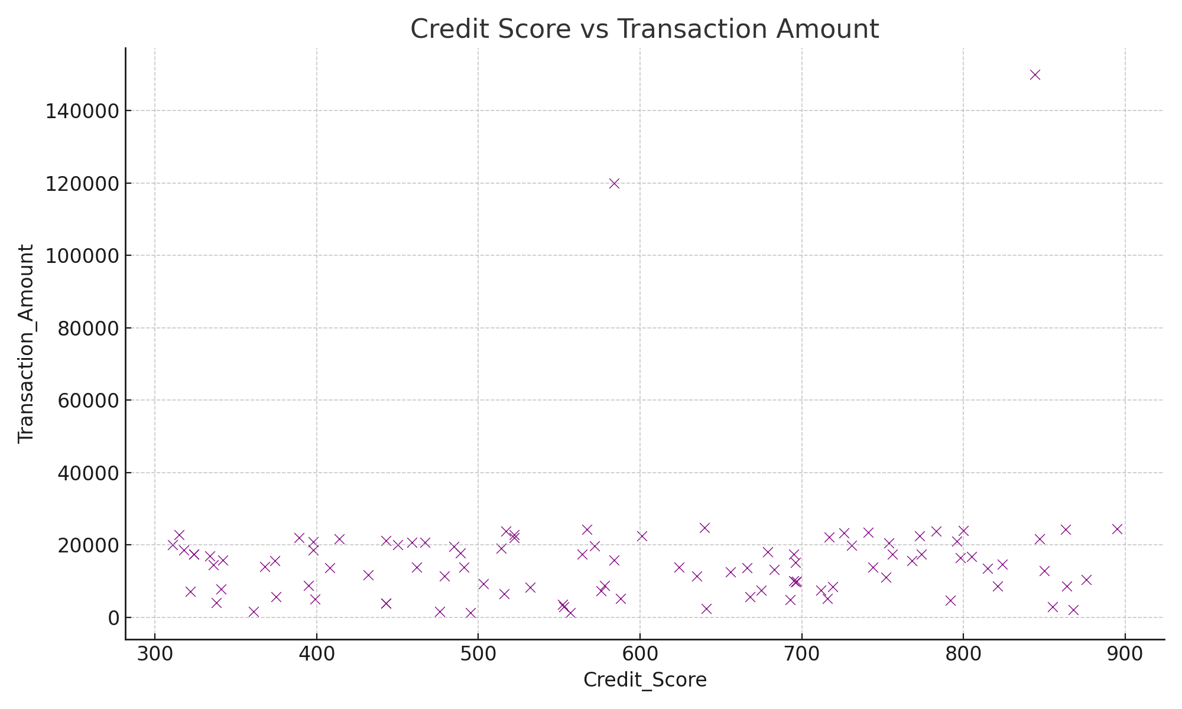
The scatter plot shows no strong relationship between credit score and transaction amount. Customers with both low and high scores make transactions of all sizes.

Question 6: How can we clean this data?
To make this data ready for analysis, we can:
1. Remove duplicate rows using the 'Duplicate Row Filter' node.
2. Handle outliers using 'Numeric Outliers' or 'Rule Engine' nodes.
3. Normalize numeric columns using the 'Normalizer' node.
4. Use filters to focus on valid transaction amounts only.

Final Insights
This case study showed how data quality problems like duplicates and outliers can affect finance data. Using simple tools and visualizations, we can clean and understand the dataset better.

