Case Study: Customer Purchase Behavior Analysis
This case study helps understand customer purchase behavior using data from 100 retail customers. We will clean data, explore it, and visualize relationships to get insights useful for marketing and business decisions.

Dataset Information
The dataset has both numeric and text columns that describe customers and their purchases.
Column Name | Data Type | Description
CustomerID | Integer | Unique ID assigned to each customer.
Age | Numeric | Age of the customer in years.
Gender | String | Gender of the customer (Male/Female).
City | String | City where the customer lives.
Annual_Income | Numeric | Customer’s yearly income in INR.
Purchase_Amount | Numeric | Total purchase amount spent in INR.
Product_Category | String | Type of product purchased (e.g., Electronics, Clothing, etc.).

Study Objective
The goal is to find patterns between age, gender, city, income, and purchase amount. We use visual analysis to make results simple to understand. The study uses Univariate (single variable) and Bivariate (two-variable) analysis.

Exploratory Data Analysis (EDA): Questions and Answers
- Q1. Are there missing values in the dataset?
Yes, some columns such as Age, Annual_Income, Purchase_Amount, and Gender had missing values. We filled missing numeric values with the median and text values with the most frequent entry. This step ensures that no rows are lost during analysis.
- Q2. What is the age distribution of customers?
A histogram was plotted for the Age column. It shows that most customers are between 25 and 45 years old. This helps us know the age group that contributes most to sales.
- Q3. What is the gender distribution?
A bar chart was used for the Gender column. The dataset shows a nearly balanced number of male and female customers. This means marketing campaigns can target both genders equally.
- Q4. Which product category is most popular?
A bar chart was used to count purchases in each product category. Electronics and Clothing were the most popular categories.
- Q5. Does age affect purchase amount?
A scatter plot of Age vs Purchase_Amount was used. There is no strong pattern, but middle-aged customers tend to spend slightly more.
- Q6. Do males and females spend differently?
A box plot comparing Gender and Purchase_Amount shows that both genders have similar spending patterns, with a few high spenders among both groups.
- Q7. Which city has the highest average income?
A bar chart of average income per city was used. Bangalore and Mumbai customers have higher average incomes compared to others.
- Q8. Which product category has the highest purchase amount?
A box plot of Product_Category vs Purchase_Amount was used. Electronics and Home Decor show higher spending levels.

Visual Analysis with Explanations
Below are graphs used for understanding the data. Each plot type is explained simply with what it shows and how to read it.

Age Distribution
**Plot Type:** Histogram
**Why this plot is used:** To show how customer ages are spread across different ranges.
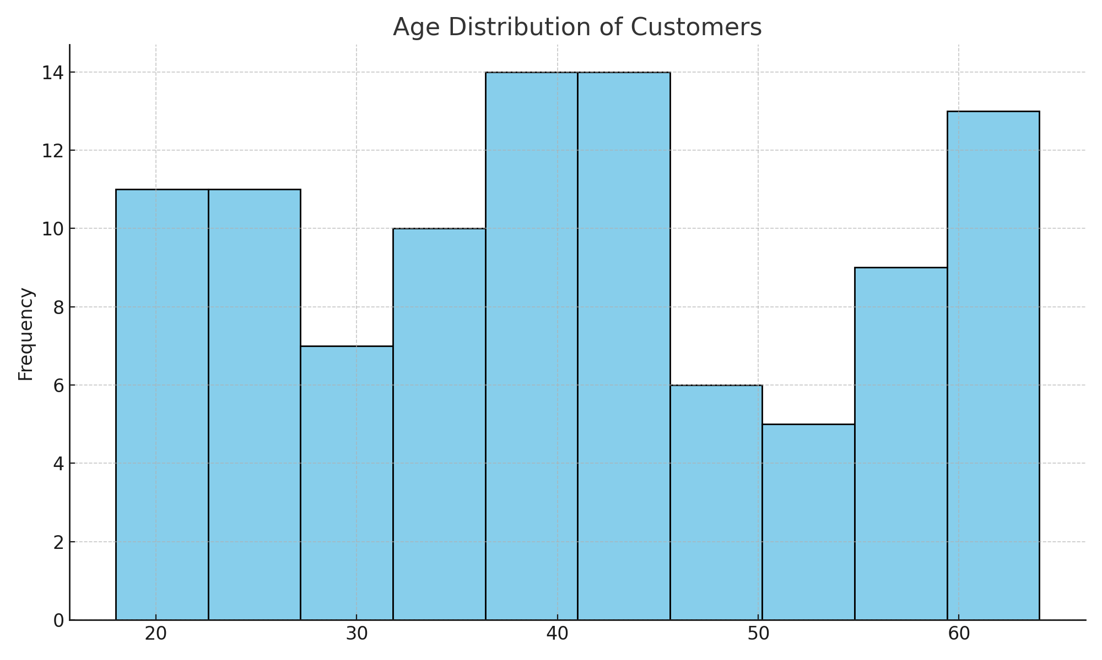
**Interpretation:** Most customers are between 25 and 45 years old. These are the key target customers for marketing.

Gender Distribution
**Plot Type:** Bar Chart
**Why this plot is used:** To compare the number of male and female customers.
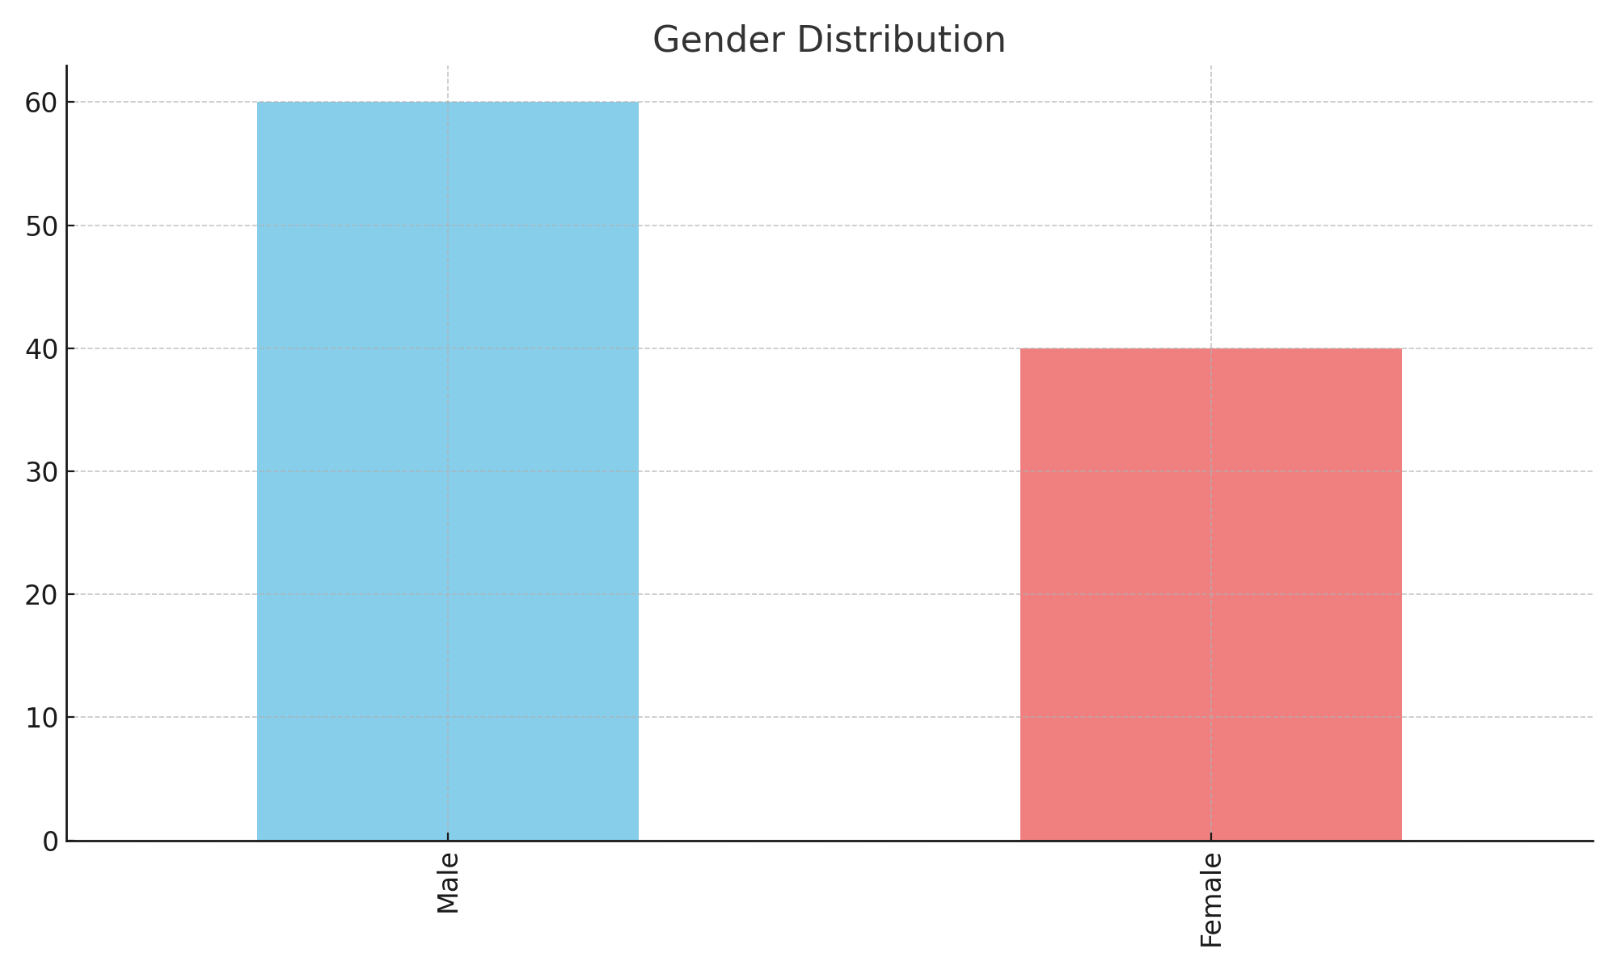
**Interpretation:** The bar heights show both genders are nearly equal. Marketing can target both equally.

Product Category Popularity
**Plot Type:** Bar Chart
**Why this plot is used:** To see which product types are most purchased.
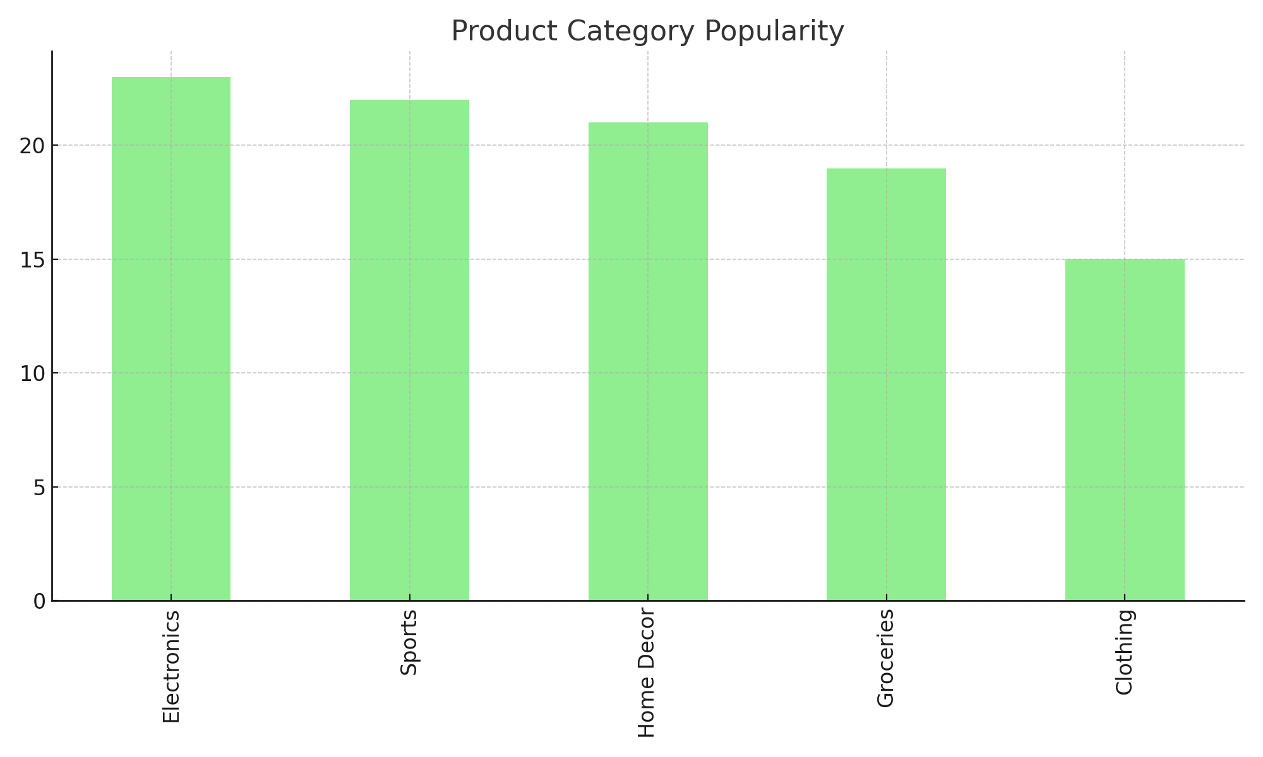
**Interpretation:** Electronics and Clothing are the top-selling categories.

Age vs Purchase Amount
**Plot Type:** Scatter Plot
**Why this plot is used:** To check if purchase amount changes with customer age.
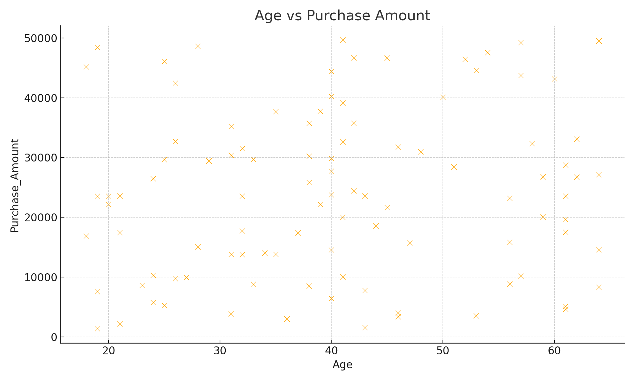
**Interpretation:** The points are spread randomly, meaning age does not strongly affect how much a customer spends.

Gender vs Purchase Amount
**Plot Type:** Box Plot
**Why this plot is used:** To compare how much male and female customers spend on average.
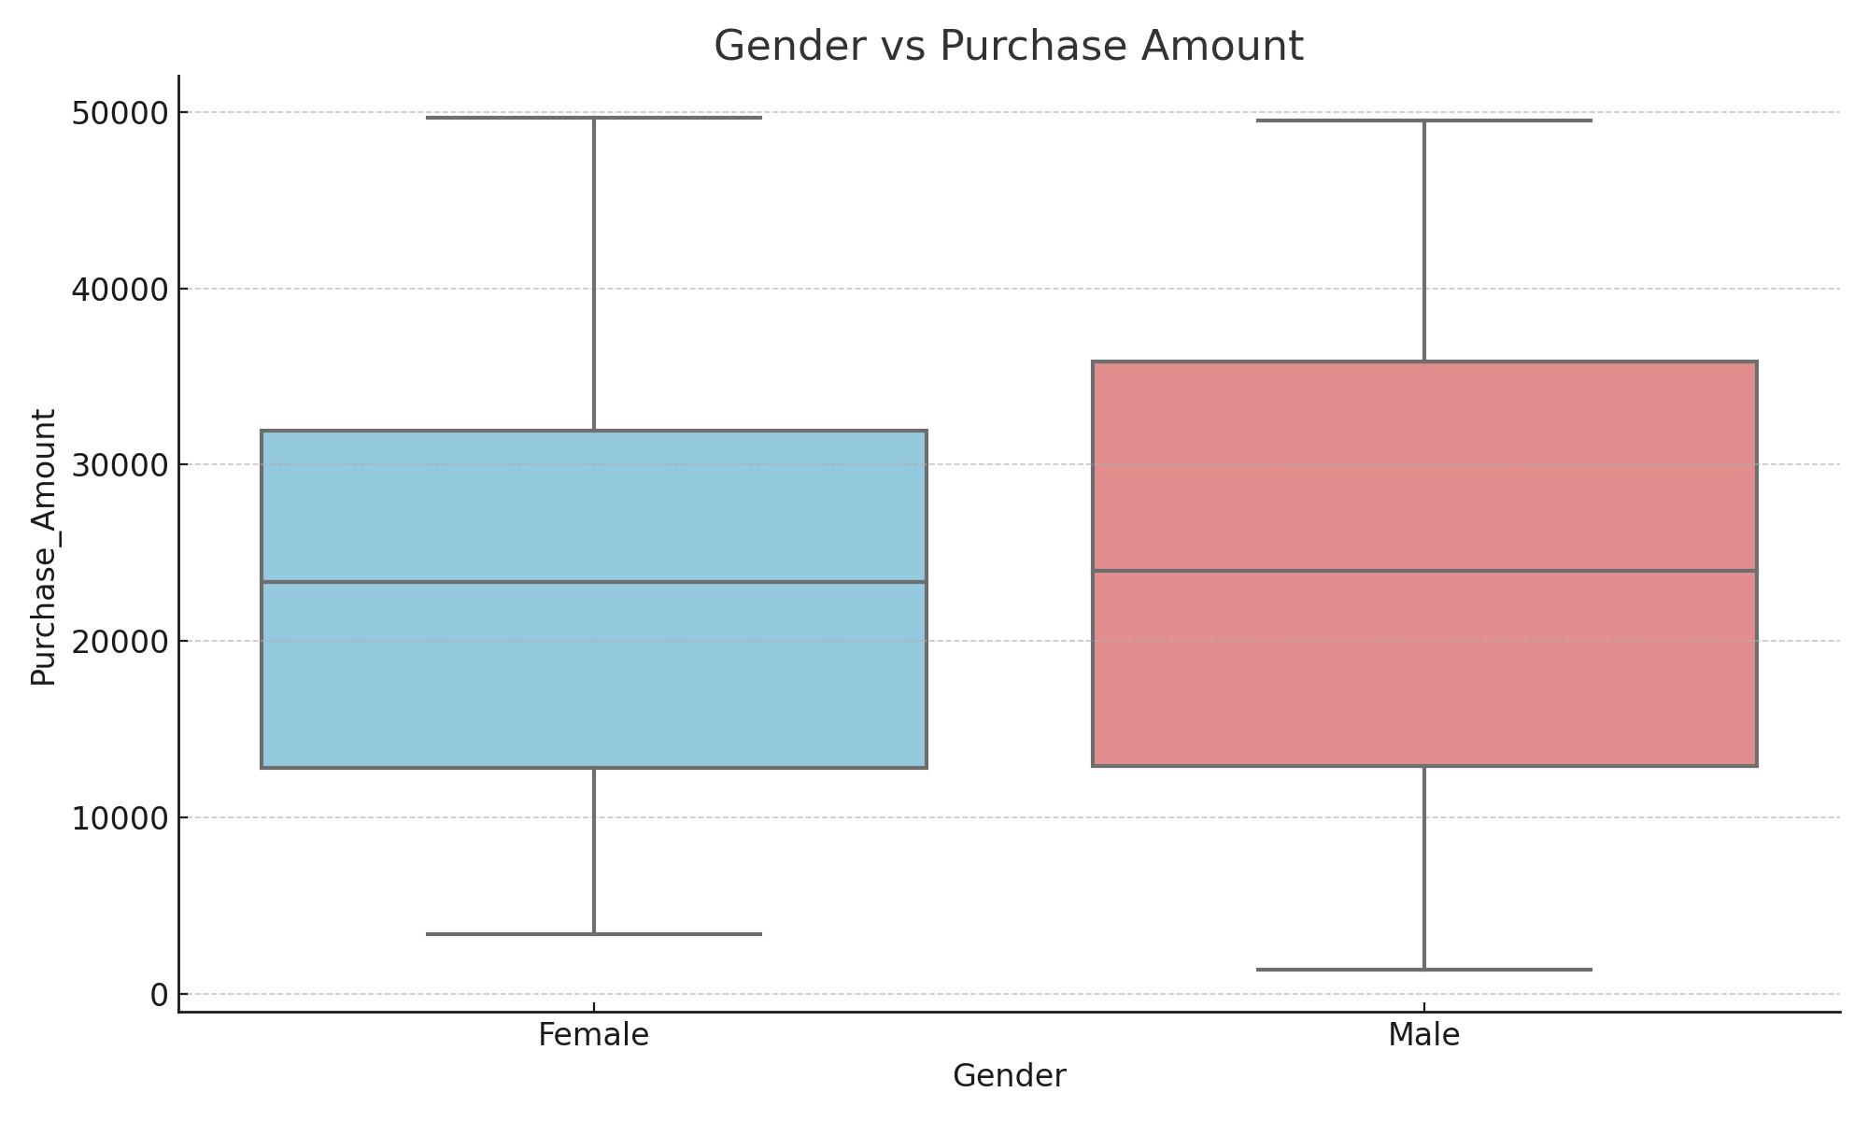
**Interpretation:** Both genders have similar spending levels, but some customers of both genders spend much more than average.

Average Annual Income by City
**Plot Type:** Bar Chart
**Why this plot is used:** To compare average income across cities.
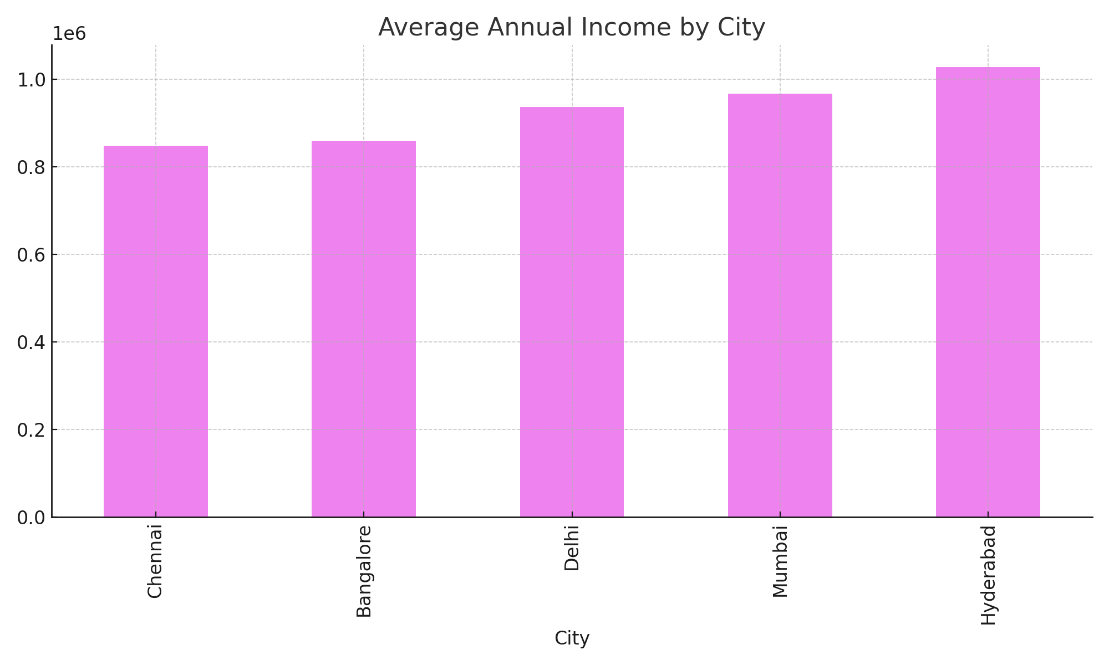
**Interpretation:** Bangalore and Mumbai show higher average incomes, meaning these cities have higher purchasing power.

Product Category vs Purchase Amount
**Plot Type:** Box Plot
**Why this plot is used:** To compare how much people spend on each product type.
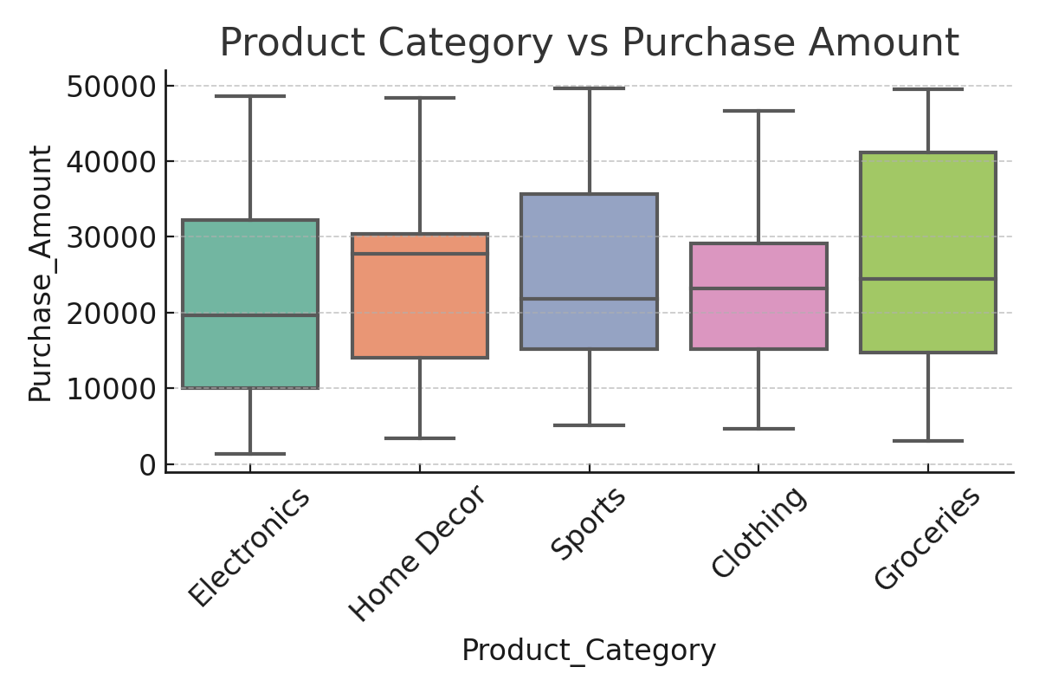
**Interpretation:** Electronics and Home Decor have higher purchase amounts, suggesting customers spend more on these items.

Final Insights
From all visual and data analysis, we found:
• Majority of customers are 25–45 years old.
• Gender distribution is balanced.
• Bangalore and Mumbai customers have higher incomes.
• Electronics and Clothing are best-selling products.
• Spending increases slightly with income but not directly with age.
Businesses can use these insights to focus offers on high-income cities and popular product types.

