Customer Behavior and Subscription Analysis - Teaching Version
This case study is designed to help students from all backgrounds understand the basic steps of data analysis. We will move step-by-step through a complete cycle — from understanding data, cleaning it, and visualizing patterns, to interpreting results in plain English. Each part includes three sections:
1️⃣ Question – what we want to know
2️⃣ What We Did – what action we performed
3️⃣ What We See – what we understood from the result.

1. Understanding the Problem
The company wants to understand what kind of customers are more likely to subscribe to a service. We have a small dataset with 100 customers that includes their age, income, gender, and subscription status. Some values are missing or incorrect, just like in real life, so we will clean and analyze this data step by step.

2. Data Cleaning

Question:
Are there any missing or unusual values in the data that could affect our understanding?

What We Did:
We checked for missing values and found that some rows did not have 'Age' or 'Income'. To fix this, we replaced missing values with the middle value (median), which is fairer than using the average. We also looked for income values that were extremely high or low and adjusted them slightly so they don’t mislead our charts.

What We See:
Now our data is complete and ready for analysis. Every customer has valid numbers for age and income, and extreme values are controlled so the charts will be easier to read.

3. Univariate Analysis
In this step, we look at one column (variable) at a time to understand how it behaves.

Age Distribution
Question: What is the age pattern of our customers? Are they mostly young, middle-aged, or older?
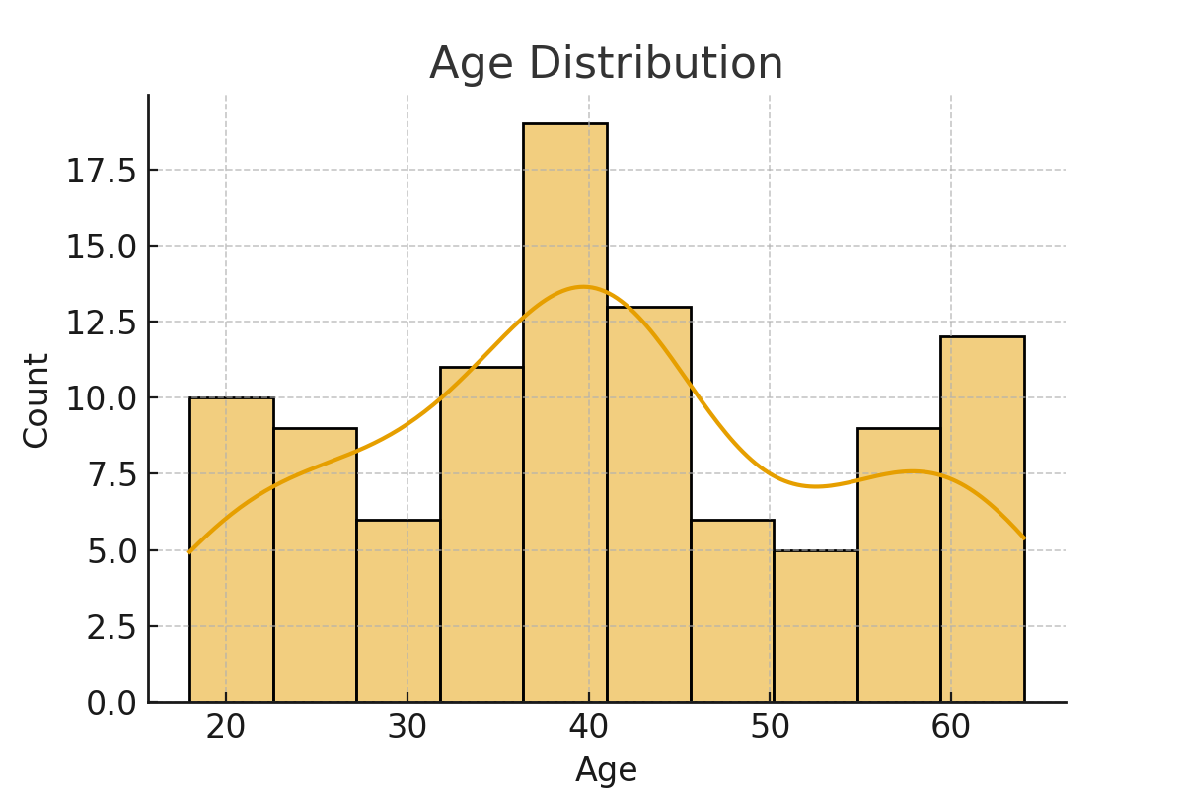
What We Did: We made a histogram to count how many customers fall in each age range.
What We See: Most customers are between 25 and 45 years old. This shows our customers are mostly working professionals.

Income Distribution
Question: What kind of income range do our customers belong to?
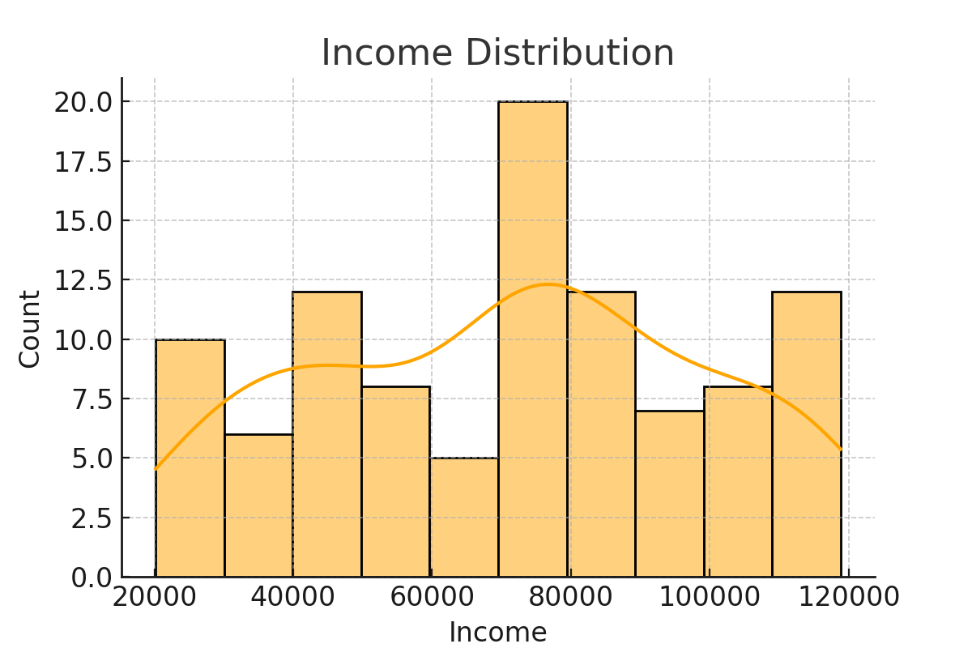
What We Did: We plotted the number of customers at different income levels.
What We See: Most customers earn between ₹40,000 and ₹80,000 per year. A few customers have higher incomes, which causes a small tail on the right side.

Gender Distribution
Question: Do we have more male or female customers?
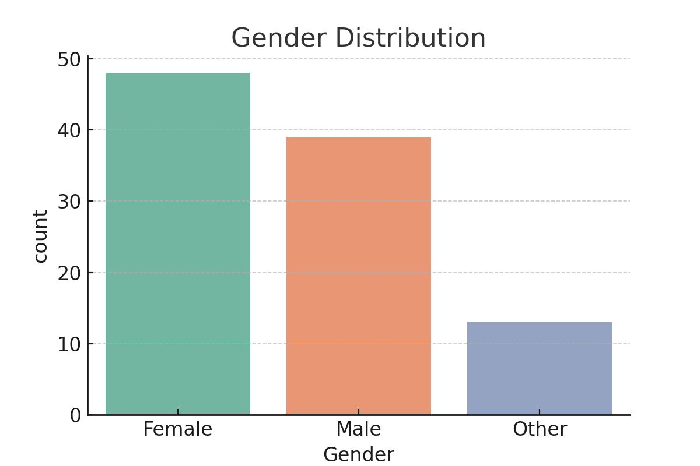
What We Did: We made a count plot showing the number of customers by gender.
What We See: The company has a balanced mix of male and female customers, with a small number identifying as ‘Other’.

Subscription Status Distribution
Question: How many customers subscribed and how many didn’t?
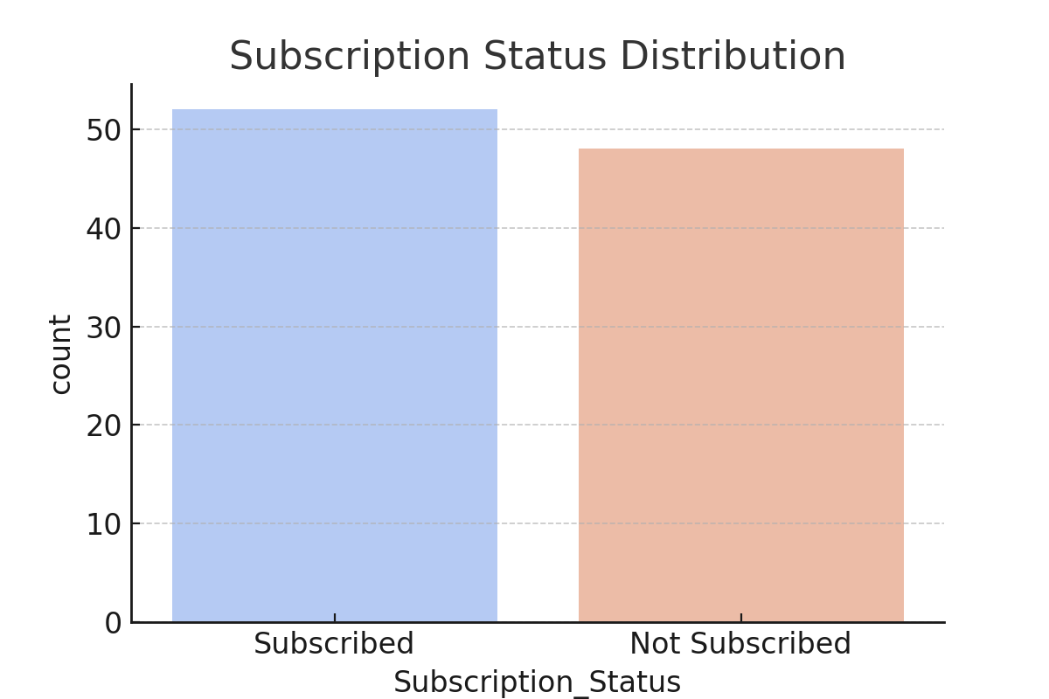
What We Did: We created a simple bar chart to show the total ‘Subscribed’ vs ‘Not Subscribed’.
What We See: More people have not subscribed yet. The company should focus its marketing on converting them.

4. Bivariate Analysis
Now we look at relationships between two variables — for example, income and subscription status.

Income vs Subscription Status
Question: Do people with higher income subscribe more often?
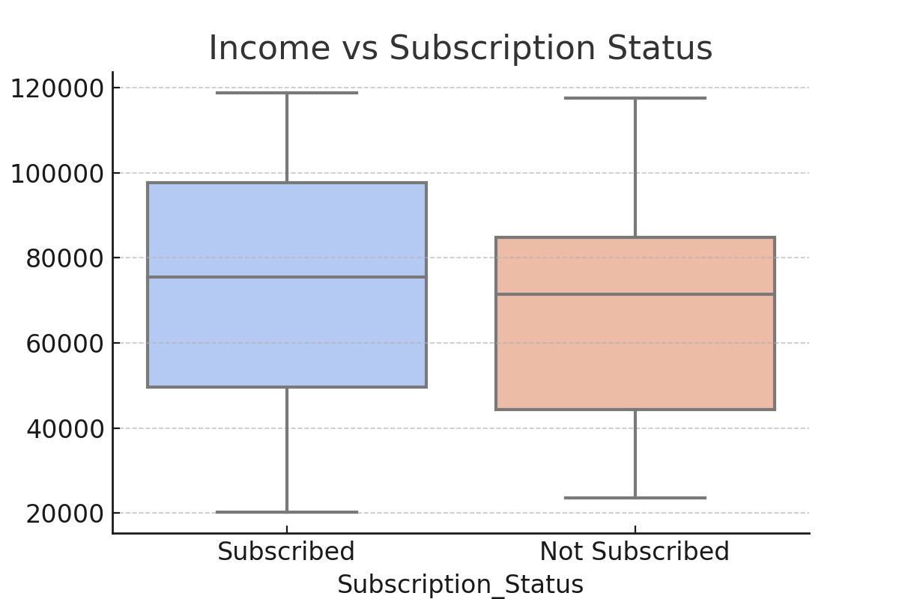
What We Did: We drew a boxplot comparing income for subscribed and non-subscribed customers.
What We See: People who subscribed generally have slightly higher incomes. This suggests income could play a role in decision-making.

Gender vs Subscription Status
Question: Is there any difference in subscription based on gender?
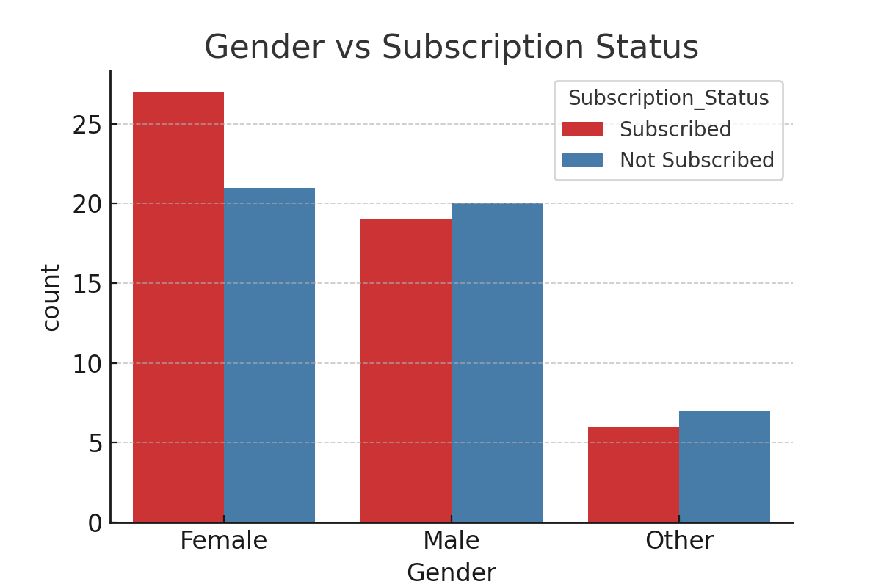
What We Did: We made a bar chart showing how many males, females, and others subscribed or didn’t.
What We See: Female customers have a slightly higher subscription rate. The company can explore female-focused campaigns.

Age vs Subscription Status
Question: Does age make a difference in subscription decisions?
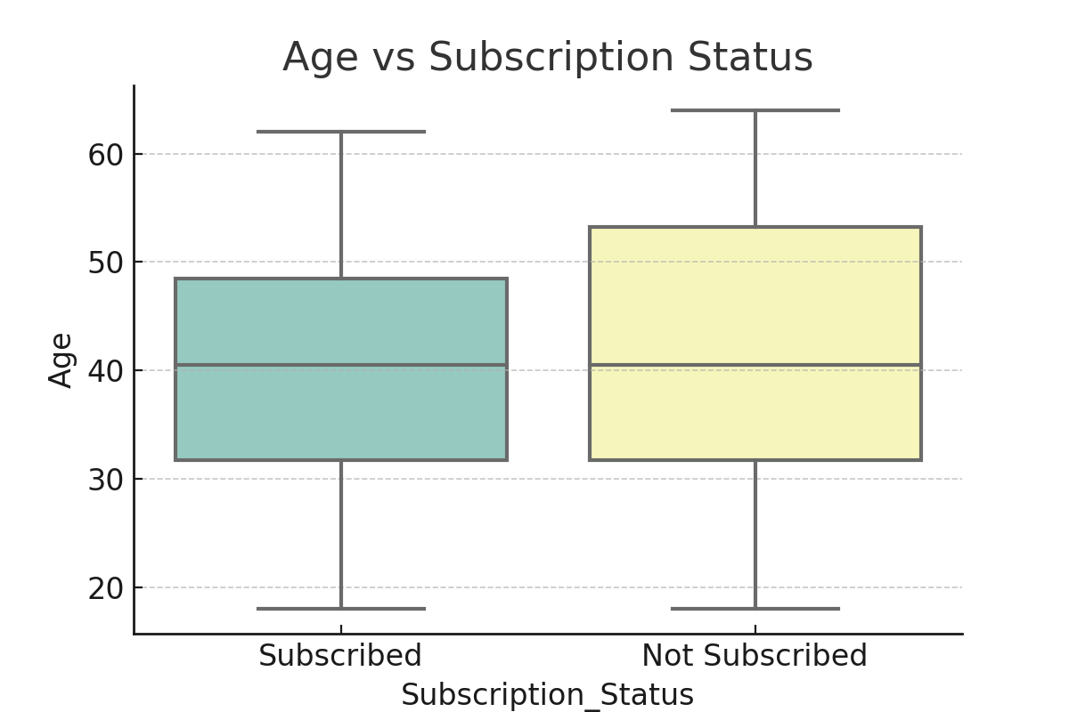
What We Did: We compared the ages of people who subscribed and didn’t.
What We See: There isn’t a big difference. Both groups have a similar age spread, so age may not be a major factor.

Correlation Heatmap
Question: Are Age and Income related to each other?
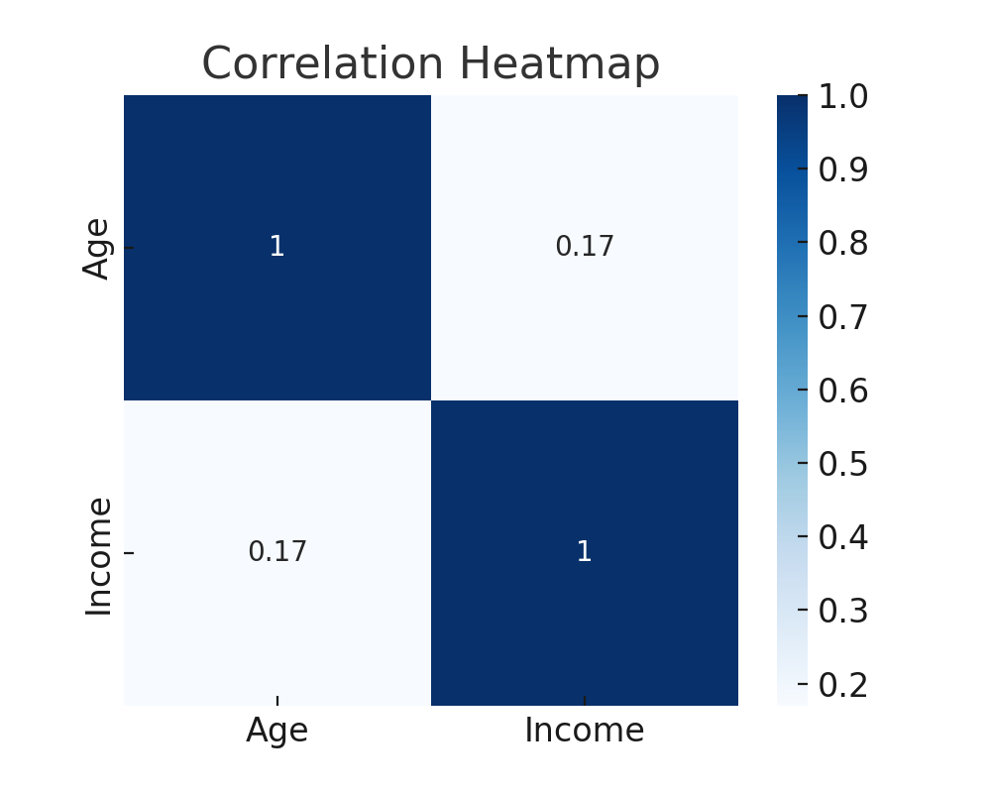
What We Did: We created a heatmap that shows how strongly two numbers move together.
What We See: The numbers are very light, meaning there is little to no relation between age and income in this data.

5. Summary of the Whole Process
We started with a raw dataset that had missing and uneven data. We cleaned it, explored each column one by one, and then compared pairs of columns to find relationships. This complete cycle — from cleaning to understanding — is the basic flow of Exploratory Data Analysis (EDA).
From our findings:
• Middle-income customers are more likely to subscribe.
• Females show a slightly higher interest in subscriptions.
• Age doesn’t affect much.
• The company can focus on working-age female customers with middle to high income for better marketing results.

