Exploratory Data Analysis (EDA) – Bank Marketing Dataset
This report explores the Portuguese Bank Marketing dataset using Python. Each question is analyzed with visual plots and interpreted in simple language for easy understanding.

1️⃣ What is the average age of subscribers vs. non-subscribers?
A box plot helps compare the average age. Subscribers are slightly older (40.9 yrs) than non-subscribers (39.9 yrs).
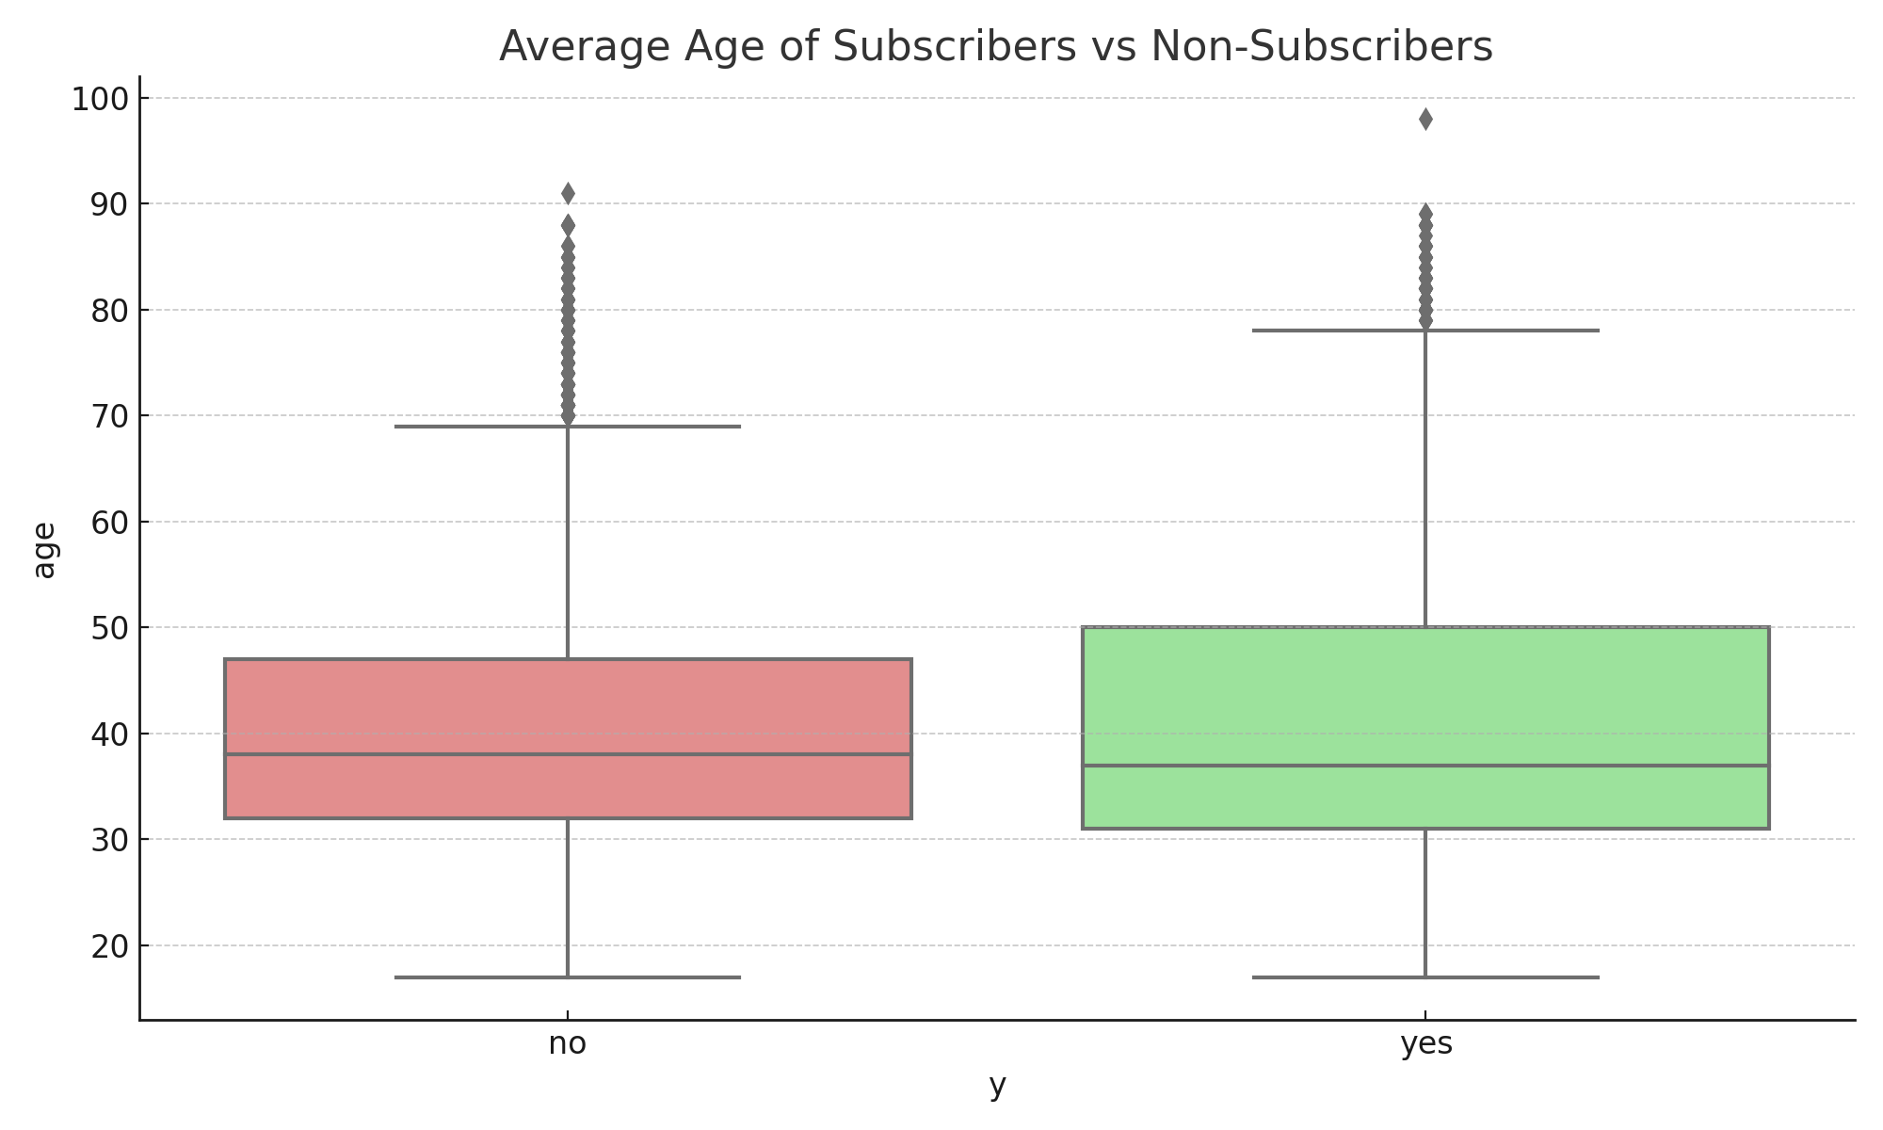

2️⃣ Which job types and education levels have the highest subscription rate?
Bar charts show Students (30.5%) and Retired (25.5%) are most likely to subscribe. Education shows Illiterate (18.8%) and University degree (13.8%) as top groups.
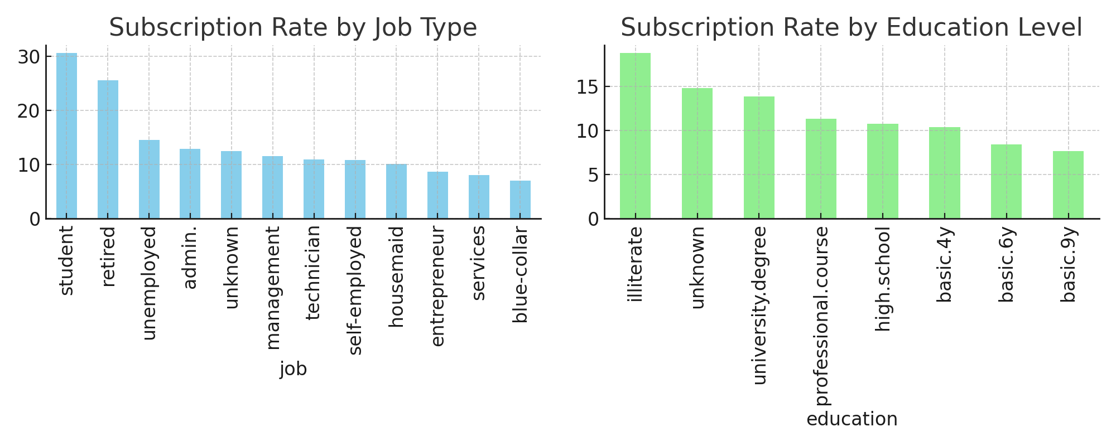

3️⃣ Does marital status affect response?
Singles show the highest subscription rate (~14%). Married and divorced are similar (~10%).
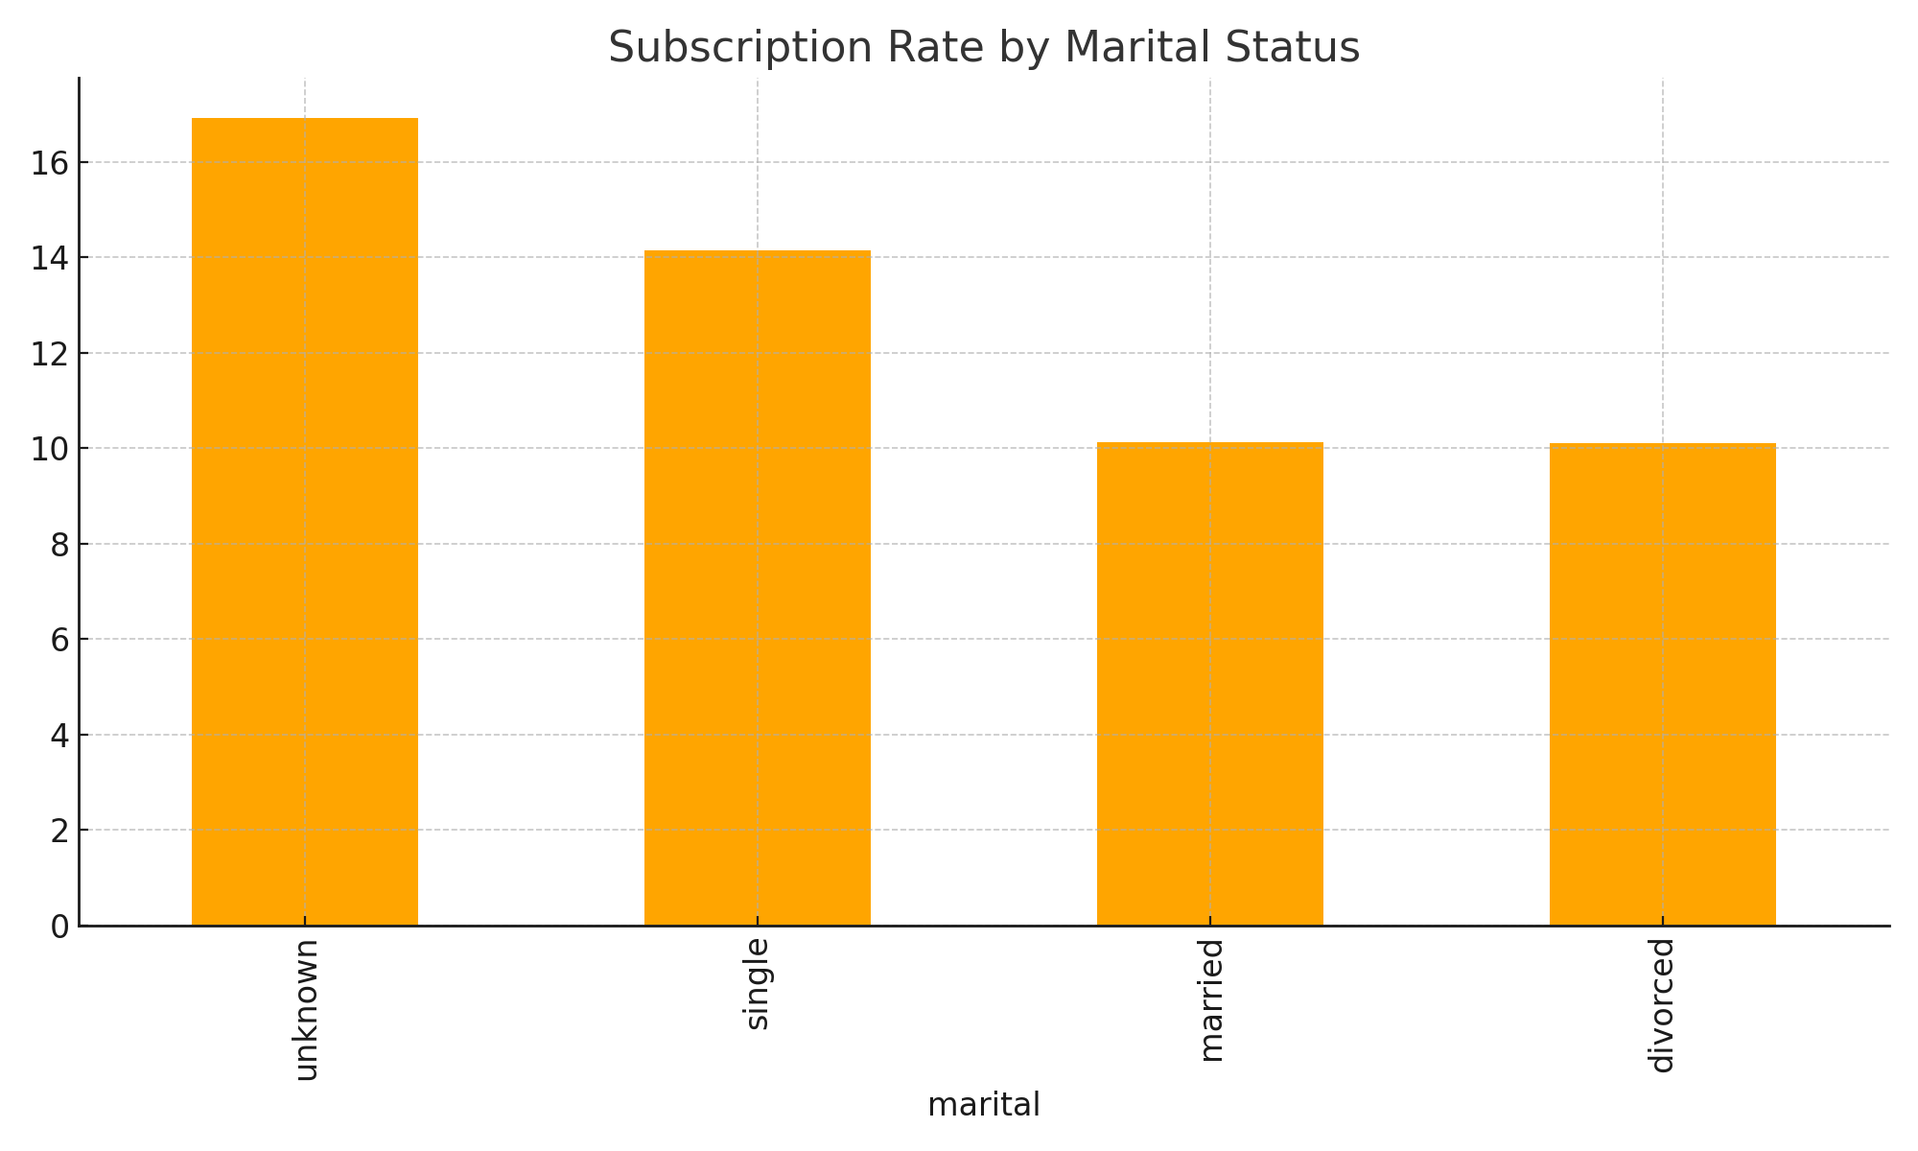

4️⃣ How many calls are typically needed to get a 'yes'?
Box plot shows successful calls need fewer attempts (2.05 calls) than unsuccessful ones (2.62).
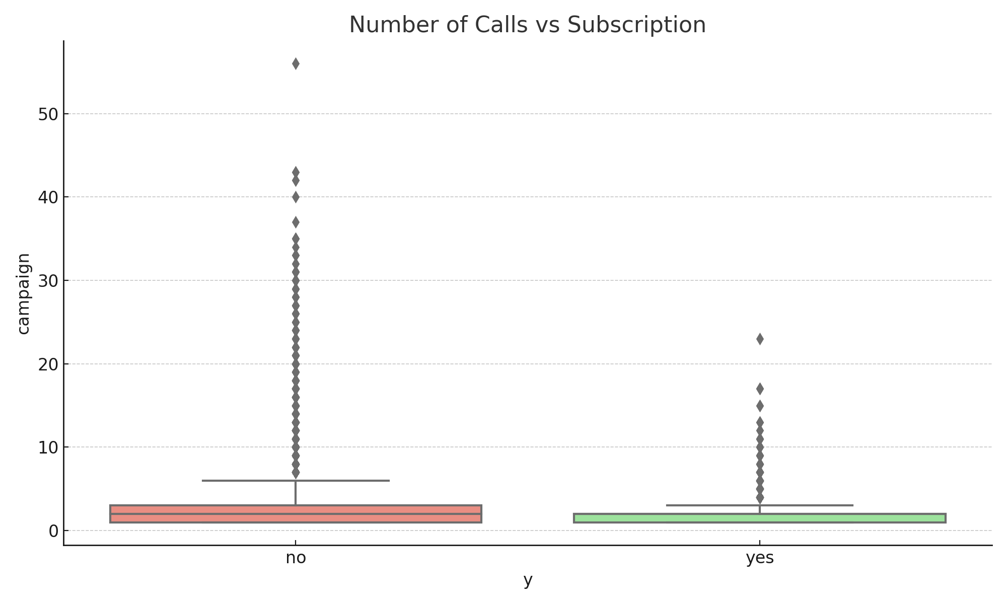

5️⃣ Do longer call durations lead to more subscriptions?
Subscribers have much longer calls (avg 549 sec) than non-subscribers (avg 221 sec). Longer calls increase success.
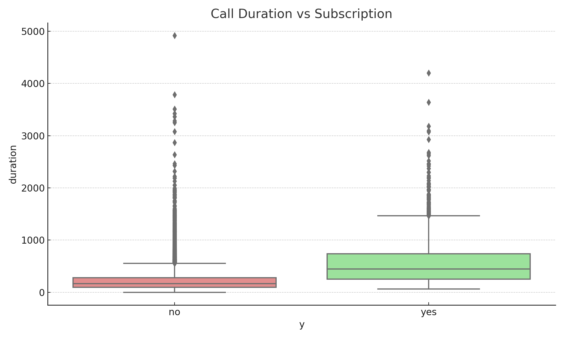

6️⃣ Does contact method (cellular vs telephone) make a difference?
Cellular calls are more successful (14.7%) than landline (5.3%). Mobile contact works better.
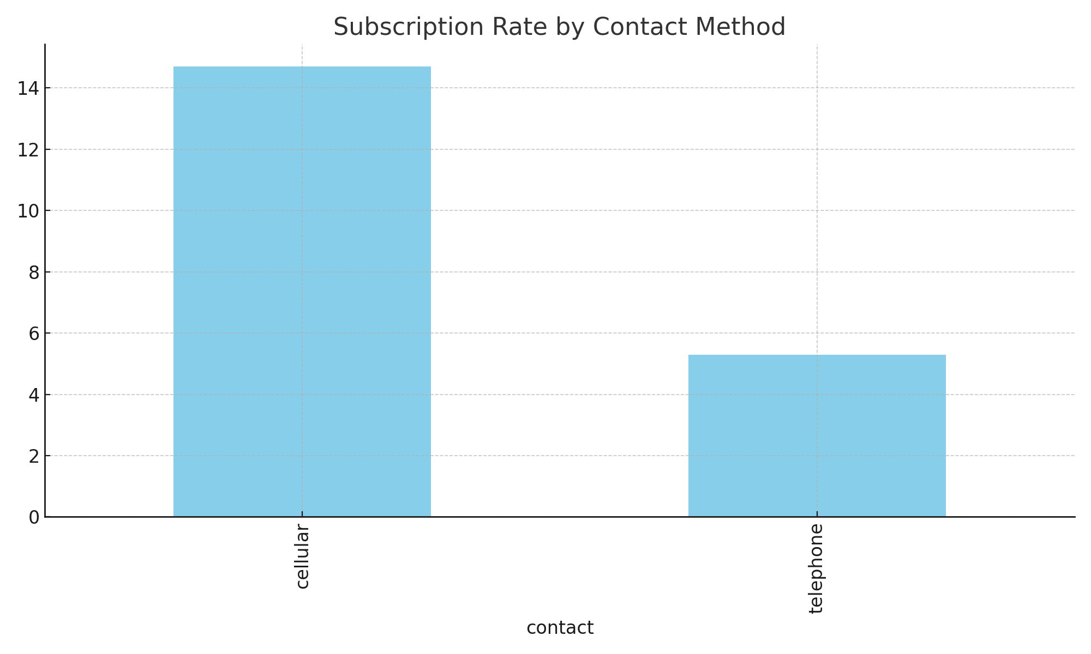

7️⃣ In which months or days are subscriptions highest?
December, March, and September show the highest success rates. Thursdays perform best among weekdays.
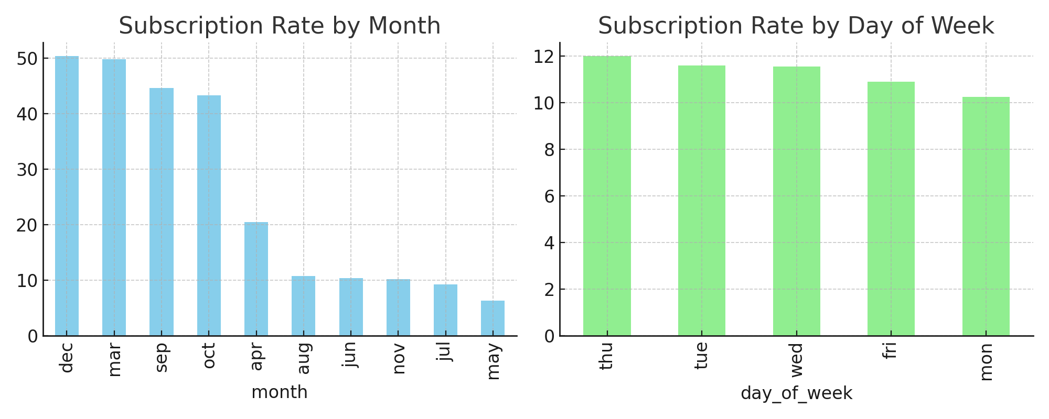

8️⃣ Are customers with loans or housing mortgages more or less likely to subscribe?
Loan and housing status do not significantly affect subscription (~11% for all groups).
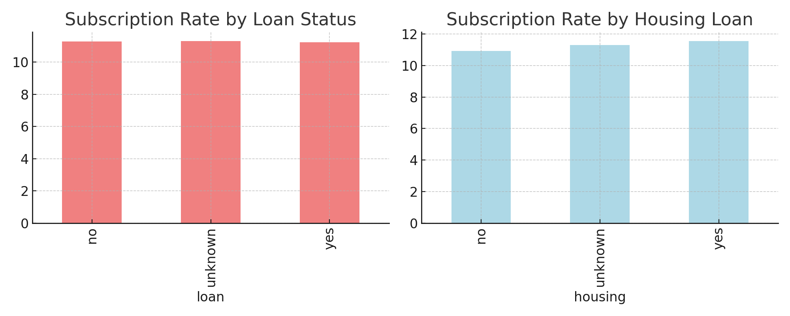

9️⃣ What’s the relationship between previous campaign outcomes and current success?
Customers with past success have a much higher chance (65%) of subscribing again. Previous good experience builds trust.
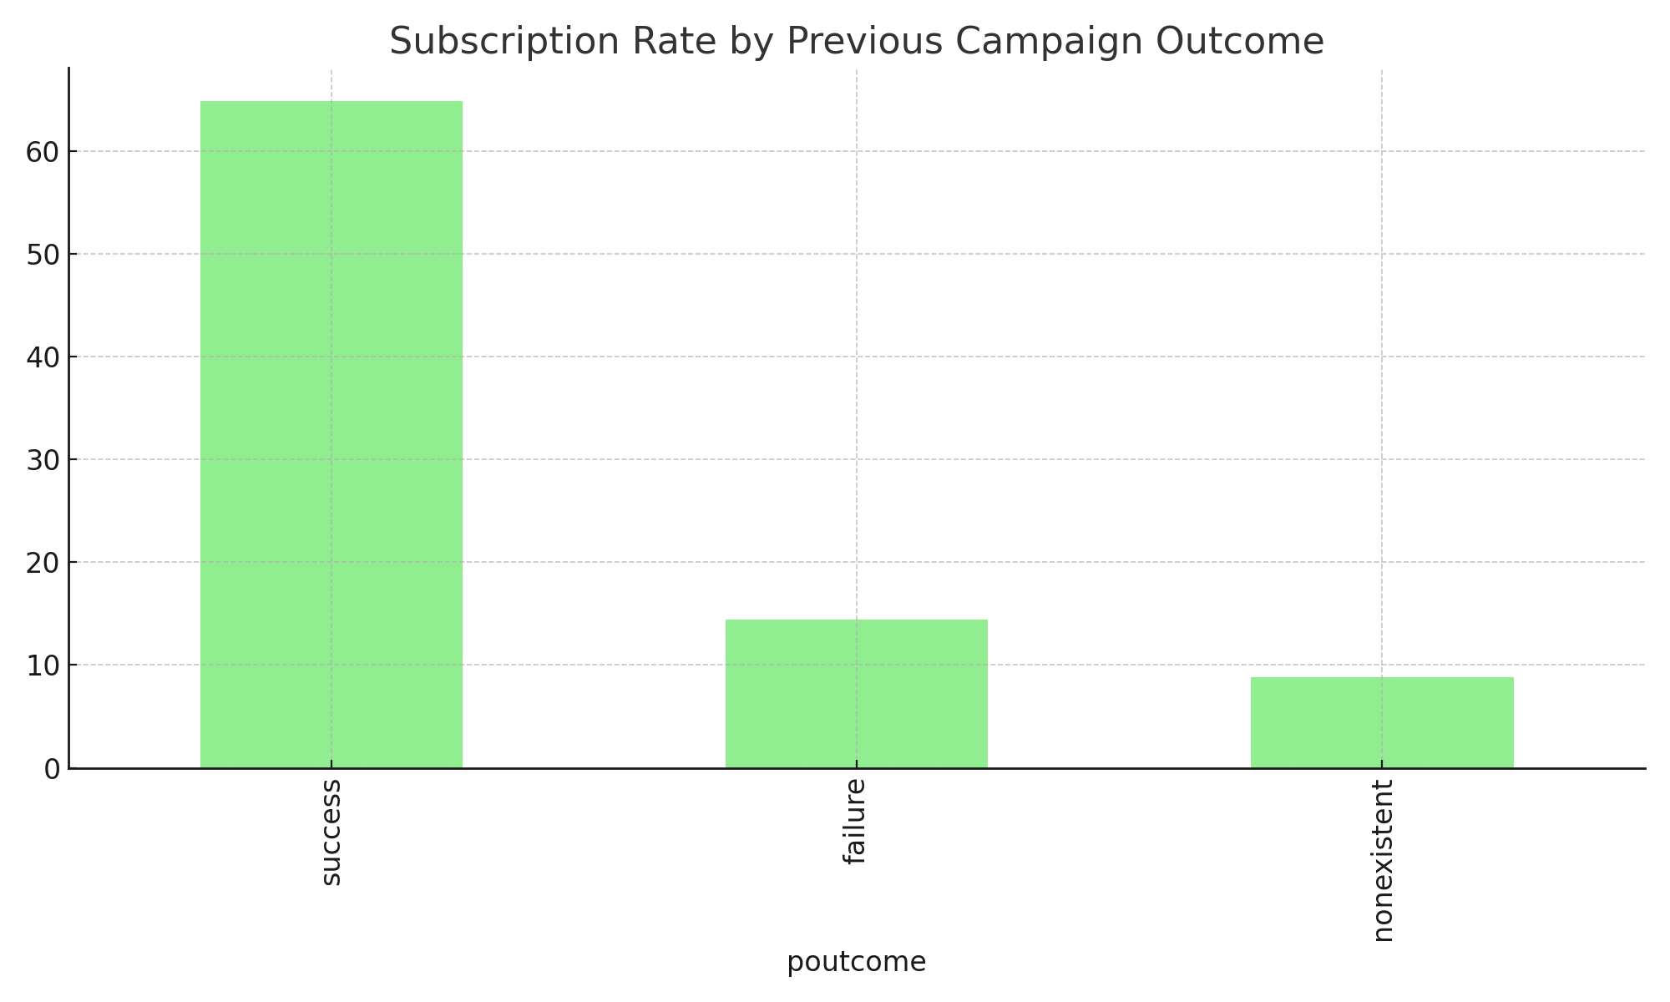

Summary of Key Insights
Question | Key Finding
Average age | Subscribers slightly older (40.9 yrs)
Job & education | Students and retired most likely; Illiterate & University educated respond more
Marital status | Singles subscribe more often
Calls needed | Around 2 calls; fewer for successful outcomes
Call duration | Longer calls → more 'yes' responses
Contact method | Cellular calls 3× more effective
Time trends | Dec, Mar, Sep best months; Thursday best day
Loans/Mortgages | Little impact on decision
Previous outcome | Past success strongly predicts new success
Overall, the analysis shows that customer age, contact method, call duration, and previous successful contact play a major role in determining subscription success.

