Decision-Making Under Uncertainty and Changing Constraints
Empirical Research Briefing for Adaptive AI Decision Support
Part A. Executive Summary

Research objective and empirical approach
My research investigates individual differences in how people evaluate alternatives, commit to decisions and adapt their behaviour under uncertainty and changing constraints. The central question is whether decision-making capabilities are better understood through context-dependent combinations of psychological characteristics, neural organisation, computational processes and behavioural responses, rather than as a single static general ability.
The empirical research included two complementary studies. The first developed and validated the 31-item Startup Founder Success Scale (SFSS) in a sample of 10,007 participants (6,142 successful startup founders, 2,004 corporate managers and 1,861 aspiring entrepreneurs), identifying six founder-related traits associated with realised entrepreneurial success.
The second study applied the SFSS to an independent cohort of 62 participants (31 successful startup founders and 31 aspiring entrepreneurs). It examined decision-making across six levels, beginning with two aspects of individual variation: founder-related traits measured by the SFSS (L1) and intrinsic neural network organisation measured through resting-state EEG (L2).
The next four levels were examined through two gamified experimental decision-making tasks, each representing a different environment: volatile uncertainty, in which participants learned option values from feedback as reward contingencies changed, and changing explicit constraints, in which probabilities and potential gains were known but each outcome altered progress towards a target and the number of opportunities remaining. During these tasks, I measured neural activity associated with different stages of decision-making using EEG (L3), estimated computational decision processes and recorded task-state variables (L4), examined observed choice patterns and behavioural adjustments (L5), and assessed decision performance within the tasks (L6). The task analyses drew on our previously published theoretical framework of three decision-making stages (Evaluation, Commitment and Feedback), allowing neural, computational and behavioural processes to be examined at corresponding stages across both tasks.
Entrepreneurship served as the initial testbed for this research, but the underlying questions extend beyond founders. Decision-making under volatile uncertainty and changing constraints is also central to fields such as space operations, defence, emergency response and medicine, where decisions can have substantial consequences and conditions may change rapidly. Whether the patterns identified in entrepreneurs extend to these settings remains to be investigated. The longer-term aim is to examine these differences across professional populations and determine whether they can inform more effective, individually adapted decision support.

Principal empirical findings
1. Founder-related differences were multidimensional. Successful founders scored significantly higher across all six SFSS dimensions in the experimental cohort. Resting-state EEG analyses also identified differences in how neural networks were organised between eyes-closed and eyes-open conditions. Compared with aspiring entrepreneurs, successful founders showed smaller and more spatially constrained changes in alpha-band connectivity, alongside larger increases in gamma-band network integration measures. These patterns may reflect differences in how large-scale neural organisation responds to changes in resting conditions, although their functional significance for decision-making remains to be established.
2. Decision behaviour differed according to environmental demands. Across the two decision tasks, founder-group differences were expressed primarily through behavioural and computational measures rather than uniformly greater exploration, risk-taking or neural response magnitude. In the volatile-learning task, the clearest differences concerned choice uncertainty, value-consistent selection and performance. Under changing explicit constraints, they concerned adjustment to goal progress, remaining opportunities and feedback. Successful founders achieved higher mean performance in both environments.
3. Distinct multilevel combinations were associated with performance in each environment. Integrating six organisational measurement levels produced different retained models for the two tasks. The model for volatile uncertainty combined Strategic Innovativeness, gamma-band characteristic path length change between resting conditions, feedback-related midfrontal theta mean power, selected-choice probability and post-positive stay rate. It accounted for 82.2% of the variance in ideal-observer regret (R² = .822; leave-one-out cross-validated R² = .790). The changing-constraints model combined Courageous Decision-Making, eyes-open gamma-band global efficiency, commitment-related CPP peak amplitude, signed final-trial required gain after accounting for the multiplier and post-gain risk adjustment (leave-one-out cross-validated R² = .542 for multiplier-adjusted mean final-block score). Both models were selected and evaluated within the same cohort (N = 60), so their predictive results remain exploratory rather than independently validated. The key finding is that different combinations of individual characteristics, neural measures and decision processes were associated with performance in each environment. No single set of predictors was common to both.
4. Multilevel profiles were associated with performance in their corresponding decision environments. The MAB profile correlated significantly with MAB performance (Spearman ρ = .492, p < .001), and the TBS profile with TBS performance (ρ = .419, p < .001). Neither profile showed a significant association with performance in the other task. This suggests that a participant's multilevel profile may be more informative about performance in the environment for which it was constructed, although the differences between within-task and cross-task correlations were not formally tested. Representational similarity analysis also identified selective relationships among neural, computational, behavioural and performance measures, rather than a common pattern across all measurement domains. Together, these findings are consistent with context-dependent organisation. In the exploratory four-profile classification, successful founders were more frequently represented in the Dual-regime category (8 of 10 participants), while aspiring entrepreneurs predominated in the Low-expression category (6 of 7). However, the overall association between founder status and profile membership did not reach statistical significance (permutation p = .0599), so these patterns remain descriptive.
Implications for the proposed collaboration
The empirical findings raise the possibility that an adaptive AI teammate may need to model the individual decision-maker and the decision environment jointly. Such a model would need to account for uncertainty on both sides: the conditions under which a decision is being made and what the system does or does not know about the person making it. This is where I see a particularly interesting connection with your work on uncertainty and knowledge representation. Building on the ideas in the draft paper you shared, I think we should consider not only how an AI represents uncertainty, but also when it should help resolve it, challenge an assumption, present competing interpretations or deliberately leave a question open.
The central research question could be: How can an AI teammate represent uncertainty about both the individual and the decision environment, and adapt when and how it intervenes to improve human judgment without replacing it?
The present empirical findings provide a starting point for developing this framework, rather than evidence that such an AI teammate already works. Once we have a coherent model, we could test whether assistance adapted to the individual and the situation improves judgment and appropriate reliance compared with generic AI support.

Part B. Detailed Empirical Findings

Research background and rationale
Entrepreneurship provides a useful setting for studying decision-making under uncertainty. Founders must frequently act with incomplete information, intepret feedback whose reliability is unclear and adjust their choices as opportunities and constraints change. Yet relatively little is known about how differences between individuals are expressed during these decisions, or how psychological characteristics relate to the neural and computational processes involved.
A central motivation is the distinction between relatively stable individual characteristics and the processes through which people actually make and adapt decisions. Traditional personality and entrepreneurial-intention approaches help explain who enters entrepreneurship, but offer a less complete account of how individuals evaluate uncertain options, respond to changing conditions, learn from outcomes, and adjust their strategies over time. The research therefore brings together three complementary perspectives: entrepreneurship research, which examines the contexts and consequences of entrepreneurial action; decision science, which provides formal accounts of learning, evaluation and adaptive choice; and cognitive neuroscience, which investigates the neural processes supporting those decisions.
Study 1: Development and validation of the Startup Founder Success Scale (SFSS) (Thesis Chapter 2)
Danilovska et al. (2026), PLOS ONE. https://doi.org/10.1371/journal.pone.0351970
The Startup Founder Success Scale (SFSS) identifies six characteristics associated with realised entrepreneurial success, extending beyond the broad personality traits and entrepreneurial intentions commonly examined in entrepreneurship research.
The research involved 10,007 participants from more than 80 countries, comprising 6,142 successful startup founders, 2,004 corporate managers and 1,861 aspiring entrepreneurs. Successful founders were identified through predefined, externally verifiable funding, revenue or acquisition benchmarks. The instrument was developed using evidence from successful founders' experiences, expert input and psychometric analyses, resulting in a 31-item scale measuring six dimensions:
- Relentless Resilience
- Value-Creating Opportunism
- Intrinsic Curiosity
- Courageous Decision-Making
- Strategic Innovativeness
- Transformational Leadership
Exploratory and confirmatory factor analyses supported the proposed multidimensional structure, with the six dimensions collectively accounting for approximately 71% of the common variance in the scale's latent trait structure. The dimensions differentiated successful founders from corporate managers and aspiring entrepreneurs, with large group-level effect sizes (Cohen's d = 0.83–1.77). The five-factor configuration excluding Transformational Leadership demonstrated stronger overall statistical fit, while the six-factor model retained conceptually relevant leadership-related information. The SFSS provides a domain-specific measure of founder characteristics associated with entrepreneurial success. Whether these characteristics predict future success remains to be tested longitudinally.
Relevance to the proposed collaboration: SFSS offers an empirically grounded representation of relatively stable founder-related characteristics that could form one component of an adaptive decision-maker model. The subsequent experimental research investigates how such characteristics relate to neural, computational and behavioural processes under different decision-making demands.
Study 2, Part I: Founder characteristics in the experimental EEG cohort (Thesis Chapter 3)
The difference between successful founders and aspiring entrepreneurs was also evident in the experimental cohort. Successful founders scored significantly higher across all six SFSS dimensions, with every comparison surviving Benjamini–Hochberg FDR correction (all adjusted p < .001). Effect sizes were consistently large (Hedges' g = 1.33–1.73), particularly for Strategic Innovativeness, Relentless Resilience and Value-Creating Opportunism. The overall SFSS score also differed substantially between groups (SSF: M = 4.64; AE: M = 4.02; Hedges' g = 2.60, adjusted p < .001). The aim was not to repeat the original psychometric validation, but to characterise the participants whose neural activity and decision behaviour were examined in subsequent analyses.
Overall scale reliability remained high in the experimental cohort (Cronbach's α = .91). Although individual scores overlapped between groups, successful founders scored substantially higher across the six SFSS dimensions. Scores in both groups were concentrated toward the upper end of the response scale, suggesting potential range restriction and ceiling effects. One possible explanation is the composition of the comparison group: aspiring entrepreneurs may already exhibit relatively high levels of founder-related characteristics, despite not yet having achieved the outcomes used to define successful founders. This possibility should be considered when interpreting the group differences. The six SFSS dimensions were subsequently retained as dispositional variables for examining their associations with resting-state neural organisation, task-evoked neural activity, computational decision processes, behavioural adaptation and performance across the two decision environments.
Relevance to the proposed collaboration: The SFSS measures provide information about relatively stable founder characteristics. The subsequent analyses examine how these characteristics relate to neural activity, decision behaviour and performance under different task demands.
Study 2, Part II: Founder-related differences in intrinsic neural network organisation (Thesis Chapter 4)
Chapter 4 investigated whether the founder characteristics identified in the preceding analysis were accompanied by differences in resting-state brain-network organisation. Resting-state EEG was recorded from the experimental cohort (N = 62) using a high-density, 128-channel system under eyes-closed (EC) and eyes-open (EO) conditions. Paired resting-state data were available for 60 participants, as eyes-open recordings were missing for two participants. Functional connectivity was estimated using weighted imaginary coherence, and graph-theoretical analyses examined global network strength, efficiency, characteristic path length and assortativity across frequency bands. The analyses distinguished group differences within each resting condition from changes between eyes-closed and eyes-open conditions within the same individuals (Δ = EO − EC). The strongest group differences were concentrated in the alpha and gamma frequency bands and survived FDR correction.
In the alpha band, successful founders exhibited lower eyes-closed global network strength and efficiency, together with higher characteristic path length, compared with aspiring entrepreneurs (|d| = 1.02–1.18). Across EC–EO differences, founders exhibited smaller reductions in network strength and efficiency and smaller increases in characteristic path length (|d| = 1.18–1.44; all pFDR < .001). In the gamma band, significant differences were confined to EC–EO measures. Successful founders showed larger increases in global strength and efficiency, accompanied by greater reductions in characteristic path length (|d| = 0.93–1.02; pFDR ≤ .0069). The effects were broadly distributed across the network rather than restricted to isolated scalp locations.
The combined alpha- and gamma-band findings suggest that successful founders may differ in how large-scale neural networks are reorganised as the brain moves between internally and externally oriented resting conditions. Their smaller and less spatially distributed alpha-band changes are consistent with more constrained reorganisation of networks involved in inhibitory regulation and information gating. At the same time, the larger gamma-band increases in network strength and efficiency, accompanied by shorter characteristic path lengths, suggest stronger integration-related changes as external sensory input becomes available. Together, these patterns raise the possibility of a different balance between maintaining existing network organisation and recruiting wider neural coordination.
Exploratory analyses examined whether the six SFSS dimensions were associated with these intrinsic network measures. Strategic Innovativeness and Transformational Leadership showed tentative associations with gamma-band differences between resting conditions. However, the multivariate trait–brain relationship did not survive permutation testing (Rc = .53, p = .093). Overall, the findings indicate that the two entrepreneurial groups differed in both alpha-band baseline topology and cross-band patterns of resting-state network organisation across EC and EO conditions. These differences are observational and do not establish that resting-state organisation causes entrepreneurial success or directly predicts adaptive decision performance.
Relevance to the proposed collaboration: These results add information about intrinsic brain organisation that the questionnaire measures do not capture. They raise the possibility that an adaptive model of the decision-maker could eventually incorporate information about intrinsic neural organisation alongside psychological traits and observed decision behaviour, while explicitly representing uncertainty about the relationships between these measures.
Study 2, Part III: Computational, behavioural and neural processes during decision-making (Thesis Chapter 5)
Theoretical foundation: Danilovska et al. (2026), Brain Organoid and Systems Neuroscience. https://doi.org/10.34133/bosn.0006
Chapter 5 investigated how founder-related individual differences were expressed during active decision-making in the same experimental cohort (N = 62; 31 successful startup founders and 31 aspiring entrepreneurs). The analyses drew on our previously published theoretical framework, which brings together neuroscience and decision science to examine entrepreneurial decision-making across three stages: Evaluation, where individuals assess available information and opportunities; Commitment, where a decision is translated into action; and Feedback, where outcomes inform subsequent choices.
Participants completed two complementary repeated-choice tasks during high-density EEG recording. The three-stage framework guided the alignment of neural, computational and behavioural measures with different moments in the decision process, allowing corresponding processes to be examined across the two decision environments.
The tasks represented two distinct decision environments:
1. Multi-Armed Bandit (MAB): Decision-making under volatile uncertainty. Participants completed 200 choices among six options with undisclosed outcome probabilities. After an initial stable phase, reward contingencies became volatile, requiring participants to infer option values from feedback, update expectations and regulate exploration versus exploitation.
2. Target-Based Sequential Decision (TBS): Decision-making under changing constraints. Participants completed 192 choices organised into 24 eight-trial blocks. Unlike MAB, probabilities and potential gains were explicit. However, each outcome changed the participant's position relative to a target while the remaining decision horizon contracted, requiring continuous adjustment of safer versus riskier choice policies. A final-trial multiplier introduced an additional constraint affecting target attainment.
Behavioural and computational analyses identified founder-group differences, with 26 of 75 prespecified comparisons surviving FDR correction. Several significant measures captured related aspects of decision behaviour rather than independent processes. Importantly, the differences did not reflect uniformly greater exploration, exploitation or risk-taking.
Figure 1
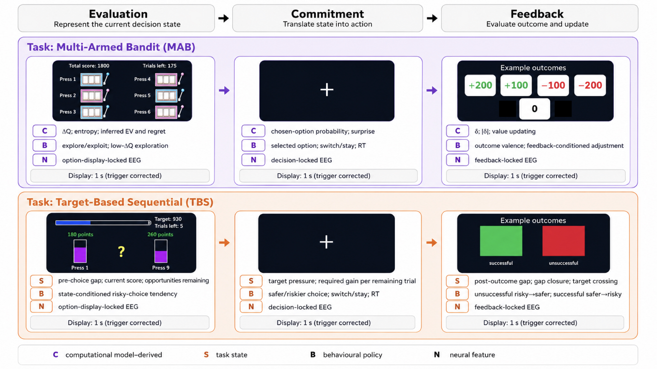
Two decision environments and their alignment with the evaluation, commitment and feedback stages
Note. The upper panel illustrates the Multi-Armed Bandit (MAB) task, in which participants learn uncertain option values under stable and subsequently volatile reward contingencies. The lower panel illustrates the Target-Based Sequential Decision (TBS) task, in which participants choose between explicitly defined alternatives while adapting to changing targets and remaining opportunities. Both tasks follow an evaluation, commitment and feedback structure. C = computational model-derived measure; S = task-state measure; B = behavioural-policy measure; N = neural measure; EV = expected value; RT = reaction time. Screens are schematic illustrations of the experimental tasks. Neural measures were aligned with option presentation, response and feedback. Aggregate performance measures are omitted because they were calculated across trials or blocks.
In the MAB task, successful founders exhibited lower choice entropy during the stable phase and a greater increase when conditions became volatile. They more frequently selected options associated with higher ideal-observer expected values and showed lower ideal-observer regret. In the final integrated performance analysis, successful founders accumulated significantly more points than aspiring entrepreneurs (8,954.8 versus 6,841.9; Hedges' g = 0.885, pFDR = .00134). They also achieved higher scores during both the stable and volatile phases, although the volatile-phase difference did not survive the separately corrected rank-sum sensitivity analysis. These findings indicate differences in context-sensitive choice uncertainty, value-consistent decision-making and performance as reward contingencies changed.
The behavioural differences took a different form in TBS. Successful founders responded more quickly and showed selective differences in their choice policies within blocks and in their adjustments following feedback. They attained targets significantly more frequently after application of the multiplier (75.4% versus 58.9%; Hedges' g = 1.712, pFDR = 2.845 × 10⁻⁸) and achieved higher mean final-block scores (1,769.0 versus 1,509.4; Hedges' g = 1.038, pFDR = .000283). However, the groups did not differ reliably in their overall preference for risky choices or in general measures of sensitivity to pressure, remaining opportunities and target magnitude.
The neural findings were more selective. Average participant-level ERP and theta measures did not show FDR-supported founder-group effects or Group × Task interactions, although several differences between the tasks were significant. The most informative founder-related neural findings emerged in specific trial-level relationships between neural activity and decision variables. These included feedback-related posterior P3 coupling with prediction-error magnitude in MAB, N2 sensitivity to target gap during TBS evaluation, and differences in the relationship between centroparietal positivity (CPP) buildup and risky choice during TBS commitment. These findings concerned neural–decision coupling rather than uniformly larger neural responses among successful founders.
Exploratory multivariate analyses additionally identified task-specific neural–behavioural covariance patterns, particularly involving value-related evaluation in MAB and the relationship between evolving goal-state evaluation and response commitment in TBS. The statistical evidence for these patterns was weaker and did not consistently survive broader multiple-comparison correction.
Overall interpretation: Founder-related differences were expressed primarily through behavioural and computational processes that varied with the decision context, rather than through consistently greater risk-taking, exploration or stronger neural responses. In MAB, successful founders more consistently selected options with higher estimated values as reward contingencies changed. In TBS, the differences concerned how participants adjusted their choices as target requirements evolved and opportunities diminished.
Connection to the multilevel analysis: These findings establish the behavioural, computational and task-related neural evidence that Chapter 6 brings together with founder characteristics and resting-state neural organisation. This integration allows the relationships between different measurement levels and task performance to be examined within the same individuals across the two decision environments.
Study 2, Part IV: Multilevel integration of decision-making capabilities across two environments (Thesis Chapter 6)
Chapter 6 integrated the psychological, neural, computational, behavioural and performance measures collected in the experimental cohort to investigate how different organisational levels relate to one another and whether their relationships with performance differ across decision environments. The analysis distinguished six organisational levels: founder-related traits (L1), intrinsic resting-state neural organisation (L2), task-evoked neural activity (L3), computational and task-state measures (L4), behavioural policy (L5), and task performance (L6). These levels represented complementary measurement domains rather than an assumed causal hierarchy. The Multi-Armed Bandit (MAB) and Target-Based Sequential Decision (TBS) tasks were analysed separately to preserve their different decision demands.
Cross-level associations and configurations. Of 11,874 prespecified cross-level associations, 195 survived family-level false discovery rate correction. An exploratory analysis identified 1,488 complete six-level configurations linking measures across the organisational domains, of which 1,081 contained at least one FDR-supported association. No complete configuration had all five constituent associations survive correction. The configurations were therefore treated as candidate patterns of multilevel organisation, not established causal pathways.
Task-specific multilevel models. Separate multilevel models were retained for MAB and TBS, using combinations of psychological, neural, computational and behavioural measures (L1–L5) to account for differences in task performance. The retained MAB model combined Strategic Innovativeness, gamma-band characteristic path length change between resting conditions, feedback-related midfrontal theta, selected-choice probability and post-positive choice persistence. It accounted for 82.2% of the variance in ideal-observer regret, with leave-one-out cross-validated R² = .790. The retained TBS model combined Courageous Decision-Making, eyes-open gamma-band global efficiency, commitment-related CPP peak amplitude, signed final-trial required gain and post-gain risk adjustment. Its leave-one-out cross-validated R² was .542 for multiplier-adjusted mean final-block score. In both models, the selected founder-trait and resting-state variables contributed additional predictive information alongside task-derived measures. However, model selection and evaluation were conducted within the same cohort (N = 60), so the predictive estimates are conditional on the retained specifications and do not constitute independent external validation. The TBS model additionally requires caution because the final-trial required-gain measure and performance outcome share information derived from accumulated scores.
Individual decision-making profiles. The five measures retained for each task were also used to construct continuous participant profiles. The MAB profile was associated with MAB performance (Spearman ρ = .492, p < .001), and the TBS profile with TBS performance (ρ = .419, p < .001). Neither profile showed a significant association with performance in the other task. The differences between within-task and cross-task correlations were not formally tested.
Participants were also described using four exploratory configurations: MAB-specialised, TBS-specialised, Dual-regime and Low-expression. These categories illustrated variation in how the two task-related profiles were jointly expressed, but were not interpreted as fixed decision-maker types.
The distribution of successful founders and aspiring entrepreneurs across these configurations was also examined. The MAB-specialised and TBS-specialised categories contained relatively similar numbers from both groups. By contrast, eight of the ten Dual-regime participants were successful founders, while six of the seven Low-expression participants were aspiring entrepreneurs. Although these smaller categories showed an uneven distribution, the overall association between founder status and profile membership did not reach statistical significance (permutation p = .0599). These differences therefore remain descriptive and require confirmation in larger samples.
Figure 2
Individual differences across two decision-making environments: Continuous multilevel profiles
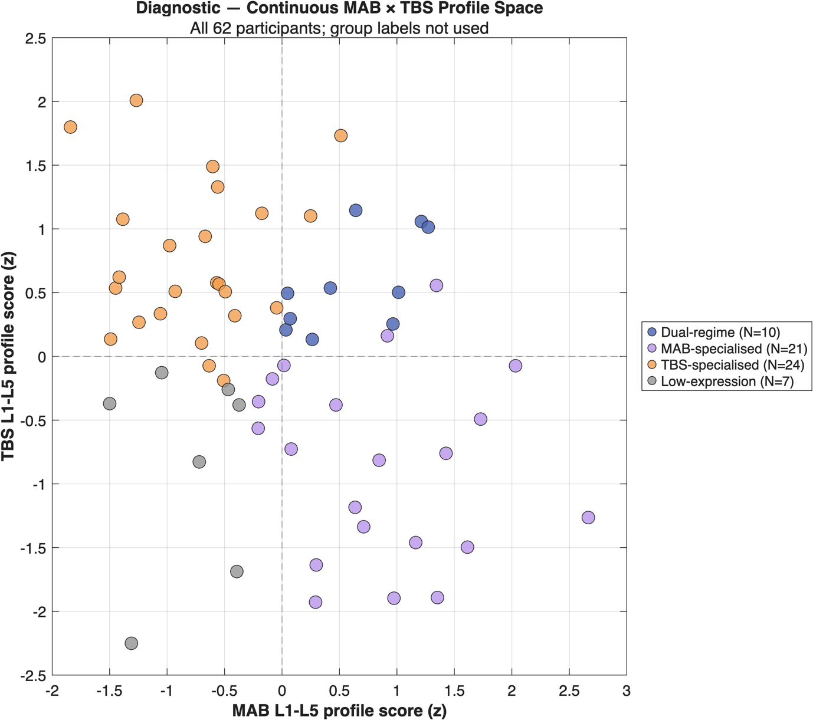
Note. Each point represents one participant (N = 62), positioned according to their standardised profiles for decision-making under volatile uncertainty (MAB) and changing constraints (TBS). Colours distinguish four descriptive configurations: MAB-specialised, TBS-specialised, Dual-regime and Low-expression. Dashed lines indicate zero on each profile dimension. Profiles were derived from the five psychological, neural, computational and behavioural measures (L1–L5) retained for each task, without using founder-group membership in profile scoring or assignment. The categories are descriptive and do not represent validated or fixed decision-maker types.
Figure 3
Multilevel composition of decision-making profiles across two environments
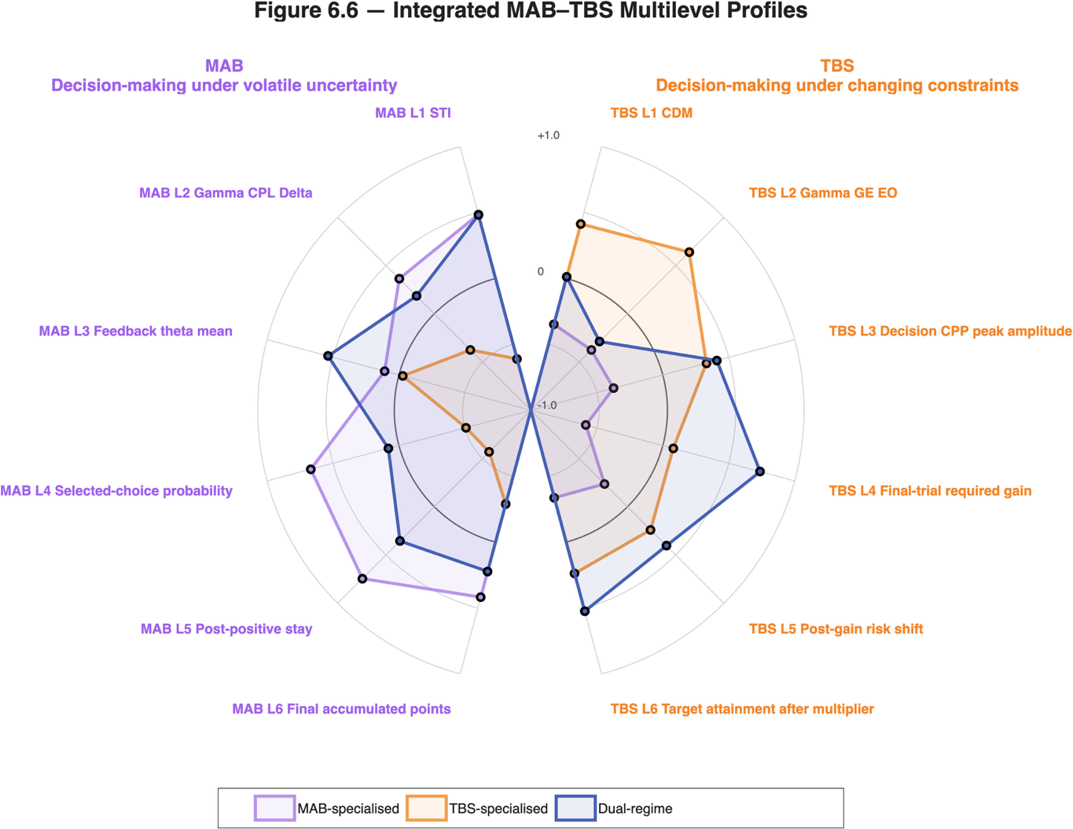
Note. Mirrored radar plots show mean standardised MAB and TBS profile components (L1–L5: founder traits, resting-state EEG, task-evoked EEG, computational measures and behavioural policy) for three exploratory categories: MAB-specialised, TBS-specialised and Dual-regime. Performance (L6) is shown for comparison but was excluded from profile scoring and assignment. TBS components follow model coefficient directions and may differ from raw measurement directions. Low-expression participants are omitted for clarity. The categories are descriptive, not validated decision-maker types.
Representational similarity across levels. A complementary analysis investigated whether participants who resembled one another in one measurement domain also resembled one another in others. Six of 45 domain comparisons survived FDR correction. The clearest cross-task correspondence involved task-evoked neural measures, while within-task relationships were concentrated among computational, behavioural and performance domains. No second-order similarity relationship involving the complete trait or resting-state domains survived correction.
Overall interpretation. Different combinations of psychological, neural, computational and behavioural measures were associated with performance in the two tasks. The profile and representational similarity analyses also showed limited correspondence across environments, although not all cross-task differences were formally tested.
Relevance to the proposed collaboration: The two decision environments produced different patterns of association among individual characteristics, neural measures and decision behaviour. This raises a question for the proposed collaboration: how could an AI teammate recognise which aspects of a person's decision-making are relevant to the current situation, and how much confidence should it place in that assessment? The present findings do not answer that question, but they provide empirical material from which to begin developing and testing such a model.

