Assumptions, models and ideas in Human-centred AI
Existing standards for Cultural Heritage documentation, such as CIDOC-CRM, offer rich semantic representation and rigorous definitions, sympathetic to the data and the different and varied perspectives of the CH community. Some of them have extensions offer more precise semantics to domain-specific arrangements, like metadata about argumentation and inference making, observations and measurements in descriptive and empirical sciences, etc. While these advances have yielded significant benefits in terms of interoperability, normalization and discovery of data, less linear and absolute forms of CH manifestations demand a new paradigm in which plurality, subjectivity, inaccuracy, controversy, misconceptions and other defining features of the human’s individual and collective psyche are properly managed and integrated.

An extensive body of research in knowledge representation and reasoning has focused on logic-based models for handling such phenomena, ranging from non-monotonic logics to probabilistic models, argumentation systems and others (van Harmelen et al., 2008). Since Semantic Web ontologies became the standard data models for the representation of data and metadata in various domains, there have been some attempts to enhance the reasoning capabilities: defining language extensions to handle imperfect information, creating specific ontologies for the representation of non-factual data, or following loosely-coupled approaches in which the ontological representation of a domain and the rules for reasoning are treated separately. Our project will follow the latter approach:
- Regarding the knowledge representation needs, it will investigate the applicability of the CIDOC-CRM reference model and some of its extensions within the conceptual framework of Caglioni & Fusco (2014), which includes the notions shown in the diagram below, to properly deal with the different types of factual and subjective information relevant to the CH area, from the case of automatic annotations (e.g. made by computer vision or speech recognition systems) to that of an old person asked about her memories who replies that she cannot remember some facts, or the disparity regarding the interpretation of a facial expression on a picture.

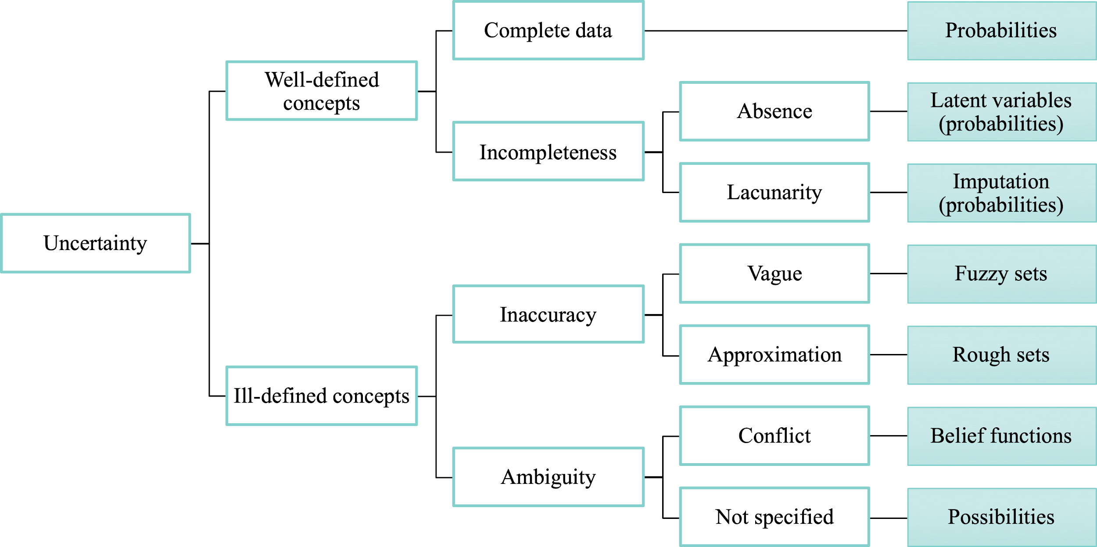
Notions of uncertainty to be supported by the NFOLD reference models, with the corresponding representation artefacts.

- The management of conflicts resulting from contradictory annotations will be informed by the taxonomy of Resendes et al. (2014), which underpins strategies of conflict avoidance, conflict resolution, acknowledgement of inability to solve, and acknowledgement of occurrence.
- As for the reasoning needs, the project will characterise the applicability of various solutions in a case-by-case fashion, fed by the pilot experiments. Starting from the representation artefacts appearing on the rightmost column of the diagram above, the framework will incorporate techniques of probabilistic and statistical reasoning (Briggs, 2016; Oates & Sullivan, 2019), defeasible reasoning (Antoniou and Bikakis, 2007) and computational argumentation (Micallef et al., 2012; Patkos et al., 2016). If the need arises at some point, these may be supplemented with other forms of non-demonstrative reasoning, namely abductive reasoning (Janíček, 2012) to discover new rules from incomplete sets of observations, and approaches based on many-valued logic for paraconsistent reasoning (Kaminski et al., 2015), which can logically avoid trivialisation (any conclusion would follow) from contradictory bits.

References
- Briggs, W. (2016) Uncertainty: The soul of modeling, probability and statistics. Springer.
- Caglioni, Matteo & Fusco, Giovanni. (2014). Formal Ontologies and Uncertainty. In Geographical Knowledge. TeMA - Journal of Land Use, Mobility and Environment. 10.6092/1970-9870/2530.
- Kaminski, T., Knorr, M., & Leite, J. (2015). Efficient paraconsistent reasoning with ontologies and rules. IJCAI.
- Micallef, L., Dragicevic, P., Fekete, J.-D. (2012) Assessing the effect of visualizations on Bayesian reasoning through crowdsourcing. IEEE Transactions on Visualization and Computer Graphics, 18 (12), pp. 2536-2545.
- Oates, C.J., Sullivan, T.J. (2019) A modern retrospective on probabilistic numerics. Statistics and Computing, 29 (6), pp. 1335-1351.
- Resendes, S., Carreira, P., & Santos, A.C. (2014). Conflict detection and resolution in home and building automation systems: a literature review. Journal of Ambient Intelligence and Humanized Computing, 5, 699-715.
- Valtolina, S. (2016). A storytelling-driven framework for cultural heritage dissemination. Data Science and Engineering, 1(2), 114-123.

