📘 Personal Knowledge Vault (Vault Project)
Personal Knowledge Vault
A full-stack web application that allows users to securely manage personal notes. The project uses Spring Boot for the backend and React.js for the frontend, with JWT-based authentication.

1️⃣ Modules Overview
🔐 Authentication Module
- User Registration
- User Login
- User Logout
- JWT-based authentication
- Secured APIs using Spring Security
- Axios for handling HTTP requests
- OAuth2 login (Google )

🖥️ Frontend Module (React.js)
- User-friendly UI for login & registration
- Notes dashboard
- Create, edit, delete notes
- Add Notes , Favorite Notes & Save Note
- API integration with backend using JWT

📝 Notes Management Module
- Create notes
- View all notes (user-specific)
- View note
- Update notes
- Delete notes
- favorite notes

⚙️ Common Modules
- Global exception handling
- Validation (Jakarta Validation)
- Layered architecture (Controller → Service → Repository)

2️⃣ Getting Started
Follow the steps below to run the full-stack application (Frontend+Backend) locally.
Step 1: Clone the Repository
https://github.com/mlondhe69-art/Personal_Knowledge_Vault
Step 2: Frontend Setup (React.js)
- Navigate to the frontend folder:
cd frontend
2. Install dependencies:
npm install
- Start the React application:
npm start
- Frontend will run at:
http://localhost:5173

Step 3: Backend Setup (Spring Boot)
- Open the backend project in Eclipse or IntelliJ
- Configure database and JWT settings in application.properties
- Run the backend application
mvn spring-boot:run
- Backend will start at:
http://localhost:8080

3️⃣Tech Stack

Frontend
- HTML & CSS
- JavaScript (ES6)
- React.js
- Axios / Fetch API
Backend
- Java 17
- Spring Boot 3.x
- Spring Security
- JWT (JSON Web Token)
- Spring Data JPA (Hibernate)
- MySQL / H2
Tools
- Maven
- Node.js & npm
- Git & GitHub
4️⃣ Project UI:
- Home Page-
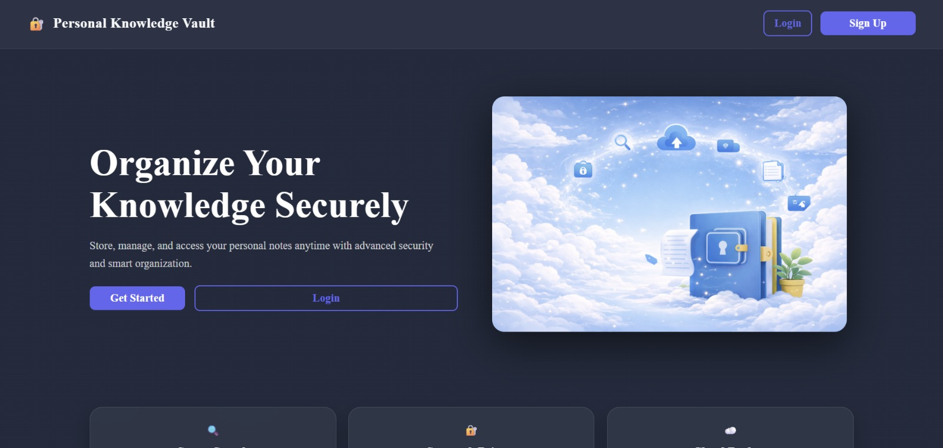
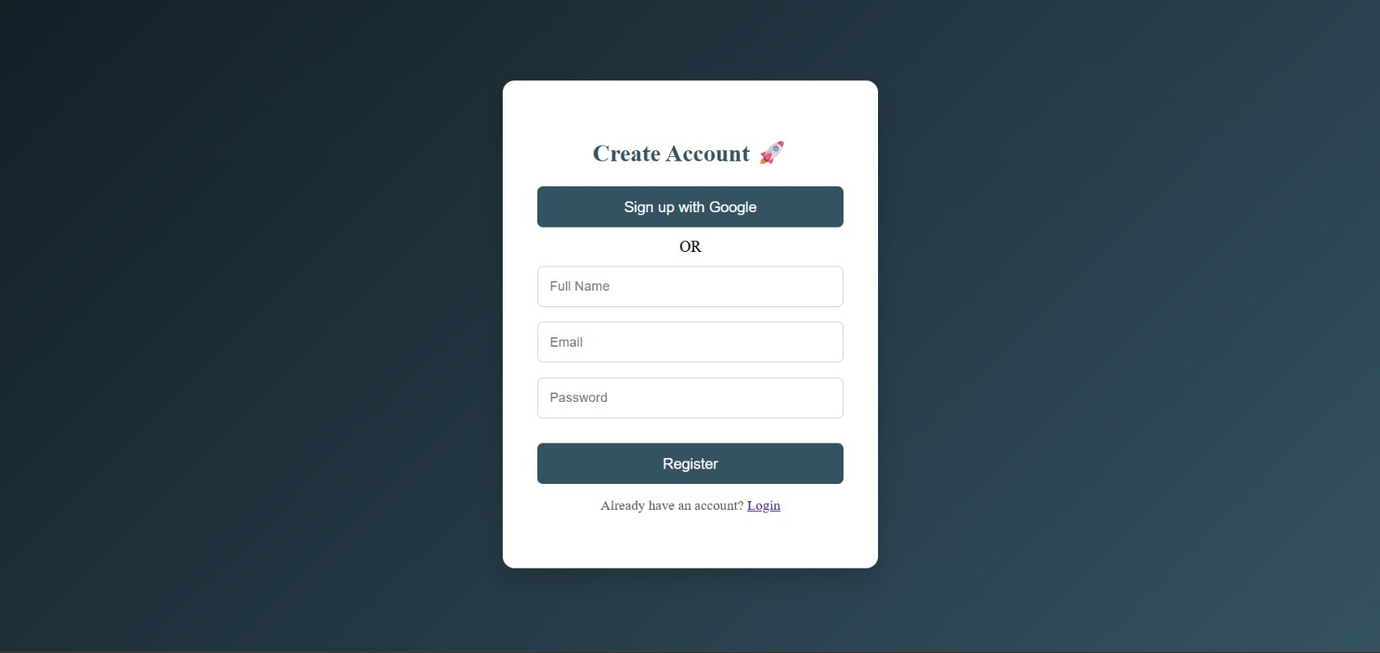
- Register Page-

- Login Page-

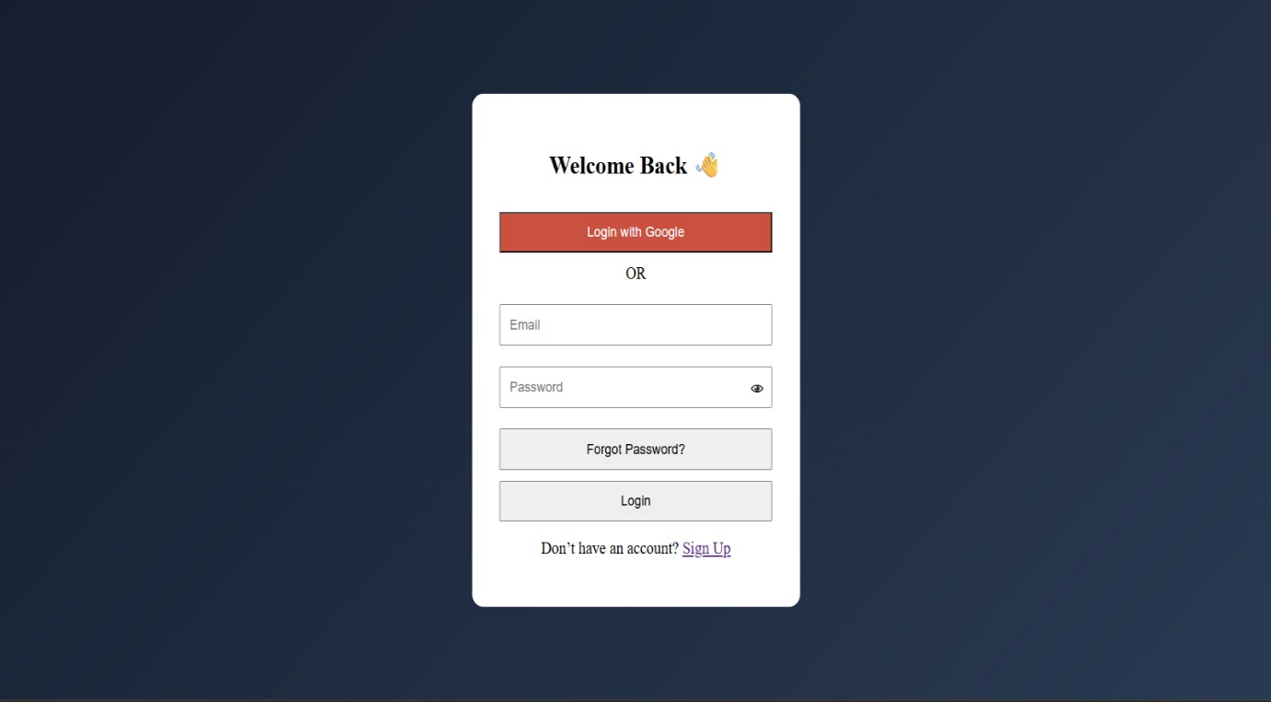
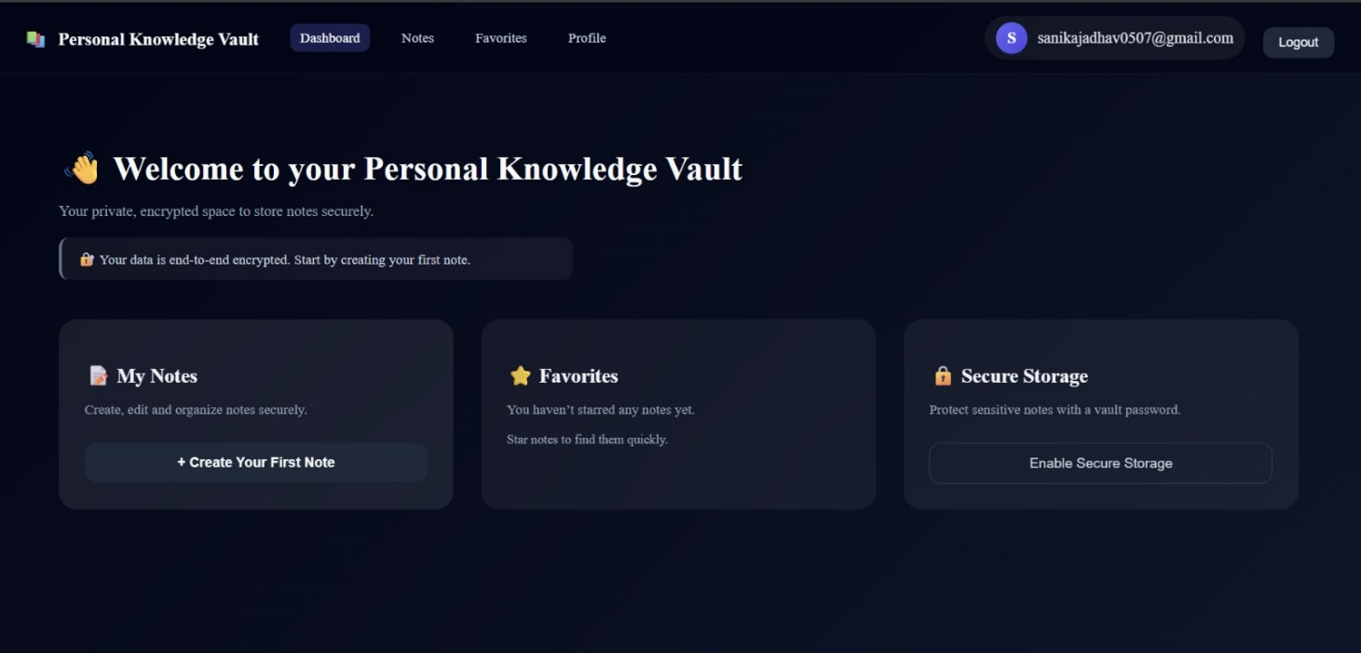
- Dashboard Page-

- Notes Page-
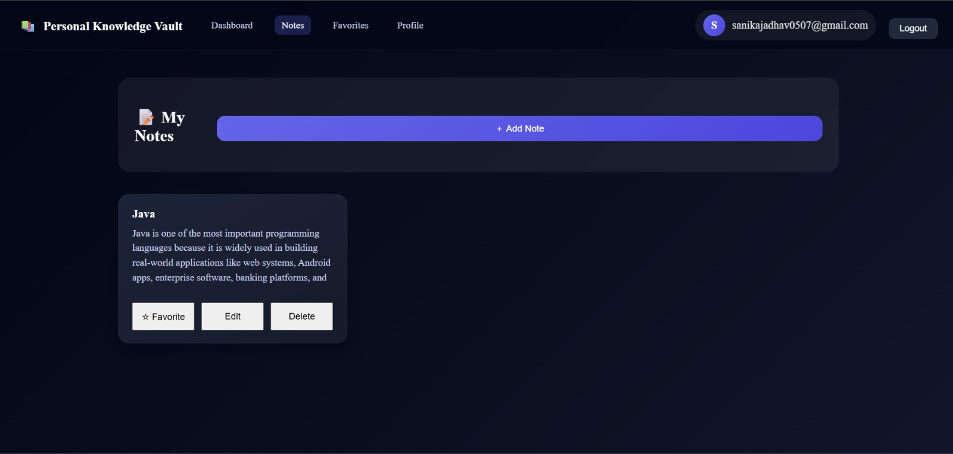

- Add New Note Page-
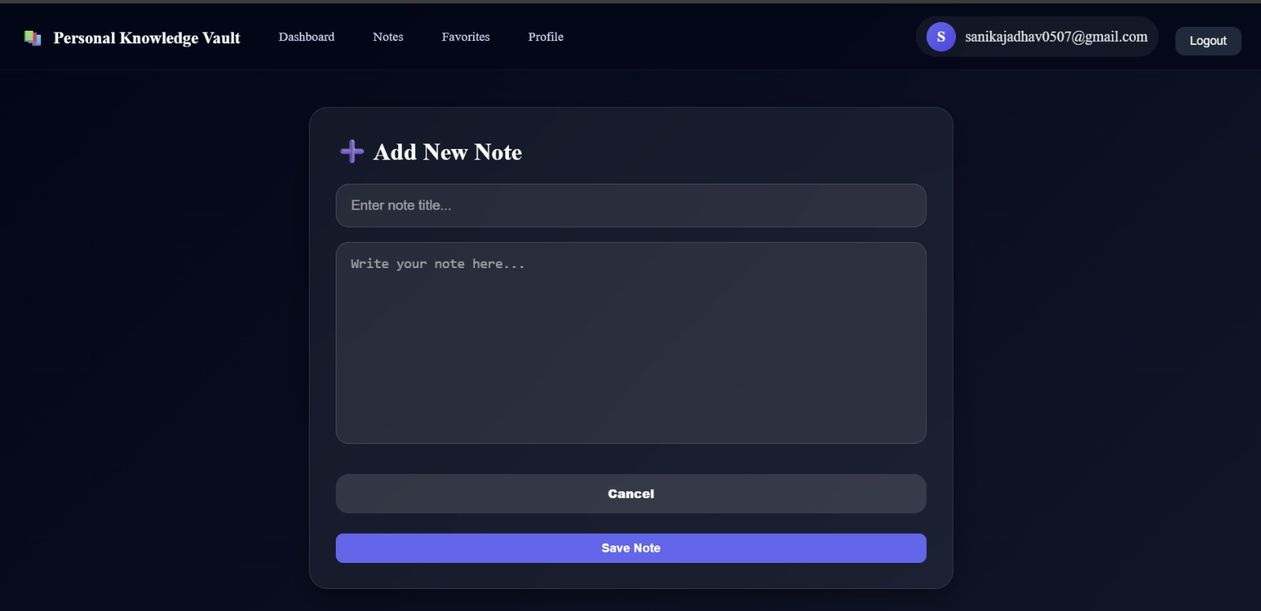

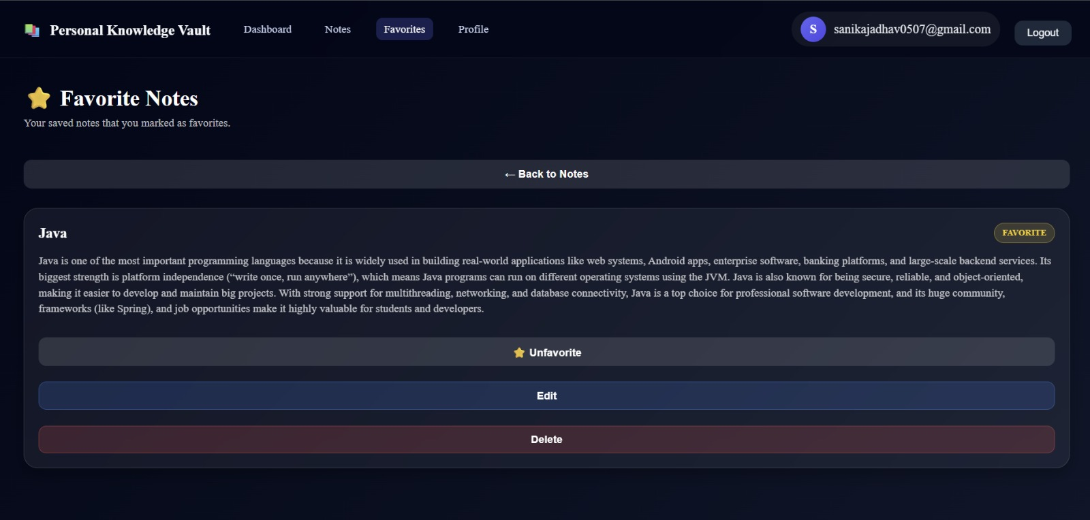
- Favorite Note Page-

- Profile Page-
