**Learn to Cook**

COSC 412 Individual Project

Michael Long

Towson University

Rebecca Broadwater

COSC 412 Fall 2020

Table of Contents

Part 1: **Introduction ..................................................................................................................... 3**

1.1 Project Overview ........................................................................................................... **3**

1.2 Project Deliverables ....................................................................................................... **3**

1.3 Evolution of the SPMP ................................................................................................... **3**

1.4 Reference Materials ....................................................................................................... **3**

1.5 Definitions and Acronyms .............................................................................................. **3**

Part 2: **Project Organization**

2.1 Process Model ............................................................................................................... **4**

2.2 Organizational Structure ................................................................................................. **4**

2.3 Organizational Interface ................................................................................................. **4**

2.4 Project Responsibilities .................................................................................................. **4**

Part 3: **Managerial Process**

3.1 Management Objectives and Priorities ............................................................................. **5**

3.2 Assumptions, Dependencies, and Constraints …........................................................ **5**

3.3 Risk Management .......................................................................................................... **5**

3.4 Monitoring and Controlling Mechanisms ......................................................................... **5**

3.5 Staffing Plan …........................................................................................................... **5**

Part 4: **Technical Process**

4.1 Methods, Tools, and Techniques ..................................................................................... **6**

4.2 Software Documentation ................................................................................................ **6**

4.3 Project Support Functions ............................................................................................... **6**

Part 5: **Description of Work Packages**

Work Breakdown Structure (WBS) ....................................................................................... **7**

Project Schedule .................................................................................................................. **7**

**Part 1: Introduction**

1.1 Project Overview

This cooking website will be different from the usual cooking respite because it will not have any specific measurements. The focus of this website is to help people learn how to cook rather than just blindly follow a recipe. Instead of saying that you should add exactly a tablespoon of salt, it will say salt to taste. The difference is that in the first example a cook might not be paying attention to the process at all and may just be reading the instructions, while in the second example you have to be tasting and thinking about the food, deciding what it need for yourself.

1.2 Project Deliverables

Proposal – 9/6/2020

SPMP – 10/16/2020

Project Due -11/10/2020

Final Presentation – 11/30/2020

1.3 Evolution of the SPMP

Changes in the SPMP will be heavily reliant on what the customer wants. The original SPMP will be the first time the customer will see the entire product laid out which will likely lead to drastic changes so that the end result can be exactly what the customer has envisioned.

1.4 Reference Materials

N/A

1.5 Definitions Acronyms & Explanations

Database (DB): A collection of data which will be used for holding user's personal information along with their fitness activity.

SPMP: Software Project Management Plan

**Part 2: Project Organization**

2.1 Process Model

Iterative Process Model

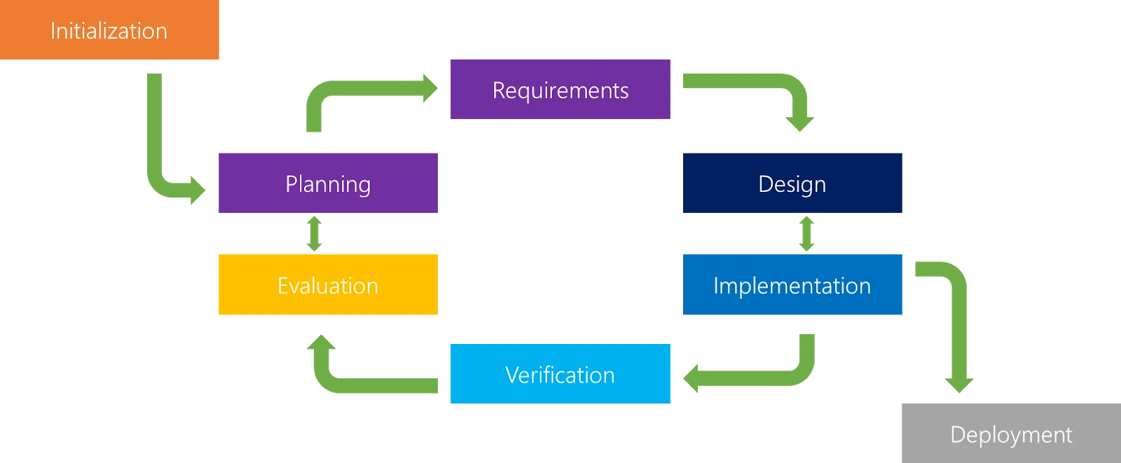

2.2 Organizational Structure

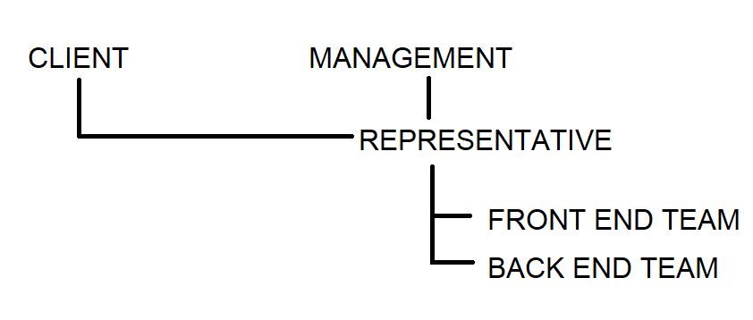

2.3 Organizational Interfaces

GitHub

2.4 Project Responsibilities

The major tasks of this project include setting up the front end of the website for users to interact with and the backend database that will hold all of the recipes.

**Part 3: Managerial Process**

3.1 Management Objectives and Priorities

This project will be managed into small goals and tasks to constantly be able to report back to the client with updates. These updates can also change the direction of the project as the client may have a different vision then what was originally expected.

3.2 Assumptions, Dependencies, and Constraints

This project is under a time constraint, it must be completed by November 10th by midnight

3.3 Risk Management

Risks for this project include the learning curve for overcoming aspects of the project that may not be familiar and other commitments including work or school that can be time consuming.

3.4 Monitoring and Controlling Mechanisms

Updates on the project will be provided via the link to its GitHub. This can be checked at any time.

3.5 Staffing Plan

This project will have a one man staff

**Part 4: Technical Process**

4.1 Methods, Tools, and Techniques

GitHub – Keep record of all updates to the project. Code and deliverables

HTML – Design the structure of the website

Python – Code the pages and any pathways

CSS – Design the style of the website

4.2 Software Documentation

The documentation plan is to update the SPMP with all updates as needed, ensuring that the revision sheet is updated as well. Anything that does not fit into the SPMP will be written up on a separate word document and added to the repository.

4.3 Project Support Functions

Quality assurance will be guaranteed by having consistent checks with the client to make sure our progress and plans continue to align with their vision. As far as configuration management and dealing with change, the project will be altered as needed, within reason, depending on the client’s needs.

**Part 5: Description of Work Packages**

5.1 Work Breakdown Schedule (WBS)

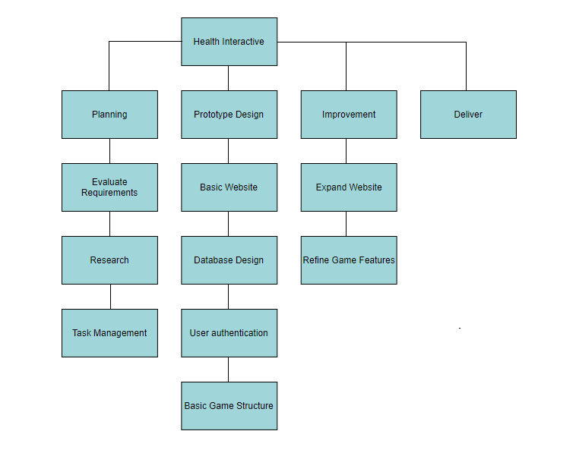

5.2 Project Schedule

Timeline:

