Beer Judge

Introduction
Given the explosion of the craft beer industry in the United States and Canada selecting a craft beer is difficult. There are now 167 craft breweries in Ontario, each producing multiple beers. Access to out of province beer is growing. There are simply too many beers for a human to process. I propose to make a beer recommendation system with the input being list of choices (a menu) and the output a ranked list based on the user's past preferences.

Literature Review
I've reviewed the linked literature on text based recommendation systems, most implement a cosine measure for similarity and some form of term frequency – inverse document frequency to generate weighted bags of words to use as part of the comparison. LDA is also a popular feature extraction methodology.
http://www.aclweb.org/anthology/C10-2079
This paper proposes a hand built model for text classification, it has a particularly good feature extraction set, and is similar to using LDA.
http://sydney.edu.au/engineering/it/~josiah/wi03_recommender.pdf
An interesting idea is presented here, in that the ratio of unique words used across all reviews to the number of reviews can separate good text prediction from bad. It also suggests that for Text Classification that Naive Bayes, knn and Decision Trees have equal performance.
http://www.cs.utexas.edu/~ml/papers/pbennett-ugthesis.pdf
A model similar to a Naive Bayes classifier is presented here, with the probability distribution being used to output a score for a classifier.
http://kth.diva-portal.org/smash/get/diva2:759691/FULLTEXT01.pdf
This is a good overview of using LDA as a feature extraction method, and it uses a simple model to compute similarity between movies.

Dataset
The data set is a webscrape of 620,000 beer reviews from RateBeer.com. The data consists of 23 fields which are detailed in columns.rtf on the github https://github.com/mlongland/RyersonProject. I have added a few csv files in the github repository with some basic statistics broken down by beer style. A simple regression on the alcohol content is shown In simple analysis to show that higher alcohol content has a roughly linear positive effect on the rating of a beer. Alongside the text reviews which users submit there are a few other categories that would likely make good features such as the brewery, the alcohol content, the beer style and the bitterness (IBU). The main feature I will be using is the score, a rating out of 5 which a user gives a beer.

Approach

Step 1: Data Collection
Use import.io webscraping service to crawl RateBeer.com and extract the 23 columns of information in each beer review. This is downloaded into a json file.

Step 2: Parse Data
Use python to parse the json file into several flat files, but mainly AllBeer.txt which can then be used in Spark. https://github.com/mlongland/RyersonProject/blob/master/Scribbles/testreadjson.py

Step 3: Preliminaries/Shaping
Read the file into Spark, normalize the relevant data, split the data into training and test sets, 80/20.

Step 4: Create feature sets from reviews
Implement TF IDF functions in Spark, make bags of words for each user and weight by the rating the user gives the beer, this forms a list of ranked features which the user likes. Apply a similar TF-IDF to each beer to identify weighted traits for each beer. Later add other beer features to increase feature space.

Step 5: Measure distances
Using the test data set for each user as a menu, generate a distance score from the beer to the user preferences. Output a sorted menu with the beers and distance scores.

Step 6: Quantifying the fit
Using a measure such as the Spearman Rank coefficient, quantify the goodness of the fit to the user's actual scores.

Step 7: Evaluate the Iteration
Using the fit, examine which features are valuable and which are not.

Step 8: Refine features
Refine the features and generate new feature set for testing.

Step 9: Abandon the text and use an ALS Collaborative Filter
Train an ALS collaborative filter to recommend beers based on other user's reviews.

Results
A look at the distribution of scores which the user's give show that most ratings fall between 3 and 4 with a peak at 3.4. A Long tail to the low side shows that users are generally unwilling to give bad scores to beers even if they don't like them. Anything above a 4 is really an exceptional score.
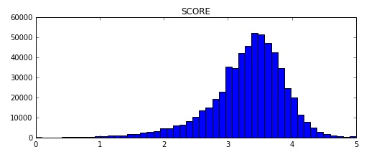
Spearman correlation was used to compare the order of the predicted ratings to the order of the user's actual ratings. This is a tough measurement as the granularity of the data isn't toned down at all. A score from 0-5 is actually 50 possible scores. The predictor being off by even 0.1 will frequently change the order of a list as most ratings fall tightly around 3.4.
Using a cosine distance measure with a feature reduced set and TF-IDF scores yields a Spearman correlation of 0.171. Using a Naive Bayes classifier, trained for each user individually yields a similar Spearman correlation of 0.176 and a Mean Squared Error (MSE) of 0.277. The MSE for the cosine distance isn't applicable as the method does not predict a score, just the order.
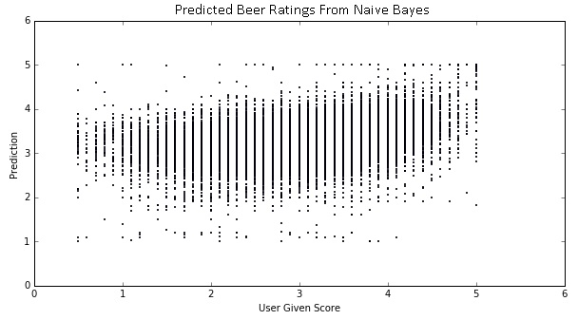
The Spearman Correlation using an Alternating Least Squares Collaborative Filter is 0.516 for all the beers in the test set and 0.472 for a reduced 10 item menu. The MSE is 0.209, corresponding to an RMSE of 0.45. Also the mean error is 0.16, which indicates that there is some bias to the low side.

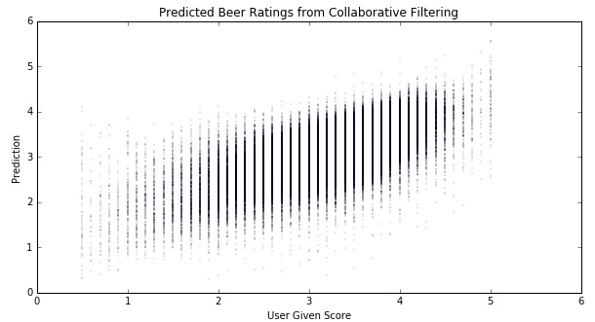
A clear positive trend can be seen between the predictions and the user's given score. It should also be noted that the RMSE is similar to the Netflix prize results, and this is to be expected since ALS collaborative filter is the technique which won.

Conclusions
So clearly ALS is the winning method for creating a recommendation service from the various methods I've tried. Ordering a list with high granularity is not an easy task. Simple averages of style and brewery show that people have loyalties and those are decent predictors of the user's score. I believe the data is just too sparse to make meaningful connections between a user's preferences and a beer's traits using text analysis. The average review has a scant 26 words, and not all words are useful.
The feature extraction methodology I used seemed to be quite good at pulling traits from the descriptions, this would be of use in a broader recommendation sense that it could be added along side the recommended beers for users to inspect the traits in the beer.
Technology wise, using PySpark and Python with Flask with iPython NoteBooks to have an all in one solution fo parsing data, training models and publishing the results to a web capable RESTful API is pretty seamless and is good toolset. Having MLlib in Spark and NumPy and SciPy available makes the possibilities for Data Science huge without having to switch platforms constantly as when using Pig, Hive, and R.

