**Exercises about file and directory permission**

1. List the permissions in your current directory, including hidden files.

ls -la (a to see the hidden files)

1. Create a file called perm1. Now, check the default permissions and user and group ownership

touch perm1.txt



1. Change permissions of perm1 so that everyone can read and only the owner user can write. Specify the command in all possible ways.

chmod 644 perm1.txt

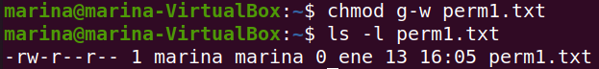

1. Create a file called script1.sh, including the content below. List the default permissions.

#!/bin/bash

clear

who

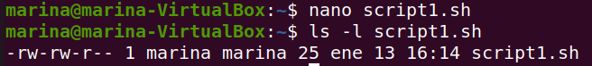

By default, for safety reasons, there’s no x permission.

1. Remove the read permission from the owner and try to open the file

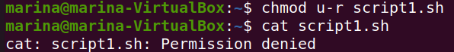

1. Remove the write permission from the owner on the file script.sh. Add the line below. Is it possible? Why?

new line

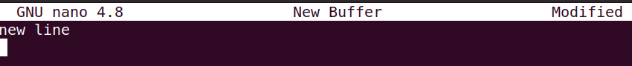



I don’t have permission as owner neither read nor write, so the system creates another file if I want to write something out.

1. Change the permissions on the file script1.sh so that the owner can read, write and execute, but you deny all the permissions from the group and others.

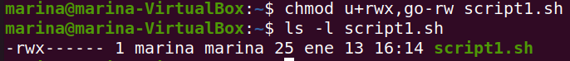

1. Add the line indicated in exercise 6, in case it was not possible. Try to run the file like a command.

nano script1.sh

bash script1.sh (bash is an external tool to execute a script)

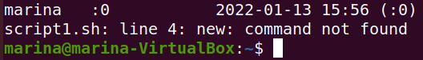

1. Remove the read permission from the owner on the file script1.sh. Try to run the file. Is it possible? No.

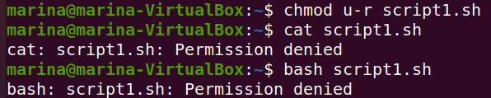

1. Create a directory called “systems”. Remove the write permission from it and try to copy script1.sh inside.

mkdir systems

chmod u-w script1.sh



1. If you were not able to copy the file, add the write permission again and copy the file inside.

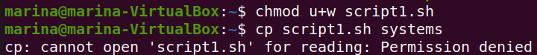

1. Remove the read permission from the user on the directory “systems” and try to list its contents.

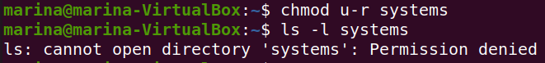

1. Change the permissions from “sytems” so that the owner can read, write and execute, but the group and others can only read.

chmod go-wx systems

drwxr--r-- 2 marina marina 4096 ene 13 16:41 systems

1. Remove the execute permission from “systems”. Can you execute systems/script1.sh? Is it possible to access the directory to execute the file?

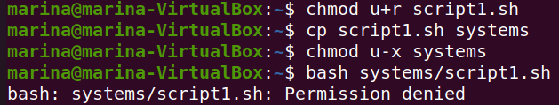

1. Assign the execute permission to the directory again

chmod u+x systems

1. Create two files called “lucy” and “charles” into “systems”. Change permissions of “charles”, so that others can write and execute.

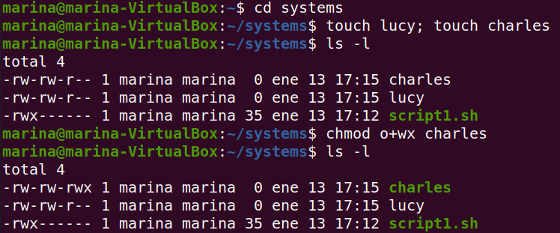

1. Change permissions of “lucy” so that the owner can read and execute, the group can read and write and others can only write. Specify the command in all possible ways

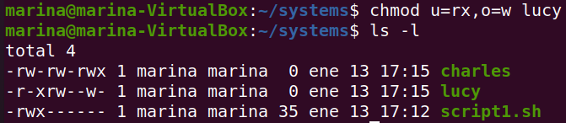

1. Log in as root. Change the ownership of “charles” to “root”. Exit the root session. Now, try to change the permission so that others cannot read and execute. Is it possible? Why?

As I changed the ownership of Charles, now if I am not logged in as root I couldn’t be able to modify the permissions.

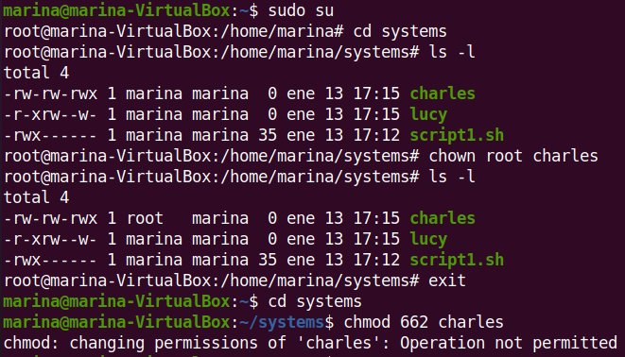

1. Change the permissions of “charles” so that everybody can do everything.

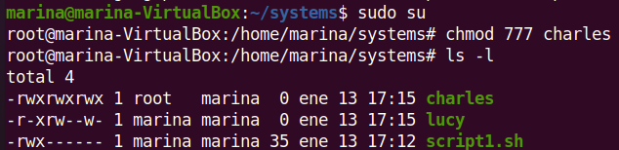

1. Change the permissions of “lucy” so that the group can read and write, but the owner and others cannot do anything. Can you open the file?

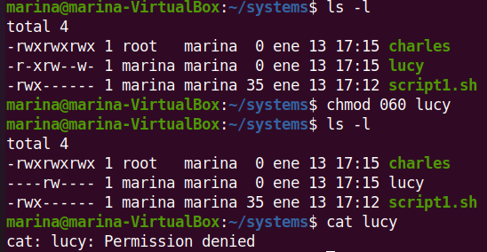

No, I cannot open the file if I am into the systems directory as just the group has that permission.

1. Create a group called “newgroup”. Set the group as the owner of the file “lucy” and “root” as the owner user.

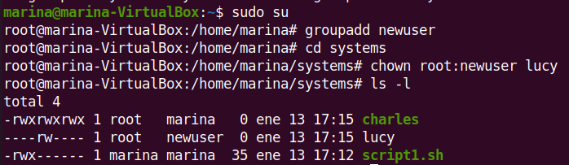

1. Add your user to the secondary group “newgroup”. Try to open the file “lucy” now. Is it possible?

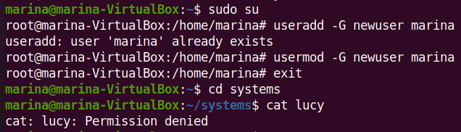

No, its not possible.

1. Change permissions of “lucy” so that everybody can read.

