19.

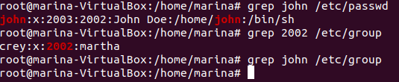

Here we have that John’s primary group is crey (id 2002). Also, john doesn’t have a secondary group as we are not able to find the user at the last command.

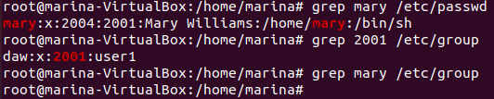

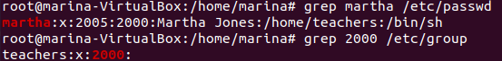

20. I can’t delete the groups I have created as they are primary groups of a user.

21.

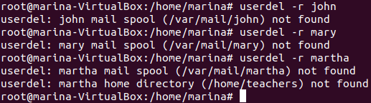

22.

