MPPUK006
CL730S22 Specification

Table of content
- BASIC PARAMETERS ........................................................................................................................... 1
- MECHANICAL PARAMETERS ......................................................................................................... 7
- REFERENCE STANDARD ................................................................................................................ 14
- ENVIRONMENTAL PARAMETERS ............................................................................................. 15
- ELECTRICAL PARAMETERS ........................................................................................................ 15

- EMC PARAMETERS ........................................................................................................................... 15

Meter Requirement S
pecification

2018.08.0
9
-
V1.
2

- FUNCTIONS ........................................................................................................................................... 16

1 Basic Parameters
Item | Comment


SHENZHEN CLOU ELECTRONICS CO. LTD

CLOU Building

Hi
-
tech Industry Park North
,
Baoshen Road South

Shenzhen, Guangdong
, China

Postcode: 518057

Email:
oversea@szclou.com

34048

E3440

Page
1

of
21

Type(外部型号) |  | CL730S22
Accuracy  精度等级 | Active  有功电能 |         
 | Reactive 无功电能 |       
Voltage  电压 | Nominal voltage  Un  额定电压 |     



 | Operating range  电压工作范围 | 0.8 Un-1.2Un
 | Overvoltage  极限工作电压 | 1.9Un (Default)
 | Remark
Current  电流 | Basic current Ib  额定电流 |   

 | Max current Imax  最大电流 |     
 | Active Istart  有功启动电流 |   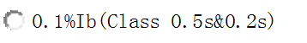
 | Reactive Istart  无功启动电流 |     
 | Remark | None
Frequency  频率 | Nominal frequency Fn  额定频率 | 
 | Operating range  频率工作范围 |   
 | Remark | None
Meter constant  脉冲常数 | Active  (imp/kWh)  有功脉冲常数 | 
 | Reactive  (imp/kVarh)  无功脉冲常数 |   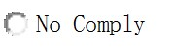
 | Remark | None

Local communication  本地通信 | Type  通信方式 | RS485(Default)  RS232  Modulated IR  No modulated IR(Default)  SCSSCAAA9(SCSSCAAJ1)  Contact Card  NFC Card
 |  |  | No Specify
 |  |  | No Comply
 | Remark
AMI communication  AMI 通信 | Type  通信方式 | FSK-PLC G3-PLC Prime-PLC  Hi-PLC  2G(GPRS) 3G 4G  MBUS-Wire MBUS-Wireless  RF RF&PLC  No Specify No Comply
 | Plug and play  模块可拔插 | 
 | Remark | No Up-link communication method needed
UIU/HHU communication 用户单元/掌机通信 | Type  通信方式 | FSK-PLC G3-PLC Prime-PLC  Hi-PLC  RF Cable
 |  |  | No Specify
 | Remark | No Down-link communication method needed
Display  显示 | Type  显示方式 |     
 | E integer num  电量整数个数 |     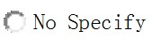

 | E decimal num  电量小数个数 |   
 | Backlight color  背光颜色 |   
 | Remark
LED  指示灯 | Active pulse  有功脉冲灯 | 
 | Reactive pulse  无功脉冲灯 | 
 | Alarm  报警灯 | 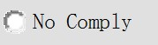
 | Credit (2 color)  金额指示灯 | 
 | Power  上电指示灯 | 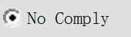
 | Communication  通信指示灯 | 
 | 电流反向报警指示灯 | 
 | Remark
Pulse output  脉冲输出端子 | Active  有功电能脉冲 | 
 | Reactive  无功电能脉冲 | 
 | Remark | None
Beep 蜂鸣器 |  | 
Latch Relay 磁保持继电器  (一般配置在直接接入式电表中) | Pole number  控制回路 |   
 | UC level  UC 等级 |   
 | Remark

Power Relay 功率继电器  (一般配置在间接接入式电表中) |  | 
Key&  Detection  按键&检测 | Display button  显示按键 | 
 | MD button  清需量按键 | 
 | STS keypad  STS 键盘 | 
 | Meter Cover  开表盖检测 | Comply
 | Terminal cover  开端盖检测 | 
 | Top cover  开上盖检测 | 
 | Battery cover 开电池盖检测 | 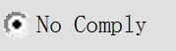
 | Module cover 开模块盖检测 | 
 | Magnetic 磁检测-42 | 
 | Remark
RTC 时钟 |  |       
Subsidiary power  辅助电源 | Super capacitor  超级电容 | 
 | RTC battery  时钟电池 | 
 | Replaced battery  可更换电池 | 
 | Remark | None
Measurement elements  计量单元 | Phase line  火线 | 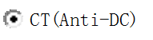  
 | Neutral line  零线 |   
 | Loss neutral measurement 掉零线计量-43 |     
 | Remark

2 Mechanical Parameters
Item 项目 |  | Comment 备注
Structure  结构 |  |     
Wiring connection  接线方式 | 1P2W |   
 | 3P4W |   
 | Remark
Meter No.  表号 | Type  类型 |         
 | Remark

Cover  上盖 | Material 材质  (透明上盖默认 PC；  非透明上盖默认  PC+10%GF) |         
 | Color  颜色 |       
 | Remark
Base cover  底壳 | Material 材质  (透明底壳默认 PC；  非透明底壳默认  PC+10%GF) |         
 | Color  颜色 |       
 | Remark | None
Terminal cover  端盖 | Material 材质  (透明端盖默认 PC；  非透明端盖默认  PC+10%GF) |         
 | Color  颜色 |       

 | Type  类型 |     
 | Remark
Terminal block  端子座 | Block material  端子塑胶部分 |     
 | Wiring clamping type  端子接线 |     
 | Terminal material 金属端子  (固定端子默认铜；移动端子默认  铁) |     
 | material coating  金属端子镀层 (铜默认镀镍；铁默认镀彩锌) |       
 | Clamping screw material  端子螺钉 |     
 | Clamping screw coating  端子螺钉镀层 (铜默认镀镍；铁默认镀彩锌) |       
 | Remark | None

Dust and water protection  防尘防水 | Degree  等级 |       
 | Remark
Dimension(mm) |  | 285.0mm×175.0mm×90.0mm
Name plate  铭牌 | Material 材质  (其中 Laser 工艺的铭牌无法呈现彩色) | 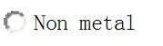  
 | Language  语言 |   
 | Remark | 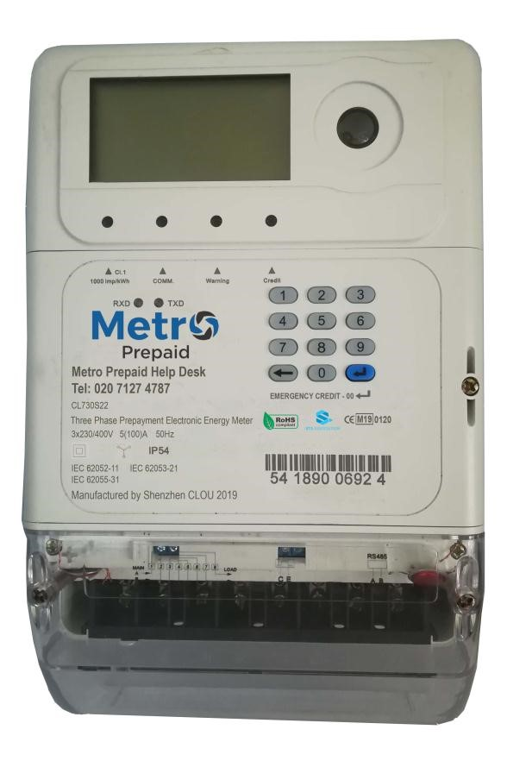

Wiring diagram  接线图 | Material  材质 | 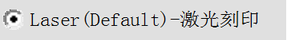      
 | Position  展现位置 | 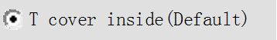      
 | Remark | None
Sealing  密封 | Type  密封类型 |       

 | Seals material 铅封材质 |   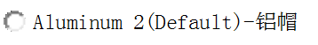                  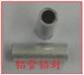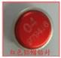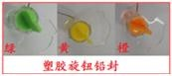  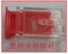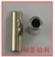
 | Seals wiring 铅封线  (采用非螺钉密封方式的电表则不要铅封  线) |   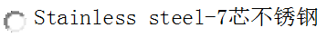      
 | Seals fixed  铅封安装位置  (采用非螺钉密封方式的电表则不要铅  封) | Top cover  Terminal cover  Module cover  Battery cover  MD button  No Specify  No Comply
 | Remark | Terminal cover seal in the box

Packing  (大货项目需要填写，样机项目可都  选择 No  Comply) | Type  包装方式 |  | 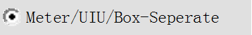  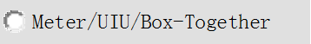            
 | Shipping mark color  唛头颜色 |  |       
 | Shipping mark language  唛头语言 |  |   
 | Pallet  栈板 | Dimension  尺寸 |   
 |  | Material  材质 |       
 |  | Sticker  -133  贴纸 |     
 | Quality certification  合格证 |  |   
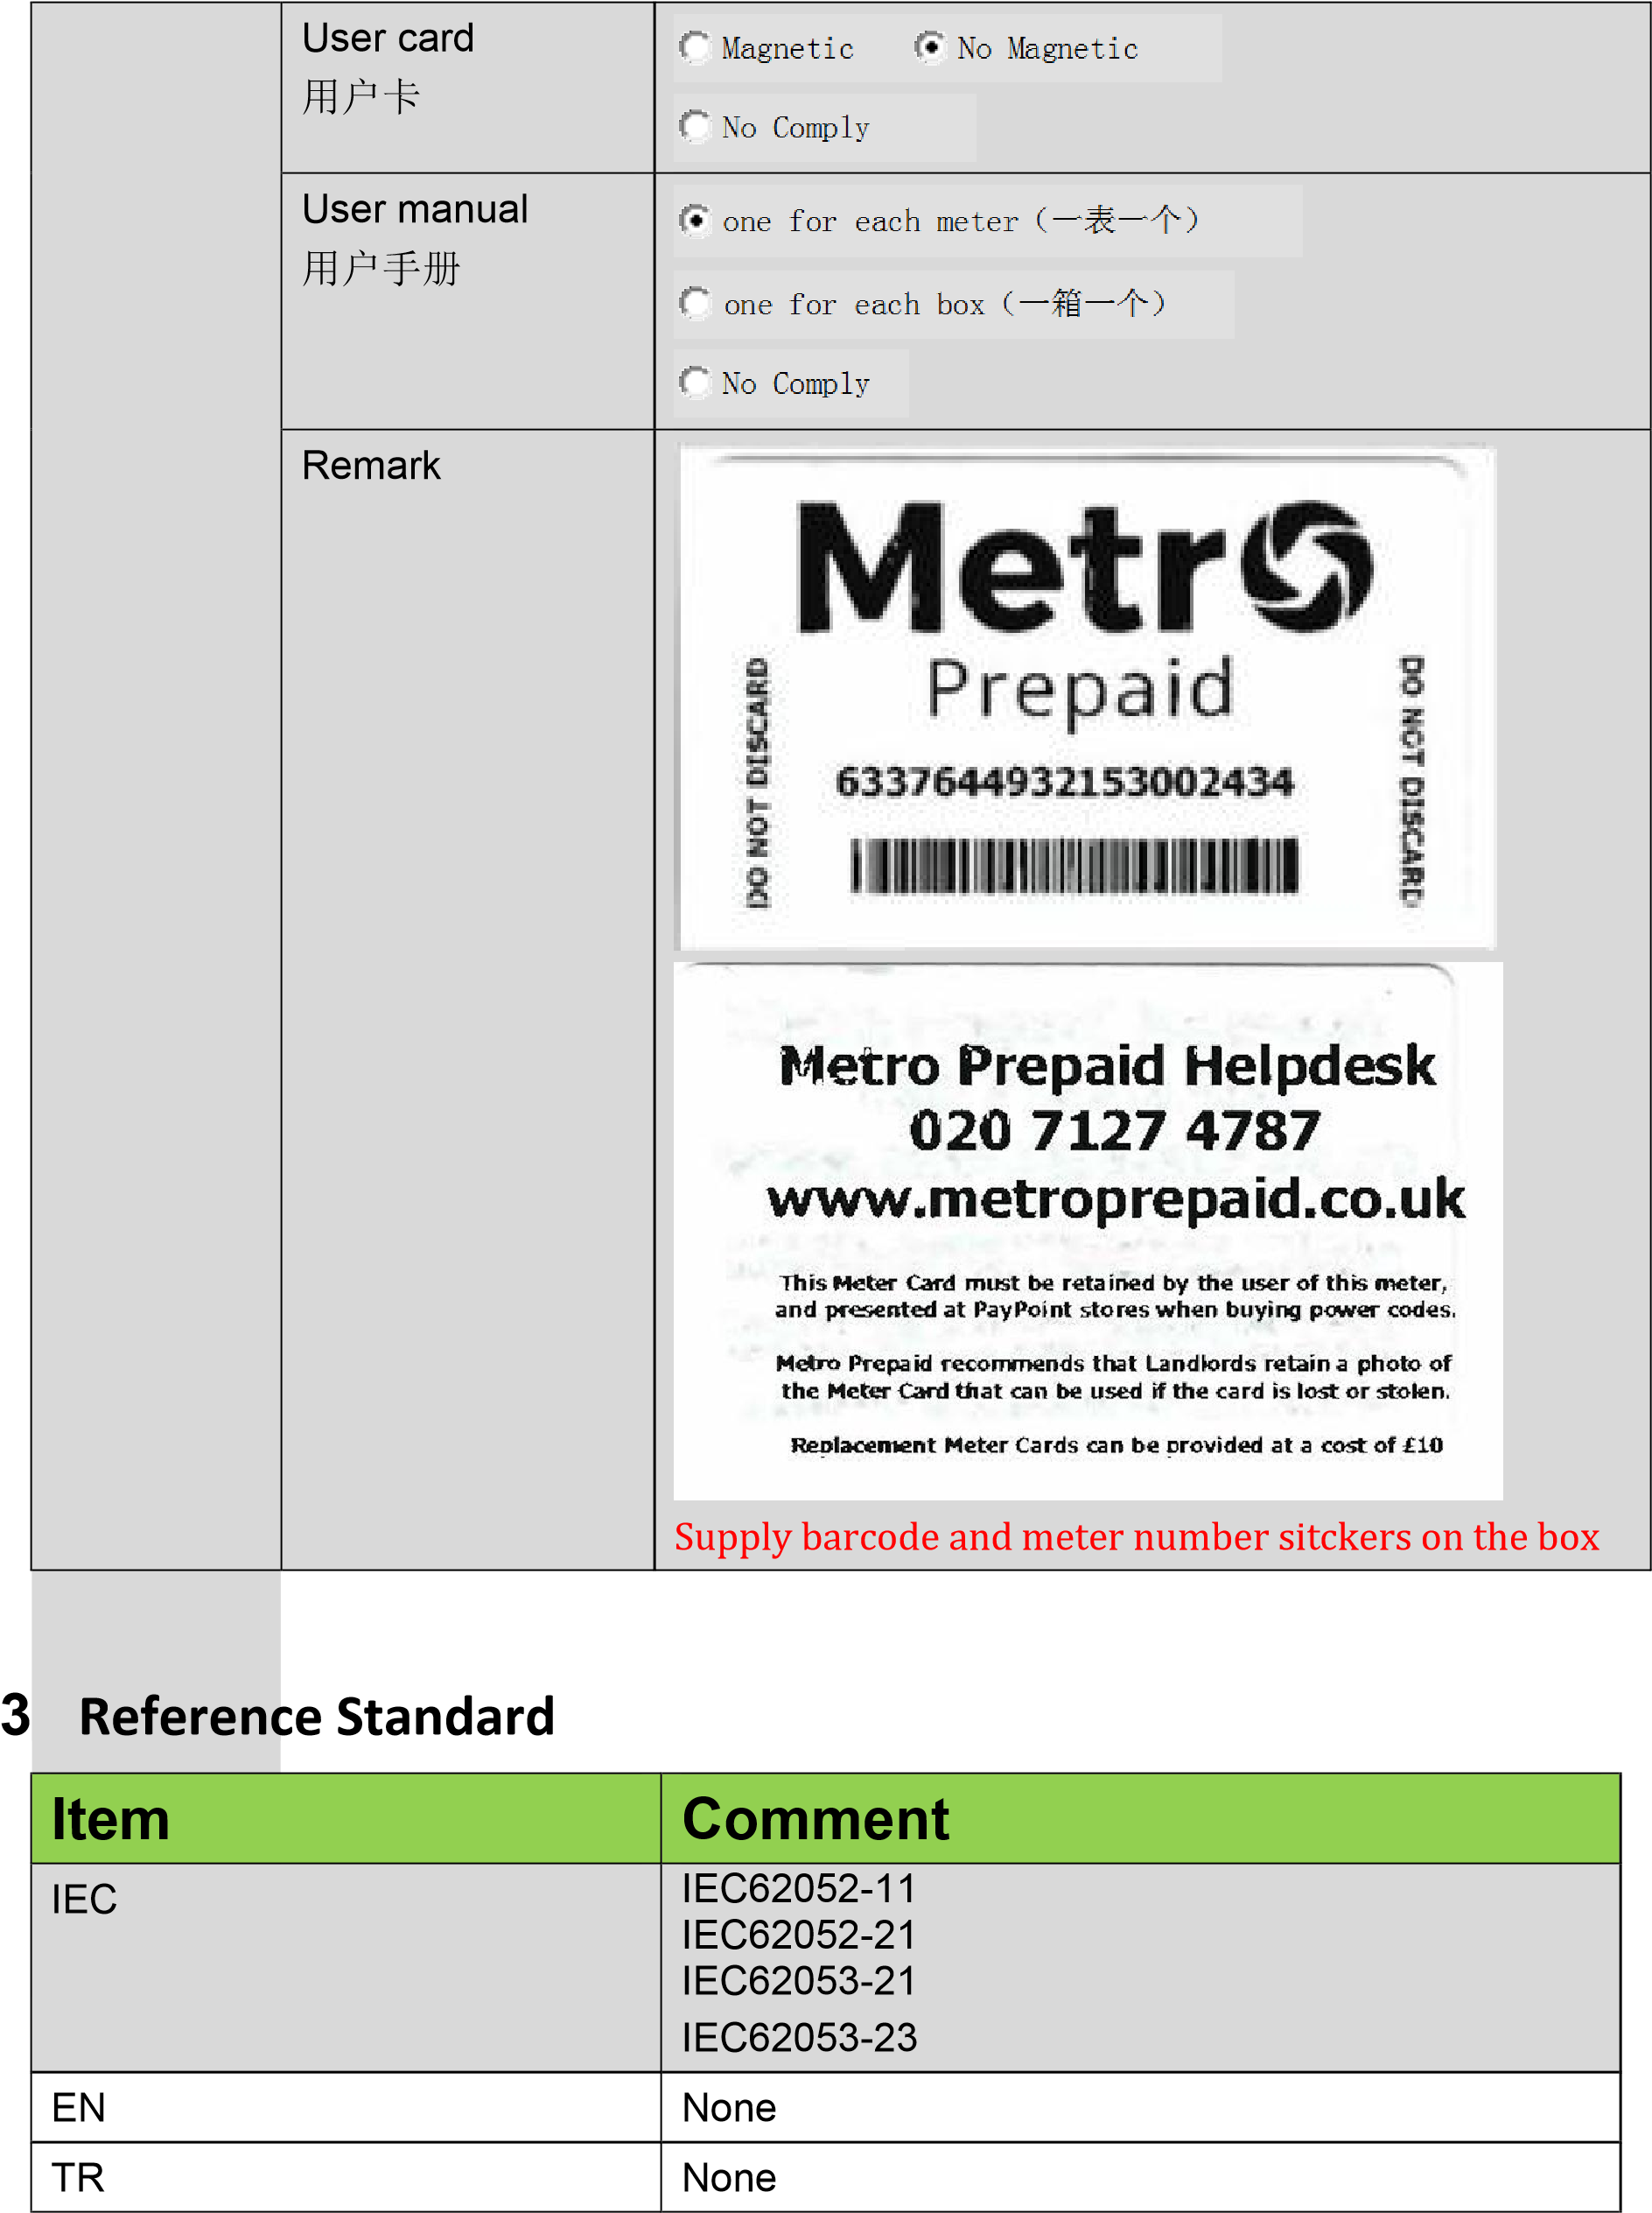

4 Environmental Parameters
Item | Comment
Operation temperature range | -25℃～70℃
Limit operation temperature range | -25℃～70℃
Limit storage and transport temperature range | -40℃～70℃
Humidity | 0% ≤ H ≤ 95％
Altitude | 1,000m
Remark | None
STS | IEC 62055-31  IEC 62055-41 (Edition 2.0)  IEC 62055-51
DLMS | IEC 62056-21  IEC 62056-42  IEC 62056-46  IEC 62056-53  IEC 62056-61  IEC 62056-62

5 Electrical Parameters
Item | Comment
Power consumption, voltage circuit | <2 W/8VA per phase
Power consumption, current circuit | <0.5 VA per phase
Impulse Voltage | Insulation Class II  8 kV
AC Voltage | Insulation Class II  AC voltage on main circuit : 4 kV  AC voltage on Auxiliary Contact : 2 kV
Remark | None

6 EMC Parameters
Item | Comment
Electrostatic Discharge Immunity | Contact Discharge:8KV Air Discharge:15KV
HF Electromagnetic Field Immunity | 80 MHz-2 GHz  30 V/m
Fast Transient Burst | 4 kV/100 kHz
Radio Interference Test | Equipment of CISPR 22 Class B
Immunity to conducted disturbances induced by radiofrequency fields | 150 kHz－80 MHz  10 V/m
Surge Immunity | 4 kV
Remark

7 Functions
Item 项目 |  | Comment 备注
Energy  电量 | Combined Active(kWh)  合相有功电能 | Total with multi-tariff  Import with multi-tariff  Export with multi-tariff  No Specify  No Comply
Phase A/B/C Active(kWh)
分相有功电能
 |  |  | Total
Import
Export

No Specify

 |  |  | No Comply
Combined
Reactive(kVar h)
合相无功电能
 |  |  | Total with multi-tariff
Import with multi-tariff
Export with multi-tariff
Quadrant 1~4
No Specify

No Comply

 | Phase A/B/C Reactive(kVar h)  分相无功电能 | Total  Import  Export  No Specify
 |  |  | No Comply
 | Combined  Apparent(kVA  h)  合相视在电能 |  | Total with  Import with  Export with | multi-tariff  multi-tariff  multi-tariff
 |  |  | No Specify
 |  |  | No Comply
 | Phase A/B/C  apparent(kVA  h)  分相视在电能 | Total  Import  Export  No Specify  No Comply
 | Remark
Max  Demand 最大需量 | Combined Active(kW)  合相有功最大  需量 | Total with multi-tariff  Import with multi-tariff  Export with multi-tariff  No Specify  No Comply
 | Combined  Reactive(kVar) 合相无功最大  需量 | Total with multi-tariff  Import with multi-tariff  Export with multi-tariff  No Specify  No Comply
 | Combined  Apparent(kVA) 合相视在最大  需量 | Total with multi-tariff  Import with multi-tariff  Export with multi-tariff  No Specify    No Comply
 | Calc method  需量计算方式 | Block ^{Slide}  No Specify No Comply

 | Interval  需量周期 | 60min 30min 15min 10min  5min  No Specify No Comply
 | Sub-Interval  滑差周期 | 60min 30min 15min 10min  5min 1min  No Specify No Comply
 | Remark
Real value measurement  测量值 |  | Voltage(V)  Current(A)  Active power(KW)  Reactive power(KVar)  Apparent power(KVA)  Power factor
 |  |  | Frequency
TOU Tariff  时分多费率 | Rates number | 4
 | Remark | TOU，single tariff
Step Tariff  阶梯费率 | Steps number | None
 | Remark | None
月冻结  Monthly  billing | Billing count  结算次数 | Last 12th
 | Billing time  结算时间 | The default billing time is 00:00:00 of the 1th day in each month.
 | Billing data  结算数据 | Not Specified
 | Remark | None
日冻结  Daily billing | Billing count  结算次数 | Record the last 31th daily billing data
 | Billing time  结算时间 | The default billing time is 00:00 of each day.
 | Billing data  结算数据 | Not Specified
 | Remark | None
Button | Display button | None

LED | Active Energy Pulse LED | Active Energy Pulse LED
 | Reactive  Energy Pulse LED | None
 | Alarm LED | Yes
Self-diagnose  自检 |  | Not Specified
Calendar  日历 | Time zone  时区 | Pls confirm: GMT+0
 | Daylight saving time  夏令时 | Not Comply
 | Remark | None
Prepayme nt 预付费 | Type | STS
 | Switch between Prepaid and Postpaid | Yes
 | Remark | Pls confirm following information:  - Default SGC: need to be confirmed  - Default Credit:10kWh  - The default relay status is ‘disconnected’ after manufacturing, and tampering detection is blocked. After installation, a short code ‘12345’ needs to be input into the meter, then the meter will be switched to commissioning mode. The meter will perform self-test, activate the tampering detection function and switch on the relay；  - Prepaid and postpaid mode switchable  - Credit alarm 1（no sound, flashing light only） 10kWh  - Overdraft credit（透支额度） 20kWh  Maximum Credit Stored（最大囤积额度）999999.99kWh
Pls confirm: Log | Terminal cover open  开端盖 | Comply

事件记录 | Meter cover open  开表盖 | Comply
 | Current reverse  电流反向 | Comply
 | Magnetic influence  外磁场干扰 | No Comply
 | Current unbalanced  电流不平衡 | Comply
 | Overload  过载 | Comply
 | Over current  过流 | Comply
 | Over voltage  (For each phase)  过压 | Comply
 | Low voltage  (For each phase)  欠压 | Comply
 | Power off/on  上下电 | Comply
 | Switch off/on  拉合闸 | Comply
 | Clock setting  时钟设置 | Comply
 | Loss phase  (For each phase)  掉相 | Comply
 | Remark |  |  | Overvoltage (过压判断阀值) | 1.2Un
 |  |  |  | Judgment delay for over voltage (过压判断延时) | 60s
 |  |  |  | Low voltage(欠压判断阀值) | 0.7Un
 |  |  |  | Judgment delay for low  voltage(欠压判断延时) | 60s
 |  |  |  | Judgment delay for reverse  (反向判断延时) | 60s
 |  |  |  | The reverse relay disconnect threshold（反向  继电器断开门限） | 5A
 |  |  |  | Judgment delay for reverse  disconnect(反向断开判断延时) | 60s
 |  |  |  | Low power factor threshold  （低功率因数门限） | 0.8
 |  |  |  | Judgment delay for Low  power factor（低功率因数判断延时） | 60s
 |  |  |  | Overload(过载判断阀值) | 24.15kW(1.05Ima  x)
 |  |  |  | 过流门限值 | 105A
 |  |  |  | Delay of beginning  overload (过载进入判断延时) | 30s
 |  |  |  | Delay of ending overload  (过载退出判断延时) | 30s
 |  |  |  | Recover overload(过载恢复  判断延时) | 30min
 |  |  |  | Delay of no overload(无过  载判断延时) | 30min
Meter relay will switch off when ‘Over Voltage’, ‘Under
Voltage’ or ‘Current Reversed’ event occurred to this meter
Load profile |  | No Specify
继电器、阈值与负控 |  | Meter relay will disconnect automatically once meter credit runs out
其他 |  | None

