MICHAEL LOWE

COP 4600

LAB 4 DEBUGGER

Context: Given the program, divint.cc my assignment was to find the bug, which caused my program to crash and draw the following error (below).

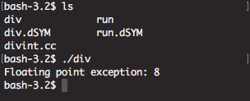

After installing GNU’s GDB program and compiling my program with the –g flag in the following manner:

**G++ -g divint.cc –o div**

Exploring further I was able to discover using my GDB tools break at the print after each function call, I realized there was an issue with the second function call. To better see the outputs, I modified the code to print on each line(just for my own sanity)

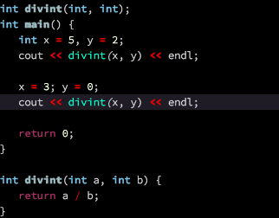

After setting my breakpoints at the end of each function call, in GDB I ran into an error because I was using my mac to do this project. I had to trouble shoot it to get the correct output from GDB—using commands break 10 and break 13, then running the program with run div

Once running, I realized that the error was triggered at line 12 with the function calling a request to divide by zero. 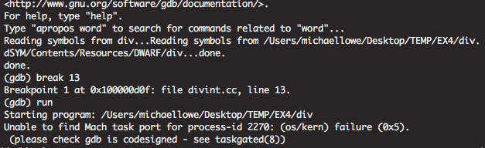

Once handled, the program ceased to crash, and the bug was handled.

