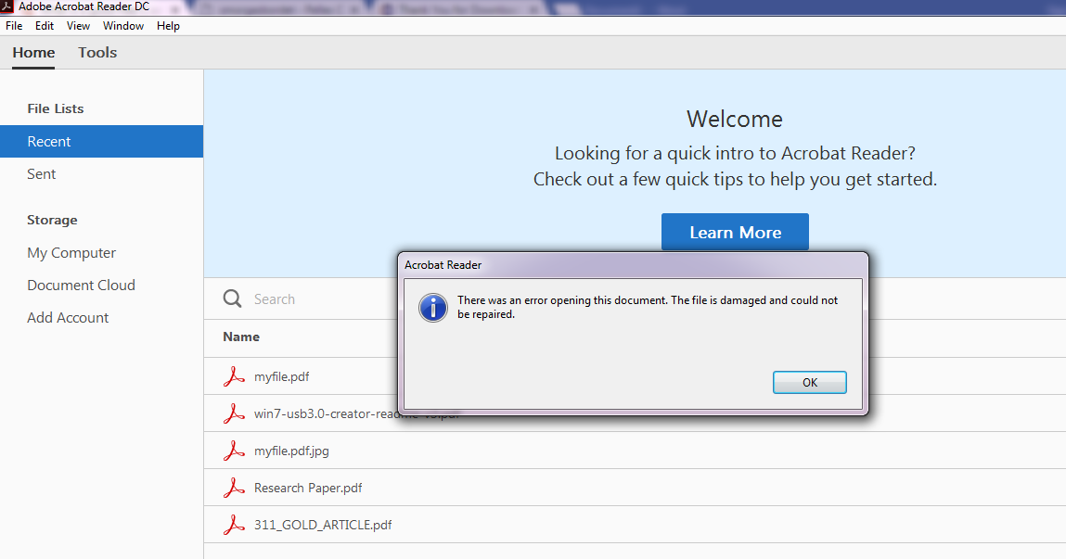

The attempted download of “myfile.pdf” was corrupted. This was due to the DDOS attack during the file download from the genuine client.

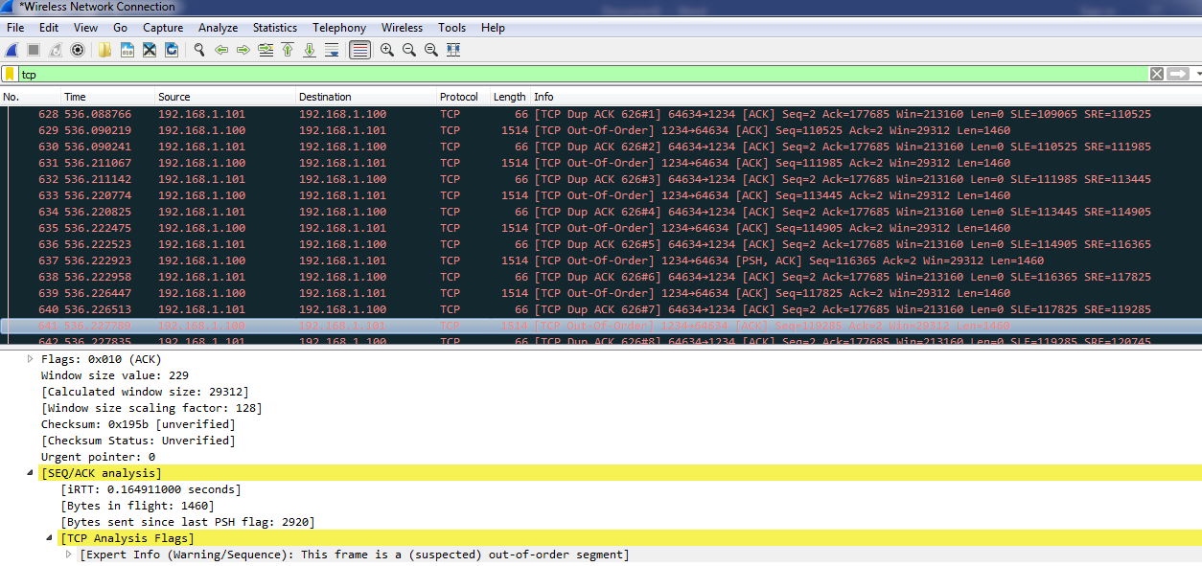

192.168.1.101 was the client, and 192.168.2.100 was the server in this scenario. The specific highlighted black wireshark alert in this screenshot represents a frame suspected out of order. In other words, the “myfile.pdf” file being delivered in bytes was not being received correctly due to the DDOS attack performed while downloading from the TCP server.