Face Recognition – HLD (high level design document)

LINK - https://github.com/mlpocprojects/Face_Recognition.git

Components –

- Architecture

  - Administration module
    - Description
    - Library
    - Diagram

  - Face Detection module
    - Description
    - Face Detection
    - Face Recognition
    - Liveness Detection
    - Data Augmentation
    - Mask Addition

  - Database
    - Description
    - Technology
    - Use

- Administration module

  - Description -
    - GUI to install project whole project in local system.
    - It also install face detection module.
    - It provides UI to configure whole system with users, camera etc.

  - Library used – Tkinter (Python)
  - What the system does----

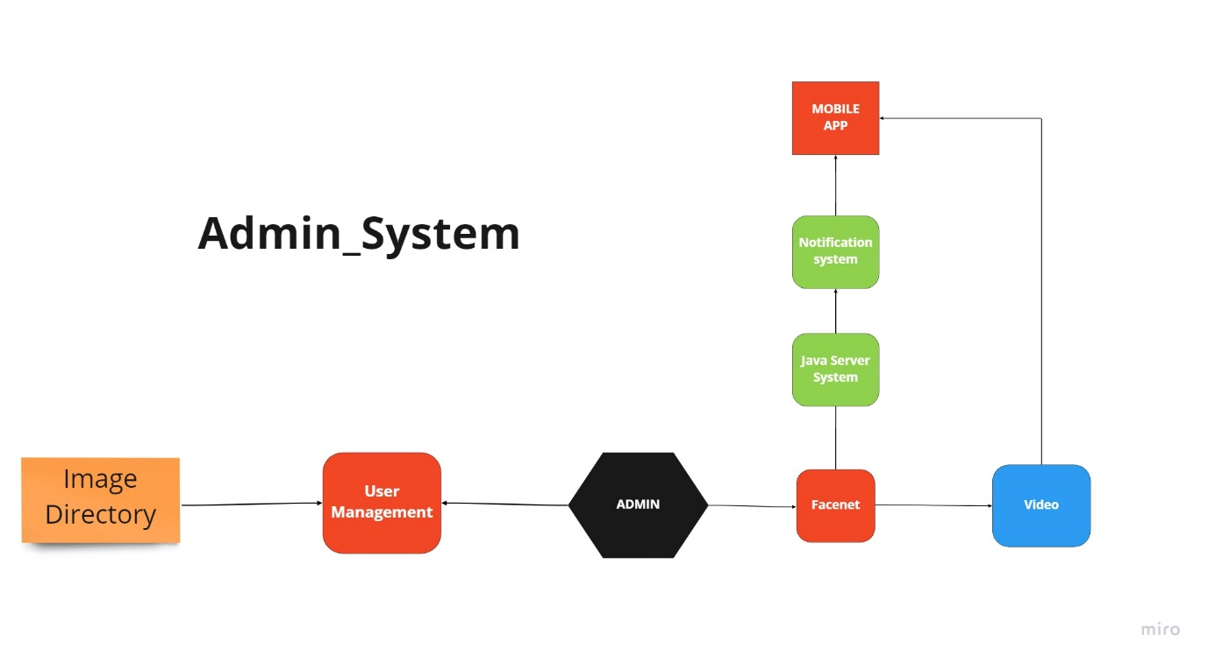

- Face Recognition Module –

  - Description -
    - AI based system
    - The System uses advance CNN’s to detect and predict faces of individuals.
    - It works on the concept of comparing embeddings created using the Facenet Architecture.

  - Face Detection
    - MTCCN is used for face detection. Another option available is Mediapipe.
    - (LIST OPTIONS)
    - MTCNN is used to detect the face images, crop them and send them to the face recognition algorithm

  - Face Recognition
    - FaceNet is the name of the facial recognition system that was proposed by Google Researchers in 2015 in the paper titled FaceNet: A Unified Embedding for Face Recognition and Clustering.
    - It achieved state-of-the-art results in the many benchmark face recognition dataset such as Labeled Faces in the Wild (LFW) and Youtube Face Database.
    - The system is considered state-of-the art in the domain of face recognition.

  - Liveness Detection
    - We will use computer vision techniques to extracting the eyes, mediapipe python modules will provide the landmarks later calculate distances between points on the eyes to predict the blinking of the eyes.
    - https://www.youtube.com/watch?v=XIJD43rbI-4

  - Data Augmentation
    - Data augmentation in data analysis are techniques used to increase the amount of data by adding slightly modified copies of already existing data or newly created synthetic data from existing data.
    - https://github.com/albumentations-team/albumentations

  - Mask Addition
    - MaskTheFace is computer vision-based script to mask faces in images.
    - It uses a dlib based face landmarks detector to identify the face tilt and six key features of the face necessary for applying mask.
    - Based on the face tilt, corresponding mask template is selected from the library of mask. The template mask is then transformed based on the six key features to fit perfectly on the face.

Live User Face Recognition
Camera
Live Feed
Images
User Face Recognition
Embedding Creation
Live Feed With User
Analysis Function
DataFrame
Embed Function
Start
Run.py

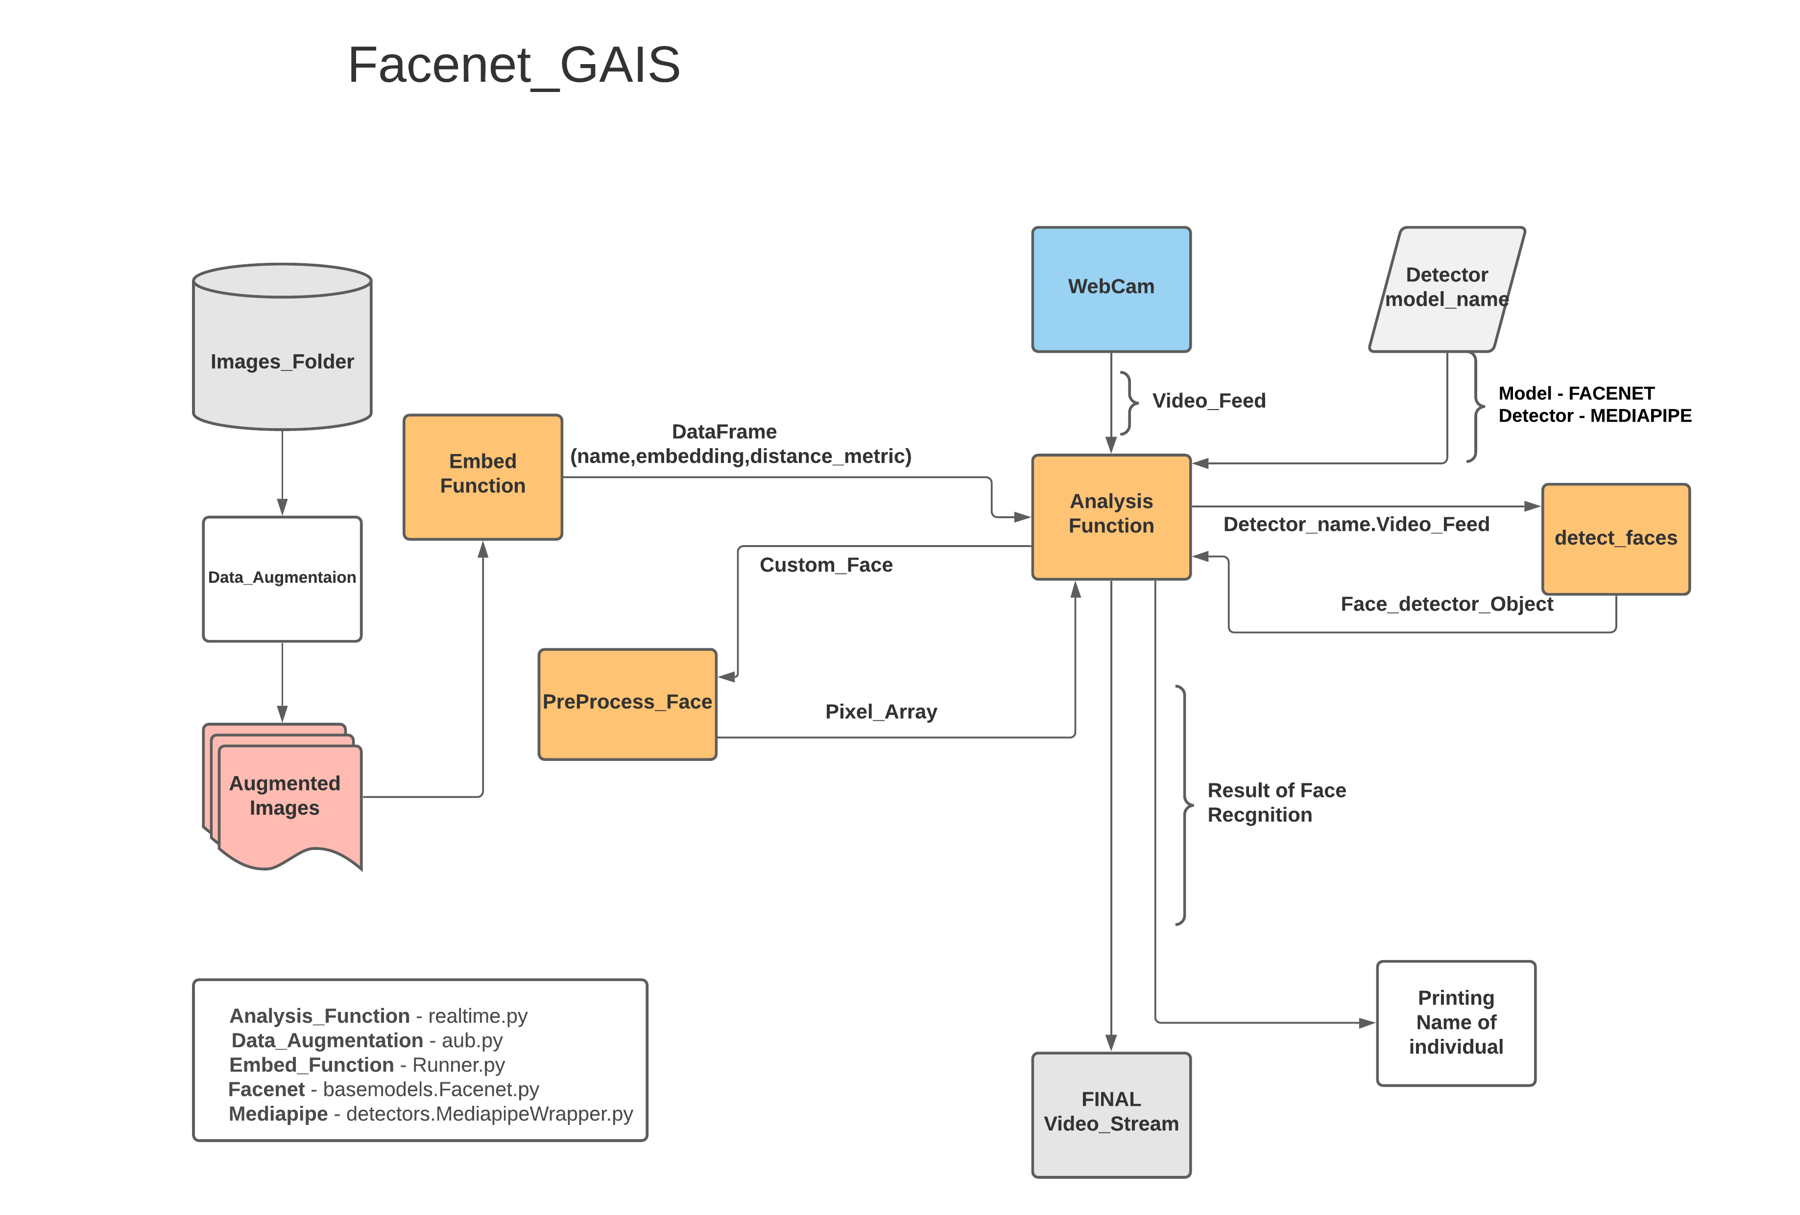
Technologies used mention in this image – talk about possible options and all other variations we tried with. Mention all details about the project with history.

- Database

- Description
  - MySQL Based system used.
  - Objective to store user information based on apk downloads.
  - Using API to send notification on APP

- Library used –
  - MySQL
  - Rest API

- Connection Points –
  - Table name – “tb_user”
  - Columns – ID , token

