Step By Step Working Of MLExe file :-

Step 1:Check For Python In Existing System
After running exe file first step is to click Install button to check whether python is present in system or not if not it will download python installer file for you.
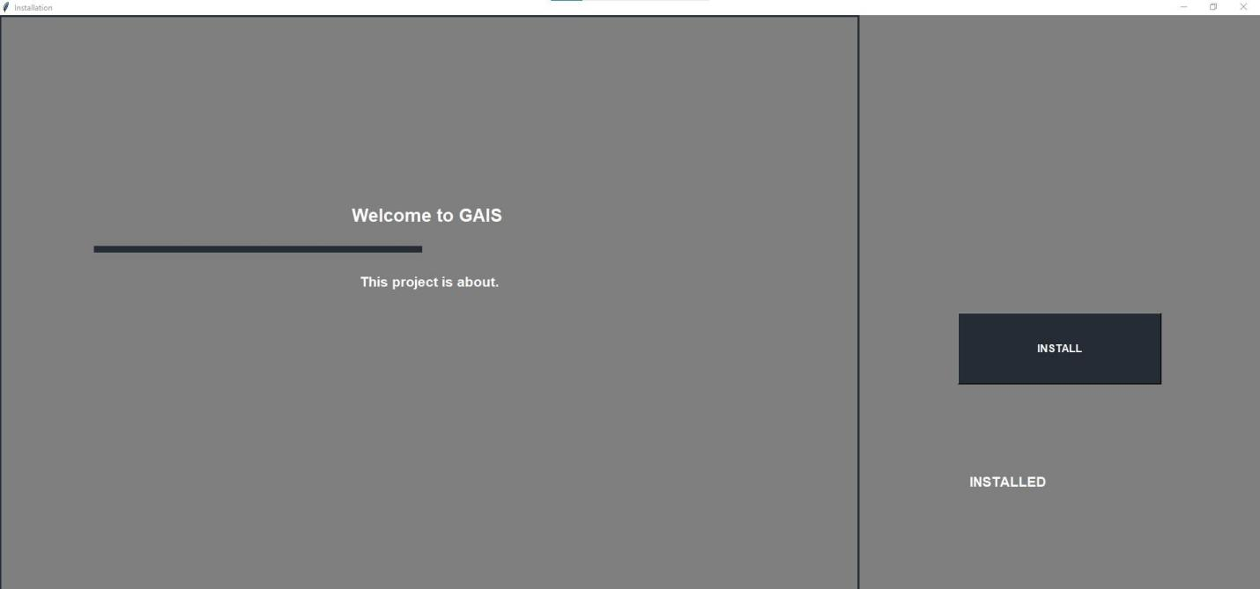

Step 2:Check if camera attached is working or not
After first step click on Camera Management button

Which will redirect you to page.
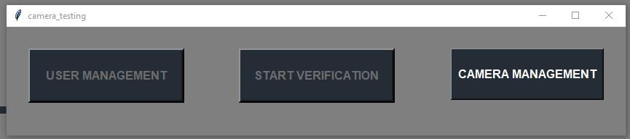

Where you have to check camera by putting camera_url camera and press test camera button and after checking we can press stop button to stop checking and close button to then interact with user management and start detection.
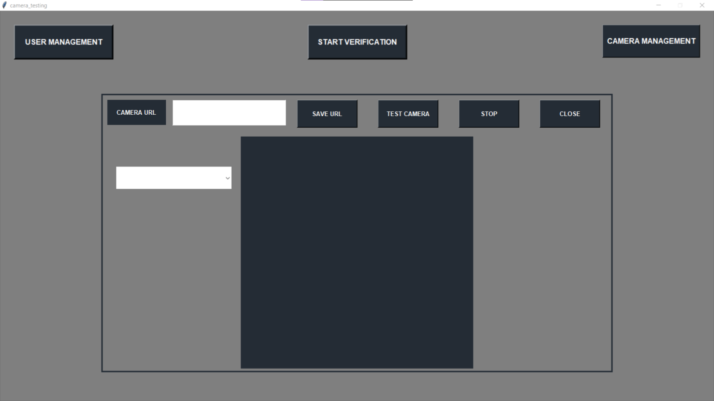
After pressing user management button it will redirect to user management page.
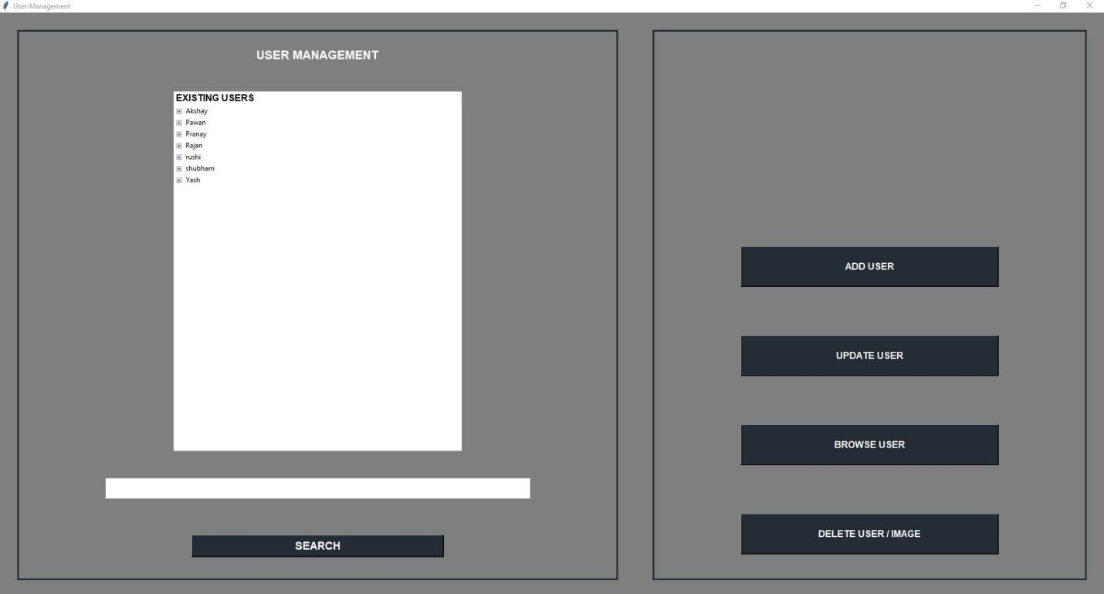
In user management than there is search bar which is used to search specific user among rest of it.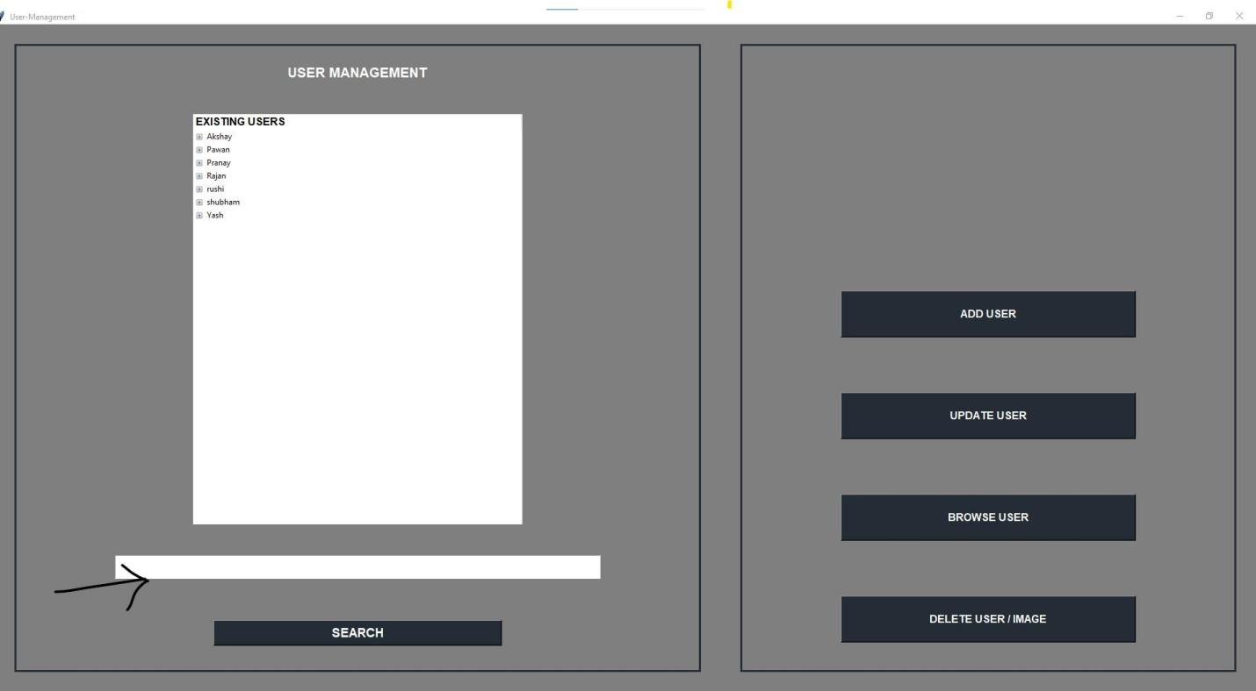

Then there is add user button on pressing which will show entry box and browse button to add images to user directory.
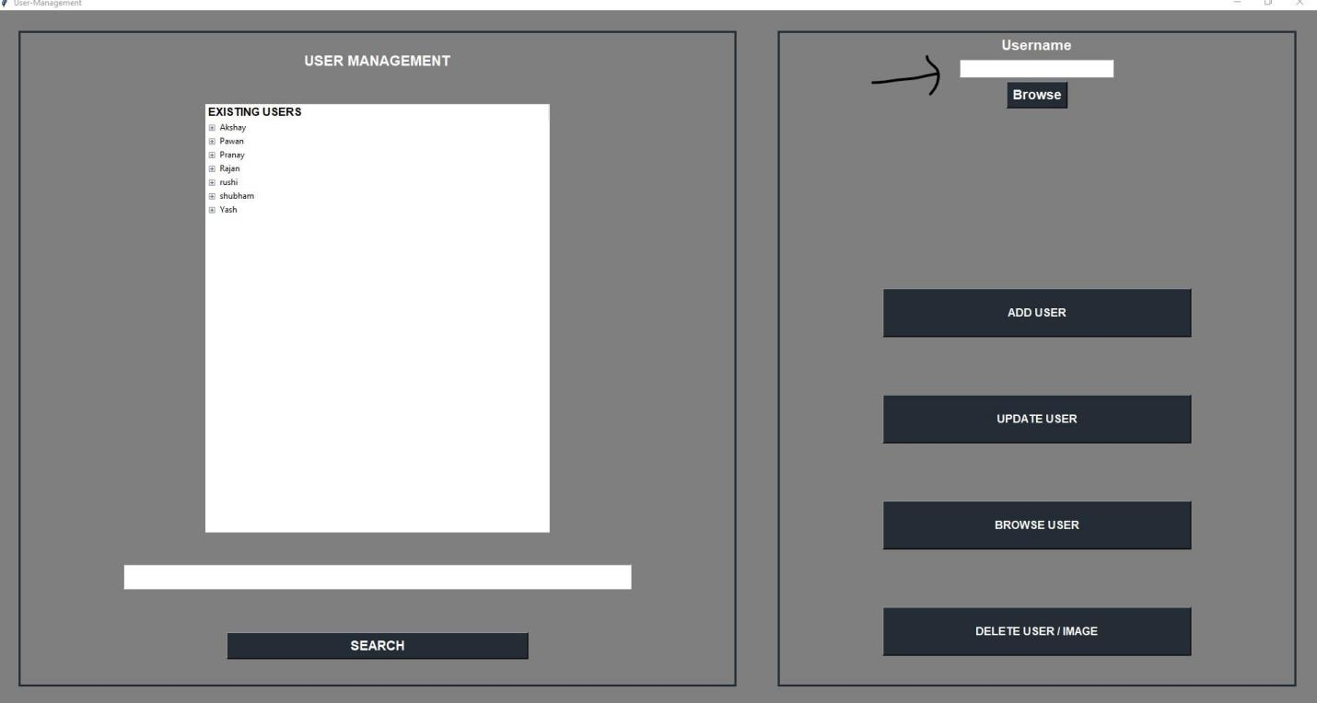
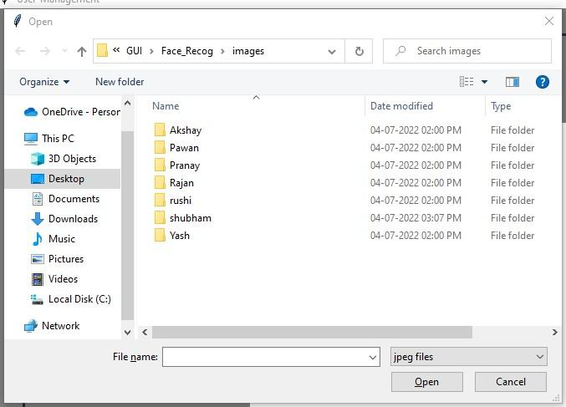
Then there Update button which is used to update user images from directory where user can add images you just need to select user by selecting user from list by pressing it and clicking update button. It will update added images to user..
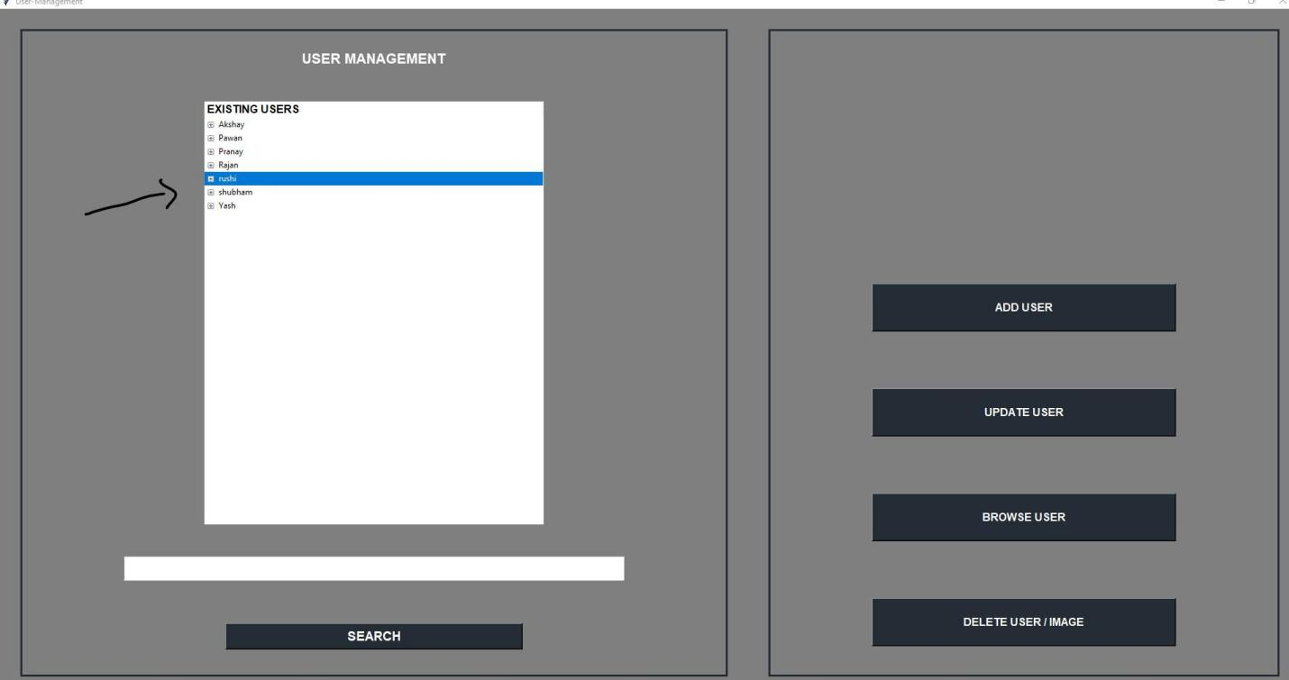
Then there is browse button which is used to browse user and see images in it you just have to select user from list and press browse image button to browse.
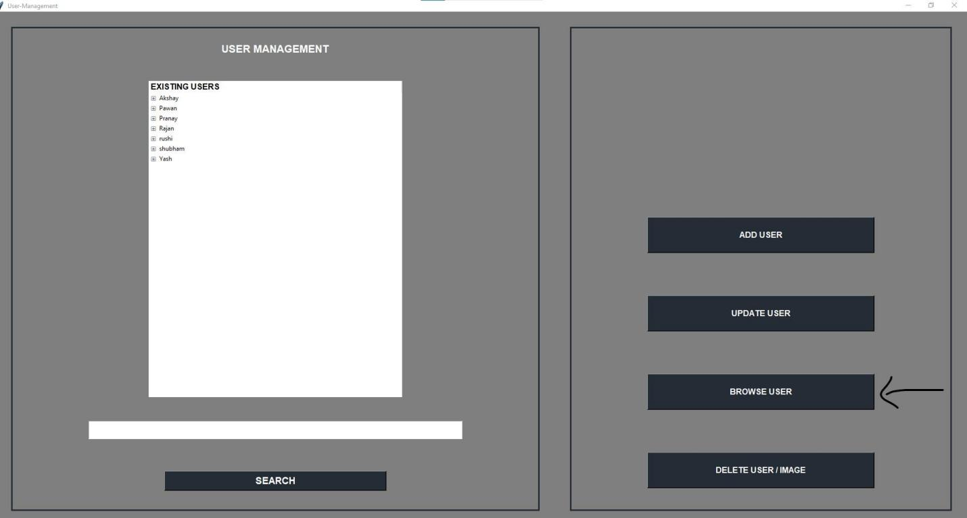

Then there is delete button which is used to delete specific user images or image directory of user you just have to select specific image or user directory,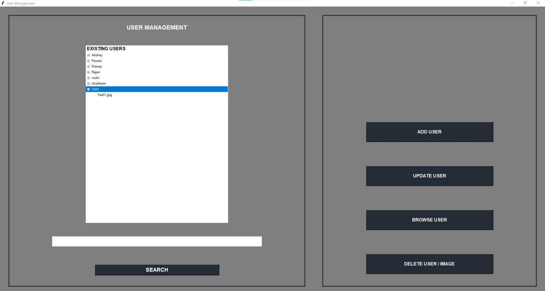
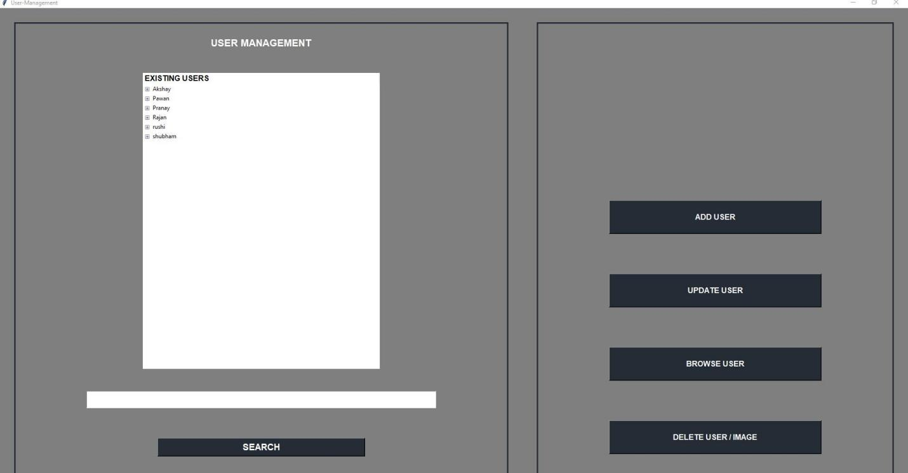

After performing user management we need to start our face detection model by pressing start detection button.
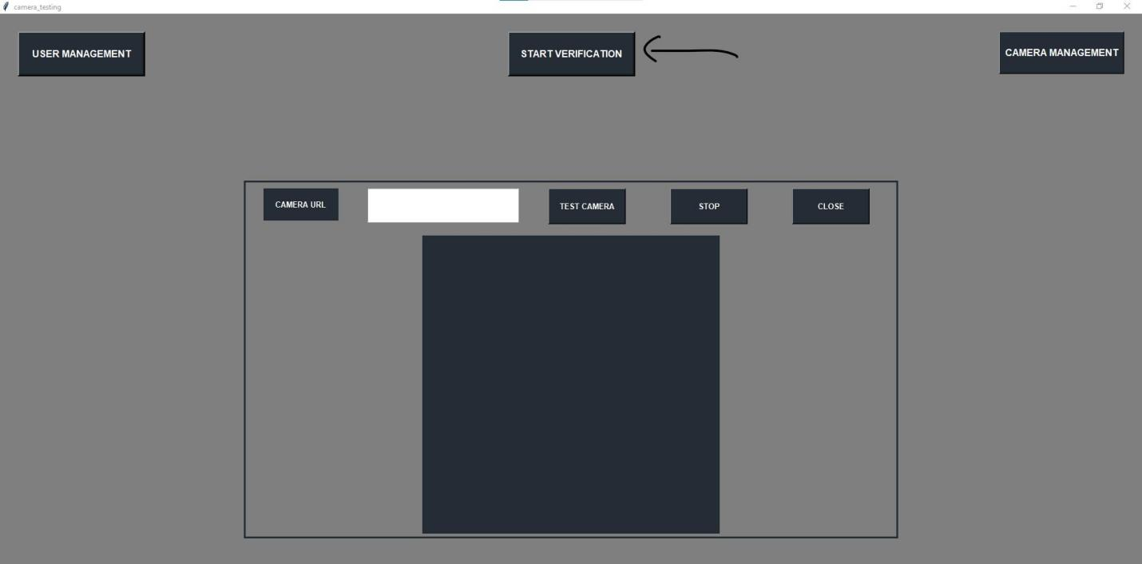
After hitting button it takes some time and automatically opens a link in browser and start face detection.
