Your challenge is to scrape the Cook County Recorder of Deeds website.

* [http://162.217.184.82/i2/default.aspx#](http://162.217.184.82/i2/default.aspx)

The pin number you can use to test your code is **09-22-418-034-0000.**

After entering that pin into the website, your browser will look like the image below.

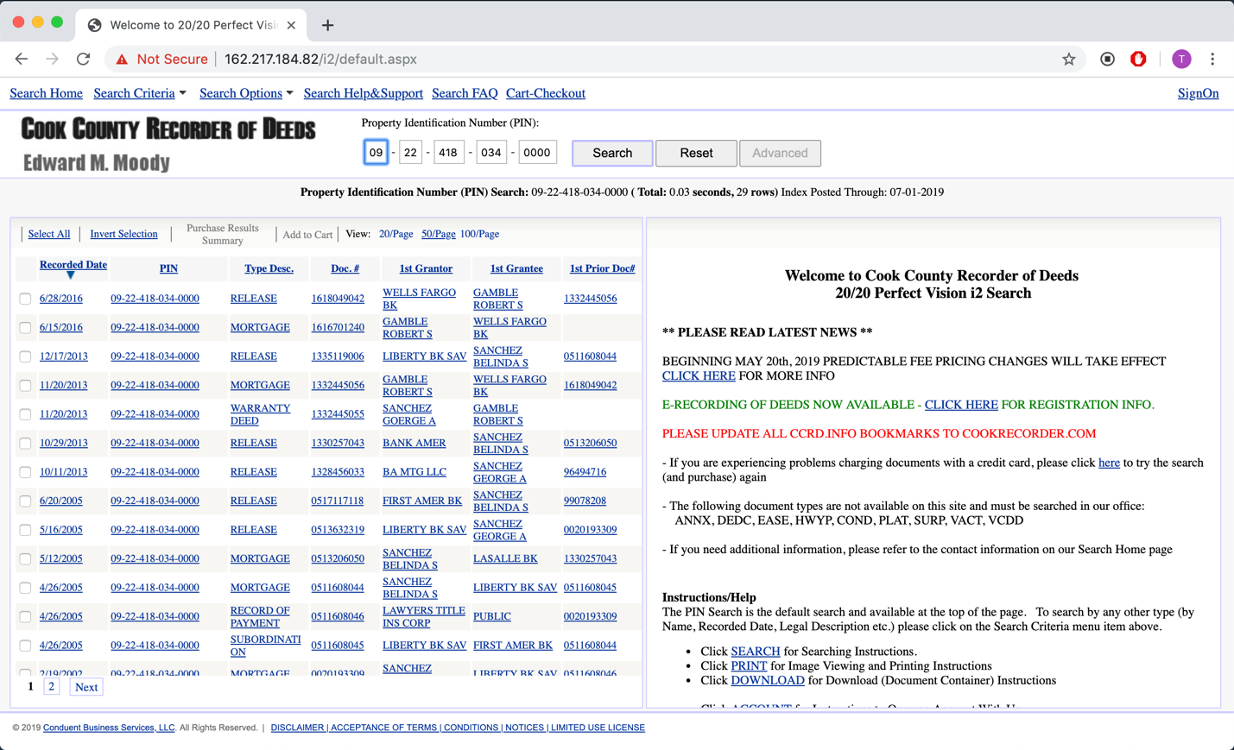

As you can see, there are two pages of results in the table. Your scraper should work with multiple paged results.

The information that we are asking you to collect is the information that appears when a user clicks on one of the rows in the table. After clicking a row in the table, the screen will look like the image below.

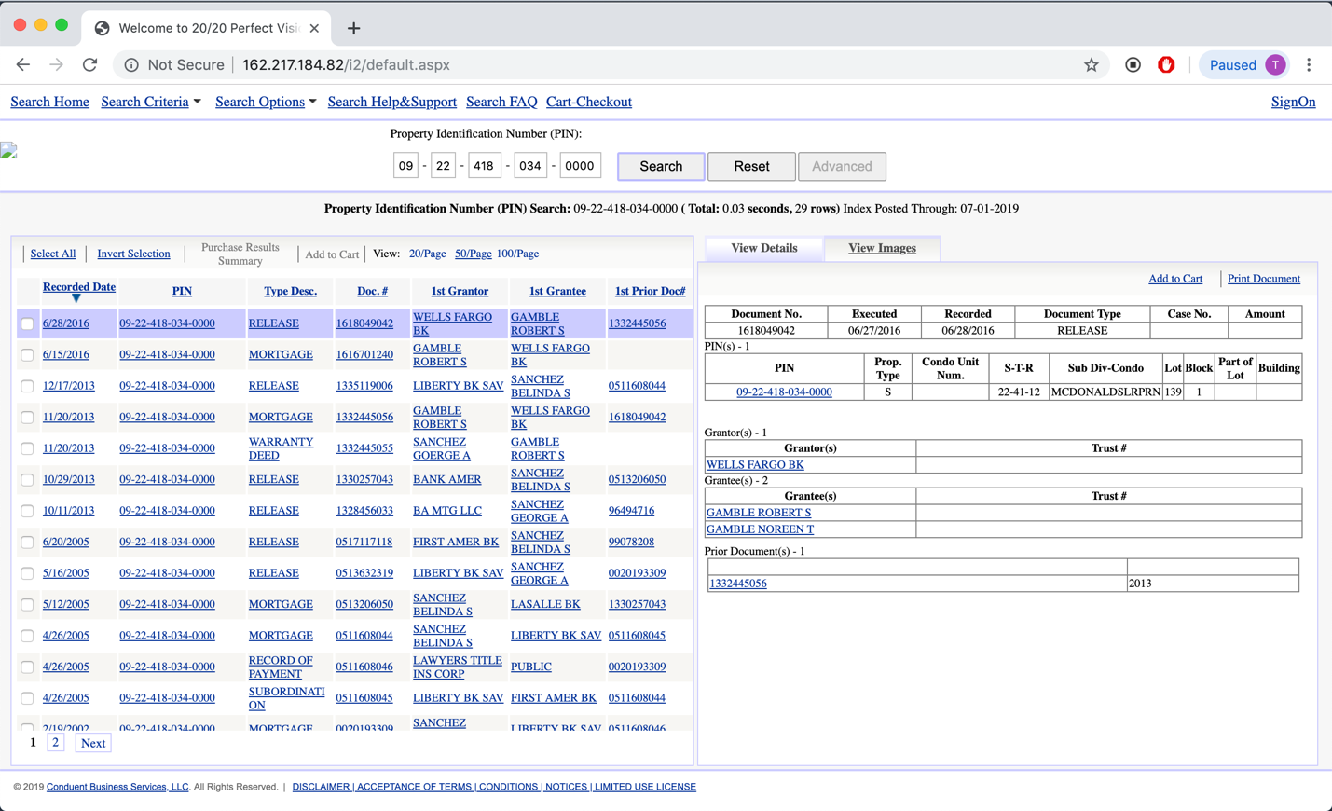

For the pin code **09-22-418-034-0000,** there are 29 records in the Cook County Recorder of Deeds. Your deliverable for this challenge is a script that can pull these 29 HTML pages and store them in the folder **results/.** There must be fields such as Document No., Executed, Recorded, etc. inside each of the HTML files.

Parsing this information into a format like JSON is not necessary. The HTML body is enough.

Good luck!