Comprehensive Interpretive Report

Section I: Patient Information

Table 1. Patient Information

Name | Gregory Grinch
Date of Birth | 01- 02-1980
Age | 45
Sex | Male
Education | NA
Marital Status | Unmarried
Contextual Factors | Prolonged homelessness and isolation; high prevalence of adverse childhood experiences

Section II: Clinical Intake and Mental Status Examination

Clinical Intake

Reason for Referral
Gregory Grinch was criminally referred for psychological assessment by the Whoville Superior Court. The referral was provide following charges of breaking and entering as well as vandalism.

Symptoms and Traits
Symptoms and Traits (January through November) include 1) Somatoform (e.g., malaise, head and gastrointestinal pain); 2) Internalization with subfactors of fear (e.g., interaction anxiety, public spaces anxiety, situational phobias, psychological panic, ritualistic behaviors) and distress (e.g., dysmorphia, anhedonia, insomnia, agitation, retardation, wellbeing decrements, avoidance, hypoarousal, numbing, dissociation, irritability). Symptoms and Traits (December) include 1) Disordered thinking (e.g., psychoticism, disorganization, avolition); 2) Detachment (e.g., suspiciousness); 3) Disinhibited Externalization (e.g., problematic impulsivity, irresponsibility, theft, risk taking, workaholism, destructive aggression, relational aggression, blame, externalization of emotion, rebelliousness, excitement seeking); and 4) Antagonistic externalizing (e.g., attention seeking, callousness, grandiosity, manipulativeness, egocentricity, dominance) (see DSM-5-TR for symptoms and diagnostic criteria).

Behavior Onset and Duration
Greg disclosed a complex pattern of criminal behavior spanning 15-17 years, beginning at age 16 when he ran away from home following traumatic peer rejection.
Severity. The patient’s B&E and vandalism behaviors are notably seasonal, occurring year-round for survival and escalating in frequency and symptomatic severity during the month of December. Greg described his B&E and vandalism behaviors as absent acute psychopathology symptomatology during the months of January through November; however, during the month of December, Greg disclosed “seeing red” and acting from “rage and anger.”
Frequency. Greg described his adolescent B&E as survival-based, reporting homeless beginning at the age of 16; however, in his early twenties continuing into his late twenties, Greg noticed he was “good at B&E” and began building skill capacity for the efficient extraction of valuables during criminal events. At the time of the interview, Greg considered B&E his primary vocation. Greg reported seasonally (i.e., December) “relishing” his ability to break and enter and produce vandalism for “emotional expression” facilitating the externalization of latent anger, rage, and castigation. The seasonal frequency appears connected to his adoptive family’s and hometown’s emphasis on Christmas traditions, which seem to serve as a seasonal trigger, amplifying feelings of exclusion and lack of belonging, rooted in childhood.

Patient History
Social History. Mr. Grinch has been completely isolated for the past 15-17 years. He has had no
peer relationships, no contact with family, and no romantic relationships from the age of 16 to the present. He described one singular romantic interest during middle/high school where he reciprocated interest with a girl, only to be publicly ridiculed by his entire class when he attempted to give her a gift. This experience appears to have profoundly shaped his subsequent withdrawal from all social connection. He has no current social support network of any kind.
Family History. Greg reported a history of abandonment. He stated “[he] was dropped at the doorstep” of two women in an unwed, non-romantic partnership who informally adopted him at the age of one year. One adoptive parent worked at the local elementary school as a teacher, while the other was a “stay-at-home mom.” Both adoptive parents graduated high school, and neither enrolled in higher education. Greg was the only child in the household (i.e., no siblings or step siblings). Greg denied verbal or physical contact with biological parents from the age of one year, as well as zero contact with either adoptive parent from the age of 16 to the present. He denied knowledge of either family's medical or psychiatric history. Greg described his childhood
relationship with his adoptive parents as “without emotional acceptance,” sharing that he never felt he could be himself in their home. Greg's adoptive parents promoted a culture of “Christmas joy and celebration.” Greg reported a profound cultural disconnection relative to his family's cultural traditions.
Medical And Psychiatric History. Mr. Grinch denied receiving any medical, psychiatric, or other
forms of professional care for the entirety of his lifespan. Although he presents with atypical facial and body features, these features have never been medically evaluated. He takes no medications. He reports chronic sleep difficulties (e.g., averaging 3-4 hours of sleep per night). No history of psychiatric hospitalizations, suicide attempts, or previous mental health treatment. This session was his first contact with the mental health system.
Educational and Occupational History. Greg described his childhood educational experiences as
“bad” across grades K-9. He denied a learning disability and academic goal across the lifespan. He attributed performance decrements to environmental distress. From age six onward, Greg disclosed victimization of relentless bullying and ridicule for his atypical appearance. He left home/school at age 16 and never completed high school. His cognitive functioning during our interview appeared average to above-average, suggesting his academic struggles stemmed from the hostile environment rather than intellectual limitations. Greg’s occupational history is sparse. He worked “some odd jobs here and there” but was reportedly fired due to frequent “disagreements” with staff. At the age of 16, B&E became his sole vocation and profession. Greg reported minimal satisfaction with his present vocation, describing it as “a way to get by” and “release tension.” Trauma History. Beyond the above described traumatic peer rejection at age 16, Mr. Grinch disclosed multiple adverse childhood experiences (ACEs) including biological parent abandonment, adoption without secure attachment, chronic bullying from age six onward, persistent emotional rejection, and a lack of cultural belonging relative to his adoptive family’s Christmas tradition.
Substance Use History. Greg denied alcohol, supplement, prescription and recreational drug use; reported consumption of up to two pots of coffee daily. No tobacco use was reported.

Mental Status Examination

Appearance and Behavior.
Mr. Grinch was appropriately dressed in typical clothing, with adequate hygiene, and notable facial and bodily features self-described as “dysmorphic.” Behavior was cooperative with adequate eye contact and a willingness to answer questions, though his responses often appeared guarded. His psychomotor activity appeared within normal limits with little agitation or psychomotor retardation observed.

Speech and Communication.
Volume (soft), emotionality (lacking, depressed), and tone (flat); language production and comprehension appeared intact.

Mood and Affect.
Incongruence of mood/affect demonstrated by verbal satisfaction with lifestyle and notable emotional longing; emotional range was constricted, with underlying emotionality (e.g., anger, rage, vigilance) apparent when discussing his adoptive family’s cultural traditions.

Thought Process and Content.
Linear and logical thought process moderated by topic of discussion (e.g., December, and non-December months); coherent chronological narrative of life experiences; content of thoughts centered on adulthood perceptions of rejection, lack of belonging, and anger toward societal norms/traditional practices, especially Christmas traditions.

Cognition.
Oriented to person, place, time, and circumstance. Adequate attention, concentration, and disclosure of historical information, moderated by ACEs. Memory functioning appeared grossly intact for immediate and recent memory, with notable remote memory impairment.

Insight and Judgment.
Markedly poor insight demonstrated by inability to connect consumption of two pots of coffee daily with sleep difficulties (3-4 hours nightly), minimal awareness of ACEs and behavioral patterns continuing into adulthood, and little awareness of criminal lifestyle preventing relationship formation; perspective on change was impaired with limited recognition of the maladaptive nature of his coping patterns or need for intervention beyond satisfying court requirements; judgment appeared significantly impaired, evidenced by a 15-17 year pattern of illegal activity; decision-making relied almost exclusively on avoidant strategies of withdrawal, isolation, and criminality.

Section III: Administered Psychodiagnostic Assessments

Table 2. Assessment Information

Assessment | Administration Date | Administration Setting
Minnesota Multiphasic Personality Inventory-3 | 2026-02-28 | Online
Personality Assessment Inventory | 2026-01-29 | Online
Millon Clinical Multiaxial Inventory, Fourth Edition | 2026-03-18 | Online
Assessment Descriptions

Minnesota Multiphasic Personality Inventory-3 (MMPI-3)
Description. The MMPI-3 is a 335-item self-report assessment designed for adults aged 18 and older. Normative Sample. It features updated norms based on 2020 U.S. Census projections, with a nationally representative sample of 810 men and 810 women. The test is used in mental health, medical, forensic, and public safety settings. Source.

Personality Assessment Inventory (PAI)
Description. The PAI is a 344-item self-report measure of personality and psychopathology for adults aged 18 and older. It uses a 4-point Likert scale and provides scores on 4 validity scales, 11 clinical scales (9 with subscales), 5 treatment consideration scales, and 2 interpersonal scales. Normative Sample. Norms are based on a Census-Matched Standardization Sample (N=1,000). Source. Morey, L. C. (2003). An interpretive guide to the Personality Assessment Inventory. Psychological Assessment Resources.

Millon Clinical Multiaxial Inventory, Fourth Edition (MCMI-IV)
Description. The MCMI-IV is a 195-item self-report inventory designed to assess personality disorders and clinical syndromes in adults (18+) in clinical settings. It provides Base Rate (BR) scores derived from clinical prevalence data, with 5 Modifier Indices, 12 Clinical Personality Patterns, 3 Severe Personality Pathology scales, 7 Clinical Syndromes, and 3 Severe Clinical Syndromes. Normative Sample. The instrument is normed on 1,547 clinical subjects (individuals seeking mental health services). Source. Millon, T., Grossman, S., & Millon, C. (2015). Millon Clinical Multiaxial Inventory-IV manual. Minneapolis, MN: Pearson Assessments.

Section III: Omnibus Psychodiagnostic Assessment Interpretation

Validity
Administration. The patient was administered the MMPI-3, PAI, and MCMI-IV at seperate intervals (see Table 2) at the direction of the Whoville superior court, in order to determine the patient’s psychological profile, risk to the community and self, and treatment options. Validity. The questionable (MMPI-3), provisional (MCMI-4), and valid (PAI) psychodiagnostic assessment validity statuses are adequate addressed by the patient’s intake report, where chronic isolation, abnormally-high and atypical symptom presentation were endorsed. The reader may interpret the psychodiagnostics assessment results with confidence.

Clinical Syndromes
Clinically significant levels of anatagonistic externalizing behaviors (e.g., MMPI-3 (Aggression; T=86), MCMI-IV (Sadistic; BR=97), and PAI (Antisocial Features; T=94)) provide the patient with a robust intrapsychic defense against clinically significant levels of internalizing pathology (e.g., PAI (Depression; T=92), MCMI-IV (Major Depression; BR= 91) amplified by detached and disordered thinking (e.g., MMPI-3 (Thought Dsyfunction; T=100), MCMI-IV (Delusional; BR=94), and PAI (Paranoia; T=100)). The patient’s clinical presentation oscillates from rigid hyper-vigilance to impulsive hostility.

Personality Pathology
The patient’s personality is markedly paranoid (e.g., MCMI-IV (Paranoid; BR=114), and PAI (Paranoia; T=100)) elevating clinical the need for hyper-vigiliance and hostistility. The consequence of such a personality is social detachment (e.g., PAI (Social Detachment; T=94) habituated antisocial behaviors (e.g., PAI (Antisocial; T=93), MCMI-IV (Antisocial; T=98), and sadistic aggression (e.g., MCMI-IV (Sadistic; BR=97), PAI (Physical Aggression; T=100) that reaches the level of psychoticism (e.g., MMPI-3 (Psychoticism; T=99).

Clinical Personality Patterns
The patient’s personality function is demonstrated by MCMI-IV scale elevations: Antisocial (BR=98), Sadistic (BR=97), and Narcissistic (BR=86). Antisocial pattern. Driven by a strong pull toward active and self-polarities, this pattern is motivated by the preservation of Self at the cost of others, manifest as impulsive risk taking, a lack of empathy for others, and supreme entitlement. The desire for unconditional autonomy is compounded by revenge-seeking ruminations; and, predictive of a history of unlawful or boundary-violating behaviors (odds ratio = XXX). Sadistic pattern. Driven by a desire to derive pleasure from the pain of others, this personality pattern suggest the patient is motivated by inflicting pain (e.g., humiliation, degradation, physical aggression) and exploiting the weaknesses of others (e.g., manipulation) toward the aggrandizement of Self. The intrapsychic dynamics of the patient’s sadism demands self-righteous rationalization, in this patient’s presentation, the sublimation and projection of sadism in the month of December. Narcissistic pattern. Driven by a narrow focus of Self, this personality pattern suggests the patient is motivated a belief structure that places their ability and overall worth above all others; however, extricating their self-worth from external validation sources, has yielded patterned oscillation from relative contentment (occurring January through November) to deep dissatisfaction (occurring in December).

Section VIII: Treatment Considerations

The patient’s profile suggests an individual in acute distress with significant risk for harm to others, and moderate risk of harm to Self. The co-occurrence of immediate risk, severe clinical syndrome presentation, personality pathology, and clinical personality patterns necessitates a compulsory treatment schedule following inpatient guidelines established by psychodynamic XYZ: risk assessment, psychiatric stabilization, therapeutic alliance development, ego-formation, and self-sustaining intrapersonal behaviors.

Recommended Treatment Schedule
---------------------------------------------------------------------------------------------------------------------------------------------------
Treatment: Safety Assessment and Planning
Action: Use the Columbia-Suicide Severity Rating Scale (C-SSRS) to assess the severity and immediacy of suicidal risk
Action: Implement a comprehensive safety plan that addresses suicidal risk and externalized aggression. Establish a clear behavioral contracts within a modified treatment environment to reduce access to means of harm.
---------------------------------------------------------------------------------------------------------------------------------------------------
Treatment: Psychiatric Stabilization.
Action: The patient requires psychiatric stabilization to address comorbid depression with delusional features, prior to therapeutic work. A psychopharmacology consult for psychotic levels of paranoid ideation is also recommended.
---------------------------------------------------------------------------------------------------------------------------------------
Treatment: Contracting
Action: The patient’s clinical personality patterns suggest a high likelihood of treatment resistance. The patient will benefit from court-mandated therapy for 50 sessions with treatment to be discontinued thereafter following re-assessment and at the discretion of the supervision clinician. A treatment contract where the patient endorses the purpose of treatment is recommended, if attainable.
---------------------------------------------------------------------------------------------------------------------------------------
Treatment: Therapeutic Alliance Formation
Action: The patient’s paranoid, narcissistic, and antisocial personality patterns demands clinical treatment framed as bolstering personal-effectiveness. The patient’s personality structures will reject alliance-building that perceived as attempts to control or diminish.
---------------------------------------------------------------------------------------------------------------------------------------
Treatment: Intraindividual Interoception and Interpersonal Empathy Formation
Action: Use mindfulness-based treatments to bolster the patient’s capacity for interoception and individual mental state connection. If progress is established, expand to mentalization-based interventions focused on developing capacity to understand one's own and others' mental states. Psychodynamic techniques may also prove helpful to process elicited cognitions contributing toward the patient’s personality pathology and clinical sequelae.
--------------------------------------------------------------------------------------------------------------------------------------------------------

Section VIII: Comprehensive Interpretation

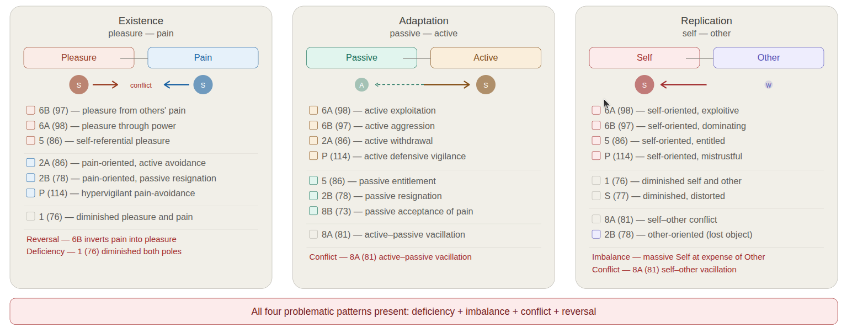
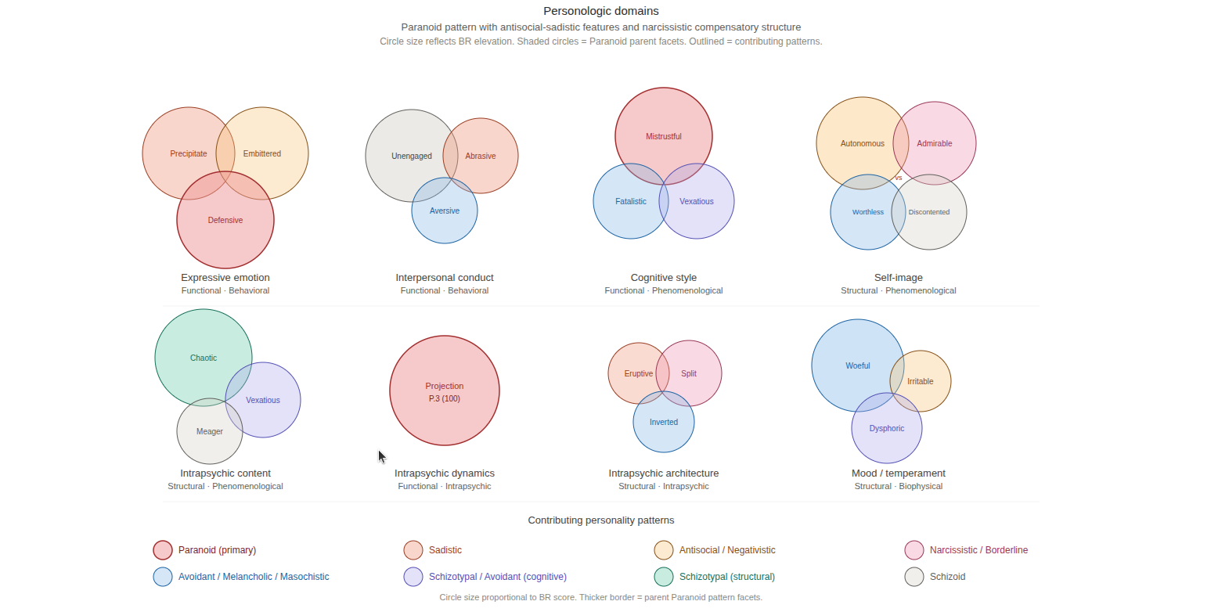

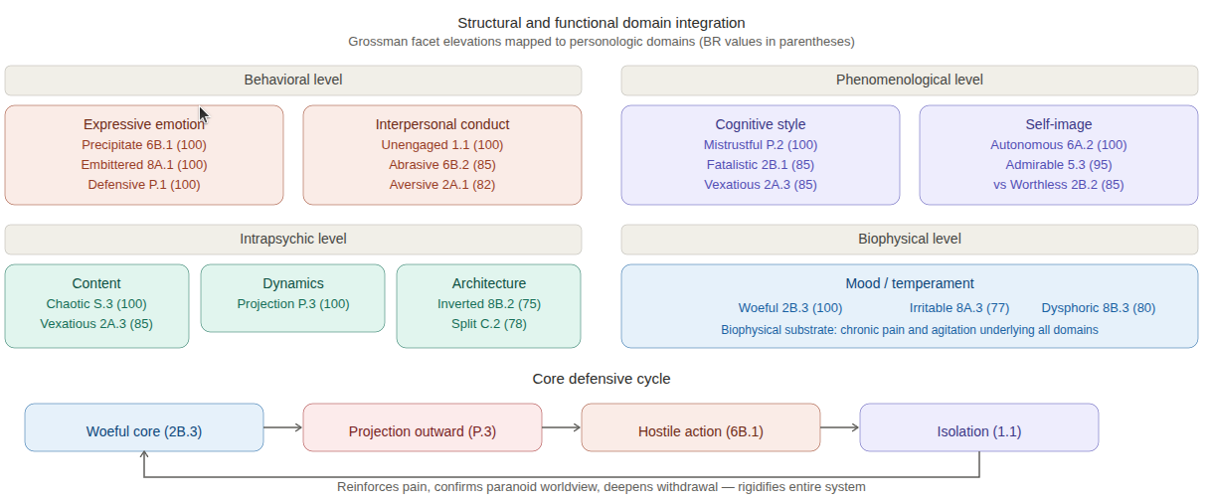

The client’s MMPI-3 profile is a valid and interpretable assessment that demonstrates adequate overall psychological functioning with narrow areas of concern related to social withdrawal, reduced positive emotionality, and substance-related difficulties.

The most salient clinical theme across client’s profile is a constellation of detachment-related features characterized by social avoidance, anhedonia, and introversion. This pattern emerges consistently across three distinct scale domains. The Introversion/Low Positive Emotionality scale (T=65) indicates reduced capacity for pleasure and preference for solitude, while the Social Avoidance scale (T=66) demonstrates active discomfort and withdrawal from social contexts. The slightly elevated Low Positive Emotions scale (T=60) further corroborates this picture of diminished positive affect. Importantly, indications of social withdrawal and emotional restriction occur in the absence of significant demoralization, anxiety, or negative emotional states, suggesting that his detachment reflects a dispositional tendency toward introversion and anhedonia rather than a consequence of emotional distress or cognitive dysfunction.

A second clinical concern involves problematic substance use. The moderately elevated Substance Abuse scale (T=65) indicates a significant history of substance-related difficulties, including past or current problematic use of alcohol or drugs and possible misuse of prescription medication. The presence of this elevation in an otherwise psychologically intact profile warrants careful clinical attention to the frequency, duration, consequences, and current status of his substance use patterns.

The relationship between these two clinical themes warrants consideration. The client’s social avoidance and anhedonia may contribute to or be exacerbated by substance use, or substance use may have contributed to his social withdrawal. Alternatively, these domains may represent relatively independent areas of difficulty. The absence of elevations on aggression, disconstraint, and negative emotionality scales suggests that the client’s substance use does not reflect impulsivity or behavioral disinhibition; but may reflect attempts to self-medicate toward the management of anhedonia, social discomfort, or other episodic experiences/situational factors not fully captured by the current assessment. Nonetheless, the overall profile is consistent with adequate psychological functioning and effective coping capacity across major domains of mental health.

Section IX: Treatment Recommendations

Treatment Recommendations

1. Comprehensive Substance Use Assessment and Motivational Interviewing

Assessment. The moderately elevated Substance Abuse scale (T=65) indicates a significant history of problematic substance that may warrant clinical attention. Before initiating other interventions, a detailed functional analysis of the client’s substance use patterns, including frequency, duration, consequences, and current status is warranted.

Treatment Implementation. The treating clinician may use Motivational Interviewing to explore ambivalence about change and clarify intrinsic motivation for abstinence or harm reduction.

2. Behavioral Activation with Psychodynamic Exploration of Detachment

Treatment Implementation. The treating clinician may use structured behavioral activation targeting approach-oriented activities and social engagement, beginning with low-demand social contexts and gradually increasing the challenge. Concurrently, psychodynamic inquiry may be used to explore the origins and function of the detachment; it may reflects a stable temperamental disposition, adaptive withdrawal from past relational harm, or defensive retreat from perceived social threat.

3. Mindfulness-Based Approach to Pleasure Capacity and Present-Moment Awareness

The client may benefit from mindfulness-based cognitive therapy or acceptance and commitment therapy targeting increased awareness of subtle positive experiences and values-aligned living. This approach is particularly well-suited to the client’s profile given his intact reality testing and absence of significant negative emotional states.

Section X: Report Summary

The client's MMPI-3 profile is valid and interpretable and demonstrates adequate overall psychological functioning with two areas of clinical concern. A consistent pattern of social withdrawal, anhedonia, and introversion is present across multiple scale domains (Social Avoidance T=66, Introversion/Low Positive Emotionality T=65, Low Positive Emotions T=60), reflecting a dispositional tendency toward detachment that occurs in the absence of significant anxiety, demoralization, or thought disturbance. A second clinical concern involves a moderately elevated Substance Abuse scale (T=65), indicating a significant history of problematic substance use warranting comprehensive assessment and intervention. The absence of elevations on aggression, disconstraint, and negative emotionality scales suggests that the client’s substance use may reflect attempts to manage anhedonia or social discomfort rather than behavioral impulsivity. Treatment planning should prioritize substance use assessment and motivational interviewing, integrated with behavioral activation and exploration of the psychological function of his social detachment.

Summary

Total scales: 52
Elevated scales: 3

Examiner Signature _______________________  Date ____________________________________ | Supervisor Signature _______________________  Date ____________________________________

