MMPI-3 Interpretive Report

Test Information
Test ID | 737_Y
Test Date | 2026-02-28
Examinee ID | 737_Y
Completion Rate | 100.0% (335/335 items)

Protocol Validity
Status: VALID

Validity Scales
Scale | Raw Score | T-Score | Items Scored | Interpretation
CRIN - Combined Response Inconsistency | 3 | 42 | 86/86 | Within Normal Limits
VRIN - Variable Response Inconsistency | 2 | 43 | 53/53 | Within Normal Limits
TRIN - True Response Inconsistency | 14 | 54T | 33/33 | Within Normal Limits
F - Infrequent Responses | 1 | 44 | 35/35 | Within Normal Limits
Fp - Infrequent Psychopathology Responses | 1 | 50 | 21/21 | Within Normal Limits
Fs - Infrequent Somatic Responses | 2 | 53 | 16/16 | Within Normal Limits
FBS - Symptom Validity Scale | 8 | 48 | 30/30 | Within Normal Limits
RBS - Response Bias Scale | 3 | 39 | 28/28 | Within Normal Limits
L - Uncommon Virtues | 1 | 40 | 14/14 | Within Normal Limits
K - Adjustment Validity | 4 | 44 | 14/14 | Within Normal Limits

Higher-Order Scales
Scale | Raw Score | T-Score | Items Scored | Interpretation
EID - Emotional/Internalizing Dysfunction | 13 | 52 | 42/42 | Within Normal Limits
THD - Thought Dysfunction | 3 | 53 | 27/27 | Within Normal Limits
BXD - Behavioral/Externalizing Dysfunction | 10 | 56 | 24/24 | Within Normal Limits

The client's performance across the three Higher-Order Scales reveals a profile within normal limits across all major domains of psychological functioning. The Emotional/Internalizing Dysfunction scale score of 52 indicates an average level of emotional adjustment, with no evidence of significant mood disturbance, demoralization, or internalizing difficulties. Similarly, the Thought Dysfunction scale score of 53 falls within expected parameters, suggesting an absence of disordered thinking, unusual perceptual experiences, or cognitive dysfunction. The Behavioral/Externalizing Dysfunction scale score of 56 further indicates that the client reports typical levels of behavioral constraint and does not endorse a broad range of acting-out or externalizing behaviors.
The consistency of average scores across these three dimensions suggests that the client's current psychological presentation does not reflect prominent difficulties in the domains of affect regulation, reality testing, or impulse control. No further interpretation of the Substantive Scales appears warranted at this time, as the absence of clinically meaningful elevations across the hierarchical structure of the MMPI-3 indicates that more specific scale examination would not yield clinically significant findings. The overall profile is consistent with adequate psychological functioning and effective coping capacity across major domains of mental health.

Restructured Clinical Scales
Scale | Raw Score | T-Score | Items Scored | Interpretation
RCd - Demoralization | 2 | 45 | 17/17 | Within Normal Limits
RC1 - Somatic Complaints | 3 | 50 | 21/21 | Within Normal Limits
RC2 - Low Positive Emotions | 6 | 60 | 14/14 | Slightly Elevated
RC4 - Antisocial Behavior | 5 | 53 | 14/14 | Within Normal Limits
RC6 - Ideas of Persecution | 3 | 57 | 14/14 | Within Normal Limits
RC7 - Dysfunctional Negative Emotions | 11 | 58 | 19/19 | Within Normal Limits
RC8 - Aberrant Experiences | 3 | 52 | 18/18 | Within Normal Limits
RC9 - Hypomanic Activation | 7 | 51 | 15/15 | Within Normal Limits

Prior to interpreting the substantive scale results, the validity of this protocol has been established through examination of the MMPI-3 Validity Scales. The client provided scorable responses to all items with no indications of inconsistent responding, overreporting, or underreporting. The protocol is valid and interpretable.
The client's Restructured Clinical Scale profile reveals a relatively unremarkable psychological presentation with minimal clinical elevations. Only one scale reaches a level warranting interpretive attention. The remaining scales fall within normal limits or show negligible elevations that do not exceed clinically meaningful thresholds.
The client's score on RC2 (T = 60) is slightly elevated, suggesting a modest reduction in positive emotional experiences relative to the normative sample. This elevation indicates that the client reports a mild degree of anhedonia and reduced capacity for pleasure. The client is likely to endorse decreased interest in activities, a somewhat blunted affective range, and diminished engagement with rewarding experiences. He may present as somewhat pessimistic in outlook and demonstrate reduced social engagement or energy in interpersonal contexts.
The modest elevation on RC2 should be interpreted with caution given the absence of significant elevations on related scales. The client's Demoralization score (RCd = 45) remains within normal limits, suggesting that this anhedonia is not accompanied by the pervasive unhappiness, hopelessness, or sense of being overwhelmed that would characterize more severe emotional disturbance. The absence of meaningful elevations on Dysfunctional Negative Emotions (RC7 = 58) further indicates that the client is not experiencing substantial anxiety, worry, or other negative emotional states that would typically co-occur with more clinically significant anhedonia.
The RC2 elevation may reflect a dispositional tendency toward reduced positive emotionality, a transient period of diminished motivation or engagement, or environmental circumstances limiting opportunities for positive affect. Further clinical inquiry regarding the client's subjective experience of pleasure, motivation for activities, and recent life circumstances would help clarify the clinical significance of this finding.
The client's Restructured Clinical Scale profile suggests adequate psychological functioning with minimal psychop

Specific Problems Scales
Scale | Raw Score | T-Score | Items Scored | Interpretation
MLS - Malaise | 5 | 59 | 7/7 | Within Normal Limits
NUC - Neurological Complaints | 2 | 52 | 10/10 | Within Normal Limits
EAT - Eating Concerns | 0 | 44 | 5/5 | Within Normal Limits
COG - Cognitive Complaints | 1 | 46 | 11/11 | Within Normal Limits
SUI - Suicidal/Death Ideation | 1 | 58 | 7/7 | Within Normal Limits
HLP - Helplessness/Hopelessness | 0 | 40 | 7/7 | Within Normal Limits
SFD - Self-Doubt | 1 | 50 | 7/7 | Within Normal Limits
NFC - Inefficacy | 3 | 50 | 9/9 | Within Normal Limits
STR - Stress | 4 | 59 | 6/6 | Within Normal Limits
WRY - Worry | 0 | 37 | 7/7 | Within Normal Limits
CMP - Compulsivity | 5 | 56 | 8/8 | Within Normal Limits
ARX - Anxiety-Related Experiences | 1 | 44 | 15/15 | Within Normal Limits
ANP - Anger Proneness | 3 | 51 | 12/12 | Within Normal Limits
BRF - Behavior-Restricting Fears | 0 | 43 | 7/7 | Within Normal Limits
FML - Family Problems | 2 | 48 | 10/10 | Within Normal Limits
JCP - Juvenile Conduct Problems | 2 | 52 | 7/7 | Within Normal Limits
SUB - Substance Abuse | 5 | 65 | 9/9 | Moderately Elevated
IMP - Impulsivity | 1 | 45 | 6/6 | Within Normal Limits
ACT - Activation | 4 | 53 | 8/8 | Within Normal Limits
AGG - Aggression | 0 | 39 | 6/6 | Within Normal Limits
CYN - Cynicism | 3 | 42 | 13/13 | Within Normal Limits
SFI - Self-Importance | 7 | 49 | 10/10 | Within Normal Limits
DOM - Dominance | 3 | 40 | 9/9 | Within Normal Limits
DSF - Disaffiliativeness | 1 | 48 | 7/7 | Within Normal Limits
SAV - Social Avoidance | 7 | 66 | 9/9 | Moderately Elevated
SHY - Shyness | 4 | 55 | 7/7 | Within Normal Limits

The client responded to all MMPI-3 items and demonstrated consistent responding patterns. Validity scale scores fall within normal limits, indicating no evidence of overreporting, underreporting, or inconsistent responding. The protocol is valid for clinical interpretation.
The client's Specific Problems scale profile reveals two moderately elevated scores requiring clinical attention. These elevations suggest distinct areas of concern that warrant further exploration and clinical follow-up.
The client's elevated Substance Abuse (SUB) scale score indicates a significant history of problematic substance use. The client reports past and current substance abuse, including problematic use of alcohol or drugs and possible misuse of prescription medication. This elevation suggests the client may have experienced legal or interpersonal difficulties as a consequence of substance-related behavior. The prominence of this finding warrants comprehensive assessment of the frequency, duration, and consequences of substance use, as well as evaluation of current substance use patterns and motivation for change.
The client's elevated Social Avoidance (SAV) scale score indicates avoidance of social situations and limited engagement in social activities. The client reports discomfort in social settings and a preference for isolation from others. This elevation suggests the client experiences anxiety or discomfort in social contexts and may have difficulty forming or maintaining close relationships. The client likely presents as socially withdrawn and may be perceived by others as socially disengaged. This pattern of social avoidance may reflect underlying social anxiety, introversion, or interpersonal difficulties that merit clinical attention.
Notably, the client's remaining Specific Problems scales fall within normal limits, indicating the absence of significant depressive symptoms, worry, cognitive complaints, behavioral impulsivity, or interpersonal aggression. The client does not report suicidal ideation, hopelessness, or marked feelings of self-doubt.

Personality Psychopathology Five (PSY-5) Scales
Scale | Raw Score | T-Score | Items Scored | Interpretation
AGGR - Aggressiveness | 3 | 37 | 15/15 | Within Normal Limits
PSYC - Psychoticism | 2 | 52 | 20/20 | Within Normal Limits
DISC - Disconstraint | 9 | 57 | 18/18 | Within Normal Limits
NEGE - Negative Emotionality/Neuroticism | 3 | 47 | 15/15 | Within Normal Limits
INTR - Introversion/Low Positive Emotionality | 9 | 65 | 14/14 | Moderately Elevated

Mr. Mapoles's profile on the PSY-5 Scales reveals a relatively circumscribed area of personality pathology. Four of the five scales fall within normal limits, suggesting overall adaptive functioning across most dimensions of personality psychopathology. The client's only clinically elevated score appears on the Introversion/Low Positive Emotionality (INTR) scale, which warrants interpretive attention.
The elevated INTR score indicates that Mr. Mapoles reports reduced capacity for positive emotional experience and a preference for solitude and limited social engagement. This elevation suggests features consistent with detachment-related personality traits, including social withdrawal, emotional restriction, and diminished capacity to experience pleasure in interpersonal contexts. Research on the INTR scale demonstrates associations with broader detachment domains across contemporary personality disorder models, including low positive emotionality and reduced approach motivation. Mr. Mapoles's profile suggests he may experience difficulty forming and maintaining close relationships, prefer solitary activities, and report limited enjoyment from social interactions. These characteristics may reflect underlying anhedonia or a more stable temperamental disposition toward introversion.
The absence of elevation on the remaining PSY-5 scales is clinically noteworthy. Specifically, Mr. Mapoles does not endorse significant features of aggressiveness, psychoticism, disconstraint, or negative emotionality. This pattern suggests that his personality functioning does not involve antagonistic traits, cognitive peculiarities, behavioral disinhibition, or pronounced emotional distress. The overall configuration indicates that any interpersonal or functional difficulties Mr. Mapoles may experience are likely attributable to his withdrawal and social detachment rather than to externalizing behaviors, emotional dysregulation, or thought disturbance.

Profile Integration
Mr. Mapoles's MMPI-3 profile reveals a valid and interpretable assessment demonstrating adequate overall psychological functioning with a circumscribed pattern of concerns centered on social withdrawal, reduced positive emotionality, and substance-related difficulties. The validity scales confirm that he approached the assessment cooperatively and responded in a straightforward manner, establishing confidence in the interpretability of his substantive scale results.
The most salient clinical theme across Mr. Mapoles's profile is a constellation of detachment-related features characterized by social avoidance, anhedonia, and introversion. This pattern emerges consistently across three distinct scale domains. The Introversion/Low Positive Emotionality scale (T=65) indicates reduced capacity for pleasure and preference for solitude, while the Social Avoidance scale (T=66) demonstrates active discomfort and withdrawal from social contexts. The slightly elevated Low Positive Emotions scale (T=60) further corroborates this picture of diminished positive affectivity. Importantly, this social withdrawal and emotional restriction occur in the absence of significant demoralization, anxiety, or negative emotional states, suggesting that Mr. Mapoles's detachment reflects a dispositional tendency toward introversion and anhedonia rather than a consequence of emotional distress or cognitive dysfunction. His normal-range scores across emotional and thought dysfunction domains indicate he maintains reality testing and does not experience prominent mood or anxiety symptoms that would typically drive social withdrawal.
A second clinical concern involves problematic substance use. The moderately elevated Substance Abuse scale (T=65) indicates a significant history of substance-related difficulties, including past or current problematic use of alcohol or drugs and possible misuse of prescription medication. The presence of this elevation in an otherwise psychologically intact profile warrants careful clinical attention to the frequency, duration, consequences, and current status of his substance use patterns.
The relationship between these two clinical themes warrants consideration. The client's social avoidance and anhedonia may contribute to or be exacerbated by substance use, or substance use may have contributed to his social withdrawal. Alternatively, these domains may represent relatively independent areas of difficulty. The absence of elevations on aggression, disconstraint, and negative emotionality scales suggests that Mr. Mapoles's substance use does not reflect impulsivity or behavioral disinhibition but may instead reflect attempts to manage anhedonia or social discomfort, or may relate to situational factors not fully captured by the current assessment.
The overall profile is consistent with adequate psychological functioning and effective coping capacity across major domains of mental health, with the notable exceptions of social engagement and substance use patterns. Further clinical inquiry regarding the onset, course, and context of both his social avoidance and substance use would enhance understanding of these concerns and inform treatment planning.

Treatment Recommendations
1. Comprehensive Substance Use Assessment and Motivational Interviewing
The moderately elevated Substance Abuse scale (T=65) indicates a significant history of problematic substance use warranting immediate clinical attention. Before initiating other interventions, conduct a detailed functional analysis of Mr. Mapoles's substance use patterns, including frequency, duration, consequences, and current status. Implement Motivational Interviewing to explore ambivalence about change and clarify intrinsic motivation for abstinence or harm reduction. Given the absence of elevations on disconstraint and aggression scales, his substance use likely reflects attempts to self-manage anhedonia or social discomfort rather than behavioral disinhibition—a clinical formulation that should inform treatment messaging and collaborative goal-setting.
2. Behavioral Activation with Psychodynamic Exploration of Detachment
The consistent elevation across social avoidance (SAV, T=66), introversion/low positive emotionality (INTR, T=65), and low positive emotions (RC2, T=60) indicates a circumscribed pattern of social withdrawal and anhedonia occurring in the absence of significant anxiety or demoralization. Implement structured behavioral activation targeting approach-oriented activities and social engagement, beginning with low-demand social contexts and gradually increasing challenge. Concurrently, use psychodynamic inquiry to explore the origins and function of his detachment—whether it reflects a stable temperamental disposition, adaptive withdrawal from past relational harm, or defensive retreat from perceived social threat. This integrated approach addresses both the behavioral pattern and underlying psychological meaning.
3. Mindfulness-Based Approach to Pleasure Capacity and Present-Moment Awareness
Mr. Mapoles's anhedonia (reflected across RC2, INTR, and SAV elevations) may benefit from mindfulness-based cognitive therapy or acceptance and commitment therapy (ACT) targeting increased awareness of subtle positive experiences and values-aligned living. These modalities help clients with reduced positive emotionality reconnect with capacity for pleasure through non-striving attention to present-moment experience and clarification of intrinsic values beyond social performance. This approach is particularly suited to his profile given his intact reality testing and absence of significant negative emotional states—he does not require crisis-oriented or emotion-regulation-focused interventions, but rather gentle reorientation toward approach motivation and engagement.

Summary
Total scales: 52
Elevated scales: 3

Report generated: 2026-03-14 15:03:32

Mr. Mapoles's MMPI-3 profile demonstrates valid and interpretable results, revealing adequate overall psychological functioning with two circumscribed areas of clinical concern. A consistent pattern of social withdrawal, anhedonia, and introversion emerges across multiple scale domains (Social Avoidance T=66, Introversion/Low Positive Emotionality T=65, Low Positive Emotions T=60), reflecting a dispositional tendency toward detachment that occurs in the absence of significant anxiety, demoralization, or thought disturbance. A second clinical concern involves a moderately elevated Substance Abuse scale (T=65), indicating a significant history of problematic substance use warranting comprehensive assessment and intervention. The absence of elevations on aggression, disconstraint, and negative emotionality scales suggests that Mr. Mapoles's substance use may reflect attempts to manage anhedonia or social discomfort rather than behavioral impulsivity. Treatment planning should prioritize substance use assessment and motivational interviewing, integrated with behavioral activation and exploration of the psychological function of his social detachment.

Profile Visualization
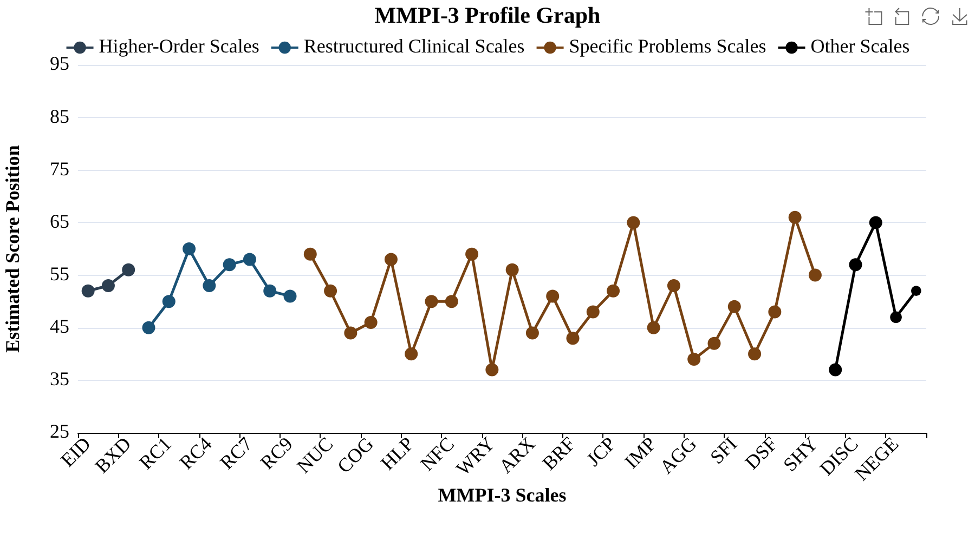
Visual representation of score elevations across all scales.

Detailed Domain Graphs
The following graphs show scales organized by clinical dysfunction domains.

Somatic Cognitive Dysfunction
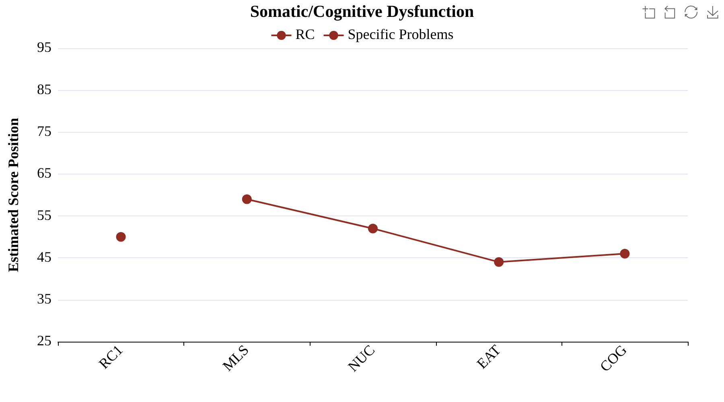

Emotional Dysfunction
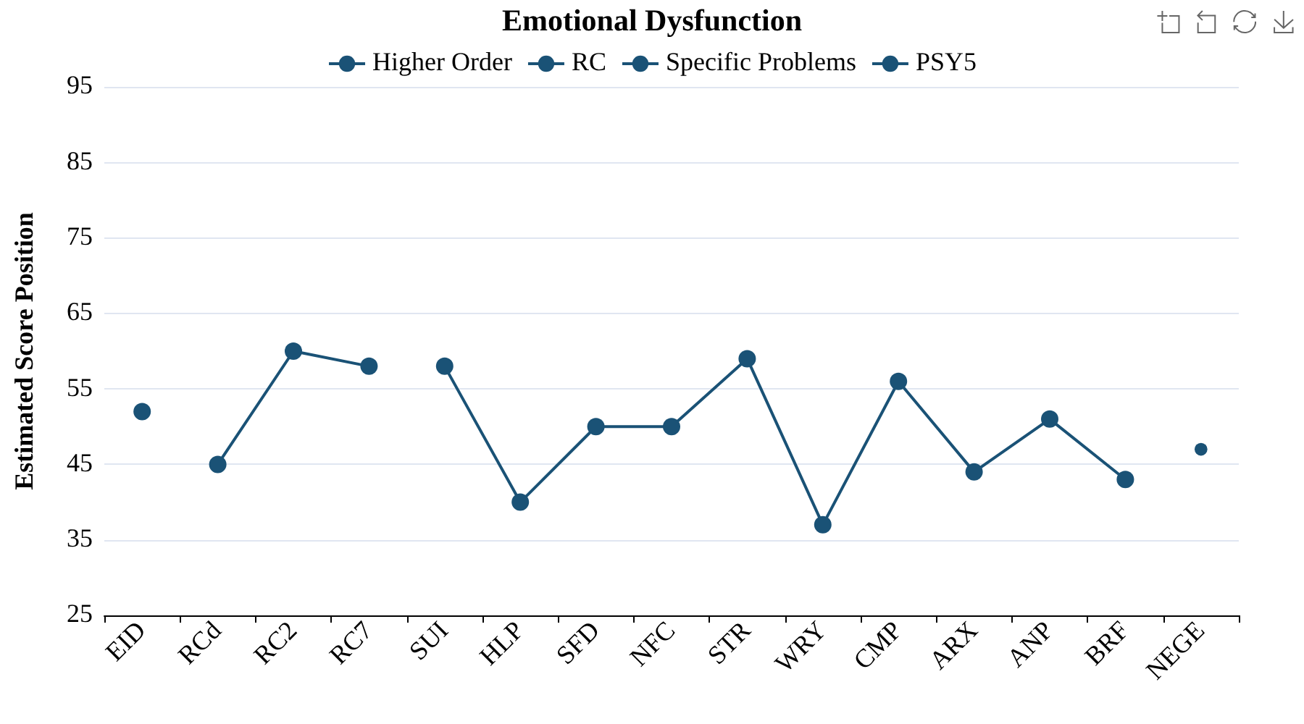

Thought Dysfunction
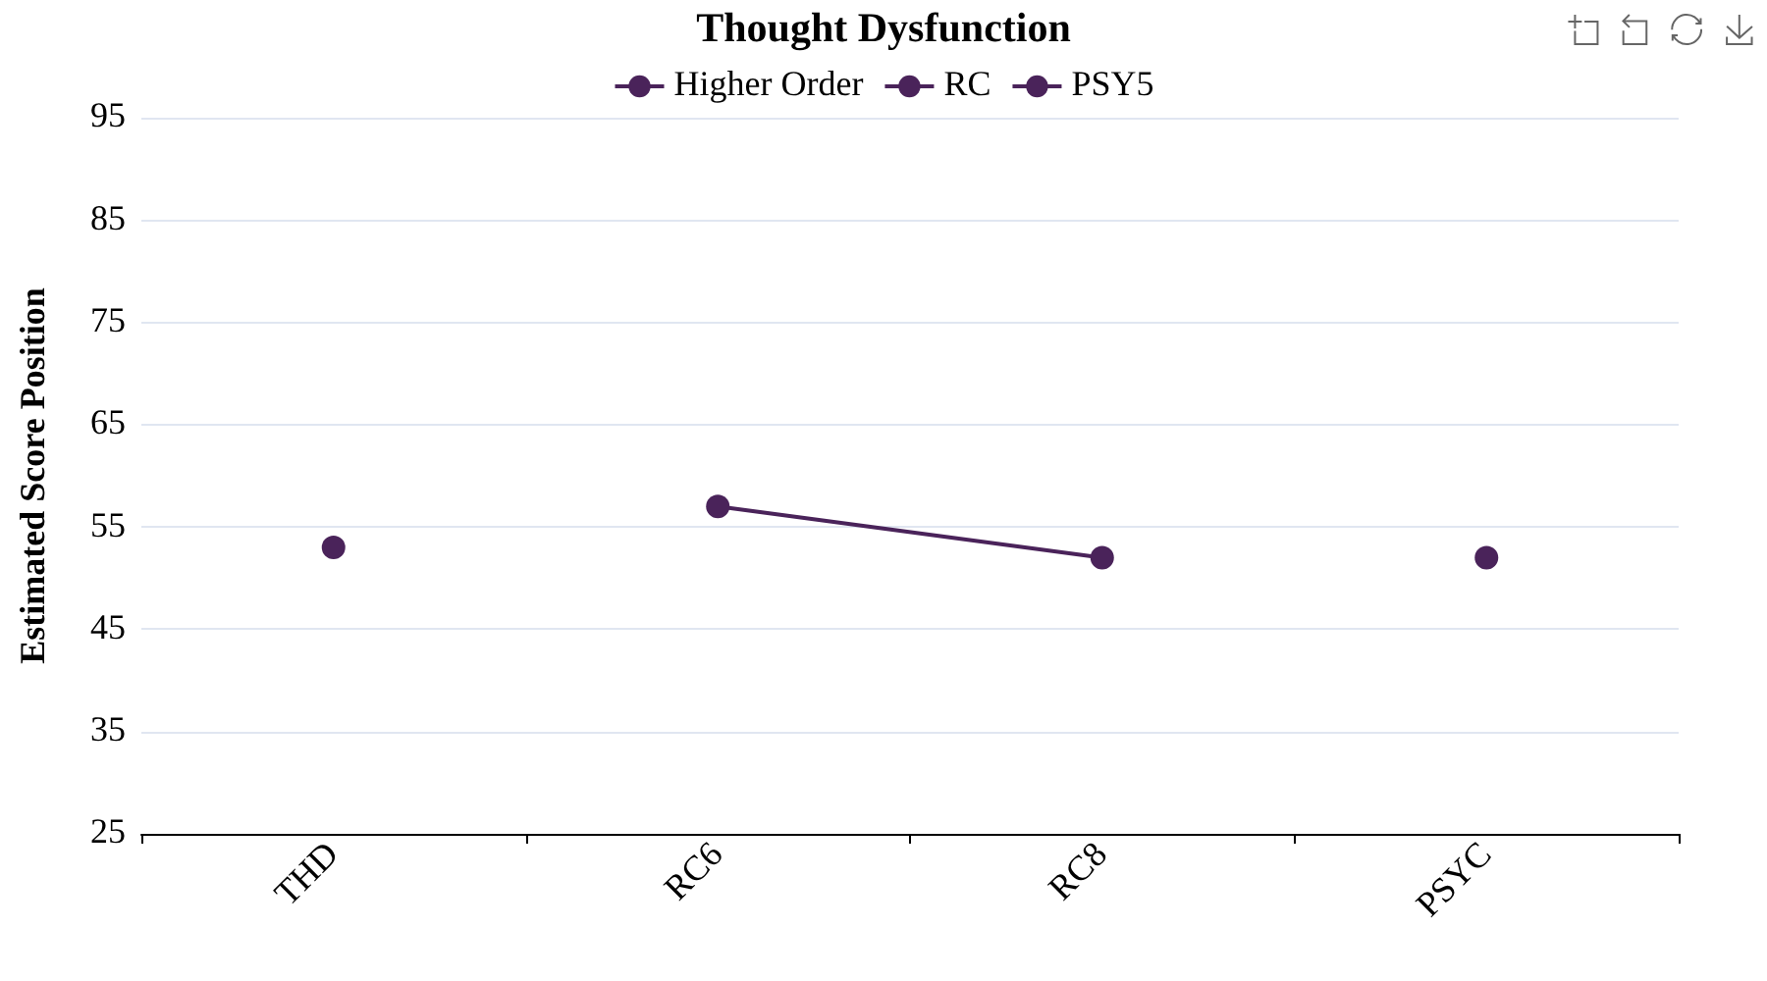

Behavioral Dysfunction
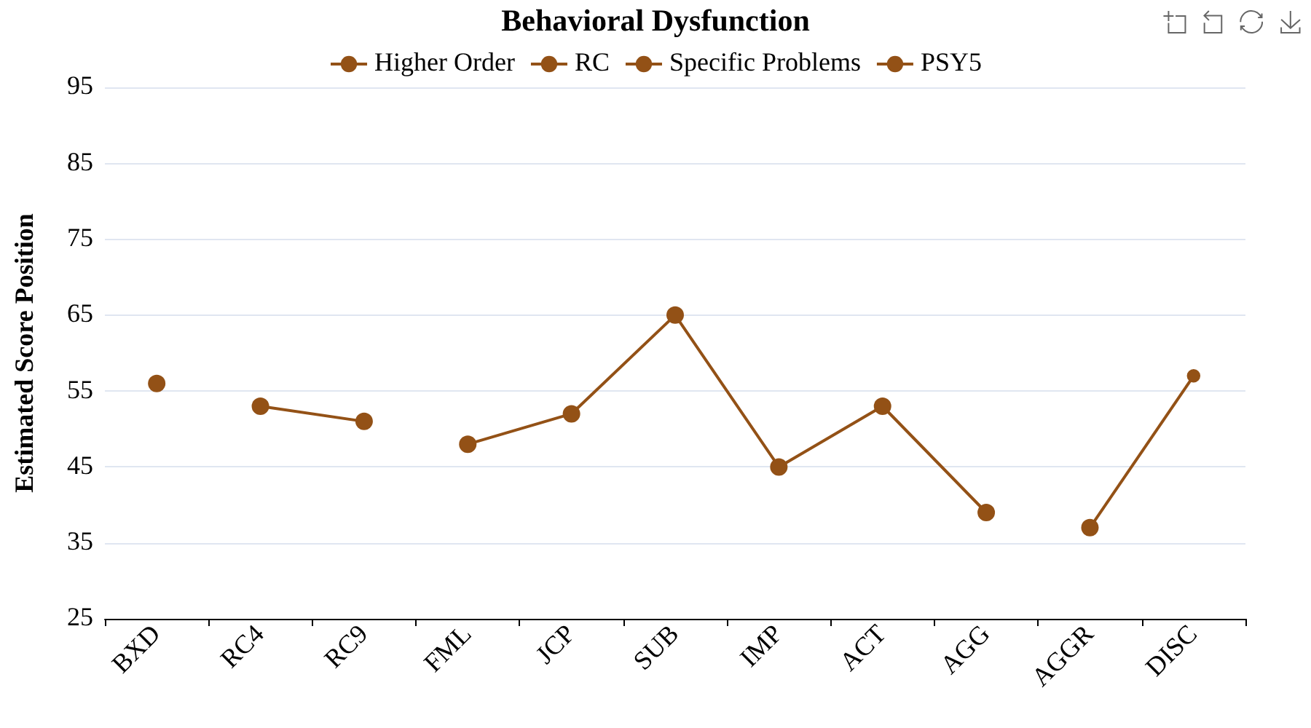

Interpersonal Functioning
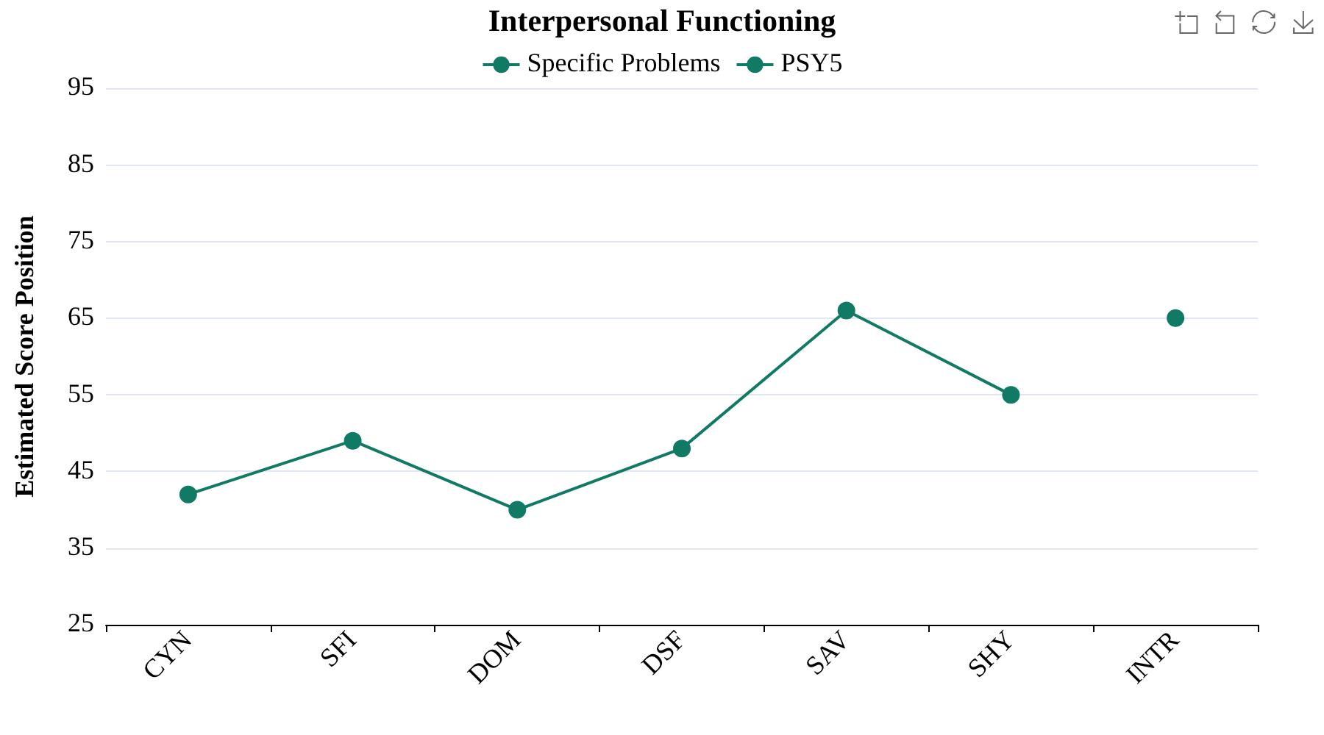

Disclaimer
IMPORTANT DISCLAIMER:
This report was generated for educational and research purposes only.

Appendix A
Scale Name Abbreviations
Abbreviation | Scale | Abbreviation | Scale
F | Infrequent Responses | STR | Stress
Fp | Infrequent Psychopathology Responses | WRY | Worry
Fs | Infrequent Somatic Responses | CMP | Compulsivity
FBS | Symptom Validity Scale | ARX | Anxiety-Related Experiences
RBS | Response Bias Scale | ANP | Anger Proneness
L | Uncommon Virtues | BRF | Behavior-Restricting Fears
K | Adjustment Validity | FML | Family Problems
EID | Emotional/Internalizing Dysfunction | JCP | Juvenile Conduct Problems
THD | Thought Dysfunction | SUB | Substance Abuse
BXD | Behavioral/Externalizing Dysfunction | IMP | Impulsivity
RCd | Demoralization | ACT | Activation
RC1 | Somatic Complaints | AGG | Aggression
RC2 | Low Positive Emotions | CYN | Cynicism
RC4 | Antisocial Behavior | SFI | Self-Importance
RC6 | Ideas of Persecution | DOM | Dominance
RC7 | Dysfunctional Negative Emotions | DSF | Disaffiliativeness
RC8 | Aberrant Experiences | SAV | Social Avoidance
RC9 | Hypomanic Activation | SHY | Shyness
MLS | Malaise | AGGR | Aggressiveness
NUC | Neurological Complaints | PSYC | Psychoticism
EAT | Eating Concerns | DISC | Disconstraint
COG | Cognitive Complaints | NEGE | Negative Emotionality/Neuroticism
SUI | Suicidal/Death Ideation | INTR | Introversion/Low Positive Emotionality
HLP | Helplessness/Hopelessness | CRIN | Combined Response Inconsistency
SFD | Self-Doubt | VRIN | Variable Response Inconsistency
NFC | Inefficacy | TRIN | True Response Inconsistency

