MMPI-3 Score Report

Test Information
Test ID | 737_Y
Test Date | 2026-02-28
Examinee ID | 737_Y
Completion Rate | 100.0% (335/335 items)

Protocol Validity
Status: VALID

Validity Scales
Scale | Raw Score | T-Score | Items Scored | Interpretation
CRIN - Combined Response Inconsistency | 3 | 42 | 86/86 | Within Normal Limits
VRIN - Variable Response Inconsistency | 2 | 43 | 53/53 | Within Normal Limits
TRIN - True Response Inconsistency | 14 | 54T | 33/33 | Within Normal Limits
F - Infrequent Responses | 1 | 44 | 35/35 | Within Normal Limits
Fp - Infrequent Psychopathology Responses | 1 | 50 | 21/21 | Within Normal Limits
Fs - Infrequent Somatic Responses | 2 | 53 | 16/16 | Within Normal Limits
FBS - Symptom Validity Scale | 8 | 48 | 30/30 | Within Normal Limits
RBS - Response Bias Scale | 3 | 39 | 28/28 | Within Normal Limits
L - Uncommon Virtues | 1 | 40 | 14/14 | Within Normal Limits
K - Adjustment Validity | 4 | 44 | 14/14 | Within Normal Limits

Higher-Order Scales
Scale | Raw Score | T-Score | Items Scored | Interpretation
EID - Emotional/Internalizing Dysfunction | 13 | 52 | 42/42 | Within Normal Limits
THD - Thought Dysfunction | 3 | 53 | 27/27 | Within Normal Limits
BXD - Behavioral/Externalizing Dysfunction | 10 | 56 | 24/24 | Within Normal Limits

Restructured Clinical Scales
Scale | Raw Score | T-Score | Items Scored | Interpretation
RCd - Demoralization | 2 | 45 | 17/17 | Within Normal Limits
RC1 - Somatic Complaints | 3 | 50 | 21/21 | Within Normal Limits
RC2 - Low Positive Emotions | 6 | 60 | 14/14 | Slightly Elevated
RC4 - Antisocial Behavior | 5 | 53 | 14/14 | Within Normal Limits
RC6 - Ideas of Persecution | 3 | 57 | 14/14 | Within Normal Limits
RC7 - Dysfunctional Negative Emotions | 11 | 58 | 19/19 | Within Normal Limits
RC8 - Aberrant Experiences | 3 | 52 | 18/18 | Within Normal Limits
RC9 - Hypomanic Activation | 7 | 51 | 15/15 | Within Normal Limits

Specific Problems Scales
Scale | Raw Score | T-Score | Items Scored | Interpretation
MLS - Malaise | 5 | 59 | 7/7 | Within Normal Limits
NUC - Neurological Complaints | 2 | 52 | 10/10 | Within Normal Limits
EAT - Eating Concerns | 0 | 44 | 5/5 | Within Normal Limits
COG - Cognitive Complaints | 1 | 46 | 11/11 | Within Normal Limits
SUI - Suicidal/Death Ideation | 1 | 58 | 7/7 | Within Normal Limits
HLP - Helplessness/Hopelessness | 0 | 40 | 7/7 | Within Normal Limits
SFD - Self-Doubt | 1 | 50 | 7/7 | Within Normal Limits
NFC - Inefficacy | 3 | 50 | 9/9 | Within Normal Limits
STR - Stress | 4 | 59 | 6/6 | Within Normal Limits
WRY - Worry | 0 | 37 | 7/7 | Within Normal Limits
CMP - Compulsivity | 5 | 56 | 8/8 | Within Normal Limits
ARX - Anxiety-Related Experiences | 1 | 44 | 15/15 | Within Normal Limits
ANP - Anger Proneness | 3 | 51 | 12/12 | Within Normal Limits
BRF - Behavior-Restricting Fears | 0 | 43 | 7/7 | Within Normal Limits
FML - Family Problems | 2 | 48 | 10/10 | Within Normal Limits
JCP - Juvenile Conduct Problems | 2 | 52 | 7/7 | Within Normal Limits
SUB - Substance Abuse | 5 | 65 | 9/9 | Moderately Elevated
IMP - Impulsivity | 1 | 45 | 6/6 | Within Normal Limits
ACT - Activation | 4 | 53 | 8/8 | Within Normal Limits
AGG - Aggression | 0 | 39 | 6/6 | Within Normal Limits
CYN - Cynicism | 3 | 42 | 13/13 | Within Normal Limits
SFI - Self-Importance | 7 | 49 | 10/10 | Within Normal Limits
DOM - Dominance | 3 | 40 | 9/9 | Within Normal Limits
DSF - Disaffiliativeness | 1 | 48 | 7/7 | Within Normal Limits
SAV - Social Avoidance | 7 | 66 | 9/9 | Moderately Elevated
SHY - Shyness | 4 | 55 | 7/7 | Within Normal Limits

Personality Psychopathology Five (PSY-5) Scales
Scale | Raw Score | T-Score | Items Scored | Interpretation
AGGR - Aggressiveness | 3 | 37 | 15/15 | Within Normal Limits
PSYC - Psychoticism | 2 | 52 | 20/20 | Within Normal Limits
DISC - Disconstraint | 9 | 57 | 18/18 | Within Normal Limits
NEGE - Negative Emotionality/Neuroticism | 3 | 47 | 15/15 | Within Normal Limits
INTR - Introversion/Low Positive Emotionality | 9 | 65 | 14/14 | Moderately Elevated

Summary
Total scales: 52
Elevated scales: 3

Report generated: 2026-03-14 14:08:34

Profile Visualization
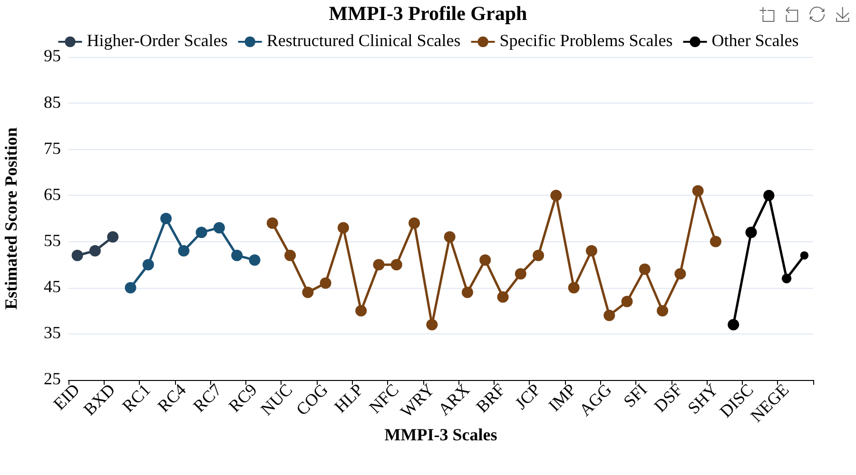
Visual representation of score elevations across all scales.

Detailed Domain Graphs
The following graphs show scales organized by clinical dysfunction domains.

Somatic Cognitive Dysfunction
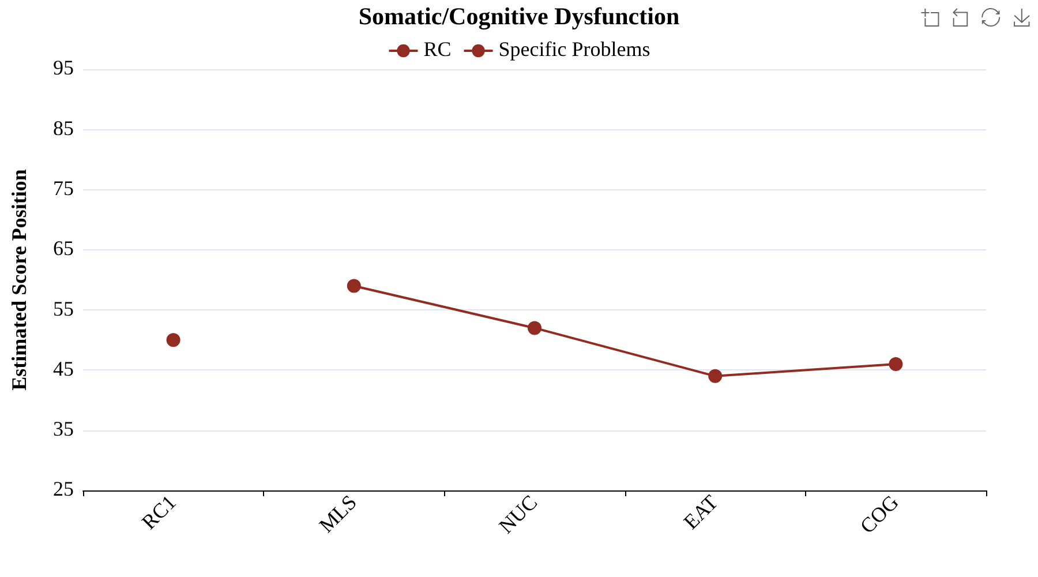

Emotional Dysfunction
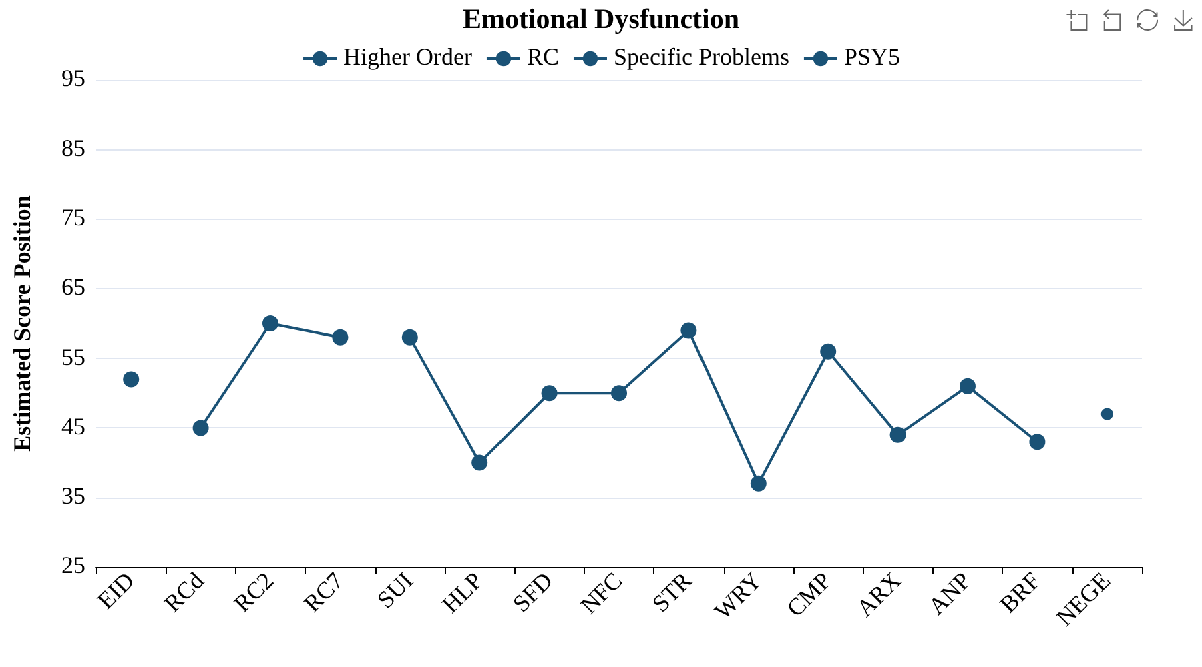

Thought Dysfunction
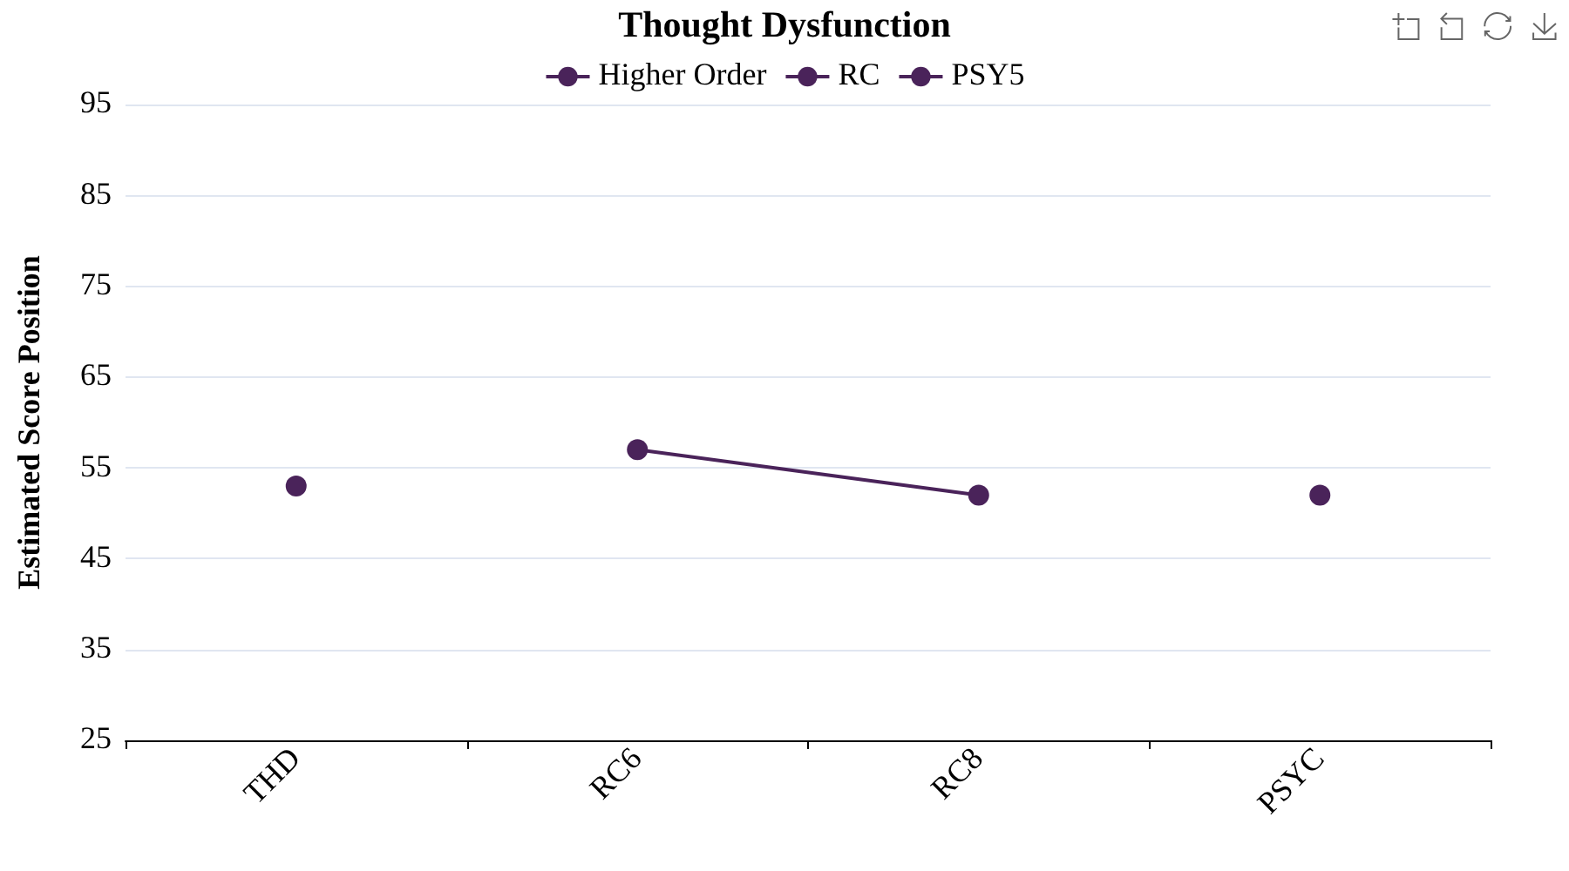

Behavioral Dysfunction
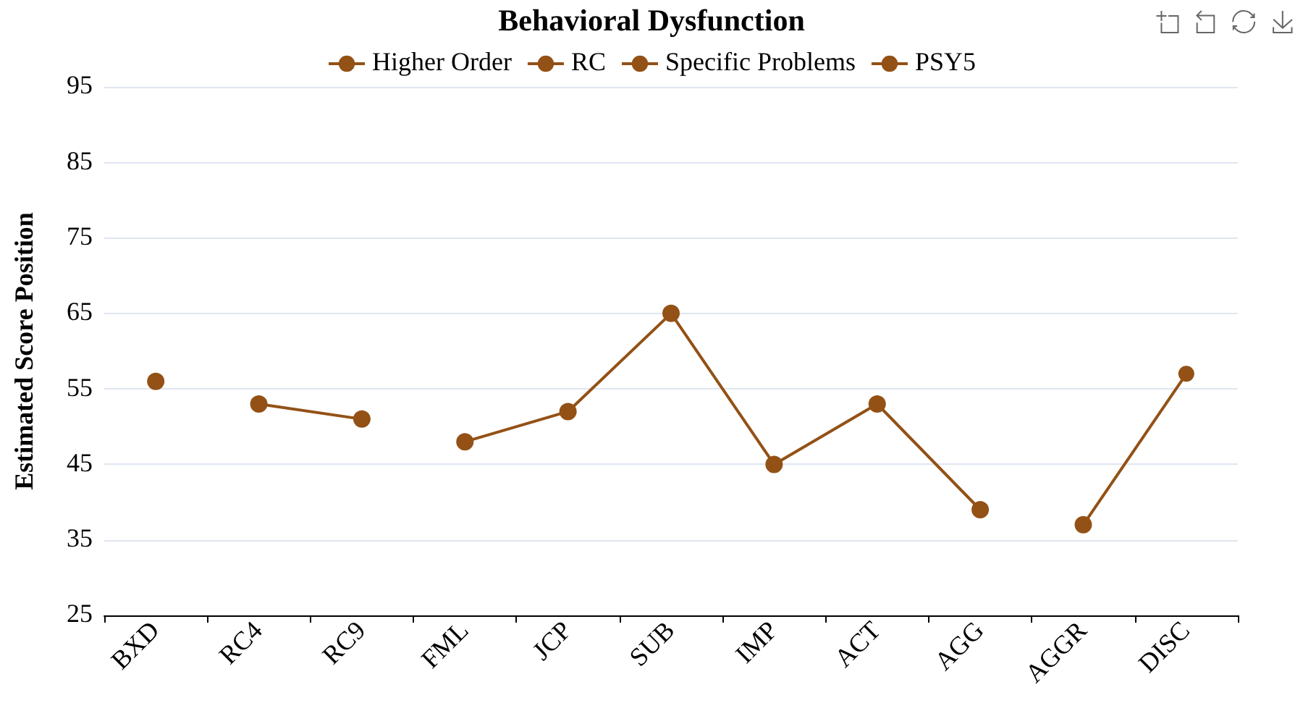

Interpersonal Functioning
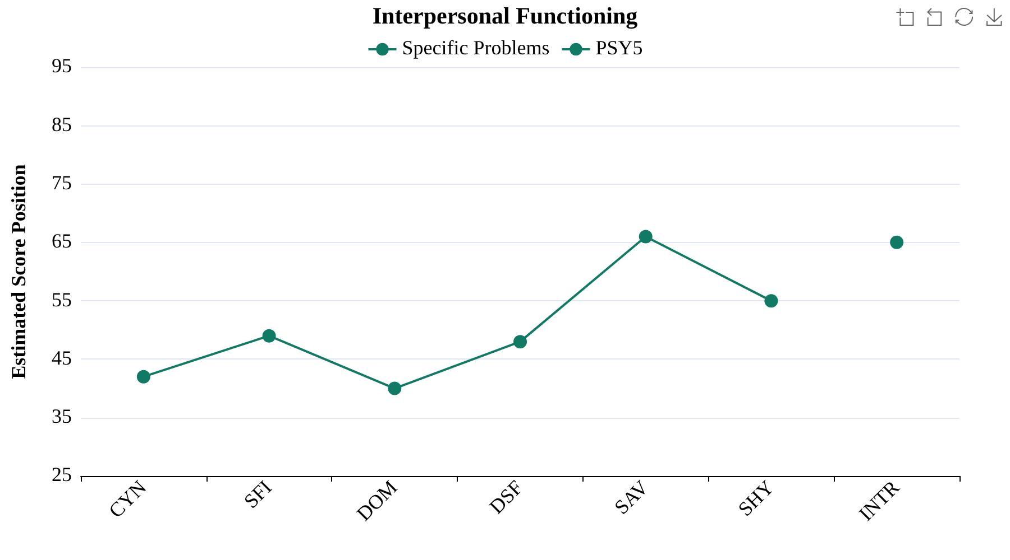

Disclaimer
IMPORTANT DISCLAIMER:
This report was generated for educational and research purposes only.

Appendix A
Scale Name Abbreviations
Abbreviation | Scale | Abbreviation | Scale
F | Infrequent Responses | STR | Stress
Fp | Infrequent Psychopathology Responses | WRY | Worry
Fs | Infrequent Somatic Responses | CMP | Compulsivity
FBS | Symptom Validity Scale | ARX | Anxiety-Related Experiences
RBS | Response Bias Scale | ANP | Anger Proneness
L | Uncommon Virtues | BRF | Behavior-Restricting Fears
K | Adjustment Validity | FML | Family Problems
EID | Emotional/Internalizing Dysfunction | JCP | Juvenile Conduct Problems
THD | Thought Dysfunction | SUB | Substance Abuse
BXD | Behavioral/Externalizing Dysfunction | IMP | Impulsivity
RCd | Demoralization | ACT | Activation
RC1 | Somatic Complaints | AGG | Aggression
RC2 | Low Positive Emotions | CYN | Cynicism
RC4 | Antisocial Behavior | SFI | Self-Importance
RC6 | Ideas of Persecution | DOM | Dominance
RC7 | Dysfunctional Negative Emotions | DSF | Disaffiliativeness
RC8 | Aberrant Experiences | SAV | Social Avoidance
RC9 | Hypomanic Activation | SHY | Shyness
MLS | Malaise | AGGR | Aggressiveness
NUC | Neurological Complaints | PSYC | Psychoticism
EAT | Eating Concerns | DISC | Disconstraint
COG | Cognitive Complaints | NEGE | Negative Emotionality/Neuroticism
SUI | Suicidal/Death Ideation | INTR | Introversion/Low Positive Emotionality
HLP | Helplessness/Hopelessness | CRIN | Combined Response Inconsistency
SFD | Self-Doubt | VRIN | Variable Response Inconsistency
NFC | Inefficacy | TRIN | True Response Inconsistency

