MMPI-3 Interpretive Report

Test Information
Test ID | TEST_001
Test Date | 2025-01-15
Examinee ID | EX_001
Completion Rate | 100.0% (335/335 items)

Protocol Validity
Status: VALID

Validity Scales
Scale | Raw Score | T-Score | Items Scored | Interpretation
CRIN - Combined Response Inconsistency | 11 | 66 | 86/86 | Moderately Elevated
VRIN - Variable Response Inconsistency | 8 | 68 | 53/53 | Moderately Elevated
TRIN - True Response Inconsistency | 14 | 54T | 33/33 | Within Normal Limits
F - Infrequent Responses | 23 | 113 | 35/35 | Clinically Significant
Fp - Infrequent Psychopathology Responses | 12 | 120 | 21/21 | Clinically Significant
Fs - Infrequent Somatic Responses | 4 | 64 | 16/16 | Slightly Elevated
FBS - Symptom Validity Scale | 16 | 70 | 30/30 | Moderately Elevated
RBS - Response Bias Scale | 12 | 72 | 28/28 | Moderately Elevated
L - Uncommon Virtues | 2 | 44 | 14/14 | Within Normal Limits
K - Adjustment Validity | 2 | 38 | 14/14 | Within Normal Limits

Higher-Order Scales
Scale | Raw Score | T-Score | Items Scored | Interpretation
EID - Emotional/Internalizing Dysfunction | 35 | 81 | 42/42 | Clinically Significant
THD - Thought Dysfunction | 22 | 100 | 27/27 | Clinically Significant
BXD - Behavioral/Externalizing Dysfunction | 16 | 70 | 24/24 | Moderately Elevated

The client's MMPI-3 Higher-Order Scale profile reveals clinically significant elevations across all three broad domains of psychological dysfunction, with Thought Dysfunction (THD; T = 100) emerging as the most prominent finding, followed by Emotional/Internalizing Dysfunction (EID; T = 81) and Behavioral/Externalizing Dysfunction (BXD; T = 70).
The THD score of 100 represents an extreme elevation indicating serious thought dysfunction. This score reflects the client's endorsement of a pervasive pattern of disordered thinking that is consistent with features of psychotic-spectrum disturbance, potentially encompassing paranoid or nonparanoid delusional ideation, hallucinatory experiences, and markedly unrealistic thinking. The severity of this elevation warrants careful evaluation for disorders associated with significant thought dysfunction, and the specific nature of these difficulties should be further clarified through examination of RC6 and RC8 scale scores. At this level of elevation, the client may require inpatient treatment, and the need for antipsychotic medication should be evaluated.
The EID score of 81 indicates considerable emotional distress that the client is likely experiencing as a crisis. This degree of emotional and internalizing dysfunction is consistent with a broad constellation of difficulties including demoralization, depressive affect, anxiety, feelings of helplessness, and a pervasive sense of being overwhelmed. Research consistently links EID elevations of this magnitude to significant impairment in daily functioning, heightened risk for suicidal ideation, and presentations involving depression, anxiety, and related internalizing disorders. The co-occurrence of this level of emotional distress alongside serious thought dysfunction suggests a complex clinical presentation in which affective disruption and disordered thinking may be mutually reinforcing, a pattern that is consistent with features of schizoaffective presentations or severe mood disorders with psychotic features.
The BXD score of 70 indicates significant externalizing and acting-out behavior that is likely to have resulted in interpersonal and functional difficulties. This elevation suggests the presence of undercontrolled behavior, which may manifest as poor impulse control, substance misuse, or conflictual interpersonal conduct. The specific manifestations of this behavioral dysfunction should be clarified through examination of the associated RC and Specific Problems scales. Individuals with this level of behavioral

Restructured Clinical Scales
Scale | Raw Score | T-Score | Items Scored | Interpretation
RCd - Demoralization | 15 | 74 | 17/17 | Moderately Elevated
RC1 - Somatic Complaints | 10 | 67 | 21/21 | Moderately Elevated
RC2 - Low Positive Emotions | 11 | 79 | 14/14 | Moderately Elevated
RC4 - Antisocial Behavior | 8 | 62 | 14/14 | Slightly Elevated
RC6 - Ideas of Persecution | 14 | 92 | 14/14 | Clinically Significant
RC7 - Dysfunctional Negative Emotions | 15 | 72 | 19/19 | Moderately Elevated
RC8 - Aberrant Experiences | 12 | 88 | 18/18 | Clinically Significant
RC9 - Hypomanic Activation | 9 | 57 | 15/15 | Within Normal Limits

The client's Restructured Clinical Scale profile reveals a complex clinical presentation characterized most prominently by severe persecutory ideation, significant aberrant experiences, and notable anhedonia, with additional elevations across several emotional and somatic dimensions warranting integrated interpretation.
The client's score on RC6 (Ideas of Persecution; T = 92) represents the most elevated scale in the profile and falls well within the clinically significant range. This score indicates that the client endorsed an extensive and pervasive pattern of persecutory beliefs, suggesting that they perceive others as intentionally threatening, deceptive, or malicious toward them. At this level of elevation, the client very likely experiences significant paranoid ideation that may include firmly held convictions of being targeted, surveilled, or conspired against. The near-maximum raw score (14 out of 14) underscores the thoroughness with which the client endorsed persecutory content, raising the possibility that these beliefs are entrenched and may approach delusional intensity. This degree of elevation is consistent with features of psychotic-spectrum conditions involving paranoid symptomatology and warrants careful diagnostic evaluation for disorders associated with persecutory delusions. Given the severity of these beliefs, the client may require immediate clinical attention to assess the extent to which persecutory thinking compromises reality testing, safety, and interpersonal functioning.
The client's score on RC8 (Aberrant Experiences; T = 88) is the second most elevated scale and similarly falls in the clinically significant range. This score indicates that the client reported a wide array of unusual sensory, perceptual, and cognitive experiences that fall well outside the range of normative functioning. These may include hallucination-like phenomena, unusual thought processes, and other experiences commonly associated with disordered thinking. The co-elevation of RC6 and RC8 is particularly noteworthy, as their combined elevation reflects dysfunction across both persecutory and non-persecutory dimensions of thought disturbance. This pattern is consistent with a broad thought dysfunction syndrome and suggests the need for careful evaluation for psychotic-spectrum disorders, including schizophrenia-spectrum conditions or schizoaffective disorder. The convergence of these two scales strengthens the inference that the client's reality testing is substantially compromised and that antipsychotic medication and possibly inpatient stabilization should be evaluated.
The client's score on RC

Specific Problems Scales
Scale | Raw Score | T-Score | Items Scored | Interpretation
MLS - Malaise | 7 | 77 | 7/7 | Moderately Elevated
NUC - Neurological Complaints | 3 | 56 | 10/10 | Within Normal Limits
EAT - Eating Concerns | 2 | 65 | 5/5 | Moderately Elevated
COG - Cognitive Complaints | 3 | 53 | 11/11 | Within Normal Limits
SUI - Suicidal/Death Ideation | 4 | 80 | 7/7 | Clinically Significant
HLP - Helplessness/Hopelessness | 7 | 86 | 7/7 | Clinically Significant
SFD - Self-Doubt | 6 | 72 | 7/7 | Moderately Elevated
NFC - Inefficacy | 7 | 66 | 9/9 | Moderately Elevated
STR - Stress | 4 | 59 | 6/6 | Within Normal Limits
WRY - Worry | 6 | 65 | 7/7 | Moderately Elevated
CMP - Compulsivity | 5 | 56 | 8/8 | Within Normal Limits
ARX - Anxiety-Related Experiences | 11 | 73 | 15/15 | Moderately Elevated
ANP - Anger Proneness | 11 | 74 | 12/12 | Moderately Elevated
BRF - Behavior-Restricting Fears | 2 | 63 | 7/7 | Slightly Elevated
FML - Family Problems | 5 | 59 | 10/10 | Within Normal Limits
JCP - Juvenile Conduct Problems | 5 | 68 | 7/7 | Moderately Elevated
SUB - Substance Abuse | 0 | 39 | 9/9 | Within Normal Limits
IMP - Impulsivity | 5 | 66 | 6/6 | Moderately Elevated
ACT - Activation | 3 | 49 | 8/8 | Within Normal Limits
AGG - Aggression | 6 | 86 | 6/6 | Clinically Significant
CYN - Cynicism | 13 | 79 | 13/13 | Moderately Elevated
SFI - Self-Importance | 8 | 54 | 10/10 | Within Normal Limits
DOM - Dominance | 5 | 42 | 9/9 | Within Normal Limits
DSF - Disaffiliativeness | 7 | 78 | 7/7 | Moderately Elevated
SAV - Social Avoidance | 9 | 77 | 9/9 | Moderately Elevated
SHY - Shyness | 5 | 61 | 7/7 | Slightly Elevated

The client's Specific Problems scale profile reveals a complex pattern of clinically significant elevations spanning multiple domains of functioning, with the most prominent elevations occurring on the Aggression (AGG; T = 86), Helplessness/Hopelessness (HLP; T = 86), and Suicidal/Death Ideation (SUI; T = 80) scales.
The client's score on AGG represents the maximum attainable raw score on this scale, indicating that she endorsed every item assessing physically aggressive and violent behavior. This elevation is consistent with features of a pervasive pattern of hostile acting-out behavior that may include intimidation, threats, and physical aggression toward others. Research has linked scores at this level to histories of violent and abusive behavior, and this finding warrants careful clinical attention, particularly given its co-occurrence with significant emotional distress and interpersonal dysfunction elsewhere in the profile.
The equally elevated HLP score, also reflecting the maximum possible raw score, indicates that the client endorsed the full range of content reflecting feelings of helplessness and hopelessness. This score suggests a deeply entrenched belief that her circumstances cannot improve and that she is beyond the reach of help. Research has consistently associated scores at this level with ratings of hopelessness and pessimism, dependency characteristic of Cluster C personality presentations, and risk for suicidal ideation and behavior. The pervasiveness of this hopelessness likely functions as a core psychological vulnerability that undermines the client's capacity to envision or pursue meaningful change, potentially reinforcing both her passive interpersonal stance and her emotional despair.
The clinically significant elevation on SUI indicates that the client endorsed content reflecting suicidal and death-related ideation. Research has demonstrated that scores at this level predict not only current suicidal ideation but also future suicide attempts, with the scale outperforming even expressed ideation and past attempt history as a predictor of future self-harm behavior in some samples. The convergence of elevated SUI with the markedly elevated HLP score amplifies concern, as the combination of active death-related ideation with profound hopelessness represents a particularly high-risk configuration. This pairing is consistent with the interpersonal theory of suicide constructs of perceived burdensomeness and thwarted belongingness, both of which have been empirically linked to elev

Personality Psychopathology Five (PSY-5) Scales
Scale | Raw Score | T-Score | Items Scored | Interpretation
AGGR - Aggressiveness | 10 | 57 | 15/15 | Within Normal Limits
PSYC - Psychoticism | 14 | 99 | 20/20 | Clinically Significant
DISC - Disconstraint | 10 | 60 | 18/18 | Slightly Elevated
NEGE - Negative Emotionality/Neuroticism | 12 | 68 | 15/15 | Moderately Elevated
INTR - Introversion/Low Positive Emotionality | 13 | 81 | 14/14 | Clinically Significant

The client's PSY-5 profile reveals a configuration dominated by marked elevations on Psychoticism, Introversion/Low Positive Emotionality, and Negative Emotionality/Neuroticism, suggesting a personality structure characterized by pervasive detachment, perceptual and cognitive disturbance, and chronic negative affective experiences.
The client's score on Psychoticism (PSYC; T = 99) represents the most prominent elevation in this profile and falls well within the clinically significant range. At this level, the client reports a broad range of unusual beliefs and perceptions. Empirical correlates at this elevation indicate the presence of unusual thought processes and perceptual phenomena, alienated interpersonal functioning, unrealistic thinking, and impaired reality testing. Research consistently links elevated PSYC scores with CAT-PD traits including Cognitive Problems, Fantasy Proneness, Peculiarity, Unusual Beliefs, and Unusual Experiences, as well as with Hostile Aggression, Grandiosity, and Relationship Insecurity. This degree of elevation is consistent with features of personality disorders manifesting as unusual thoughts and perceptions, such as schizotypal and paranoid personality disorders. The PSYC scale also converges empirically with the Psychoticism domain of the Alternative DSM-5 Model for Personality Disorders, and research has identified it as the sole predictor of schizotypal personality disorder in clinical and forensic samples. The severity of this elevation warrants careful evaluation of the client's contact with reality and the degree to which disordered thinking may be interfering with daily functioning and interpersonal relatedness.
The clinically significant elevation on Introversion/Low Positive Emotionality (INTR; T = 81) indicates that the client reports a pervasive absence of positive emotional experiences and a pronounced withdrawal from social engagement. Empirical research associates elevated INTR scores with traits from the detachment domain, including Anhedonia, Emotional Detachment, Romantic Disinterest, and Social Withdrawal, as well as Depressivity, low Exhibitionism, Mistrust, and Relationship Insecurity. This pattern is consistent with features of personality pathology involving significant det

Profile Integration
Before substantive interpretation of this profile is undertaken, it is essential to acknowledge that the validity scale configuration raises serious concerns about the credibility of the client's symptom presentation and, consequently, the interpretability of the clinical scales. The Fp scale reached the ceiling score of T = 120, and the F scale was markedly elevated at T = 113, a pattern that indicates the client endorsed an extraordinarily high number of symptoms that are rarely reported even by individuals with genuine, severe psychopathology. The moderately elevated VRIN (T = 68) and CRIN (T = 66) scores suggest that inconsistent responding partially contributed to these elevations, yet the magnitude of the overreporting indicators far exceeds what inconsistency alone would produce. The additional moderate elevations on FBS (T = 70) and RBS (T = 72) further suggest that the client's presentation may be characterized by noncredible somatic and cognitive complaints. Taken together, these validity findings indicate that the substantive scale scores are very likely inflated by overreporting and must be interpreted with extreme caution. The clinical themes described below should therefore be understood as reflecting the content the client chose to endorse rather than as a reliable index of her actual psychological functioning, and all substantive findings require corroboration through collateral information, behavioral observation, and clinical interview before they can be considered clinically meaningful.
With this critical caveat in mind, three salient clinical themes emerge from the integration of the substantive scales, each of which is internally consistent across multiple levels of the MMPI-3 hierarchy.
The most prominent theme involves severe thought dysfunction and compromised reality testing. The higher-order THD scale (T = 100) signals extreme disturbance in this domain, and this elevation is thoroughly confirmed and elaborated by the two restructured clinical scales that comprise it: RC6 (Ideas of Persecution; T = 92) and RC8 (Aberrant Experiences; T = 88). The client endorsed virtually the full range of persecutory content on RC6, suggesting pervasive beliefs that others are threatening, deceptive, or conspiring against her, while the RC8 elevation indicates endorsement of a broad array of unusual perceptual and cognitive experiences. The PSY-5 Psychoticism scale (T = 99) converges powerfully with these findings, reflecting the same constellation of unusual beliefs, perceptual disturbances, and impaired reality testing at the personality-trait level. The specific problems scales further elaborate this picture, with Cynicism (CYN; T = 79) reinforcing the pervasive mistrust captured by RC6 and the Disaffiliativeness scale (DSF; T = 78) reflecting an alienated, misanthropic interpersonal stance that is empirically associated with psychoticism-related personality pathology. This convergence across higher-order, restructured clinical, specific problems, and PSY-5 scales paints a consistent picture of broad thought dysfunction spanning both paranoid and non-paranoid dimensions. However, the extreme overreporting detected on the validity scales means that this presentation is consistent with, but cannot be confidently attributed to, a genuine psychotic-spectrum condition; the possibility that the client deliberately or indiscriminately endorsed psychotic content must be seriously considered.
The second major theme involves pervasive emotional distress and demoralization with acute suicide risk indicators. The higher-order EID scale (T = 81) captures broad internalizing dysfunction, which is confirmed and differentiated by several subordinate scales. RCd (Demoralization; T = 74) reflects a generalized sense of emotional distress and unhappiness, while RC2 (Low Positive Emotions; T = 79) indicates marked anhedonia and diminished capacity for pleasure. The PSY-5 INTR scale (T = 81) converges strongly with RC2, confirming at the trait level a pervasive absence of positive emotional experience and pronounced social withdrawal. The specific problems scales add critical clinical detail: HLP (T = 86) and SUI (T = 80) reached clinically significant levels, and their co-elevation constitutes a particularly concerning risk configuration in which profound hopelessness converges with active death-related ideation. Self-Doubt (SFD; T = 72), Inefficacy (NFC; T = 66), and Malaise (MLS; T = 77) further elaborate a picture of a client who perceives herself as incapable, physically depleted, and without agency. The moderate elevation on RC7 (T = 72) and the anxiety-related specific problems scales (ARX, T

Treatment Recommendations
Critical Preliminary Note: The following treatment recommendations must be contextualized within the serious validity concerns identified in this protocol. The extreme elevations on Fp (T = 120) and F (T = 113), with additional elevations on FBS (T = 70) and RBS (T = 72), indicate that the substantive scale scores are very likely inflated by overreporting. Accordingly, these recommendations address the clinical content the client endorsed while recognizing that the actual nature and severity of her difficulties require clarification through comprehensive clinical interview, collateral informant data, behavioral observation, and, where indicated, repeat assessment under conditions that minimize overreporting. Treatment planning should be updated as the clinical picture is clarified.
1. Immediate Comprehensive Suicide Risk Assessment and Safety Planning. The co-elevation of SUI (T = 80) and HLP (T = 86)—both at maximum raw scores—constitutes a high-risk configuration in which active death-related ideation converges with deeply entrenched hopelessness, a pairing consistently associated with elevated risk for suicide attempts in the empirical literature. The concurrent elevations on EID (T = 81), RCd (T = 74), and RC2 (T = 79), reflecting pervasive demoralization and anhedonia, further amplify this risk by indicating that the client perceives herself as beyond help and devoid of sources of positive experience. The AGG elevation (T = 86) raises additional concern about the client's capacity for self-directed violence. Prior to initiating any other intervention, the treating clinician should conduct a structured suicide risk assessment (e.g., the Columbia Suicide Severity Rating Scale), collaboratively develop a Safety Planning Intervention (Stanley & Brown, 2012), identify means restriction strategies, and determine the appropriate level of care. Given the severity of endorsed thought dysfunction (THD, T = 100; RC6, T = 92; RC8, T = 88) alongside this risk configuration, inpatient or crisis stabilization evaluation is warranted if clinical interview corroborates the presence of active suicidal ideation, impaired reality testing, or an inability to maintain safety.
2. Psychiatric Evaluation for Psychotic-Spectrum Symptomatology and Pharmacological Intervention. The extreme elevation on THD (T = 100), driven by convergent and clinically significant elevations on RC6 (Ideas of Persecution; T = 92), RC8 (Aberrant Experiences; T = 88), and PSYC (T = 99), indicates that the client endorsed a pervasive pattern of persecutory beliefs, unusual perceptual experiences, and broadly impaired reality testing. If corroborated by clinical interview and collateral data, this presentation warrants urgent psychiatric consultation to evaluate the need for antipsychotic medication and to conduct differential diagnosis among psychotic-spectrum disorders (e.g., schizophrenia-spectrum conditions, schizoaffective disorder, or a severe mood disorder with psychotic features, given the concurrent EID elevation of T = 81). The co-occurring AGG (T = 86) and ANP (T = 74) elevations suggest that persecutory ideation may be accompanied by hostile and aggressive behavior, which should inform risk management and medication selection. Pharmacological stabilization of thought dysfunction should be considered a prerequisite for meaningful engagement in psychotherapy, as the severity of these elevations suggests that reality testing impairment may substantially limit the client's capacity to participate in insight-oriented or reflective therapeutic work until psychotic symptoms are adequately managed.
3. Psychodynamically Informed Psychotherapy with Integrated Mindfulness-Based Stabilization, Initiated Following Symptomatic Stabilization. Once acute safety concerns are addressed and thought dysfunction is sufficiently stabilized through pharmacological intervention, a modified psychodynamic psychotherapy is recommended to address the deeply entrenched characterological and affective themes permeating this profile. The convergence of HLP (T = 86), SFD (T = 72), NFC (T = 66), and RCd (T = 74) reflects a core self-structure organized around helplessness, self-doubt, and demoralization—dynamics amenable to exploration within a psychodynamic framework focused on internalized object relations, the client's representational models of self and others, and the developmental origins of her pervasive sense of inefficacy. The marked elevations on CYN (T = 79), DSF (T = 78), RC6 (T = 92), and SAV (T = 77) together suggest

Summary
Total scales: 52
Elevated scales: 33

Report generated: 2026-03-14 16:39:53

This MMPI-3 protocol must be interpreted with extreme caution due to serious validity concerns, as the markedly elevated Fp (T = 120) and F (T = 113) scales indicate that the client endorsed an extraordinarily high volume of symptoms rarely reported even by individuals with genuine, severe psychopathology, rendering the substantive scale scores very likely inflated by overreporting. With this critical caveat, the content the client endorsed converges across multiple levels of the test hierarchy around three salient clinical themes: severe thought dysfunction characterized by pervasive persecutory ideation and aberrant perceptual experiences (THD, T = 100; RC6, T = 92; RC8, T = 88; PSYC, T = 99); profound emotional distress marked by demoralization, anhedonia, and deeply entrenched hopelessness (EID, T = 81; RC2, T = 79; HLP, T = 86); and acute suicide risk indicators reflected in the convergence of maximum-score endorsements on the Helplessness/Hopelessness and Suicidal/Death Ideation scales (SUI, T = 80). The co-elevation of AGG (T = 86) introduces additional concern regarding the client's potential for both other-directed and self-directed violence. Before these findings can inform diagnostic formulation or treatment planning, the treating clinician must clarify the nature and severity of the client's actual psychological functioning through comprehensive clinical interview, collateral informant data, and behavioral observation to differentiate genuine psychopathology from noncredible symptom presentation. Immediate priorities, pending such clarification, include structured suicide risk assessment with safety planning and psychiatric evaluation to determine the appropriate level of care.

Profile Visualization
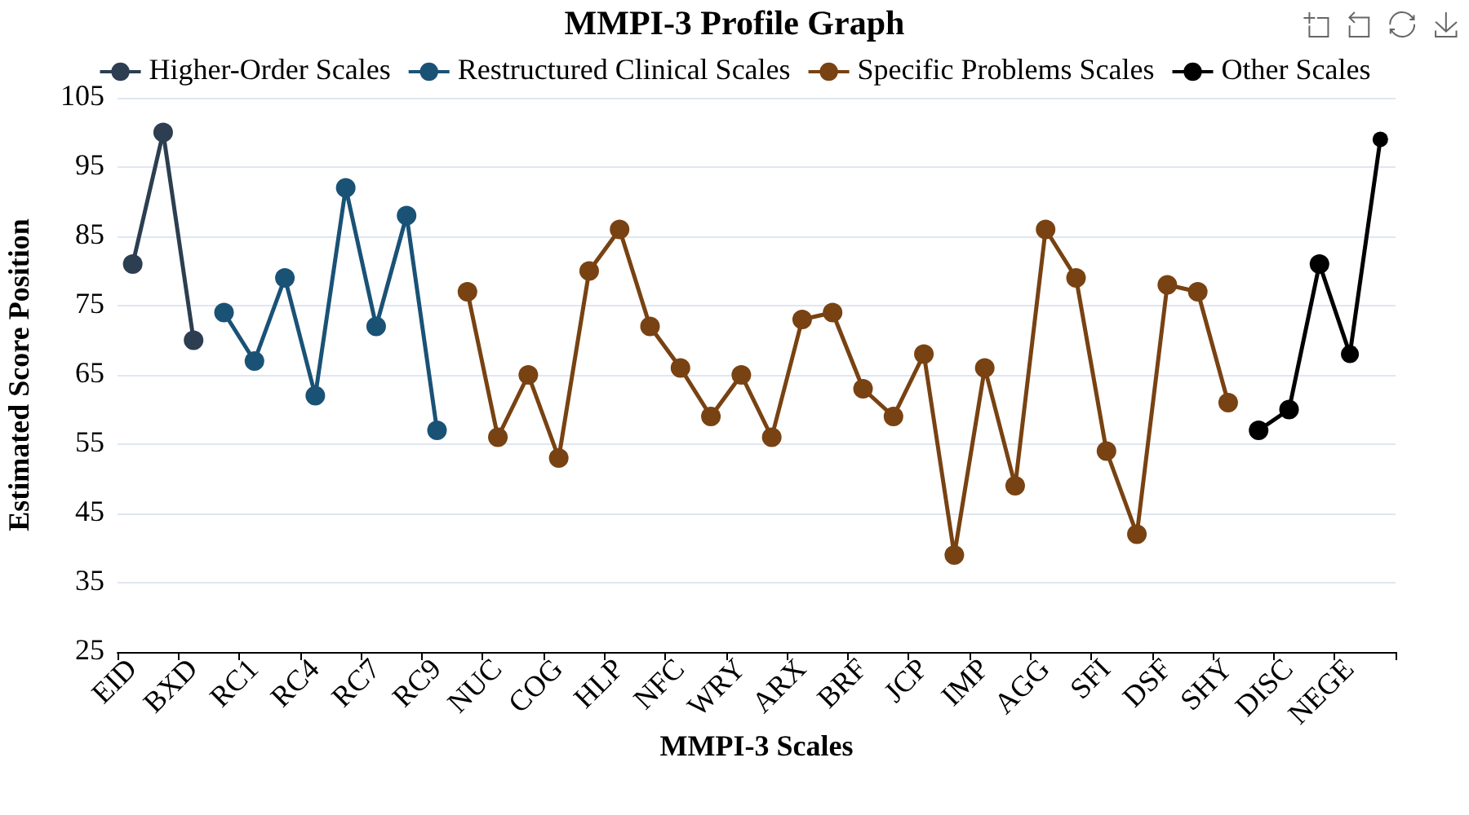
Visual representation of score elevations across all scales.

Detailed Domain Graphs
The following graphs show scales organized by clinical dysfunction domains.

Somatic Cognitive Dysfunction
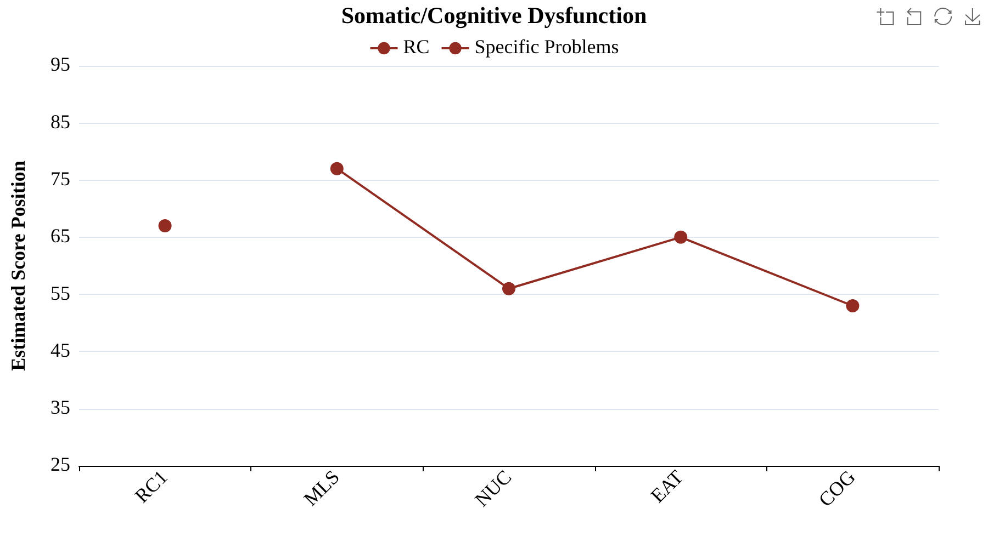

Emotional Dysfunction
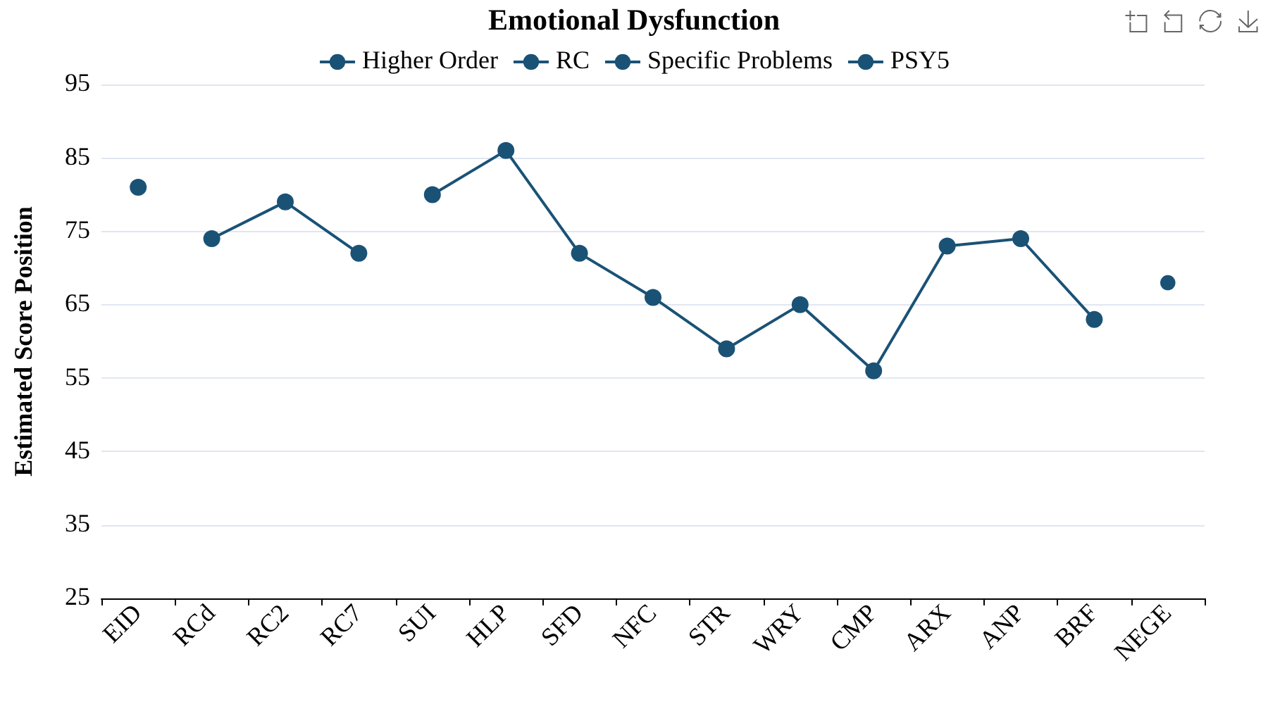

Thought Dysfunction
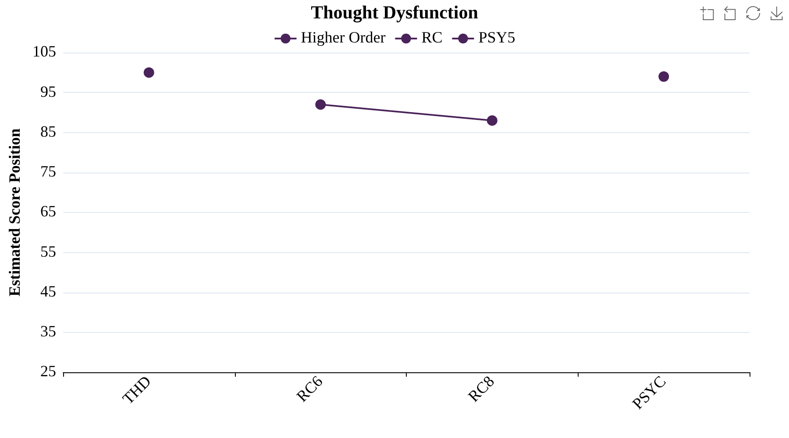

Behavioral Dysfunction
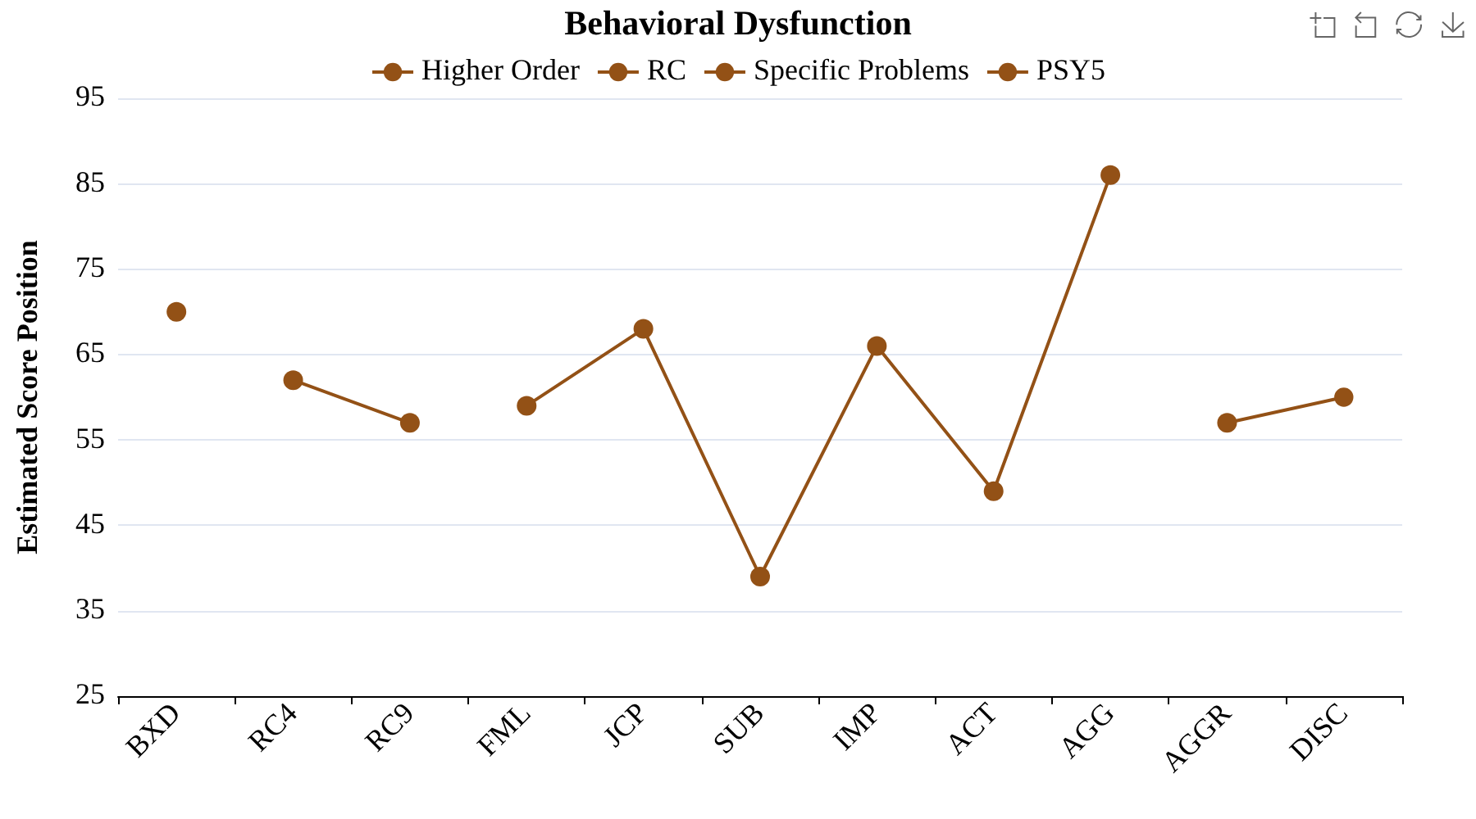

Interpersonal Functioning
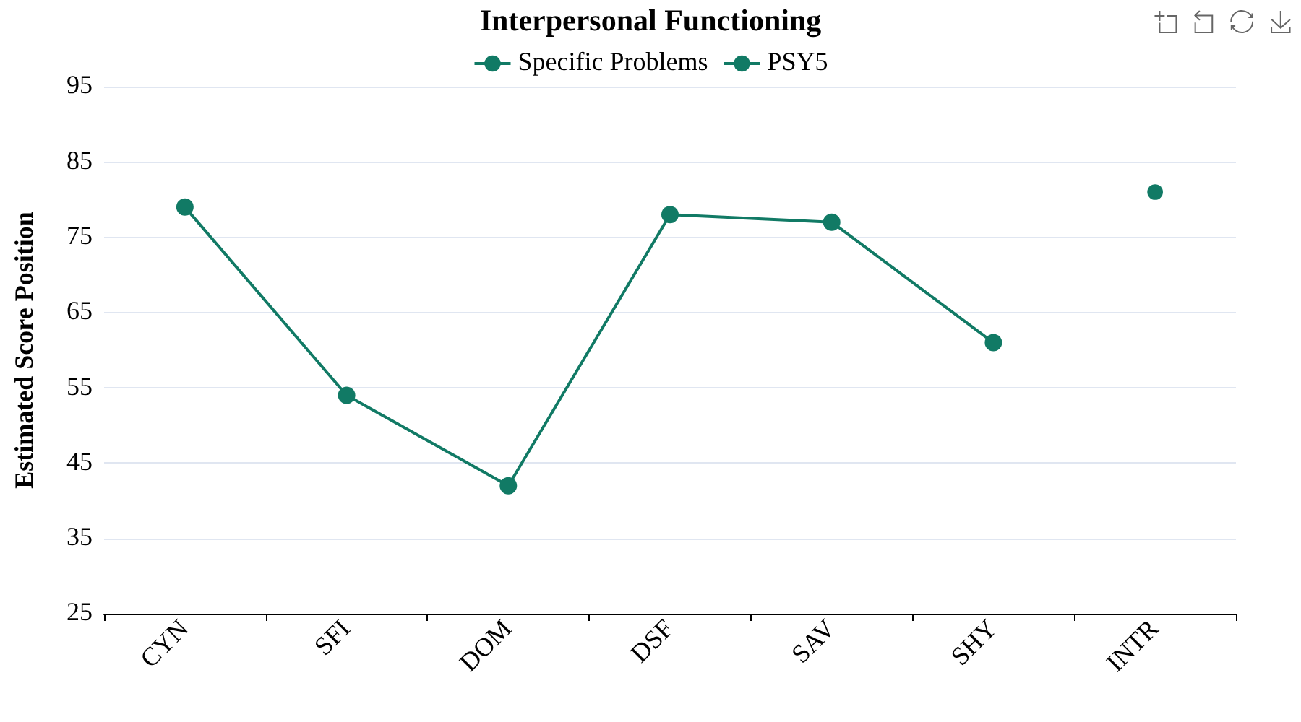

Disclaimer
IMPORTANT DISCLAIMER:
This report was generated for educational and research purposes only.

Appendix A
Scale Name Abbreviations
Abbreviation | Scale | Abbreviation | Scale
F | Infrequent Responses | STR | Stress
Fp | Infrequent Psychopathology Responses | WRY | Worry
Fs | Infrequent Somatic Responses | CMP | Compulsivity
FBS | Symptom Validity Scale | ARX | Anxiety-Related Experiences
RBS | Response Bias Scale | ANP | Anger Proneness
L | Uncommon Virtues | BRF | Behavior-Restricting Fears
K | Adjustment Validity | FML | Family Problems
EID | Emotional/Internalizing Dysfunction | JCP | Juvenile Conduct Problems
THD | Thought Dysfunction | SUB | Substance Abuse
BXD | Behavioral/Externalizing Dysfunction | IMP | Impulsivity
RCd | Demoralization | ACT | Activation
RC1 | Somatic Complaints | AGG | Aggression
RC2 | Low Positive Emotions | CYN | Cynicism
RC4 | Antisocial Behavior | SFI | Self-Importance
RC6 | Ideas of Persecution | DOM | Dominance
RC7 | Dysfunctional Negative Emotions | DSF | Disaffiliativeness
RC8 | Aberrant Experiences | SAV | Social Avoidance
RC9 | Hypomanic Activation | SHY | Shyness
MLS | Malaise | AGGR | Aggressiveness
NUC | Neurological Complaints | PSYC | Psychoticism
EAT | Eating Concerns | DISC | Disconstraint
COG | Cognitive Complaints | NEGE | Negative Emotionality/Neuroticism
SUI | Suicidal/Death Ideation | INTR | Introversion/Low Positive Emotionality
HLP | Helplessness/Hopelessness | CRIN | Combined Response Inconsistency
SFD | Self-Doubt | VRIN | Variable Response Inconsistency
NFC | Inefficacy | TRIN | True Response Inconsistency

