TestPlotEmiss:

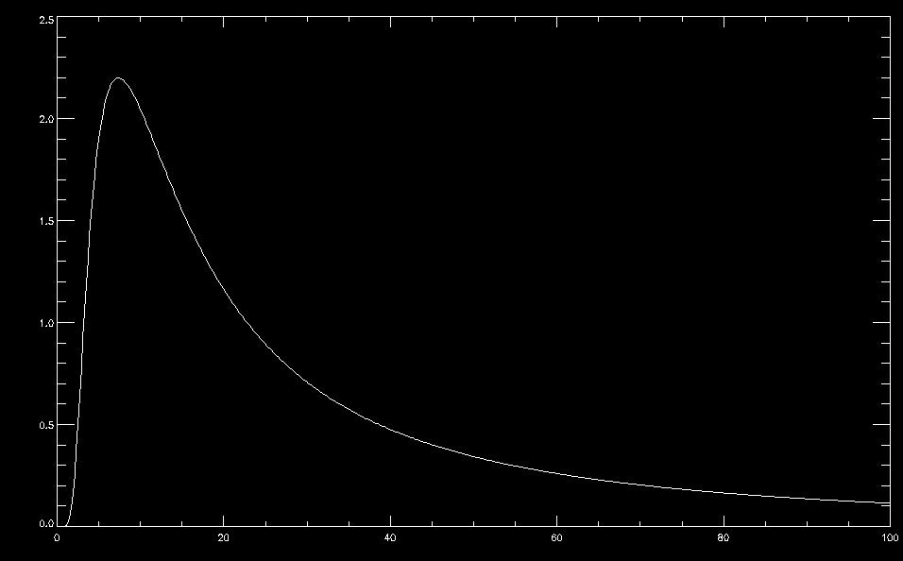
testPlotEmiss,1e19,1,100

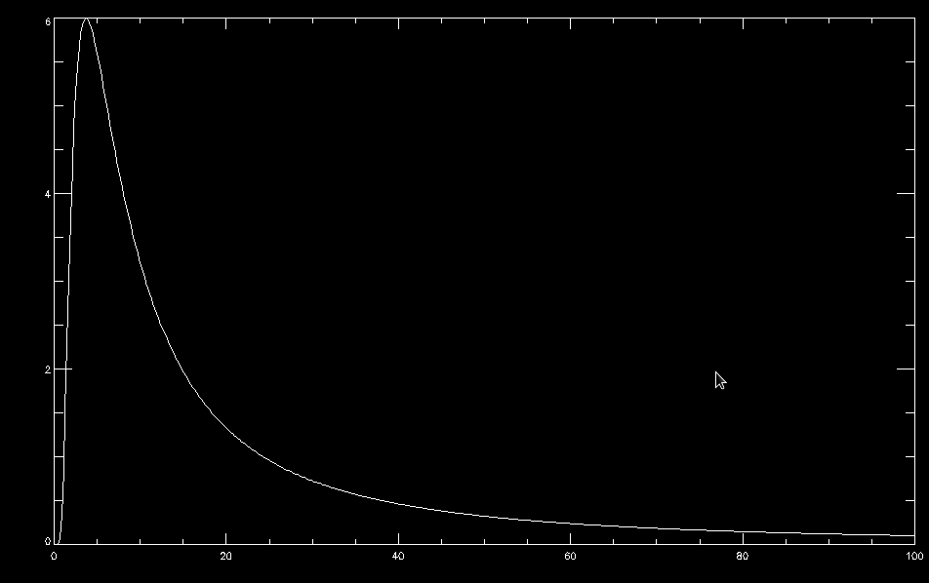
testPlotEmiss,1e19,2,100

As expected, the peak energy increases in magnitude, and also increases in energy (decreases in wavelength) when the test electron temperature is doubled.

TestMin:

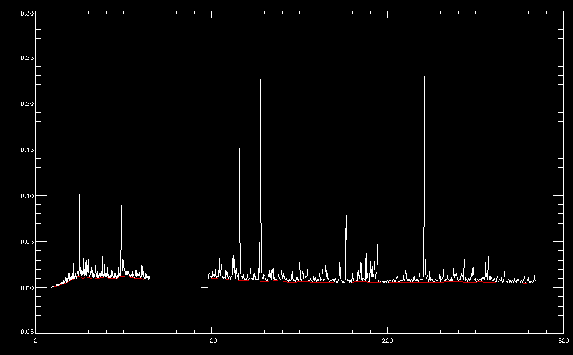
The continuum is correctly extracted from both XEUS and Loweus

testSeveralEmissEquations:

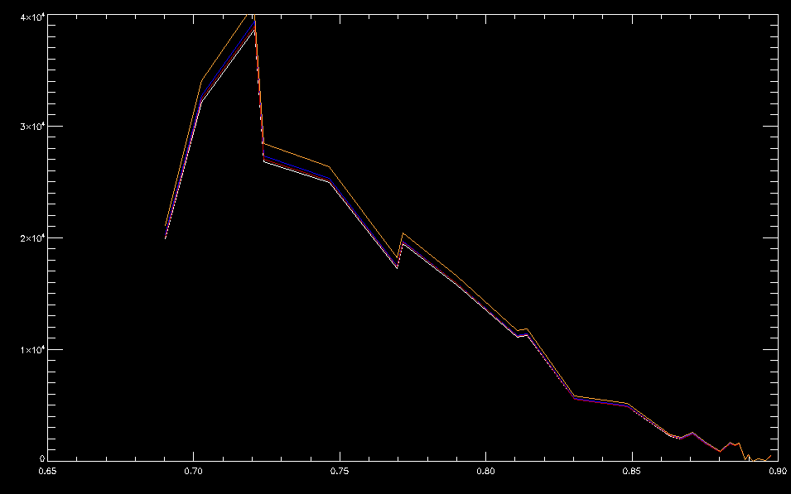
testSeveralEmissEquations,1120221009,1

Four emissivity equations are integrated over various radial conditions, all show the same qualitative behavior. The orange trace is scaled, since at the time of this writing the equation taken from xtomo_genrad_brem_emiss has a typo that causes its absolute magnitude to be off.

The four equations can be found in bremTestCodes.pro.

The red and white traces are wavelength-dependent and were integrated over a range of wavelengths
The blue and orange traces are energy-dependent and were integrated over the equivalent energy range

integrateAllWavelengths:

IDL> integrateAllWavelengths,1e18,1,1
Calculated by energyEmiss integration (W/m^3): 0.730514
Calculated by expected total power loss (W/m^3): 0.535000
IDL> integrateAllWavelengths,1e18,2,1
Calculated by energyEmiss integration (W/m^3): 1.02012
Calculated by expected total power loss (W/m^3): 0.756604
IDL> integrateAllWavelengths,1e19,2,1
Calculated by energyEmiss integration (W/m^3): 102.012
Calculated by expected total power loss (W/m^3): 75.6604

The integrated energyEmiss equation is close to the expected total power loss. They are not exactly the same since the calculated total bremsstrahlung does not account for the gaunt factor.

As expected, increasing electron temperature increases total power emission, and increasing electron density also increases total power emission

