Airline Safety 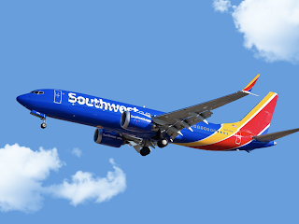

Did you know….

Passenger flight fatalities have steadily decreased since 2000

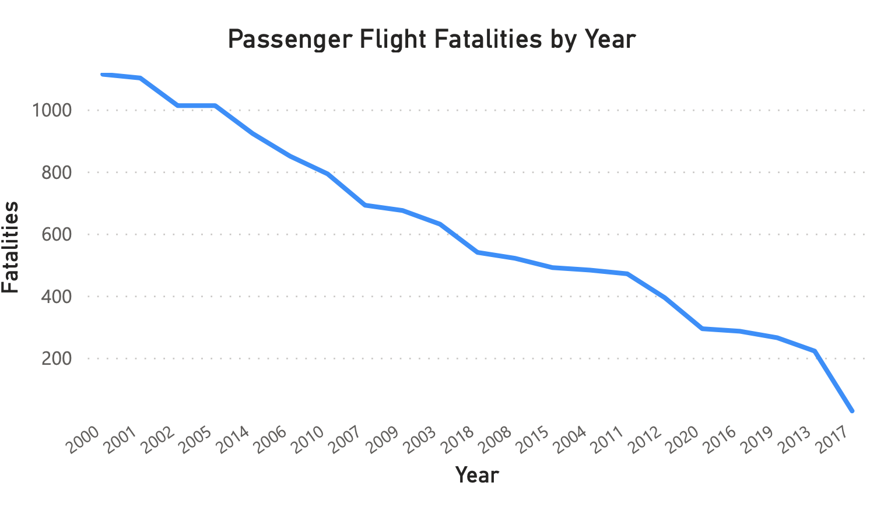

….and in that time, passengers traveling has continued to increase

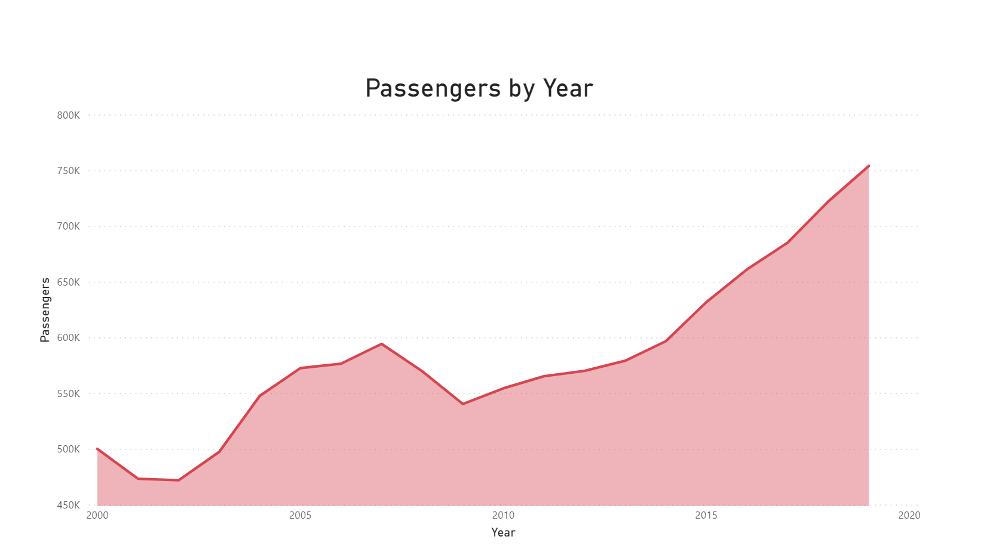

Airline fatalities only account for 1.28% of transportation fatalities, compared to 94.05% for highway fatalities

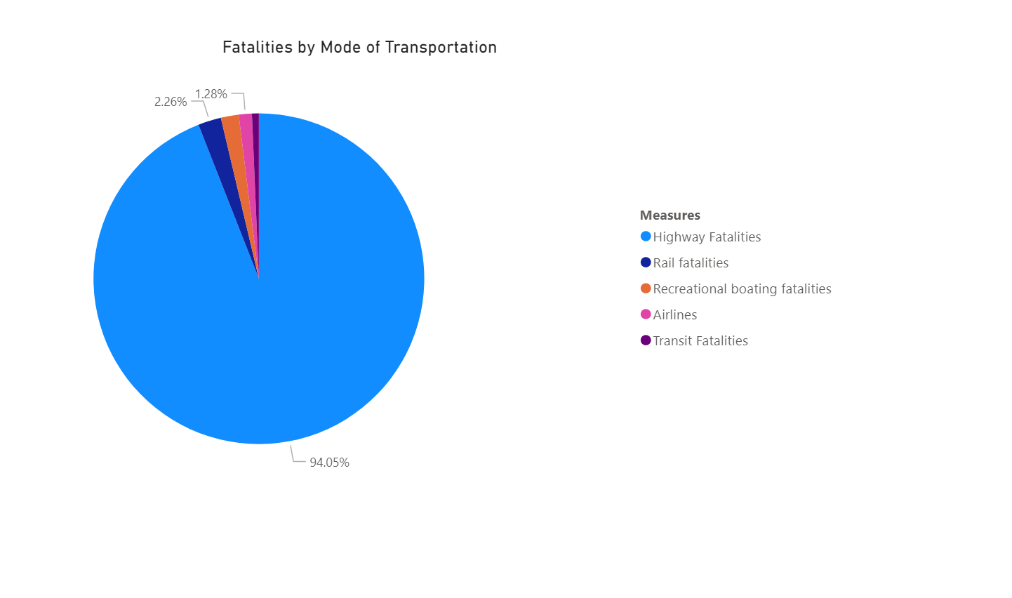

In the last 20 years, fatal accidents per 10 MILLION departures has only been between 0 and 3 (and was only 3 once!)

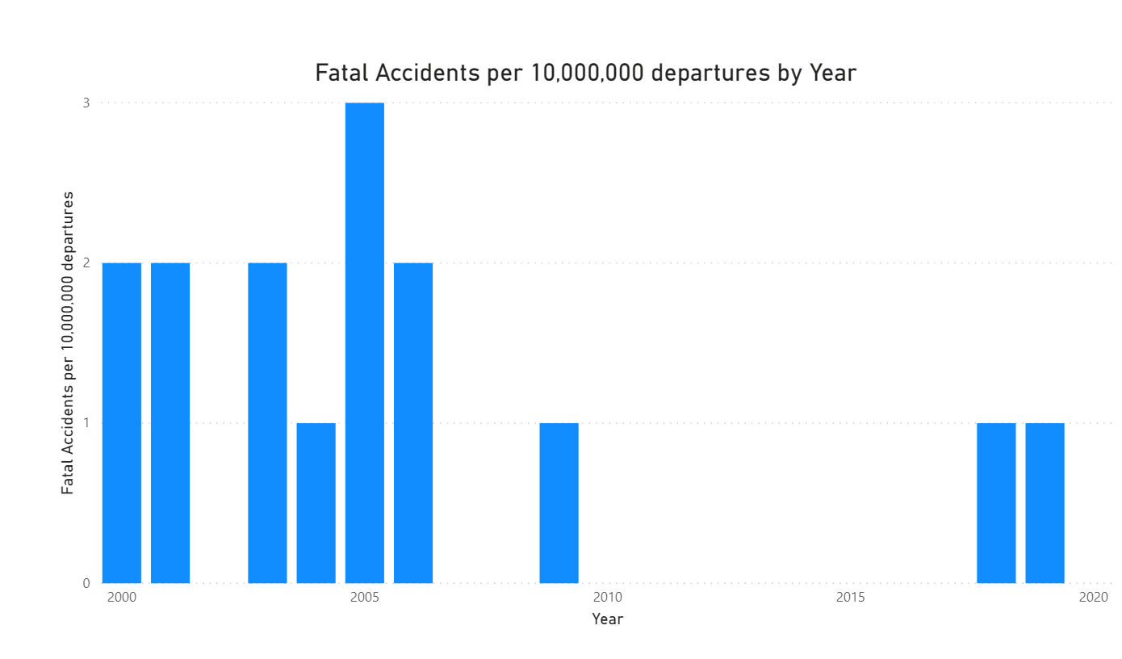

Southwest Airlines has over 3 BILLION available seat km per week, and had ZERO fatalities between 2000 and 2014

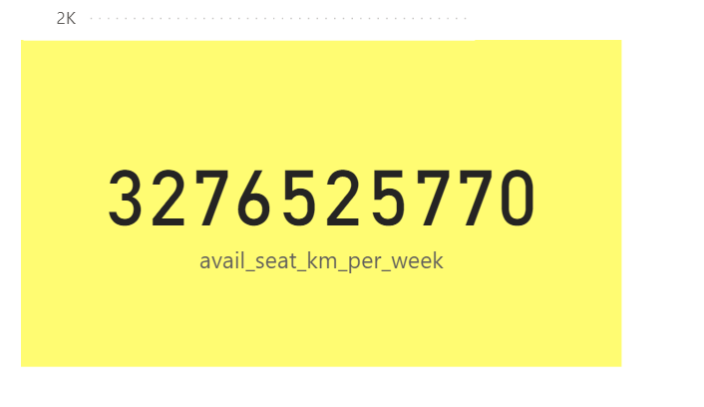

Compared to other North American airlines, Southwest is about in the middle for seats and lower than several other airlines for incidents and fatalities

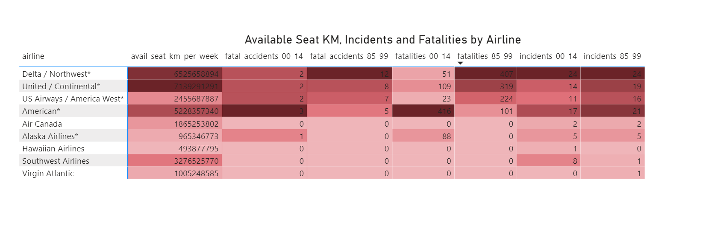

We are dedicated to keeping safety a top priority and hope you will fly with us soon!

References:

https://data.world/fivethirtyeight/airline-safety

https://www.bts.gov/browse-statistical-products-and-data/state-transportation-statistics/ transportation-safety

https://www.airlines.org/dataset/safety-record-of-u-s-air-carriers/

https://www.bts.gov/browse-statistical-products-and-data/state-transportation-statistics/ transportation-safety

https://www.airlines.org/dataset/safety-record-of-u-s-air-carriers/

https://www.airlines.org/dataset/annual-results-world-airlines/