Naming conventions

Capitalization Styles
It is suggested to use the following three conventions for capitalizing identifiers: Pascal case, Camel case, and Uppercase.

Pascal case
The first letter in the identifier and the first letter of each subsequent concatenated word are capitalized. Applies for identifiers of three or more characters.

Example:
HttpSessionState, UnicodeEncoding

Camel case
The first letter of an identifier is lowercase and the first letter of each subsequent concatenated word is capitalized. Applies for identifiers of three or more characters.

Example:
sessionState, lastName

Uppercase
All letters in the identifier are capitalized. Should be used only for identifiers that consist of two or fewer letters.

Example:
System.IO, System.Web.UI

Namespace Naming Guidelines
The general rule for naming namespaces recommended by Microsoft is to use the company name followed by the technology name and optionally the feature and design:
CompanyName.TechnologyName[.Feature][.Design]. For the ECMS project the following “root” namespaces is suggested:
Epam.Ecms

Further breakdown is recommended as well.

Example:
Epam.Ecms.BO
Epam.Ecms.Web.UI
Epam.Ecms.Web.UI.Controls

Class Naming Guidelines
The rules to follow when naming classes:
- A noun or noun phrase should be used to name a class.
- Only Pascal case is allowed.
- No type prefix (C, T).
- No underscore character.
- Collections should always have the suffix Collection.
- Exceptions should always have the suffix Exception.

Example:
CompanyBase, PhysicalDunsCollection, BadDataException

Interface Naming Guidelines
The rules to follow when naming interfaces:
- A noun, noun phrase or adjective that describes behavior should be used to name an interface.
- Only Pascal case is allowed.
- Should always have a type prefix with the letter I.
- No underscore character.

Example:
ICompany, ICompanyDal, IDisposable

Enumeration Naming Guidelines
The rules to follow when naming enumeration types:
- Only Pascal case is allowed for both type name and value name.
- Singular name should be used for the most enumeration types. Plural name should be used for the bit fields.
- No “Enum” suffix.

Example:
SearchType { All, Single }, AccessMode { ReadOnly, Update }

Method Naming Guidelines
The rules to follow when naming methods:
- A verb or verb phrase should be used to name a method.
- Only Pascal case is allowed

Example:
Invoke(), Search(), AddRange()

Property Naming Guidelines
The rules to follow when naming properties:
- A noun or noun phrase should be used to name a property.
- Only Pascal case is allowed.

Example:
Color, FirstName

Parameter/Class Field Member Naming Guidelines
The rules to follow when naming parameters or class field members:
- Only Camel case is allowed for parameters and private/protected fields.
- Only Pascal case is allowed for public fields (use properties instead of public fields).
- Give descriptive names.
- Names should describe meaning, not the type.
- No underscore or “m_” prefix for class members.

Example:
companyInfo, firstName

When following the rules stated above, the situation when method parameter has the same name as class field member may arise. In this case class member should be referenced via prefix this. No such situation exists for property set accessor.

Example:
public class SomeClass
{
string fileName;
public void Create(string fileName)
{
this.fileName = fileName;
}
public string FileName
{
get { return fileName; }
set { fileName = value; }
}
}

Constant Naming Guidelines
In .NET constant cannot be on its own. It has to have a logical “container”. The rules to follow when naming constants:
- A noun or noun phrase should be used to name a constant.
- Only Pascal case is allowed.

Stored procedure names should not be defined as constants and be specified directly while constructing data access objects.

Example:
public class Constants
{
public const string SessionKey = "ProfileSession";
}

Constant can be easily identified while coding in IDE.
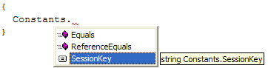

XML Documentation
It is strongly encouraged to use XML Documentation feature available in C#. The special /// delimiter is used to describe class, method, parameters. Visual Studio .NET has smart comment editing feature automatically inserting documentation tags. At least summary tag is required, remarks tag is recommended.

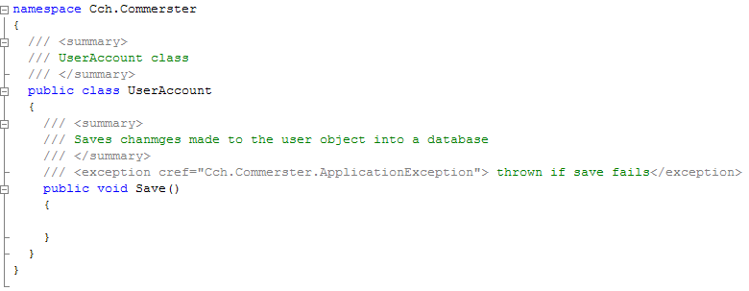

Comments

Use // as a comment. It is recommended to use Ctrl+K+D with “Ghost Doc” visual studio plugin installed to comment out a block

Hungarian Notation
In the nowadays, when developers have powerful development tools with intelli-sense the use of Hungarian notation is fading away. In the OOP programming Hungarian notation brings confusion instead of help. Hungarian notations is a taboo (Except web forms).

File Names

C# Source Files
Name of the source file should be the name of the class defined in that file. Do not define more than one public class in one file. File name should be the public class name plus “.cs”.

Example:
class SomeClass
{
}
in SomeClass.cs

Assembly Files
Follow the rules from Namespace Naming Guidelines to give name to the assemblies.

Example:
Epam.Ecms.dll

ASPX/ASCX Files
The rules to follow when naming classes:
- A noun or noun phrase should be used to name a class.
- Only Pascal case is allowed.
- No underscore character.

By default Visual Studio .NET creates three files when new Web Form is added. For “DocumentSearch” the following files will be created:
DocumentSearch.aspx, DocumentSearch.aspx.cs, DocumentSearch.cs.designer

HTML Files
Follow 4.3 rules

Example:
StaticPage.htm

JS Files
JavaScript files should be names as its corresponding html file. The global js files should follow 4.4.

Example:
GlobalFunctions.js

XML/XSL Files
Follow 4.3 rules

Example:
StaticList.xml, StaticList.xsl

Indentation

Whitespace

Only tabs should be used for white spaces, never use spaces. Setup the IDE as shown below for C# and HTML. Note that "Tab Size" is a personal setting and can be 4 instead of 2, it is important for "Keep tabs" to be on.
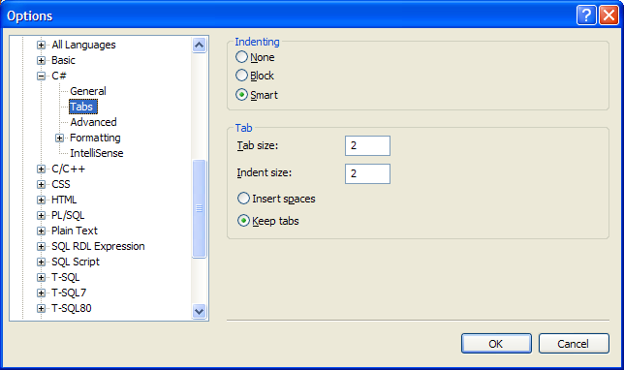

Wrapping lines

Break line after a comma or an operator. Place one tab for the new lines.

Example:
AddParameter<TParam, object>(command, paramName,
ParameterDirection.Output,
paramType, null);

Statements

return statement

There should be no parentheses if return statement is used along with variable name or a string. Expressions should have parentheses.

Example:
object Foo()
{
object o = new object();
return o;
}

int Bar()
{
return (2 + 4);
}

Braces

Open brace should be on the new line

if/try/catch/for/foreach/while/switch statements

There should be exactly one space after the if/try/catch/for/foreach/while/switch statements.

Example:
if (condition)
{
// multiple lines
}
else
{
// multiple lines
}
if (condition)
Foo();
else
Bar();
for (int i = 0; i++; i < 10)
{
}
foreach (object o in someCollection)
{
}
try
{
}
catch (ApplicationException ex)
{
}
finally
{
}

Binary operators

There should be exactly one space before and after binary operators.

