RStudio2

## Assignment 2.1

### 1.Calculate the mean sales’ values for each color.

|  |  |
| --- | --- |
| Color | avg_sales |
| Blue | 58.11429 |
| Green | 53.55000 |
| Red | 38.78261 |
| Silver | 77.22727 |

### 2. Calculate the mean sales’ values for each region.

|  |  |
| --- | --- |
| Region | avg_sales |
| East | 60.21429 |
| North | 60.63333 |
| South | 54.37500 |
| West | 54.03125 |

### 3.Identify the five highest sales’ value according to date, color and region separately.

|  |  |
| --- | --- |
| Date | Sales |
| 14-Dec-2018 | 120 |
| 7-Feb-2019 | 120 |
| 21-Jun-2018 | 112 |
| 30-Apr-2018 | 112 |
| 13-Nov-2018 | 105 |

|  |  |
| --- | --- |
| Color | Sales |
| Silver | 120 |
| Silver | 112 |
| Silver | 105 |
| Blue | 104 |
| Green | 104 |

|  |  |
| --- | --- |
| Region | Sales |
| North | 120 |
| West | 120 |
| East | 112 |
| West | 112 |
| East | 105 |

### 4.Identify the month in which the mean sales’ value is the highest.

The month with the highest sales is Jun, 80.75

### 5.Plot the sales according to years.

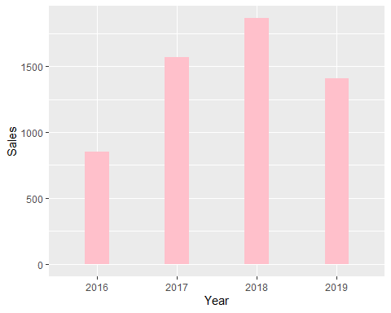

## 

## Assignment 2.2

### 1.Take a sample of 100 words from this data, and save this sample as a new data

|  |
| --- |
| x |
| carry |
| make |
| middle |
| marry |
| minute |
| bus |
| throw |
| today |
| then |
| forget |
| since |
| hang |
| find |
| court |
| operate |
| switch |
| of |
| top |
| laugh |
| dead |
| position |
| original |
| no |
| hand |
| sheet |
| secure |
| pass |
| side |
| condition |
| america |
| wife |
| normal |
| happy |
| begin |
| serve |
| minister |
| lead |
| practise |
| near |
| mention |
| proper |
| community |
| county |
| from |
| thou |
| sunday |
| company |
| easy |
| he |
| else |
| square |
| situate |
| load |
| wear |
| speed |
| watch |
| low |
| toward |
| another |
| suggest |
| study |
| doctor |
| door |
| consult |
| book |
| arrange |
| wood |
| four |
| word |
| first |
| black |
| comment |
| beat |
| university |
| close |
| machine |
| appear |
| twelve |
| colleague |
| welcome |
| so |
| cold |
| ago |
| grant |
| apparent |
| surprise |
| work |
| protect |
| history |
| flat |
| coffee |
| power |
| possible |
| per |
| walk |
| weigh |
| programme |
| quarter |
| list |
| create |

### 2.Find words which are starting with “a” and ending with “e”.

Words are starting with “a” and ending with “e” arrange

## 3.Calculate the number of words which have more than 3 vowels.

number of words which have more than 3 vowels is 8.

### 4.List the five longest word in your data

|  |  |
| --- | --- |
| word | num |
| university | 10 |
| condition | 9 |
| community | 9 |
| colleague | 9 |
| programme | 9 |

### 5.Try to find word(s) which contain any of these words: age, any, day, exp, her, pro, the.

Words containing these: today, proper, sunday, company, another, protect