**WEB DEVELOPMENT**

**MINOR PROJECT**

Name :M.L.SAI SHRUTHI

Course :WEB DEVELOPMENT

Batch :SEPT-OCT 2022 WD

Subject :MINOR PROJECT

Code :WD-MINOR-SEPTEMBER

Name of the project :HISTORICAL PLACES

Mail Id :mlsaishruthi@gmail.com

**MINOR PROJECT MAIN CODE**

<!DOCTYPE html>

<html lang="en">

<head>

    <meta charset="UTF-8">

    <meta http-equiv="X-UA-Compatible" content="IE=edge">

    <meta name="viewport" content="width=device-width, initial-scale=1.0">

    <link rel="stylesheet" href="style.css">

    <title>MONUMENTS OF INDIA</title>

</head>

<body>

    <div class="container">

        <header>

            <nav>

                <div class="logo">

                    <h2>INDIAN BLOG</h2>

                </div>

                <ul>

                    <li><a href="">Home</a></li>

                    <li><a href="">Blog</a></li>

                    <li><a href="">Contact</a></li>

                </ul>

                <a href="#" class="mobile">&#9776</a>

            </nav>

        </header>

        <aside>

            <div class="post">

                <h1>TRAVEL BLOG</h1>

                <h1>TOP ATTRACTIONS</h1>

                <h1>ROAD TRIPS</h1>

            </div>

            <div class="inspiration">

                <h1>INSPIRATION</h1>

                <ul>

                    <li><a href="">Places to visit in India</a></li>

                    <li><a href="">Destinations</a></li>

                    <li><a href="">Things to do</a></li>

                    <li><a href="">Weekend Gateways</a></li>

                    <li><a href="">Adventure</a></li>

                    <li><a href="">Historical Places</a></li>

                    <li><a href="">Tours and Itineraries</a></li>

                    <li><a href="">Nightlife</a></li>

                    <li><a href="">Shopping</a></li>

                    <li><a href="">Festival and Events</a></li>

                    <li><a href="">Cafes</a></li>

                    <li><a href="">Food and Restaurants</a></li>

                    <li><a href="">Lockdown Reads</a></li>

                </ul>

            </div>

            <div class="more">

                <h1>MORE</h1>

                <ul>

                    <li><a href="">Indian Holiday List 2022</a></li>

                    <li><a href="">Long Weekends 2022</a></li>

                    <li><a href="">Travel and Tips</a></li>

                    <li><a href="">News</a></li>

                    <li><a href="">Top 10 in India</a></li>

                    <li><a href="">Indian Tourism</a></li>

                    <li><a href="">Indian Railways(IRTCT)</a></li>

                    <li><a href="">Indian Railways News</a></li>

                    <li><a href="">Metro Rail Networks</a></li>

                    <li><a href="">Web Check-in</a></li>

                </ul>

            </div>

            <div class="hotels">

                <h1>BUDGET HOTELS</h1>

                <ul>

                    <li><a href="">Quarantine Hotels</a></li>

                    <li><a href="">Hotels in Delhi</a></li>

                    <li><a href="">Hotels in Mumbai</a></li>

                    <li><a href="">Hotels in Bangalore</a></li>

                    <li><a href="">Hotels in Chennai</a></li>

                    <li><a href="">Hotels in Pune</a></li>

                    <li><a href="">Hotels in Hyderabad</a></li>

                    <li><a href="">Hotels in Goa</a></li>

                    <li><a href="">Hotels in Kolkata</a></li>

                    <li><a href="">Hotels in Jaipur</a></li>

                </ul>

            </div>

        </aside>

        <main>

            <div class="Monuments-of-India">

                <div class="meta">

                    <h1>TAJ MAHAL</h1>

                </div>

                <div class="post">

                    <a href="https://en.wikipedia.org/wiki/Taj_Mahal">

                        <img src="tajmahal.jpg">

                    </a>

                    <p>An immense mausoleum of white marble, built in Agra between 1631 and 1648 by order of the Mughal emperor Shah Jahan in memory of his favourite wife, the Taj Mahal is the jewel of Muslim art in India and one of the universally admired masterpieces of the world's heritage.</p>

                    <p><b>Location</b>-Agra,Uttar Pradesh</p>

                    <p><b>How to reach –</b><br>

                        By Air: Pandit Deen Dayal Upadhyay Airport in Agra is 12 km from the monument. Take an auto-rickshaw or cab from there.<br>

                        By Train: The nearest railway station is Agra Cantt. at 6 km, from where you can hire a cab, auto-rickshaw or e-rickshaw.<br>

                        By Road: If you are travelling by road from Delhi NCR and other nearby cities, you can take a taxi or bus.<br></p>

                    <p><b>Entry ticket prices (per person) –</b><br>

                        Indians: INR 45<br>

                        Foreigners: INR 1050<br>

                        SAARC and BIMSTEC: INR 535<br>

                        Additional: INR 200 for the mausoleum<br>

                        Free for children below 15 years of age<br></p>

                    <p><b>Timings –</b><br>

                        Taj Mahal is closed on Fridays.<br>

                        It is open from 6 AM to 6:30 PM. It is also open on a full moon night as well as two nights before and after the full moon.<br></p>

                    <p><b>Important Facts –</b><br>

                        It is believed to have been built in the memory of Mumtaz Mahal, Shah Jahan’s third wife.<br></p>

                </div>

            </div>

            <div class="Monuments-of-India">

                <div class="meta">

                    <h1>QUTUB MINAR</h1>

                </div>

                <div class="post">

                    <a href="https://en.wikipedia.org/wiki/Qutub_Minar">

                        <img src="qutubminar.jpg">

                    </a>

                    <p>An immense mausoleum of white marble, built in Agra between 1631 and 1648 by order of the Mughal emperor Shah Jahan in memory of his favourite wife, the Taj Mahal is the jewel of Muslim art in India and one of the universally admired masterpieces of the world's heritage.</p>

                    <p><b>Location-</b>Seth Sarai, Mehrauli, New Delhi</p>

                    <p><b>How to reach –</b><br>

                        By Air: Fly to New Delhi’s Indira Gandhi International Airport (14 km away) and then take a cab, bus or metro.<br>

                        By Train: New Delhi railway station is 14 km away, from where you can hire a taxi or take the bus or metro.<br>

                        By Road: Book a taxi or take a private or state transport bus to reach Qutub Minar from Uttar Pradesh, Punjab, and other nearby places.<br></p>

                    <p><b>Entry ticket prices (per person) –</b><br>

                        Indians: INR 10<br>

                        Foreigners: INR 250<br>

                        Free for children below 15 years of age<br></p>

                    <p><b>Timings –</b><br>

                        Qutub Minar is open all 7 days of the week, from 7 AM to 5 PM.<br></p>

                    <p><b>Important facts –</b><br>

                        This UNESCO World Heritage Site has 5 stories.<br></p>

                </div>

            </div>

            <div class="Monuments-of-India">

                <div class="meta">

                    <h1>CHARMINAR</h1>

                </div>

                <div class="post">

                    <a href="https://en.wikipedia.org/wiki/Charminar">

                        <img src="charminar.jpg">

                    </a>

                    <p>An immense mausoleum of white marble, built in Agra between 1631 and 1648 by order of the Mughal emperor Shah Jahan in memory of his favourite wife, the Taj Mahal is the jewel of Muslim art in India and one of the universally admired masterpieces of the world's heritage.</p>

                    <p><b>Location-</b>Charminar Rd, Char Kaman, Ghansi Bazaar, Hyderabad</p>

                    <p><b>How to reach –</b><br>

                        By Air: Rajiv Gandhi International Airportis 24 km away. Take a bus, taxi or town car from there.<br>

                        By Train: Hyderabad Deccan railway station is at 5 km, from where you can take a cab or auto-rickshaw.<br>

                        By Road: The city has good road connectivity with Bangalore, Chennai, Mumbai, and Hampi.<br></p>

                    <p><b>Entry ticket prices (per person) –</b><br>

                        Indians: INR 5<br>

                        Foreigners: INR 100<br>

                        SAARC and BIMSTEC: INR 40<br>

                        Free entry for children below 15 years<br></p>

                    <p><b>Timings –</b><br>

                        The monument is open all days of the week, from 9:30 AM to 5:30 PM.<br></p>

                    <p><b>Important facts –</b>

                        It looks beautiful when illuminated in the evening for some time.<br></p>

                </div>

            </div>

            <div class="Monuments-of-India">

                <div class="meta">

                    <h1>INDIA GATE</h1>

                </div>

                <div class="post">

                    <a href="https://en.wikipedia.org/wiki/India_Gate">

                        <img src="indiagate.jpg">

                    </a>

                    <p>An immense mausoleum of white marble, built in Agra between 1631 and 1648 by order of the Mughal emperor Shah Jahan in memory of his favourite wife, the Taj Mahal is the jewel of Muslim art in India and one of the universally admired masterpieces of the world's heritage.</p>

                    <p><b>Location-</b>Rajpath, India Gate, New Delhi</p>

                    <p><b>How to reach –</b><br>

                        By Air: Fly to New Delhi’s Indira Gandhi International Airport (14 km away) and then take a bus or taxi. You can also take the metro to Central Secretariat metro station (3 km away) and then board an auto-rickshaw.<br>

                        By Train: New Delhi railway station is 5 km away, from where you can take an auto-rickshaw or taxi.<br>

                        By Road: When travelling from a nearby city, you can book a taxi or take a private or state transport bus.<br></p>

                    <p><b>Entry ticket prices –</b><br> Free entry for all<br></p>

                    <p><b>Timings –</b><br>

                        India Gate is open to visitors 24 hours a day, 7 days a week.<br>

                        Boat timings are from 2 PM to 9 PM and light show timings are from 7 PM to 9: 30 PM.<br></p>

                    <p><b>Important facts –</b><br>

                        It has a children’s park and boat club.<br></p>

                </div>

            </div>

            <div class="Monuments-of-India">

                <div class="meta">

                    <h1>RED FORT</h1>

                </div>

                <div class="post">

                    <a href="https://en.wikipedia.org/wiki/Red_Fort">

                        <img src="redfort.jpg">

                    </a>

                    <p>An immense mausoleum of white marble, built in Agra between 1631 and 1648 by order of the Mughal emperor Shah Jahan in memory of his favourite wife, the Taj Mahal is the jewel of Muslim art in India and one of the universally admired masterpieces of the world's heritage.</p>

                    <p><b>Location-Netaji Subhash Marg, Chandni Chowk, New Delhi</b></p>

                    <p><b>How to reach –</b>

                        By Air: New Delhi’s Indira Gandhi International Airport is 20 km away, from where you can take a cab, bus or metro. Chandni Chowk metro station is 2 km away.

                        By Train: On reaching Delhi Junction (3 km away), take an auto-rickshaw or cab.

                        By Road: You can get a taxi or bus from Punjab, Haryana, Jaipur, Shimla and other places.</p>

                    <p><b>Entry ticket prices (per person) –</b><br>

                        Indians: INR 35<br>

                        Foreigners: INR 500<br>

                        Video Camera: INR 25 extra<br>

                        Light and sound show:<br>

                        Adults: INR 60 on weekdays and INR 80 on weekends<br>

                        Children: INR 20 on weekdays and INR 30 on weekends<br></p>

                    <p><b>Timings –</b><br>

                        Red Fort timings are 9:30 AM to 4:30 PM. It is closed on Mondays.<br></p>

                    <p><b>Important facts –</b><br>

                        Red Fort is a UNESCO World Heritage Site.<br>

                        It is a politically significant monument where Independence Day celebrations are held every year.<br></p>

                </div>

            </div>

            <div class="Monuments-of-India">

                <div class="meta">

                    <h1>GOLDEN TEMPLE</h1>

                </div>

                <div class="post">

                    <a href="https://en.wikipedia.org/wiki/Golden_Temple">

                        <img src="goldentemple.jpg">

                    </a>

                    <p>An immense mausoleum of white marble, built in Agra between 1631 and 1648 by order of the Mughal emperor Shah Jahan in memory of his favourite wife, the Taj Mahal is the jewel of Muslim art in India and one of the universally admired masterpieces of the world's heritage.</p>

                    <p><b>Location-</b>Golden Temple Rd, Atta Mandi, Katra Ahluwalia, Amritsar, Punjab</p>

                    <p><b>How to reach –</b><br>

                        By Air: Shri Guru Ram Dass Jee International Airport is 12 km from the temple. Take a taxi or auto-rickshaw from there. A free shuttle bus also runs between the airport and Golden Temple.<br>

                        By Train: Reach Amritsar Junction (2 km away) and take a taxi or auto-rickshaw.<br>

                        By Road: You can take a taxi or a private or government-run bus from Delhi, Chandigarh, Dharamshala, Shimla, or Jammu.<br></p>

                    <p><b>Entry ticket prices –</b><br> Free entry for all<br></p>

                    <p><b>Timings –</b><br>

                        Golden Temple is open 24 hours a day, 7 days a week.<br></p>

                    <p><b>Important facts –</b><br>

                        Some major things to see in the temple complex are Akal Takht, Sikh History Museum, Clock Tower, ber trees, Teja Singh Samundri Hall, and Guru Ram Das langar.<br></p>

                </div>

            </div>

            <div class="Monuments-of-India">

                <div class="meta">

                    <h1>MYSORE PALACE</h1>

                </div>

                <div class="post">

                    <a href="https://en.wikipedia.org/wiki/Mysore_Palace">

                        <img src="mysorepalace.jpg">

                    </a>

                    <p>An immense mausoleum of white marble, built in Agra between 1631 and 1648 by order of the Mughal emperor Shah Jahan in memory of his favourite wife, the Taj Mahal is the jewel of Muslim art in India and one of the universally admired masterpieces of the world's heritage.</p>

                    <p><b>Location-</b>SayyajiRao Rd, Agrahara, Chamrajpura, Mysore, Karnataka</p>

                    <p><b>How to reach –</b><br>

                        By Air: Reach Mysore Airport (11 km away) and take a cab or bus. For international flights, Kempegowda International Airport in Bangalore is the nearest option.<br>

                        By Train: Mysuru Junction is 2 km away. Take an auto-rickshaw or taxi from there.<br>

                        By Road: Mysore has well-maintained expressways and highways, so you can take a bus or taxi when travelling from a nearby city.<br></p>

                    <p><b>Entry ticket prices (per person) –</b><br>

                        Adults (Indians and Foreigners): INR 70<br>

                        Children (Indians and Foreigners): INR 30 (10-18 years)<br>

                        Educational tour for students: INR 10<br>

                        Children below 10 years: Free<br></p>

                    <p><b>Timings –</b><br>

                        The palace is open all days of the week, from 10 AM to 5:30 PM.<br>

                        The sound and light show is held from Monday to Saturday, from 7 PM to 7: 40 PM.<br>

                        The palace is illuminated from 7:40 to 7:45 PM on weekdays and 7 PM to 7:45 PM on Sundays, state festivals and national holidays.<br></p>

                    <p><b>Important facts –</b><br>

                        The palace faces the Chamundi Hills in the east.<br></p>

                </div>

            </div>

            <div class="Monuments-of-India">

                <div class="meta">

                    <h1>AGRA FORT</h1>

                </div>

                <div class="post">

                    <a href="https://en.wikipedia.org/wiki/Agra_Fort">

                        <img src="agrafort.jpg">

                    </a>

                    <p>An immense mausoleum of white marble, built in Agra between 1631 and 1648 by order of the Mughal emperor Shah Jahan in memory of his favourite wife, the Taj Mahal is the jewel of Muslim art in India and one of the universally admired masterpieces of the world's heritage.</p>

                    <p><b>Location-</b>Agra, Uttar Pradesh</p>

                    <p><b>How to reach –</b><br>

                        By Air: Pandit Deen Dayal Upadhyay Airport in Agra is 11 km away. Hire a cab or auto-rickshaw from there.<br>

                        By Train: Agra Cantt. railway station (5 km away) is the main railhead. You can also reach Agra Fort railway station (1 km away) and take an auto-rickshaw or cycle-rickshaw.<br>

                        By Road: Different types of AC and non-AC buses connect Agra to the nearby cities. You can also book a cab.<br></p>

                    <p><b>Entry ticket prices (per person) –</b><br>

                        Indians: INR 35<br>

                        Foreigners: INR 550<br>

                        SAARC and BIMSTEC: INR 35<br>

                        Free for children below 15 years of age<br></p>

                    <p><b>Timings –</b><br>

                        It is open from 6 AM to 6 PM, 7 days a week.<br></p>

                        <p><b>Important facts –</b><br>

                            Agra Fort is also known as Lal Qila.<br></p>

                    </div>

                </div>

                <div class="Monuments-of-India">

                    <div class="meta">

                        <h1>LOTUS TEMPLE</h1>

                    </div>

                    <div class="post">

                        <a href="https://en.wikipedia.org/wiki/Lotus_Temple">

                            <img src="lotustemple.jpg">

                        </a>

                        <p>Lotus Temple, also known as Baha’I Lotus Temple or Kamal Mandir, is an architectural marvel shaped like a white lotus flower. You can connect with your spiritual self here, through prayer and meditation, and also take a stroll around the lush green gardens bursting with colourful flowers and featuring nine reflecting pools.</p>

                        <p><b>Location–</b>Lotus Temple Road, Bahapur, Kalkaji, New Delhi</p>

                        <p><b>How to reach –</b><br>

                            By Air: Fly to Indira Gandhi International Airport (16 km from the temple), and take a cab, bus or metro. Kalka Metro Station is 450m away.<br>

                            By Train: New Delhi railway station is 15 km away. Cabs, buses and metro trains are popular modes of transport from there.<br>

                            By Road: Delhi is well-connected by a network of roads and national highways. Hence, you can take a taxi or bus and reach the city.<br></p>

                        <p><b>Entry ticket prices –</b><br> Free entry for all<br></p>

                        <p> <b>Timings –</b><br>

                            The temple is open from 9:30 AM to 5:30 PM in winters and from 9 AM to 7 PM in summers.

                            It is closed on Mondays.<br></p>

                        <p><b>Important facts –</b><br>

                            People from all religions and races can visit the temple.<br></p>

                        </div>

                </div>

                <div class="Monuments-of-India">

                    <div class="meta">

                        <h1>AJANTA and ELLORA CAVES</h1>

                    </div>

                    <div class="post">

                        <a href="https://en.wikipedia.org/wiki/Ellora_Caves">

                            <img src="ajantaandellora.jpg">

                        </a>

                        <p>These ancient rock-cut caves are among the most popular tourist attractions in Maharashtra as well as India. Ajanta Caves proudly bear testimony of the earliest Buddhist architecture, paintings and sculptures, while Ellora Caves contain rock carvings, Buddhist monasteries, and Hindu and Jain temples. Kailasha Temple (cave no. 16) is the chief attraction among the devotees of Lord Shiva. have a look on near by attractions on Aurangabad.</p>

                        <p><b>Location–</b>Ellora Cave Rd, Ellora, Maharashtra<br></p>

                        <p> <b>How to reach –</b><br>

                            By Air: Fly to Aurangabad Airport and take a bus or taxi to Ajanta (104 km away) and Ellora (36 km away). You can also take a flight to Jalgaon Airport for Ajanta Caves (47 km away).<br>

                            By Train: Jalgaon Junction is 58 km from Ajanta Caves, while Aurangabad railway Station is 29 km from Ellora Caves. Take a bus or taxi from either of the stations.<br>

                            By Road: The caves are well-connected to the nearby cities via numerous bus services. You can also book a taxi.<br></p>

                        <p><b>Entry ticket prices (per person) –</b><br>

                            <b>Ajanta Caves:</b><br>

                                Indians: INR 10<br>

                                Foreigners: INR 250<br>

                                Free entry for children below 15 years<br>

                                Camera: INR 25<br>

                            <b>Ellora Caves:</b><br>

                                Indians: INR 30<br>

                                Foreigners: INR 500<br>

                                Camera: INR 25<br></p>

                        <p><b>Timings –</b><br>

                            Ajanta Caves are closed on Mondays, while Ellora Caves are closed on Tuesdays.<br>

                            Ajanta Caves are open from 9 AM to 5 PM, while Ellora Caves are open from 6 AM to 6 PM.<br></p>

                        <p><b>Important facts –</b><br>

                            Both Ajanta and Ellora are UNESCO World Heritage sites.<br></p>

                        </div>

                    </div>

        </main>

        <footer>

            <h4>Designed and Developed by M.L.SAI SHRUTHI</h4>

        </footer>

    </div>

    <script src="app.js"></script>

</body>

</html>

**MINOR PROJECT STYLING CODE**

@import url('https://fonts.googleapis.com/css2?family=Poppins:wght@400;800&display=swap');

*{

    margin:0;

    padding:0;

    box-sizing:border-box;

}

body{

    font-family:'Poppins', sans-serif;

    background: url(background3.jpg);

    background-size:cover;

}

ul{

    list-style-type:none;

}

a{

    text-decoration:none;

    color:bisque;

}

h1{

    color:black;

    margin:16px 0;

    font-weight:800;

}

p{

    margin:16px 0;

    line-height:1.75;

    font-weight:400;

}

img{

    max-width:100%;

    height:500px;

    margin-top:16px;

}

/*navigation*/

header{

    line-height:100px;

}

nav{

    display:flex;

    align-items:center;

    justify-content:space-between;

    width:70%;

    margin:0 auto;

}

nav ul li{

    display:inline;

    padding:0 16px;

}

nav ul li a{

    color:black;

}

.mobile{

    display:none;

}

.show{

    display: block;

}

@media(max-width:768px){

    nav{

        position:static;

    }

    nav ul{

        display:none;

        width:100%;

        background-color:darkviolet;

        position:absolute;

        top:100px;

        left:0;

        right:0;

        height:40vh;

        text-align:center;

    }

    nav ul li{

        display:block;

    }

    nav ul li a{

        color:#f0ffff;

    }

    a.mobile{

        color:blanchedalmond;

        display:block;

        font-size:32px;

    }

}

aside{

    padding:64px;

}

/*blog*/

.Monuments-of-India h1{

    color:black;

}

.Monuments-of-India{

    padding:34px;

}

.container{

    display:grid;

    grid-template-columns:repeat(3,1fr);

    grid-template-rows:100px auto 100px;

    height:100vh;

    width:100%;

    margin:0 auto;

}

header{

    background-color:#0bbfff;

    grid-column-start:span 3;

}

aside{

    background-color:hotpink;

    grid-column-start:span 1;

}

main{

    background-color:mediumorchid;

    grid-column-start:span 2;

}

footer{

    background-color:deepskyblue;

    grid-column-start:span 3;

    text-align:center;

    font-size:20px;

    display:flex;

    align-items:center;

    justify-content:center;

}

@media(max-width:768px){

    .container{

        grid-template-columns:1fr;

        grid-template-rows:100px auto auto 100px;

        width:100%;

    }

    header,aside,main,footer{

        grid-column-start:span 1;

    }

}

**OUTPUT:**

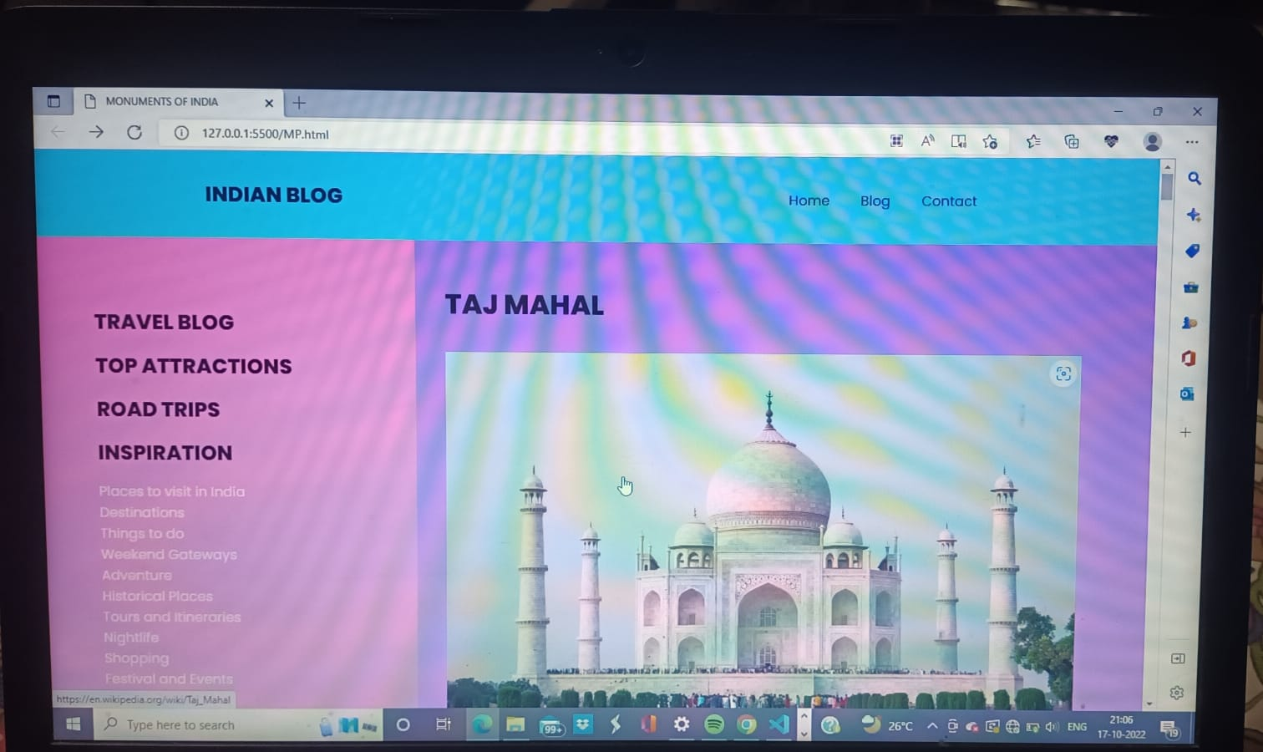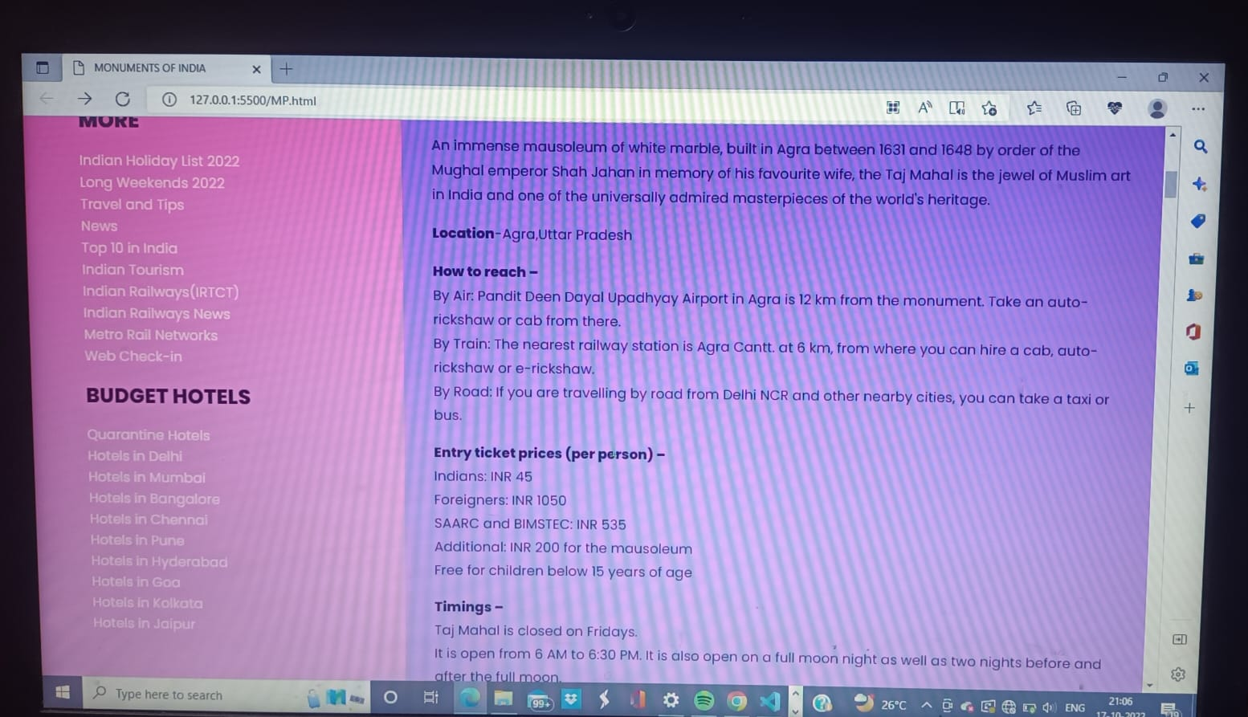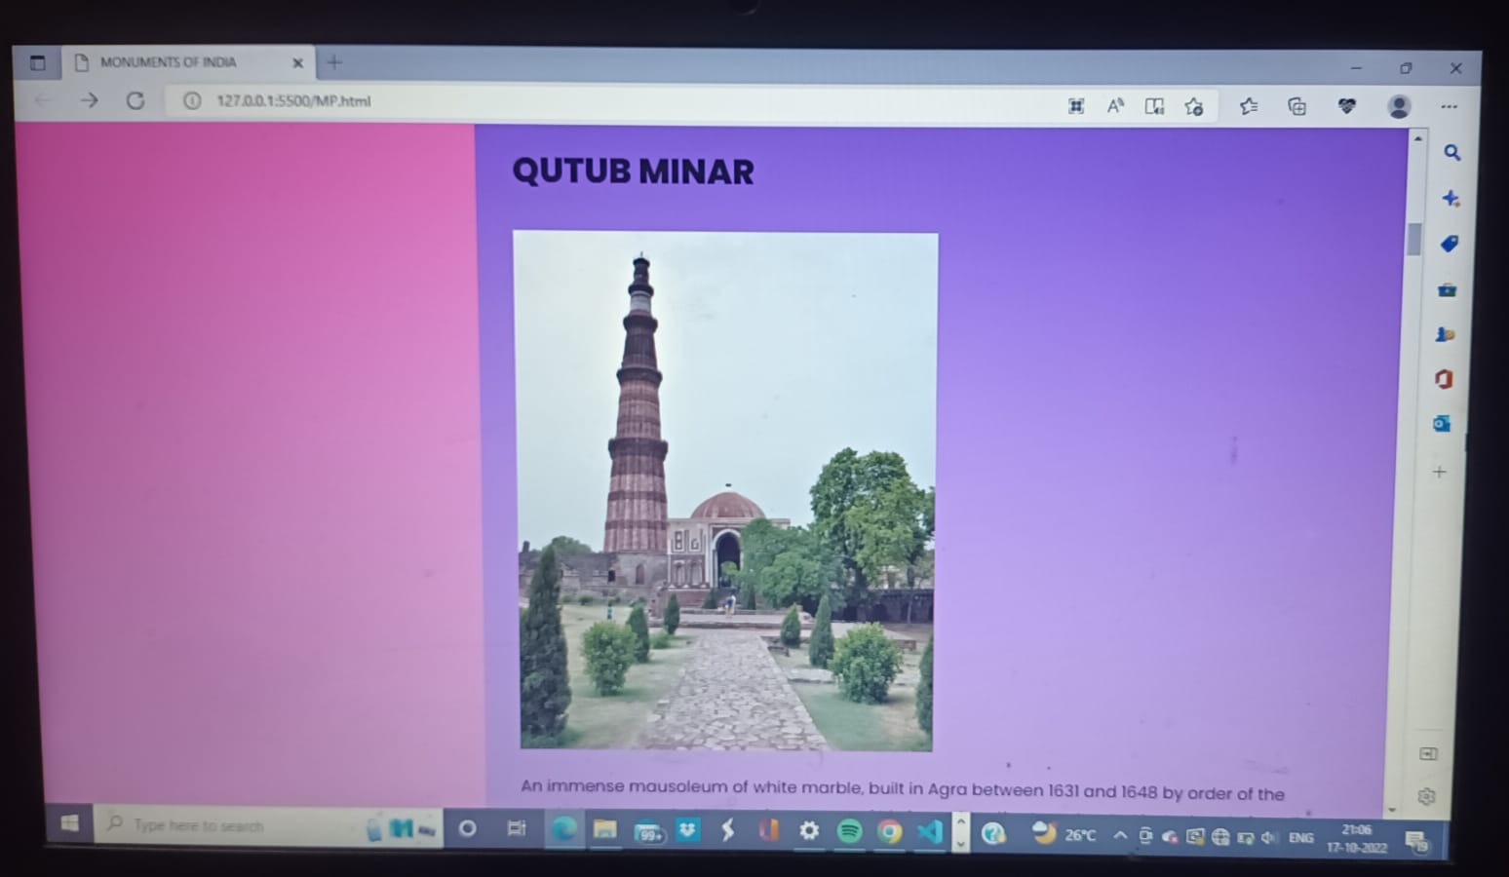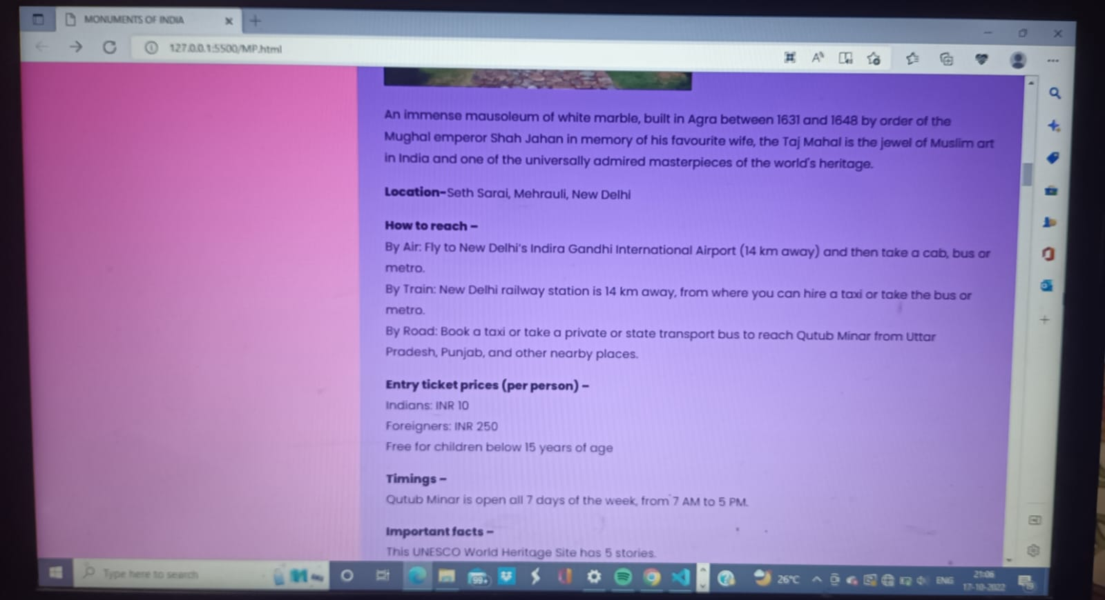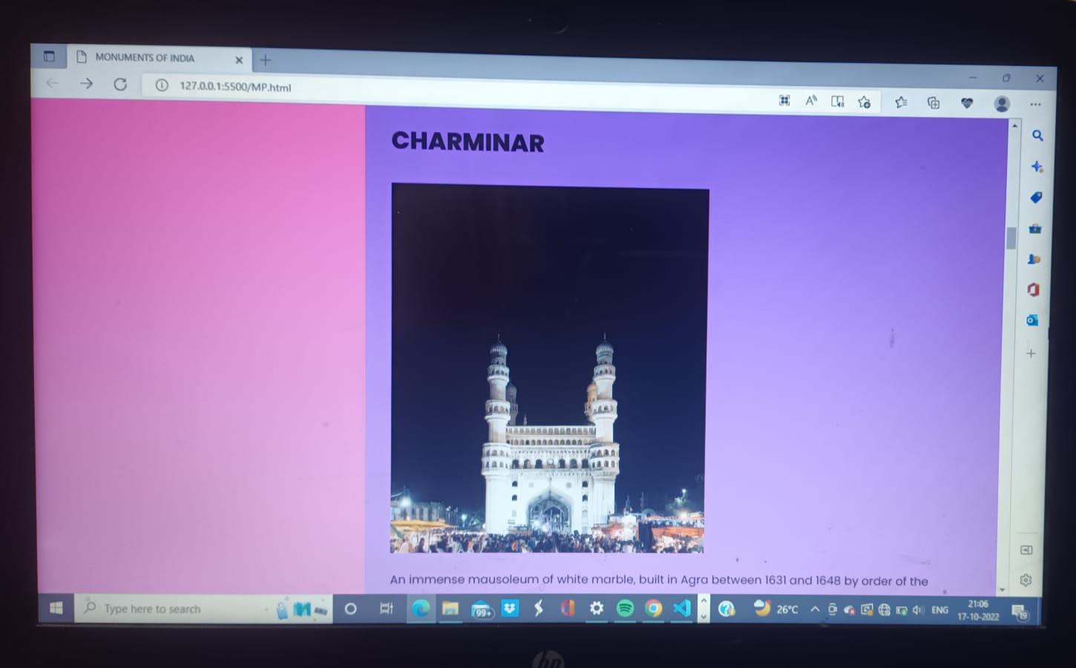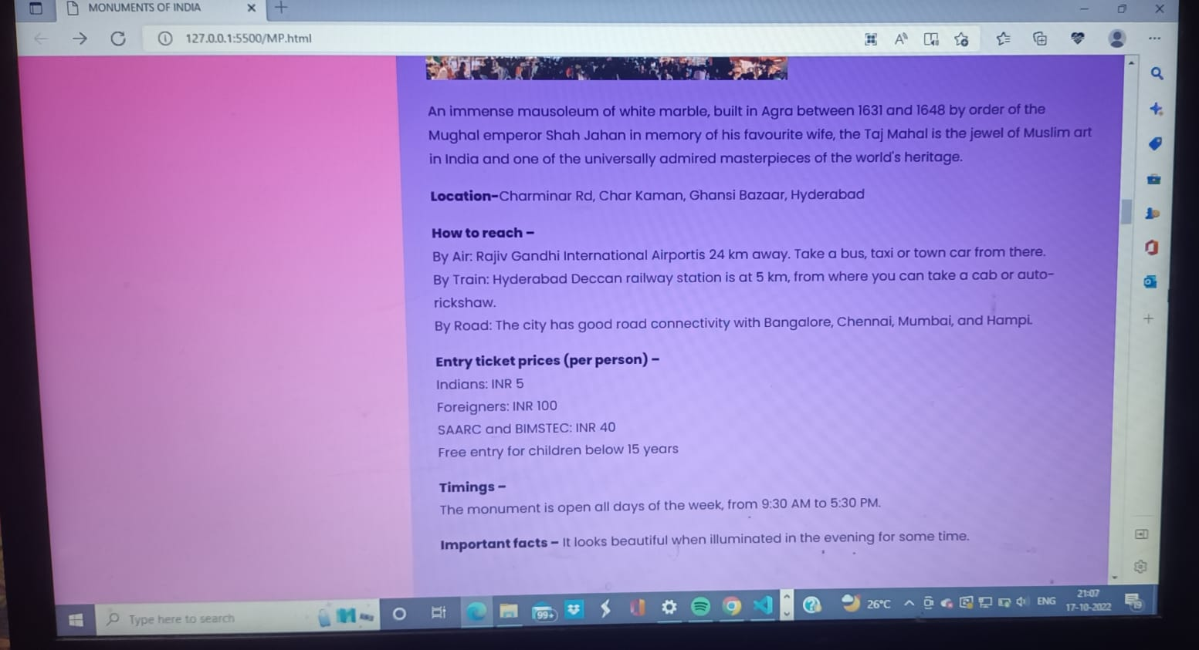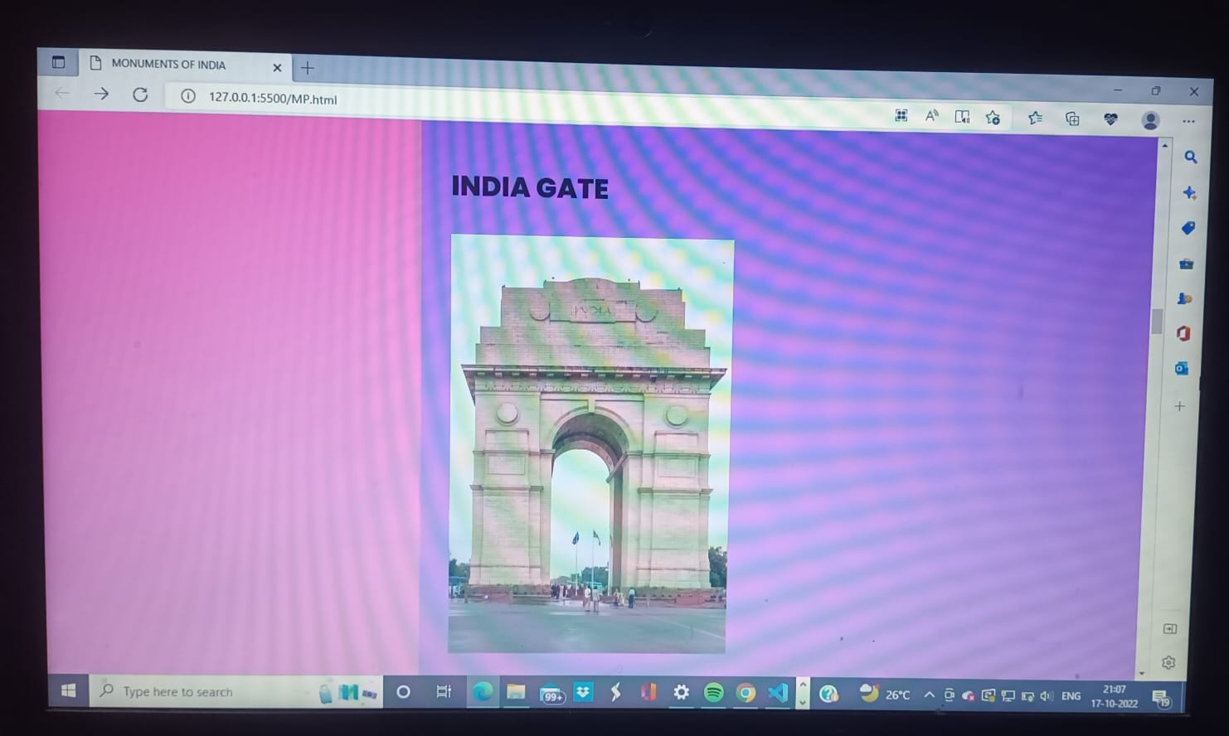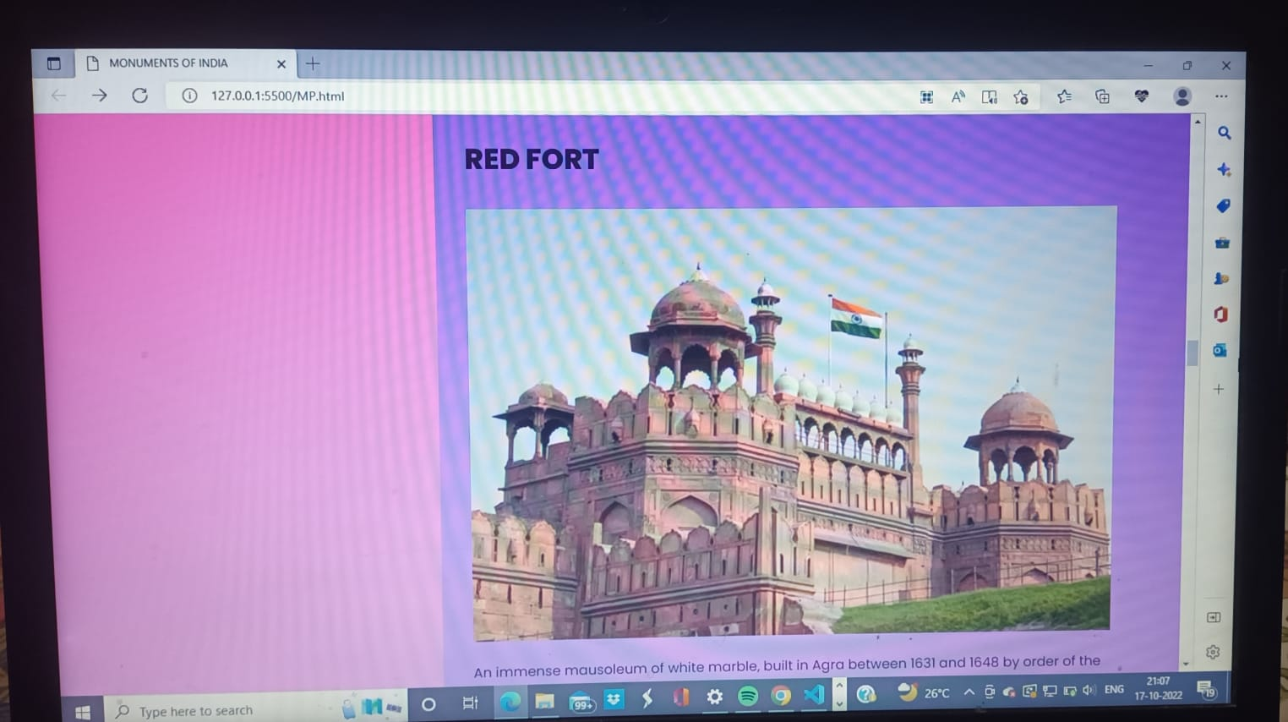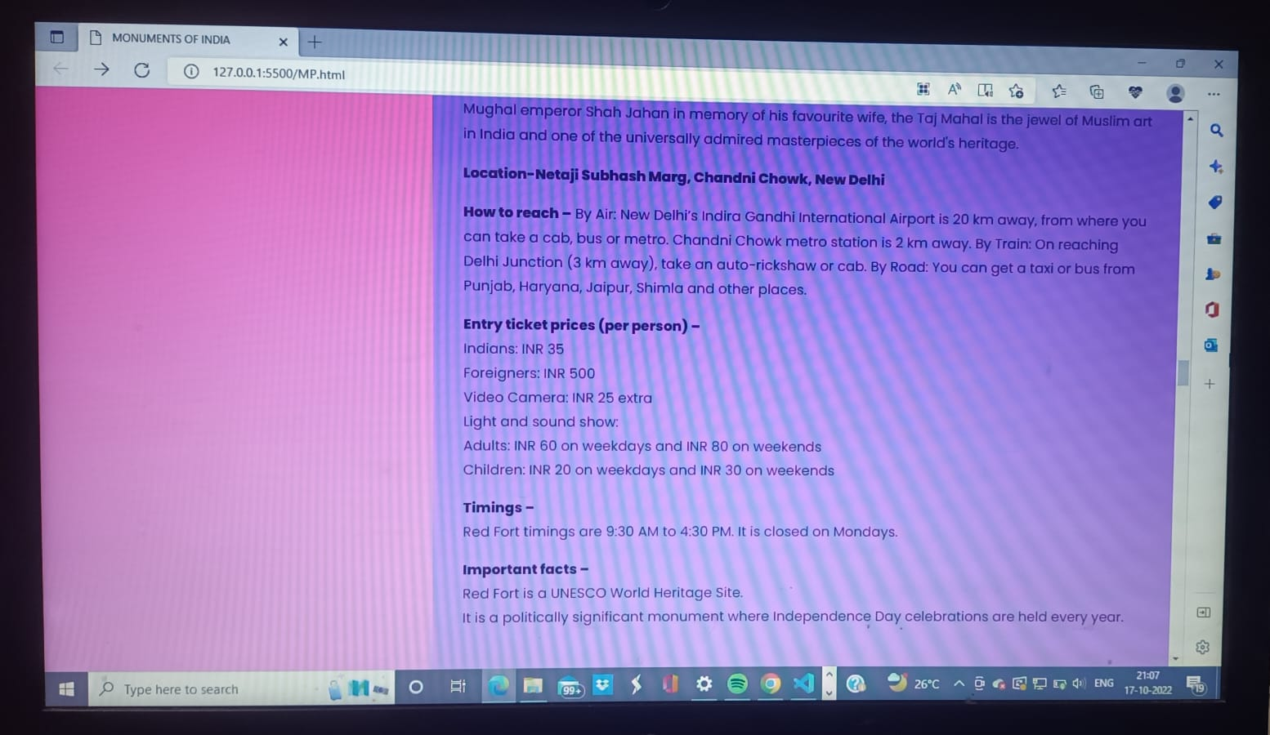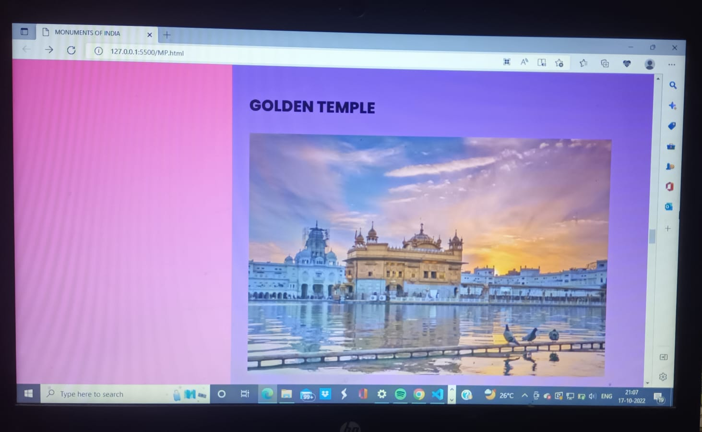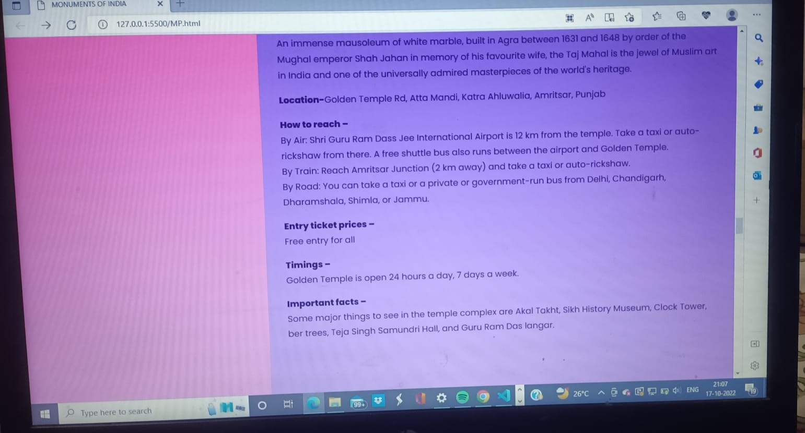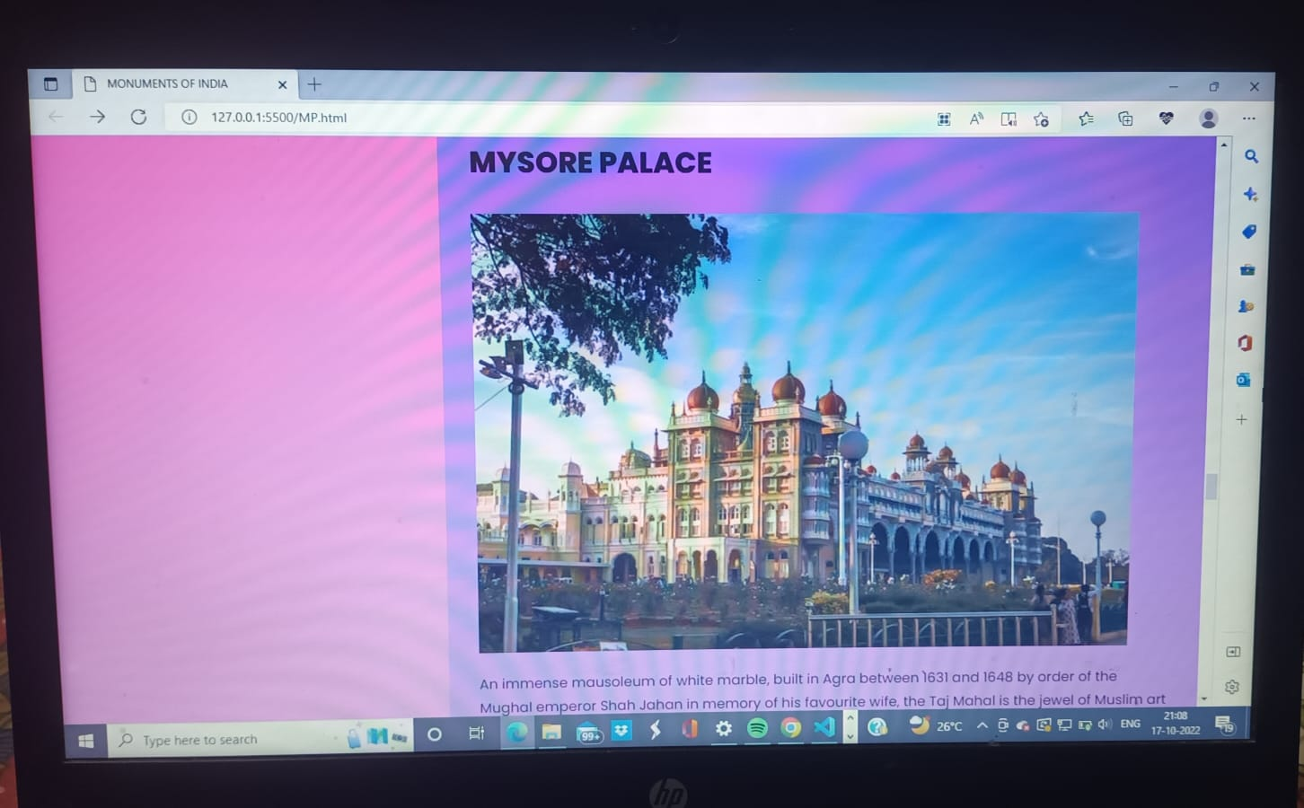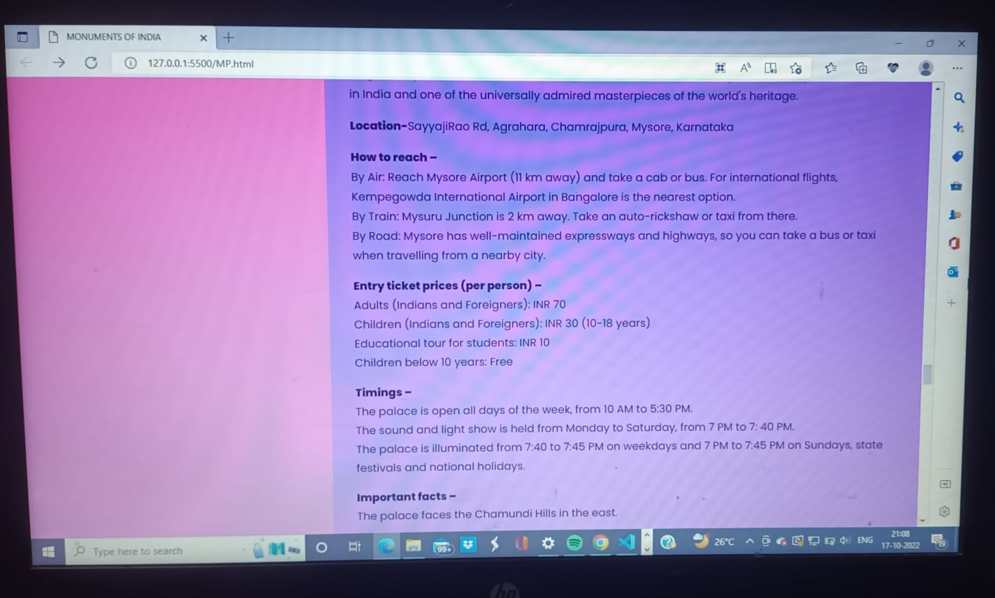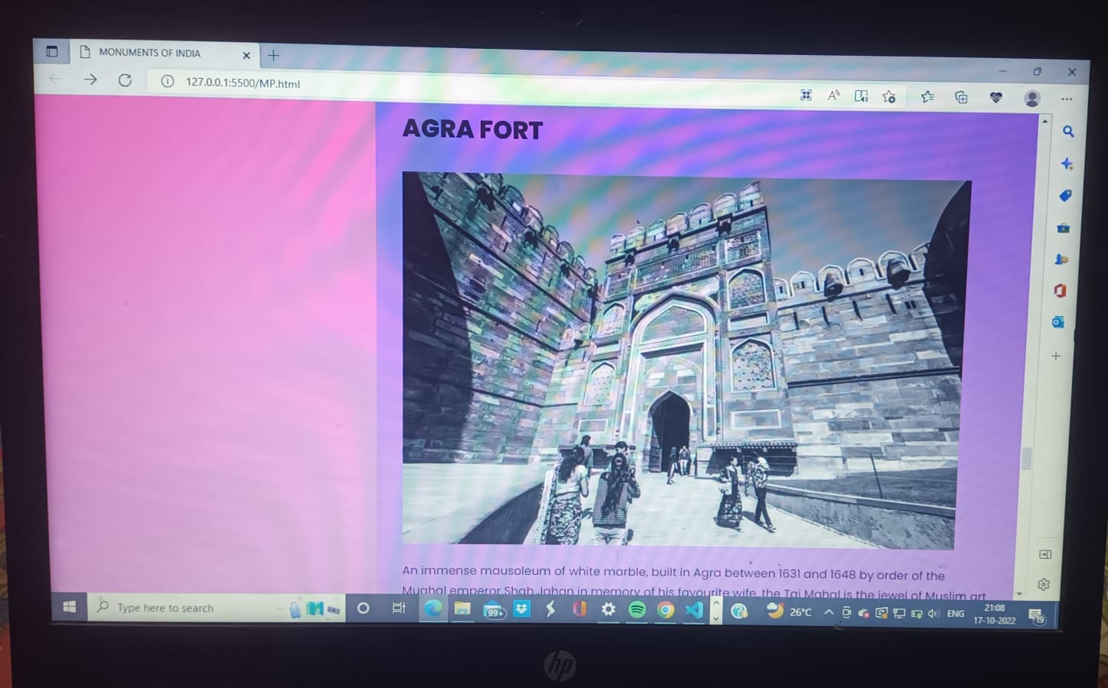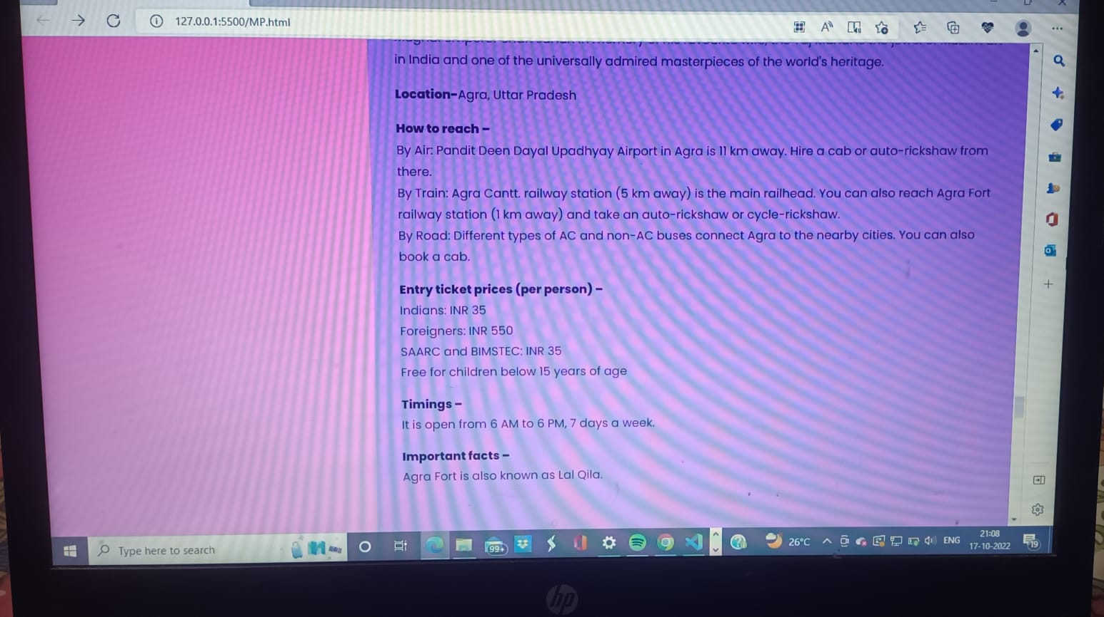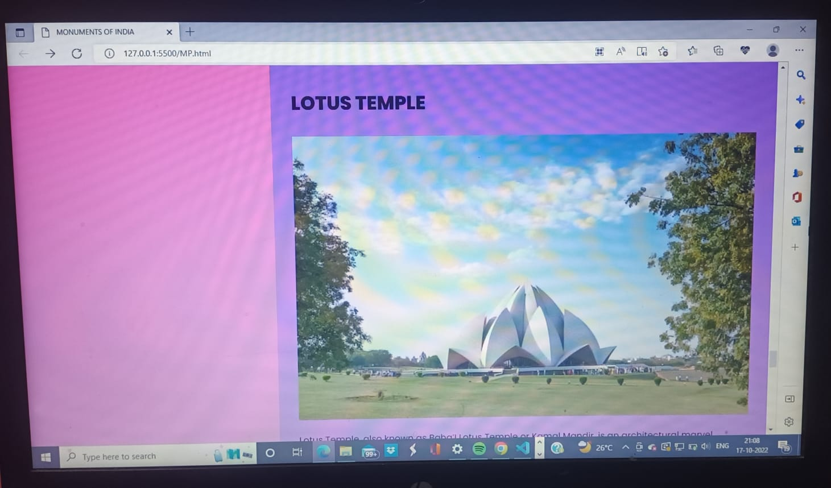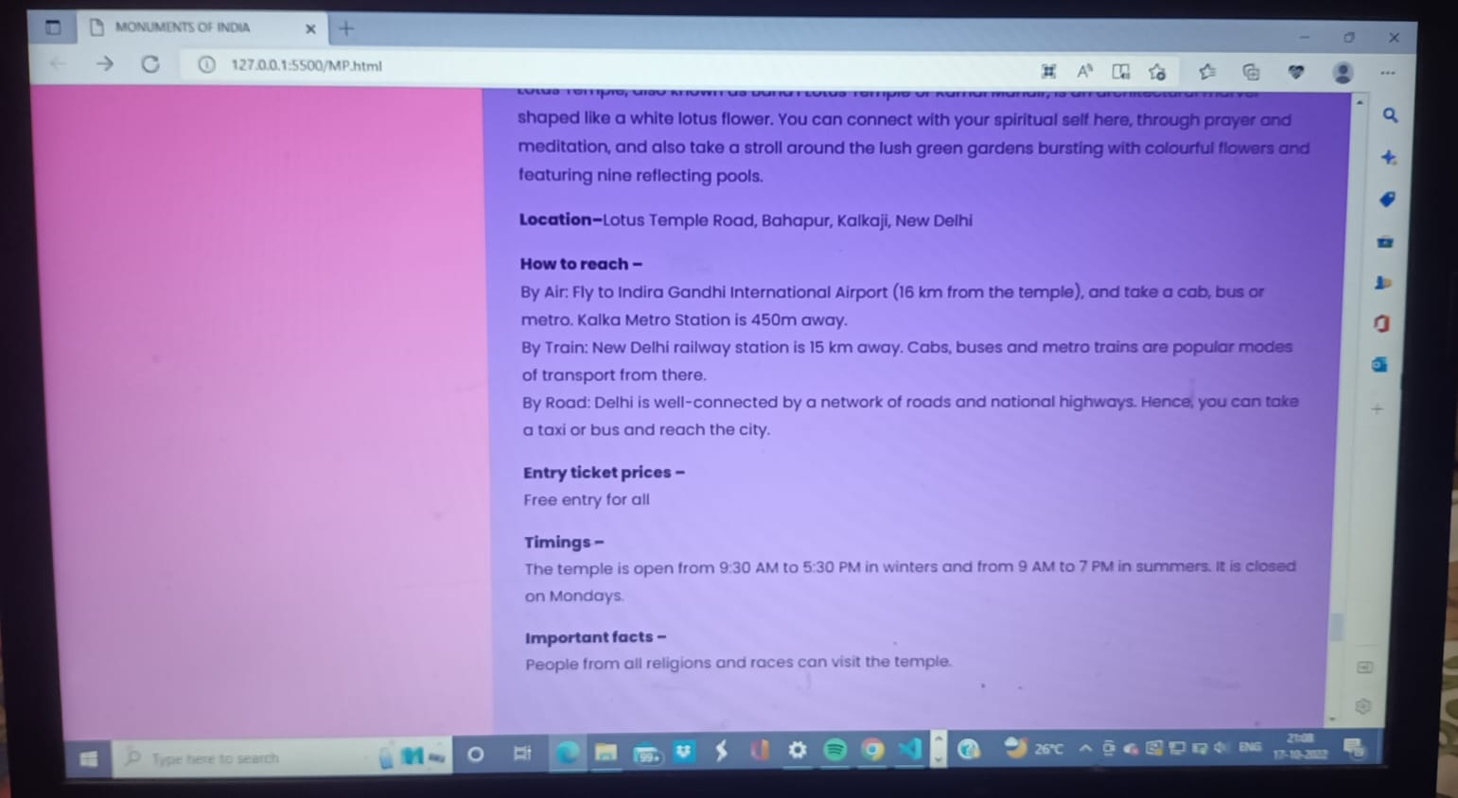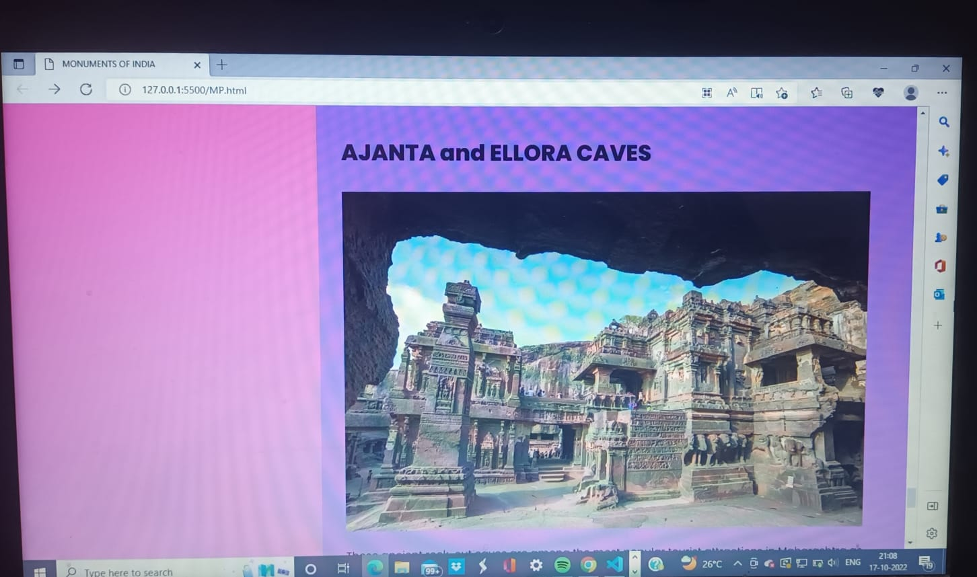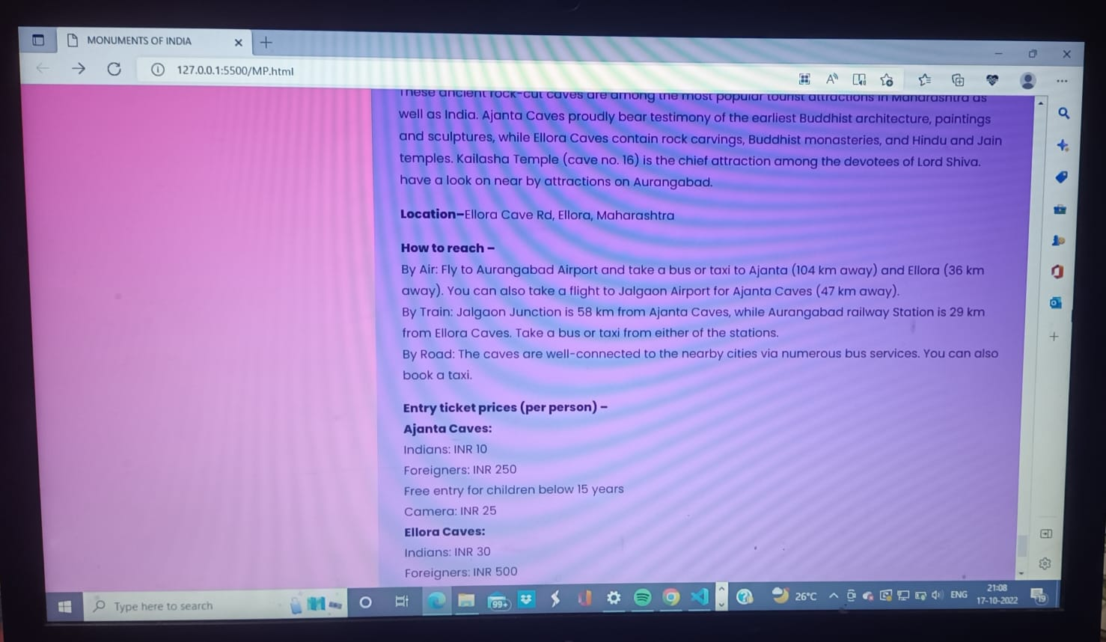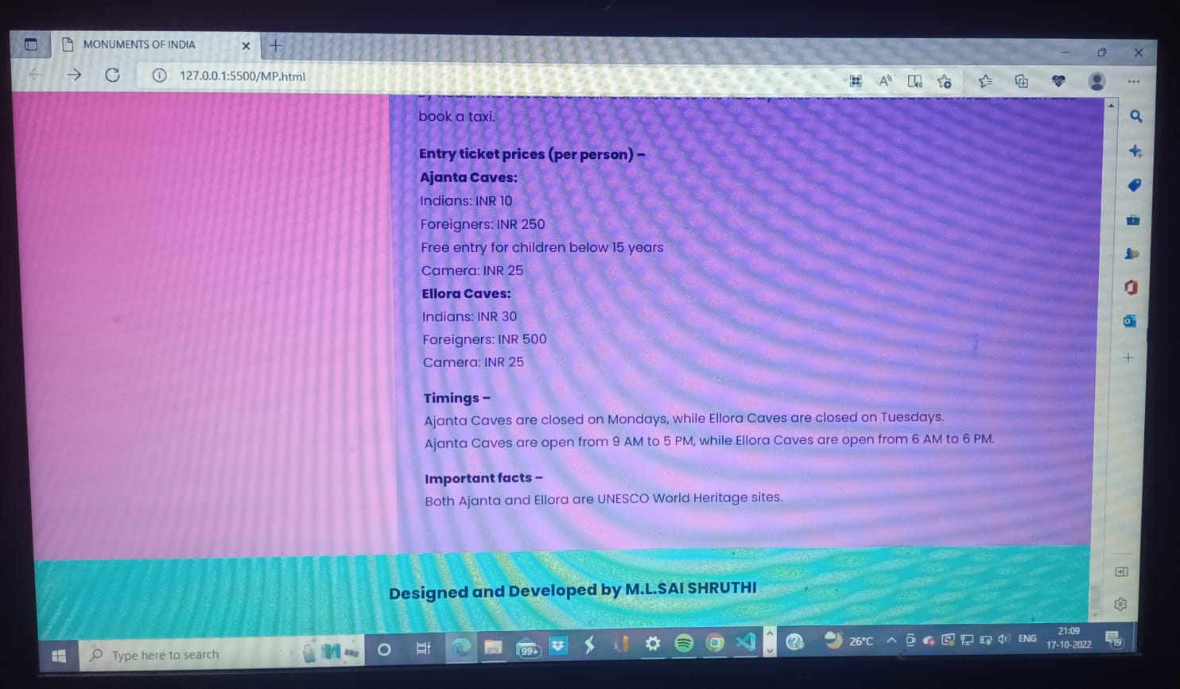

****This page is showing the HISTOTICAL PLACES IN INDIA with different styling in grid.It consists of a header and a footer with the main body and aside body.This page gives brief about the places and you can just click on the picture if you want to know more bout that historical place.****