imgfile="pizza.jpeg"
img=cv2.imread(imgfile, cv2.IMREAD_COLOR)

#img=plt.imread('pizza.jpeg')
#plt.imshow(a)

plt.imshow(img)
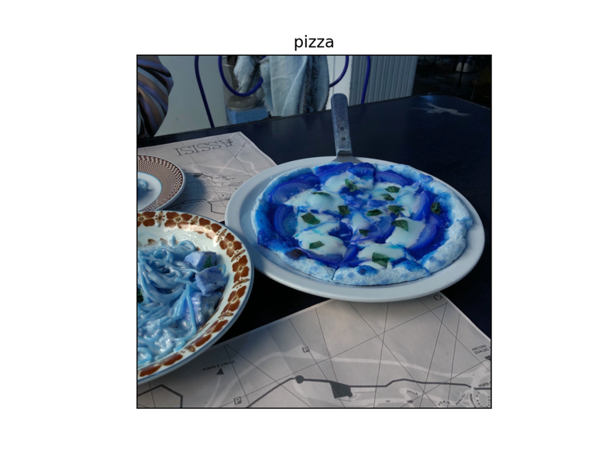

imgfile="pizza.jpeg"
img=cv2.imread(imgfile, cv2.IMREAD_GRAYSCALE)

#img=plt.imread('pizza.jpeg')
#plt.imshow(a)

plt.imshow(img)
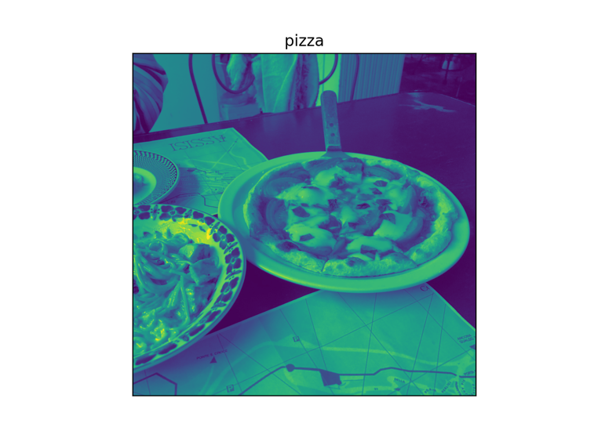

plt.imshow(img, cmap='gray')
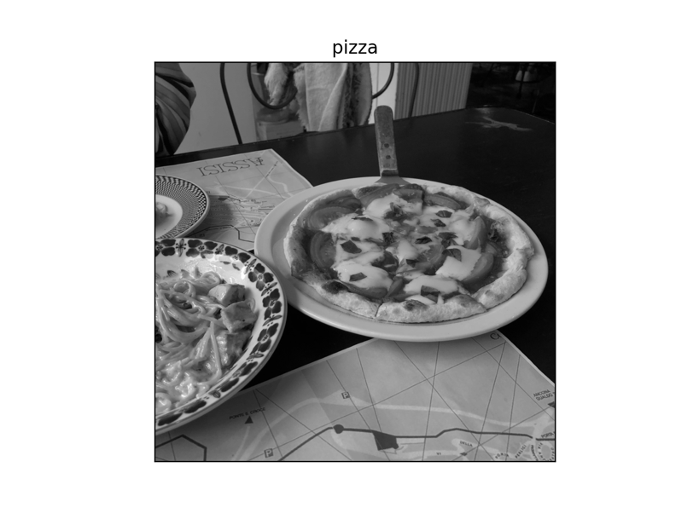

plt.imshow(img,cmap='gray',interpolation='bicubic')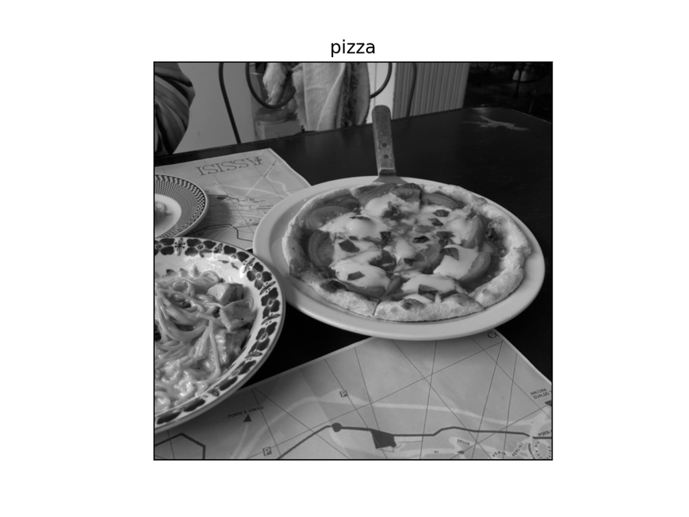

interpolation 설명
https://matplotlib.org/3.2.1/gallery/images_contours_and_fields/interpolation_methods.html
cmap
https://matplotlib.org/tutorials/colors/colormaps.html

