Trycorder Manual

The Trycorder is a tool to take measurements, used in space ships from the federation of planets.  This application try to mimic the look and feel of a control panel on a starship, and is filled with real-world measurements tools. | 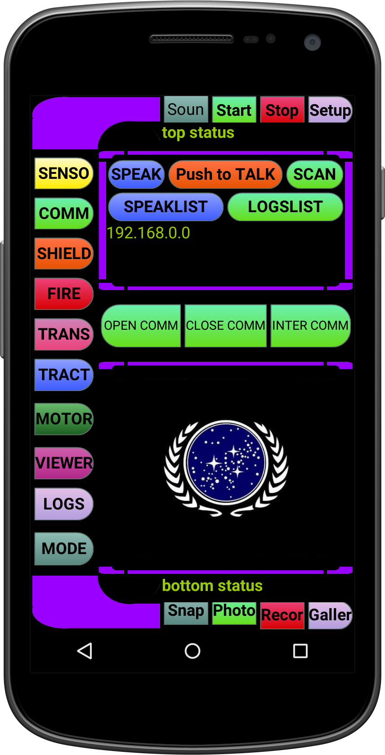 | Le Trycorder est un outil de mesure utilisé dans les vaisseaux spatiaux de la fédération des planètes.

