Trycorder Manual

The Trycorder is a tool to take measurements, used in space ships from the federation of planets.  This application try to mimic the look and feel of a control panel on a starship, and is filled with real-world measurements tools, from your cell-phone sensors.  I will try to introduce you easily but boldly to the fantastic world of the trycorder. | 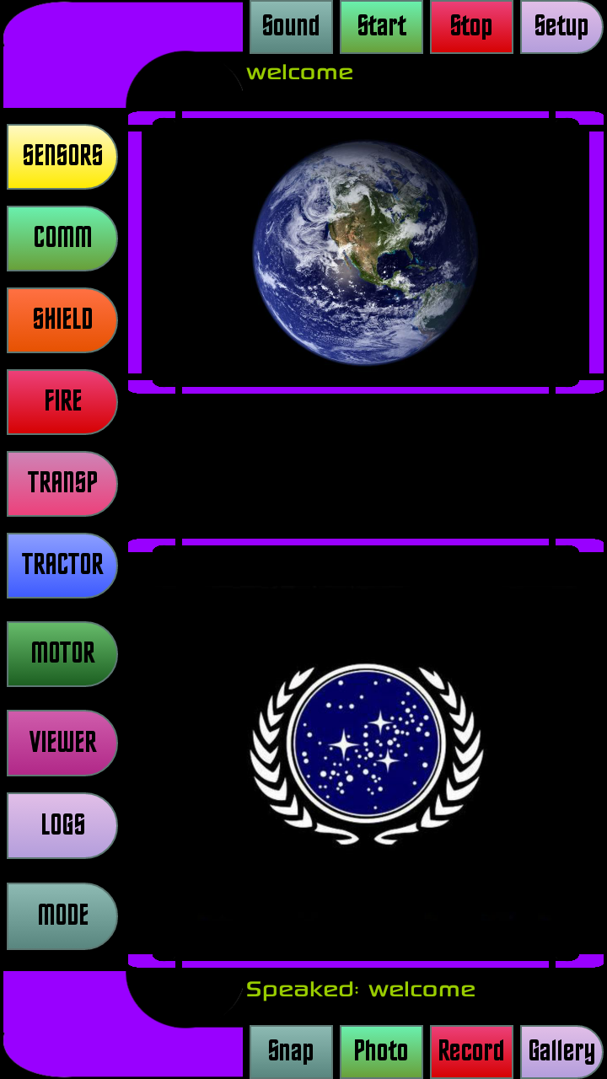 | Le Trycorder est un outil de mesure utilisé dans les vaisseaux spatiaux de la fédération des planètes.  Cette application essaie de ressembler le plus possible a un paneau de controle sur un starship, et contiens des vrais outils de mesure qui utilisent les sensors intégrés dans votre téléphone.  Je vais tenter de vous introduire facilement mais courageusement vers le merveilleux monde du trycorder.
The first button, on top left, named SENSORS, is the one who give tou all the trycorder sensors functions, from your telephone integrated sensors.  There is Magnetic, Orientation, Gravity, and Temperature / Pressure sensors  All top readings in this mode are about the real sensors in your phone. This mean you can go to the magnetic sensor mode, then pass your phone on the wall , and detect all nails and metallic conduits inside the wall.  On the same principle, you switch to orientation mode, and drive around a forest, and always know where north is, and your exact position on the gps. | 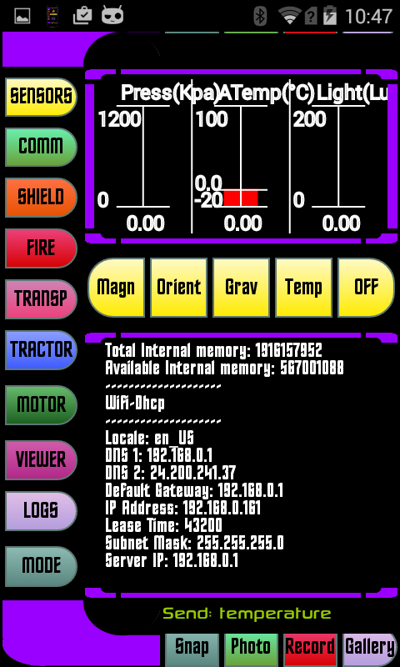 | 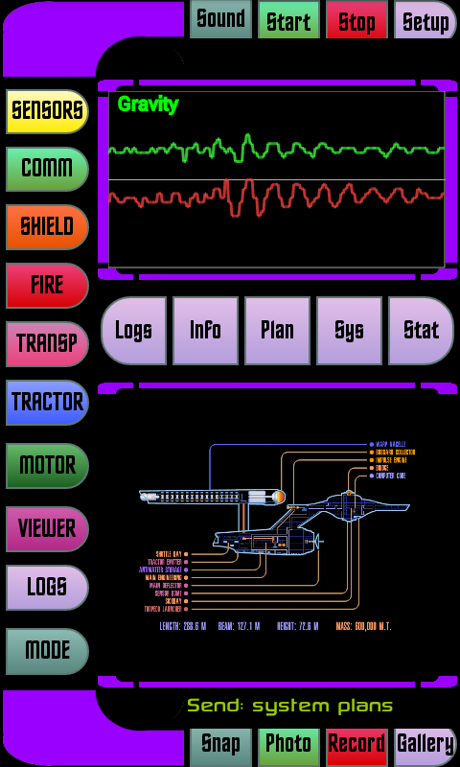
The Trycorder is now (from version 4.Pi) able to communicate with a central starship and log all orders given from all trycorders in the world (this include only planet earth and satellites for the moment)  and respond to every trycorder with a “server ok” message.  This is the first phase in the development of a full messenger like application.  This is initialized at start, and you have a manual control to every orders given, with the activation of the COMM button (2dn left) | 