Trycorder
Introduction

For the non-trekkies, a Trycorder is a portable measuring tool, communication tool, and remote-control tool for your Starship. It has been used a lot in many very popular Science-Fiction TV serie and Movies.

This is an itch I had to scratch for a long time.

I wanted a full fledged trycorder without announcements, free as a beer, and free public code.

I did'nt found what i was searching for, so I made one.

The wish to have a full trycorder was so strong, I had to Learn Java, Learn Android-Studio, Learn Android Programming, starting with a classic "Hello World!" program, Learn Activities, Fragments, Permissions, and the rest, and all of this Before I started a single line of my project.

After 3 long and painful months, I finally started the project, and drived it to a version 1.0, where I decided to share my fun with others.

With this Trycorder, You can do the following:
- Look, feel, and sound like the federation trycorder.
- Fits in your pocket, so you can beam out on demand.
- Scan your environment, temperature, pressure, light, magnetic, gravity, orientation,...
- Control the device by voice-command. (Press top left, and say "fire" or "beam me up" for example)
- Take pictures and recordings from your findings on new planets.
- Remote control your own starship, fire, communications, shields, transporter, viewer, ...
(You have to provide the starship, and make sure it is on the wifi router that you use).
- Consult logs of operations. View the pictures and recordings you got back from your away mission.
- View Magnetic, Orientation, Gravity, Temperature sensors values drawn in the sensor area.
- View Phaser, Torpedo, Transporter operation in your sensor screen.
- View Shields, Communication Waveform, Tractor Beam sensor animation on your sensor screen.
- The application is usable in space, provided your phone is space-proof, and you wear a space-suit.
- The application can be adapted easily for different starships remote protocols.
- For captains only: Crew Information and Evaluation module. (to be found under logs/crew) (Contacts access)
- For the first time in versions following the 4.Pi (ie:4.3.141592) , The Trycorder is connecting with a central server who receive every orders from planetary trycorders. Those orders are logged, and executed on the server. (Some Text-To-Voice system here translate your action into an audible message on the bridge (the development computer area)) :-)
The Main Intelligence of the central server can respond to you.
- And many more to come ...

To install
Download the APK, and install it by clicking on it after the download (in your Download directory on your phone, using your phone file manager)
or
Download the sources on github and have fun with android studio. (github.org/mlsoft)

Tested on:
Samsung Galaxy Nexus (GT-I9250): CyanogenMod 6.0.1, CyanogenMod 5.1.1
Motorola Moto-G (XT-1032): CyanogenMod 6.0.1, CyanogenMod 4.4.4, CyanogenMod-7.1
Samsung Ace-II (GT-S7560M): CyanogenMod 4.4.4
LG P705g: Stock 4.0.3 (unrooted plain stock)
Tablet Datawind 7Ci, Android-4.1

Please tell me of your success so i can add to the list of tested phones.

Remember: Every button has a function, and every surface is used and clickable. some functions may not be obvious, like speech recognition that you activate by clicking in the top left corner in the curve. (just try "computer fire" , "computer beam me up", "computer shields" , or read the source code for a complete list of words who trigger actions.)

The trycorder contains more than 100 operating buttons, 15 animations, dozens of sounds, around 8 sensors, speech recognition and voice interaction, and a captains-only crew evaluation and information module.

Have FUN !!!

For those who have a Force-Close on first opening, make sure your android device is setup this way.
Have Google Text-to-Speech installed and running in default us-english (and more if you need)
Have Google voice recognition active for us-english (and more if you need)
Have Google map installed (optionnal but nice to locate yourself on the current planet)
Have Location service Enabled (GPS)
Have Wifi operationnal (for info about your internet connection in the info panel, and location service)
Allow all six permissions that the application ask for.

Developpers
For those who write android code too, this trycorder is made of hundreds of differents examples
in the differents forums i follow. This is a good example of over-populated buttons groups, with a lot of
examples applications all mixed together, trying to look like to a useful tool.

This fantastic tool, helped me learn everything (hum! almost) in android where I had an itch for.

Now people on XDA have a fantastic toy, to play with, learn in, and impress friends.

The Trycorder is a tool to take measurements, used in space ships from the federation of planets.  This application try to mimic the look and feel of a control panel on a starship, and is filled with real-world measurements tools, from your cell-phone sensors.  I will try to introduce you easily but boldly to the fantastic world of the trycorder. | 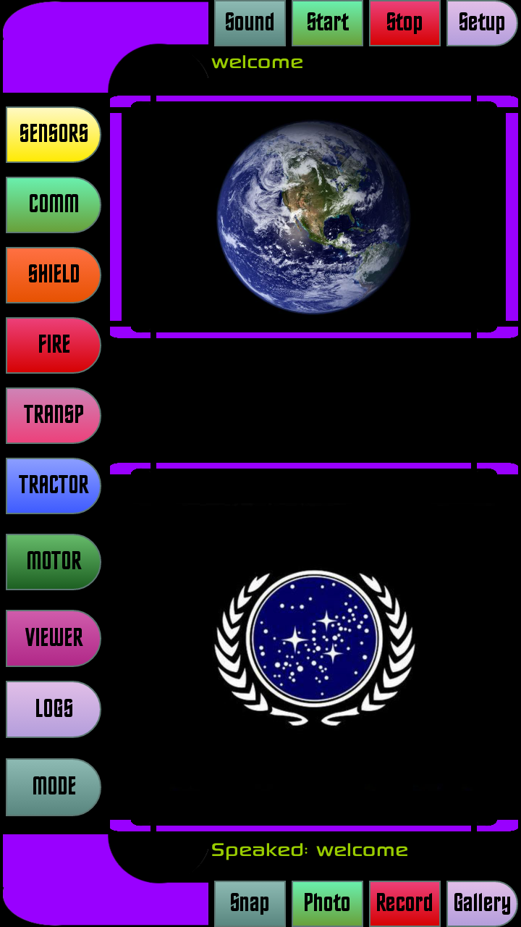 | Le Trycorder est un outil de mesure utilisé dans les vaisseaux spatiaux de la fédération des planètes.  Cette application essaie de ressembler le plus possible a un paneau de controle sur un starship, et contiens des vrais outils de mesure qui utilisent les sensors intégrés dans votre téléphone.  Je vais tenter de vous introduire facilement mais courageusement vers le merveilleux monde du trycorder.
The first button, on top left, named SENSORS, is the one who give tou all the trycorder sensors functions, from your telephone integrated sensors.  All top readings in this mode are about the real sensors in your phone. This mean you can go to the magnetic sensor mode, then pass your phone on the wall , and detect all nails and metallic conduits inside the wall.  On the same principle, you switch to orientation mode, and drive around a forest, and always know where north is, and your exact position on the gps, or press on the circle and open Google-maps. | 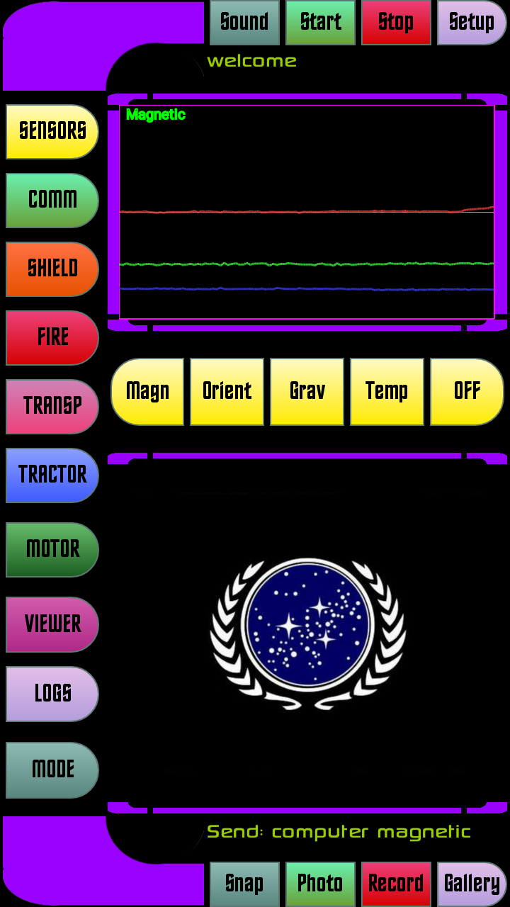 | 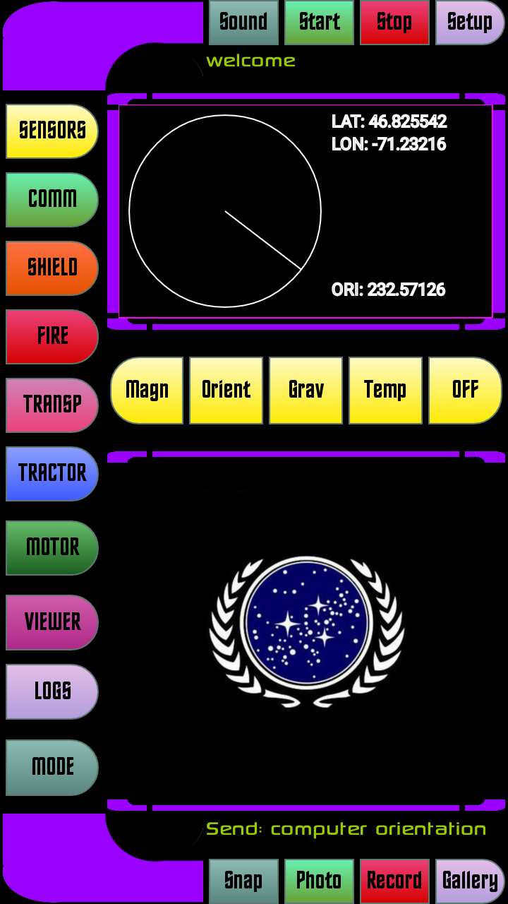
This is the same with Gravity mode where you can move your phone in any direction and see the 3 dimensional forces applied to the phone.  The next panel group Temperature, Pressure, and Luminosity in the same box. Its the values the phone reports to the system, for example, the temperature is read from CPU temperature. Light and Pressure are ambient light, and current pressure in your surroundings. | 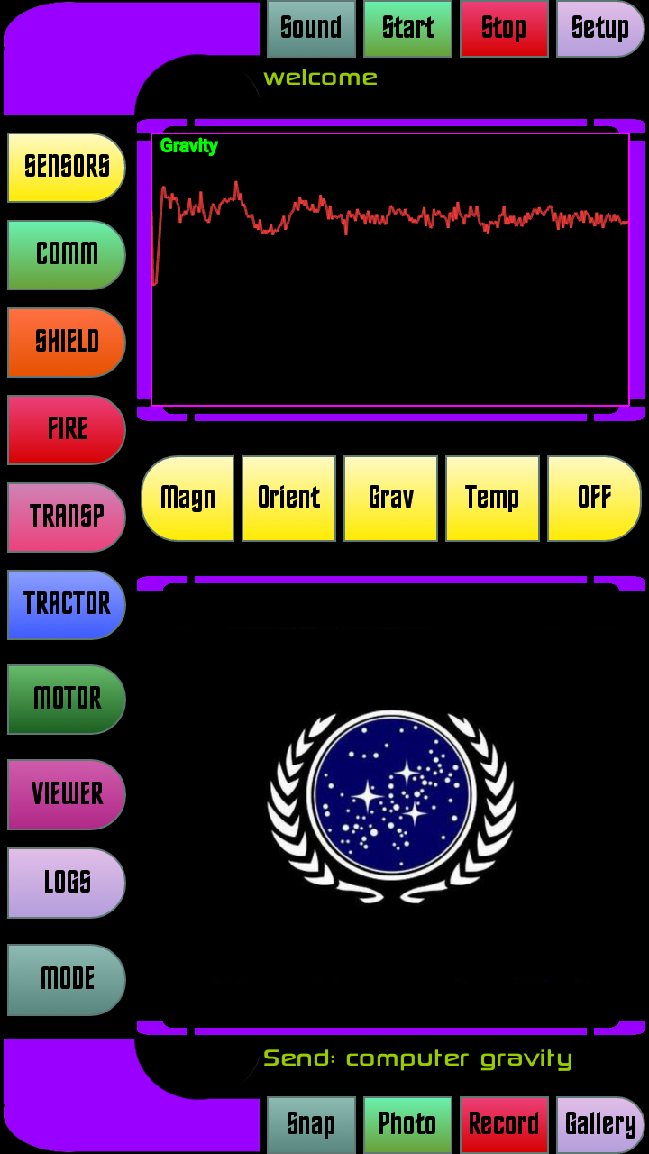 | 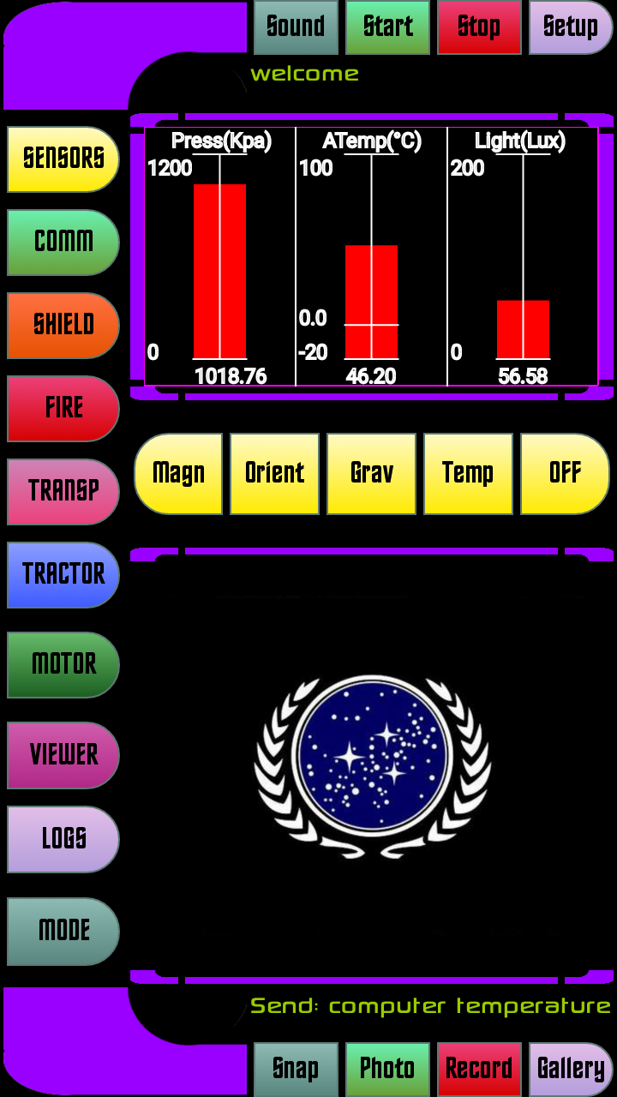
The communication functions are the most funny thing.  The open-comm button permits to have a visual of the audio around you. (with a cute little trekkie sound)  The close-comm button just close it up.  The next communicators functions are of much more complexity and usefulness. | 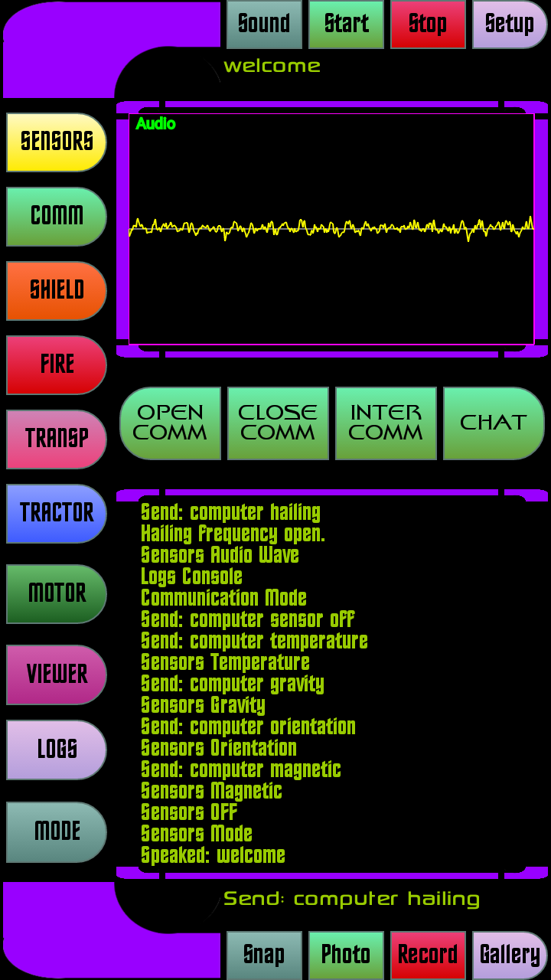 | 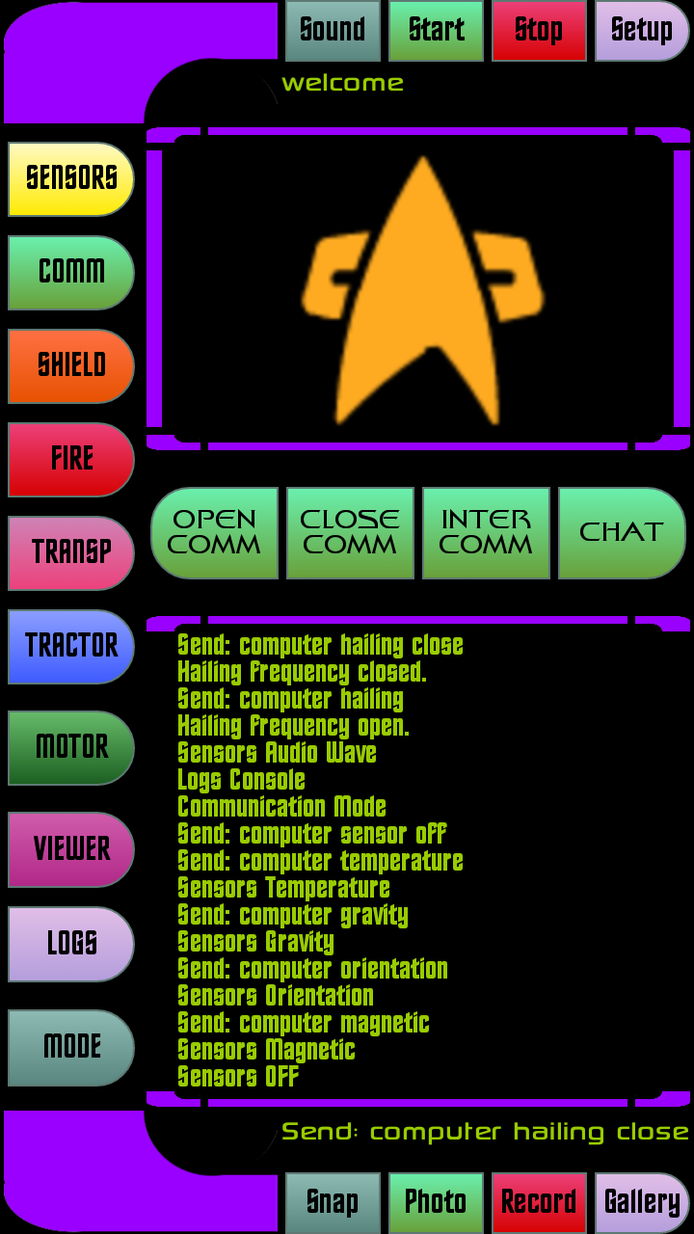
The Trycorder is able to communicate with a central starship and log all orders given from all trycorders in the world (this include only planet earth and satellites for the moment)  and respond to every trycorder with a “server ok” message.  A communication stay active when a trycorder is running and its service is started, between the trycorder and the Starship (who is a Linux machine with a starship server)  This is the first phase in the development of a full messenger like application. | 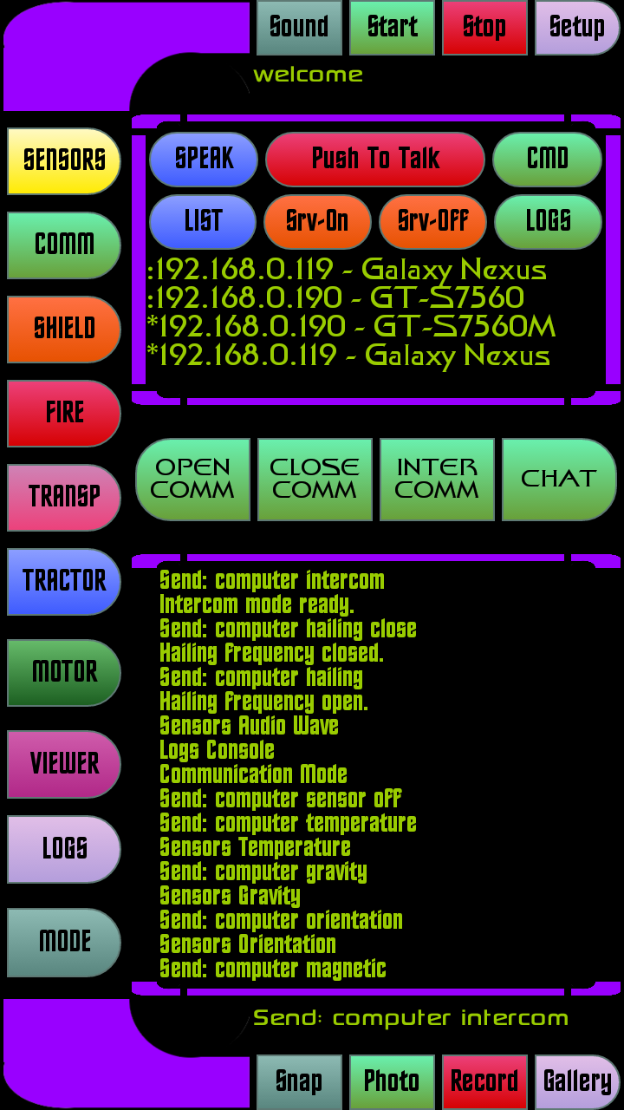
The CHAT button gives you control over the starship, or all other trycorders online in the world. | 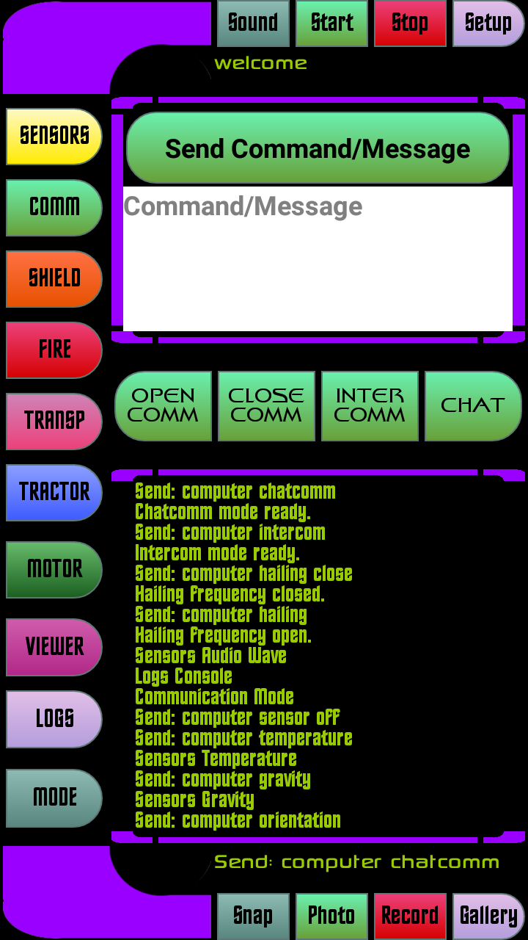
The shield operation do not really need explanations.  You can raise shields around the starship, or lower them.  There is also a frequency control and strenght control to ajust for differents weapons. | 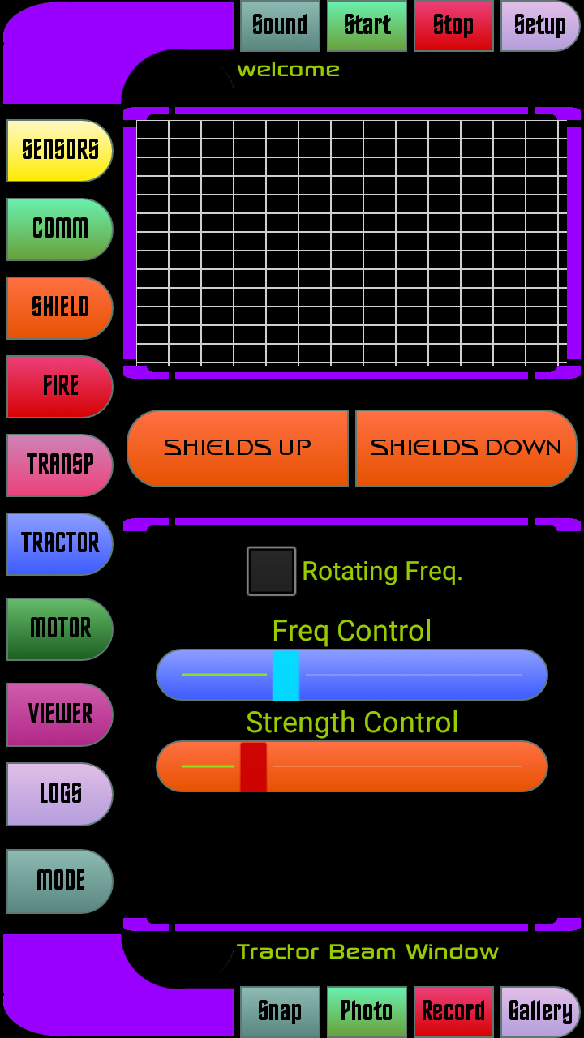
The fire functions permit you to respond to an attack with phasers or torpedos.  You can also ajust strenght and direction of your reply.  The controls for Yellow Alert and Red Alert are on this panel also. | 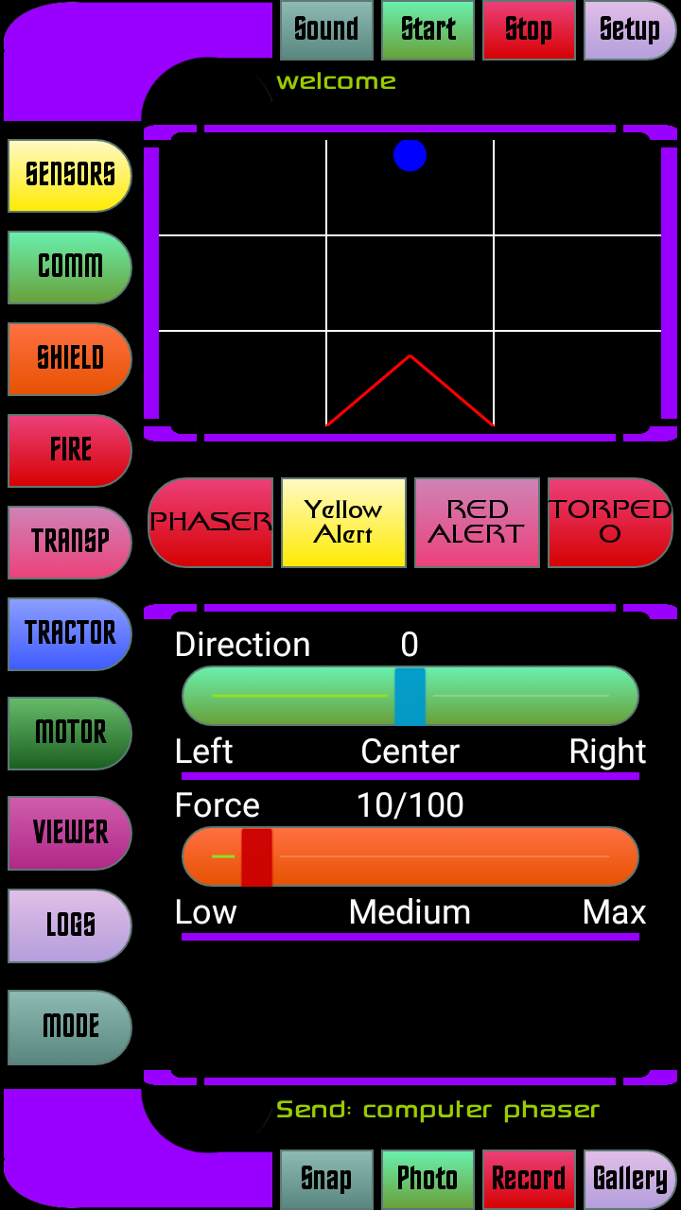 | 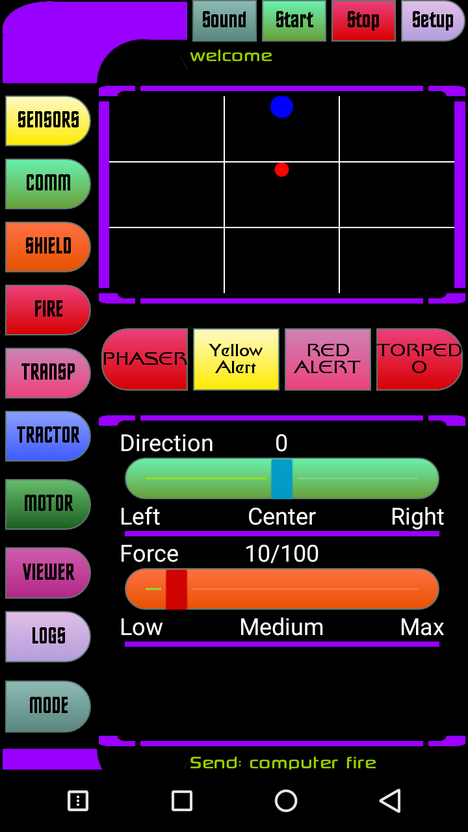
The transporter function permits to transport someone from a starship or to a starship, by remote control from your trycorder.  You can even use the manual control in the bottom area to pass difficult transport. | 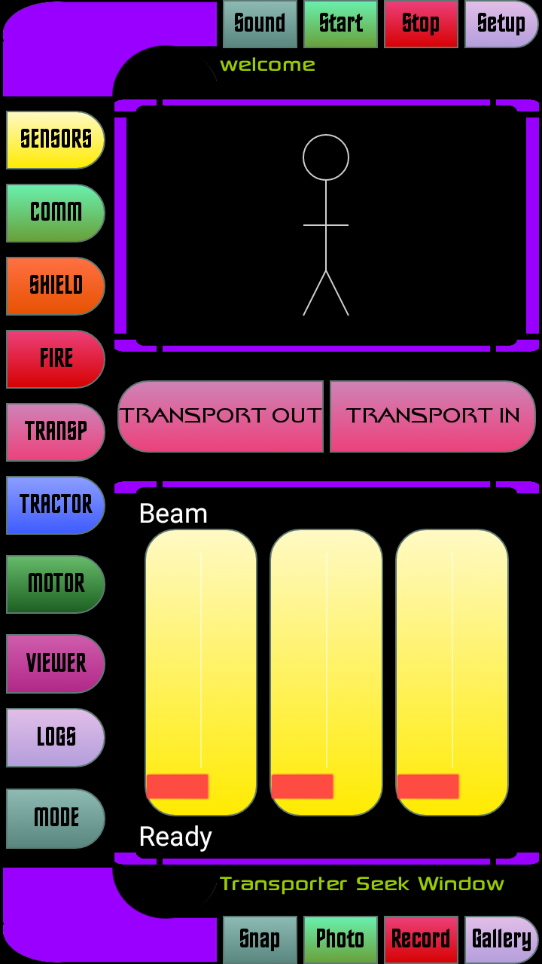 | 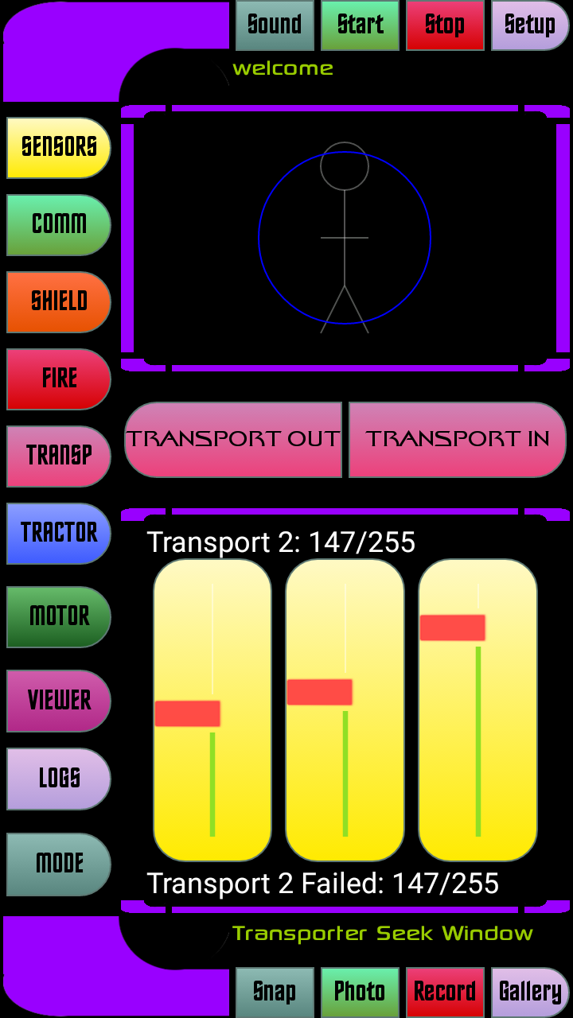
The Tractor Beam permits to push or pull on an object in space, from the tractor beam of the starship.  You can control the process from your trycorder. | 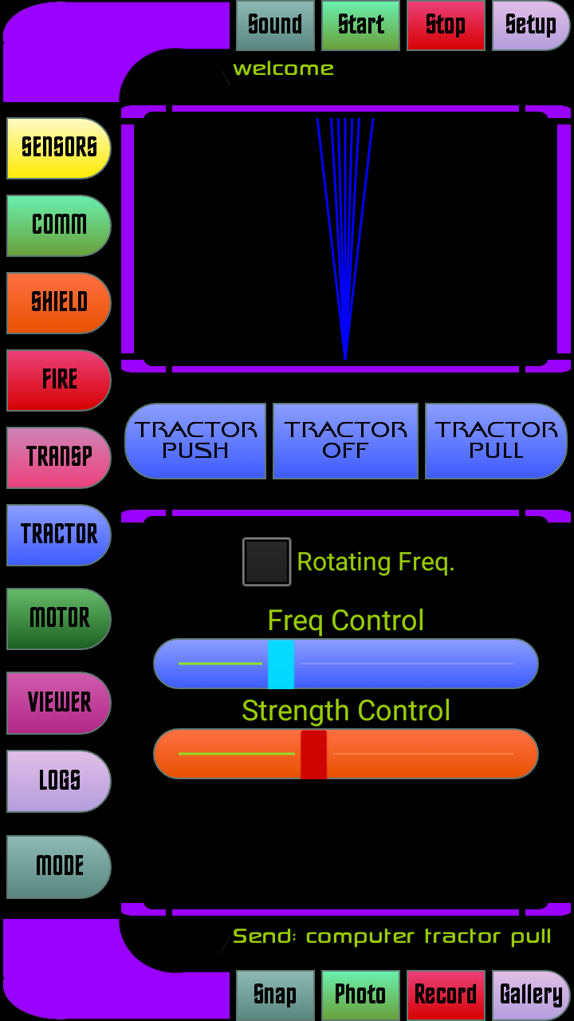
The motor panel gives you control over the motor panels from your trycorder.  There is choice between Impulse-Power, Warp-Drive, or hold position. | 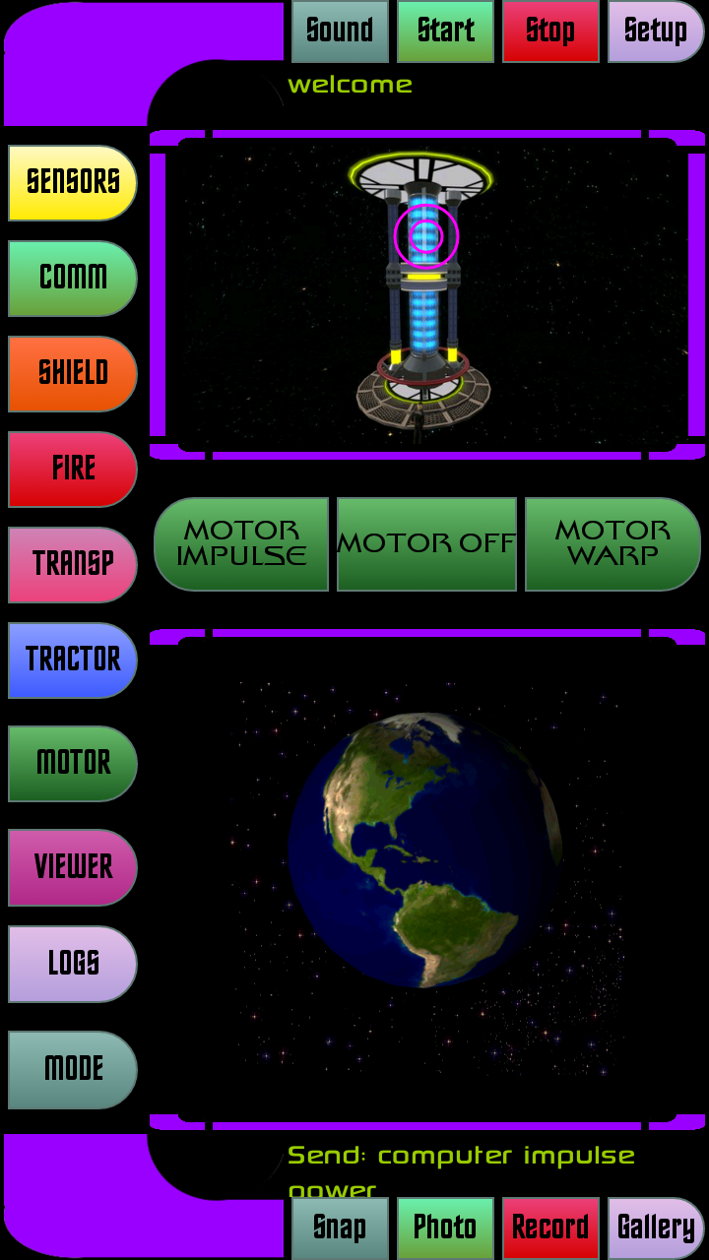 | 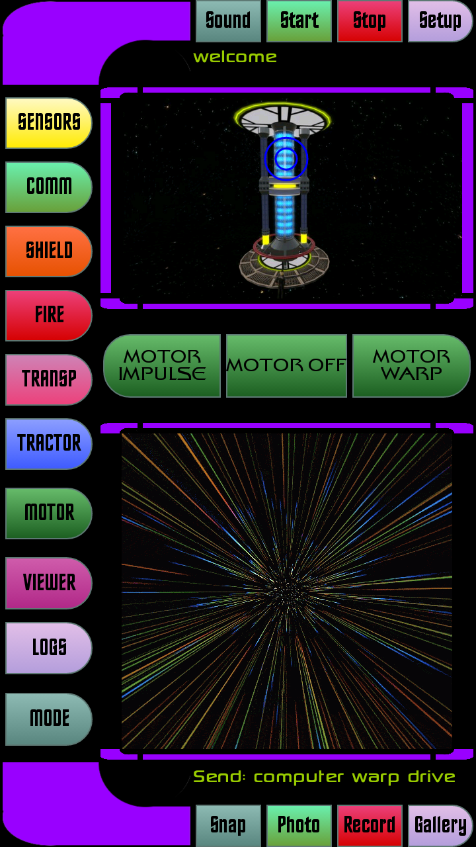
The viewer mode permits to see aliens around you, and identify their face if you snapshot it  Most of the buttons are self explanatory. | 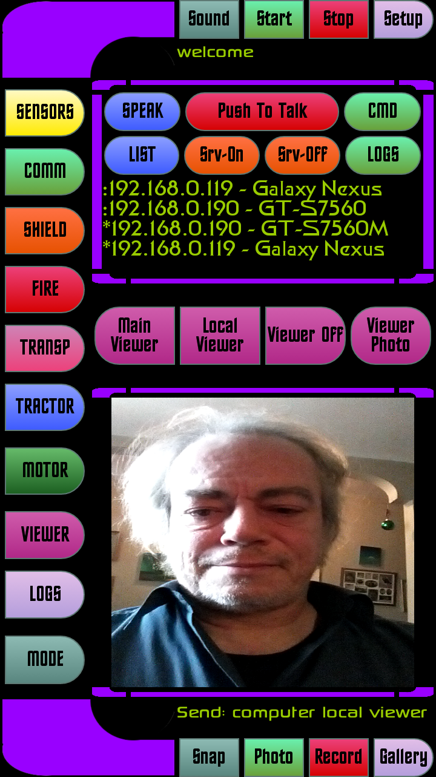
The logs panel gives you a lot of information about your trycorder, the commands executed, channels opened, data transfer, and all a lot of other informations. | 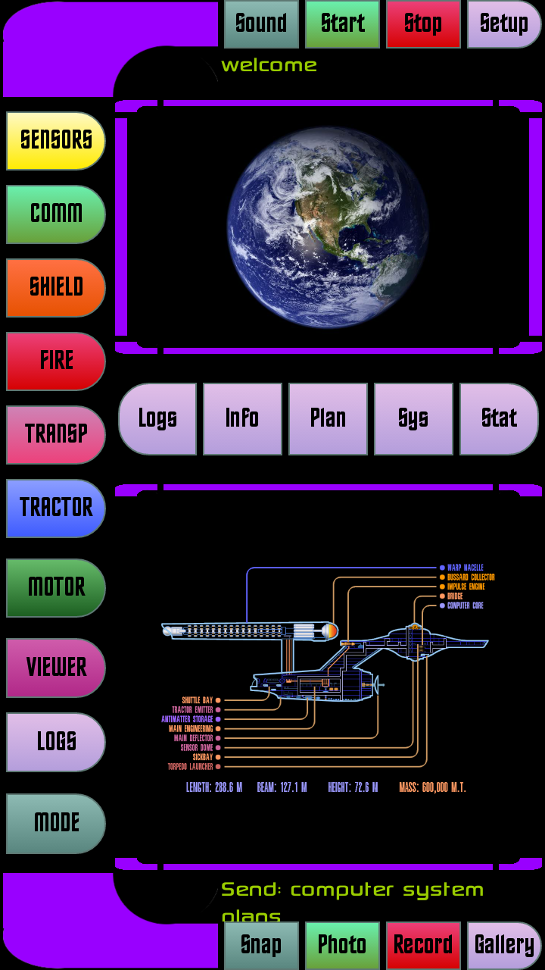  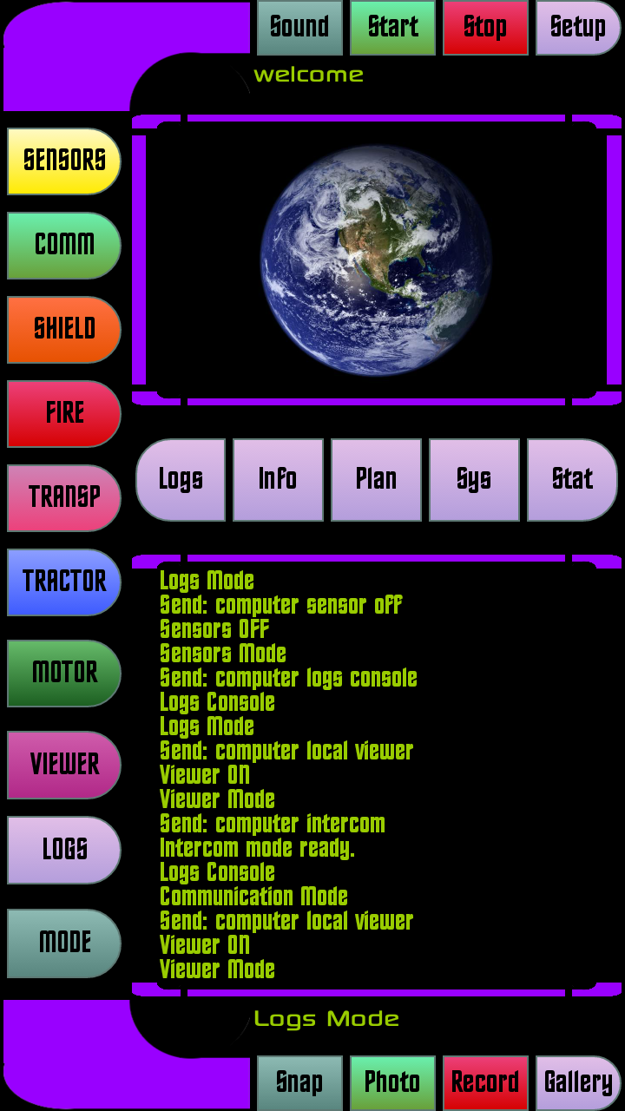
 | 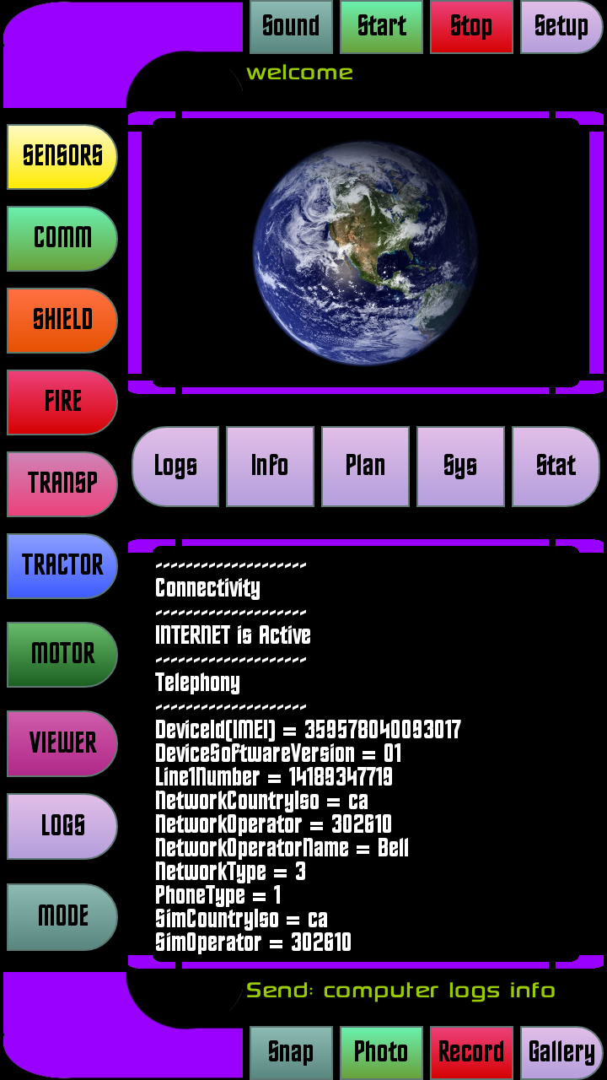 | 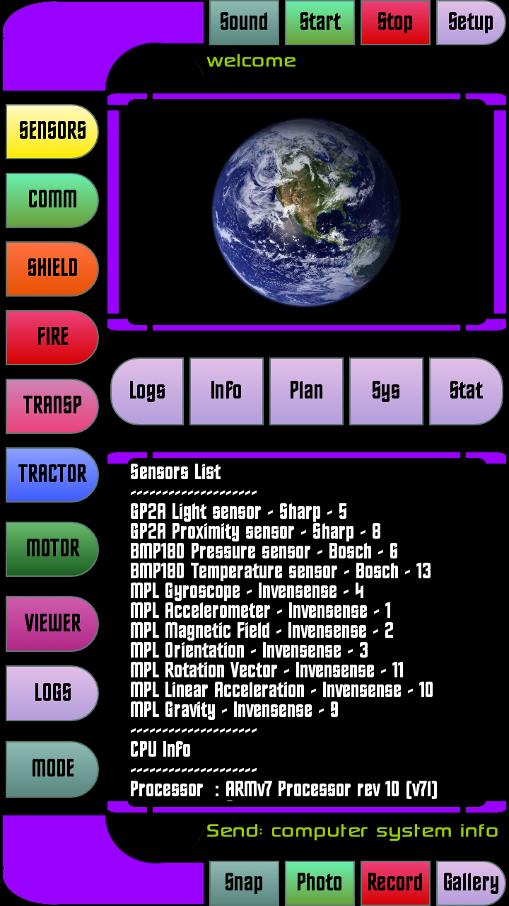
Finally the Mode button gives you a lot of other extensions you can try.  The Photo gallery allows you to check every photos you took with your Trycorder (phone). The Vodeo gallery does the same with videos.  The Client mode is a test mode for local communication between two trycorders on the same wifi.  The Vision Cam1 and Cam2 are test modules permitting to view differents aspects of the reality around you with your camera.  The Multisensor module is described just below. | 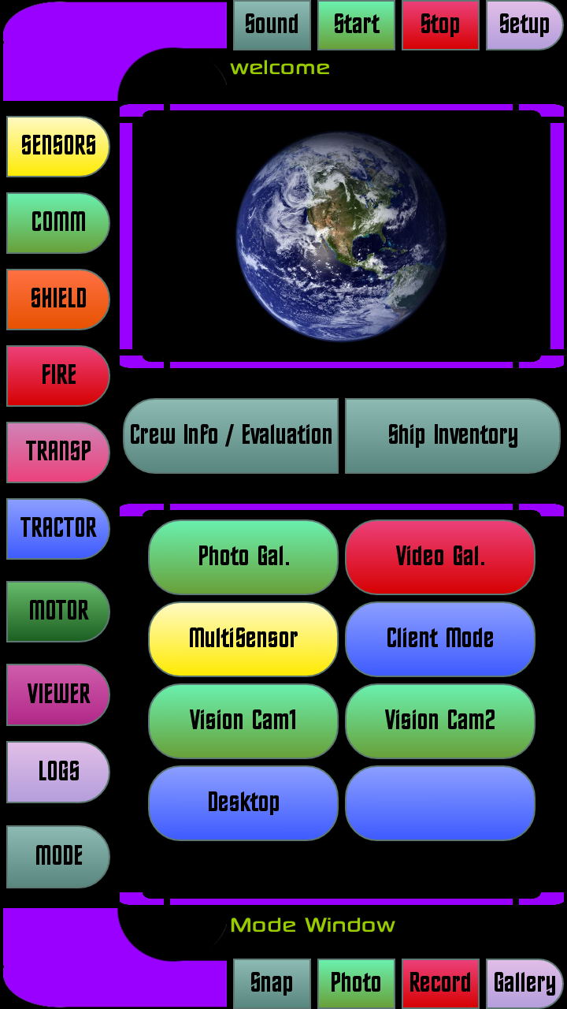
You can see an example of the Multisensor Mode, where all physical sensors are visible at the same time.  This way you can check everything aroung you with your sensors and detect immediately any anomaly in the environment like our friend Spock did.  To return to the main screen of the Trycorder, press the BACK button on top. | 

