PSC Bridges-2 Guide: Spring 2024 Edition

The Pittsburgh Supercomputing Cluster (PSC) provides powerful systems for high-performance computing to researchers and universities. It is located at 300 S Craig St, Pittsburgh, PA 15213.
In 15-418, we often use these machines for Assignments 3 and 4. You have the option to use them for your final projects as well.

For more information on what kind of resources the PSC provides, please see this page on their newest supercomputer, Bridges-2 (https://www.psc.edu/resources/bridges-2).

Creating Accounts for PSC
- Create an ACCESS Account and specify tour ACCESS username in the Google Form posted on Piazza.
- You should receive an email several hours later with a PSC username. These will be your credentials for SSH-ing to the PSC. Note that this may be different from your ACCESS username.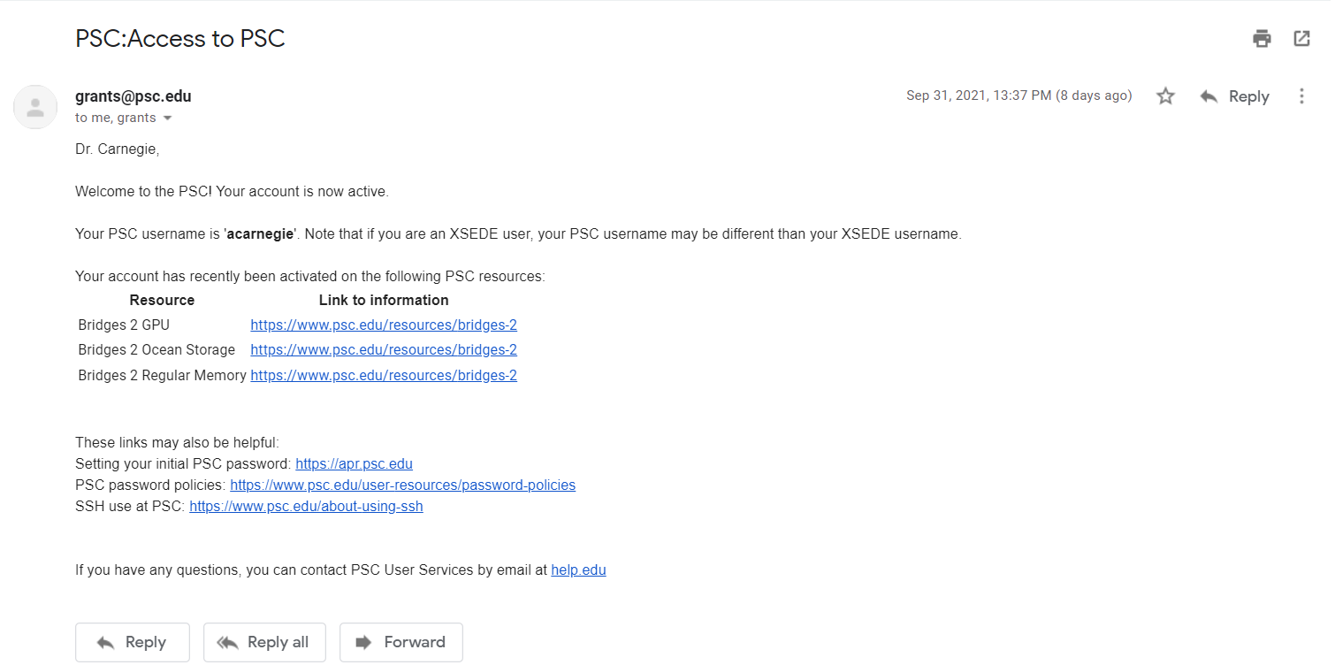
- Visit the PSC Password Change Utility to select an initial PSC password. This will be used to SSH into the PSC machines.

Connecting to Bridges-2
Bridges-2 has login nodes which are used for managing files and submitting batch jobs, as well as compute nodes which perform intensive computations. When you connect to Bridges-2, you are connecting to a login node, and may run interactive sessions or batch jobs on compute nodes as desired.

To connect to Bridges-2 over SSH: use your PSC username from the “Access to PSC” email from above. You will be prompted for your PSC password that you provided in the Password Change Utility.

$ ssh <psc_username>@bridges2.psc.edu

Compute Nodes
For 15-418, we have access to the Regular Memory (RM) and V100 GPU compute nodes. These nodes are further subdivided into shared and non-shared nodes:
- In shared nodes, users may choose to allocate only a fraction of the available CPU/GPU units for each job. For smaller workloads that do not require the resources of the entire machine, using shared nodes may allow your job to move faster through the queue.
- In non-shared nodes, users will be allocated the entirety of the CPU/GPU resources available to that node. Jobs running on an RM node will be allocated all 128 CPU cores, and jobs running on a GPU node will be allocated all 8 GPU cores.

More information on the technical specifications of these compute nodes is given in the section below.

Interactive Sessions
Interactive sessions are one of the two ways to perform computations on Bridges-2; the other way is to use batch jobs. In interactive sessions, you type commands into a shell and receive live output. To start a session, use

$ interact -options
Options | Description | Default
-p partition | Partition requested where partition = RM | RM-shared | GPU | GPU-shared | RM-shared
-t HH:MM:SS | Walltime requested (maximum 8 hours) | 60:00 (1 hour)
-N n | Number of nodes requested | 1
--ntasks-per-node=n | Number of cores to allocate per node  (Note: Only applies to shared partitions) | 1
--gres=gpu:type:n | Number/type of GPUs requested where  n = 1-8 and type = v100-16 | N/A

Do not run your code on the login server, as they are designed for submitting jobs and editing files. For intensive computations, you should start an interactive session first.

To launch an interactive session with less than four GPUs (n <= 4) please use the following launch command as a reference:

$ interact --gres=gpu:n -p GPU-shared

If you want to launch a node with more than four GPUs, then you can only use the GPU partition and all 8 GPUs. Use the following reference command:

$ interact --gres=gpu:8 -p GPU

Batch Jobs
In batch jobs, you create a job script with commands to run and submit this job to a queue. The job will run as soon as resources are available, and on completion the command-line output will be written to a file called slurm-jobid.out in the same directory that the job was submitted from.

You may submit any script you’d like as a batch script, as long as the first line indicates what shell you are using (e.g. #!/bin/bash, #!/usr/bin/python3, etc.).

You can also manage your upcoming and completed jobs using the following commands:
- squeue -u username Show jobs that belong to you on the queue
- scancel job_id Cancel a specific job ID
- job_info job_id Show information on completed jobs

To submit a batch job, use the following command:

$ sbatch -options script_filename
Options | Description | Default
-p partition | Partition requested where partition = RM | RM-shared | GPU | GPU-shared | RM
-t HH:MM:SS | Walltime requested (maximum 8 hours) | 30:00  (30 min)
-N n | Number of nodes requested | 1
--ntasks-per-node=n | Number of cores to allocate per node  (Note: Only applies to shared partitions) | 1
-o filename | Name of output file (relative to the directory that the job was submitted from) | slurm-jobid.out
--gpus=type:n | Number/type of GPUs requested where  n = 1-8 and type = v100-16 | N/A

Programming Environment (as of Spring 2024)
For Assignment 3, Bridges-2 automatically provides OpenMP support using the -fopenmp compiler flag. However, for Assignment 4, MPI must be separately loaded using the command shown below.

You can use the module package to load different versions of software that are not available by default. Here are some modules that may be useful:
- module load openmpi/4.0.2-gcc8.3.1 For OpenMPI support
- module load cuda For CUDA support
- module load nvhpc For nvcc/nvc++
- module load gcc/10.2.0 For an updated version of gcc
- module load intel/2021.3.0 For icc/ispc

Here are some additional commands provided by the module package:
- module avail package_name See what modules are available for a software package
- module load package_name Load a given module (use module unload to unload)
- module list List all currently loaded modules
- module purge Unload all modules

Compute Node Technical Specifications
Here are the technical specifications for the regular memory nodes:
- Regular Memory (512x)
  - CPU: 2x AMD EPYC 7742 (2.25-3.40 GHz, 2x64 cores per node)
  - RAM: 256 GB
  - Cache: 256 MB L3 cache, 8 memory channels
  - Local Storage: 3.84 TB NVMe SSD
  - Network: Mellanox ConnectX-6-HDR Infiniband 200Gb/s Adapter

Note that we do not have access to the Extreme Memory (EM) or SXM2 GPU nodes, which are also provided by Bridges-2.

User Guide
For more information on PSC and Bridges-2, please see the Bridges-2 User Guide

