An Introduction to GIS
Using QGIS (v. 3.0)

Author: Michael L. Treglia
mtreglia@gmail.com
13 May 2018

License: This work is licensed under a Creative Commons Attribution-NonCommercial-ShareAlike 4.0 International License. Please see the following website for complete license details or contact Michael Treglia at mtreglia@gmail.com with concerns. http://creativecommons.org/licenses/by-nc-sa/4.0/legalcode

Opening Notes

Open-source tools for various types of work, are constantly expanding. Herein, I provide a tutorial of QGIS (www.qgis.org), which is capable of almost any GIS operation I’ve ever needed, either on its own, or using the various plugins and associated tools. QGIS installs and directly links with other programs including SAGA GIS and GRASS GIS, allowing users to take advantage of cooperation among the free and open source software developers. Furthermore, data can be exported to a variety of formats, for use in other programs.
My goal here is to provide a basic skill-set to the new GIS/QGIS user, so they may navigate the software for their own work, and further explore its capabilities. This tutorial is by no-means comprehensive. I suggest users browse and search the QGIS documentation (https://qgis.org/en/docs/index.html) when they are stuck, or make use of relevant support channels (https://qgis.org/en/site/forusers/support.html). Furthermore, a lot of examples are given here without going into intricacies of analysis. Thus, I suggest before quantitative analytics, users read further on the tools/analyses that can be employed.

Table of Contents
Opening Notes 1
Table of Contents 2
Installing QGIS 4
Installing Plugins 5
Data Sources Used in this Tutorial 6
Get to Know QGIS 7
Opening Files (General) 8
Open Shapefiles, 8
Open Delimited Text Layer (e.g., points based on a table with Coordinates) 9
Add a Background Layer 12
Open and Manipulate a Raster Layer 12
Projections 15
Projection of Layers and Project 15
Changing Projections (CRS) 16
Changing Project CRS 16
Changing Vector CRS (for a Shapefile or Text-Delimited Layer) 17
Changing Raster CRS 18
Geo-Processing of Data Layers and Associated Tables 20
Some Basic Vector Operations 20
Clipping (Remove unwanted sections of a layer, based on bounds of another Layer) 20
Difference Clip (Clip out the inner area of a polygon) 22
View and Edit the Attribute Table 23
Spatial Join 24
Some Basic Raster Operations 26
Calculate Slope from a DEM 26
Reclassify Raster 28
Raster Calculator 32
Using Vector and Raster Datasets Together 34
Clipping a Raster 34
Compute Zonal Statistics for Polygons 36
Making a Quality Map 37
Setting up for a Map 37
Putting Everything Together 40
Adding the Map of interest to the Layout 40
Adding Gridlines and Coordinates 40
Adding Scale Bar, North Arrow, and Legend 42
Adding an Inset 44
Final Formatting and Exporting the Map 45
Exporting the Map 45
Closing Remarks 47

Installing QGIS
I generally recommend working with the most recent version of QGIS available, with the most recent features, or the most recent Long Term Release, which is designed to be maintained with bug-fixes and such for the next three release cycles. Long term releases might not have the most newest features found in the most recent version, but focus is broader stability across time. At the time of writing, the most recent version is 3.0.2; the long-term release is 2.18.9. Everything presented herein was tested using QGIS 3.0.2, 64 bit, on Windows 10. Though there have been some changes since 2.18.x, the general workflows will be consistent. (Releases are denoted as x.y.z, where changes in ‘x’ denotes some potentially larger changes in the software, changes in ‘y’ denote additions of features and bug fixes, and changes in ‘z’ generally reflect bug-fixes.)

For Windows users:
Download and run the standalone installer, available here: https://qgis.org/en/site/forusers/download.html (QGIS Standalone Installer Version 3.0.2 will be sufficient; the OSGeo4W installer gives more advanced options, but is not needed).
- When it gives you the option, you do not need to download the sample datasets, although feel free to and use them for other tutorials or examples.

For Mac OS users:
Download files should be available on the main QGIS download page. (At time of writing, when clicking to expand the box for “MacOS” from a non-Mac computer, the page scrolls to the bottom; if this happens, users should scroll up to find the download links!)

For Linux Users:
Follow instructions provided here: https://qgis.org/en/site/forusers/alldownloads.html#linux.

Installing Plugins
One of the strengths of QGIS is the availability of capable plugins that have been written for it.
- To see what plugins are installed, open QGIS by double-clicking on the “QGIS Desktop” icon on your desktop or in your start menu.
- Then, click the Plugins menu at the top of the main QGIS window, and navigate to “Manage and Install Plugins”.
- When the Plugins window opens, search for the following plugins and install them if they are not indicated as already installed (having a checked- or unchecked-box to the left of the name; uninstalled plugins will have a puzzle piece emblem next to the name):
  - QuickMapServices
  - Processing (installed by default)
- To ensure these plugins are active, make sure the box next to the name has a check-mark in it.

Data Sources Used in this Tutorial
The data sources used in this tutorial are available for download in a single .zip folder, at the URL where you accessed this document. Individual data layers and original sources are listed below. Please see the URLs for the original sources or the included metadata for individual layers for more detail. Throughout the document, I primarily refer to layers with the italicized names given below.

Text Delimited Table
- Copperhead Data – “Brazos County A contortrix_TxCentral.csv” – Specimen locations for copperheads, Agkistrodon contortrix, in Brazos County, Texas, provided by the Biodiversity Research and Teaching Collections at Texas A&M University (https://brtc.tamu.edu/). Most localities were definitely collected in the WGS84 datum; the others are assumed to be for this tutorial.

Vector Data (Shapefiles)
The following layers for Brazos County and the city of College Station, TX were accessed from the City of College Station GIS Department in 2014 (newer files may be available at: http://www.cstx.gov/index.aspx?page=3683).
1) County Boundary – Brazos_County_Boundary_8-20-02.shp (in /CountyBoundary)
2) City Limits – City_Limits.shp (in /CityBoundary)
3) Rivers and Streams – Rivers_and_Streams.shp (in: /RiversStreams”)

Raster Data
The raster dataset used in this tutorial is the 1 Arc-second (~30m) Digital Elevation Model from the U.S. Geological Survey
- DEM – imgn31w097_1.img (in /DEM 1ArcSec)

Get to Know QGIS
Open QGIS on your computer using the QGIS Desktop icon in your Start Menu or Desktop.
- By default, only one pane is likely open – the “Layers/Browser” pane on the left side. You can adjust what is open by going to the “View” menu from the toolbar, and mouse-over “Panels”, and see different options.
- Explore icons by hovering over them with the mouse; click on menu-bar items to explore the drop-down menus.
- To save the project click the “Save” icon and designate a file location. When you re-open a project, any layers that you were using should be in the same locations on your computer; if they are not, you will need to re-designate the appropriate file paths. If you transfer data and a project file to another computer, keep the files in the same locations relative to one another and the project should open without a problem. Make sure to periodically save the project as you work. In the latest versions, QGIS automatically shows the most recent projects. You can simply click a desired project to return to it, or otherwise navigate through QGIS to proceed with a new project.

Opening Files (General)
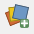
Starting with version 3.0.0, QGIS has a universal Data Source Manager that facilitates opening myriad types of files from a central interface. The icon, pictured at left, should be the top-most on the left side of the screen. Users can also access it via “CTRL + L” (on Windows) or going to “Layer” on the toolbar at the top and finding it. As with earlier versions of QGIS, users can still go to “Layer” -> [Desired Layer Type] to load specific types of data, and this will call the Data Source Manager with the appropriate tab.

Many common spatial data formats can also be opened by going to the “Browser” pane, navigating to the file location, and clicking/dragging the file into the general view or into the “Layers” pane.

Open Shapefiles,
Shapefiles (.shp extension) are one file format of vector data (points/lines/polygons) commonly used in GIS. Though these are largely replaced by files within ESRI File Geodatabases (.gdb extension) in ESRI products and Geopackage (.gpkg extension) in QGIS, a lot of datasets are still distributed as shapefiles.
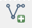
- Within the Data Source Manager, click the “Vector” tab on the left (Or use “Layer” menu from the toolbar and navigate to “Add Layer” -> “Add Vector Layer”)
  - Set the Source Type to “File” and Encoding to “System”.
  - Click “Browse” and navigate to the appropriate files, using the appropriate file types (for Shapefiles, set to “ESRI Shapefiles [OGR] (*.shp)”).
  - Select County Boundary, City Limits, and Rivers and Stream layers respectively, and click the “Add” button.
**Note –To access data from ESRI Geodatabase (.gdb files; not used in this exercise), set “Source Type” to “Directory”, and navigate to .gdb files.
- Adjust the layer order by clicking and dragging layers up and down in the “Layers” pane.
  - Put Rivers and Streams on top, then City Limits, and County Boundary
- To adjust layer symbology (how the data appear):
  - Right click on individual layers and select “Properties” (or Double Click on the layer)
  - Select “Style” on the left; click on a symbol in the “Symbol Layers” box, and customize to your liking.
    - You can also open a “Layer Styling” panel via “View” on the toolbar -> “Panels” -> “Layer Styling”
- To view the tabular data associated with a layer, right click on the layer and select “Open Attribute Table”.
- To view information about a layer at a specific point in space, click on the “Identify Features” icon on the tool bar, and click on the point of interest. The default setting show information about the layer highlighted in the “Layers” pane.

Open Delimited Text Layer (e.g., points based on a table with Coordinates)
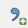
- In the Data Source Manager “Add Delimited Text Layer” icon. (See example dialogue box on next page.)
  - Navigate to the appropriate file (Copperhead Data; “Brazos County_A contortrix.csv”)
  - Expand the “File Format” section and select the appropriate text delimiter (comma for this file).
  - Expand the “Records and Fields” section – if the first line contains field names (column names) as in this case, make sure the “First record has field names” box is checked.
  - Expand the “Geometry Definition” section (typically “Point Coordinates”), and identify fields for X and Y coordinates (e.g., Longitude and Latitude, respectively).
  - If the data are based on a geographic projection Decimal Degrees are expected as with the Copperhead data; if data are as Degrees Minutes Seconds, check the “DMS Coordinates” box.
    - By default, the CRS (Coordinate Reference System) for the new layer is set to the CRS of the project, Lat/Long, WGS84 (EPSG 4326). You can change the CRS of the layer by clicking on the globe icon, though that is not needed in this case.
  - Click “Add”
  - The layer should now appear in “Layers” pane. You can adjust the symbology by editing the properties as described above.
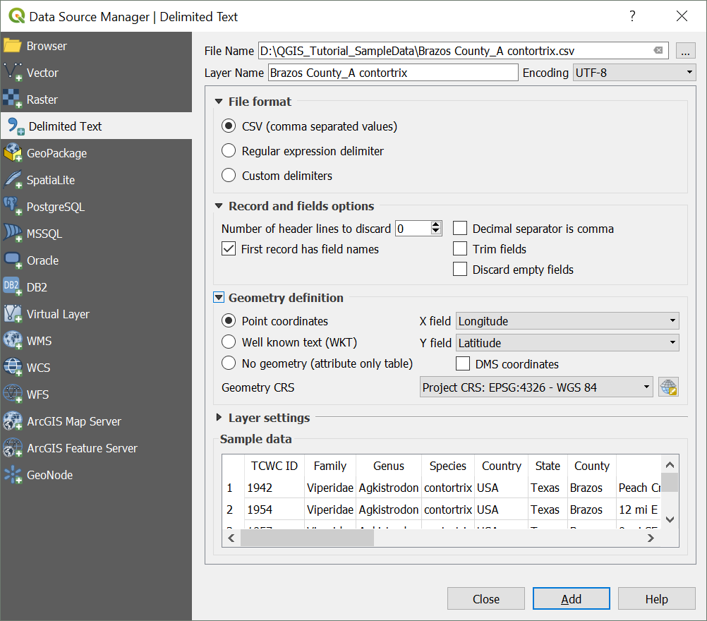

Add a Background Layer
When we import spatial data, we often like to visualize them over some sort of background layer, such as aerial imagery, or a simple map. This allows us to identify if layers are being displayed in approximately the right location, and it can help with some preliminary interpretation of data. For this exercise, we will utilize the QuickMapServices Plugin.
- Click on “Web” from the menu bar at top, navigate to “QuickMapServices Plugin” -> “Search QMS”; the search panel for this plugin will appear.
- By default, some Google layers will be available to load. If you click “Add” while selecting any specific layer, the newly added background layers will appear as the bottom-most layer.
  - You can also use the Search bar to find map services that are made available in this plug-in (e.g., search for Google, Bing, or Open Street Map).

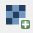
Open and Manipulate a Raster Layer
- In the Data Source Manager click the “Raster” icon
  - Navigate to the desired file; can either specify desired file type or browse any of the available types. Browse to the “DEM 1ArcSec” folder and select “imgn31w097_1.img”.
- Change Color Palette to enhance visualization.
  - Right-click on the layer (“imgn31w097_1”) and select “Properties”
  - Click “Style” – There are lots of options to adjust. The below steps just serve as an example. (See next page for sample dialogue box).
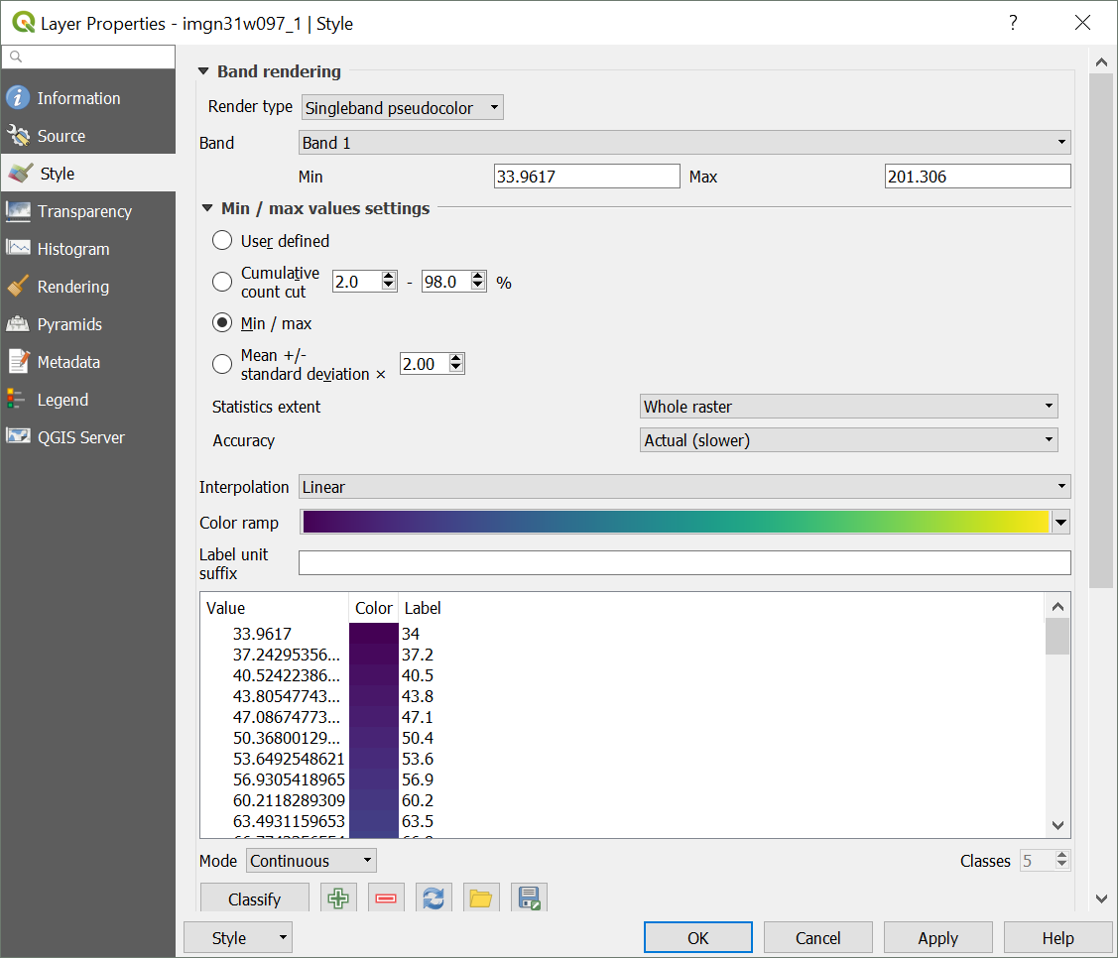
    - Change “Render Type” to “Singleband pseudocolor” (Avoid multi-band options unless you are using multi-band imagery (e.g., Landsat imagery))
    - Adjust the Min/Max settings as desired.
      - Using the true “Min/Max” (third option) will have the color gradient span the entire range of values in the raster dataset.
    - Select a color ramp that you like (e.g., the default is ‘viridis’) and click “Classify” button to set bins automatically, and click “Apply”. If you like it, click “OK”, if not, adjust as needed. Feel free to try adjusting other options too.
      - You can also adjust colors and labels in the editing box to the left.
      - You can use “Save Style” and “Load Style” buttons to use a standard color ramp across multiple projects or raster layers.

You can use the “Zoom In” tool to zoom in enough to see individual pixels. Select the tool from the toolbar, and click and drag a box on the area you wish to zoom to.
- To measure an individual pixel and make sure it is the size you expect click on the “Measure” tool from the toolbar, and select “Measure Line” from the drop-down menu.
  - Click at one edge of the pixel, and drag the cursor to the other side; the dialogue box will show the measurement based on the units and datum of the Project CRS (see Projections [next section]).

Projections

Projection of Layers and Project
QGIS automatically reads projection information (i.e., the Coordinate Reference System [CRS]), if available, from respective layer files. For shapefiles, it relies on the “.prj” file; for raster data, it is often embedded in the file. If you load data without built-in projection information (e.g., a Delimited Text File), it generally assumes a geographic coordinate system (Lat/Long), and uses the World Geodetic Survey 1984 (WGS84) datum, or may use the Project CRS the user to specify. It is always a good idea to check that the projection information is interpreted correctly by QGIS.
- To check the CRS, (and set it if it was not automatically detected) right-click on layer and select “Set Layer CRS”.
  - If you do this for the Copperhead Data you will see the CRS that selected is WGS84 (using Lat/Long coordinates). This is correct – the datum of the original data was exactly that, so nothing needs to be changed, although if it was incorrect, you could fix that here.
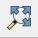
By default, QGIS uses “Projection on the Fly” – for visualization (but not necessarily analysis) of multiple layers in different CRSs, they are automatically transformed to be in the same coordinate space. Previous versions of QGIS had a box to check within the ‘CRS’ tab of Project Properties (Accessed via “File” -> “Project Properties” or by clicking on the ‘EPSG: [Current CRS]’ in the bottom left of the screen - 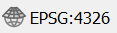). In newer versions of QGIS (3.x.x), you an turn off Projection on the Fly by checking the box for “No Projection (or unknown/non-Earth Projection)”, which will project everything on cartesian coordinates. If you do this and – click the “Zoom Full” button on the toolbar at top, and the map area will zoom out to include all layers. (In this situation, will want to turn off the QuickMapServices layer, and you will a large blank space between very small datasets.)

Changing Projections (CRS)
For many operations it is necessary to have all layers in the same CRS; even if it is not necessary, it can help speed-up processing considerably. The DEM has elevation in meters, according the layer’s metadata, and it is in a geographic projection (Lat/Long, NAD83). However, for computing some derivatives of elevation such as Slope, it is helpful to have the horizontal units the same as the units for elevation. Thus, we will work in a projection that is also defined in meters, the Albers Equal Area Projection. This projection may cause some distortion in shape, but maintains accurate area measurements. This is just a demonstration, and in doing your own work, it is important to consider how spatial distortions may manifest in different projections.
The steps for converting the CRS of raster and vector layers are somewhat different. Furthermore, when converting the CRS of raster layers, it is important to think about how resampling may cause distortion. This will not be covered in depth here, but Mike Bostock provides a useful visualization of this: https://bost.ocks.org/mike/example/.

Changing Project CRS
As aforementioned, we will use the Albers Equal Area Projection, useful for dealing with the DEM. Other projections, such as Universal Transverse Mercator could also be used.
- Navigate to the Project Properties dialogue box.
  - Browse for “North_America_Albers_Equal_Area_Conic” or use the Filter box to search for that, and select the appropriate CRS. A standard code used for this CRS (the EPSG code) is 102008.
- Alternatively, right-click on a layer with the desired CRS, and select “Set Project CRS from Layer” [not applicable for this project].

Changing Vector CRS (for a Shapefile or Text-Delimited Layer)
This process involves creating a new shapefile with the desired CRS.
- Right-click on layer that you wish to change the CRS of (in this case, select the Copperhead Data) and Select “Save As”
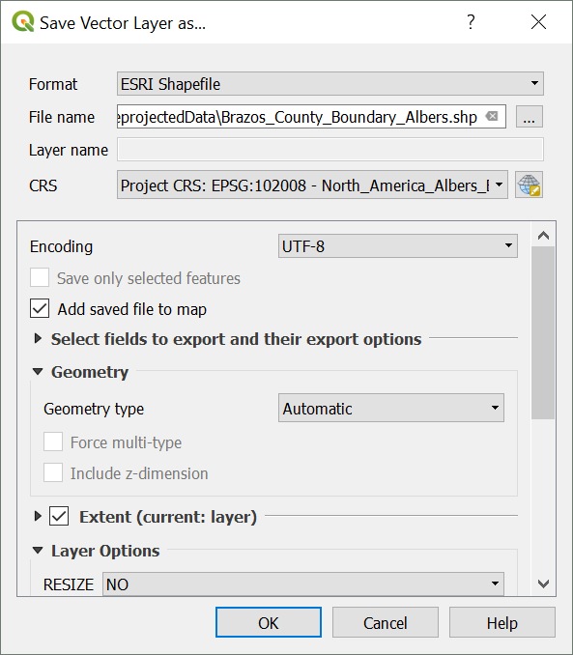
- Set “Format” to “ESRI Shapefile” (or GeoPackage, as a newer, open-standard format).
- Use the “Save As” box to designate an appropriate file location and name for the resulting shapefile.
- For the CRS, you can use the “Project CRS” (Or use the Browse button to navigate to the appropriate CRS if necessary).
  - Selecting “Layer CRS” retains the original CRS
- Check the box for “Add Saved File to Map”
- Click “OK” (the original layer can then be removed from the map by right clicking on it and selecting “remove).
- Now do this for the remaining shapefiles.

Changing Raster CRS
As with vector datasets, when reprojecting a raster, a new file is created and added to the project
- Click on the “Raster” toolbar menu -> “Projections” -> “Warp (Reproject)”.
In the Dialogue box (illustrated on the next page):
- Designate the input file from the current project
- The Source CRS can be left blank if it’s correctly assigned already
- Set the Target SRS to the desired CRS (EPSG 102008).
- Check the box for “Load into canvas when finished” to bring the final product into the current project.
- Boxes for NoData and Output resolution boxes can be left untouched for default settings (e.g., the NoData value will be assigned to a default for the data type; the Output resolution will be approximately the same size as the original, but with units converted).
- Select the desired resampling method.
  - For continuous variables, typically want to use something like bilinear or cubic spline that interpolates. If it is a categorical variable, nearest neighbor (“Near”) is generally appropriate.
- Advanced parameters can be untouched for this exercise, though here you will find options for changing the data time, and a few other parameters.
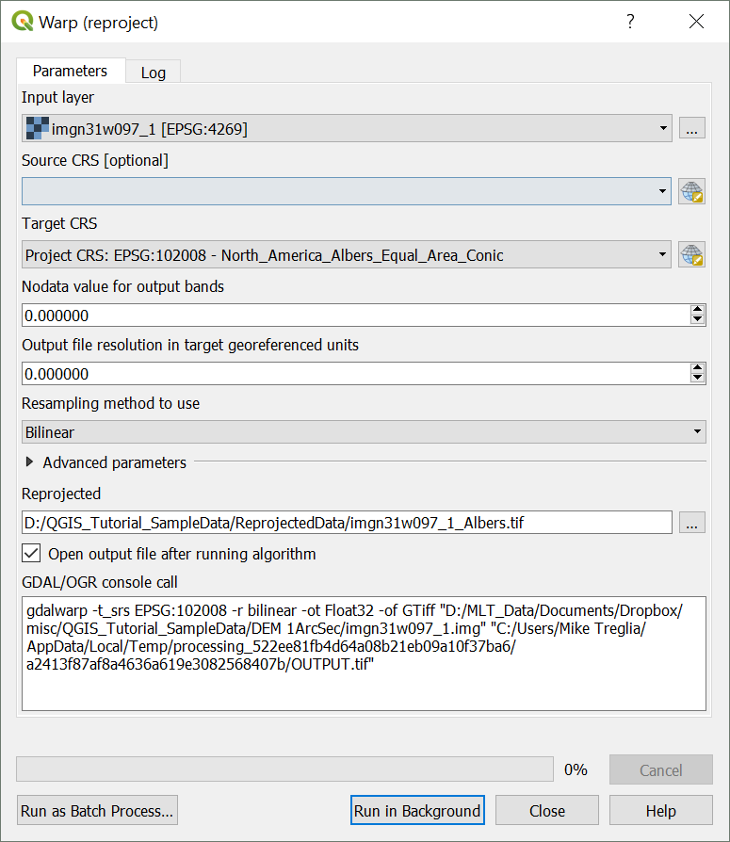
- For this case, users should set a file path for the Reprojected file.
**Note – This uses a tool called ‘GDAL’ to do the processing, with code that could be used in a command line tool (and edited) presented at the bottom of this window. Details for this specific operation are given at http://www.gdal.org/gdalwarp.html.
After these reprojections, you can remove the original layers.

Geo-Processing of Data Layers and Associated Tables
QGIS has a wide variety of built-in processing operations, and with the other included programs it has incredible capability and functionality, easily accessible via the Processing Toolbox. We will only cover a handful of operations here, but I suggest exploring menus, the Processing Toolbox, and plugins to find other operations that you need. In QGIS, these operations generally create a new layer rather than simply editing the original. All tools directed via toolbar menus should generally be available via the (searchable) Processing Panel – search for the tool, and double-click on it to open the respective menu. To turn on the Processing Panel, assuming the Processing plug-in is activated, click the “Processing” toolbar menu, and select “Toolbox”.

Some Basic Vector Operations

Clipping (Remove unwanted sections of a layer, based on bounds of another Layer)
Hypothetically, say we are working on a project that involves streams of the city of College Station, but the stream layer that we downloaded was for the entirety of Brazos County. Thus, we can clip the Rivers and Streams to the College Station Boundary.
- Select the Vector menu at the top and navigate to “Geoprocessing Tools” and then “Clip” (illustrated on the next page)
  - Input Vector Layer is the layer that you want altered (Rivers and Streams [Reprojected to Albers Equal Area]).
  - Clip Layer is the Layer that you are clipping data to (City Limits [Reprojected to Albers Equal Area]).
  - Under “Clipped” designate the new file you want to create in the Output Shapefile box
(e.g., “CS_Rivers_Albers.shp”).
    - Note – the default file type is GeoPackage; you will need to scroll through file types to select “SHP” for shapefile.
- Make sure the box next to “Open output file after running the algorithm” is checked and click “Run in Background”.
- Upon completion, view the result and remove the original if it is no-longer needed.
  - The result from processing operations such as this are generically named upon being brought into the existing project. The layer is easily re-named by right-clicking, and selecting “Rename”.

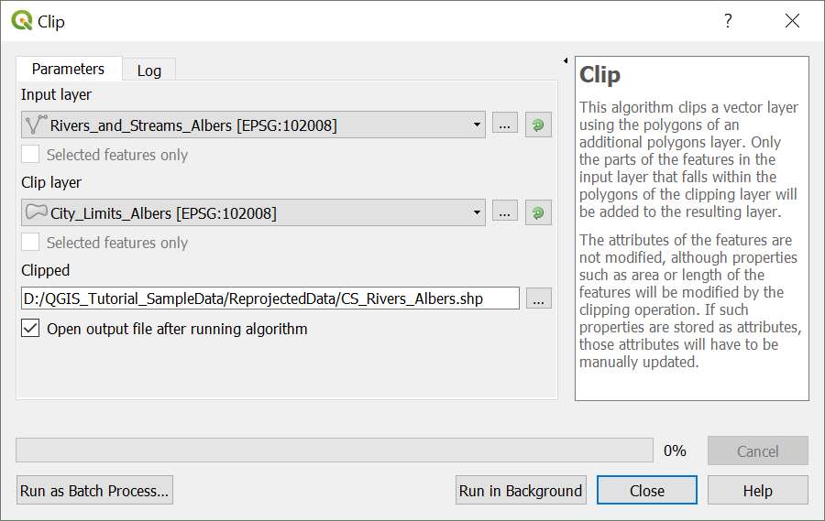

Difference Clip (Clip out the inner area of a polygon)
In another scenario, we may be interested in a geographic area, excluding a core area. With the data at hand, perhaps we are interested in something about County Boundary, but wish to exclude the area of College Station. This is done through a Difference Clip.
- Select the Vector menu at the top and navigate to “Geoprocessing Tools” and then “Difference”.
  - Input Vector Layer is the layer that you want altered (Brazos County Boundary [Reprojected to Albers Equal Area]).
  - Clip Layer is the layer subtracting from the Input Vector Layer (City Limits [Reprojected to Albers Equal Area]).
  - Under “Difference” designate the new file you want to create in the Output Shapefile box (“BrazosCounty_noCS_Albers.shp”).
- Make sure the box next to “Open output file after running the algorithm” is checked and click “Run in Background”.
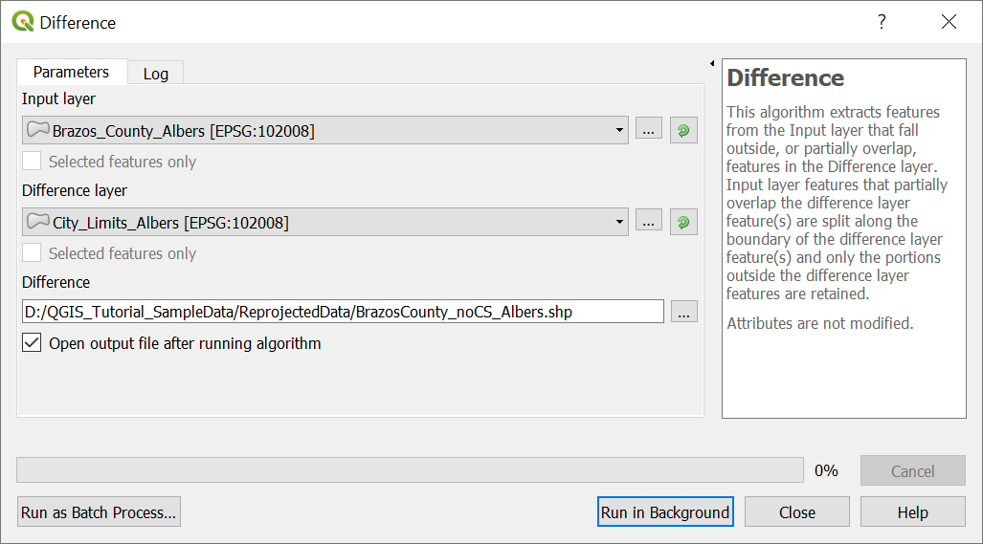
- Upon completion, inspect the result.

View and Edit the Attribute Table
Many times we need to look at the attribute table for a given layer, and sometimes even make some edits.
- To view the attribute table, simply right click on the desired layer and select “Open Attribute Table”. Let’s start with the attribute table for the Rivers and Streams layer.
There’s lots of information here that came with the layer. Some things that might be of interest for researchers include the Name and the HydroType (what type of stream/river each element is).

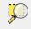
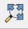
If you want to look at a single data entry simply select that row by clicking on the number to the left of the data, and it will become highlighted on the map. For the stream segments, they’re small, so you’ll need to zoom in to see it. While looking at the map, select the Rivers and Streams layer by clicking on it in the Layers pane, and then use the “Zoom to Selection” icon to focus on the selected stream segment. To zoom out to the entire map again, use the “Zoom Full” icon, or click the “Zoom Out” icon and click on the map.

To edit the table, you must first enable editing by clicking the “Toggle Editing Mode” icon in the toolbar above the table. Then you can edit text, and add/delete rows or columns using the icons at the top of the window. You can also do some table manipulations by altering the layer properties.

Spatial Join
We can use the spatial relationships among objects in our project to join tables with different information.

Go to the “Vector” toolbar menu -> “Data Management Tools” -> “Join attributes by location”. (Dialogue box on the next page).
- The “Target Vector Layer” will be the layer we wish to add information to (Rivers and Streams)
- The “Join Vector Layer” will be the layer we wish to add information from (Brazos County Boundary)
- For this example, use the default options, but you can set specific geometric qualifiers (the default that the two layers “intersect”); and no need in this case to save a new layer ,but simply follow the option to “Create a Temporary Layer”.
- Make sure the box next to “Open output file after running the algorithm” is checked and click “Run in Background”.
- Click “Run in Background”
- If you open the attribute table for the new stream layer, you will see all of the information from County Boundary now associated with the streams.
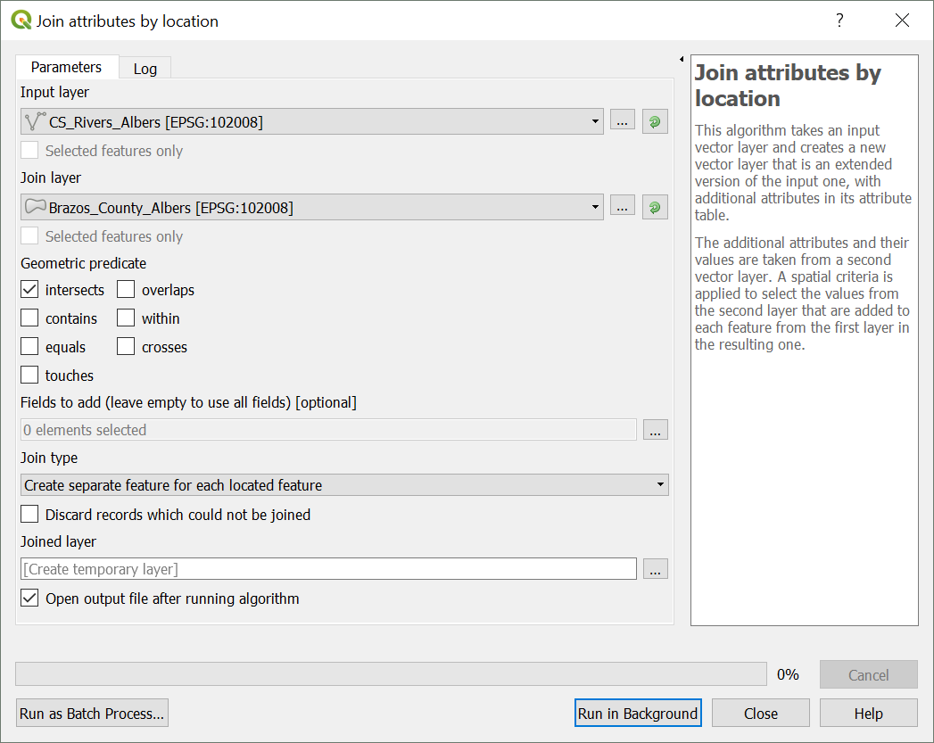

Some Basic Raster Operations
Both stand-alone and with plugins, QGIS has a set of tools for working with raster data. Only a handful are covered here, but I encourage readers to browse menus, plug-ins, and documentation to find other operations you may need. Note that there are also various image processing tools that are useful for remote sensing work.

Calculate Slope from a DEM
- Click on the “Raster” toolbar menu -> “Analysis” -> “Slope”.
- Select the appropriate Input Layer (DEM [Reprojected to Albers Equal Area]).
  - This is a single band layer, so “Band 1” is the only option for Band Number”.
  - Ratio of Vertical Units to Horizontal Units can be useful for when the coordinate system is in different units from the vertical units. In this case, both are in meters, so it can be left as 1.
  - In this case specify a file location for the output.
  - Make sure the box next to “Open output file after running the algorithm” is checked and click “Run in Background”.
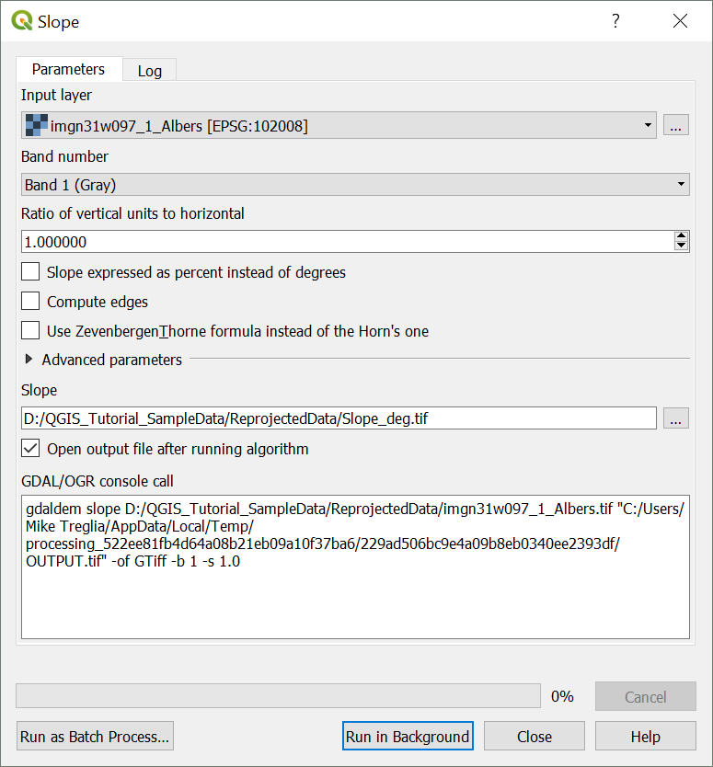
*Note – As with the reprojection of rasters, other raster processing can be done via GDAL command line tools, with the code being used given the bottom of this dialogue box: http://www.gdal.org/gdaldem.html..

Reclassify Raster
Many times we need to reclassify values from a raster dataset. In this example, we will change continuous data into categorical groups; this may be appropriate if we know specific tolerances of a species, and have a relevant raster layer. I find the easiest ways to reclassify a dataset are using either the GRASS or SAGA GIS utilities, accessed through the Processing Toolbox. Here, we’ll use GRASS GIS (https://grass.osgeo.org/).
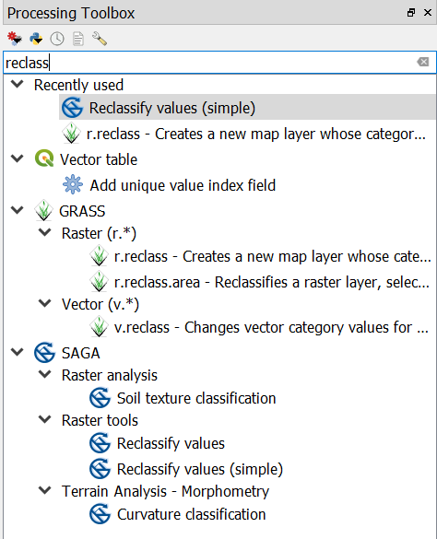
- Open the Processing Toolbox - click the Processing menu, on the menu bar at top, and select “Toolbox”.
- You should now see the “Processing Toolbox”. You can simply type in the Search box for “reclass” and one of the options, under GRASS will be “r.reclass”. Double-click on this.

We will reclassify values of the DEM (elevation) to indicate that elevations are suitable for a hypothetical species (>75 m; set to 1), or not suitable (≤ 75 m; set to 0).

You can use the dialogue box on the next page as an example. This will involve chosing the appropriate file to reclassify (the DEM in this case), and either designating a file with reclassification rules, or writing the reclassification rules in the appropriate box. Details for this are available from the GRASS documentation, which can be pulled up via the “Help” button (also available for this function at: https://grass.osgeo.org/grass70/manuals/r.reclass.html ). The min. and max. values for a raster can easily be checked by going to the Style options, setting the “Min/Max Value Settings” to “Min/Max”, designating the “Statistics extent” as the “Whole Raster”, the “Accuracy” as the “Actual (slower)”, clicking “Apply”, and viewing the min/max values.
- As with most operations, you there are Advanced parameters that can be adjusted (not necessary here).
- The output file can be designated via the box under “Reclassified”.
- Make sure the box next to “Open output file after running the algorithm” is checked and click “Run in Background”.
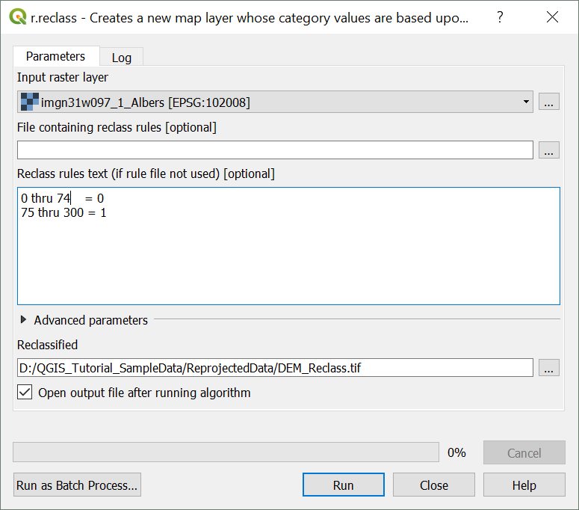
We will now do the same thing for the Slope raster, following the values in the lookup table below. (Low slopes, 0-2° are suitable for the hypothetical species; high slopes, >2°, are not). Rename and save this new layer appropriately (e.g., Slope_Reclass.tif)
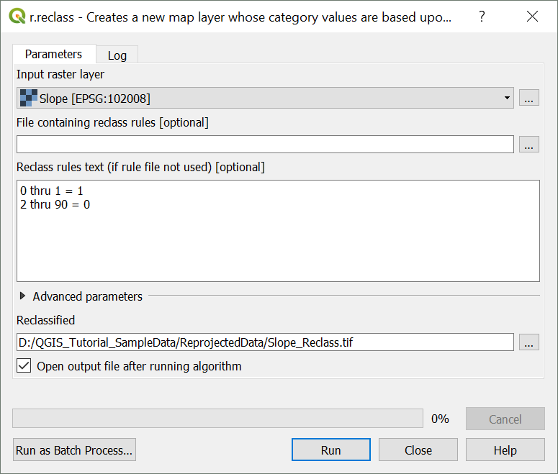
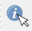
To verify that these reclassified layers are correct, you can bring the respective reclassified layer to the top, and use the “Identify Features” tool to inspect the values of each raster. Click on the icon in the toolbar, and a new pane should appear (typically on the lower left, “Identify Results”). Then click the mouse on a point, and it will by default show you the properties (e.g., value or fields) of the layer highlighted in the “Layers” pane. You can adjust the “Mode” and “View” options in the pane, to view characteristics of multiple layers at once. (Users can also install the “Value Tool” plug-in, which will allow display of raster values wherever the mouse is hovering.
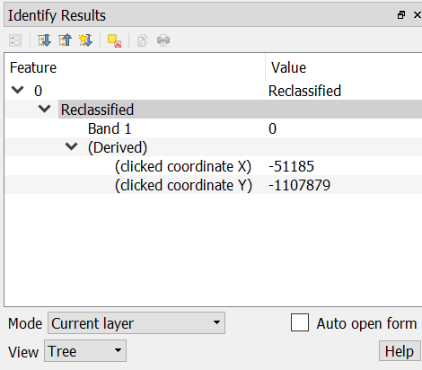

Raster Calculator
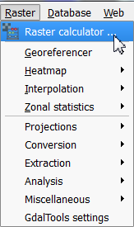
Many times we need to create a new raster layer that is based on a composite of other layers. For example, in the previous examples we reclassified DEM Albers and Slope Albers rasters to identify where elevation and slope are suitable for a hypothetical species. We can combine these reclassified layers, mathematically, to identify where BOTH elevation and slope are suitable, simply by multiplying overlapping pixels from the respective layers. In this resulting raster, areas where a pixel is 0 in either raster will be 0 (unsuitable based on both layers); locations where both characteristics are suitable will be represented by values of 1.
- Use the Raster menu on the menu bar and navigate to “Raster Calculator”.
- In the dialogue box that pops up, double-click either the DEM Reclass or the Slope Reclass layer to add it to the expression box in the bottom. (See next page for an example dialogue box.)
- Click the “*” button to designate the multiply function.
- Add the other relevant layer to the expression box
- Designate an output location, set the format, check “Add result to project”, and click “OK”.
After processing, you will see the new layer in the “Layers” pane, and you can explore it to ensure the output is as-expected.
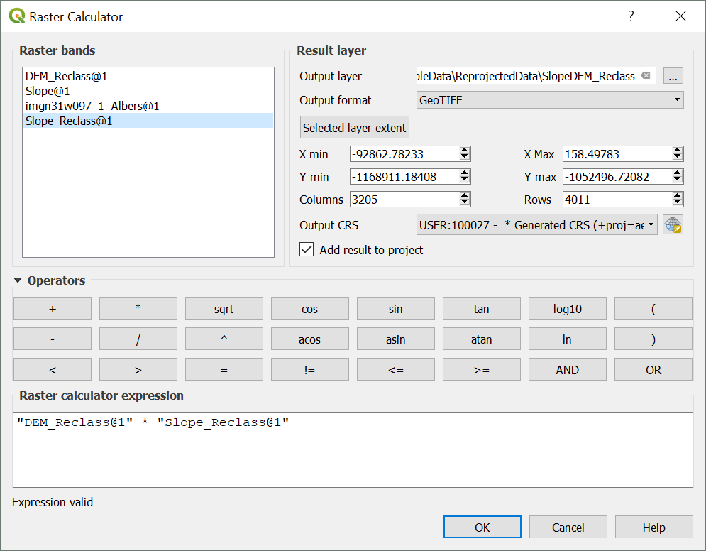
You can use this tool for various other calculations, using the buttons provided. You can also type in the “Raster calculator expression” box at the bottom, to add numeric terms and such.

Using Vector and Raster Datasets Together

Clipping a Raster
When downloading raster layers, they are frequently available for larger areas than necessary, which can contribute to additional processing time and decrease available memory. To deal with this, we can easily clip the raster to the bounds of a vector dataset or to a set of boundaries based on coordinates.
- Click on the “Raster” menu from the menu bar, navigate to “Extraction” and click on “Clip raster by mask layer” to open the relevant dialogue box (shown on the next page).
- Designate a raster as the input file (I will use “SlopeDEM_Reclass”, the result of the previous raster calculation).
- For “Mask layer” select a vector layer that you want to use for the boundaries of the new raster layer. We’ll use the City Limits [Reprojected to Albers Equal Area] in this exercise.
- Keep the default boxes checked.
- Make sure the box next to “Open output file after running the algorithm” is checked and click “Run in Background”.

The new layer will appear in the Layers pane and you can inspect as needed.
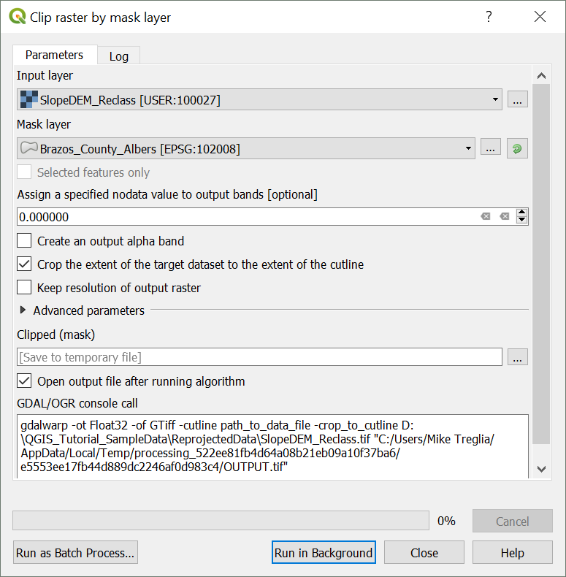

Compute Zonal Statistics for Polygons
It is often useful to calculate metrics from a raster layer for a vector dataset, for example the mean elevation or slope of a polygon. The “Zonal Statistics” tool is great for this, and there are other tools (e.g., in SAGA and GRASS) that allow additional flexibility.
- In the Processing Toolbox panel search for “Zonal statistics” and double-click on the first option (under “Raster Analysis” with the QGIS Icon).
- For “Raster layer”, select the raster that you want to compute statistics from; for the “Polygon layer containing the zones”, select the appropriate vector layer. We’ll use the DEM and the County Boundary layers, respectively, both reprojected.
- Designate a prefix for the resulting columns (to help remember which raster you used) and click “OK”. We will use the default statistics, but these can be selected further by clicking on the “. . .” next to the box.
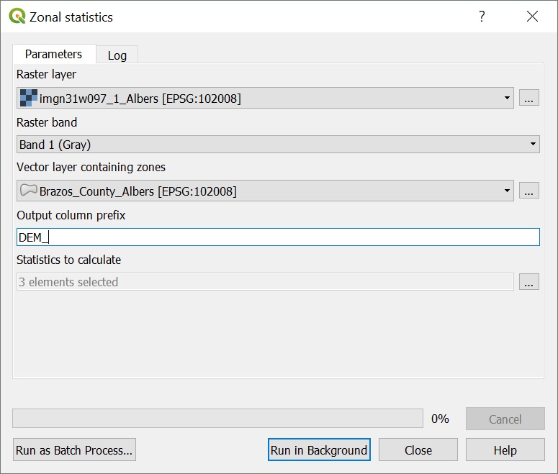
You can view the result by opening the attribute table for the polygon layer; and you will see new columns representing the “count” (count of all contained pixels”, the “sum” (sum of all values for the contained pixels), and the “mean” (average of all values for the contained pixels).

Making a Quality Map
QGIS works well for making maps, with easily customizable symbology, and a good set of tools to develop a layout for print and publication. Here, we will make a basic map of the hypothetical habitat suitability raster for the city of College Station, with an inset showing where College Station is in Brazos County. We will include standard map elements including a scale bar, north arrow, legend, and coordinate grid. I encourage you to explore other options and setups for this, or try making one with your own data. As with the other features of QGIS, we only have time to highlight a relatively small subset of map-making tools.
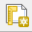
- To get started, open the print composer by clicking on icon indicated at left. If you were to have an existing layout that you wish to access in the project, click on the icon to the right, “Composer Manager”. After clicking the icon to create a new layout, you can either designate a new name or allow the program to generate one for you.

Setting up for a Map
Maps that you bring into the composer will be based on what you see in the main QGIS window. Let’s go back to that for now and start by visualizing the layers of the City Limits, Clipped DEM/Slope Reclass, and Rivers of College Station (from the vector clipping exercise). You can order them as you wish, but make sure you can see all elements (for the City Limits layer, you can have that on top as long as you adjust the transparency or fill so you can see the other layers, and make sure the city boundary is obvious). Manipulate the symbology and labels for these layers to your liking, so they will appear alright in a map together. See my set-up on the next page. The yellow color represents areas suitable for the hypothetical species, purple represents unsuitable, and the blue lines are the rivers and streams.
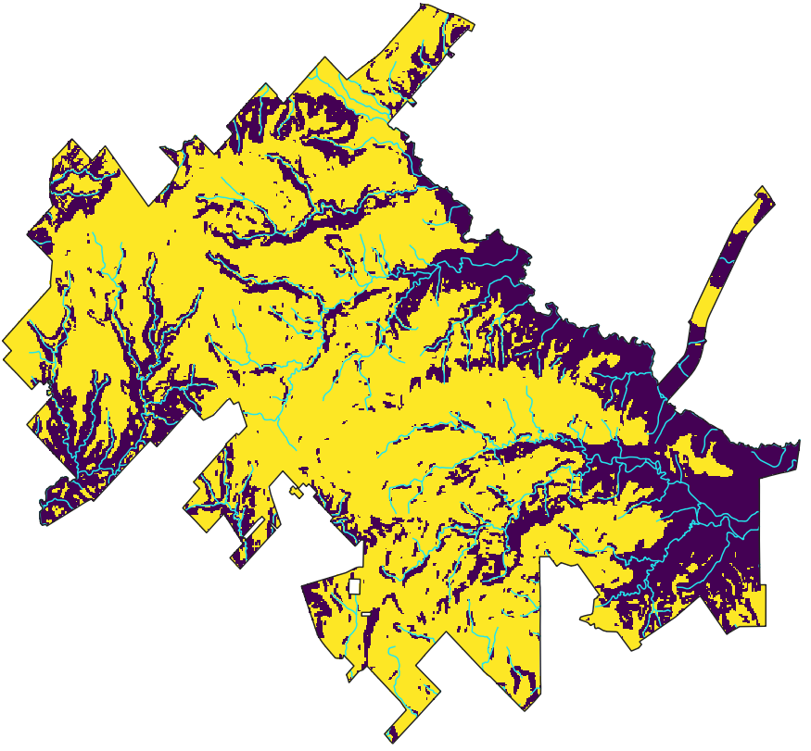
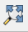
Think about what types of coordinate you want to show on the borders of the map; they have to be the same as used in the Project CRS. Many people like to see the geographic coordinates. For this I often work with the Project CRS as WGS84, and use projection on-the-fly (you can also specify the CRS for the coordinates within the Composer Manager). You may want to be explicit in a caption about what projection you used to conduct any analyses. After setting that, make sure to click the “Zoom Full” button to make sure the focal area takes up as much of the viewing area as possible. (You can also adjust the viewing scale using the “Scale” adjustment at the bottom of the main QGIS screen.)
Once satisfied with the layout of the main map, we are ready to start putting a final layout together.
- Go back to the Composition window.
- Right click on the page and select “Page Properties” – you’ll see an “Item Properties” box highlight on the right
- The only thing we’ll change for now is the Paper Size – change to “ANSI A (Letter; 8.5x11 in).
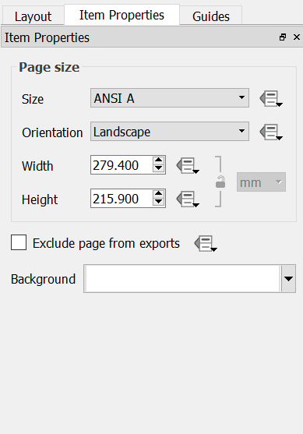

Putting Everything Together

Adding the Map of interest to the Layout
- In the Composition window click the “Add Map” icon, and click and drag a box for in the area you would like the main map to occupy. The view from the main QGIS window should now appear in that area.
  - You can go to the “Item Properties” tab to adjust the extent displayed and such. I simply click the button “Set to Map Canvas Extent” to show the same extent as in the main QGIS window.
    - By default, the map layout is cached in memory; if you adjust anything in the main map, click the “Update Preview” button to show the updated version.
    - Check the box for “Lock layers for map item”; if you don’t, when you create an inset, this map will be altered.
*Note: the “Item Properties” tab is dynamic, changing with the type of object you have selected.

Adding Gridlines and Coordinates
- In the “Item Properties” tab, expand the section for “Grids” and click the “+” icon (creating “Grid 1”), then select/highlight “Grid 1” and click “Modify”. The settings I use are described in context on the next pages and the general appearance is illustrated below.
- The Map units will be the same as used in the Project CRS, but could be specified in another CRS if desired. Adjust the spacing and offset in the “Interval” and “Offset” boxes. This usually takes some trial ane error to make it aesthetically pleasing.
- While in the “Grid” menu, expand the “Frame” section and change “Frame style” to “Zebra”.
- Expand the “Draw coordinates” section and check the respective box. Adjust settings as you see fit.
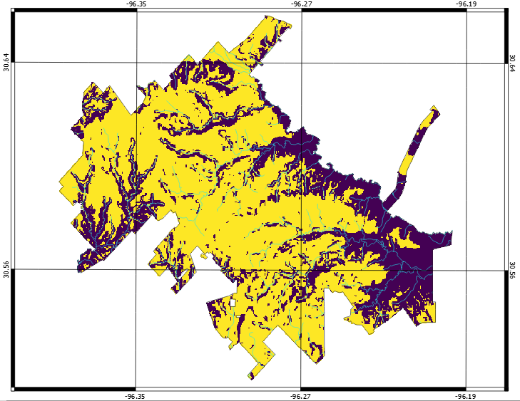

Adding Scale Bar, North Arrow, and Legend
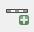
- For the Scale Bar: click the “Add Scale Bar” icon, and click and drag a box where you want the scale bar to be placed.
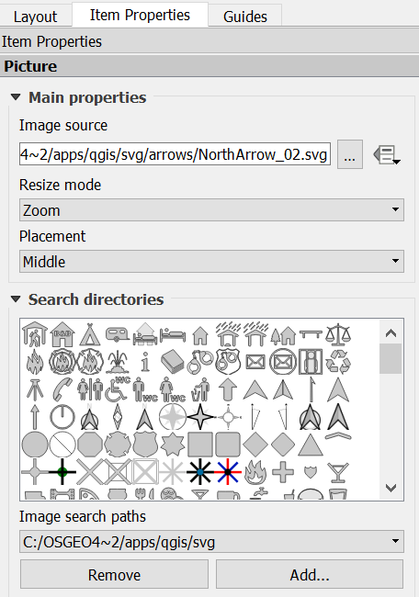
  - The scale bar will appear in that area with some default settings. You can adjust things like the units and appearance in the “Item Properties’ tab, which now characterizes the scale bar.
- For the North Arrow: click the “Add Image” icon, and click and drag a box where you want the north arrow placed.
  - In the “Item Properties” tab, expand the section for “Search Directories”. The default path links to a directory that has available images included with QGIS. You will see a few that work as a north arrow; select one and click the “Add” button. You can rotate it if necessary, to match rotation of the map if it is not the typical north-to-the-top orientation.
- For the Legend: Click the “Add new legend” icon, and click and drag a box where you want it to be placed. A default legend will appear in that area; the box will automatically resize to accommodate the dimensions.
  - Again, use the “Item Properties” tab to adjust the settings. Most obviously, we want to change some of the labels in the legend so they are not simply the layer names from our QGIS project. Note that you cannot change the symbology here – you must do that in the main QGIS project window.
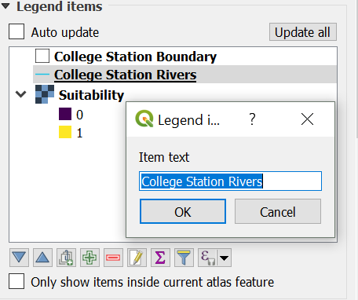
    - Expand the “Legend items” section and uncheck the “Auto Update” box. You can add a new layer to the legend, re-arrange the order, and rename items. To change the name of an entry, click on the legend entry you wish to edit, and click the “Edit” icon and type a new name that you prefer. In the example shown below, the City Limits entry is being renamed to “College Station Boundary”. For editing specific entries for grouped legend items (e.g., the legend for Habitat Suitability layer), expand the group by clicking the “+” icon next the highest level item, and select the specific item you wish to edit before clicking the “Edit” icon.
    - You can add and edit a box around the legend by clicking the box for, and expanding the “Frame” section.

Adding an Inset
Now, the map is starting to really look like a map, but one thing that is useful to have is an inset that shows where things are in the broader context. To create this, we need to again set up our layers as we wish them to appear in the inset. The only layers we really need here are the County Boundary and the City Limits. It is best to use a copy of the City Limits layer, as it is used on the main map, and editing the original will alter the final product when we export it. To duplicate a layer, in the “Layers” pane of the main QGIS window, select the layer you want a copy of, right click, and click “Duplicate”.
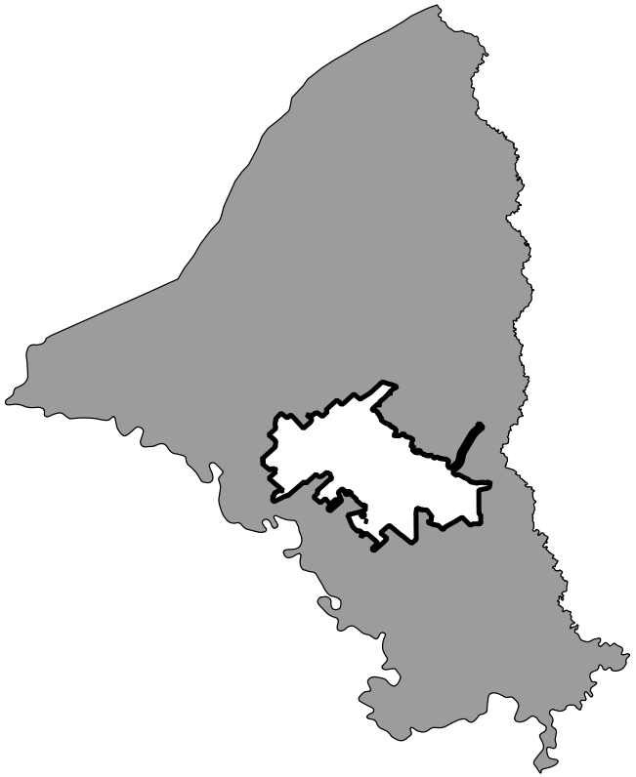
- Do as described earlier to create a suitable looking map with the Brazos County Boundary and City Limits layers in the main QGIS window. Below is an example setup.

- In the Composition window, click the “Add new map” icon again, and draw a box where you want it to appear. You can edit it, as with the main map, using the “Item Properties” tab. Perhaps add a frame to it, to make it stand out and delineate it as a separate entity from the rest of the map. You can also add gridlines and coodinates as desired.
- Again, check the box for “Lock layers for map item”.
- You can add a label to this using the “Add new label” icon; select it and click and drag a box where you would like the text.
  - In the “Item Properties” tab you can edit the text, font characteristics, and text box characteristics.

Final Formatting and Exporting the Map
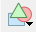
We are almost done creating a final, high quality map. Now you can add anything else you need. On the next page, you can see my final version; the only other element I have added is another label to serve as a title for the map. If you need to move anything around, make sure the “select/move” icon is selected, click on the focal element, and move or re-size it. You can also add shapes and arrows using the “Add ellipse” and “Add arrow” icons. Furthermore, though not included on this map, you can add another text box for annotations, with important details like source data, projection information, etc.

Exporting the Map
From the Composition window you can export the final product to various image formats, to an SVG file, or to a PDF file. Simply click on the respective icons from the toolbar at top (shown below, in order), designate a file name, location, any other specifics you’d like to adjust, and click “OK”.
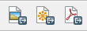
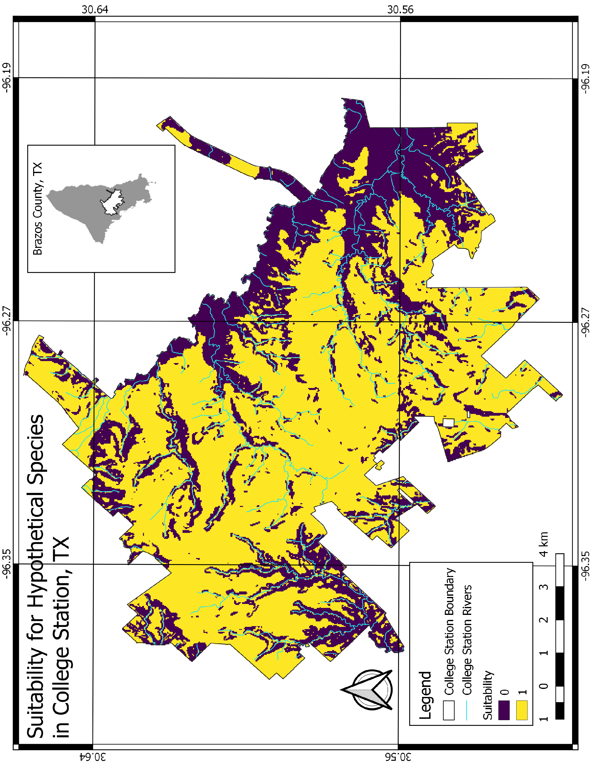

Closing Remarks
My goal in this tutorial is to give new users a working knowledge of QGIS. Although this only covers a handful of the many possible operations, I hope that folks who have completed it have sufficient familiarity with QGIS to explore it further on their own. If you continue expanding your use of QGIS, you may wish to script your work for better reproducibility and documentation. Python is a common language used for scripting in QGIS, and you can find more details on the web (e.g., https://docs.qgis.org/testing/en/docs/pyqgis_developer_cookbook/intro.html).
QGIS is constantly being further developed, and I suggest users periodically check for updates to the software, as new tools are often implemented, and processing and data management protocols are often improved. Since I first started using QGIS, the software has become much more user-friendly, tools have become much more expansive, bugs have been fixed, and many operations are faster. This is largely thanks to sponsors of the project, and many who put their volunteer time into it, and I encourage others to contribute when and where possible.

