## Introduction

the problem

why it is important

solution

Recently published data [3] has indicated that there has been a 1.7-percent decrease in the number of traffic fatalities in 2022 compared to the year prior. Unfortunately, it has been estimated that one person has been killed every 12 minutes in traffic crashes in 2022 and the 10-year trend ( 2013 to 2022 ) has shown a 30% increase in fatal traffic accidents. When examining only the state of Indiana, traffic fatalities have increased by 2% from 2021 to 2022 [2]. This is extremely concerning considering our neighboring states have all had decreases in traffic fatalities, see Figure 1.

A portion of these traffic deaths have been the result of high-speed police pursuits. [1] At least 3,336 people across the country were killed in police pursuits from 2017 through 2022, see Figure 2. More than half of those fatalities were either non-driving passengers in fleeing vehicles or bystanders. Officers accounted for less than 1% of those killed.

Beginning in 2023, [4] Indiana has established a statewide policy on the minimum standards for vehicle pursuits. Back in 2020 when the Indianapolis Metropolitan Police Department established restrictions on police pursuits the Assistant Chief Chris Bailey commented, “The number one thing we have to remember is public safety and officer safety”. The National Highway Traffic Safety Administration said 101 people died in Indiana in crashes related to police pursuits from 2010 to 2020.

With more police departments enforcing restrictions on police pursuits there still needs to be a way to identify, monitor, and track high-speed drivers. Here is where we need to leverage modern advances in machine vision. Carefully placed cameras, working in tandem with officers, identifying and tracking of high-speed vehicles can be done without police car or helicopter pursuit and other means of stopping the speeding vehicle can be executed such as tire deflation devices. These alternative methods using technology would benefit officers and public safety by minimizing the risk of accidents and injuries caused by pursuits, allow law enforcement to be more strategic in their pursuits rather than reactive, and the data collected can be analyzed to identify high-risk areas and times for future traffic enforcement strategies.

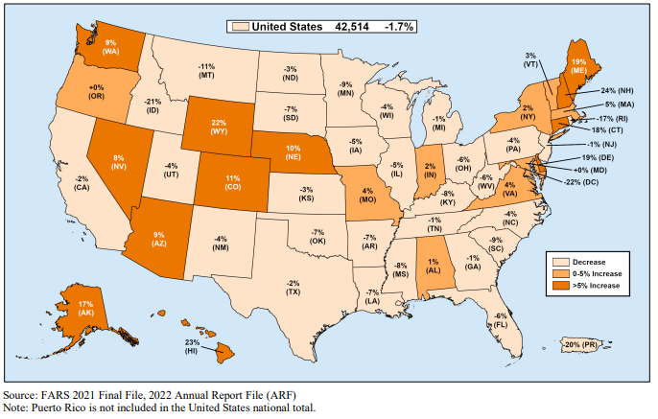

## References

[1]A. Hernández, “In reversal, more states allow high-speed police chases,” Washington State Standard, 17-Apr-2024. [Online]. Available: https://washingtonstatestandard.com/2024/04/15/in-reversal-more-areas-allow-high-speed-police-chases/#:~:text=In%202022%2C%20the%20number%20of%20pursuits%20reached%201%2C028%2C%20a%20staggering,times%20higher%20than%20white%20people. [Accessed: 30-Sep-2024]

[2]“State Traffic Data: 2022,” 2022 Data-State Traffic Data. [Online]. Available: https://crashstats.nhtsa.dot.gov/Api/Public/ViewPublication/813627. [Accessed: 01-Oct-2024]

[3]2022 Data: Summary of Motor Vehicle Traffic Crashes. [Online]. Available: https://crashstats.nhtsa.dot.gov/Api/Public/ViewPublication/813643. [Accessed: 01-Oct-2024]

[4]Minimum standards for vehicle pursuits. [Online]. Available: https://www.in.gov/ilea/files/02-Minimum-Standards-for-Vehicle-Pursuits-11.7.22.pdf. [Accessed: 01-Oct-2024]

[5]V. Ryckaert, “IMPD less likely to pursue; more likely to stop chases after tightening policy in 2020,” WRTV Indianapolis, 09-Aug-2023. [Online]. Available: https://www.wrtv.com/news/public-safety/impd-less-likely-to-pursue-more-likely-to-stop-chases-after-tightening-policy-in-2020. [Accessed: 30-Sep-2024]