Although I am late to the game, this is what worked for me:

Right-Click on Project->Properties->C/C++ General->Preprocessor Include Paths, Macros, etc. --> Click "Providers" tab --> CDT GCC Built-in Compiler Settings

Uncheck "Use global provider shared between projects"

Add -std=c++0x

It will then look something like this:

${COMMAND} ${FLAGS} -E -P -v -dD -std=c++0x "${INPUTS}"

Rebuild index.

Using Debian Jessie + Eclipse Kepler Build id: 20140224-0627

解决unresolved问题：

打开Eclipse后，编辑c/c++，编译时出错：* could not be resolved ，但运行结果正确。解决办法：

在eclipse上，project->properties->C/C++ General->indexer,将大部分选项都选中，如下图所示：

假如都按照图片上的选项都选上了还是不行，则假如你的工程为C++工程，则Index unused headers as C++ files 选中，Index unused headers as C files 就别选中了，反之为C工程，则[Index unused headers as C++ files不选，[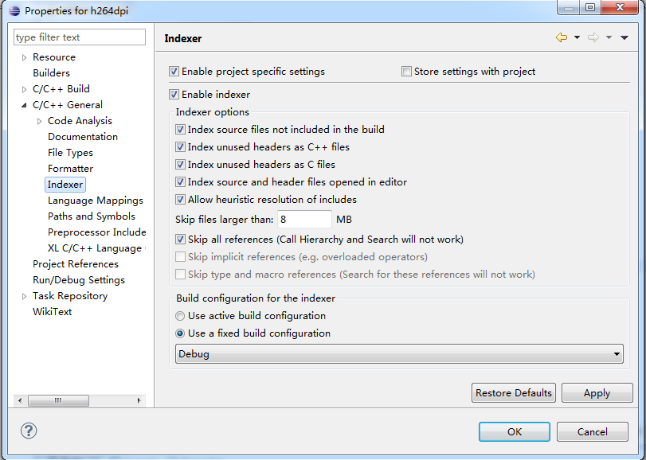](http://img1.51cto.com/attachment/201211/121021246.png)](http://img1.51cto.com/attachment/201211/121021246.png)

  然后，退出eclipse,重新打开即可