

1.1 Revised Use Case Set

Entity/Domain Class | Verified CRUD Use Case | Related Use Cases
Student | Create Student
 | Track Tutoring Request | View Student (includes)
TutoringRequest | Create Tutoring Request
 | Track Tutoring Request | View Tutoring Request (includes)
Tutor | Update Tutor Availability | View Tutor(includes)
Administrator | Create Report | View Tutoring Session (includes),
Report | Create Report | View Student (extends),  View Tutor (extends),  View Tutoring Session (includes),  View Tutoring Request (extends)

1.1 Revised Use Case Set

1.2 Revised “Create tutoring request” Use Case
Use Case Name: | Create tutoring request
Actor(s): | Student (Primary)
Pre-conditions: | 1. Student is registered and logged into the system
Post-conditions: | 1. A new tutoring request is created and stored in the system.  2. The request status is set to "Submitted"
Flow of Activities: | Actor | System
 | 1.Student navigates to the create request section. | 1.1 System displays all tutoring request linked to the student(if any).  1.2 System displays a "Create New  Application" button.
 | 2. Student request a new tutoring assistance.. | 2.1 System creates a new tutoring request  draft.  2.2 System retrieves the student's  profile data.  2.3 System pre-populates the  application form with known details  (Student Number, First Name, Last Name,  Date of Birth, Contact Information, Faculty,  Programme of Study, Academic Risk Level).  2.4 System prompts for the tutoring request details.
 | 3. Student enter the required details | 3.1 System validates the entered details  3.2 System prompts for supporting  documents required.
 | 4. Student uploads the required  supporting documents. | 4.1 System validates each file's format  and size.  4.2 System stores the documents and  links them to the request.
 | 5. Student reviews the request  and submits it | 5.1 System performs a final validation  check on all required fields.  5.2 System sets the request status  to "Submitted".  5.3 System saves the complete  request to the database.  5.4 System displays a successful  submission confirmation message to  the student.
Alternate Path: | Actor | System
(Cancel request) | 5. Student choose to cancels the tutoring request before completion. | 5.1 System set the request status to "Cancelled"  5.2 System confirms the cancelling.

1.3. Revised “Track tutoring request” Use Case
Use Case Name: | Track tutoring request
Actor(s): | Student (Primary)
Pre-conditions: | 1.The student is registered and logged into the tutoring system.  2.Request has already been submitted and stored in the system
Post-conditions: | 1. The tutoring request status is viewed by a student.
Flow of Activities: | 1. Student navigates to the tutoring request section | 1.1.System displays all tutoring requests linked to the student.  1.2 System shows each request's status such as pending, accepting or decline offer.
Flow of Activities: | 2.Student selects a specific tutoring request to track. | 2.1.System retrieves the selected request details.  2.2.a if Student clicks ”accept”:  system display tutor information scheduled session date and progress notes.  2.2.b if Student clicks ”decline”:  system display confirm or decline prompt,  system changes status to "Cancelled"
Alternate Path: | Actor | System
(Cancel tracking) | 3. Student cancels tutoring request tracking. | 3.1 System redirect student to home page.

1.4 Revised “Update tutor availability” Use Case
Use Case Name: | Update Tutor Availability
Actor: | Tutor (Primary)
Pre-Conditions: | The tutor must be registered on the system  The tutor must be logged in
Post-Conditions: | 1. The tutors updated availability schedule must must be saved on the system  2. Updated availability schedule must be used when matching tutor with students and scheduling secessions
Flow of Activities: | Actor | System
 | 1. The Tutor selects Update Tutor Availability option | 1.1 The system displays the current tutor’s availability schedule
 | 2. The tutor adds or removes their available days and times | 2.1a The system checks if the availability information has been entered correctly
 | 3. The tutor submits the updated availability schedule | 3.1 The system saves the updated availability schedule  3.2 The system displays a confirmation message “Availability updated successfully”  3.3 The updated tutor’s availability is used by the system when matching the tutor with suitable tutoring requests and scheduling tutoring sessions
Alternate Paths: | Actor | System
(Invalid Availability) | 4. Tutor enters  invalid data (e.g.,invalid time slots). | 4.1 If the availability information is invalid the system displays an error message “Invalid Availability”
(Cancel Update) | 5. Before submitting the changes tutor selects “Cancel” | 5.1 The system discards the changes and the existing availability remains unchanged

1.5 Revised “Create [tutoring] report” Use Case
Use Case Name | Create Report
Actor(s) | Administrator (Primary)
Pre-Conditions | 1. Administrator is logged into the system.  2. The system contains data.
Post-Conditions | 1. A new report is generated and saved in the system.  2. The report is available for viewing, printing, or export.
Flows of Activities: | Actor | System
 | 1. Administrator requests to  generate a report. | 1.1 System displays the report generation module.  1.2 System prompts for report type  selection.
 | 2. Administrator selects a report  type (e.g."Tutoring report or matches report"). | 2.1 System retrieves the parameters  needed for the selected report type.  2.2 System displays input fields for criteria
 | 3. Administrator specifies the  desired criteria and parameters. | .1 System validates the parameters (e.g.,  valid date format)
 | 4. Administrator confirms the  selection and requests to  generate the report. | 4.1 System compiles data from the  database based on the criteria.  4.2 System formats the data into the  chosen report layout.  4.3 System displays a preview of the  generated report.  4.4 System provides options to export,  print, or save the report.
 | 5. Administrator selects an  export option (e.g., PDF,docx). | 5.1 System generates the file in the  requested format.  5.2 System downloads the file to the  administrator's machine or saves it to a  reports repository
Alternative Flows: | Actor | System
(No Data Found) | 6. Administrator confirms  criteria | 6.1 System queries the database and  finds no records matching the criteria.  6.2 System displays a message: "No data found for the selected criteria."  6.3 System returns to the criteria selection  step (2.2).

2. Domain Class Diagram

Domain Class Diagram : OPTIMA Academic Support System (OASS)
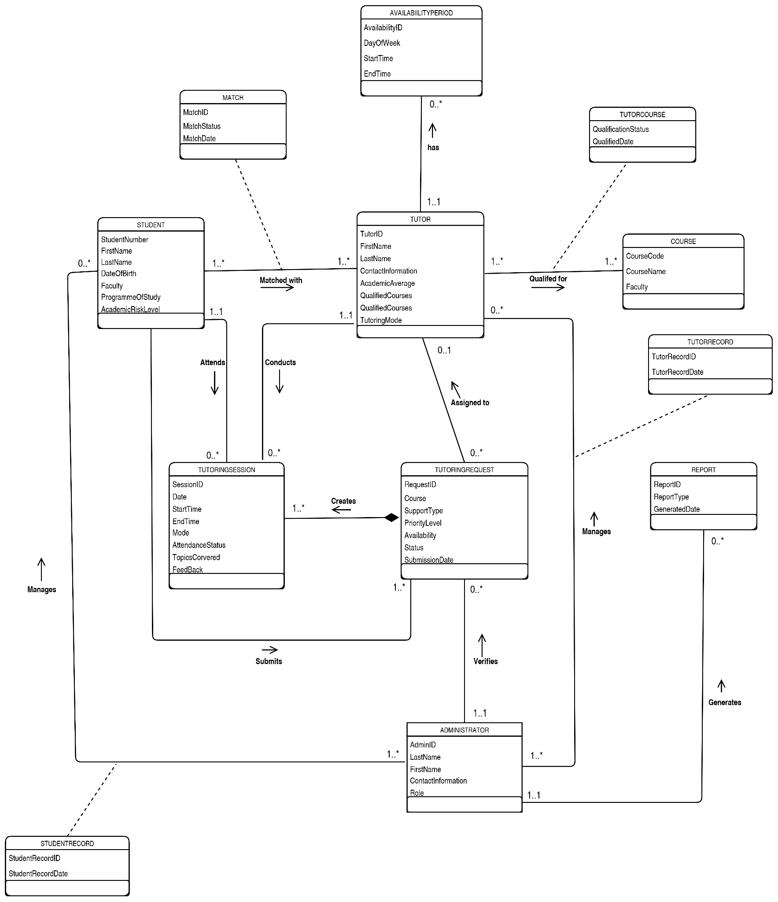
3. Database Design

3.1 Entity Relationship Diagram (ERD)

Entity Relationship Diagram : OPTIMA Academic Support System (OASS)

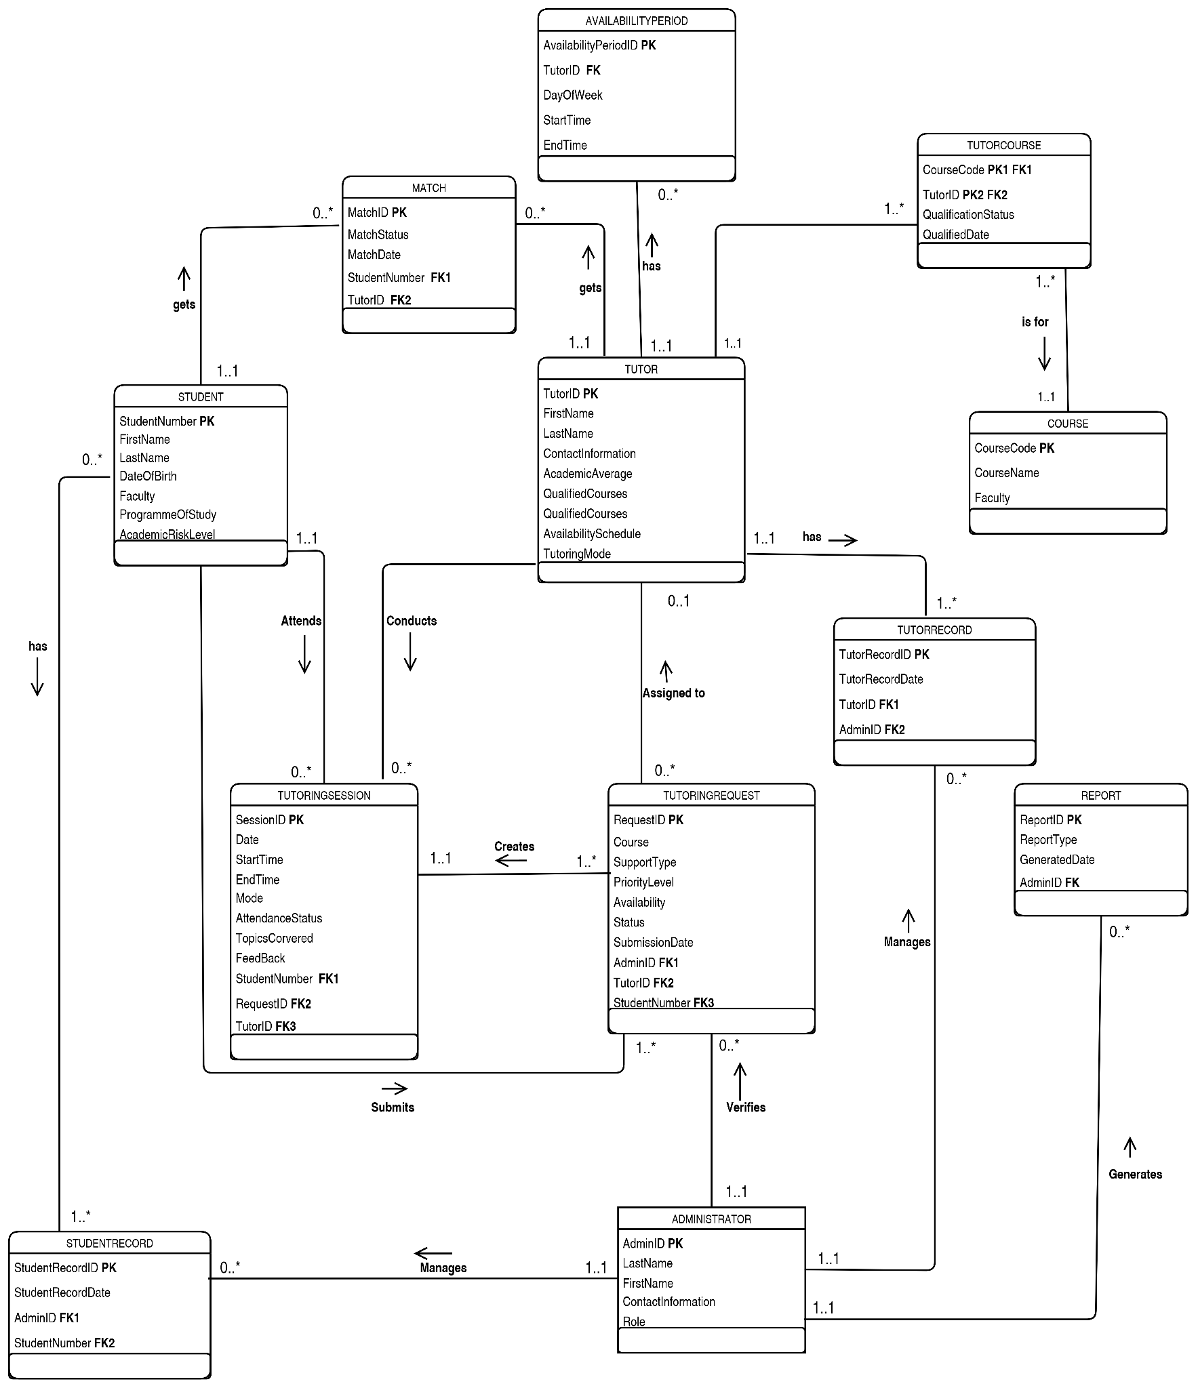

3.2 Data Dictionary Extract

Table: STUDENT
Scope: Data about students who register for academic support, including their personal information, academic details, and contact information. The table stores the attributes of objects belonging to the class "Student".
Attribute Listing:
StudentNumber
• Description: A unique number identifying each student in the system
• Type: 10-digit integer
• Format: ##########
• Note: This is the primary key, cannot be NULL and must be unique
FirstName
• Description: The first name of the student
• Type: 50-character string
• Format: N/A
• Note: Cannot contain numbers, required field
LastName
• Description: The last name of the student
• Type: 50-character string
• Format: N/A
• Note: Cannot contain numbers, required field
DateOfBirth
• Description: The date of birth of the student
• Type: Date
• Format: DD/MM/YYYY
• Note: Must be a valid date
ContactInformation
• Description: Contact details of the student, including telephone number and email address
• Type: 100-character string
• Format: N/A
• Note: Should contain valid contact information
Faculty
• Description: The faculty in which the student is enrolled
• Type: 100-character string
• Format: N/A
• Note: Must represent a valid faculty
ProgrammeOfStudy
• Description: The academic programme or degree in which the student is enrolled
• Type: 100-character string
• Format: N/A
• Note: Required field
AcademicRiskLevel
• Description: Indicates the student's level of academic risk and is used when determining the priority of a tutoring request
• Type: 20-character string
• Format: N/A
• Note: Valid values may include Low, Medium, and High

—------------------------------------------------------------------------------------------------------------------------

Table: TUTOR
Scope: Data about tutors who provide academic support to students, including their personal information, academic average, availability, and preferred tutoring mode. The table stores the attributes of objects belonging to the class "Tutor".
Attribute Listing:
TutorID
• Description: A unique identifier for each tutor in the system
• Type: 8-character alphanumeric
• Format: TUT#####
• Note: This is the primary key, cannot be NULL and must be unique
FirstName
• Description: The first name of the tutor
• Type: 50-character string
• Format: N/A
• Note: Cannot contain numbers, required field
LastName
• Description: The last name of the tutor
• Type: 50-character string
• Format: N/A
• Note: Cannot contain numbers, required field
ContactInformation
• Description: Contact details of the tutor, including telephone number and email address
• Type: 100-character string
• Format: N/A
• Note: Should contain valid contact information
AcademicAverage
• Description: The tutor's academic average used when determining tutor suitability
• Type: Decimal
• Format: ##.##
• Note: Must be between 0 and 100
AvailabilitySchedule
• Description: Represents the general availability schedule of the tutor
• Type: String
• Format: N/A
• Note: Detailed availability periods are stored in the AVAILABILITYPERIOD table
TutoringMode
• Description: The preferred mode through which the tutor provides academic support
• Type: 20-character string
• Format: N/A
• Note: Valid values may include Online, In-Person, and Hybrid

Table: TUTORINGREQUEST
Scope: Data about tutoring requests submitted by students, including the requested course, type of academic support, priority level, availability, status, and submission details. The table stores the attributes of objects belonging to the class "TutoringRequest".
Attribute Listing:
RequestID
• Description: A unique identifier for each tutoring request in the system
• Type: 10-character alphanumeric
• Format: REQ#######
• Note: This is the primary key, cannot be NULL and must be unique
CourseCode
• Description: Reference to the course for which the student is requesting tutoring support
• Type: 10-character alphanumeric
• Format: N/A
• Note: This is a foreign key linked to the COURSE table and must exist in the COURSE table
SupportType
• Description: The type of academic support requested by the student
• Type: 50-character string
• Format: N/A
• Note: Valid values include Content Clarification, Exam Preparation, Assignment Assistance, and Study Skills
PriorityLevel
• Description: The priority assigned to the tutoring request based on the student's academic risk level
• Type: 20-character string
• Format: N/A
• Note: Valid values may include Low, Medium, and High
Availability
• Description: The times when the student is available to receive tutoring support
• Type: 200-character string
• Format: N/A
• Note: Should contain valid availability information
Status
• Description: The current status of the tutoring request within the tutoring request lifecycle
• Type: 20-character string
• Format: N/A
• Note: Valid values include Submitted, Verified, Matched, Scheduled, In Progress, Completed, Rejected, and Unfulfilled
SubmissionDate
• Description: The date and time when the tutoring request was submitted
• Type: Datetime
• Format: DD/MM/YYYY HH:MM:SS
• Note: Automatically populated by the system upon submission
AdminID
• Description: Reference to the administrator responsible for verifying the tutoring request
• Type: 8-character alphanumeric
• Format: ADM#####
• Note: This is a foreign key linked to the ADMINISTRATOR table
TutorID
• Description: Reference to the tutor assigned to the tutoring request
• Type: 8-character alphanumeric
• Format: TUT#####
• Note: This is a foreign key linked to the TUTOR table and may be NULL before a tutor is assigned
StudentNumber
• Description: Reference to the student who submitted the tutoring request
• Type: 10-digit integer
• Format: ##########
• Note: This is a foreign key linked to the STUDENT table and cannot be NULL

Table: REPORT
Scope: Data about reports generated by administrators to provide information about tutoring engagement, tutor workload, support demand, and academic performance improvement. The table stores the attributes of objects belonging to the class "Report".
Attribute Listing:
ReportID
• Description: A unique identifier for each generated report
• Type: 10-character alphanumeric
• Format: RPT#######
• Note: This is the primary key, automatically generated by the system and cannot be NULL
ReportType
• Description: The type of report generated by the administrator
• Type: 50-character string
• Format: N/A
• Note: Valid values may include Tutor Workload, Support Demand, Student Engagement, and Academic Performance
GeneratedDate
• Description: The date and time when the report was generated
• Type: Datetime
• Format: DD/MM/YYYY HH:MM:SS
• Note: Automatically populated by the system upon report generation
AdminID
• Description: Reference to the administrator who generated the report
• Type: 8-character alphanumeric
• Format: ADM#####
• Note: This is a foreign key linked to the ADMINISTRATOR table and cannot be NULL

