

4. Systems Design
4.1 Sequence Diagram: Update Tutor Availability
4.2 Sequence Diagram: Create tutoring request

4.3 Sequence Diagram: Create tutoring report

4.4 Storyboards


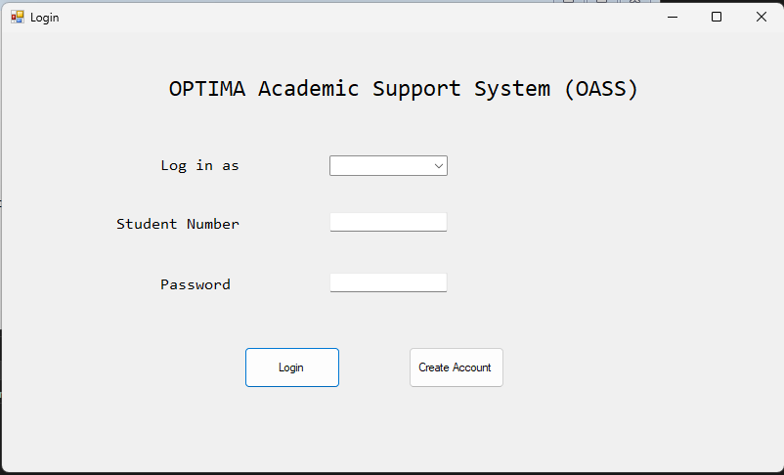
Greg is currently a second-year BCom Information Systems student who is struggling academically. He has heard about the Tutoring and Support Management System and wants to make use of its services to book sessions with tutors.
Greg gets his laptop and decides to book a session for assistance with his Information Systems module. He already has an account, so he inputs his details to sign in.
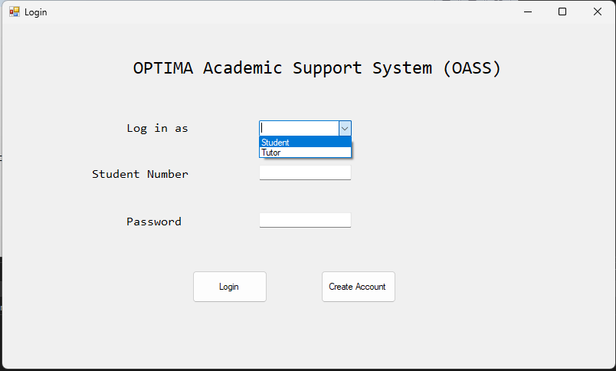

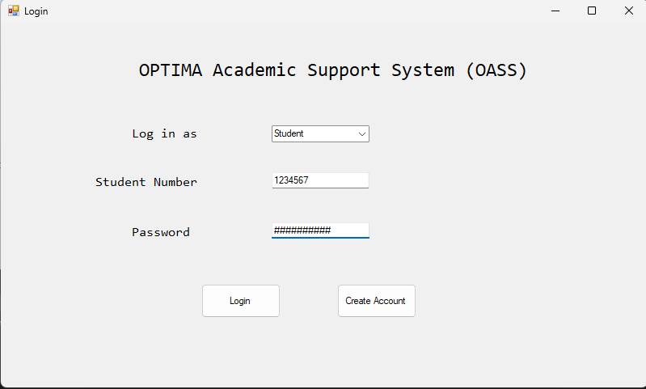
Greg enters his Student Number and Password, then clicks ‘Login’.
Greg selects the option to log in as a Student.
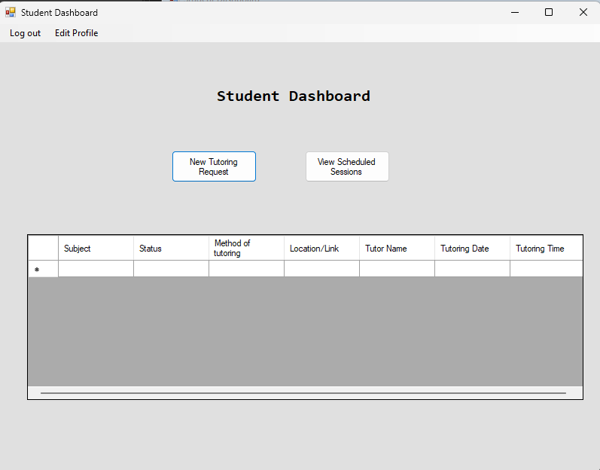
Greg then clicks the ‘New Tutoring Request’ button.

Once logged in, Greg is directed to the Student Dashboard, where he has the option to edit his profile, log out, add a new tutoring request and view scheduled sessions.
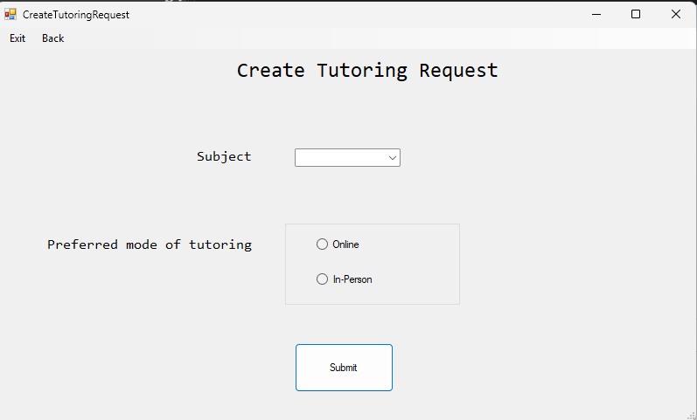
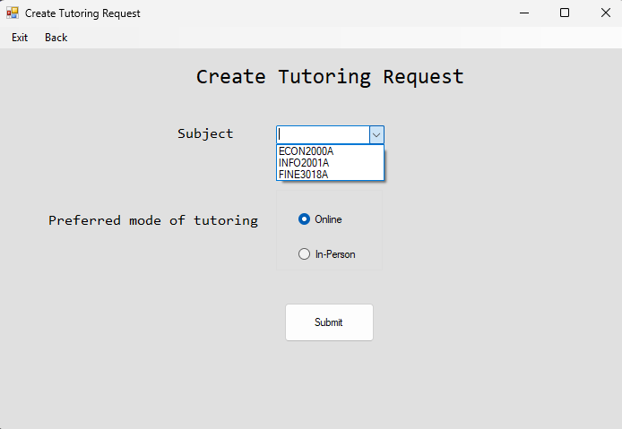
Greg enters the subject he would like tutoring for (using the combo box which has all the modules he is currently registered for) and whether he wants the session to be online or in-person. Once details have been entered he will click ‘Submit’.
Greg then gets directed to the ‘Create Tutoring Request’ page, where he can add the details for the tutoring request.
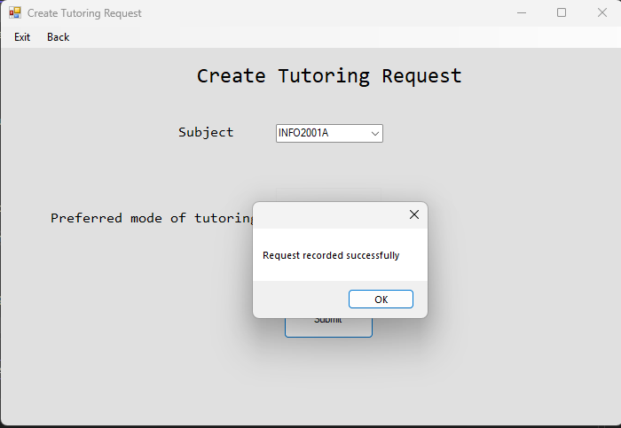
Greg will be informed that his request was successfully reported.
After submitting the request, Greg gets directed back to the Student Dashboard. He checks whether his schedule has been successfully scheduled by clicking ‘View Scheduled Sessions’

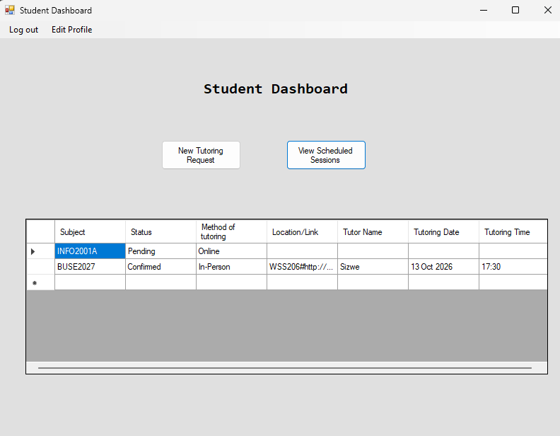
Greg views his upcoming tutoring schedule. Then he logs out.
0

￼
5. Report Design.
5.1 Report on outstanding tutoring requests remaining aged 7 days or more.
A. Report Rationale Table
Report Name | Outstanding Tutoring Requests
Report type | Exception Report
Report Format | On-screen Tabular Report
Report Recipient(s) | Academic Coordinators and Processing Officers
Report Frequency | Daily
Report Justification/ Rationale | To identify tutoring requests that have remained in Submitted status for seven or more days so that delays can be identified and acted upon before students wait unnecessarily for academic support.
Decision(s) Made as a Result of the Report | Administrators can determine which requests should be verified or followed up first, investigate reasons for delays, contact affected students where necessary, and prioritise outstanding requests according to urgency and academic priority.

Business Question:
Which tutoring requests have remained in Submitted status for seven or more days and therefore require verification or follow-up?
B. Report Prototype
OPTIMA Academic Support System(OASS) Outstanding Tutoring Requests — 7 Days or More
Report Date: 04/10/2026
Exception Condition: Submitted for 7 days or more
Total Outstanding Requests: 4
Oldest Request: 11 days
High Priority: 2
Medium Priority: 1
Low Priority: 1

Request ID | Student Number | Course Code | Status | Submission | Days Waiting | Priority
001 | 296589 | INFO100 | Submitted | 23/09/2026 | 11 | High
002 | 296678 | COMS204 | Submitted | 24/09/2026 | 10 | Medium
003 | 296456 | ACC548 | Submitted | 25/09/2026 | 9 | Low
004 | 309588 | MATH986 | Submitted | 26/09/2026 | 8 | High

C. Tables and Fields Supplying Each Measure
Display measure | SourceTable | Field(s) Used
Request ID | TUTORINGREQUEST | ID
Student Number | STUDENT | studentNumber
Student Name | STUDENT | firstName, lastName
Course Code | COURSE | courseCode
Submission Date | TUTORINGREQUEST | submissionDate
Status | TUTORINGREQUEST | status
Days Waiting | Derived from SubmissionDate and Report Date
Priority | TUTORINGREQUEST | priorityLevel

5.2 Report on tutor workload by reporting period
A.Report Rationale Table
Report name: | Tutor Workload Report
Report type: | Management report
Report format: | Tabular report displayed on-screen and available for export to PDF or DOCX
Report recipient(s) | Administrator, Academic Coordinator and Report Analysts
Report frequency: | On demand for selected reporting period, such as weekly, monthly or semester-based reporting
Report Justification/  Rationale | The Tutor Workload Report provides administrators with a summary of tutoring activity for each tutor during a selected period. It shows the number of tutoring sessions currently scheduled and the number successfully completed by each tutor. This allows administrators to monitor tutor workload distribution and identify tutors who may be overutilized or underutilised. The report supports the system requirement to consider tutor workload when matching students to tutors and helps ensure that tutoring responsibilities are distributed appropriately.
Decision(s) made as a result of the report: | Administrators can decide whether additional tutoring requests should be assigned to a tutor, whether workload should be redistributed to other tutors, whether additional tutors are required for periods of high demand, and whether tutors with low workloads can accommodate additional student

B.Report Prototype
OPTIMA Academic Support System (OASS) Tutor Workload Report
Report ID: RPT000001
Reporting Period: 01/09/2026 - 30/09/2026
Generated Date: 03/10/2026
Generated By: ADM20021
Tutor ID | Tutor Name | Scheduled Sessions | Completed Sessions | Total Session Hours
TUT0001 | Ayanda Nkosi | 8 | 6 | 21.0
TUT0002 | Thabo Mokoena | 5 | 5 | 15.0
TUT0003 | Lerato Dube | 9 | 7 | 24.0
TUT0004 | Karabo Molefe | 4 | 3 | 10.5
TUT0005 | Nandi Khumalo | 7 | 4 | 18.0
TOTAL |  | 33 | 25 | 88.5

Report Summary
Total sessions: 33 sessions
Total completed hours: 25 hours
Tutors Included: 5 tutors
Total Sessions Hours: 88.5 hours

C.Data Used to Produce the Report
Report Information | Table | Field(s) Used
Tutor identifier | TUTOR | tutorID
Tutor name | TUTOR | firstName, lastName
Tutor linked to session | TUTORINGSESSION | tutorID
Session identifier | TUTORINGSESSION | SessionID
Reporting period | TUTORINGSESSION | Date
Scheduled session count | TUTORINGSESSION | status = "Scheduled"
Completed session count | TUTORINGSESSION | status = "Completed"
Session duration | TUTORINGSESSION | startTime, endTime
Report identifier | REPORT | reportID
Report type | REPORT | reportType
Generated date | REPORT | generatedDate
Administrator generating report | REPORT | adminID

5.3 Report 3
A.Report Rationale Table
Item | Description
Report Name | Student Engagement Report
Report Type | Summary / Management Report
Report Format | On-screen Tabular Report
Report Recipient(s) | Academic Coordinators, Processing Officers and Reports Analysts
Report Frequency | On demand for a selected reporting period
Report Justification / Rationale | The report provides administrators with a focused summary of student participation in the tutoring support system. It enables them to identify students who are actively requesting support, monitor students classified as high academic risk, and determine whether tutoring requests are progressing appropriately.
Decision(s) Made as a Result of the Report | Administrators can determine which students may require additional academic intervention, which tutoring requests require follow-up, and where academic-support resources may need to be prioritised.

B.Report Definition
The Student Engagement Report provides a summary of student participation in the tutoring support system for the selected period. The report shows the number of tutoring requests submitted by each student, the student's academic risk level, and the current status of their tutoring requests. This enables administrators to monitor student engagement with academic support services and identify students who may require additional intervention. The report also assists administrators in determining whether academically at-risk students are actively using tutoring support and whether their tutoring requests are progressing through the required stages.
C.Business Question:
Which students are engaging with the tutoring support system, which students are at academic risk, and are their tutoring requests progressing appropriately?
D.Practice Business Value
The Student Engagement Report provides practical value to the OPTIMA Academic Support System (OASS) as it:
- Allows administrators to monitor students classified as High Academic Risk.
- Assists in evaluating whether tutoring requests are being processed efficiently.
- Supports decision-making regarding resource allocation and student support programmes.
- Helps administrators identify students actively seeking academic support.
- Enables early intervention for students whose requests remain unresolved or unfulfilled.
E. Example of Report Output
Student Engagement Report
Reporting Period: 01/09/2026 – 30/09/2026
Generated Date: 03/10/2026
Student Number | Student Name | Faculty | Academic Risk-level | Number of Request | Current Request Status
246810 | John Smith | Commerce | Medium | 3 | Matched
123456 | Sarah Jones | Science | High | 2 | Scheduled
357921 | Thando Mokoena | Engineering | High | 2 | Unfulfilled
468013 | Lerato Nkosi | Humanities | Low | 1 | Completed

F. Tables and Fields Supplying Each Measure
Display Measure | Source Table | Source Field
Student Number | Student | studentNumder
Student Name | Student | firstName,lastName
Faculty | Student | faculty
Academic Risk Level | Student | academicRiskLevel
Number of Request | TUTORINGREQUEST | requestID
Current Request Status | TUTORINGREQUEST | status
Request Submission Date | TUTORINGREQUEST | submissionDate

G. Explaining each measure
Student Number
Retrieved from:
- Table: Student
- Field: studentNumber
Student Number uniquely identifies each student in the system
It allows tutoring requests to be associated with the correct student and enables administrators to distinguish between students who may have similar names.
Student Name
Retrieved from:
- Table: Student
- Fields: firstName, lastName
These fields are combined to display the student's full name.

Faculty
Retrieved from:
- Table: Student
- Field: faculty
Shows the faculty in which the student is enrolled.
This provides useful context when administrators review student engagement and may also help identify faculties where demand for tutoring support is concentrated

Academic Risk Level
Retrieved from:
- Table: STUDENT
- Field: academicRiskLevel
Indicates whether the student is classified as Low, Medium, or High risk.

Number of Requests
Retrieved from:
- Table: TUTORINGREQUEST
- Field: requestID

This measure shows how many tutoring requests the student submitted during the selected reporting period.
The value is calculated by counting the student's tutoring requests within the selected reporting period.

Current Request Status
Retrieved from:
Table: TUTORINGREQUEST
Field: status

The recognised statuses in the current design are:
- Submitted
- Verified
- Matched
- Scheduled
- In Progress
- Completed
- Rejected
- Unfulfilled
Request Submission Date
Retrieved from:
Table: TUTORINGREQUEST
Field: submissionDate
Request Submission Date records the date on which the tutoring request was submitted.
It is used for two purposes in this report:
- To determine whether the tutoring request falls within the selected reporting period.
- To determine which tutoring request is the student's most recently submitted request.
Submission date therefore supports the report logic but does not necessarily have to be displayed as a separate report column.
Reporting Period
The Student Engagement Report is generated for a selected reporting period.
Only tutoring requests whose Submission Date falls within the selected reporting period are included when calculating the Number of Requests.

Reporting Period
The Student Engagement Report is generated for a selected reporting period.
Only tutoring activity within the selected reporting period is included in the report.
Relationship Between the Data
The Student Engagement Report combines student information with tutoring-request information.
Report Logic
The report includes students who have tutoring-request activity during the selected reporting period.
For each student, the system determines:
- how many tutoring requests were submitted during the period;
- the student's academic risk level;
- the status of the student's most recent tutoring request.
The report then presents this information in a simple table that allows administrators to quickly identify students who may need attention.
H. Is the ERD revision Required ?

No ERD revision is required. All the information needed for the Student Engagement Report already exists within the current ERD and Data Dictionary.

The STUDENT entity supplies:
- Student Number
- First Name
- Last Name
- Faculty
- Academic Risk Level
The TUTORINGREQUEST entity supplies:
- Request ID
- Status
- Submission Date
The existing relationship between STUDENT and TUTORINGREQUEST allows tutoring requests to be associated with the student who submitted them.
The Number of Requests is a derived value. It is produced by counting the number of tutoring requests submitted by the student during the selected reporting period.
The Student Name is displayed by combining the student's First Name and Last Name.
The Current Request Status is obtained from the student's most recently submitted tutoring request.
Therefore, the existing ERD contains all the data required to produce the report, and no additional entity or attribute is required.

