The classic statement of the problem, given above, uses unidentified nodes—that is, they are all alike except for the way in which they are connected. There is a variation in which the nodes are identified—each node is given a unique name or color.
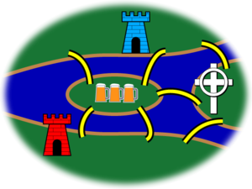
A variant with red and blue castles, a church and an inn.
The northern bank of the river is occupied by the Schloß, or castle, of the Blue Prince; the southern by that of the Red Prince. The east bank is home to the Bishop's Kirche, or church; and on the small island in the center is a Gasthaus, or inn.
It is understood that the problems to follow should be taken in order, and begin with a statement of the original problem:
It being customary among the townsmen, after some hours in the Gasthaus, to attempt to walk the bridges, many have returned for more refreshment claiming success. However, none have been able to repeat the feat by the light of day.

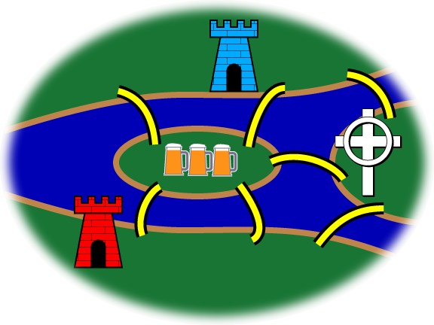
Bridge 8: The Blue Prince, having analyzed the town's bridge system by means of graph theory, concludes that the bridges cannot be walked. He contrives a stealthy plan to build an eighth bridge so that he can begin in the evening at his Schloß, walk the bridges, and end at the Gasthaus to brag of his victory. Of course, he wants the Red Prince to be unable to duplicate the feat from the Red Castle. Where does the Blue Prince build the eighth bridge?
Solution: In order for
End Here
Start Here
Bridge 9: The Red Prince, infuriated by his brother's Gordian solution to the problem, wants to build a ninth bridge, enabling him to begin at his Schloß, walk the bridges, and end at the Gasthaus to rub dirt in his brother's face. As an extra bit of revenge, his brother should then no longer be able to walk the bridges starting at his Schloß and ending at the Gasthaus as before. Where does the Red Prince build the ninth bridge?

Bridge 10: The Bishop has watched this furious bridge-building with dismay. It upsets the town's Weltanschauung and, worse, contributes to excessive drunkenness. He wants to build a tenth bridge that allows all the inhabitants to walk the bridges and return to their own beds. Where does the Bishop build the tenth bridge?

