**Activity 1 – Practice with Linearization (2)**

(Estimated Time = 20 minutes)

Individually, but in consultation with your team: (Textbook pg. 386)

1. Linearize the Power equation: y = bxm.

|  |  |
| --- | --- |
| x | y |
| 2 | 3.69 |
| 10 | 5.99 |
| 20 | 7.37 |
| 50 | 9.70 |
| 75 | 10.96 |
| 100 | 11.94 |

2. Linearize the data.

3. Plot the data using linear scales.

4. Determine the slope, m, and intercept, b.

5. Write the linear and general form of the equation.

6. Plot the data using log scales.

**Activity 2 – Practice with Linearization (3)**

(Estimated Time = 20 minutes)

Individually, but in consultation with your team: (Textbook pg. 388; use the values in the table below because those in the textbook are incorrect.)

1. Linearize the logarithmic equation: x = b10my.

|  |  |
| --- | --- |
| x | y |
| 0.44 | 2 |
| 1.15 | 20 |
| 5.65 | 50 |
| 21.24 | 75 |
| 47 | 90 |
| 79.81 | 100 |

2. Linearize the data.

3. Plot the data using linear scales.

4. Determine the slope, m, and intercept, b.

5. Write the linear and general form of the equation.

6. Plot the data using log scales.

**Activity 3 –Function Discovery in MATLAB**

(Estimated Time = 10 minutes)

For each of the following mathematical functions, write the letter of the graphs shown below that best represents the shape of that function and the MATLAB command (**plot**, **semilogy**, **semilogx**, or **loglog**) that would generate a plot of the same function to make it appear linear.

The origin of each graph given below is in the lower left of the graph window except for Graph A. In each case, x is independent, y is dependent, and constants K, L, V, W, g may be positive or negative.

|  |  |  |  |  |  |  |
| --- | --- | --- | --- | --- | --- | --- |
| Mathematical Function | MATLAB Command | Graph |  | Mathematical Function | MATLAB Command | Graph |
| y = e^(gx) |  |  |  | y = x^2 |  |  |
| y = W*x^(0.5) |  |  |  | y = (V/x) |  |  |
| y = ln(x) |  |  |  | y = K*x + C |  |  |

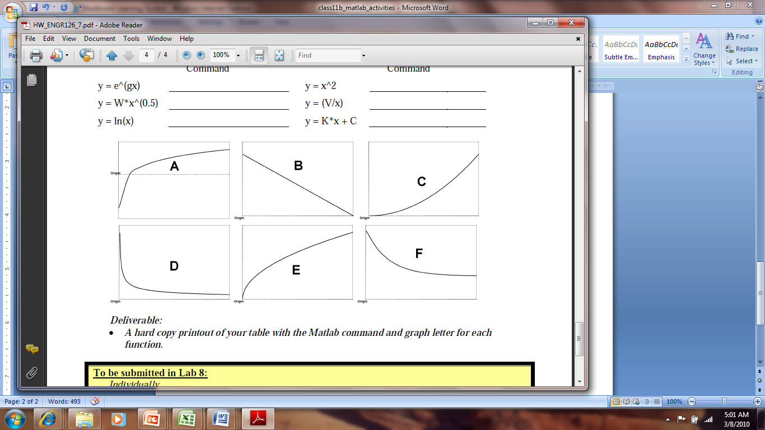

**Activity 4 – Function Discovery in MATLAB**

(Estimated Time = 20 minutes)

You have been employed as an intern for a leading bioremediation company. The company is conducting research with microorganisms, especially bacteria, to cleanup of oil spills in a variety of environments (contaminated soil, contaminated water, and sludges). You are part of a team that is working with bacteria to degrade kerosene that has contaminated the soil at a gas station with underground storage tanks that is currently being remodeled.

Part of your assignment as an intern is to develop mathematical models for the growth of the bacteria. Data has been supplied to you from the research team on the growth of the bacteria as a function of time and is shown in Table 1.

**Table 1: Bacteria Growth as a Function of Time [1]**

|  |  |
| --- | --- |
| **Time**  **(days)** | **Cell Concentration**  **(g/L)** |
| 1 | 1.0 x 106 |
| 5 | 7.5 x 106 |
| 10 | 1.25 x 107 |
| 15 | 3.15 x 107 |
| 20 | 4.2 x 107 |

1. Livingston, R.J. and M.R. Islam, 1999. “Laboratory Modeling, Field Study, and Numerical Simulation of Bioremediation of

Petroleum Contaminants”, *Energy Sources*, Volume. 21, pages 113-129.)

1. Open **script_header_template.m** in the MATLAB editor and re-save as **bacteria_grow.m**. Modify the Comments section for this problem.

2. Under the Input Section, assign variables for time and cell concentration.

3. Under the Output Section, use the **subplot** command to plot four graphs in one figure using a 2x2 matrix format. Remember to include titles and labels for each graph. The scales on each graph should be as follows:

a. one graph with rectilinear scales for both x and y axes.

b. one semi-log graph with a rectilinear scale for the x axis and log scale for the y axis.

c. one semi-log graph with a rectilinear scale for the y axis and log scale for the x axis.

d. one log-log graph with log scales on both x and y axes.

4. Based on the four graphs, write the **general form** of the equation that could be used as a model for cell growth. Place your answer in the Output Section in an **fprintf** statement. Clearly justify your answer.

5. Using what you have learned about linearizing data, use MATLAB to determine the constants (***m*** and ***b***) in the equation you identified in step 4. Write out the linear and general form of the equation with the values of ***m*** and ***b*** plugged in. Place your answer in the Output Section in an **fprintf** statement.

**Activity 5 – More Function Discovery in MATLAB**

(Estimated Time = 10 minutes)

Through this exercise, you will gain more practice plotting and recognizing log-log and semi-log relationships.

The Japan Automobile Manufacturers Association of Canada keeps track of all cars of Japanese makes. The table shows the number of vehicles made by Honda, Toyota, Nissan, and others in Canada and exported from 1989 to 1995. For purposes of analysis, the engineer has chosen to represent years with an index (since year 0 is an arbitrary choice).

|  |  |
| --- | --- |
| **Year Index** | **Vehicles Exported** |
| 1 | 78,484 |
| 2 | 161,071 |
| 3 | 240,190 |
| 4 | 249,660 |
| 5 | 303,424 |
| 6 | 309,362 |
| 7 | 320,268 |

1. Open **script_header_template.m** in the MATLAB editor and re-save as **class9b_activity5.m**.

2. Under the Input Section, define variables for the year index and number of vehicles exported data.

3. Under the Output Section, plot the number of vehicles exported as a function of the year index that is suitable for technical presentation.

4. Interpret the plot, identify the relationship, and use MATLAB commands to linearize the data.

5. Use the polyfit command to determine the slope and intercept of the linearized form.

6. Use fprintf statements to display the linearized and general forms of the equation.

7. Plot the data using log scales that is suitable for technical presentation.