Network exploration

### installing/loading libraries

# install.packages("BiocManager")   
# BiocManager::install("WGCNA")   
  
packs <- c("sna", "tsna", "ndtv", "tidyverse")  
for (i in 1:length(packs)){  
 if(packs[i] %in% rownames(installed.packages()) == FALSE){  
 install.packages(packs[i], repos="http://cran.univ-paris1.fr/")  
 }  
 library(packs[i], character.only = TRUE)  
}

### data

indir <- "/Users/susana.martinez/Documents/LAO_TS_analysis/MGE_analysis/Host_CRISPR_MGE_analysis/Networks"  
  
# phage networks  
nodes_ph.in <- paste(indir, "Final_nodes_spreadMGMT_phage.tsv", sep = "/")  
net_ph.in <- paste(indir, "Final_rbin_phagenet.tsv", sep = "/")  
  
# plasmid networks  
nodes_pl.in <- paste(indir, "Final_nodes_spreadMGMT_plasmid.tsv", sep = "/")  
net_pl.in <- paste(indir, "Final_rbin_plasmidnet.tsv", sep = "/")

### PH-host network: interactions

* Get edge attributes, i.e. present/absence og edges per time point

# get unite(A-B)/dates with 0 or 1, and then get average, median, sd  
# which will be then the wight of the edge, variance, etc.  
  
nodes_ph <- read_tsv(nodes_ph.in) %>% gather(date, omic, -node, -type) %>% filter(!is.na(omic))  
net_ph <- read_tsv(net_ph.in)  
  
net_ph %>%   
 inner_join(., nodes_ph, by = c("rbin" = "node")) %>% filter(!is.na(omic)) %>%   
 select(-omic, -type) %>%  
 inner_join(., nodes_ph, by = c("pspcc" = "node", "date")) %>% filter(!is.na(omic)) %>%   
 select(-omic, -type) %>%   
 unite("edge", c("rbin", "pspcc"), sep = "-") %>%   
 mutate(interaction = 1) %>%   
 spread(date, interaction, fill = 0) -> edge_tab  
#write_tsv(edge_tab, paste(indir, "ALL_phage_networks", "Edge_attributes.tsv", sep = "/"))  
  
edge_tab %>%   
 gather(date, presence, -edge) %>%   
 group_by(edge) %>%   
 mutate(n_occurrence = sum(presence)) %>%   
 mutate(weight_edge = mean(presence)) -> edge_tab_weigth_occ  
write_tsv(edge_tab_weigth_occ, paste(indir, "ALL_phage_networks", "Edge_attributes_witgh_dates.tsv", sep = "/"))

* Estimate a weight per edge based on the averaged presence

edge_tab_weigth_occ %>%   
 spread(date, presence) %>%   
 select(weight_edge) %>%   
 ggplot(aes(x=weight_edge)) +   
 geom_histogram()

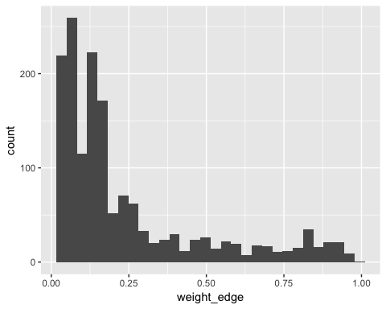

edge_tab_weigth_occ %>%  
 spread(date, presence) %>%   
 select(n_occurrence) %>%   
 ggplot(aes(x=n_occurrence)) +   
 geom_histogram() +  
 scale_x_discrete(limits=0:51)

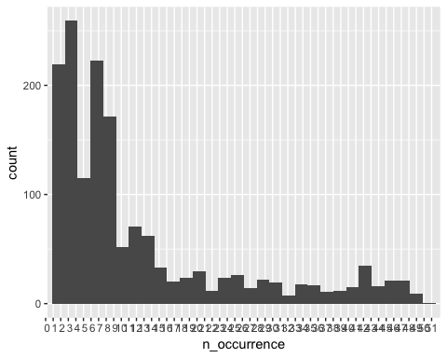 + Difference in the number of new edges per time point: with respect to the previous time point

TPs <- edge_tab_weigth_occ %>% ungroup() %>% select(date) %>% unique() %>% mutate(date = as.Date(date))  
  
edge_tab_weigth_occ %>%   
 ungroup() %>%   
 mutate(date = as.Date(date)) %>%   
 group_by(date) %>%   
 mutate(n_ints = sum(presence)) %>%   
 ungroup() %>%   
 select(date, n_ints) %>% unique() %>%   
 mutate(t_minus_1 = lag(n_ints)-n_ints) %>%  
 gather(type, value, -date) %>%   
 group_by(type) %>%   
 mutate(average=mean(value, na.rm=TRUE), median = median(value, na.rm=TRUE), variance = sd(value, na.rm=TRUE)) -> n_ints_with_lag  
  
n_ints_with_lag %>%   
 ggplot(aes(x=date, y=value, fill=type)) +  
 geom_line() +   
 scale_x_date(breaks=TPs$date) +  
 theme_classic() +   
 theme(axis.text.x = element_text(angle = 90))

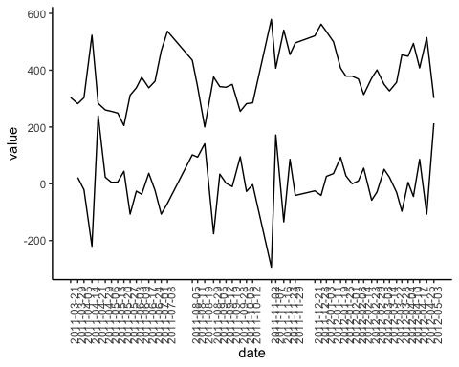

n_ints_with_lag %>% ungroup() %>% select(2,4,5,6) %>% unique()

## # A tibble: 2 x 4  
## type average median variance  
## <chr> <dbl> <dbl> <dbl>  
## 1 n_ints 382. 369 98.0  
## 2 t_minus_1 0.04 3.5 97.5

* new edges per time point, i.e. edges that did not appear until TPn –> new interactions over time

edge_tab_weigth_occ %>%   
 ungroup() %>%   
 select(1,2,3) %>%   
 group_by(date) %>%   
 mutate(int_per_tp = sum(presence)) %>% ungroup() %>%   
 group_by(edge) %>%   
 mutate(cummulative_presence_ints = cumsum(presence)) %>%   
 mutate(new_ints = case_when(cummulative_presence_ints == 0 ~ 0,  
 cummulative_presence_ints == 1 & lag(cummulative_presence_ints) == 0 ~ 1,  
 cummulative_presence_ints == lag(cummulative_presence_ints) ~ 0,  
 cummulative_presence_ints > 1 ~ 0)) %>% ungroup() %>%   
 select(edge, date, new_ints, int_per_tp) %>% unique() %>%   
 group_by(date) %>%   
 mutate(new_ints_date = sum(new_ints, na.rm = T)) %>%   
 ungroup() %>%   
 select(date, new_ints_date, int_per_tp) %>% unique() %>%   
 gather(type, value, -date) %>%   
 mutate(date = as.Date(date)) %>%   
 ggplot(aes(x=date, y=value, colour=type)) +  
 geom_line(show.legend = T) +   
 scale_x_date(breaks=TPs$date) +  
 theme_classic() +   
 theme(axis.text.x = element_text(angle = 90))+  
 ggtitle("New interactions over time")

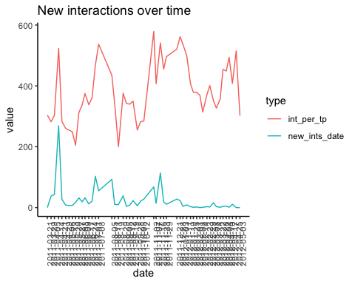 + Weighted nteractions per time point: avergae, median, sd, per time point and show over time

edge_tab_weigth_occ %>%   
 ungroup() %>%   
 mutate(weight_edge = ifelse(weight_edge*presence == 0, NA, weight_edge*presence)) %>%   
 select(edge, date, weight_edge) %>%   
 group_by(date) %>%   
 mutate(average = mean(weight_edge, na.rm = T), median = median(weight_edge, na.rm = T), variance = sd(weight_edge, na.rm = T)) %>%   
 ungroup() %>%   
 select(-edge, -weight_edge) %>% unique() %>%   
 gather(variable, value, -date) %>%   
 mutate(date = as.Date(date)) %>%   
 ggplot(aes(x=date, y=value, colour=variable)) +  
 geom_line(show.legend = F) +   
 scale_x_date(breaks=TPs$date) +  
 facet_wrap(~variable, ncol = 1) +   
 theme_classic() +   
 theme(axis.text.x = element_text(angle = 90))+  
 ggtitle("Weighted interactions: stats over time")

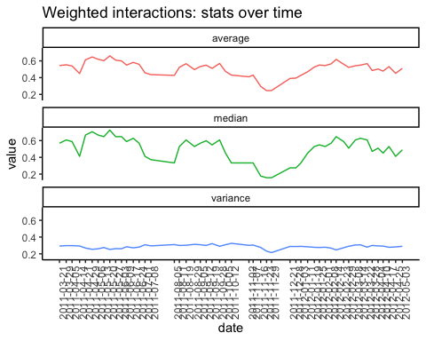 + Jaccard distances between time points, based on the presence/abscence of edges and the weight when there is edge

# get matrix to calculate distances  
# presence/absence  
# weighted network  
edge_tab_weigth_occ %>%   
 mutate(weight_edge = ifelse(weight_edge*presence == 0, 0, weight_edge*presence)) %>%   
 select(edge, date, weight_edge) %>%   
 spread(date, weight_edge) %>%   
 remove_rownames() %>%   
 column_to_rownames("edge") %>%   
 as.matrix() %>%   
 t() -> mt_pa  
  
library(vegan)  
rm(list=c("jaccard_pa_bi", "lag_dist_pa_b", "jaccard_pa", "lag_dist_pa"))  
  
jaccard_pa_bi <- vegdist(mt_pa, method = "jaccard", diag=F, binary=T) %>% as.matrix()  
lag_dist_pa_bi <- jaccard_pa_bi[row(jaccard_pa_bi) == col(jaccard_pa_bi) + 1]  
lag_dist_pa_bi %>%   
 as.tibble() %>%   
 mutate(date = as.Date(colnames(jaccard_pa_bi)[-1])) -> lag_dist_pa_bi  
  
###  
jaccard_pa <- vegdist(mt_pa, method = "jaccard", diag=F) %>% as.matrix()  
lag_dist_pa <- jaccard_pa[row(jaccard_pa) == col(jaccard_pa) + 1]  
lag_dist_pa %>%   
 as.tibble() %>%   
 mutate(date = as.Date(colnames(jaccard_pa)[-1])) %>%   
 full_join(lag_dist_pa_bi,., by = "date") %>%   
 rename(jaccard_binary = value.x, jaccard_weighted = value.y) %>%   
 gather(type, value, -date) %>%   
 ggplot(aes(x=date, y=value, color=type)) +  
 geom_line(show.legend = T) +   
 scale_x_date(breaks=TPs$date[-1]) +  
 facet_wrap(~type, ncol = 1) +   
 theme_classic() +   
 theme(axis.text.x = element_text(angle = 90))+  
 ggtitle("Jaccard distances (t-1)")

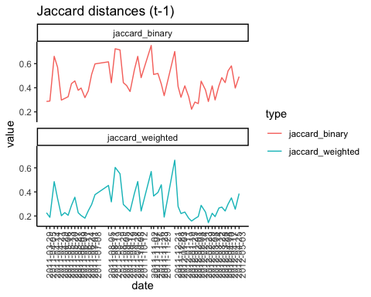 + Entropy

#install.packages("entropy")  
library(entropy)  
edge_tab_weigth_occ %>%   
 select(date, presence) %>%  
 group_by(date) %>%   
 mutate(entropy = entropy(presence)) %>%   
 ungroup() %>%   
 select(date, entropy) %>% unique() %>%   
 mutate(date = as.Date(date)) %>%   
 gather(type, value, -date) %>%   
 ggplot(aes(x=date, y=value)) +  
 geom_line(show.legend = F) +   
 scale_x_date(breaks=TPs$date) +  
 theme_classic() +   
 theme(axis.text.x = element_text(angle = 90))+  
 ggtitle("Entropy per time point, based on presence/absence of interaction")

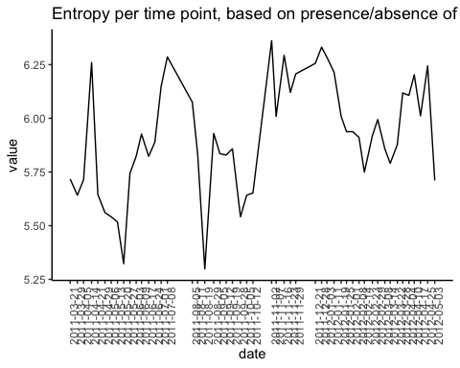

### PH-host network: nodes

# get node degree, but per part, since this is a bipartite net  
edge_tab_weigth_occ %>%   
 select(edge, date, presence) %>%   
 separate(edge, into = c("A", "B"), sep = "-")

## # A tibble: 80,529 x 4  
## A B date presence  
## <chr> <chr> <chr> <dbl>  
## 1 A01_O1.2.4 A01_C1.1.14_contig_12673 2011-03-21 0  
## 2 A01_O1.2.4 A01_E1.2.10_contig_32472 2011-03-21 0  
## 3 A01_O1.2.4 A01_E13_contig_43485 2011-03-21 0  
## 4 A01_O1.2.4 A01_N_contig_18941 2011-03-21 0  
## 5 A01_O1.2.4 A01_N_contig_30400 2011-03-21 0  
## 6 A01_O1.2.4 A01_N_contig_39579 2011-03-21 0  
## 7 A01_O1.2.4 A01_N_contig_70118 2011-03-21 0  
## 8 A01_O1.2.4 A02_N_contig_82475 2011-03-21 0  
## 9 A01_O1.2.4 D01_L1.42_contig_218719 2011-03-21 0  
## 10 A01_O1.2.4 D01_N_contig_228630 2011-03-21 0  
## # ... with 80,519 more rows

### Convert the ReGe-PH net to ReGe-ReGe net connected by common CRISPR interactions