Single Loop circuit

Conservation of Energy:

$$V_{bat}-V_{R}=0$$

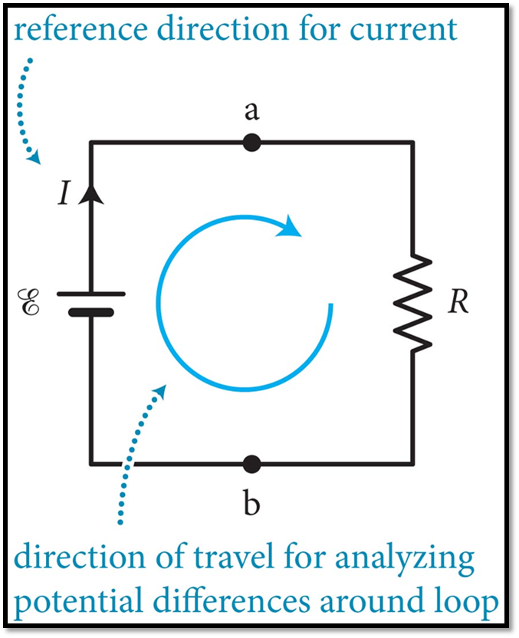

We have the same circuit again.

This time we have marked points A and B to be references.

Note the curly E next to the battery.

That curly E stands for electromotive force or E M F.

It is just the potential difference or voltage of the battery.

E M F is an old designation, but it means basically the same thing as voltage.

I will be writing E M F as V bat or V battery

Conservation of energy tells us that if we look at the electric potential around the circuit, once we have completed a loop, we must be at the potential we started at.

In other words, the potential difference around a closed loop is zero.

Let’s start at point B and move clockwise around the circuit.

Moving clockwise we come to the low potential side of the battery first and step up to the higher potential side.

That is an increase in potential.

In other words, the potential difference across the battery, when going clockwise, is positive.

When going across the resistor we are dropping in potential.

Then we are back at point B.