**Use Case Diagram** João Esteves 47994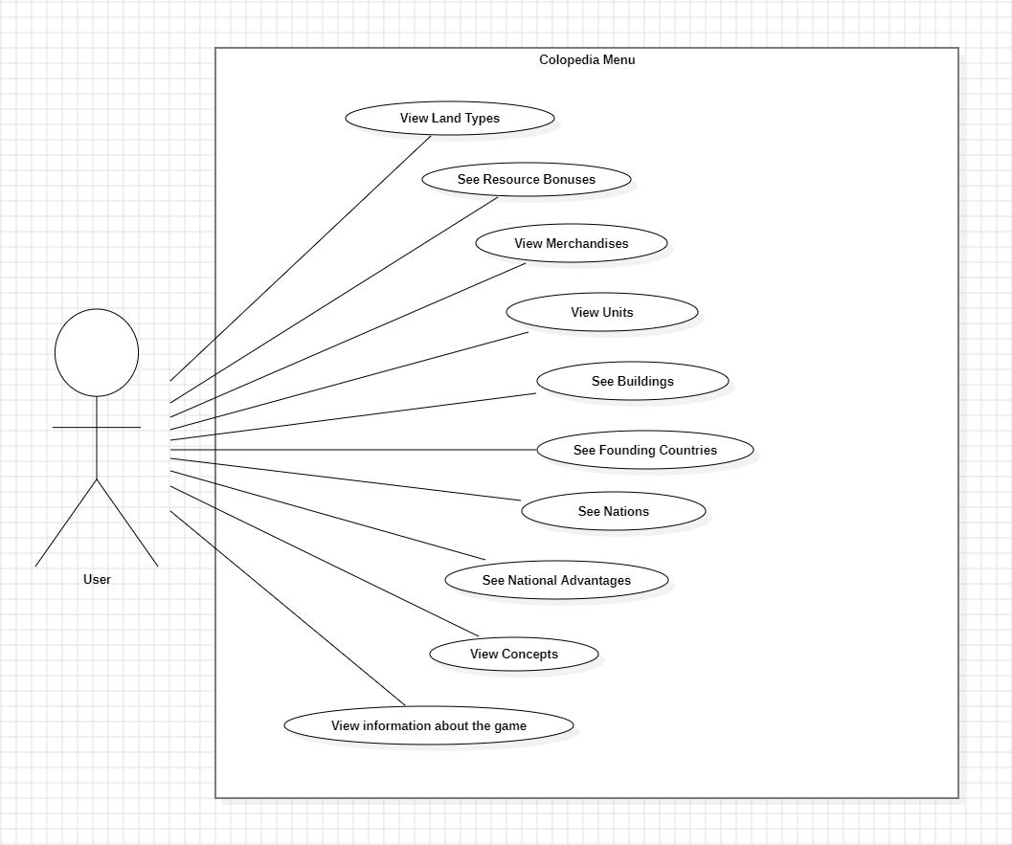

**Colopedia Menu**

**Use Cases**

Name: View Land Types

Description: The User can consult the types of terrain available in the game, as well as their information.

Primary Actor: User

--

Name: See Resource Bonuses

Description: The User can consult resource bonuses as well as their information.

Primary Actor: User

--

Name: View Merchandises

Description: The User can consult the goods available in the game and have access to their information.

Primary Actor: User

--

Name: View Units

Description: The User can consult the units available in the game and have access to their information.

Primary Actor: User

--

Name: See Buildings

Description: The User can consult the buildings available in the game and have access to their information.

Primary Actor: User

--

Name: See Founding Countries

Description: The User can consult information about the founding countries.

Primary Actor: User

--

Name: See Nations

Description: The User can consult the nations available in the game, as well as their information.

Primary Actor: User

--

Name: See National Advantages

Description: The User can consult information about national advantages.

Primary Actor: User

--

Name: View Concepts

Description: The User can consult information about different concepts present in the game.

Primary Actor: User

--

Name: View information about the game

Description: The User can check the game credits.

Primary Actor: User