net.sf.freecol.FreeCol:

Large Class:

The FreeCol class contains a large number of methods and properties, which might indicate that it's doing too many things.

Duplicated Code:

There are instances of duplicated code, such as similar error handling patterns found in different methods.

Net.sf.freecol.server.generator.TerrainGenerator:

Long Method:

The generateMap method is quite lengthy, performing multiple tasks such as importing tiles, setting regions, creating mountains, rivers, lakes, and bonuses.

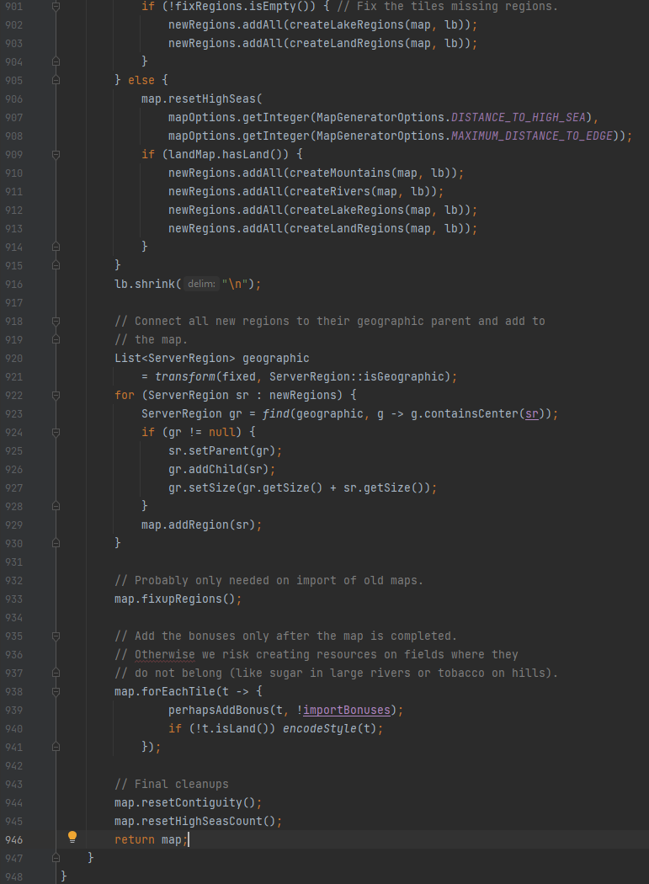

Data Clumps:

There are multiple groups of related parameters used across methods, such as latitude-related parameters. These data clumps suggest that certain parameters might be better organized into objects or data structures, creating classes or structures to encapsulate related parameters, would make the code more organized and selfexplanatory.

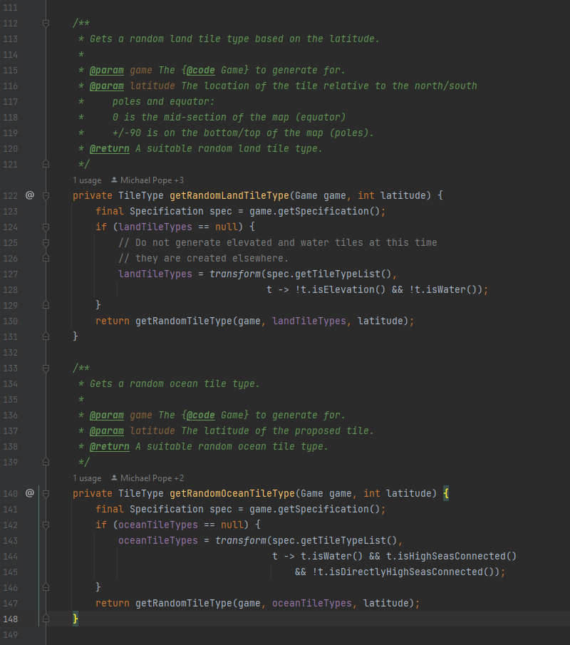

For example, latitude is passed to

methods like getRandomLandTileType

and getRandomOceanTileType.

Net.sf.freecol.server.generator.SimpleMapGenerator:

Long Method:

The createEuropeanUnits method is quite long and performs multiple tasks, including handling different types of units, selecting starting positions, and checking various conditions. Long methods can be hard to understand, maintain, and test. My suggestion is refactoring this method into smaller, more focused methods that handle specific tasks.

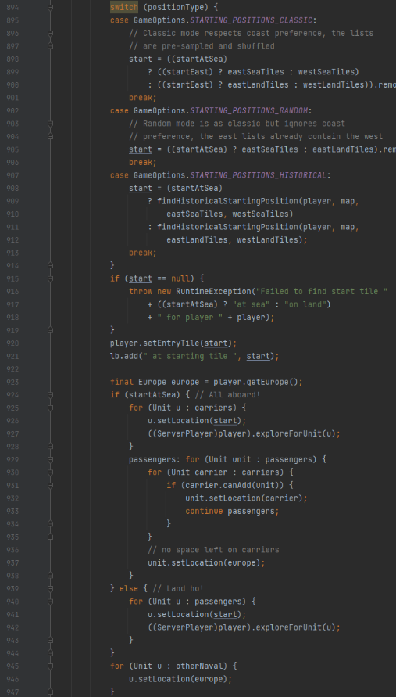

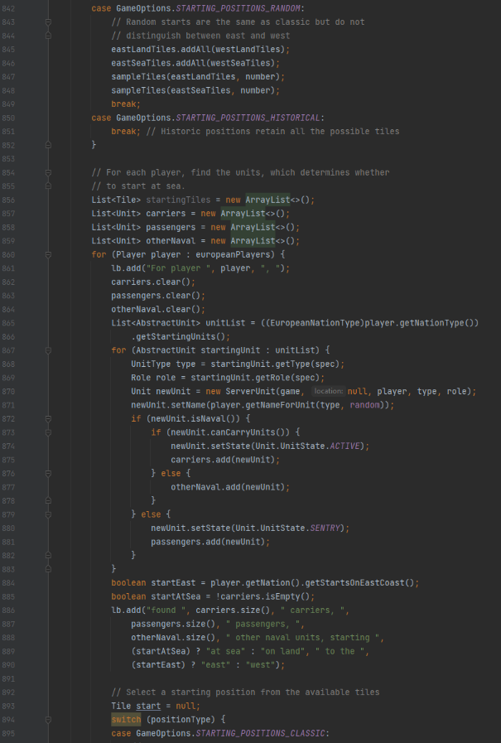

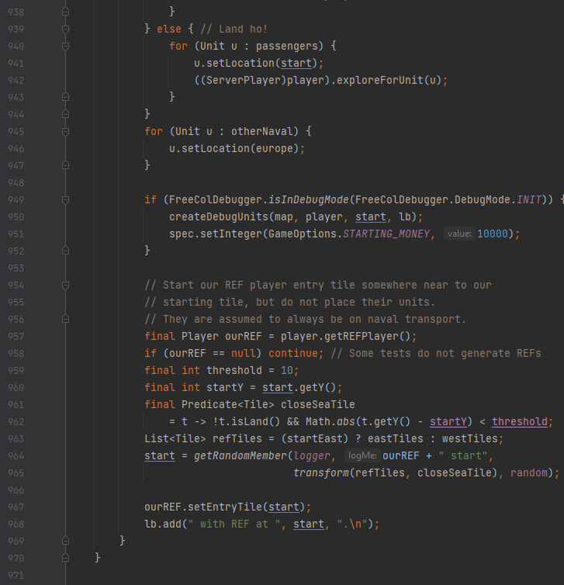

Data Clumps:

There are instances of using groups of related data as method parameters, such as generateSkillForLocation taking Map, Tile, and NationType as parameters. This indicates a data clump, where certain groups of parameters are frequently passed together. Encapsulating related parameters into a class or structure to improve code readability and maintainability.

