***GETTING STARTED WITH ARDUROS R1:***

1. **Connecting to ArduROS**

* Rotate the red button clockwise to turn on the UGV button mounted between two antennae.
* After a beep, you can see GPS, mounted at the center blinking.
* You can use any device Laptop/Mobile to check the available WIFI connections
  + Connect to the *Ardu-X i.e., X is different for each UAV*
  + ***Password****: aionrobotics*

**SSH (Access through terminal)**

* Open a Terminal and use the following commands
  + ssh -x aion@[10.0.1.128](mailto:root@10.1.0.128)
  + user login: aion
  + password: aion
* One can also use *Putty Terminal for WIndows*

**Snowflake (Access through GUI)**

* Install Snowflake and launch in your system
* Start a New Connection, add relative ingredients, and connect

**Name:** Any, **Host:** 10.0.1.128 **Port:** 22 (By default)

**User:** aion **Password:** aion

Figure 1: Snowflake: GUI Connection with ArduROS R1

1. **Moving ArduROS using MAVROS (Go with the Flow)**

**Connect MAVLINK with ROS using MAVROS**

Open a Terminal (SSH/Snowflake) and run a following command

***roslaunch aion_control aion_io.launch ugv_model:=r1***

* + This command enables **ROS-MASTER** (roscore)
  + 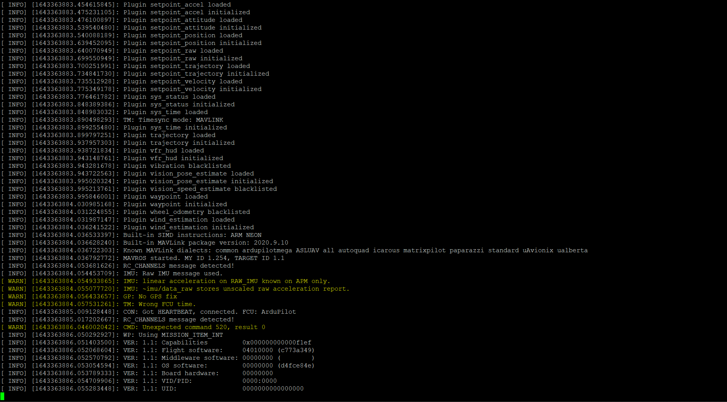Connects MAVLINK (FCU) with ROS
  + Open 2nd terminal.
  + Again Run this command: ssh -x aion@[10.0.1.128](mailto:root@10.1.0.128) on 2nd terminal.

Run the following command for available topics in mavros package

***rostopic list***

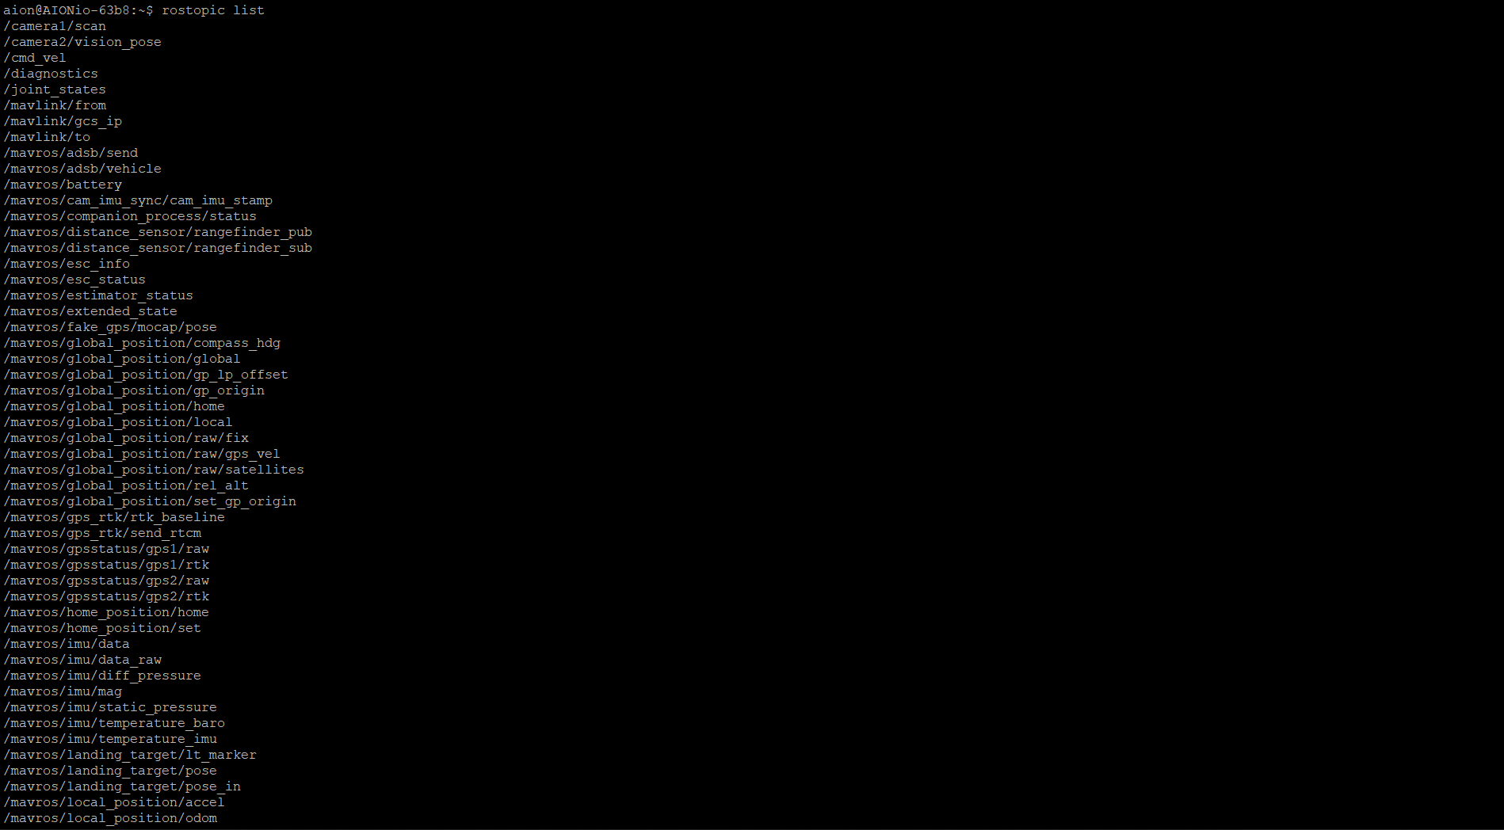

**Select the Mode of *ArduROS R1***

There are many modes of operation for ArduROS i.e., GUIDED, MANUAL, AUTO, RTL, Steering, Hold etcetera. To select the mode of operation, use the following command. Apply this command twice to see *Mode Changed* in a Terminal followed by a beep.

***rosrun mavros mavsys mode -c GUIDED***

One can also confirm the status of ArduROS using a command in a Terminal and see the current mode and arm/disarm status.

***rostopic echo /mavros/state***

**Make sure to Lock the GPS**

Take the rover to a open air place/outdoor

Wait until the GPS blinking lights turns green from yellow

**Arm the ArduROS**

To bind the connection between our onboard computer and Flight controller Unit - FCU, you need to ARM the vehicle using following command

***rosrun mavros mavsafety arm***

**Start Moving**

**Note: This command will make your ArduROS run so be ready to stop it by pressing Ctrl+C to avoid damage.**

The rover is subscribing *cmd_vel* topic which if published via terminal can make rover move. To publish *cmd_vel on a terminal use the following command*

***rostopic pub -r 10 /cmd_vel geometry_msgs/Twist '{linear: {x: 0.1, y: 0.0, z: 0.0}, angular: {x: 0.0,y: 0.0,z: 0.0}}'***

linear: x: 0.1, y: 0.0, z: 0.0 à Linear Speed ( x: 0.5 A speed can be increased like this )

angular: x: 0.0, y: 0.0, z: 0.0 à angular Speed

The command below will let rover move faster

***rostopic pub -r 10 /cmd_vel geometry_msgs/Twist '{linear: {x: 0.5, y: 0.0, z: 0.0}, angular: {x: 0.0,y: 0.0,z: 0.0}}'***

1. **Moving ArduROS using MAVROS using GPS location**

To test in a confined area please make sure to use exact GPS value for destination. You can simply take your rover from launch point to a destination point. Use the following command to check the current GPS location of rover using its mounted GPS Module i.e., Here3

**rostopic echo /mavros/global_position/global**

Note the destination GPS position and replace in the following command with longitude and latitude

**rostopic pub /mavros/setpoint_raw/global mavros_msgs/GlobalPositionTarget -1 "{'longitude': 14.51218,'latitude': 10.15785}**

Your rover will start its journey and will manage its heading as well towards destination.

You can **stop your rover anytime by pressing Ctrl+C**

1. **Autonomous Mission Planning using MAVROS without Mission Planner/Q Ground Control**
2. **Check the state of the Pixhawk:**

To plan mission Autonomously make sure ArduRos is in MANUAL mode by echoing the state topic using:

***rostopic echo /mavros/state***

otherwise set mode to manual using/

1. **Set the mode Manual**

***rosrun mavros mavsys mode -c MANUAL***

1. **Set Home location (GPS):**

Set the home position of ArduROS by following command, This position will be used a reference for Return to Launch (RTL) by default

***rosrun mavros mavcmd sethome -c 33.7661421 72.8255066 439.741995865***

1. **Write mission waypoints to Flight Controller Unit (FCU) I.e., Pixhawk**

There are three methos to write mission waypoints to FCU

**METHOD 1: Using Text File**

1. Create a text file using following command in a terminal

Nano mission.txt



1. Load waypoints from mission.txt file to FCU

***rosrun mavros mavwp load mission.txt***

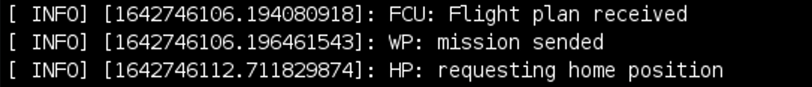

**METHOD 2: Using mavwp node**

1. Write waypoints directly into FCU by calling ros_service

rosservice call /mavros/mission/push "start_index: 0

waypoints:

- {frame: 0, command: 16, is_current: false, autocontinue: false, param1: 0.0, param2: 0.0, param3: 0.0, param4: 0.0, x_lat: 33.7661421, y_long: 72.8255066, z_alt: 0.0}

- {frame: 0, command: 16, is_current: false, autocontinue: false, param1: 0.0, param2: 0.0, param3: 0.0, param4: 0.0, x_lat: 33.7661645, y_long: 72.8254724, z_alt: 0.0}

- {frame: 0, command: 16, is_current: false, autocontinue: false, param1: 0.0, param2: 0.0, param3: 0.0, param4: 0.0, x_lat: 33.7660909, y_long: 72.8254858, z_alt: 0.0}

- {frame: 0, command: 16, is_current: false, autocontinue: false, param1: 0.0, param2: 0.0, param3: 0.0, param4: 0.0, x_lat: 33.7659571, y_long: 72.8254724, z_alt: 0.0}

- {frame: 0, command: 16, is_current: false, autocontinue: false, param1: 0.0, param2: 0.0, param3: 0.0, param4: 0.0, x_lat: 33.7658768, y_long: 72.8254776, z_alt: 0.0}"

1. Write these waypoints to a mission.txt file using

***rosrun mavros mavwp dump mission.txt***

**METHOD 3: Using Terminal**

1. Write waypoints directly into FCU by calling ros_service

rosservice call /mavros/mission/push "start_index: 0

waypoints:

- {frame: 0, command: 16, is_current: false, autocontinue: false, param1: 0.0, param2: 0.0, param3: 0.0, param4: 0.0, x_lat: 33.7661421, y_long: 72.8255066, z_alt: 0.0}

- {frame: 0, command: 16, is_current: false, autocontinue: false, param1: 0.0, param2: 0.0, param3: 0.0, param4: 0.0, x_lat: 33.7661645, y_long: 72.8254724, z_alt: 0.0}

- {frame: 0, command: 16, is_current: false, autocontinue: false, param1: 0.0, param2: 0.0, param3: 0.0, param4: 0.0, x_lat: 33.7660909, y_long: 72.8254858, z_alt: 0.0}

- {frame: 0, command: 16, is_current: false, autocontinue: false, param1: 0.0, param2: 0.0, param3: 0.0, param4: 0.0, x_lat: 33.7659571, y_long: 72.8254724, z_alt: 0.0}

- {frame: 0, command: 16, is_current: false, autocontinue: false, param1: 0.0, param2: 0.0, param3: 0.0, param4: 0.0, x_lat: 33.7658768, y_long: 72.8254776, z_alt: 0.0}"

**CAUTION before writing the mission:**

* Make sure the GPS points used to write Mission in previous commands are accurate. It’s a must practice to validate these waypoints manually before writing of mission.

1. **Read Waypoints in FCU**

***rosrun mavros mavwp pull***

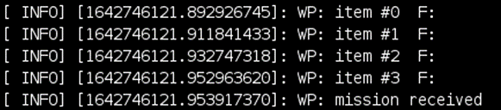

1. **Change Mode:**

Currently the FCU is in MANUAL mode and to proceed further we need to change mode to

AUTO to execute Mission

***rosrun mavros mavsys mode -c AUTO***

1. **Teleoperation of UGV using Keyboard**

* Keyboard node can be found

/home/aion/AIONio_ws/src/move_ugv/src/keyboard_non_blocking_input_node.cpp

* Teleop_ugv node can be found

/home/aion/AIONio_ws/src/move_ugv/src/ teleop_ugv.cpp

1. **Move UGV in a cartesian plane**

rostopic pub /mavros/setpoint_position/local geometry_msgs/PoseStamped "header:

seq: 0

stamp:

secs: 0

nsecs: 0

frame_id: ''

pose:

position:

x: 0.0

y: 0.0

z: 0.0

orientation:

x: 0.0

y: 0.0

z: 0.0

w: 0.0"